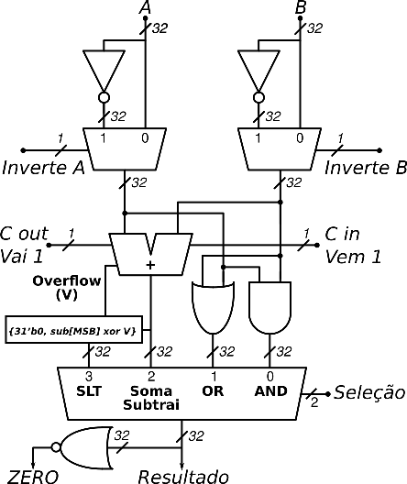**Tabelas da Unidade de Controle da ULA.**

**Ordenação bits ULActrl:**

|  |  |
| --- | --- |
| **Ordenação dos bits de Controle da ULA (ULActrl)** | **Ponto de Controle** |
| 3 (MSB) | inverteA |
| 2 | inverteB |
| 1 | Seleção bit 1 |
| 0 (LSB) | Seleção bit 0 |

**Tabela de operação da ULA MIPS DLX:**

|  |  |  |  |  |  |
| --- | --- | --- | --- | --- | --- |
| **Instrução** **(opcode hex)** | **Opcode** **(opcode bin)** | **Funct** (**bin)** | **ULA** **Executa** | **ULActrl** **(bin)** | **ULAop** **(N bits)** |
|  | 6 bits | 6 bits |  | 4 bits |  |
|  | **31 ~ 26** | **5 ~ 0** |  | **InvA, InvB, Sel[1,0]** |  |
| **Tipo R:** |  |  |  |  |  |
| ADD (0x00) | 00.0000 |  | (add) |  |  |
| SUB (0x00) | 00.0000 |  | (sub) |  |  |
| AND (0x00) | 00.0000 |  | (and) |  |  |
| OR (0x00) | 00.0000 |  | (or) |  |  |
| SLT (0x00) | 00.0000 |  | (slt) |  |  |
| **Tipo I:** |  |  |  |  |  |
| LW (0x23) |  |  |  |  |  |
| SW (0x2B) |  |  |  |  |  |
| BEQ (0x04) |  |  |  |  |  |

**Tabela com o Resumo do Controle da ULA**:

|  |  |  |  |  |
| --- | --- | --- | --- | --- |
| **Instrução** **(opcode hex)** | **ULAop** **(N bits)** | **Funct** **(6 bits)** | **ULA** **Executa** | **ULActrl** **(4 bits)** |
| LW (0x23) (I) |  |  | (add) |  |
| SW (0x2B) (I) |  |  | (add) |  |
| BEQ (0x04) (I) |  |  | (sub) |  |
| ADD (0x00) (R) |  |  | (add) |  |
| SUB (0x00) (R) |  |  | (sub) |  |
| AND (0x00) (R) |  |  | (and) |  |
| OR (0x00) (R) |  |  | (or) |  |
| SLT (0x00) (R) |  |  | (slt) |  |