Khmer Angkor Keyboard
Contents
Overview 2
Khmer Angkor Keyboard Layouts 2
Desktop Layout –Windows/macOS 2
Touch Layout –Android/iOS 3
Khmer Character Categories and Keystrokes for Desktop 7
Consonants 7
Dependent Vowels 8
Signs 8
Independent Vowels 8
Diacritics 9
Native Punctuations 9
Latin Punctuations 9
Currencies 9
Khmer Numerals 9
Divination Lore 10
Khmer Lunar Dates 10
Discouraged/Obsolete characters 10
Characters used in minority languages 11
Joiners and Spaces 11
Typing in Khmer 11
Silent Auto-correction 11
Subscript + Vowel 12
Subscript + ្រ [U+17D2] [U+179A] 12
Subscript + Consonant Shifter + Vowel 12
Consonant Shifter + Vowel 12
Vowel with Nikahit [U+17C6] 12
Vowel ោ [U+17C4] and Vowel ើ [U+17BE] 12
Visually Identical Subscript 13
Vowel Rotation 13
Beep / Constraints 13
Mistyped Characters 14

Overview
This documentation is adapted from three sources: ‘How to Type Khmer Unicode,’ ‘the Unicode Standard, Version 10.0.0’ and a paper authored by the Keyman team entitled ‘Spoof-Vulnerable Rendering in Khmer Unicode Implementation’ presented at Asia Conference on Information System in 2017. Customizations have been made by the Keyman team. A layer is added to both desktop layout in order to dedicate to the Khmer divination lore and Khmer lunar dates.

Khmer Angkor Keyboard Layouts

Desktop Layout –Windows/macOS
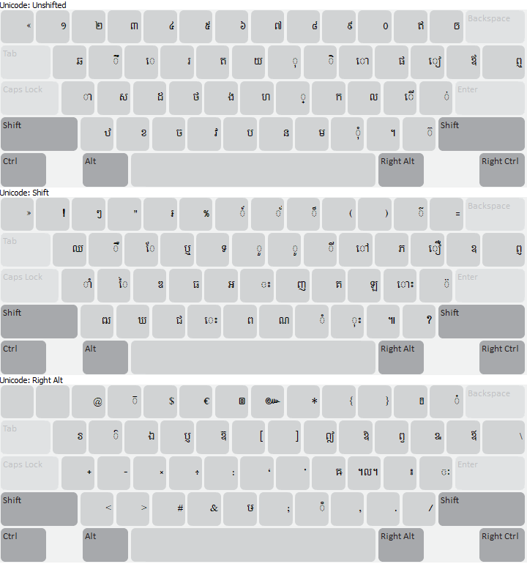
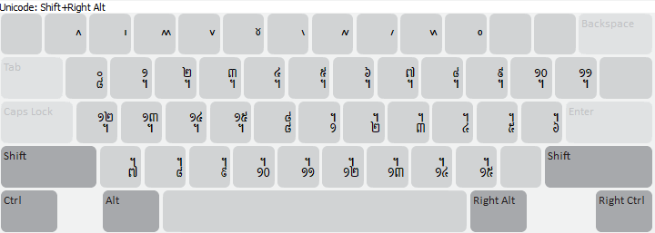

Touch Layout –Android/iOS
On a normal keyboard, one ought to select "្" and a consonant to get a ceong. For example, "្" + "ក" will output "្ក". But on this keyboard, "្" is​ no longer needed. Simply press and drag down (flick down) on any consonant key, and you will have the corresponding ceong. Using the flick gesture is much quicker than having to press twice to get a ceong of a consonant!

Switching Layouts:
This keyboard offers four layouts for your convenience: default, shift, Khmer numeric, and Arabic numeric.

- Shift Layout: press "⇧" to switch to the shift layout for more consonants and vowels.
- Khmer Numeric Layout: press "១២ឥ" to switch to the Khmer numeric layout for Khmer numerals and symbols.
- Arabic Numeric Layout: double-press "១២ឥ" to switch to the Arabic numeric layout for standard numbers and symbols.

To go to a certain layout, press the key as mentioned above. The key you press will turn blue meaning that you are currently on that layout. To return to the previous layout, press the key again.



Phone - Default layout with flick gesture example on “ក” key
This is the first layout that you will see after you installed the keyboard. It contains important consonants and vowels that are commonly used in Khmer texts. Look closely at the top right corner of each key, you will see a small indicator showing what a flick down will produce. This can be a ceong, a dependent vowel, or a symbol.

For example, flicking down on "ក" (ka) gives you "្ក" (ceong ka), while flicking down on "ិ" gives you "ី".



Phone - Shift layout
Similar to the Default layout, the Shift layout includes both consonants and vowels, but it also provides additional diacritics.

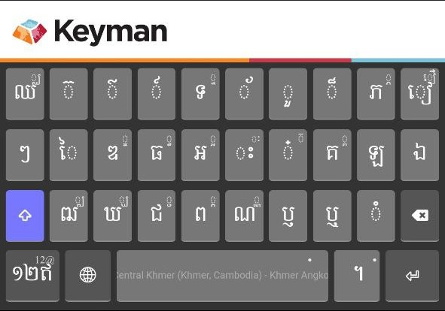

Phone - Khmer Numeric layout
This layout provides easy access to Khmer numerals, symbols, and independent vowels. For convenience, almost all independent vowels are grouped together on this layout.

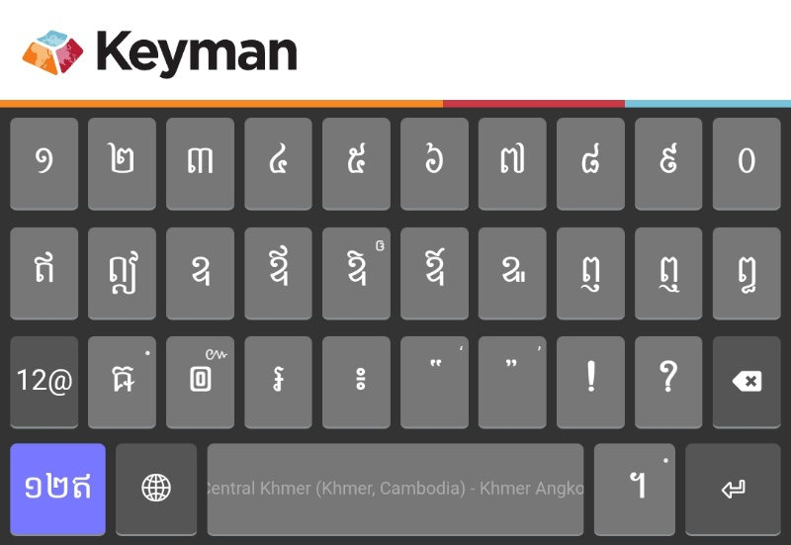

Phone - Numeric layout
This layout offers standard Arabic numbers and symbols for your convenience.

Keys with a small dot on the top right corner, indicating it has hidden keys. To access them, simply press and hold (long press) the key for a few seconds. More keys will appear with a selected key highlighted in blue. If that's not the key you need, slide your finger left or right to choose the desired key. To cancel the long press and hide the key menu, simply drag your finger away from the key and release it.



Available on mobile devices only, a feature called text prediction (lexical model) will be included with the Khmer Angkor keyboard. This feature enhances your ability to write Khmer text more easily and efficiently.

Example: “ខ្ញុំទៅសាលារៀន។”


Tablet - Default layout
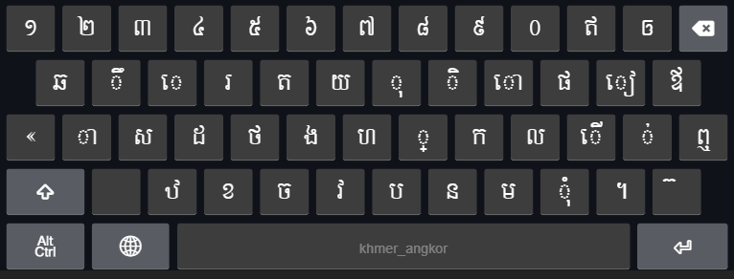
Tablet - Shift layout
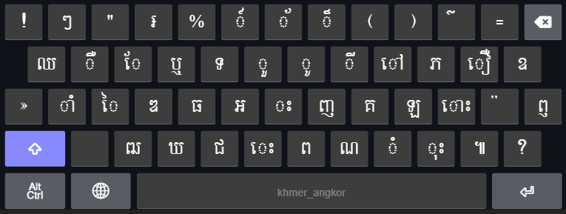
Tablet - AltGr layout
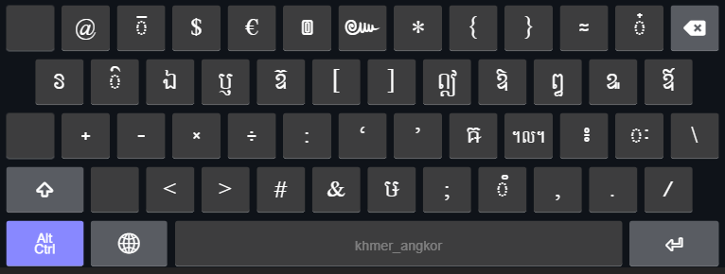

Khmer Character Categories and Keystrokes for Desktop

Consonants
Consonant | Keystroke |  | Consonant | Keystroke
ក [U+1780] | K |  | ថ [U+1790] | F
ខ [U+1781] | X |  | ទ [U+1791] | Shift T
គ [U+1782] | Shift K |  | ធ [U+1792] | Shift F
ឃ [U+1783] | Shift X |  | ន [U+1793] | N
ង [U+1784] | G |  | ប [U+1794] | B
ច [U+1785] | C |  | ផ [U+1795] | P
ឆ [U+1786] | Q |  | ព [U+1796] | Shift B
ជ [U+1787] | Shift C |  | ភ [U+1797] | Shift P
ឈ [U+1788] | Shift Q |  | ម [U+1798] | M
ញ [U+1789] | Shift J |  | យ [U+1799] | Y
ដ [U+178A] | D |  | រ [U+179A] | R
ឋ [U+178B] | Z |  | ល [U+179B] | L
ឌ [U+178C] | Shift D |  | វ [U+179C] | V
ឍ [U+178D] | Shift Z |  | ស [U+179F] | S
ណ [U+178E] | Shift N |  | ហ [U+17A0] | H
ត [U+178F] | T |  | ឡ [U+17A1] | Shift L
 |  |  | អ [U+17A2] | Shift G

Dependent Vowels
Dependent Vowel | Keystroke |  | Dependent Vowel | Keystroke
ា [U+17B6] | A |  | ៀ [U+17C0] | [
ិ [U+17B7] | I |  | េ [U+17C1] | E
ី [U+17B8] | Shift I |  | ែ [U+17C2] | Shift E
ឹ [U+17B9] | W |  | ៃ [U+17C3] | Shift S
ឺ [U+17BA] | Shift W |  | ោ [U+17C4] | O
ុ [U+17BB] | U |  | ៅ [U+17C5] | Shift O
ូ [U+17BC] | Shift U |  | ុំ [U+17BB][U+17C6] | ,
ួ [U+17BD] | Shift Y |  | ាំ [U+17B6][U+17C6] | Shift A
ើ [U+17BE] | ; |  | ុះ [U+17BB][U+17C7] | Shift ,
ឿ [U+17BF] | Shift [ |  | េះ [U+17C1][U+17C7] | Shift V
 |  |  | ោះ [U+17C4][U+17C7] | Shift ;

Signs
Sign | Keystroke
ំ [U+17C6] | Shift M
ះ [U+17C7] | Shift H
ៈ [U+17C8] | AltGr ’

Independent Vowels
Independent Vowel | Keystroke |  | Independent Vowel | Keystroke
ឥ [U+17A5] | - |  | ឭ [U+17AD] | Shift \
ឦ [U+17A6] | AltGr I |  | ឮ [U+17AE] | \
ឧ [U+17A7] | Shift ] |  | ឯ [U+17AF] | AltGr E
ឩ [U+17A9] | AltGr [ |  | ឰ [U+17B0] | AltGr P
ឪ [U+17AA] | ] |  | ឱ [U+17B1] | AltGr O
ឫ [U+17AB] | AltGr R |  | ឲ [U+17B2] | =
ឬ [U+17AC] | Shift R |  | ឳ [U+17B3] | AltGr ]

Diacritics
Diacritics | Keystroke |  | Diacritics | Keystroke
៉ [U+17C9] | Shift ’ |  | ៏ [U+17CF] | Shift 8
៊ [U+17CA] | / |  | ័ [U+17D0] | Shift 7
់ [U+17CB] | ’ |  | ៎ [U+17CE] | AltGr =
៌ [U+17CC] | Shift - |  | ៓ [U+17D3] | AltGr M
៍ [U+17CD] | Shift 6 |  | ្ [U+17D2] | J

Native Punctuations
Native Punct. | Keystroke |  | Native Punct. | Keystroke
។ [U+17D4] | . |  | ៙ [U+17D9] | AltGr 6
៕ [U+17D5] | Shift . |  | ៚ [U+17DA] | AltGr 7
៖ [U+17D6] | AltGr ; |  | ៗ [U+17D7] | Shift 2

Latin Punctuations
Latin Punct. | Keystroke |  | Latin Punct. | Keystroke
! [U+0021] | Shift 1 |  | « [U+00AB] | `
? [U+003F] | Shift ? |  | » [U+00BB] | Shift `
“ [U+0022] | Shift 3 |  | - [U+002D] | AltGr S
. [U+002E] | AltGr . |  | : [U+003A] | AltGr G
, [U+002C] | AltGr , |  | ‘ [U+2018] | AltGr H
; [U+003B] | AltGr N |  | ’ [U+2019] | AltGr J
# [U+0023] | AltGr C |  | & [U+0026] | AltGr V

Currencies
៛ [U+17DB] | Shift 4

Khmer Numerals
Khmer Numeral | Keystroke |  | Khmer Numeral | Keystroke
១ [U+17E1] | 1 |  | ៦ [U+17E6] | 6
២ [U+17E2] | 2 |  | ៧ [U+17E7] | 7
៣ [U+17E3] | 3 |  | ៨ [U+17E8] | 8
៤ [U+17E4] | 4 |  | ៩ [U+17E9] | 9
៥ [U+17E5] | 5 |  | ០ [U+17E0] | 0

Divination Lore
Divination Lore | Keystroke |  | Divination Lore | Keystroke
៱ [U+17F1] | AltGr Shift 1 |  | ៶ [U+17F6] | AltGr Shift 6
៲ [U+17F2] | AltGr Shift 2 |  | ៷ [U+17F7] | AltGr Shift 7
៳ [U+17F3] | AltGr Shift 3 |  | ៸ [U+17F8] | AltGr Shift 8
៴ [U+17F4] | AltGr Shift 4 |  | ៹ [U+17F9] | AltGr Shift 9
៵ [U+17F5] | AltGr Shift 5 |  | ៰ [U+17F0] | AltGr Shift 0

Khmer Lunar Dates
Khmer Lunar Date | Keystroke |  | Khmer Lunar Date | Keystroke
᧠ [U+19E0] | AltGr Shift Q |  | ᧰ [U+19F0] | AltGr Shift G
᧡ [U+19E1] | AltGr Shift W |  | ᧱ [U+19F1] | AltGr Shift H
᧢ [U+19E2] | AltGr Shift E |  | ᧲ [U+19F2] | AltGr Shift J
᧣ [U+19E3] | AltGr Shift R |  | ᧳ [U+19F3] | AltGr Shift K
᧤ [U+19E4] | AltGr Shift T |  | ᧴ [U+19F4] | AltGr Shift L
᧥ [U+19E5] | AltGr Shift Y |  | ᧵ [U+19F5] | AltGr Shift ;
᧦ [U+19E6] | AltGr Shift U |  | ᧶ [U+19F6] | AltGr Shift ’
᧧ [U+19E7] | AltGr Shift I |  | ᧷ [U+19F7] | AltGr Shift Z
᧨ [U+19E8] | AltGr Shift O |  | ᧸ [U+19F8] | AltGr Shift X
᧩ [U+19E9] | AltGr Shift P |  | ᧹ [U+19F9] | AltGr Shift C
᧪ [U+19EA] | AltGr Shift [ |  | ᧺ [U+19FA] | AltGr Shift V
᧫ [U+19EB] | AltGr Shift ] |  | ᧻ [U+19FB] | AltGr Shift B
᧬ [U+19EC] | AltGr Shift A |  | ᧼ [U+19FC] | AltGr Shift N
᧭ [U+19ED] | AltGr Shift S |  | ᧽ [U+19FD] | AltGr Shift M
᧮ [U+19EE] | AltGr Shift D |  | ᧾ [U+19FE] | AltGr Shift ,
᧯ [U+19EF] | AltGr Shift F |  | ᧿ [U+19FF] | AltGr Shift .

Discouraged/Obsolete characters
Character | Keystroke
៘ [U+17D8] | AltGr L
ឨ [U+17A8] | AltGr T
ៜ [U+17DC] | AltGr Q
៑ [U+17D1] | AltGr 3
៓ [U+17D3] | AltGr M

Characters used in minority languages
Other Character | Keystroke
ឝ [U+179D] | AltGr K
ឞ [U+179E] | AltGr B
៝ [U+17DD] | AltGr W

Joiners and Spaces
Key name | Keystroke
Zero-width non-joiner [U+200C] | AltGr + 1
Zero-width joiner [U+200D] | AltGr + ‘
Zero-width space [U+200B] | Spacebar
White space [U+0020] | Shift + Spacebar or Press spacebar twice
No break space [U+00A0] | AltGr + Spacebar

Typing in Khmer
Khmer Angkor keyboard adopted the key arrangement from that of Khmer NiDA keyboard. More functionalities have been added to it to assist in typing (i.e. reduce inconsistency in character sequences). Regardless of how the user may type, a well-formed word will be produced. Please note that only issues identified are covered. For how to install the Khmer Angkor keyboard, please click here for the instructions.
You can simply use Khmer Angkor as you would for any NiDA based keyboard. You may type a word in an order of how it is spelled, not how it appears to be, especially when the vowel is to the left of the consonant. For example, to type the word “តែ” which means ‘tea’, one should type the consonant first and then the vowel (i.e. press key “T” and then “Shift E”).
The order of characters is:
Consonant + Subscript(s) + Consonant Shifter + Vowel + Diacritic

Silent Auto-correction
There are eight cases of invisible typos that Khmer Angkor keyboard automatically corrects. They could not be detected with the naked eye; and the rendering engines may render them all the same on the screen. The auto-correction involves reordering and/or transducing of certain in correct characters to the correct ones in a split second.

Subscript + Vowel
When a subscript and a vowel occur together, the vowel has to come after the subscript. For instance, “ខ្មែរ” and “ខែ្មរ” look the same, but they are encoded differently.
- ខ្មែរ = ខ ្ម ែ រ (correct)
- ខែ្មរ = ខ ែ ្ម រ (incorrect)
Thanks to the context dependent rules, Khmer Angkor keyboard is able to output the second typing sequence the same as that of the first one.

Subscript + ្រ [U+17D2] [U+179A]
According to the spelling rule, in a sequence of two subscript and one of which is ្រ [U+17D2] [U+179A], the ្រ [U+17D2] [U+179A] should come after another subscript.
- កញ្ជ្រឹល = ក ញ ្ជ ្រ ឹ ល (correct)
- កញ្រ្ជឹល = ក ញ ្រ ្ជ ឹ ល (incorrect)
As you can see the two-character sequences yield the same visual output on the screen. Once again, Khmer Angkor will be able to automatically swap the sequence of the second to the first; so that the output would be both looked and encoded correctly and consistently.

Subscript + Consonant Shifter + Vowel
This is a case whereby the character sequence is vague in the Unicode Standard. Unicode Standard 4.0 and later have the consonant shifter come between the consonant and the subscript while Unicode Standard 3.0 has it after the subscript. Khmer Angkor conforms to Unicode 3.0 and it is taken as the standard sequence. If one typed a consonant shifter before a subscript, the order would be switched silently.
ម ៉ ្យ ា ង ⇒ ម ្យ ៉ ា ង

Consonant Shifter + Vowel
Consonant shifters should be typed before a vowel. (See the same in the section above)

Vowel with Nikahit [U+17C6]
Nikahit is considered as a sign in the Unicode Standard. However its function is more like that of a vowel. It is usually combined with another vowel, i.e. ុ [U+17BB] ា [U+17B6], and it should always be typed after these vowels.
ក ំ ុ ⇒ ក ុ ំ
ក ំ ា ⇒ ក ា ំ

Vowel ោ [U+17C4] and Vowel ើ [U+17BE]
These two vowels could be mistakenly typed by adding ា [U+17B6] and េ [U+17C1] respectively to េ [U+17C1]. Given this sequence, Khmer Angkor would transform them to ោ [U+17C4] and ើ [U+17BE], the correct vowel encodings.

Visually Identical Subscript
Two subscripts look exactly the same, but they are encoded with different Unicode code points, ្ដ [U+17D2][U+178A] and ្ត [U+17D2][U+178F]. According to the spelling rule, it governs that the first should come after ណ [U+178E] and the latter should come after ន [U+1793].

Vowel Rotation
Since no two-vowel sequence is allowed, once one is typed after another, the vowel would switch to the one typed last. For example, if the current character is vowel ា [U+17B6], and then ែ [U+17C2] is typed, the final output would be ែ [U+17C2], not ា [U+17B6].
NOTE: The vowel rotation would not be triggered in the following cases:
- If the first vowel is េ [U+17C1] and the second is ី [U+17B8]​ or vice versa, then the switch would not happen, but the output would be ើ [U+17BE] instead.
- If the first vowel is េ [U+17C1] and the second is ា [U+17B8] or vice versa, then the switch would not happen, but the output would be ោ [U+17C4] instead.
- If the first vowel is on the above vowels and the second is ុ [U+17BB] or vice versa, then the switch would not happen, but the output would be the corresponding consonant shifter instead. For examples: a sequence of ស ី ុ or ស ុ ី would be automated as ស៊ី (ស ៊ ី); ម ី ុ or ម ុ ី would be automated as ម៉ី (ម ៉ ី).
- When ុ [U+17BB] is typed after ាំ, it will be transformed to a consonant shifter corresponding with the consonant before ាំ before which the shifter will be placed. For example,
  - សាំ + ុ ⇒ ស៊ាំ (ស ៊ ាំ) and
  - មាំ + ុ ⇒ ម៉ាំ (ម ៉ ាំ).
- When ា or ុ is typed after ំ, the order will be reversed. For example,
  - ក + ំ + ុ ⇒ កុំ (ក ុ ំ) and
  - ក + ំ + ា ⇒ កាំ (ក ា ំ).

Beep / Constraints
- No two consecutive vowels in a syllable.
- No Bantoc is allowed after a vowel, a pseudo vowel, a consonant shifter or a subscript.
- No two consecutive subscript signs (្) are allowed.
- No two consecutive consonant shifters are allowed.

Mistyped Characters
No | Mistyped as … | Transformed to …
1 | ទ្ប (ទ ្ប) | ឡ
2 | ប្ញ (ប ្ញ) | ឫ
3 | ឫុ (ប ្ញ ុ) | ឬ
4 | ឭា (ឭ ា) | ញ
5 | ឮា (ឮ ា) | ញ
6 | ព្ញ (ព ្ញ) | ឭ
7 | ឭុ (ព ្ញ ុ) | ឮ
8 | ព្ឋ (ព ្ឋ) | ឰ
9 | ឧិ (ឧ ិ) | ឱ
10 | ឧ៌ (ឧ ៌) | ឱ
11 | ឧ៍ (ឧ ៍) | ឱ
12 | ដ្ធ (ដ ្ធ) | ដ្ឋ
13 | ទ្ឋ (ទ ្ឋ) | ទ្ធ
14 | ពន្ឋ (ព ន ្ឋ) | ពន្ធ
15 | ព័ន្ឋ (ព ័ ន ្ឋ) | ព័ន្ធ
16 | ឪ្យ (ឪ ្យ) | ឱ្យ
17 | ឳ្យ (ឳ ្យ) | ឱ្យ
18 | ញ្វ (ញ ្វ) | ព្វា (ឧទា. សព្វារុធ)
19 | េ ្យ ឺ | ឿ
20 | េ ្យ ឹ | ឿ
21 | េ ្យ ី | ឿ

It is actually not a vowel, but it behaves like one. To some, this is a diacritics.
Note the different between this character and ៊ [U+17CA].
ិ [U+17B7], ី [U+17B8], ឹ [U+17B9], ឺ [U+17BA], ើ [U+17BE], and ាំ [U+17B6] [U+17C6] are considered as superscript vowels or above vowels.
Three characters play a role similar to that of vowels, thus they are called ‘pseudo vowel’. They are: ំ [U+17C6], ះ [U+17C7], and ៈ [U+17C8].

