SIL Tai Dam keyboard layout charts
Note that high series consonants are assigned to shifted keys, and low series consonants are assigned to unshifted keys.
Chart 1: SIL Tai Dam Keyboard—unshifted
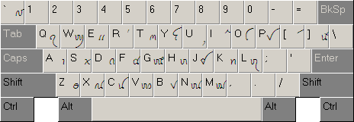
Chart 2: SIL Tai Dam Keyboard—shifted
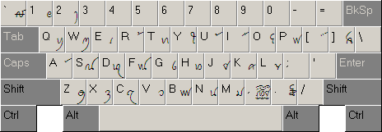
Chart 3: SIL Tai Dam Keyboard—characters requiring two keystrokes
Character | Keystrokes |  | Character | Keystrokes
ꪃ | K + K |  | ꪧ | R + R
ꪂ | k + k |  | ꪦ | r + r
ꪇ | G + G |  | ! | | + !
ꪆ | g + g |  | @ | | + @
ꪍ | C + C |  | < | | + <
ꪌ | c + c |  | > | | + >
ꪟ | P + P |  | ◌ | ( + )
ꪞ | p + p

