Algorithm for outbreak alarms Dom Rep Dengue (confirmed cases)
Observations with EWARS-csd | Recommended Actions
- CHECK OF RELIABILITY  1 Good agreement between observed and predicted incidence (<20% difference)  2 Poor agreement between observed and predicted incidence (>20% difference) (no precise prediction possible)  3 Sensitivity/PPV above or below 65% (no prec. prediction) | Action points (see national guidelines):  AP1 (green traffic light): Routine = cleaning, covering or eliminating water containers, awareness raising, focal intervention, larval survey incl. elimination of larvae, larviciding, larvivorous fish  AP2 (yellow traffic light): Stepping up routine activities (increased coverage, increased quality of application), risk communication, involving other actors.  AP3 (red traffic light): Intensified vector control as response to outbreak alarm: space spraying (fogging; day 1-7-14); increased larviciding; risk communication  (Att.! No. of houses reached is important)
- ALARM ALGORITHM
1. Alarm levels (according to alarm probability, predicted incidence rate, confidence interval)
1 Alarm below threshold
2 Alarm for 1-2 weeks above threshold
3 Alarm for 3-4 weeks above threshold
4 Alarm for > 4 weeks above threshold
2. Predicted incidence, alarm levels (confirmed cases)
1 Predicted incidence within endemic channel
2 Predicted incidence just above endemic channel (<20%)
3 Predicted incidence well above end. channel (>20%)
3. Predicted incidence per 100,000 pop. at prediction distance:  1 <50 = low  2 50-100= medium  3 100-250= high  4 > 250= super high (double weight for this factor) | Proposed algorithm for alarm levels:  For AP1: 1+ 1+ (2x1) + 0 = 4 green <8  For AP2: 3 +2 +(2x2) + 0= 9 yellow 8-13  For AP3: 4+ 3+ (2x3) + 1 = 14 red>13
4. Confidence interval (CI) of predicted incidence  0 CI within or just above endemic channel  1 CI above endemic channel | NB.: The algorithm leading to AP is country- and disease-specific. Level of incidence depends on case definition (hospitalized/confirmed/suspected)

Province (Sensitivity; PPV) | Observations on the probability of outbreak | Action points | Comments | Sign
District (1) (97%, 94%)  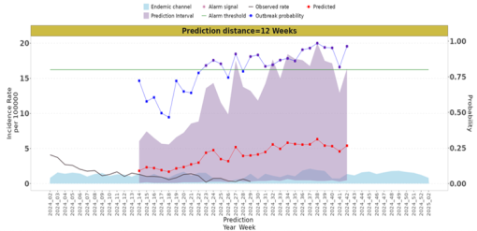 | Consecutive warning signals occur for 12 weeks (weeks 30 to 42) above the threshold, meaning a high probability of increased transmission of hospitalized dengue cases. | Intensify routine vector control activities because the alarm continues and the expected incidence is increasing. | Observed incidence and endemicity  The channels are very low.  This could be due to the low number of hospitalization cases.  The observed incidence is higher  The endemic channel.  4+2+2+0 =8 green | 
District (6) (57%, 80%)  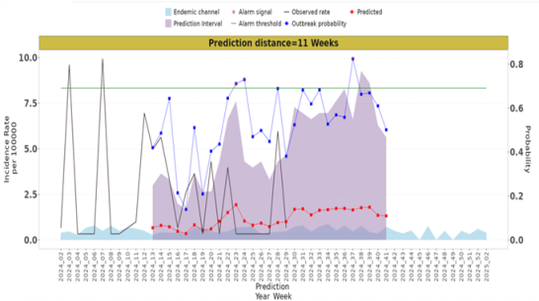 | Alarm signals occur for 1 week (week 37) above the threshold. | Ensure that routine vector control activities are carried out properly and maintained. | High expected incidence, probably due to increasing cases and peaks exceeding the average number of cases during the epidemic in 2024.  The observed incidence is above the endemic channel.  1+2+2+0 = 5 green | 
District (9) (96%, 67%)  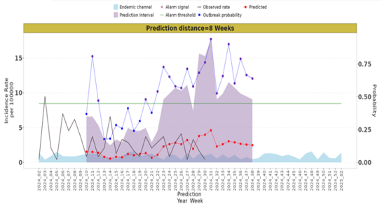 | Consecutive warning signals occur for 16 weeks (weeks 22 to 38) above the threshold. An outbreak is predicted for the prediction period. | Routine vector control activities must be intensified because the alarm continues and the expected incidence is above the endemic channel. | Between week 31 and 33, the probability of an outbreak decreases and coincides with a decrease in expected cases below the threshold but above the endemic channel.  The observed incidence is above the endemic channel.  4+2+2+0= 8 green | 
District (25) (52%, 69%)  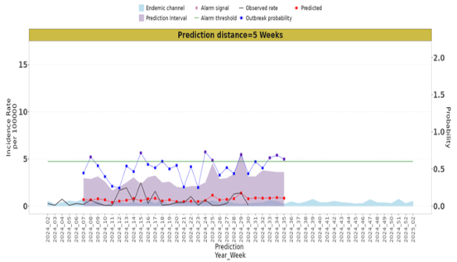 | Consecutive warning signals occur for 3 weeks (week 33-35) above the threshold, meaning an elevated outbreak probability for 3 weeks above the threshold and a slight increase in the expected incidence . | Maintain routine vector control activities and ensure they are carried out properly. | The predicted incidence of hospitalization cases remains consistently just above the endemic channel. The observed incidence is slightly above the endemic channel.  3+2+2+0=7 green | 
District (2) (66%, 92%)  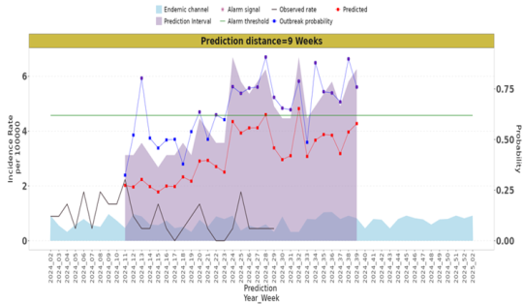 | Consecutive alarm signals occur for 15 weeks (week 24 to 39, excluding week 33) above the threshold and with a high expected incidence. | Intensify routine vector control activities due to the continued alarm and the high expected incidence. | The predicted incidence is close to the probability of an outbreak. The observed incidence is above the endemic channel.  4+3+2+0= 9 yellow | 
District (15) (79%, 84%)  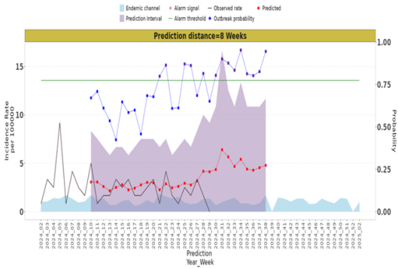 | Consecutive warning signals occur 9 weeks (week 30-38) above the threshold, meaning a high probability of an outbreak. There is also a slight increase in the expected incidence. | Intensify routine vector control activities due to the continued alarm and the expected increase in incidence. | Very good agreement between observed and predicted incidence.  The observed incidence is above the endemic channel.  4+3+2+0= 9 yellow | 
District (17) (90%, 79%)  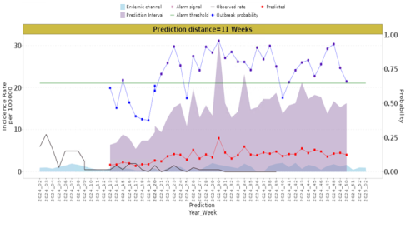 | The alarm probability exceeds the threshold for 10 weeks | Please refer to the risk map for transmission hotspots. Ensure that routine vector control activities are carried out correctly. | The expected incidence of dengue is higher than the endemic channel but less than 20 cases per 100,000 inhabitants.  4+2+2+0= 8 yellow | 
District (24) (96%, 85%)  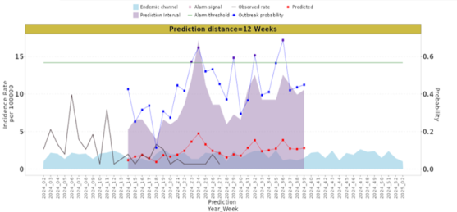 | There are no consecutive alarms during the prediction period. In weeks 29, 32 and 36 there are isolated alarm signals above the threshold. | Ensure that routine vector control activities are carried out properly and maintained. | The expected incidence is close to the probability of an outbreak.  The observed incidence is below the endemic channel.  2+2+2+0= 6 green | 
District (26) (74%, 95%)  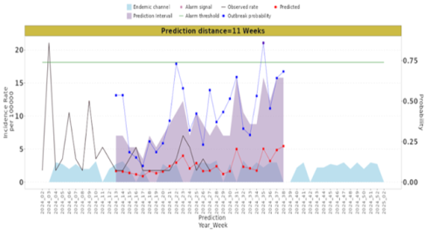 | At week 35 there is only one warning sign: the probability of an outbreak is low (below the threshold). | Ensure that routine vector control activities are carried out properly and maintained. | The expected incidence is close to the probability of an outbreak.  The observed incidence is below the endemic channel.  1+2+2+0= 5 green | 
District (3) (82%, 93%)  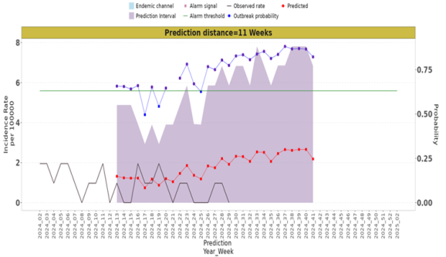 | Consecutive alarm signals occur for 11 weeks (weeks 30 to 41) above the threshold, meaning a high probability of an outbreak. | Intensify routine vector control activities (increase coverage and quality) because the alarm continues and the expected incidence is increasing. | The trend of the predicted incidence is parallel to the probability of outbreak. Up to the observation week (29) there is a good match between the predicted and observed incidence. The observed incidence is above the endemic channel.  4+3+2+0= 9 yellow | 
District (7) (78%, 95%)  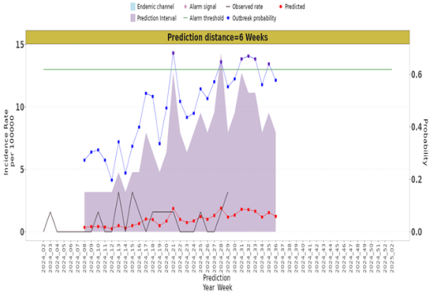 | Consecutive alarm signals occur for 3 weeks (week 30-32) above the threshold. | Ensure that routine vector control activities are carried out properly and maintained, ensuring greater coverage of target dwellings. | Good agreement between expected and observed incidence. Tendency to increase the probability of outbreak.  The observed incidence is above the endemic channel but below 5/100,000 (i.e. low endemicity).  3+3+2+0= 8 green | 
District (16) (79%, 73%)  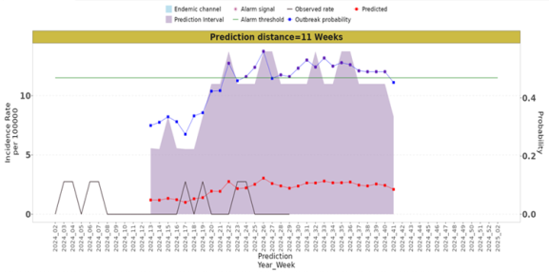 | During the prediction period, there is a probability of an outbreak for 10 weeks (week 30-40). The predicted incidence is quite low, but may increase to >10/100,000 | Intensify routine vector control activities (coverage and quality). | Very good agreement between observed and predicted incidence.  4+3+2+0= 9 yellow | 
District (20) (80%, 91%)  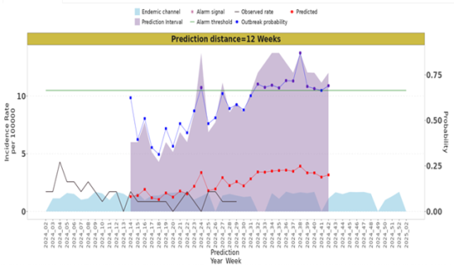 | Consecutive warning signs occur over 10 weeks (week 32-42). The expected incidence is quite low, but may increase to >10/100,000 | Maintain or intensify routine vector control activities (coverage and quality) as required  The expected incidence is above “normal” | Very good agreement between observed and predicted incidence.  4+2+2+0=8 yellow | 

