**Chapter 4**

**RESULTS AND DISCUSSIONS**

**4.1 Validation and Testing**

System Usability Test (SUS) provides a reliable tool for measuring the usability of the system. It consists of a 10-item questionnaire with five response options for respondents; from strongly agree to strongly disagree. Originally created by John Brooke in 1986, it allows you to evaluate a wide variety of products and services including hardware, software, mobile devices, websites and applications. SUS has become an industry standard, with references in over 1300 articles and publications. The noted benefits of using SUS include that it: (a) is a very easy scale to administer to participants, (b) can be used on small sample sizes with reliable results, and (c) is valid – it can effectively differentiate between usable and unusable systems. This kind of testing is needed in order for the proponents to identify if the application is rated as usable for the users. It also identifies if the application is user-friendly, consistent, unnecessarily complex to the users.

**4.1.1 System Usability System Calculation**

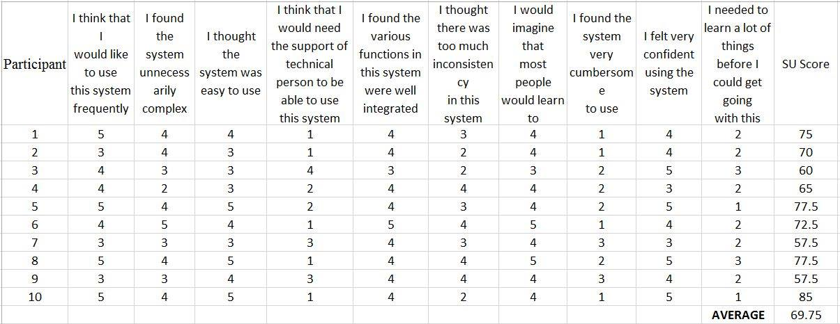

1 – Strongly Disagree; 2 – Disagree; 3 – Neutral; 4 – Agree; 5 – Strongly Disagree

*Table 4 System Usability Testing Calculation*

*(Rate from 1-5; 1 as the lowest, 5 as the highest)*

This table displays the SUS score results and average in where ten participants are assessed and answered the different questions written above. The participants can rate each question from 1, as the lowest rate, to 5, as the highest rate. The participants that took this test are students of ACLC.

**4.2 Interpretation/Discussion of Results**

Based on the SUS results shown in figure 6, the average system usability score of the 10 participants that answered the test has an average score of 69.75 which is according to the SUS, a score above 68 would be considered above average. With this data, the proponents can conclude that the Android Face Swapping Application has surpassed the average score therefore, the system is considered usable to many people. The proponents have also undergone the installation testing which tests if the application can be installed without any problems and fortunately, it was installed without having any problems.

Regarding with the face swapping and other functions, the proponents have only achieve swapping three faces but it’s still unstable. The application can perform stable face swapping but only to two faces. There are instances that it can swap up to three but only occasionally. Proper positioning of the camera, lighting, and the position of the faces can also affect the swapping function. With the current resources that the proponents have gathered, the algorithm that was used can detect more than two faces but can only swap two.

In conclusion, the algorithm that was used in developing the Android Face Swapping Application helped the proponents in achieving swapping three faces. With the current algorithm that the proponents have used and have improved, the number of faces that can be swapped, which is two, has been increased by one but it’s still unstable due to lack of resources and lack of coding logic.

**Chapter 5**

**SUMMARY, CONCLUSIONS, AND RECOMMENDATIONS**

**5.1 Summary of findings**

The study of android face swapping application was conducted for the purpose of future studies about camera manipulation and technological advancement. In addition, the android face swapping application would give entertainment and socialization to people through swapping faces using android phone's camera but with the resources that the proponents can gain access to, swapping up to three faces can only be achieved for the meantime but still the android face swapping application can stably swap two faces. The algorithm that the proponents have used and improved has greatly helped them understand the basics of camera manipulation although they need more time to analyze deeper the logic behind the algorithm that swapping of five faces. The proponents need to understand it more deeply and gain access to more advanced resources in order for them to achieve greater limits.

**5.2 Conclusion**

The proponents have failed to develop the android face swapping application that can swap five faces. Even so, what the proponents had developed can swap three faces although it’s still unstable. Still, the application is on step ahead of the usual face swapping application that can only swap two faces. There may be some applications that can swap more than two faces, but their methods on how they developed it are in private. The main objective of the proponents is to share what they achieved in studying camera manipulation and face swapping. The proponents have attained one little step ahead of the usual two-faced applications which can be used to study and be improved by future developers.

**5.3 Recommendation**

The following recommendations list the possible ways to improve this study:

* Future developers can improve the algorithm that is used in this application so that it can swap five faces and can upload what they’ve researched for future studies.
* By understanding the foundation of camera manipulation, the future developers can develop an application that is connected to augmented reality like a real time translator which translates detected foreign words through live camera feed. The Android Face Swapping Application contains an algorithm that detects objects like faces. In this case, that algorithm can be used to detect words in signboards.
* Future developers can also improve gaming industries by creating VR or Virtual Reality games which is also connected to augmented reality and camera manipulation which is present in the Android Face Swapping Application.

**5.4 Bibliography**

* Chou, A., Hong, Y. (2010, March 22). Face Detection, Extraction, and Swapping

on Mobile Devices. Retrieved from https://stacks.stanford.edu/file/druid:my512gb2187/Hong_Chou_Face_Swap.pdf

* Viola, P., Jones, M. (2015, December 18). OpenCV: Face Detection using Haar Cascades. Retrieved from http://docs.opencv.org/trunk/d7/d8b/tutorial_py_face_detection.html
* Arar, N.M., Guney, F., Bekmezci, N.K., Gao, H., Ekenel, H.K. (2012, February). Real-time Face Swapping in Video Sequences: Magic Mirror. Retrieved from

https://infoscience.epfl.ch/record/207747/files/VISAPP_2012_122_CR.pdf

* Good, O., DeWeese, John., Good, Maia., Lin, Bryan., Park, Eric., (2014, April 18). Word Lens. Retrieved from http://questvisual.com