LAB 0 - Introduction, Instructions and Resources

This “lab” provides a brief introduction to the applied portion of the course and instructions for some required setup needed for later labs. It also provides a few (optional) resources on some of the main python libraries and topics that will be covered.

# Table of Contents

Table of Contents

Introduction to the Applied Portion of the Course

Introduction

Tutorial Instructors

Things to Remember about the Labs

How to Instructions

Starting a lab

Joining the discord

Optional Resources

Artificial Neural Networks

Python

Numpy

Keras

Matplotlib

Getting Data and models from Google Drive

# Introduction to the Applied Portion of the Course

## Introduction

1. The applied portion of the course will be a series of labs.
2. The core source material is jupyter notebooks that accompany the textbook *Deep Learning with Python* by François Chollet, and are provided [for free online](https://github.com/fchollet/deep-learning-with-python-notebooks).
   * Note thatthe *Deep Learning with Python* textbook is not required for this course.
3. We have modified the notebooks to provide supplementary explanations and exercises (not required for submission for this iteration).
4. Labs will be self-paced combined with a questions and answer session on discord (more on discord in setup section).

## Tutorial Instructors

* Alkan Göktug
* Berthine Nyunga Mpinda
* Laily Ajellu
* Sarah Vollmer
* Pedram Ahadinejad
* Tyler Thomson
* Ariel Freeman-Fawcett
* Chester Wyke

## Things to Remember about the Labs

1. If your code is frozen or in an infinite loop, you can use the “Factory reset runtime” from the runtime menu at the top.
2. When looking at the expected output, take it as an approximation as there is some amount of randomness in the network initialization and training

# How to Instructions

## Starting a lab

1. Open a preview of the lab’s notebook on the [github](https://github.com/YorkU-Cameroon/ml_labs) webpage by clicking on the lab in the list
2. To open in Google Collaboratory click the “Open in Colab” button at the top of the lab.
   * 
3. At the start of a new lab it is recommended that you save a copy of each lab in your Google drive so that you can save your progress as you go. The simplest way to do so is to click the “Copy to Drive” button at the top of the notebook.
   * 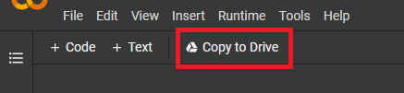

## Joining the discord

1. Tutorial instructors can be reached at our discord server. To join the discord server use the following link <https://discord.gg/aBtazkWSr3> you may need to create a discord account if you do not have one. You will also need to ensure you have the email address associated with your account verified.
2. Once you’ve successfully joined the server please email your discord username to [cameryu@googlegroups.com](mailto:cameryu@googlegroups.com) from your school email address. This will allow us to set your role to a student, which will give you access to the channels on the server.
   1. Discord usernames are of the format aaaa#9999 where aaaa is the name selected during account creation and 9999 represents a 4 digit number.
   2. You can find your username in the bottom left of the screen. If you click on it, it will be copied to your clipboard.
   3. On the right hand side you should see a list of names. If you right click on your name then you should be able to set your nickname to your actual name to make it easier for us to identify you.

# Optional Resources

## Artificial Neural Networks

* [Video with excellent visual explanations by math Youtuber 3Blue1Brown](https://www.youtube.com/watch?v=aircAruvnKk&list=PLZHQObOWTQDNU6R1_67000Dx_ZCJB-3pi&index=1)

## **Python**

* The language we will use throughout the applied portion of the course
* We will be going through some python refresher content in lab 1. Check the [lab 1](https://github.com/YorkU-Cameroon/ml_labs/blob/main/Lab01.ipynb) for help reviewing python and for additional resources.

## Numpy

* Numerical computing library that gives us numpy arrays, which you can think of as much more efficient versions of the list data type. We will use numpy arrays throughout the course, and they are found everywhere in the python data science and machine learning ecosystem.
* For a brief overview of what numpy is, you can read this [W3schools page](https://www.w3schools.com/python/numpy_intro.asp)

## Keras

* The deep learning library we will use in all labs (except lab 1).
* [Video tutorial for beginners - see 6:41 to 30:07](https://youtu.be/qFJeN9V1ZsI?t=400) (or as much as you want)

## Matplotlib

* Python library for plotting
* Note that in addition to the resources below, lab 1 briefly covers matplotlib.
* [Corey Shafer tutorial video](https://www.youtube.com/watch?v=UO98lJQ3QGI&ab_channel=CoreySchafer)  
    
    
    
    
    
  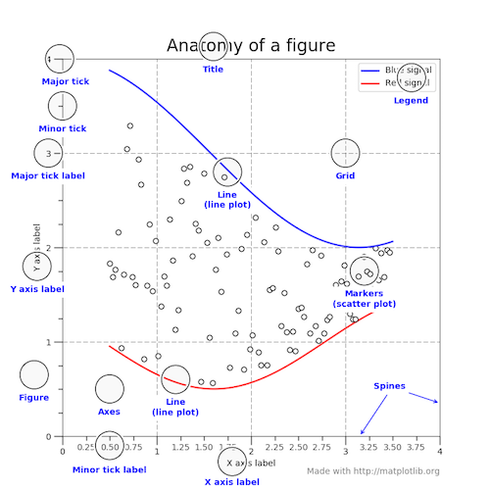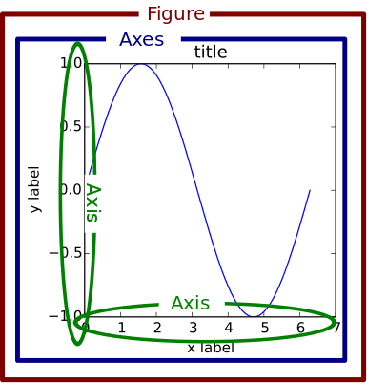
* One important concept to understand about matplotlib is that most elements of a chart are added using a specific command or property.
* The chart on the right, taken from a useful guide [here](https://realpython.com/python-matplotlib-guide/), helps illustrate how elements are referred to in matplotlib. The code used to create it can be found [here](https://matplotlib.org/examples/showcase/anatomy.html).
* Beginners to matplotlib can get very far simply by looking up how to add and modify specific elements.

# 

# Getting Data and models from Google Drive

For some of the later labs notably Lab07, the data and pretrained models have been saved in Google Drive. A few steps are required before the lab will be able to run

## Step 1 - Add a shortcut to the folder with the files to your Google Drive

Open the folder with the data which can be found [here](https://drive.google.com/drive/folders/1U70kO2HURxUKet7FW3mx6Tuz0rm8d6qC). Then at the top click on the folder name to access the menu and then choose “Add a shortcut to Drive”. (Note you’ll need to be signed into your Google account).

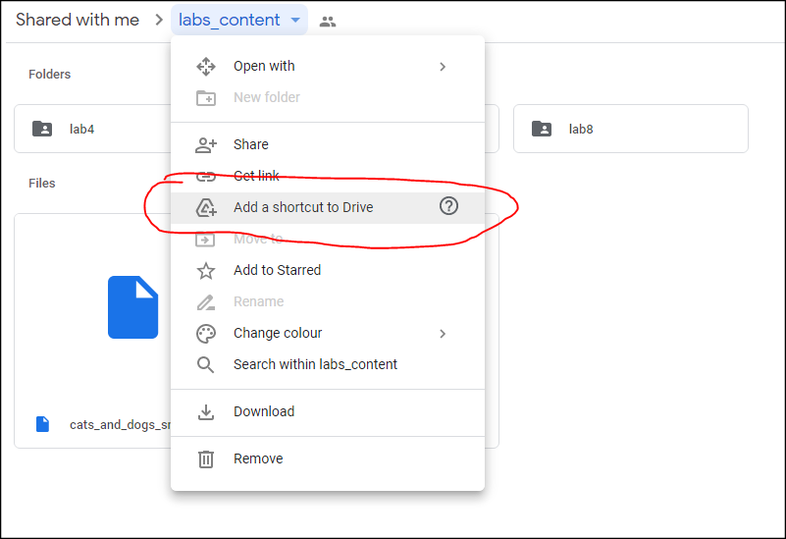

## Step 2 - Click “ADD SHORTCUT”

It should then bring up a prompt to actually add the shortcut. Note that it would have “My Drive” highlighted before you click the button.

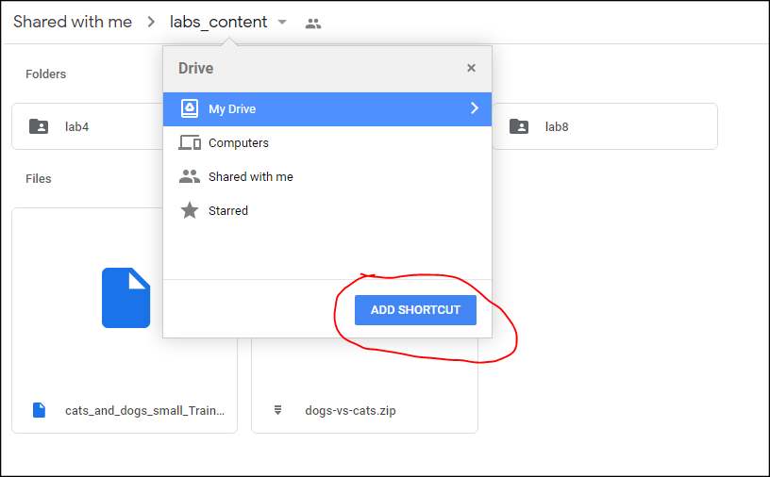

## Step 3 - Authorizing Google to access your Google Drive from Colab

When you run one of the notebooks designed to get the data from google drive (like Lab07) it Google will open a prompt asking if you want to connect to Google Drive. (Ensure you are using the same account you used in Step 1, should be able to tell using the display pic in the top right). You’ll need to select “Connect to Google Drive” and follow the prompts from there. That should get you through. If you have further problems please contact one of the TA’s for assistance.

