MIS

John Kamau

09/08/2019

# Q3 Is name of Group {0} ?

|  |  |  |
| --- | --- | --- |
| Name | Mali | Uganda |
| Yes | 66 | 51 |
| No, please type the correct group name | 86 | 84 |
| Respondents | 152 | 135 |

|  |  |  |
| --- | --- | --- |
| Name | Mali | Uganda |
| Yes | 0.434 | 0.378 |
| No, please type the correct group name | 0.566 | 0.622 |
| Percentage | 1 | 1 |

# Q4 Is {0} your Group number?

|  |  |  |
| --- | --- | --- |
| Name | Mali | Uganda |
| Yes | 66 | 45 |
| No, please type the correct group name | 86 | 47 |
| I don’t know | 0 | 41 |
| Does not want to answer | 0 | 2 |
| Respondents | 152 | 135 |

|  |  |  |
| --- | --- | --- |
| Name | Mali | Uganda |
| Yes | 0.434 | 0.333 |
| No, please type the correct group name | 0.566 | 0.348 |
| I don’t know | 0 | 0.304 |
| Does not want to answer | 0 | 0.0148 |
| Percentage | 1 | 1 |

# Q5 Is your group linked to any external savings?

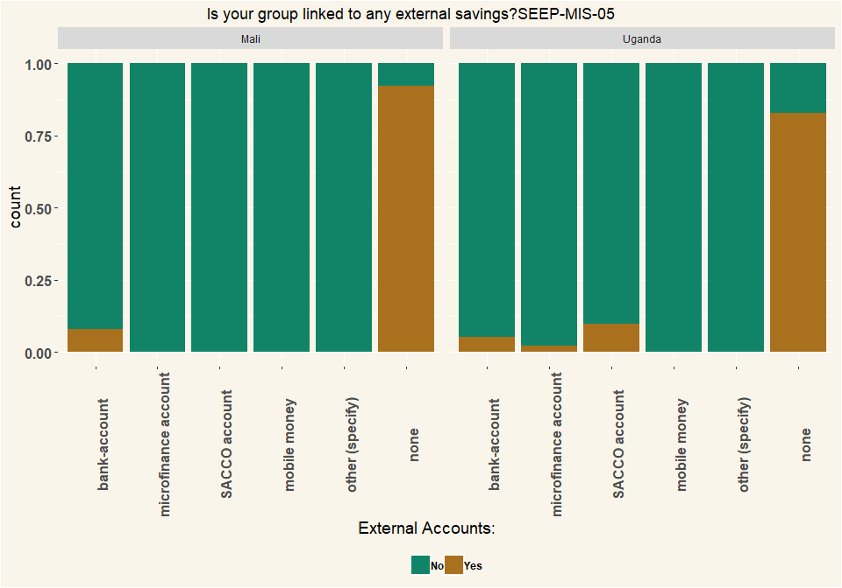

## # A tibble: 2 x 2  
## Country n  
## <chr> <int>  
## 1 Mali 152  
## 2 Uganda 135

# Q6 Is your group linked to any external credit/loans?

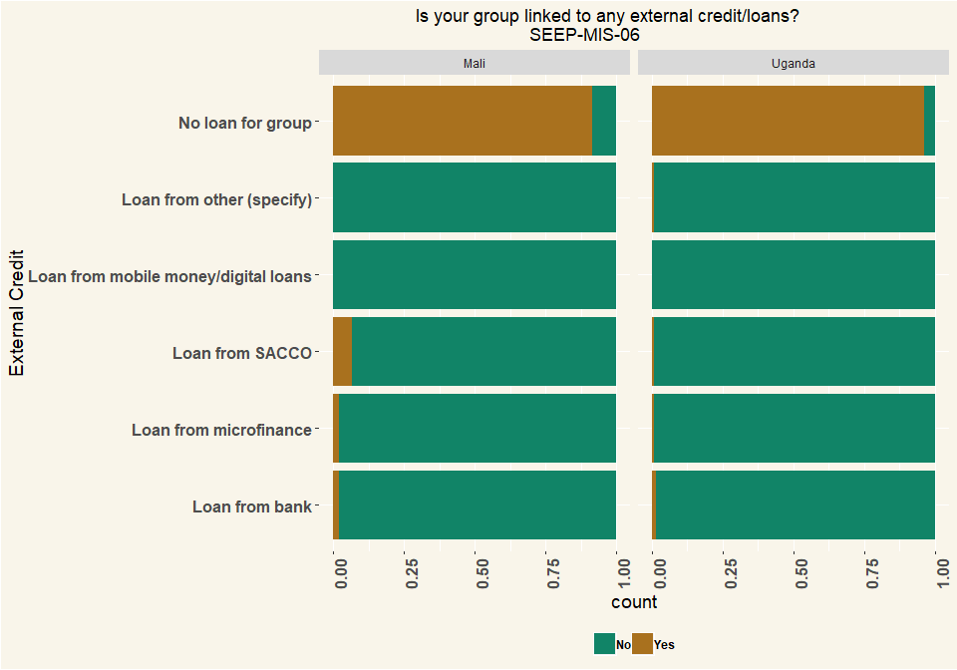

## # A tibble: 2 x 2  
## Country n  
## <chr> <int>  
## 1 Mali 152  
## 2 Uganda 135

# Q8 Date savings started this cycle

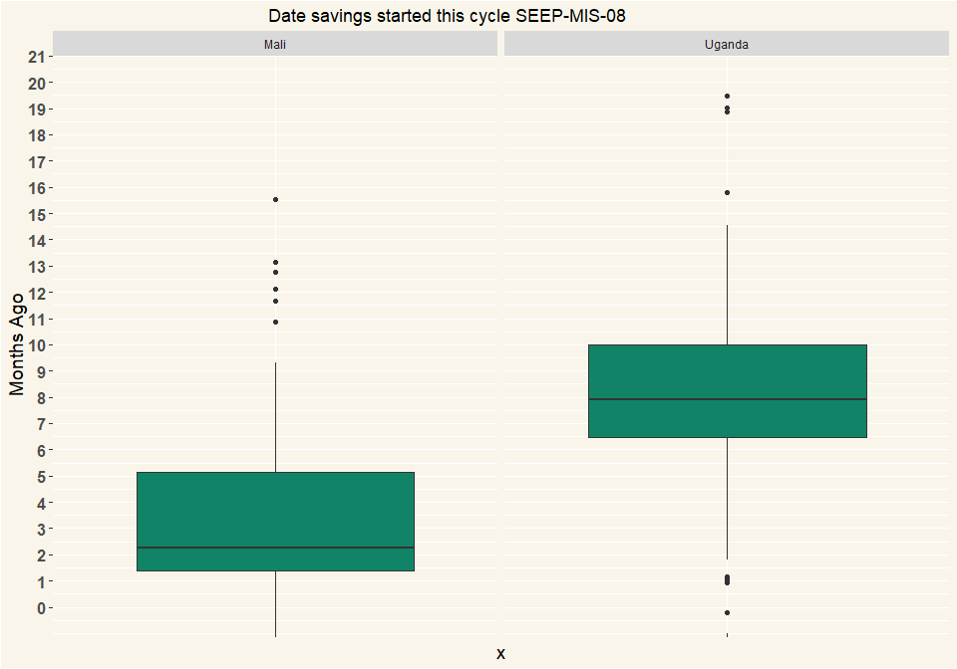

## # A tibble: 2 x 2  
## Country n  
## <chr> <int>  
## 1 Mali 152  
## 2 Uganda 134

# Q10 which type of trainer did your group have?

|  |  |  |
| --- | --- | --- |
| Type | Mali | Uganda |
| Field Officer: Project paid | 152 | 111 |
| Village Agent: Group paid | 0 | 5 |
| Village Agent: Unpaid | 0 | 4 |
| Village Agent: Unknown if paid | 0 | 3 |
| Spontaneous | 0 | 1 |
| They don’t know | 0 | 11 |
| Respondents | 152 | 135 |

|  |  |  |
| --- | --- | --- |
| Type | Mali | Uganda |
| Field Officer: Project paid | 1 | 0.822 |
| Village Agent: Group paid | 0 | 0.037 |
| Village Agent: Unpaid | 0 | 0.0296 |
| Village Agent: Unknown if paid | 0 | 0.0222 |
| Spontaneous | 0 | 0.00741 |
| They don’t know | 0 | 0.0815 |
| Percentage | 1 | 1 |

# Q11 Members at start of cycle

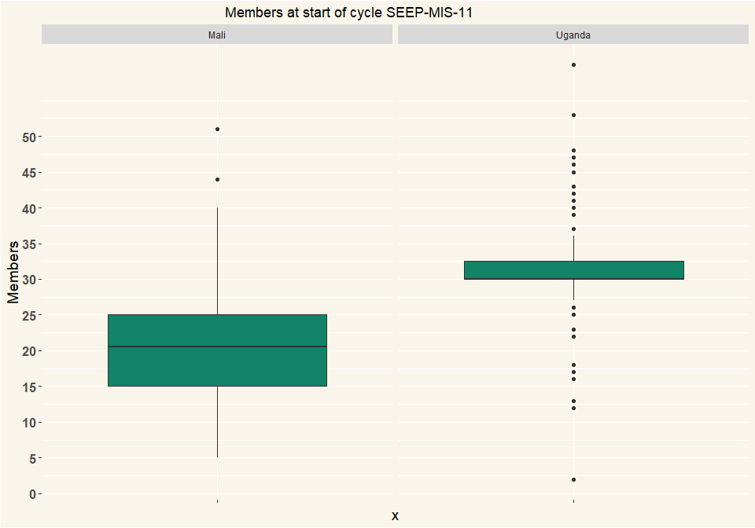

## # A tibble: 2 x 2  
## Country n  
## <chr> <int>  
## 1 Mali 152  
## 2 Uganda 135

# Q13 Registered members at present

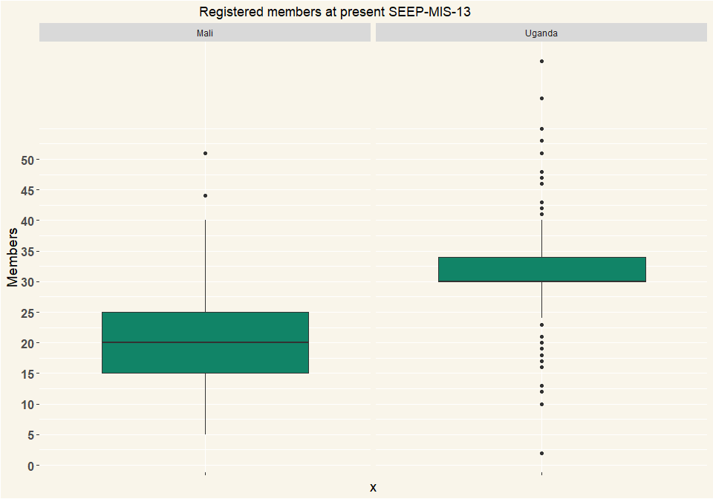

## # A tibble: 2 x 2  
## Country n  
## <chr> <int>  
## 1 Mali 152  
## 2 Uganda 135

# Q14 Registered men at present

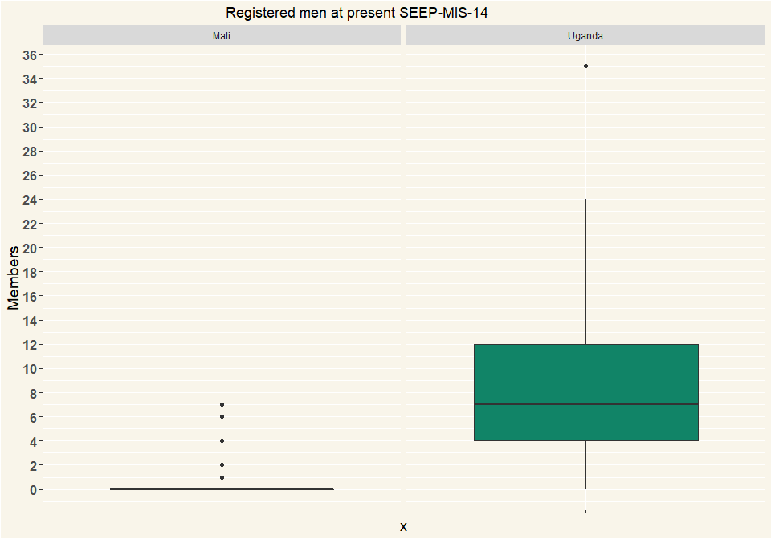

## # A tibble: 2 x 2  
## Country n  
## <chr> <int>  
## 1 Mali 152  
## 2 Uganda 135

# Q15 Registered women at present

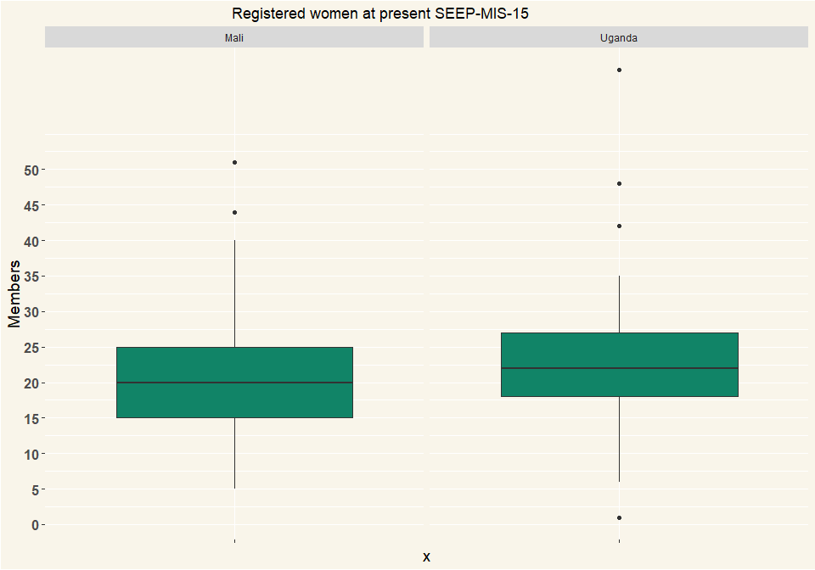

## # A tibble: 2 x 2  
## Country n  
## <chr> <int>  
## 1 Mali 152  
## 2 Uganda 135

# Q16 No. of members attending meeting

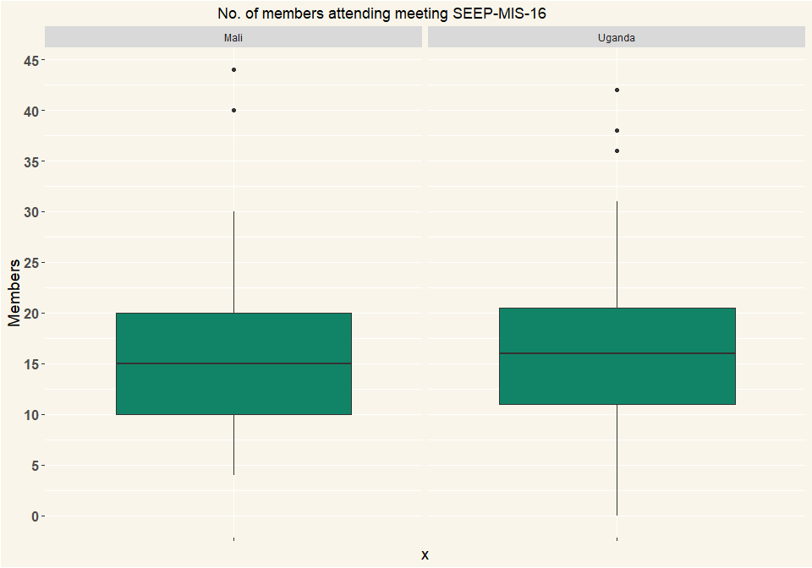

## # A tibble: 2 x 2  
## Country n  
## <chr> <int>  
## 1 Mali 152  
## 2 Uganda 135

# Q17 Total number of share bought by member {0}

I sampled 1-30 of the 500 iteration to represent the general trend

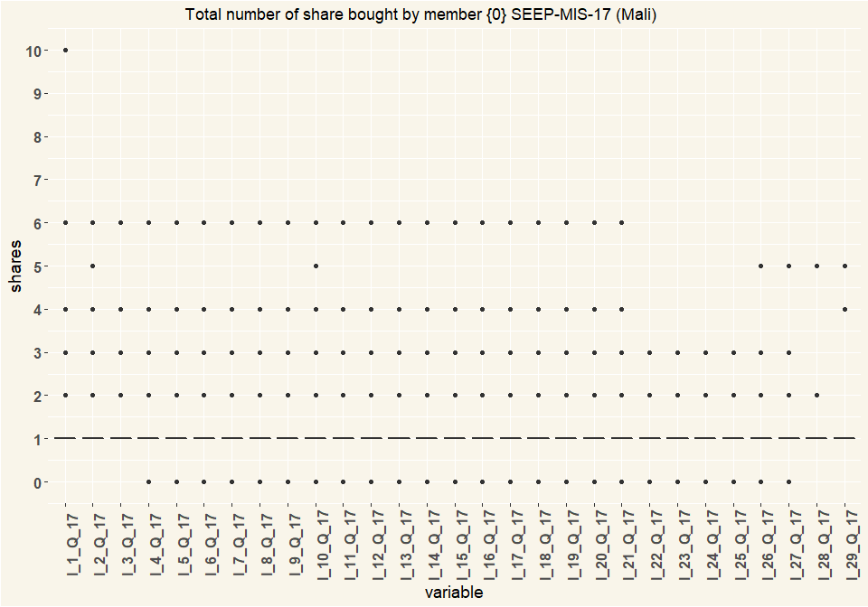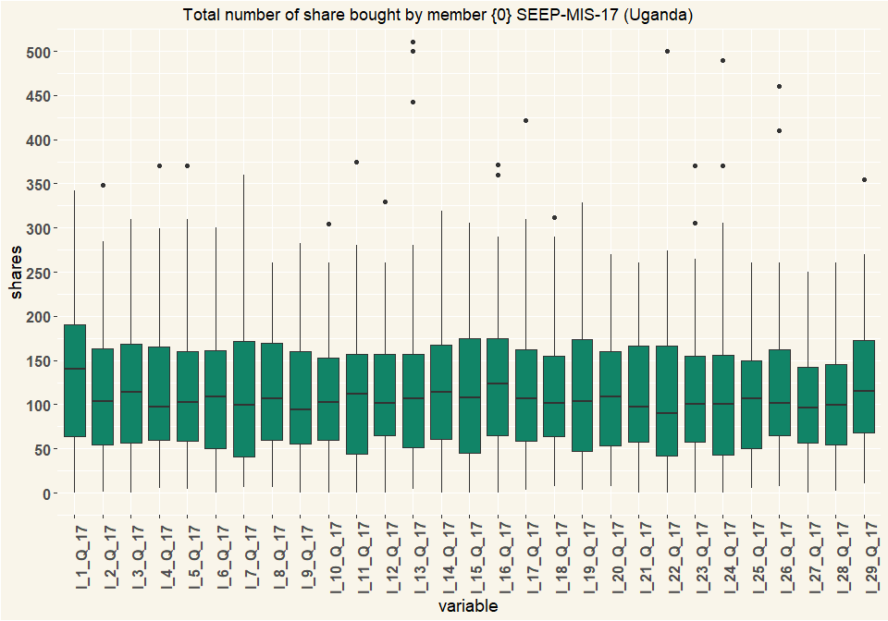

## # A tibble: 2 x 2  
## Country n  
## <chr> <int>  
## 1 Mali 152  
## 2 Uganda 135

# Q18 Value of loan outstanding by member

* Mali exchange rate 0.0017068220
* Uganda exchange rate 0.000270226

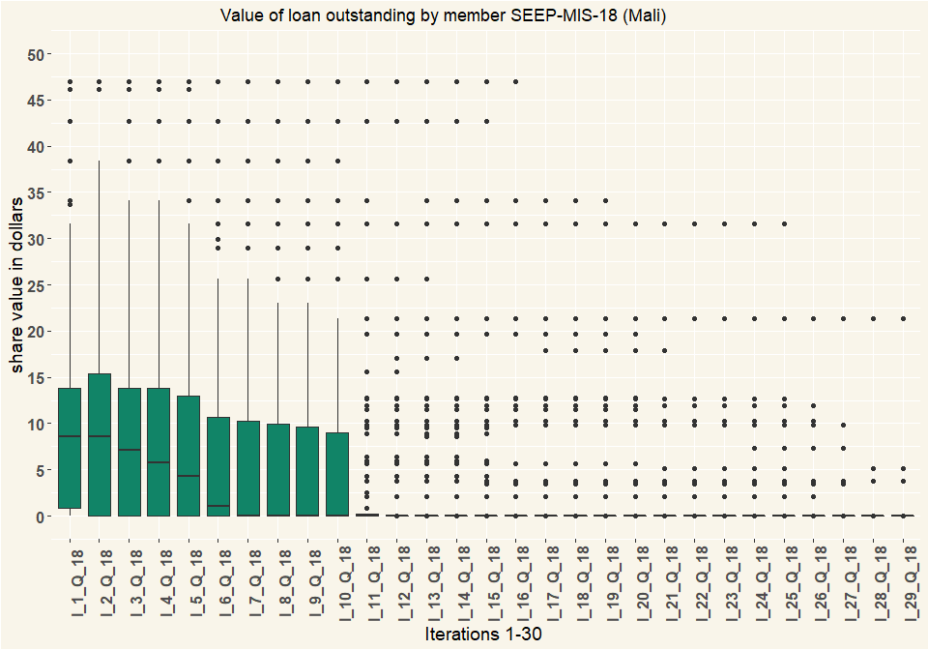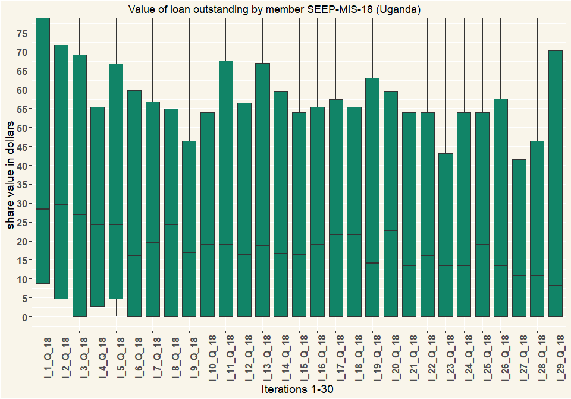

## # A tibble: 2 x 2  
## Country n  
## <chr> <int>  
## 1 Mali 152  
## 2 Uganda 135

# Q19 Dropouts this cycle

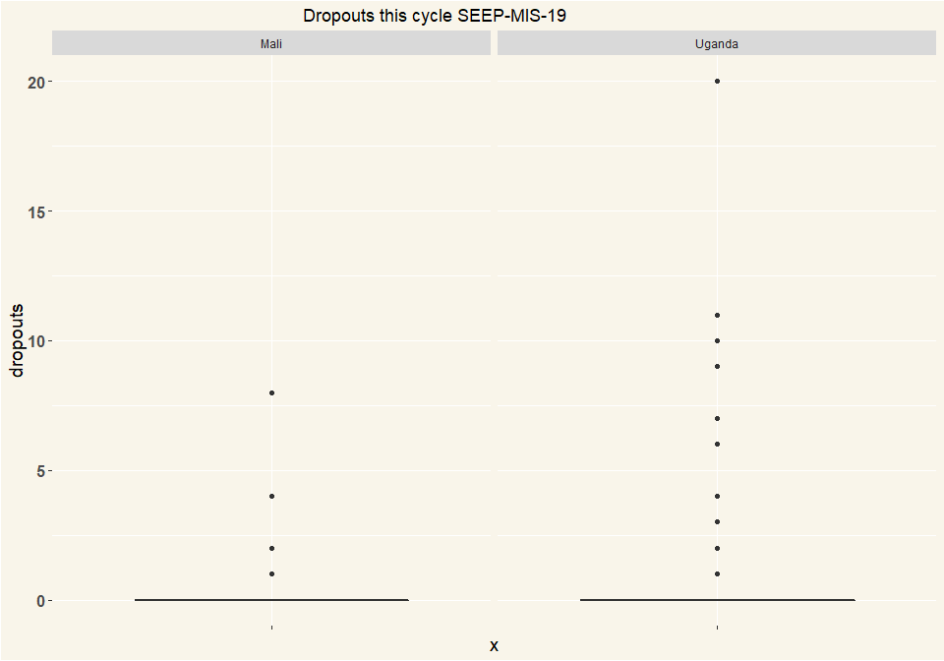

## # A tibble: 2 x 2  
## Country n  
## <chr> <int>  
## 1 Mali 152  
## 2 Uganda 135

# Q20 Value of savings this cycle Does not want to answer

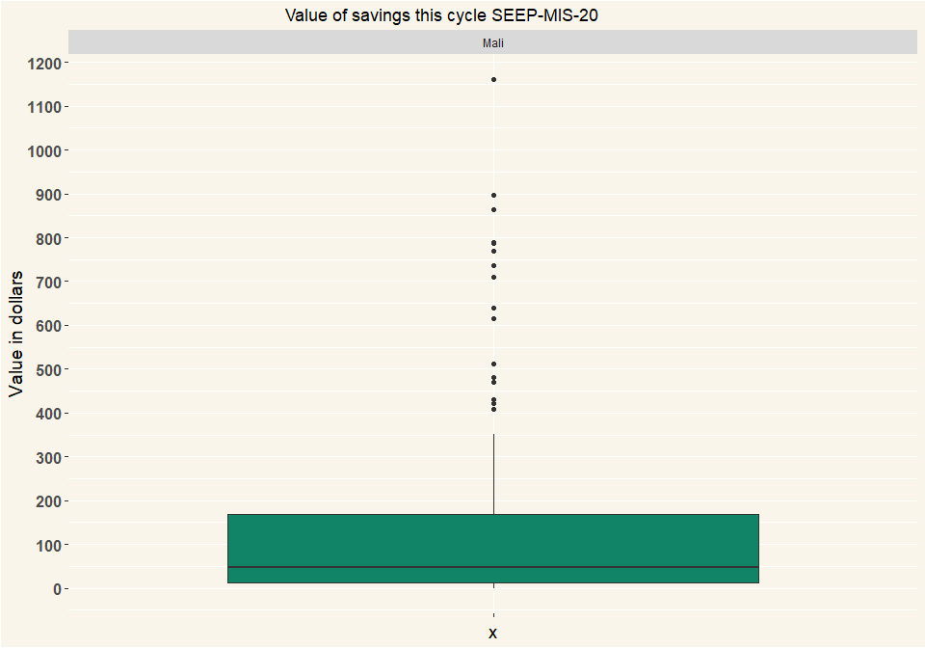

## [1] ""

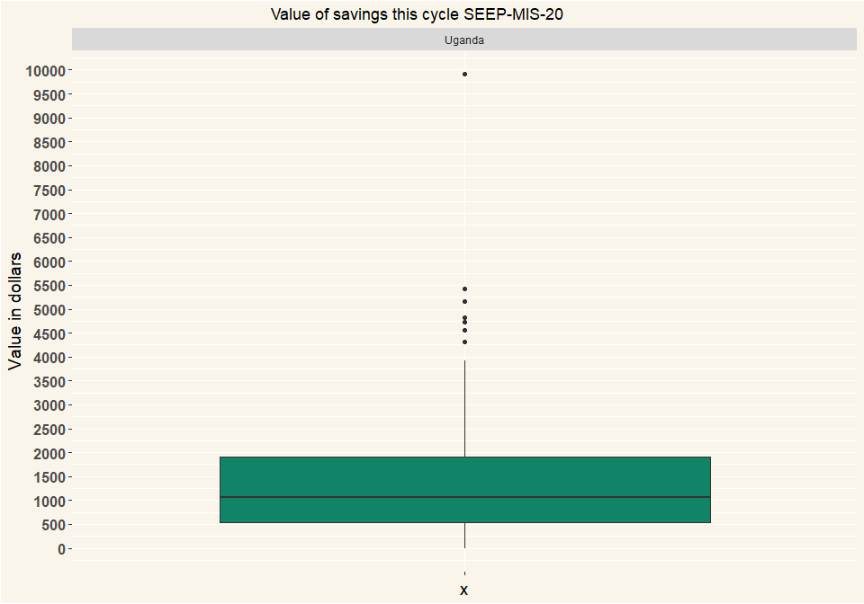

## # A tibble: 2 x 2  
## Country n  
## <chr> <int>  
## 1 Mali 152  
## 2 Uganda 135

# Q21 No. of loans outstanding

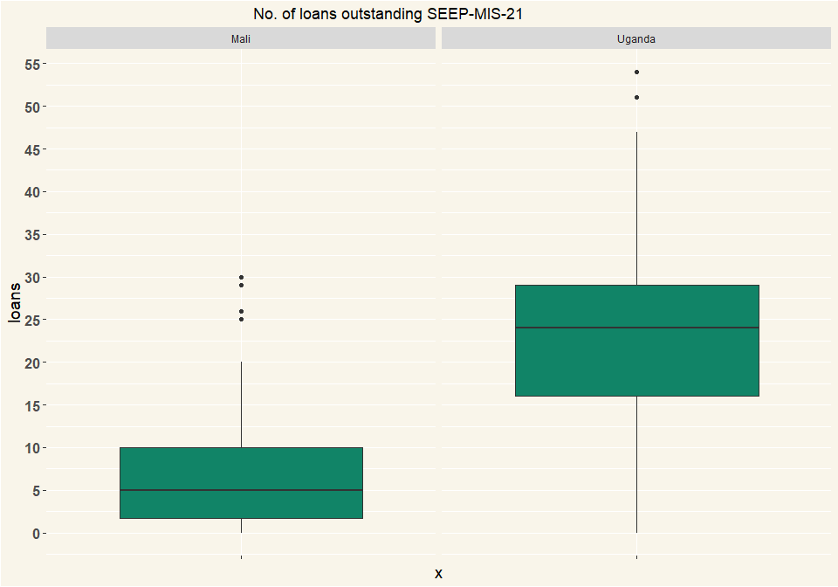

## # A tibble: 2 x 2  
## Country n  
## <chr> <int>  
## 1 Mali 152  
## 2 Uganda 135

# Q22 Value of loans outstanding

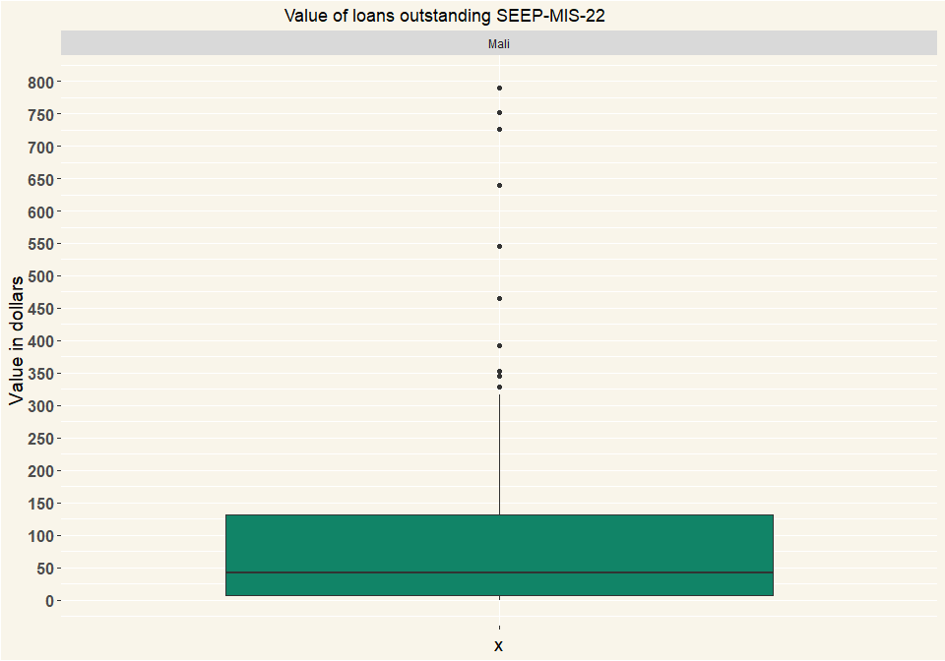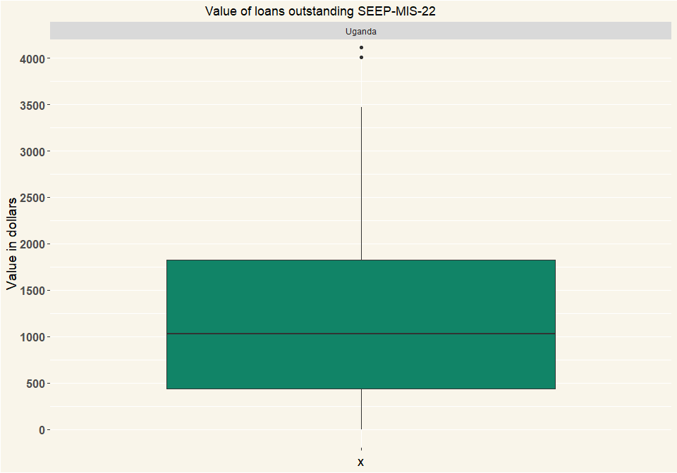

## # A tibble: 2 x 2  
## Country n  
## <chr> <int>  
## 1 Mali 152  
## 2 Uganda 135

# Q23 Write-offs this cycle

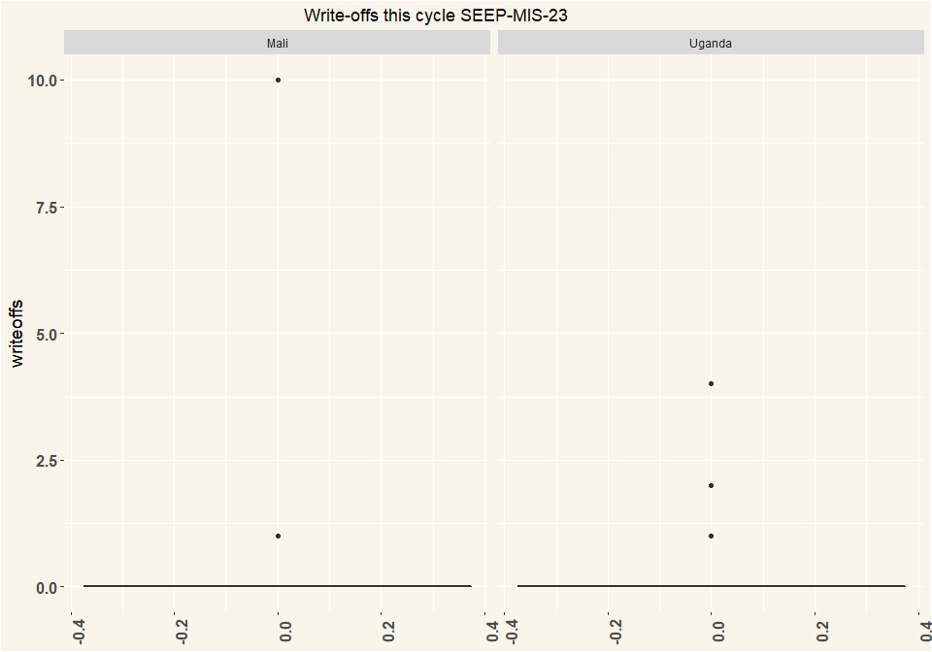

## # A tibble: 2 x 2  
## # Groups: Country [2]  
## Country n  
## <chr> <int>  
## 1 Mali 152  
## 2 Uganda 135

# 24 Loan fund: Cash in box/bank

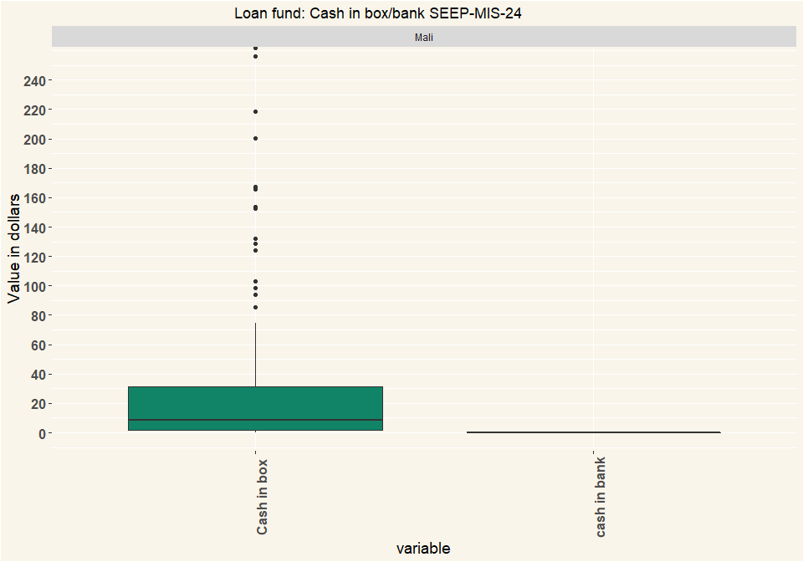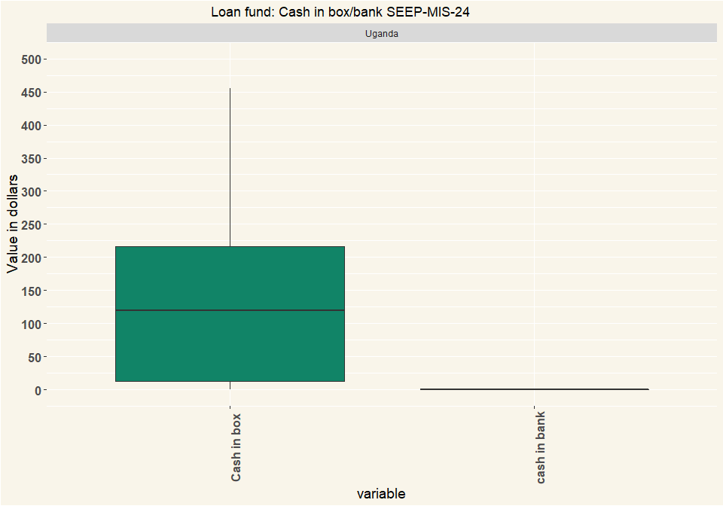

## # A tibble: 2 x 2  
## Country n  
## <chr> <int>  
## 1 Mali 139  
## 2 Uganda 15

# Q25 Cash in other funds

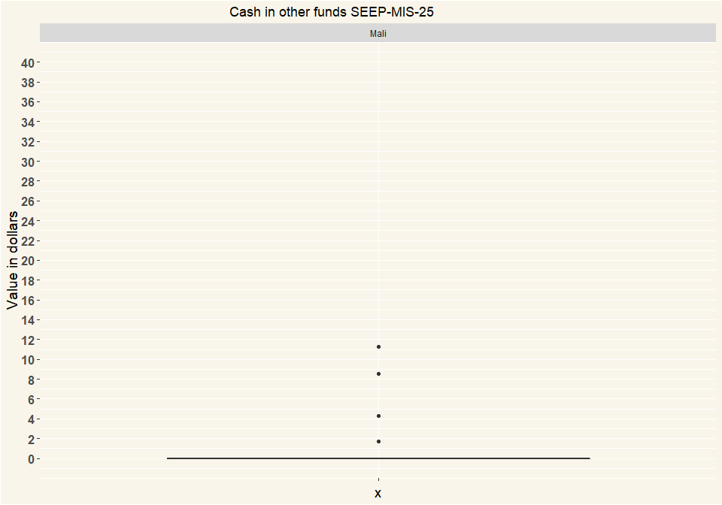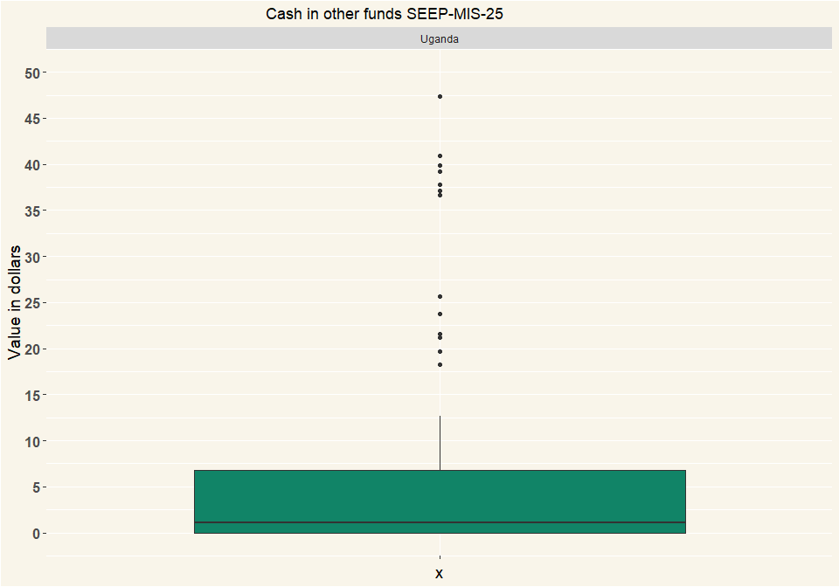

## # A tibble: 2 x 2  
## Country n  
## <chr> <int>  
## 1 Mali 152  
## 2 Uganda 135

# Q26 Property at start of cycle

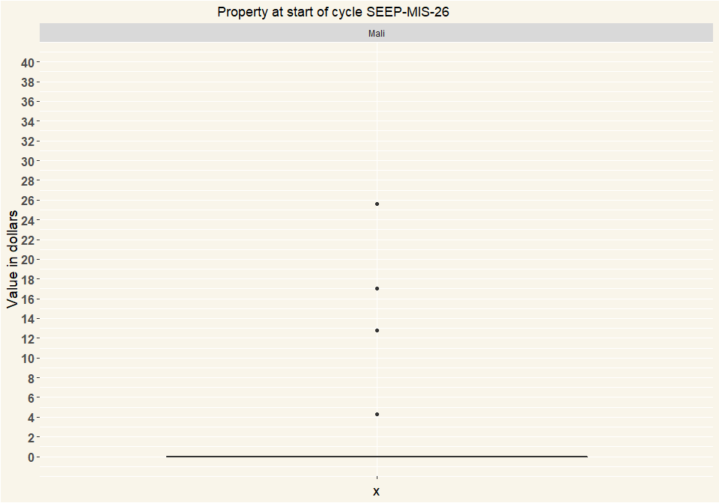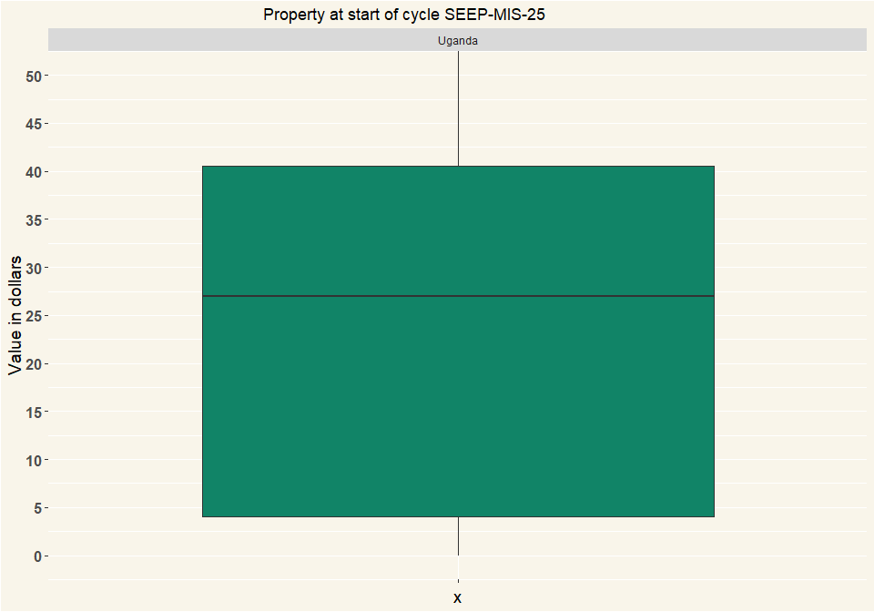

## # A tibble: 2 x 2  
## Country n  
## <chr> <int>  
## 1 Mali 152  
## 2 Uganda 135

# Q27 Property now

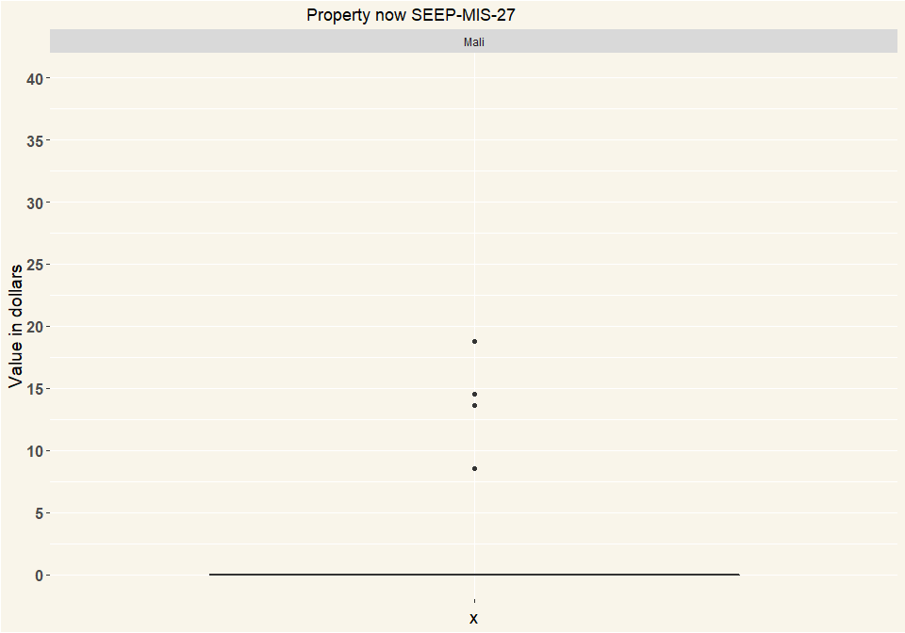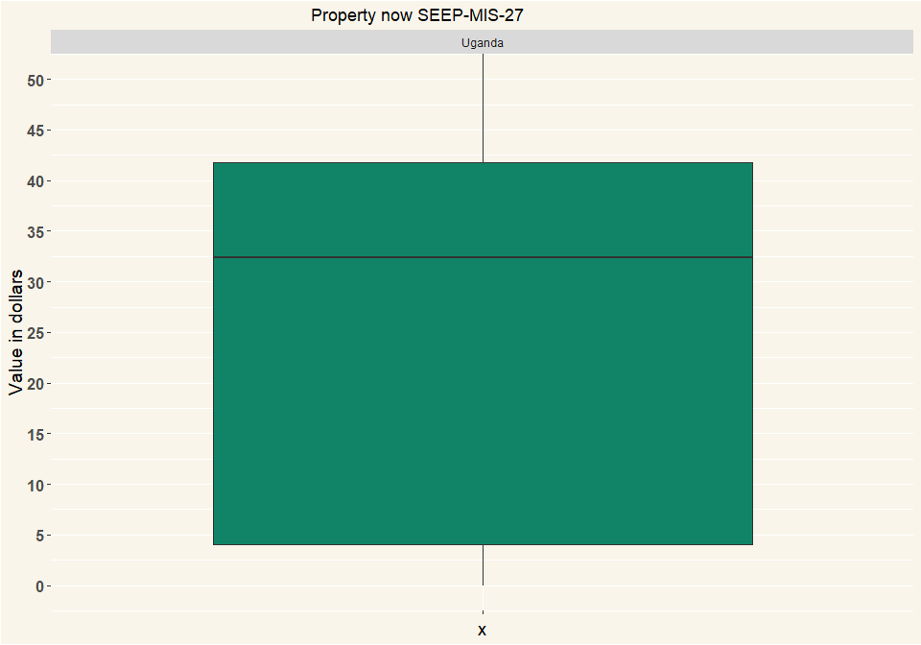

## # A tibble: 2 x 2  
## Country n  
## <chr> <int>  
## 1 Mali 152  
## 2 Uganda 135

# Q28 Debts

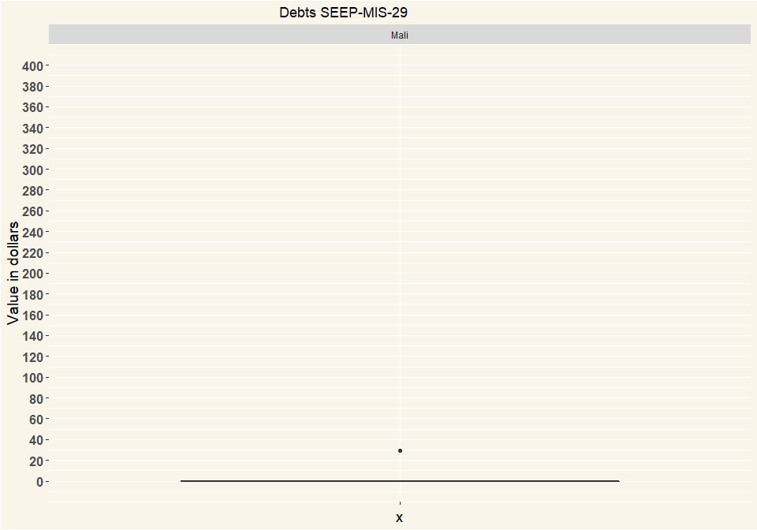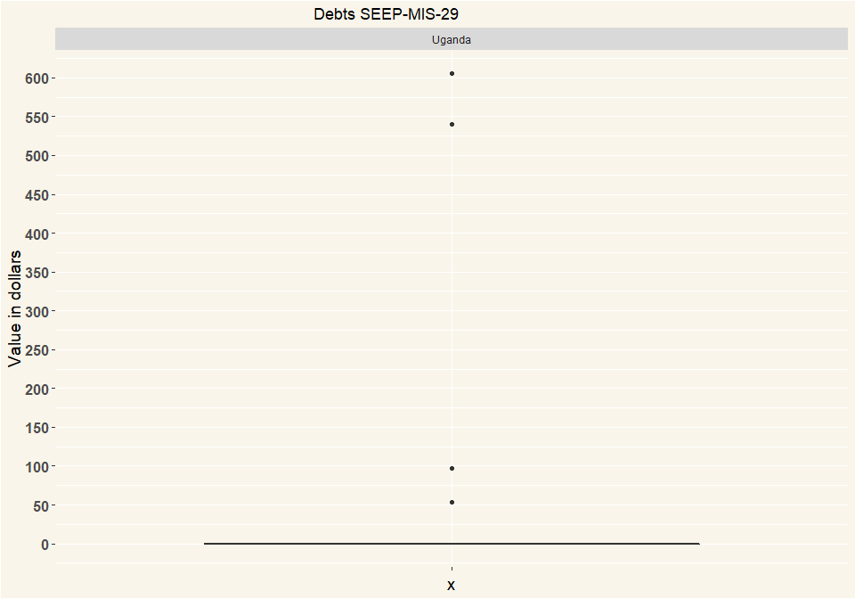

## # A tibble: 2 x 2  
## Country n  
## <chr> <int>  
## 1 Mali 152  
## 2 Uganda 135

# Q30 Your net Profit is {0} . Is that the same as you calculated yourself?

|  |  |  |
| --- | --- | --- |
| clean | Mali | Uganda |
| Yes | 124 | 107 |
| No | 0 | 2 |
| Respondents | 124 | 109 |

# Q31 You net loss is {0} ? What is the reason the group made a loss?

|  |  |  |
| --- | --- | --- |
| Reason_For_Loss | Mali | Uganda |
| au non remboursement des emprunts vu que le groupe est a son debit de cycle | 1 | 0 |
| certaines n’ont pas payé leur intérêt | 1 | 0 |
| certaines personnes n’ont pas payé leur crédit | 2 | 0 |
| children of the money tressure created a holebin the joints of the box and rhey keep on stealing coins not until rhe froup members relised it | 0 | 1 |
| Debtors | 0 | 1 |
| dettes et retards de payement des intérêts et du crédits | 1 | 0 |
| don’t know | 0 | 4 |
| i do not know | 0 | 1 |
| i do not know. | 0 | 1 |
| le montant d’épargne qui est en retard de paiement | 2 | 0 |
| le montant d’épargne qui est en retard payement | 1 | 0 |
| le montant d’épargne qui sont retard de paiement | 1 | 0 |
| les cotisations ajournées | 1 | 0 |
| les intérêts n’ont pas été remboursés | 1 | 0 |
| les intérêts ne sont pas encore remboursés | 3 | 0 |
| les intérêts non remboursés | 1 | 0 |
| les montants d’épargne et les intérêts qui sont en retard de paiement | 1 | 0 |
| les montants d’épargne qui ne sont pas payés au réunion précédente | 1 | 0 |
| les montants d’épargne qui sont en retard de paiement | 5 | 0 |
| loans not yet paid | 0 | 1 |
| low saving among members | 0 | 2 |
| low saving among members and the group does n’t give out loans | 0 | 1 |
| low saving among members,but they take higher loan amount | 0 | 1 |
| low saving and most members fear to take loans | 0 | 1 |
| low saving because of poverty | 0 | 1 |
| Members failed to pay interest as required | 0 | 1 |
| money misplaced | 0 | 1 |
| Money spent on labour in digging fish pond plus buying fish fillets amounting 1000000 is not reflected anywhere. | 0 | 1 |
| non remboursement des emprunt et intérêts sur emprunts par fois les membres remboursent globalement a la fin | 1 | 0 |
| non told | 0 | 1 |
| not sure | 0 | 2 |
| people save little and they take much loans.The property at the start of the cycle is not yet sold into cash. | 0 | 1 |
| remboursement tardive des emprunts | 1 | 0 |
| retards de payement des emprunts | 1 | 0 |
| Some members owe the group money from the previous cycle | 0 | 1 |
| the group misplaced money . | 0 | 1 |
| they don’t know but they will find out how they came to have that loss. | 0 | 1 |
| they either misplaced or gave out excess and did not record. | 0 | 1 |
| tout les intérêt non pas été remboursés | 1 | 0 |
| Respondents | 26 | 26 |

# Q32 Please write the result of the hand calculation for the profit

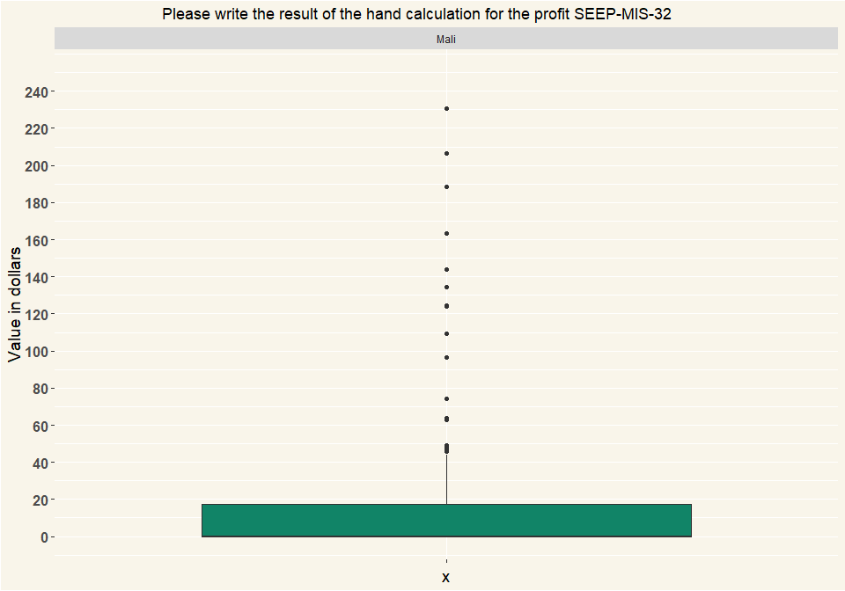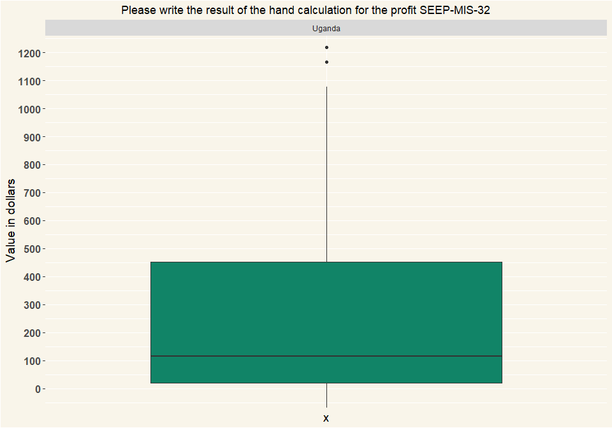

## # A tibble: 2 x 2  
## Country n  
## <chr> <int>  
## 1 Mali 152  
## 2 Uganda 135