Census Analysis

John Kamau

27/08/2019

# Introduction

## Instructions for the Survey

You have been given a list of VSLA groups with “sample instruction” (reference number of group). For instance: COMVIS-A-Replacement3. In addition to interviewing the sample groups, you will have to conduct a census of all of the VSLAs in the village, including the replicated groups. Both of these tasks will require repeated visits to the village, and therefore you must establish good relations with the village authorities. Contact with authorities When you come to the village, you should introduce yourself to the chief, or elders, depending on the social structure and expectations. Explain the purpose of your visit: You are from L-IFT, a company that does research on Savings Groups in several countries, and you have been asked to carry out a study in Mali and Uganda. You want to learn about the VSLAs in the village so that other countries can learn from the experience to make it better. Therefore you will need everyone to be very frank. You are not looking for “good news” or “bad news”. You just want to learn what has happened. Some of the interviews will be in small groups or with individuals so that people will not be embarrassed to talk about any problems they may have. Others will be before the entire village. It will take time to identify all the groups in the village. Since your objective is to identify all the groups in each village, do not limit to who you ask. Continue to ask everybody, “Do you know of any groups of villagers who meet regularly to save money?” You should ask that question to every group you visit and also during casual encounters in shops and restaurants, churches and mosques, and when simply relaxing, or walking around the village. It is important to identify all the groups in the village, and there is no list of them, except for the one that you create Members to be involved in developing the census:

1. Members from sampled groups
2. Local authorities
3. Village agents
4. Community members
5. Chiefs & elders
6. Casual accountants in shops
7. Churches & mosques

When to carry out census:

1. During meeting
2. Before the meeting
3. After the meeting
4. Hang around the village of the group and talk to anybody you can find

# Questions For the Census

# Q5 What is the status of VSLA group {0} with sample instruction {1} ?

|  |  |  |
| --- | --- | --- |
| value | Mali | Uganda |
| Group still exists with same name | 110 | 100 |
| Group still exists but new name | 1 | 14 |
| Other (specify) | 41 | 1 |
| Respondents | 152 | 115 |

|  |  |  |
| --- | --- | --- |
| value | Mali | Uganda |
| Group still exists with same name | 0.724 | 0.87 |
| Group still exists but new name | 0.00658 | 0.122 |
| Other (specify) | 0.27 | 0.0087 |
| Percentage | 1 | 1 |

|  |  |  |
| --- | --- | --- |
| value | Mali | Uganda |
| Alakandeme | 1 | 0 |
| Bajanko | 1 | 0 |
| Bendiya | 3 | 0 |
| Benkadi | 7 | 0 |
| Benkan | 2 | 0 |
| Benkeleman | 1 | 0 |
| Cesiri | 1 | 0 |
| Cessiri | 1 | 0 |
| Cessiri2 | 1 | 0 |
| Danaya | 1 | 0 |
| Denbagnouman | 1 | 0 |
| Fasojija | 1 | 0 |
| Fotemogoban | 1 | 0 |
| Jamagi | 1 | 0 |
| Jekatagne | 1 | 0 |
| Jigisèmè | 1 | 0 |
| Kaari | 1 | 0 |
| Lolo | 2 | 0 |
| Nimissaton | 1 | 0 |
| Sabali | 1 | 0 |
| Sabougnouma | 1 | 0 |
| Sankorota | 1 | 0 |
| Sigidiya | 2 | 0 |
| Tagnè | 1 | 0 |
| Tiesiri | 1 | 0 |
| Toulotesèbèsa | 1 | 0 |
| Yeleen | 1 | 0 |
| Yeredon | 1 | 0 |
| exists with same name but now in busaabale north,, reporting on that village | 0 | 1 |
| sabali | 1 | 0 |
| siguidia | 1 | 0 |

# Q8 Why did the group change its name?

|  |  |  |
| --- | --- | --- |
| value | Mali | Uganda |
| It split into two group (fissure) | 0 | 1 |
| So many members changed that it needed a new name | 0 | 6 |
| Just because they liked a new name | 0 | 7 |
| Other (specify) | 1 | 3 |
| Respondents | 1 | 17 |

|  |  |  |
| --- | --- | --- |
| value | Mali | Uganda |
| It split into two group (fissure) | 0 | 0.0588 |
| So many members changed that it needed a new name | 0 | 0.353 |
| Just because they liked a new name | 0 | 0.412 |
| Other (specify) | 1 | 0.176 |
| Percentage | 1 | 1 |

# Q10 What was the reason for the group-collapse?

There was no specified reason why the groups collapsed under this question.

|  |  |  |
| --- | --- | --- |
| variable | Mali | Uganda |
| Money missing | 0 | 5 |
| Loans not repaid | 0 | 5 |
| Religious reasons | 0 | 1 |
| Group had fulfilled its purpose and members decided to wind it up | 0 | 0 |
| Cash-box stolen by outsider | 0 | 0 |
| Cash-box stolen by group-member/committee member | 0 | 0 |
| Mismanagement committee | 0 | 0 |
| Conflicts/fights | 0 | 0 |
| Family opposition | 0 | 0 |
| Members got old or moved away | 0 | 1 |
| Other (specify) | 116 | 22 |
| Respondents | 116 | 34 |

|  |  |  |
| --- | --- | --- |
| variable | Mali | Uganda |
| Money missing | 0 | 0.147 |
| Loans not repaid | 0 | 0.147 |
| Religious reasons | 0 | 0.0294 |
| Group had fulfilled its purpose and members decided to wind it up | 0 | 0 |
| Cash-box stolen by outsider | 0 | 0 |
| Cash-box stolen by group-member/committee member | 0 | 0 |
| Mismanagement committee | 0 | 0 |
| Conflicts/fights | 0 | 0 |
| Family opposition | 0 | 0 |
| Members got old or moved away | 0 | 0.0294 |
| Other (specify) | 1 | 0.647 |
| Percentage | 1 | 1 |

# 14 Which other groups from your sample were created in this village/ villages about which you are reporting

|  |  |  |
| --- | --- | --- |
| value | Mali | Uganda |
| ahamuginda tukore | 0 | 1 |
| ahusakanya | 0 | 1 |
| alakabon | 1 | 0 |
| amanaben | 4 | 0 |
| anafilè | 1 | 0 |
| angali awaamu | 0 | 1 |
| ankadignoye warakana | 1 | 0 |
| atambula empola | 0 | 1 |
| babigumira | 0 | 1 |
| badjako | 1 | 0 |
| bakiga tumanyane | 0 | 1 |
| bakuseka maja | 0 | 4 |
| bakyala cheared at caroline bahazi | 0 | 1 |
| balijja babone | 0 | 2 |
| balikyewunya | 0 | 1 |
| balyadhusa | 0 | 1 |
| balyekomba a | 0 | 1 |
| bankadi | 3 | 0 |
| basoka kwavula | 0 | 2 |
| bendiya | 3 | 0 |
| benkadi | 47 | 0 |
| benkadi (samedine ) | 1 | 0 |
| benkadi 1 | 2 | 0 |
| benkadi 2 | 3 | 0 |
| benkan | 3 | 0 |
| benkelema | 9 | 0 |
| benkéléma | 2 | 0 |
| benkeleman | 1 | 0 |
| benkola | 7 | 0 |
| benkoma | 1 | 0 |
| bensigidja | 1 | 0 |
| bensigija | 6 | 0 |
| beri kopooto | 0 | 1 |
| bidampola | 0 | 1 |
| birimbi twetungure | 0 | 1 |
| buhesi b. kwetugura | 0 | 1 |
| buhesi twetungure | 0 | 1 |
| bungarika tukwatanise group | 0 | 1 |
| bunono bakiga tumanyane | 0 | 1 |
| bunono tukwatanise | 0 | 1 |
| bunono tweterane | 0 | 1 |
| bunono twimukye | 0 | 1 |
| burambira bika oguze | 0 | 1 |
| bushoro group b | 0 | 1 |
| bwavumpologoma | 0 | 1 |
| bwavunsolo | 0 | 1 |
| byogero | 0 | 2 |
| cessiri | 3 | 0 |
| dambe | 7 | 0 |
| danaton | 1 | 0 |
| danaya | 7 | 0 |
| danbe | 1 | 0 |
| debagnouma | 1 | 0 |
| dembe | 1 | 0 |
| deme | 2 | 0 |
| demedeme diombougou | 1 | 0 |
| demen kountio | 1 | 0 |
| demen warakana | 1 | 0 |
| djamadjigui | 1 | 0 |
| djantogneréla | 2 | 0 |
| djekafo | 1 | 0 |
| djiguissémé | 3 | 0 |
| djiguiya | 1 | 0 |
| doussoussouma | 7 | 0 |
| endenonola a | 0 | 1 |
| fasojija | 3 | 0 |
| fassoyiriwa | 1 | 0 |
| fayida | 3 | 0 |
| fotemogoban | 1 | 0 |
| gemwkumwinyo | 0 | 2 |
| gnetaka | 1 | 0 |
| gorobinè | 1 | 0 |
| heremakono | 8 | 0 |
| ibanda tukore namani | 0 | 1 |
| ihambiro kwebeisaho | 0 | 1 |
| ihambiro stage boda boda | 0 | 1 |
| ihambiro twekunde | 0 | 1 |
| ihunga hill rukungiri farmers | 0 | 1 |
| it seats at magogo primary school chaired by balaza robert | 0 | 1 |
| jamagi | 1 | 0 |
| jekatagne | 3 | 0 |
| jigifa | 2 | 0 |
| jigisèmè | 9 | 0 |
| jiguiya | 1 | 0 |
| jiguiyaton | 2 | 0 |
| jiguya | 1 | 0 |
| kaari | 2 | 0 |
| kabiirizi tukorenamani | 0 | 1 |
| kabiriizi bikiranyensya | 0 | 1 |
| kabiriizi tutunguke | 0 | 1 |
| kabiriizi twimukye | 0 | 1 |
| kadiana jigifa | 1 | 0 |
| kamakoma group a | 0 | 1 |
| kamira abekundanire | 0 | 1 |
| kamobwa twena twekundanire | 0 | 1 |
| kamu kamu | 0 | 1 |
| kamu kamu2 | 0 | 2 |
| kankelenfo | 1 | 0 |
| kantigiw | 2 | 0 |
| karama nyamba nkuyambe | 0 | 1 |
| kasozi devt group | 0 | 1 |
| katunguru bikiira nyensya | 0 | 1 |
| kazinga tubinge obworo | 0 | 1 |
| kibiizi fishing and development association | 0 | 1 |
| kibiizi tukore hamwe | 0 | 1 |
| kibiizi womens | 0 | 1 |
| kicwamba abakundine nyamba nkuyambe | 0 | 1 |
| kicwamba kabimba tukwatanise | 0 | 1 |
| kicwamba tukore | 0 | 1 |
| kicwamba tukwatanise | 0 | 1 |
| kicwamba twimukye | 0 | 2 |
| kimbugu bikiira nyenya | 0 | 1 |
| kinaaba tukundane group | 0 | 1 |
| kisiizi butogota tukundine | 0 | 1 |
| kisiizi omungozi | 0 | 1 |
| kisiizi tikwatanise | 0 | 1 |
| kitagata vsla | 0 | 1 |
| kolandiya | 1 | 0 |
| kotognontala | 4 | 0 |
| kounawolo | 5 | 0 |
| kounnawolo | 1 | 0 |
| kyarugazi vsla | 0 | 1 |
| kyebaja kobona c | 0 | 1 |
| kyebajjatobona | 0 | 1 |
| kyosinga | 0 | 1 |
| kyowamwino | 0 | 2 |
| lolo | 4 | 0 |
| lwenyi gi chandi b | 0 | 1 |
| magotekokoumala | 3 | 0 |
| maki mothi | 0 | 1 |
| malibèma | 1 | 0 |
| manamani | 1 | 0 |
| miriyagnouman | 4 | 0 |
| munaku kawama | 0 | 1 |
| musana tukore namani | 0 | 1 |
| mushunga tukwatanise | 0 | 1 |
| nakabale tuwanise obuwavu d | 0 | 1 |
| nambula mwiho b | 0 | 1 |
| namwana embeli | 0 | 1 |
| ndibogeza | 0 | 1 |
| ndigakweya | 0 | 1 |
| ngiyo beri b | 0 | 1 |
| ngnesigue | 1 | 0 |
| nkonkobore tukorere hamwe | 0 | 1 |
| nyakabingo bikiira nyensya | 0 | 1 |
| nyakabingo tukore namani | 0 | 1 |
| nyakabingo tukwatanise | 0 | 1 |
| nyakasa tukore nobwengye | 0 | 1 |
| nyakazinga tutunguke | 0 | 1 |
| nyamicucu abakyara tukwatanise | 0 | 1 |
| nyamicucu bataka kweyamba | 0 | 1 |
| nyamicucu bingabworo | 0 | 1 |
| nyamicucu tuhwerane association | 0 | 1 |
| nyamicucu women’s raising | 0 | 1 |
| nyarushanje ibanda matoke | 0 | 1 |
| nyarushanje kwetungura | 0 | 1 |
| nyarushanje matookye association | 0 | 1 |
| nyarushanje stage b tukore | 0 | 1 |
| nyazakanga tutunguke | 0 | 1 |
| rubiriizi tukore | 0 | 1 |
| rubiriizi twena tukore | 0 | 1 |
| rubirizi tutungukye | 0 | 1 |
| rubirizi twetungure | 0 | 1 |
| rutoma b zone | 0 | 1 |
| rutoma group | 0 | 1 |
| rutoma tumanyane | 0 | 1 |
| ruyonza b tutungukye | 0 | 1 |
| ruyonza tukwatanise | 0 | 1 |
| ruyonza tutungukye uweso | 0 | 1 |
| rwembunu kwetungura | 0 | 1 |
| rwentale akabox | 0 | 1 |
| sabali | 11 | 0 |
| sabougnouma | 1 | 0 |
| sabougnouman | 4 | 0 |
| sabougnouman 2 | 1 | 0 |
| sadia | 1 | 0 |
| sakenou | 4 | 0 |
| sankorotali | 1 | 0 |
| sekadhikuwe | 0 | 1 |
| sekola | 1 | 0 |
| sibahola nobona | 0 | 1 |
| sicha sitono | 0 | 1 |
| sigimamè | 8 | 0 |
| siguibekolassa | 1 | 0 |
| siguidia | 1 | 0 |
| siguikadji | 2 | 0 |
| sodia | 5 | 0 |
| soroyiriwa | 1 | 0 |
| st.jude | 0 | 1 |
| taagne | 2 | 0 |
| the group sits at the home of namugaya sarah and chaired by sarah on sunday | 0 | 1 |
| the group sits at the home of namugaya sarah and chaired by sarah on tuesday | 0 | 1 |
| thiesiry | 1 | 0 |
| tiesiri | 3 | 0 |
| tiesiri 2 | 1 | 0 |
| timinadiya | 3 | 0 |
| timinandiya | 6 | 0 |
| tokola-ayenda | 0 | 1 |
| tougousigidia | 3 | 0 |
| tougousiguidia | 1 | 0 |
| tougousikidia | 1 | 0 |
| toukoubesiguidja | 1 | 0 |
| tukola bagaya | 0 | 1 |
| tukolele walala | 0 | 1 |
| tukore namani tutungukye | 0 | 1 |
| tusubira | 0 | 1 |
| twegaitte | 0 | 1 |
| tweheyo pentalcoastal | 0 | 1 |
| tweweyo | 0 | 1 |
| tweyambe | 0 | 1 |
| twisania | 0 | 1 |
| woriroki beri | 0 | 1 |
| yankadi | 5 | 0 |
| yeleen | 2 | 0 |
| yénou | 1 | 0 |
| yénouton | 1 | 0 |
| yeredon | 9 | 0 |
| yérèdon | 1 | 0 |
| yeregna | 1 | 0 |
| yereta | 3 | 0 |
| yeretaa | 1 | 0 |
| yiriwa | 4 | 0 |
| yiriwali | 1 | 0 |
| Total Groups | 299 | 134 |

# Q17 What is the status of VSLA group {0} ?

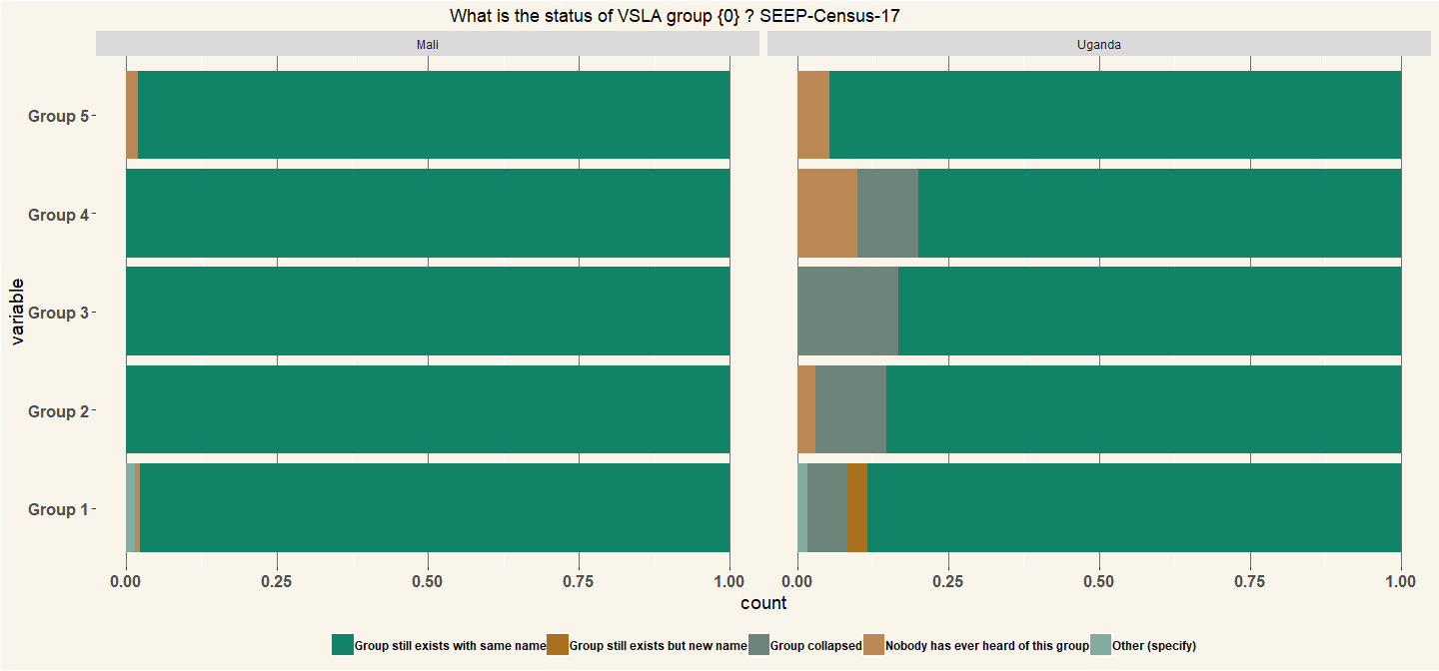

|  |  |
| --- | --- |
| Country | n |
| Mali | 131 |
| Uganda | 60 |

# Q23 Has the group {0} created or brought about other savings groups? (Combined)

|  |  |  |
| --- | --- | --- |
| combined | Mali | Uganda |
| No | 133 | 68 |
| Yes | 19 | 47 |
| Respondents | 152 | 115 |

|  |  |  |
| --- | --- | --- |
| combined | Mali | Uganda |
| No | 0.875 | 0.591 |
| Yes | 0.125 | 0.409 |
| Percentage | 1 | 1 |

# Q24 How many groups has the group {0} contributed to? (also include groups that no longer exist)

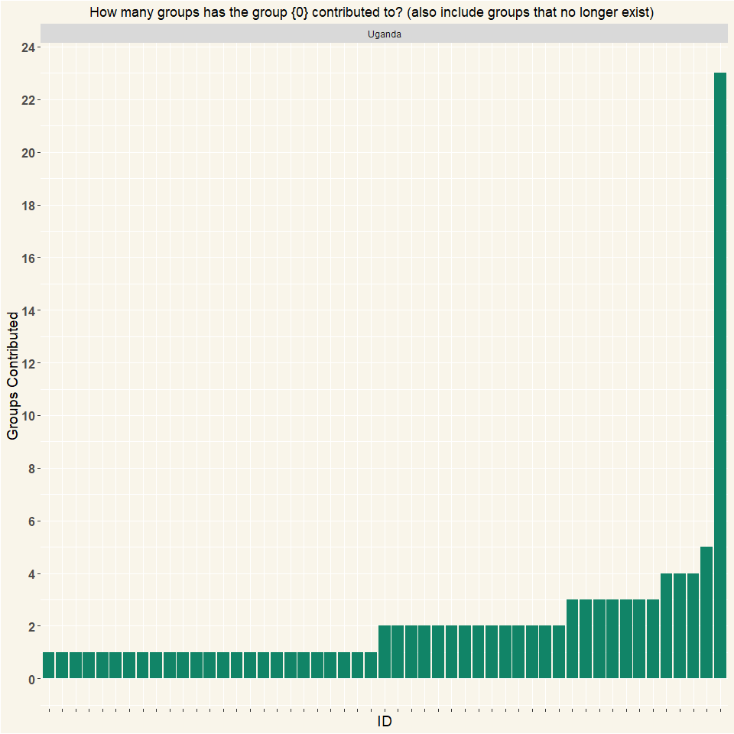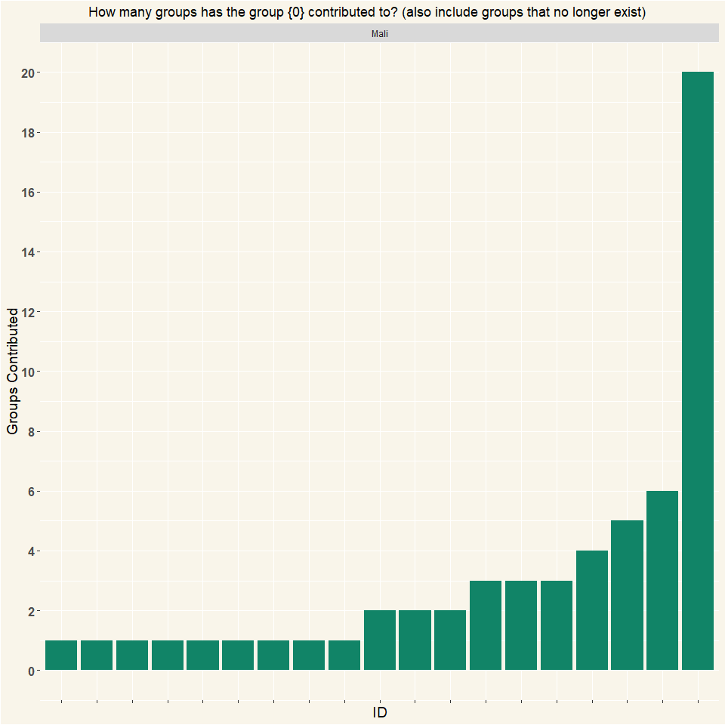

## # A tibble: 2 x 2  
## # Groups: Country [2]  
## Country n  
## <chr> <int>  
## 1 Mali 19  
## 2 Uganda 51

# Q25 What is current situation of these groups that group {0} brought or create? All are still functioning

|  |  |  |
| --- | --- | --- |
| variable | Mali | Uganda |
| All are still functioning | 25 | 50 |
| Most are still functioning | 0 | 2 |
| Some are still functioning, some collapsed | 0 | 8 |
| Most have collapsed | 0 | 1 |
| All have collapsed | 0 | 4 |
| Other (specify) | 0 | 2 |
| Respondents | 25 | 67 |

|  |  |  |
| --- | --- | --- |
| variable | Mali | Uganda |
| All are still functioning | 1 | 0.746 |
| Most are still functioning | 0 | 0.0299 |
| Some are still functioning, some collapsed | 0 | 0.119 |
| Most have collapsed | 0 | 0.0149 |
| All have collapsed | 0 | 0.0597 |
| Other (specify) | 0 | 0.0299 |
| Percentage | 1 | 1 |

# Q27 How many other groups could you find in the village?

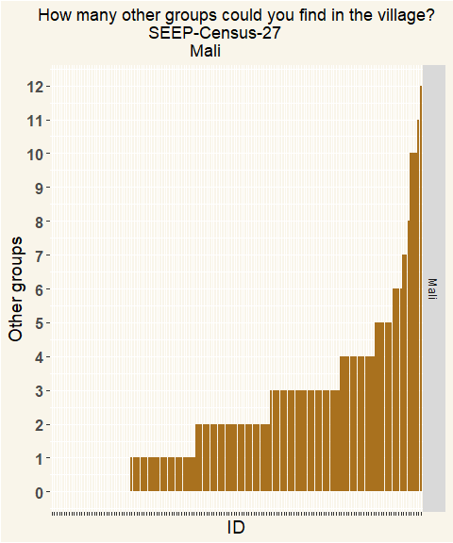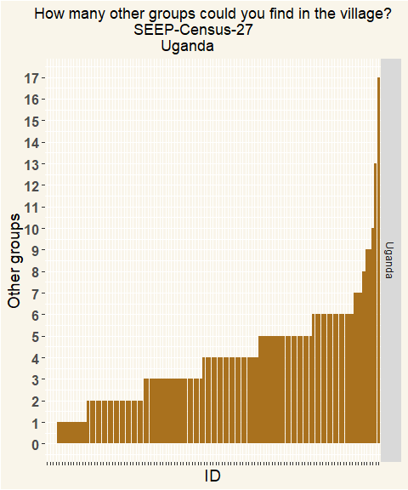

## # A tibble: 2 x 2  
## # Groups: Country [2]  
## Country n  
## <chr> <int>  
## 1 Mali 149  
## 2 Uganda 113

# Q29 FUNCTION: How does group {0} operate?

## Iteration Questions

The Size of the point on the graphs represent the number of respondents in the sample. The table that follows shows the full names of the levels within the graph Finally the last tables shows the number of respondents for each iteration.

|  |  |  |
| --- | --- | --- |
| Value | Mali | Uganda |
| (DISTRIBUTING ASCA) | 236 | 244 |
| (NON DISTRIBUTING ASCA) | 1 | 25 |
| (ROSCA) | 3 | 49 |
| dont collect savings | 1 | 6 |
| I don’t know | 0 | 2 |
| Other (specify) | 2 | 12 |
| Respondents | 243 | 338 |

|  |  |  |
| --- | --- | --- |
| Value | Mali | Uganda |
| (DISTRIBUTING ASCA) | 0.971 | 0.722 |
| (NON DISTRIBUTING ASCA) | 0.00412 | 0.074 |
| (ROSCA) | 0.0123 | 0.145 |
| dont collect savings | 0.00412 | 0.0178 |
| I don’t know | 0 | 0.00592 |
| Other (specify) | 0.00823 | 0.0355 |
| Percentage | 1 | 1 |

# Q30 ORIGIN How did group {0} come to exist?

|  |  |  |
| --- | --- | --- |
| Value | Mali | Uganda |
| Group from sample project (but outside sample) | 164 | 86 |
| Group formed by other project group | 6 | 32 |
| Group replicated from sample project group | 38 | 57 |
| Group unrelated to any project, pre-existing | 4 | 27 |
| Group unrelated to any project, but started later than project | 10 | 46 |
| Other (specify) | 18 | 64 |
| Respondents | 240 | 312 |

|  |  |  |
| --- | --- | --- |
| Value | Mali | Uganda |
| Group from sample project (but outside sample) | 0.683 | 0.276 |
| Group formed by other project group | 0.025 | 0.103 |
| Group replicated from sample project group | 0.158 | 0.183 |
| Group unrelated to any project, pre-existing | 0.0167 | 0.0865 |
| Group unrelated to any project, but started later than project | 0.0417 | 0.147 |
| Other (specify) | 0.075 | 0.205 |
| Percentage | 1 | 1 |

# Q31 Did group {0} have any relation to any of the sampled groups?

|  |  |  |
| --- | --- | --- |
| Value | Mali | Uganda |
| The group is unrelated to any of these groups | 57 | 101 |
| The group was initiated or trained by a member of this group | 18 | 18 |
| The group was started by some members who left this group | 25 | 19 |
| The group was a split off of this group | 2 | 8 |
| The group was formed by the same trainer as this group | 109 | 122 |
| Other (specify) | 2 | 16 |
| Respondents | 213 | 284 |

|  |  |  |
| --- | --- | --- |
| Value | Mali | Uganda |
| The group is unrelated to any of these groups | 0.268 | 0.356 |
| The group was initiated or trained by a member of this group | 0.0845 | 0.0634 |
| The group was started by some members who left this group | 0.117 | 0.0669 |
| The group was a split off of this group | 0.00939 | 0.0282 |
| The group was formed by the same trainer as this group | 0.512 | 0.43 |
| Other (specify) | 0.00939 | 0.0563 |
| Percentage | 1 | 1 |

# Q36 Number of members of group {0}

The Iterations were aggregated via a median value, rounded off to remove decimal group members.

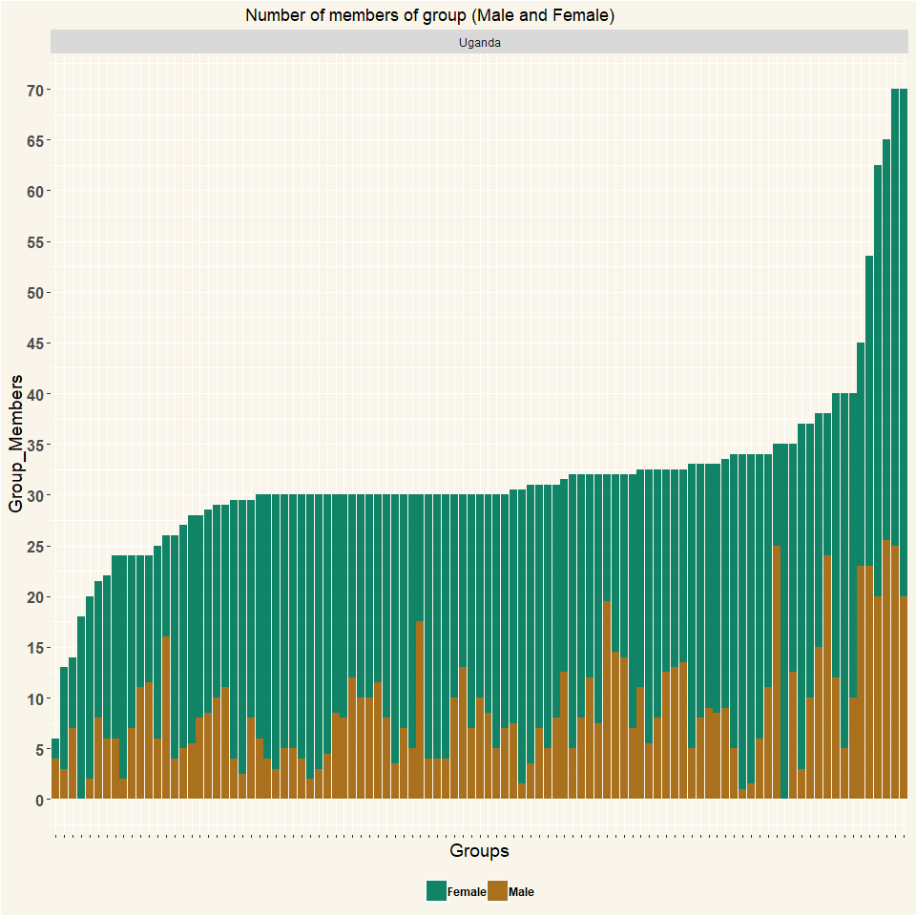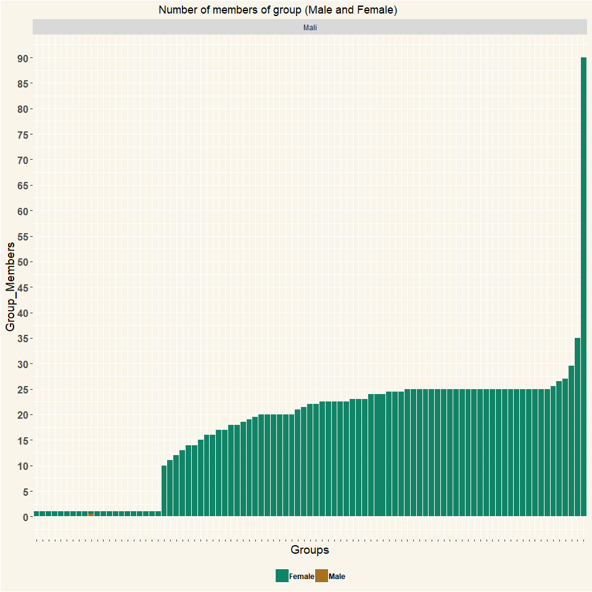

##   
## Mali Uganda   
## 91 101