Census Analysis

John Kamau

27/08/2019

# Introduction

## Instructions for the Survey

You have been given a list of VSLA groups with “sample instruction” (reference number of group). For instance: COMVIS-A-Replacement3. In addition to interviewing the sample groups, you will have to conduct a census of all of the VSLAs in the village, including the replicated groups. Both of these tasks will require repeated visits to the village, and therefore you must establish good relations with the village authorities. Contact with authorities When you come to the village, you should introduce yourself to the chief, or elders, depending on the social structure and expectations. Explain the purpose of your visit: You are from L-IFT, a company that does research on Savings Groups in several countries, and you have been asked to carry out a study in Mali and Uganda. You want to learn about the VSLAs in the village so that other countries can learn from the experience to make it better. Therefore you will need everyone to be very frank. You are not looking for “good news” or “bad news”. You just want to learn what has happened. Some of the interviews will be in small groups or with individuals so that people will not be embarrassed to talk about any problems they may have. Others will be before the entire village. It will take time to identify all the groups in the village. Since your objective is to identify all the groups in each village, do not limit to who you ask. Continue to ask everybody, “Do you know of any groups of villagers who meet regularly to save money?” You should ask that question to every group you visit and also during casual encounters in shops and restaurants, churches and mosques, and when simply relaxing, or walking around the village. It is important to identify all the groups in the village, and there is no list of them, except for the one that you create Members to be involved in developing the census:

1. Members from sampled groups
2. Local authorities
3. Village agents
4. Community members
5. Chiefs & elders
6. Casual accountants in shops
7. Churches & mosques

When to carry out census:

1. During meeting
2. Before the meeting
3. After the meeting
4. Hang around the village of the group and talk to anybody you can find

# Questions For the Census

# Q5 What is the status of VSLA group {0} with sample instruction {1} ?

|  |  |  |
| --- | --- | --- |
| value | Mali | Uganda |
| Group still exists with same name | 115 | 100 |
| Group still exists but new name | 1 | 14 |
| Other (specify) | 41 | 1 |
| Respondents | 157 | 115 |
| value | Mali | Uganda |
| Group still exists with same name | 0.732 | 0.87 |
| Group still exists but new name | 0.00637 | 0.122 |
| Other (specify) | 0.261 | 0.0087 |
| Percentage | 1 | 1 |

# Q8 Why did the group change its name?

|  |  |  |
| --- | --- | --- |
| value | Mali | Uganda |
| It split into two group (fissure) | 0 | 1 |
| So many members changed that it needed a new name | 0 | 6 |
| Just because they liked a new name | 0 | 7 |
| Other (specify) | 1 | 3 |
| Respondents | 1 | 17 |
| value | Mali | Uganda |
| It split into two group (fissure) | 0 | 0.0588 |
| So many members changed that it needed a new name | 0 | 0.353 |
| Just because they liked a new name | 0 | 0.412 |
| Other (specify) | 1 | 0.176 |
| Percentage | 1 | 1 |

# Q11 Has the group created or brought about other savings groups?

|  |  |  |
| --- | --- | --- |
| value | Mali | Uganda |
| Yes | 16 | 41 |
| No | 141 | 74 |
| Respondents | 157 | 115 |
| value | Mali | Uganda |
| Yes | 0.102 | 0.357 |
| No | 0.898 | 0.643 |
| Percentage | 1 | 1 |

# Q12 How many groups has the group contributed to? (also include groups that no longer exist) I don’t know

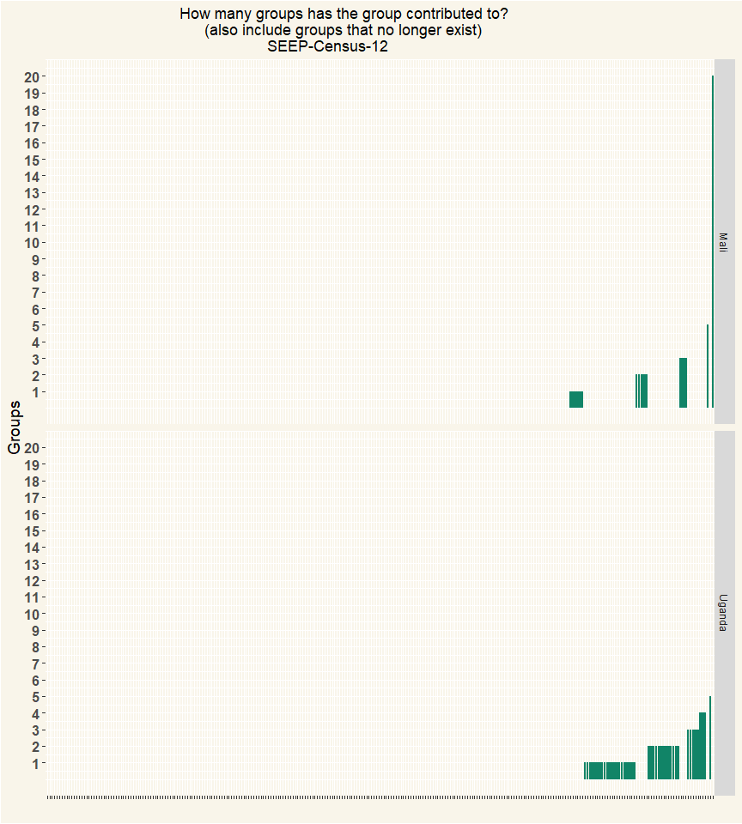

##   
## Mali Uganda   
## 157 115

# Q13 What is current situation of these groups?

|  |  |  |
| --- | --- | --- |
| value | Mali | Uganda |
| All are still functioning | 16 | 44 |
| Respondents | 16 | 44 |
| value | Mali | Uganda |
| All are still functioning | 1 | 1 |
| Percentage | 1 | 1 |

# Q17 What is the status of VSLA group {0} ?

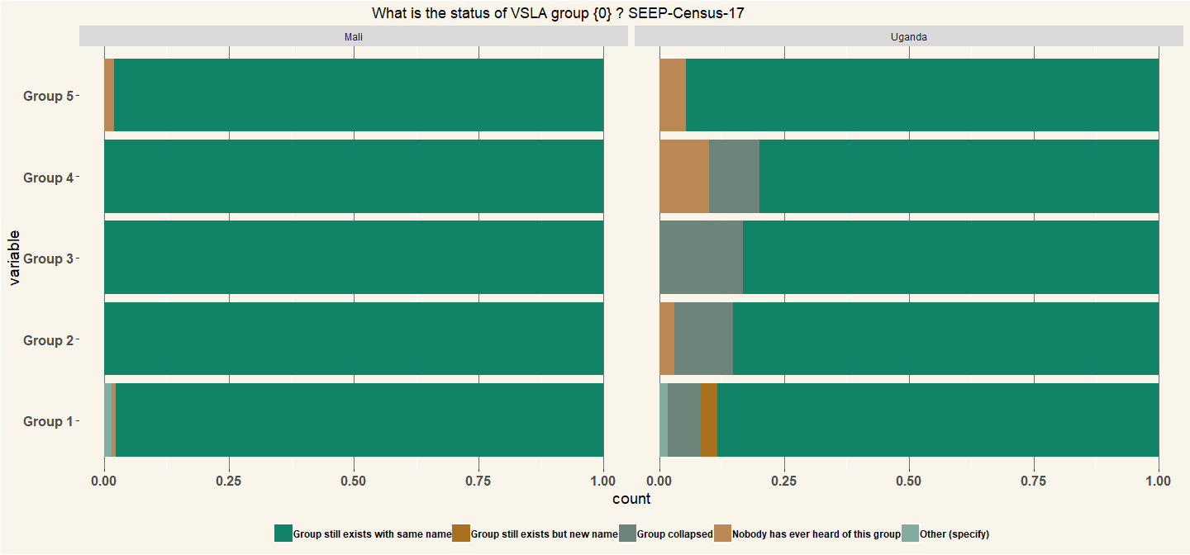

|  |  |
| --- | --- |
| Country | n |
| Mali | 136 |
| Uganda | 60 |

# Q23 Has the group {0} created or brought about other savings groups?

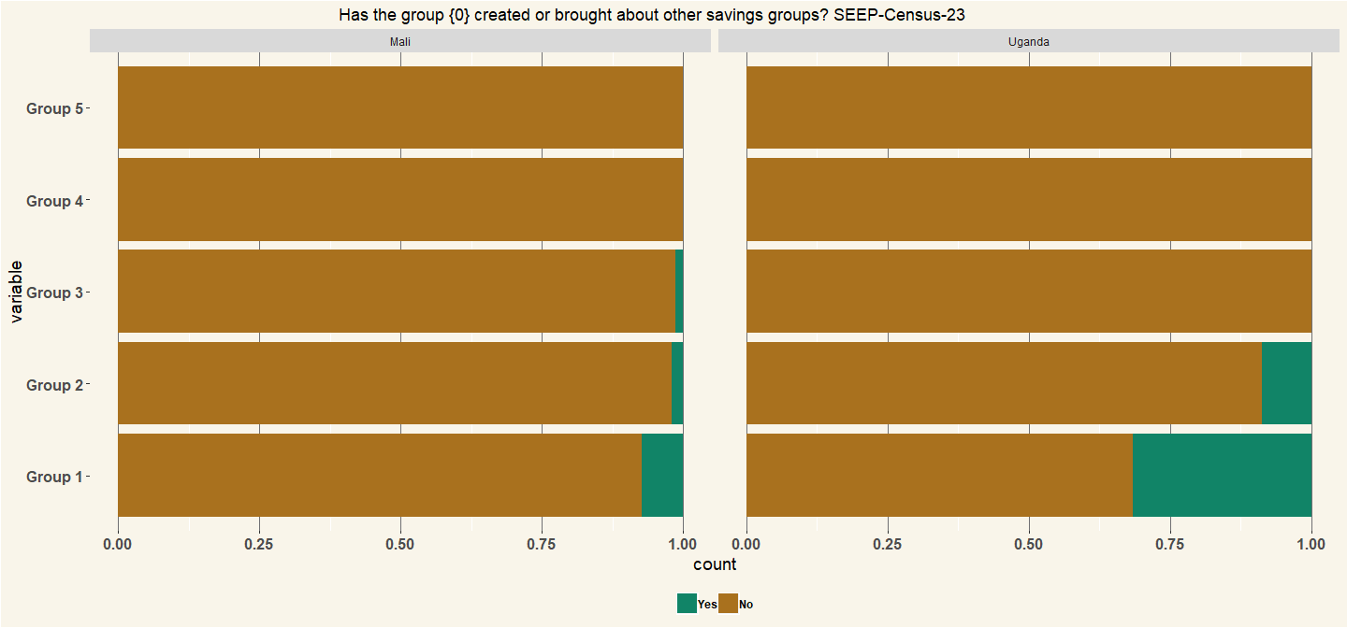

|  |  |
| --- | --- |
| Country | n |
| Mali | 136 |
| Uganda | 60 |

# Q24 How many groups has the group {0} contributed to? (also include groups that no longer exist)

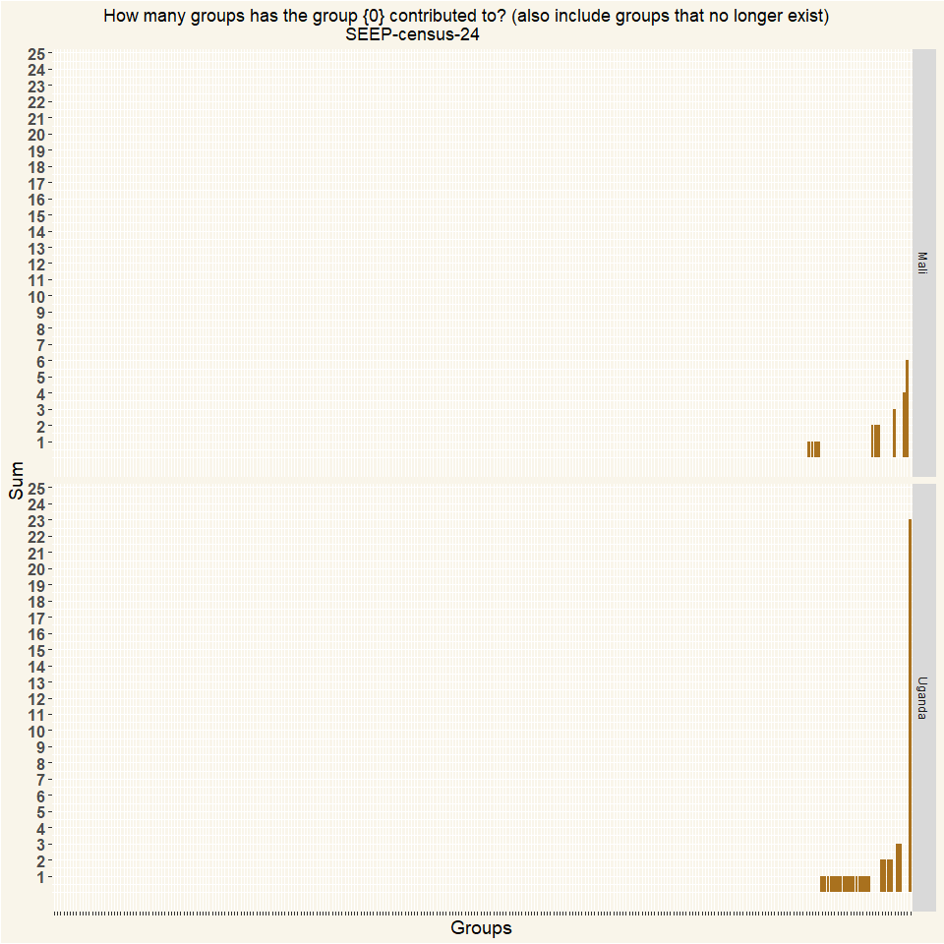

##   
## Mali Uganda   
## 157 115

# Q27 How many other groups could you find in the village?

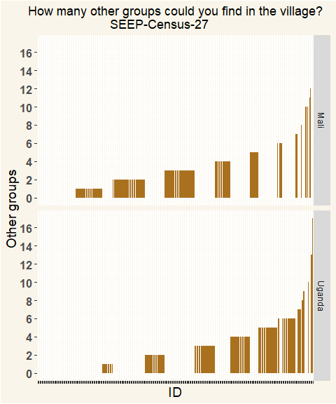

##   
## Mali Uganda   
## 154 113

# Q29 FUNCTION: How does group {0} operate?

## Iteration Questions

The Size of the point on the graphs represent the number of respondents in the sample. The table that follows shows the full names of the levels within the graph Finally the last tables shows the number of respondents for each iteration.

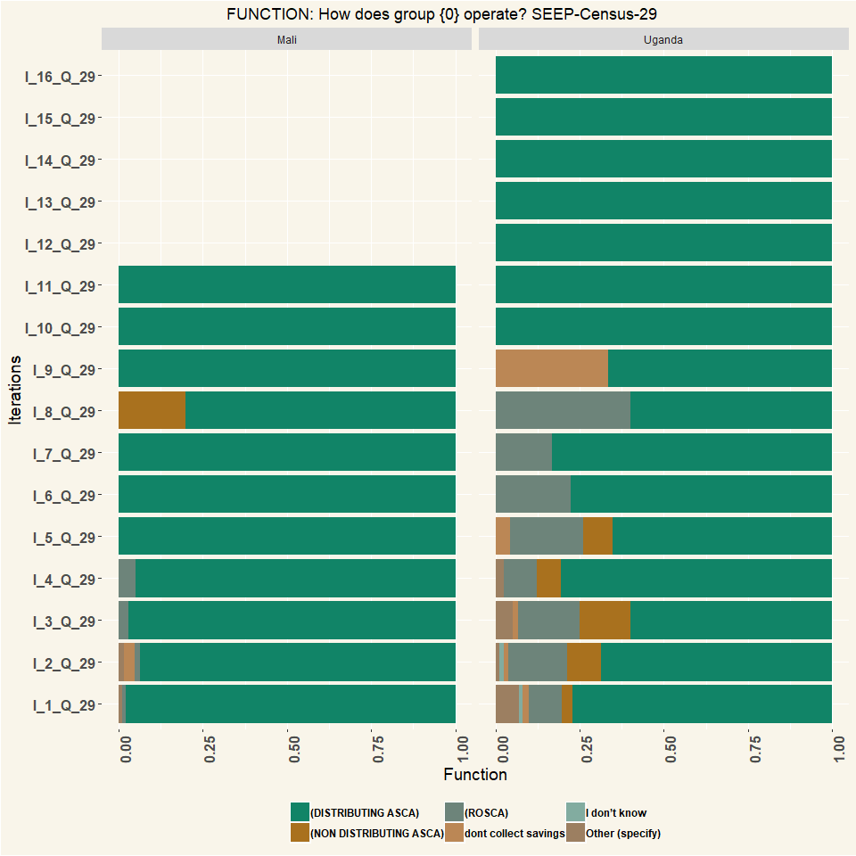

##   
## Mali Uganda   
## 157 115

# Q30 ORIGIN How did group {0} come to exist?

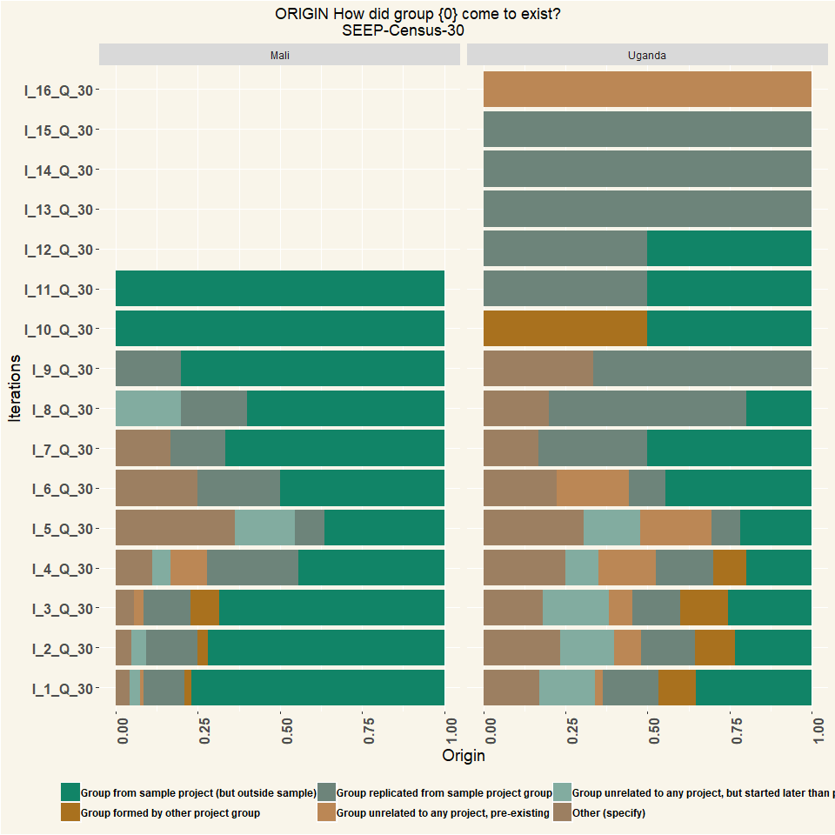

##   
## Mali Uganda   
## 157 115

# Q31 Did group {0} have any relation to any of the sampled groups?

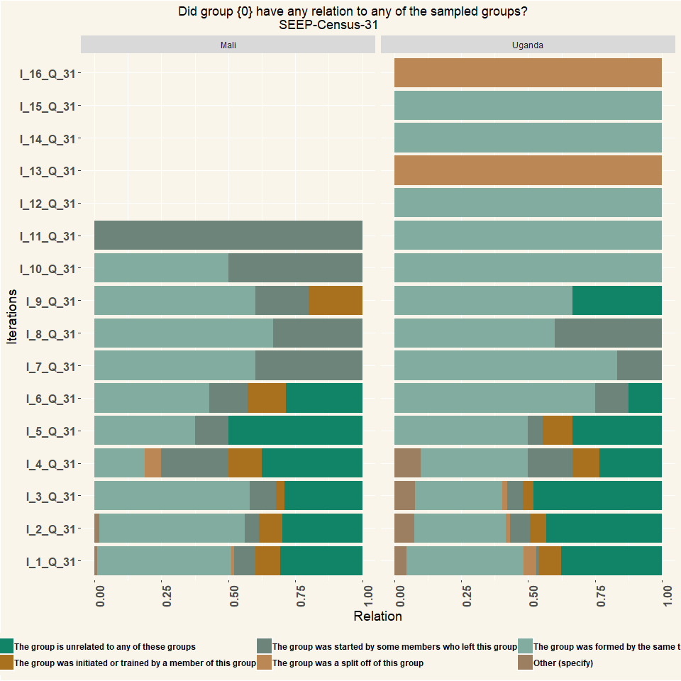

##   
## Mali Uganda   
## 157 115

# Q36 Number of members of group {0}

The Iterations were aggregated via a median value, rounded off to remove decimal group members.

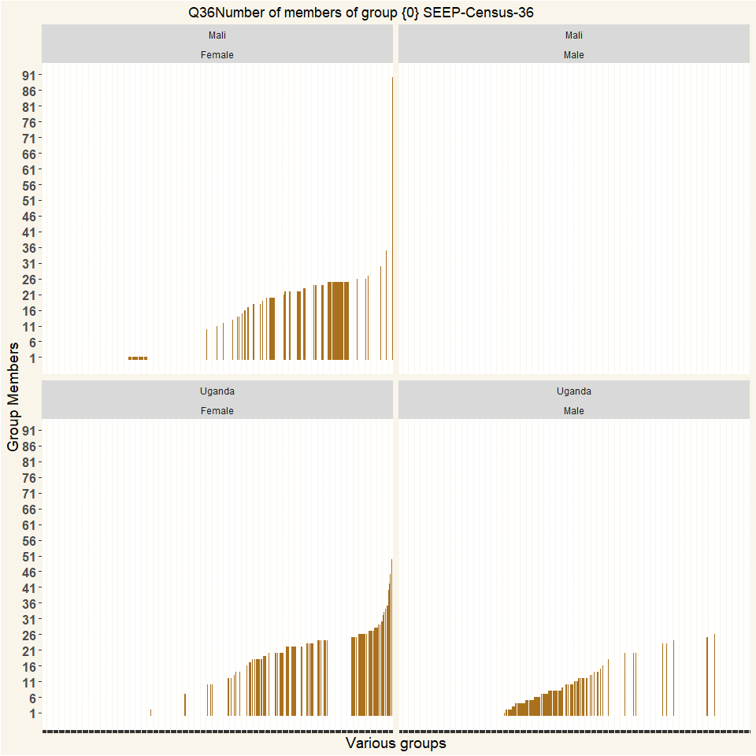

## [1] "Number of respondents"

##   
## Mali Uganda   
## 157 115