**Evaluation 3**

**1D ARRAYS - Lab 5**

1. *Find the largest and smallest element in a 1D array.*

**Program:**

#include <stdio.h>

int main()

{

int a[100],n;

printf("My name is Lajith Puthuchery and registration number is 200905106\n");

printf("Enter the size of array\n");

scanf("%d",&n);

printf("Enter the %d array elements\n",n);

for(int i=0; i<n; i++)

{

scanf("%d",&a[i]);

}

int large, small;

large=a[0];

small=a[0];

for(int i=1; i<n; i++)

{

if(a[i]>large)

{

large=a[i];

}

if(a[i]<small)

{

small=a[i];

}

}

printf("The largest number in the 1D array is %d\n",large);

printf("The smallest number in the 1D array is %d\n",small);

return 0;

}

**Output:**

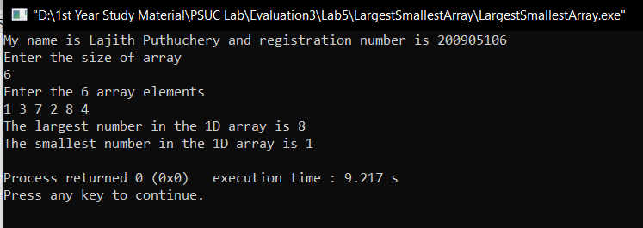

1. *Print all the prime numbers in a given 1D array.*

**Program:**

#include <stdio.h>

#include <math.h>

int main()

{

int a[100],n;

int flag=0;

printf("My name is Lajith Puthuchery and registration number is 200905106\n");

printf("Enter the size of array\n");

scanf("%d",&n);

printf("Enter the %d array elements\n",n);

for(int i=0; i<n; i++)

{

scanf("%d",&a[i]);

}

printf("The prime numbers in the array are\n");

for(int i=0; i<n; i++) //Check prime condition

{

if(a[i]==1)

{

continue;

}

flag=0;

for(int j=2; j<(a[i]); j++)

{

if(a[i]%j==0)

{

flag=1;

break;

}

}

if(flag==0)

{

printf("%d ",a[i]);

}

}

return 0;

}

**Output:**

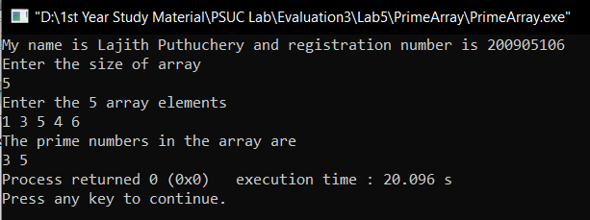

1. *Arrange the given elements in a 1D array in ascending and descending order using bubble sort method. [Hint: use switch case (as case ‘a’ and case ‘d’) to specify the order].*

**Program:**

#include <stdio.h>

int main()

{

int a[100],n;

int i,j;

int temp;

char x;

printf("My name is Lajith Puthuchery and registration number is 200905106\n");

printf("Enter the size of array\n");

scanf("%d",&n);

printf("Enter the %d array elements\n",n);

for(int i=0; i<n; i++)

{

scanf("%d",&a[i]);

}

printf("Enter 'a' to arrange the array in ascending order and 'd' to arrange in descending order\n");

scanf(" %c",&x);

for (i=0; i<n-1; i++)

{

for (j=0; j<n-i-1; j++)

{

if (a[j] > a[j+1])

{

temp =a[j];

a[j]=a[j+1];

a[j+1]=temp;

}

}

}

switch(x)

{

case 'a':

printf("The array in ascending order is:\n");

for(int i=0; i<n; i++)

{

printf("%d ",a[i]);

}

break;

case 'd':

printf("The array in descending order is:\n");

for(int i=n-1; i>0; i--)

{

printf("%d ",a[i]);

}

break;

default:

break;

}

return 0;

}

**Output:**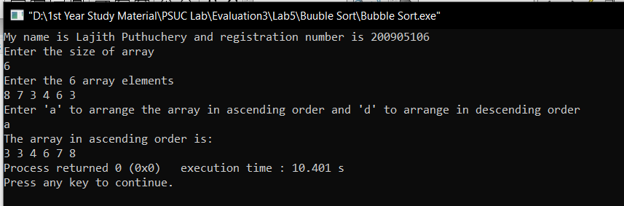

1. *Insert an element into a 1D array by getting an element and the position from the user.*

**Program:**

#include <stdio.h>

#include <math.h>

int main()

{

int a[100],n;

int ele,pos;

printf("My name is Lajith Puthuchery and registration number is 200905106\n");

printf("Enter the size of array\n");

scanf("%d",&n);

printf("Enter the %d array elements\n",n);

for(int i=0; i<n; i++)

{

scanf("%d",&a[i]);

}

printf("Enter the element to be inserted\n");

scanf("%d",&ele);

printf("Enter the position where %d is to be inserted\n",ele);

scanf("%d",&pos);

for(int i=n-1; i>=pos; i--)

{

a[i+1] = a[i];

}

a[pos]=ele;

n=n+1;

printf("The newly formed array after insertion of %d is\n",ele);

for(int i=0; i<n; i++)

{

printf("%d ",a[i]);

}

return 0;

}

**Output:**

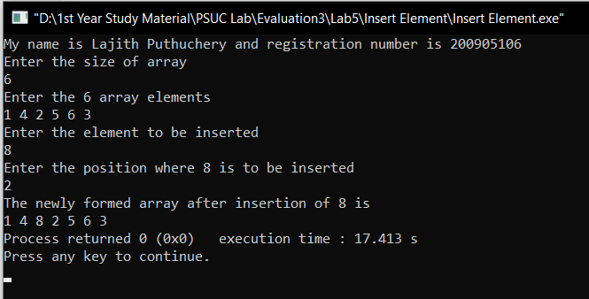

1. *Search the position of the number that is entered by the user and delete that number from the*

*array and display the resultant array elements.*

**Program:**

#include <stdio.h>

int main()

{

int a[20],n;

int num,pos=-1;

printf("My name is Lajith Puthuchery and registration number is 200905106\n");

printf("Enter the size of the array\n");

scanf("%d",&n);

printf("Enter the %d array elements\n",n);

for(int i=0; i<n; i++)

{

scanf("%d",&a[i]);

}

printf("Enter the number that you want to delete\n");

scanf("%d",&num);

//Linear Search

for(int i=0; i<n; i++)

{

if(num==a[i])

{

pos=i;

break;

}

}

if(pos==-1)

{

printf("The element does not exist in the array and hence the array stays as it is\n");

for(int i=0; i<n; i++)

{

printf("%d ",a[i]);

}

}

else

{

for(int i=pos; i<n; i++)

{

a[i]=a[i+1];

}

n=n-1;

printf("The array after deletion of %d is\n",num);

for(int i=0; i<n; i++)

{

printf("%d ",a[i]);

}

}

}

**Output:**

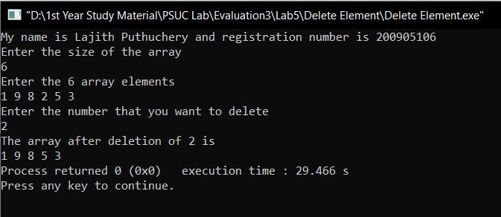

**2D ARRAYS – Lab 6**

1. Find whether a given matrix is symmetric or not. [Hint: A = A T ]

**Program:**

#include <stdio.h>

int main()

{

int a[20][20],transpose[20][20];

int m,n;

printf("My name is Lajith Puthuchery and registration number is 200905106\n");

printf("Enter the dimensions of the matrix\n");

scanf("%d %d",&m,&n);

printf("Enter the %d matrix elements\n",m*n);

for(int i=0; i<m; i++)

{

for(int j=0; j<n; j++)

{

scanf("%d",&a[i][j]);

}

}

for(int i=0; i<m; i++)

{

for(int j=0; j<n; j++)

{

transpose[j][i]=a[i][j];

}

}

printf("The original matrix is\n");

for(int i=0; i<m; i++)

{

for(int j=0; j<n; j++)

{

printf("%d ",a[i][j]);

}

printf("\n");

}

printf("The transpose matrix is\n");

for(int i=0; i<n; i++)

{

for(int j=0; j<m; j++)

{

printf("%d ",transpose[i][j]);

}

printf("\n");

}

if(m==n)

{

for(int i=0; i<m; i++)

{

for(int j=0; j<n; j++)

{

if(a[i][j]!=transpose[i][j])

{

printf("The matrix is not symmetric\n");

exit(0);

}

}

}

printf("The matrix is symmetric");

}

else

{

printf("The matrix is not symmetric");

}

return 0;

}

**Output:**

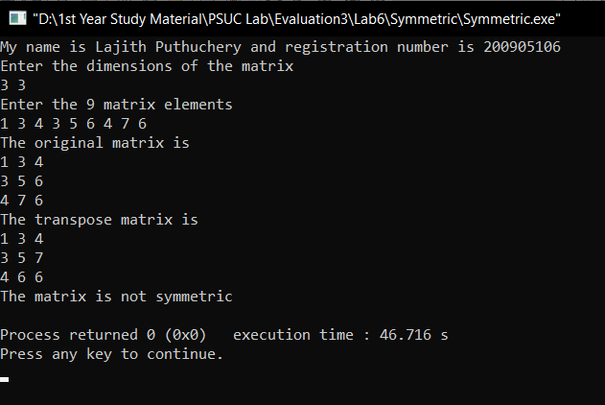

1. Find the trace and norm of a given square matrix. [Hint: Trace= sum of principal diagonal elements Norm= SQRT (sum of squares of the individual elements of an array)]

**Program:**

#include <stdio.h>

#include <math.h>

int main()

{

int a[20][20];

int m,n;

int trace=0;

float norm=0;

printf("My name is Lajith Puthuchery and registration number is 200905106\n");

printf("Enter the dimensions of the matrix\n");

scanf("%d %d",&m,&n);

printf("Enter the %d matrix elements\n",n*n);

for(int i=0; i<m; i++)

{

for(int j=0; j<n; j++)

{

scanf("%d",&a[i][j]);

}

}

printf("The entered matrix is\n");

//Display the matrix

for(int i=0; i<m; i++)

{

for(int j=0; j<n; j++)

{

printf("%d ",a[i][j]);

}

printf("\n");

}

//TraceNorm

if(m==n)

{

for(int i=0; i<m; i++)

{

for(int j=0; j<n; j++)

{

if(i==j)

{

trace+=a[i][j];

}

norm+=pow(a[i][j],2);

}

}

norm=sqrt(norm);

printf("The trace of the matrix is %d\n",trace);

printf("The norm of the matrix is %f",norm);

}

else

{

printf("Trace exists only for a square matrix\n");

}

return 0;

}

**Output:**

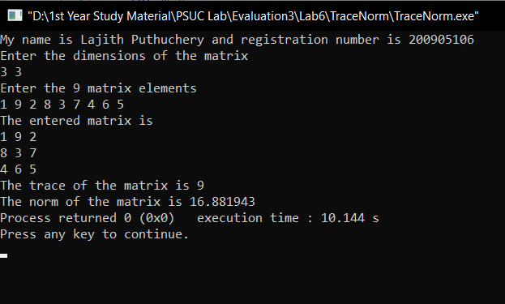

1. Perform matrix multiplication.

**Program:**

#include <stdio.h>

#include <math.h>

int main()

{

int a[20][20],b[20][20],c[20][20];

int m,n,p,q;

printf("My name is Lajith Puthuchery and registration number is 200905106\n");

printf("Enter the dimensions of the first matrix\n");

scanf("%d %d",&m,&n);

printf("Enter the %d matrix elements\n",m*n);

for(int i=0; i<m; i++)

{

for(int j=0; j<n; j++)

{

scanf("%d",&a[i][j]);

}

}

printf("Enter the dimensions of the second matrix\n");

scanf("%d %d",&p,&q);

printf("Enter the %d matrix elements\n",p*q);

for(int i=0; i<p; i++)

{

for(int j=0; j<q; j++)

{

scanf("%d",&b[i][j]);

}

}

//Display the matrix

printf("The first matrix is\n");

for(int i=0; i<m; i++)

{

for(int j=0; j<n; j++)

{

printf("%d ",a[i][j]);

}

printf("\n");

}

printf("The second matrix is\n");

for(int i=0; i<p; i++)

{

for(int j=0; j<q; j++)

{

printf("%d ",b[i][j]);

}

printf("\n");

}

//Matrix Multiplication

if(n==p)

{

for(int i=0; i<m; i++)

{

for(int j=0; j<q; j++)

{

c[i][j]=0;

for(int k=0; k<p; k++)

{

c[i][j]+=a[i][k]*b[k][j];

}

}

}

//Display the product

printf("The product matrix is\n");

for(int i=0; i<m; i++)

{

for(int j=0; j<q; j++)

{

printf("%d ",c[i][j]);

}

printf("\n");

}

}

else

{

printf("Matrix multiplication is not compatible with the above matrices");

}

return 0;

}

**Output:**

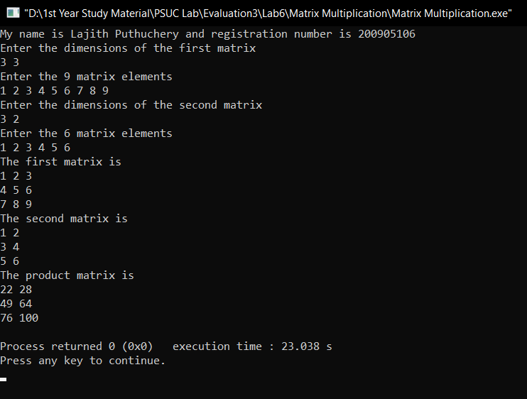

1. To interchange the primary and secondary diagonal elements in the given Matrix.

**Program:**

#include <stdio.h>

int main()

{

int a[20][20],n,p,q,x,y,temp;

printf("M name is Lajith Puthuchery and registration number is 200905106\n");

printf("Enter the number of rows/columns of the sqaure matrix\n");

scanf("%d",&n);

printf("Enter the %d matrix elements\n",n*n);

for(int i=0; i<n; i++)

{

for(int j=0; j<n; j++)

{

scanf("%d",&a[i][j]);

}

}

printf("The original matrix is\n");

for(int i=0; i<n; i++)

{

for(int j=0; j<n; j++)

{

printf("%d ",a[i][j]);

}

printf("\n");

}

//Interchange of diagonals

for(int i=0; i<n; i++)

{

for(int j=0; j<n; j++)

{

if(i==j)

{

temp=a[i][j];

a[i][j]=a[i][n-1-j];

a[i][n-1-j]=temp;

}

}

}

printf("The matrix after interchanging of primary and secondary diagonals is\n",x,y);

for(int i=0; i<n; i++)

{

for(int j=0; j<n; j++)

{

printf("%d ",a[i][j]);

}

printf("\n");

}

return 0;

}

**Output:**

1. Interchange any two Rows & Columns in the given Matrix.

**Program:**

#include <stdio.h>

int main()

{

int a[20][20],m,n,p,q,x,y,temp;

printf("M name is Lajith Puthuchery and registration number is 200905106\n");

printf("Enter the dimensions of the matrix");

scanf("%d %d",&m,&n);

printf("Enter the %d matrix elements",m*n);

for(int i=0; i<m; i++)

{

for(int j=0; j<n; j++)

{

scanf("%d",&a[i][j]);

}

}

printf("The original matrix is\n");

for(int i=0; i<m; i++)

{

for(int j=0; j<n; j++)

{

printf("%d ",a[i][j]);

}

printf("\n");

}

printf("\nEnter row number to be exchanged : ");

scanf("%d", &p);

printf("\nEnter other row number to be exchanged with : ");

scanf("%d",&q);

//Row Exchange

for(int i=0; i<n; i++)

{

temp=a[p-1][i];

a[p-1][i]=a[q-1][i];

a[q-1][i]=temp;

}

printf("The matrix after exchange of rows %d and %d is\n",p,q);

for(int i=0; i<m; i++)

{

for(int j=0; j<n; j++)

{

printf("%d ",a[i][j]);

}

printf("\n");

}

printf("\nEnter column number to be exchanged : ");

scanf("%d", &x);

printf("\nEnter other column number to be exchanged with : ");

scanf("%d",&y);

//Column Exchange

for(int i=0; i<m; i++)

{

temp=a[i][x-1];

a[i][x-1]=a[i][y-1];

a[i][y-1]=temp;

}

printf("The matrix after exchange of columns %d and %d is\n",x,y);

for(int i=0; i<m; i++)

{

for(int j=0; j<n; j++)

{

printf("%d ",a[i][j]);

}

printf("\n");

}

return 0;

}

**Output:**

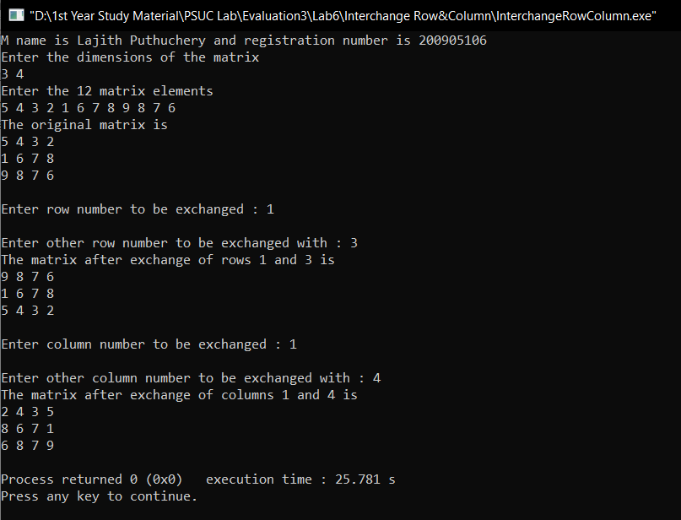

1. Search for an element in a given matrix and count the number of its occurrences.

**Program:**

#include <stdio.h>

int main()

{

int a[20][20];

int m,n,num,count=0;

printf("My name is Lajith Puthuchery and registration number is 200905106\n");

printf("Enter the dimensions of the matrix\n");

scanf("%d %d",&m,&n);

printf("Enter the %d matrix elements\n",m*n);

for(int i=0; i<m; i++)

{

for(int j=0; j<n; j++)

{

scanf("%d",&a[i][j]);

}

}

//Display the matrix

for(int i=0; i<m; i++)

{

for(int j=0; j<n; j++)

{

printf("%d ",a[i][j]);

}

printf("\n");

}

printf("Enter the element to be searched and counted\n");

scanf("%d",&num);

for(int i=0; i<m; i++)

{

for(int j=0; j<n; j++)

{

if(num==a[i][j])

{

count++;

}

}

}

printf("The frequency of the element %d in the matrix is %d",num,count);

return 0;

}

**Output:**

