AI DEFENSE LAB FOR ADAPTIVE PAYMENT FRAUD
A closed-loop GenAI red team / blue team for payment security
DISCOVER → SIMULATE → ATTACK → DETECT → ADAPT

Traditional fraud systems learn from fraud that has already happened. This lab actively searches for what the current defense does not know, generates realistic adversarial payment behaviour, stress-tests the model against it, and converts every discovered weakness into training data for the next defense.

SCOPE AND HONESTY
All data in this submission is synthetic. Every figure is a simulation result, regenerated from a single seed by `python -m src.pipeline`, and this document is generated directly from those artifacts so no number in it is typed by hand. Nothing here has been validated against real payment data, and nothing here has been reviewed or validated by Mastercard.

Mastercard Innovation Challenge 2026 · GFF Mumbai

1. Executive summary
Generative AI has collapsed the cost of producing a new, plausible, well-targeted payment fraud attack. Personalisation at scale, fluent multilingual persuasion, synthetic voice and documents, and automated variant search mean that novel attack families now arrive faster than labelled history accumulates. A supervised fraud model trained on that history is strong on what it has seen and has no representation at all of what it has not.
This project is a working laboratory for the opposite approach. It maps the emerging attack surface, has a generative red-team agent propose the next attack as a structured specification, constrains that specification against payment-domain rules, simulates it deterministically, stress-tests the defense against it, and folds whatever escapes into a cumulative replay buffer that trains the next model. Every adapted model is then a challenger that has to pass explicit promotion gates before it would go anywhere near an authorization path.
THE RESULT THAT MATTERS
With bust out removed from training entirely, the defense caught 16% of it. After the lab generated that family and replayed it into training: 86% on 44 held-out transactions, 95% interval 73-94%. This measures unseen -> learned adaptation on synthetic data — not zero-shot detection, and not production performance.

2. The problem
Static defenses struggle against generative-AI-enabled fraud for four compounding reasons:
- Novel families have no training signal. A supervised model cannot represent an attack family absent from its labels. Our leave-one-attack-family-out experiment measures exactly this collapse.
- Attackers adapt faster than labels arrive. Once a control starts biting, the attack changes. The label loop — fraud, dispute, chargeback, relabel, retrain — takes weeks or months.
- Generation is now nearly free. Producing thousands of semantically distinct lures, documents or personas costs almost nothing, which defeats template- and signature-based controls.
- Much of the new fraud is authorized by the genuine customer. In an authorized push payment scam every authentication signal is clean. The authorization-time model is the wrong control, and pretending otherwise produces misleading metrics.

3. Solution overview
Emerging fraud intelligence
|
Threat Atlas identify / threat ideation
|
Red-team agent structured attack specification
|
Constraint layer payment-domain rules: clamp or reject
|
Constrained simulator synthetic payment stream
|
Defense model authorization-time features only
/ \
detected escaped
|
Weakness analysis which signal did the model rely on?
|
Attack evolution
|
Adversarial replay
|
Retrain -> champion/challenger gate -> repeat
The two halves run on different clocks and that separation is deliberate. Authorization is synchronous and latency-bound: it reads precomputed state, scores, applies a versioned policy and logs reason codes, and it never trains. Adaptation is an offline research loop measured in days, and its output is a candidate model, not a deployment.

4. Identify — the Threat Atlas
The catalog holds 45 distinct attacks across 6 fraud surfaces and 6 payment rails. Each entry records what a defender can observe: the attacker's objective, the specific role generative AI plays, the kill chain, the transaction and behavioural signatures, how visible the attack is at authorization time, and which signals only appear after settlement. It contains no operational guidance of any kind.
Simulator status | Count | What it means
IMPLEMENTED | 12 | a dedicated injector reproduces its authorization footprint
PARAMETERIZED | 19 | reachable by configuring an existing injector, no new code
RESEARCH_ONLY | 8 | characterized but NOT simulated
FUTURE | 6 | named as planned simulator work

Fraud surface | Attacks | Simulated
Merchant & Ecosystem Abuse | 9 | 7
Account & Identity Compromise | 8 | 6
Adversarial ML & Model Evasion | 8 | 6
Social Engineering | 8 | 2
Authorized Push Payment Scams | 6 | 6
Payment Instrument Attacks | 6 | 4

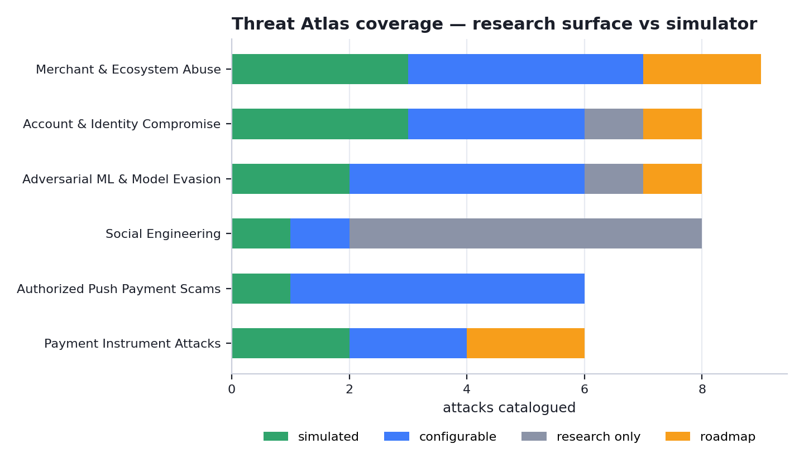
The catalog is deliberately wider than the simulator, and every entry is labelled so the gap is visible rather than implied.
WHY THE GAP IS STATED, NOT HIDDEN
23 of the 45 catalogued attacks have low or no visibility at authorization time. An authorization-time model is the wrong control for most of them, and a submission that quietly counted them as covered would be overstating what it built.

5. Generate — the constrained simulator

5.1 Where generative AI actually contributes
The language model never writes transaction rows. It writes a specification — which behavioural dial to move, in which direction, and which detector signal that is meant to defeat:
{
"attack_family": "account_takeover",
"strategy": "reuse the victim's trusted device, change merchant behaviour",
"amount_profile": "moderate",
"velocity_profile": "low_and_slow",
"device_behavior": "trusted_device",
"merchant_behavior": "new_high_risk_merchant",
"geo_behavior": "plausible",
"targets_signal": "device_changed",
"confidence": 0.82
}
That specification passes through a payment-domain constraint layer before anything is generated. An authorized push payment scam cannot run from an attacker's device, because the genuine customer is the one authenticating; a probing campaign cannot be high-value, because it would not be economic. Values outside their permitted range are clamped, contradictions are corrected to the nearest legal value, and in strict mode the specification is refused outright. A deterministic, seeded simulator then executes what survives.
THE DESIGN CLAIM
LLM creativity constrained by payment-domain simulation rules. Both paths emit the same structure and both pass through the same constraint layer, which is what lets the system be generative and reproducible at once.

TWO PATHS, AND WHICH ONE PRODUCED THE COMMITTED ARTIFACTS
DEMO MODE USES DETERMINISTIC, COMMITTED SPECIFICATIONS. Every specification in models/attack_lineage.json carries spec_source "heuristic" and every content artifact carries source "template". That is a reliability decision: the prototype must run with no API key, no network and no training, and every committed figure must reproduce from a single seed. The weakness-driven heuristic reads the same measured evidence and moves the same dials, so the behaviour demonstrated is the loop's rather than one model call's. THE OPTIONAL GENAI RED TEAM GENERATES THE SPECIFICATION INSTEAD when an API key is present: the language model receives the measured weakness and returns the structured specification, which passes through exactly the same payment-domain constraint layer before anything is simulated, stamped spec_source "llm" so the two are never confused. Run `python -m src.generate.demo_specs` to produce that evidence; with no key it writes nothing rather than substituting heuristic output for a model response.

5.2 Simulating a payment portfolio worth training on
The committed dataset holds 150,000 transactions across 6,000 cardholders and 1,200 merchants, with 1800 fraudulent authorizations at a 1.2% base rate, plus 667 transactions of fraud-actor cover traffic.
Customer archetype | Cardholders
low frequency retail | 1455
frequent urban | 1315
digital first | 1067
business user | 712
traveller | 621
thin file new | 527
high value | 303

Two design decisions do most of the work in making the data honest. First, fraud actors have a history: mule accounts, bust-out accounts and front merchants build ordinary-looking traffic before they are used, and that traffic is labelled legitimate, because at authorization time it is. Without it, 'this card has no history' becomes a synonym for fraud and the model learns the generator. Second, attacks reuse things: probing revisits the same cards and merchants, mimicry shops at the victim's own regular merchant, laundering pushes many cards through one front. Without reuse every fraudulent row would trivially be a first-ever card/merchant pair.

5.3 Fidelity diagnostics
If any single field separated fraud from genuine traffic cleanly, the detector would be reading the generator rather than the fraud, and every downstream number would be meaningless. So it is measured:
Check | Result | Detail
no single feature separates classes | PASS | strongest single feature is amount_vs_card_max_prior at AUC 0.722 (fail at 0.9)
no feature near perfect separation | PASS | none above the warning line
legit device changes exist | PASS | 15.791% of genuine transactions change device
legit new payees exist | PASS | 41.5% of genuine transactions are a first visit to that merchant
fraud sometimes uses a known device | PASS | 78.6% of fraud runs from a device the card had used before
fraud sometimes reuses a merchant | PASS | 30.5% of fraud is a repeat visit to the same merchant
fraud amounts overlap legit range | PASS | 32.2% of fraud sits inside the genuine inter-quartile amount range (INR 595-4,462)
no history is not a fraud synonym | PASS | first-ever transaction: 3.9% of genuine vs 15.1% of fraud (ratio 3.9x)
fraud timing is not uniformly nocturnal | PASS | night-time share: 13.1% genuine vs 17.1% fraud
family sample sizes support their claims | PASS | all families at or above the reporting floor
fraud actors have cover traffic | PASS | 667 legitimate-looking transactions were generated by fraud actors (mule grooming, bust-out ramp-up, front-merchant sales)

Strongest single feature: amount_vs_card_max_prior at AUC 0.722. 0 failing checks, 0 warnings.
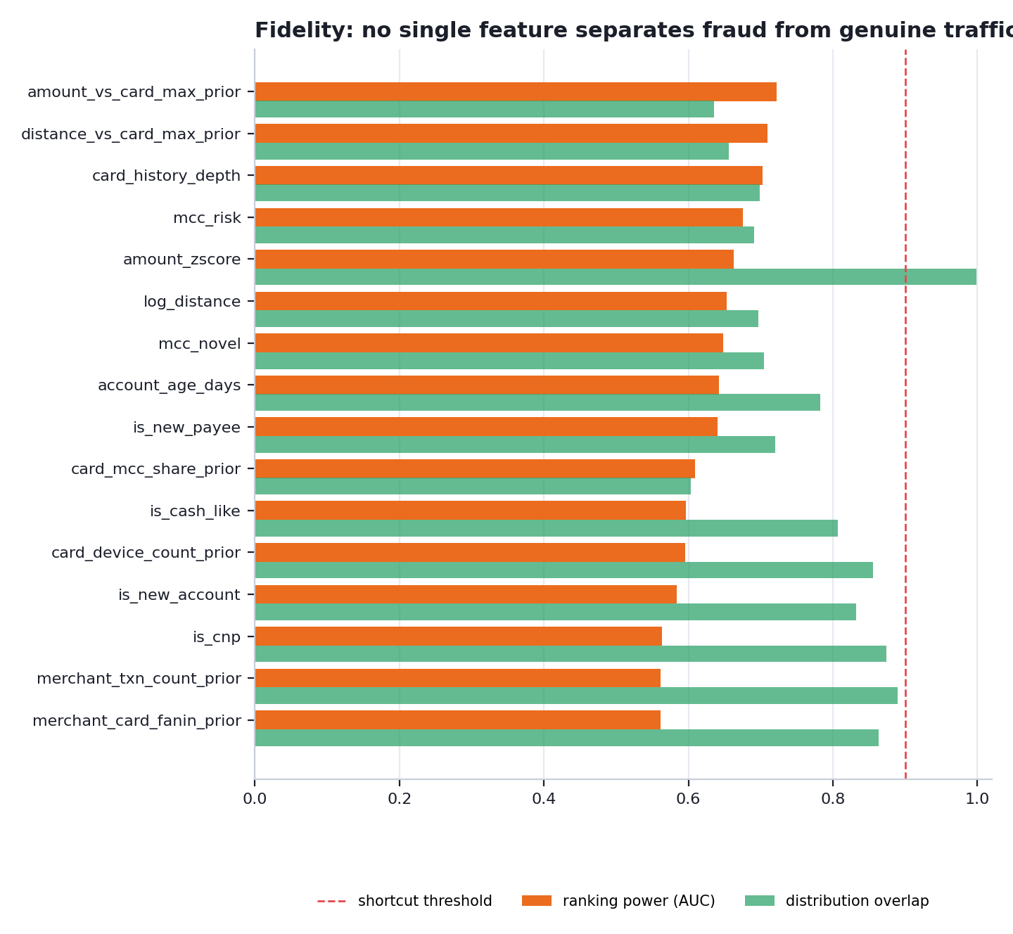
No single authorization-time feature comes close to separating the classes.
SCOPE OF THESE DIAGNOSTICS
These measure the simulator against itself. They say nothing about similarity to any real payment portfolio, and no comparison against production data of any kind has been performed.

6. Defend — the detection stack
Gradient boosting fused with an isolation forest fitted on genuine traffic only, over authorization-time features exclusively. Post-outcome fields — refunds, chargebacks, the authorization result itself — are hard-blocked in code and the block is unit-tested. Scores are isotonically calibrated on a held-out slice, so the number a reviewer sees is an estimated fraud probability rather than an arbitrary blend, and the operating threshold is chosen against an agreed false-positive budget.
Metric | Value
Recall | 67.6%
Precision | 0.242
F1 | 0.357
PR-AUC | 0.500
ROC-AUC | 0.953
False-positive rate | 1.97% (budget ≤ 2%)
False positives per 1,000 genuine payments | 19.7
Held-out test set | 37,500 transactions, 346 fraudulent

Precision is naturally modest at a 1.2% base rate. The answer is tiered decisioning — challenge, do not decline — rather than a bigger number.
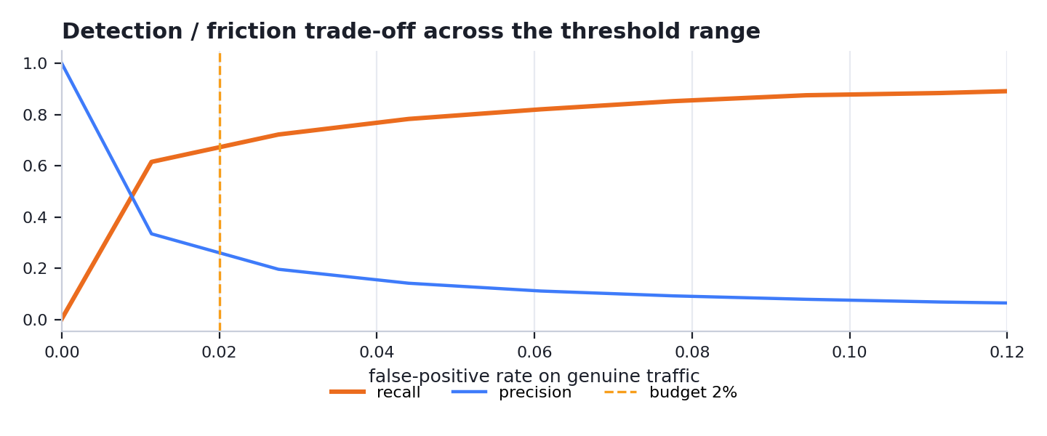
There is no magic threshold. Every point is a different answer to how much genuine friction is worth buying detection with.

6.1 Recall by attack family
Measured on an unseen, fraud-enriched frame (90,000 transactions, 2700 fraudulent) generated from a seed no model was trained or tuned on, so each family has enough held-out examples for its number to mean something.
Attack family | Recall | n | 95% interval
card_testing | 99% | 486 | 97–99%
bust_out | 97% | 162 | 93–99%
velocity_smurfing | 96% | 216 | 93–98%
merchant_laundering | 87% | 216 | 82–91%
geo_anomaly | 81% | 108 | 72–87%
otp_relay | 79% | 297 | 74–83%
scam_transfer | 77% | 270 | 72–82%
account_takeover | 70% | 351 | 65–75%
wallet_provisioning | 62% | 162 | 54–69%
adversarial_mimicry | 53% | 270 | 47–59%
friendly_fraud | 24% | 162 | 18–31%

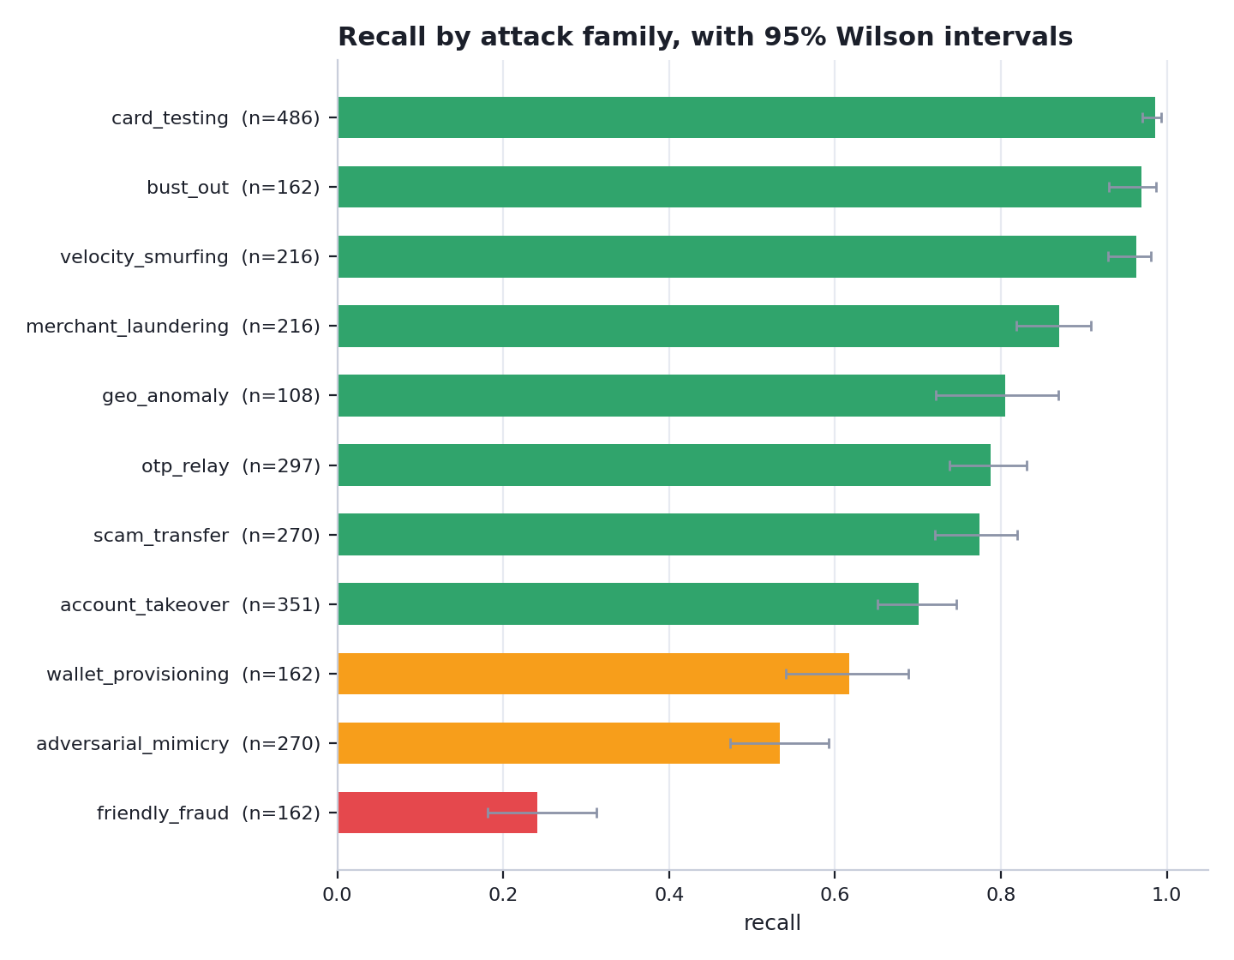
Recall by family with 95% Wilson intervals. The intervals are shown because quoting a proportion without its sample size is how efficacy claims fall over under questioning.
AUTHORIZATION-TIME-HARD FRAUD
Families whose fraud is authorized by the genuine customer on their own device — first-party dispute abuse, and scams the victim was talked into — sit at the bottom by construction. There is very little to see at authorization time. The correct control is friction, payee-risk intelligence and post-transaction recall, not a hard decline. They are reported rather than quietly excluded.

6.2 Decision policy and reason codes
The model does not emit a block. It emits a calibrated probability, which a prototype issuer-style policy layer maps to APPROVE, STEP-UP or DECLINE. The step-up boundary is the operating threshold already tuned against the false-positive budget, rather than a second unjustified constant. Each decision carries short reason codes derived from which rule-style signals fired — unusual device behaviour, abnormal velocity, atypical amount, new payee, geographic deviation, device shared across cards, merchant seeing almost only new cards — so an analyst sees why.
Operational measure | Value
False positives per 1,000 genuine payments | 19.7
Genuine customers sent to step-up | 2.40%
Genuine customers declined | 0.100%
Fraud sent to friction | 71%
Monthly step-up challenges | 274,400
Analyst-hours if all reviewed manually | 10,976

Scenario: synthetic illustrative scenario — not production economics. Volumes are derived by applying measured rates to the declared synthetic scenario. They illustrate what a false-positive rate costs operationally; they are not a forecast for any real portfolio.

7. The closed loop — red team meets blue team
One round is a full red-team experiment, not a retraining step:
- 1. Evaluate the defense currently in force on held-out traffic.
- 2. Locate its weakest families, and measure which signals its ranking of each one actually depends on, by permuting features on that family's own rows.
- 3. Propose the next attack generation as a structured specification aimed at removing that dependency.
- 4. Constrain the specification against payment-domain rules.
- 5. Simulate the evolved generation deterministically.
- 6. Stress-test the stale defense against it — this is the gap the red team just opened.
- 7. Replay what escaped into a bounded, stratified buffer holding every prior generation.
- 8. Retrain a candidate on the base data plus the whole buffer.
- 9. Re-evaluate on the new generation, every prior generation, families never attacked, and genuine traffic.
- 10. Put the candidate through champion/challenger gates.
- 11. Carry the residual weakness into the next round.
WHY THIS IS NOT A SCRIPTED STEALTH DIAL
The family attacked and the dial moved are both derived from measurement. The loop attacks whichever family the current defense handles worst, and it moves whichever dial removes the signal that model was measured to lean on. Change the model and the loop attacks something else.

Round | Family | Signal targeted | Stale | After replay | Status | n
1 | scam_transfer | mcc_risk | 74% | 68% | partial | 129
1 | wallet_provisioning | mcc_risk | 17% | 42% | residual_frontier | 77
1 | otp_relay | mcc_risk | 16% | 51% | residual_frontier | 142
2 | scam_transfer | residual amount signal | 68% | 66% | partial | 129
2 | wallet_provisioning | is_cnp | 32% | 38% | residual_frontier | 77
2 | otp_relay | residual amount signal | 43% | 42% | residual_frontier | 142
3 | scam_transfer | residual velocity signal | 56% | 49% | residual_frontier | 129
3 | wallet_provisioning | log_amount | 49% | 47% | residual_frontier | 77
3 | otp_relay | residual velocity signal | 68% | 69% | partial | 142

WHICH PATH PRODUCED THIS LINEAGE
Every node in the table above carries spec_source "heuristic". Demo mode uses the deterministic committed specifications, so these numbers reproduce from the seed with no API key. The optional GenAI red team produces the same structure through the same constraint layer, stamped spec_source "llm".

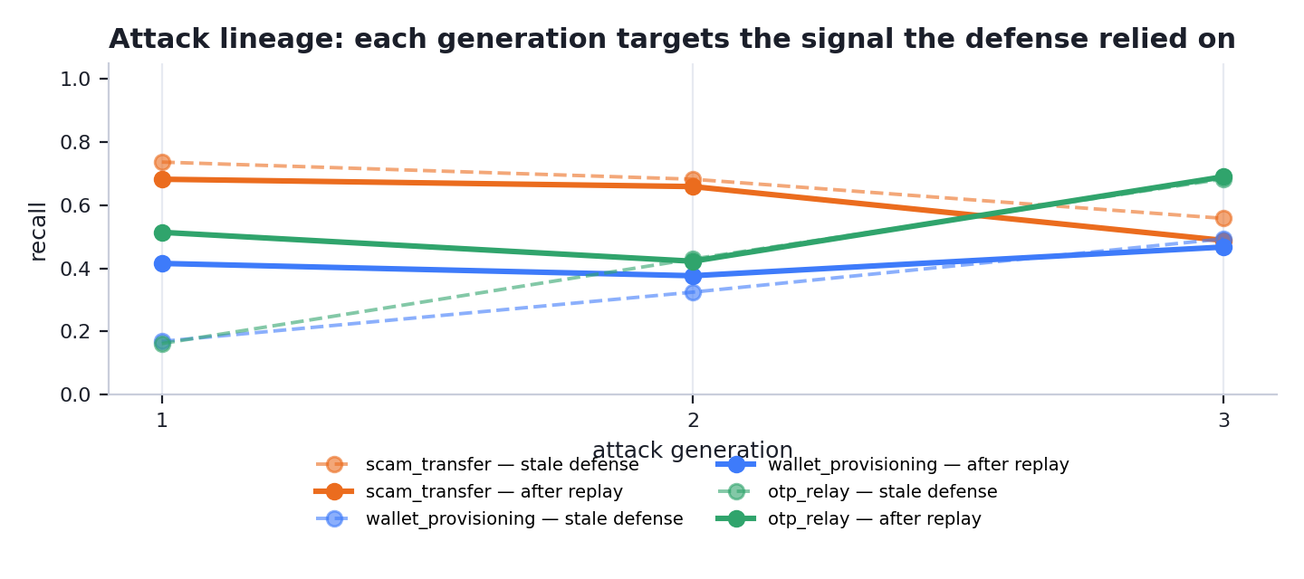
Attack lineage. Each generation targets the signal the defense was measured to rely on; the dashed line is the stale defense meeting it for the first time, the solid line is the same defense after adversarial replay.

7.1 Champion / challenger governance
An adaptive defense that deploys itself is not deployable. Every model the loop produces is a challenger measured against the model in force, and it is promoted only if it clears every gate:
Gate | Requirement
Attack recall gain | ≥ champion + 5%
Absolute false-positive ceiling | ≤ 2.5% of genuine traffic
False-positive regression | ≤ champion + 0.5%
No catastrophic forgetting | no prior family drops more than 10%
Overall ranking quality | PR-AUC ≥ champion − 0.03

In the committed run, round(s) [1] were promoted.

8. Key experiments

8.1 Rules vs static ML vs adaptive defense
The rule set is deliberately competent rather than a strawman: it includes the network-level rules a real fraud team would write once it had the same counters the model gets. Its thresholds are round, domain-chosen numbers, never fitted to this dataset. Detectors are compared at a matched false-positive budget, because comparing them at whatever operating point each happens to sit on is close to meaningless.
Detector | Recall | Precision | F1 | FP / 1,000 genuine
Rules baseline | 10% | 0.068 | 0.081 | 12.9
Static ML | 68% | 0.242 | 0.357 | 19.7
Adaptive (promoted) | 64% | 0.233 | 0.341 | 19.6
Adaptive candidate (not promoted) | 69% | 0.227 | 0.342 | 21.9

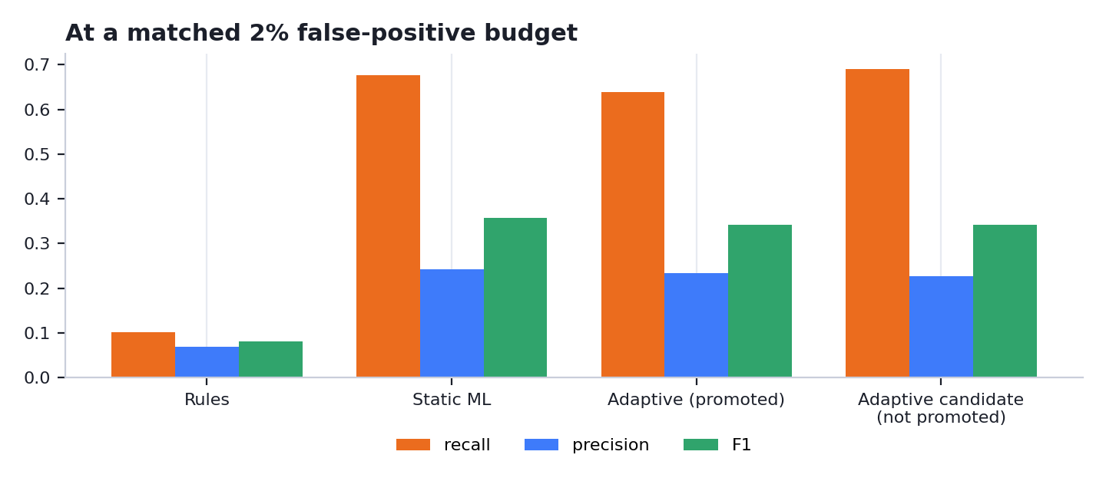
Every detector re-thresholded to spend the same false-positive budget on the same held-out split.

8.2 What adaptation buys — the evolved attacks
Section 8.1 scores every detector on the original attack distribution, which is the static model's home ground: it was trained on exactly that. The question adaptation exists to answer is what happens once the attack has moved. Both models below are scored on the same unseen frame of the FINAL evolved generation (2703 fraudulent transactions, from a seed neither model has seen.)
Defense | Mean recall on evolved attacks | FPR
Static defense (never saw the evolved attack) | 49% | 1.97%
Adaptive defense (trained through the loop) | 48% | 0.97%
Promoted champion | 51% | 1.25%

Evolved family | Static defense | Adaptive defense | Promoted champion
scam_transfer | 74% (n=483) | 38% (n=483) | 56% (n=483)
wallet_provisioning | 42% (n=290) | 39% (n=290) | 42% (n=290)
otp_relay | 33% (n=531) | 68% (n=531) | 55% (n=531)

WHY THE STATIC MODEL CAN STILL LOOK BETTER ELSEWHERE
On the original distribution the static model is at or near the top, and it should be — that is the data it was trained on. The adaptive model carries several generations of evolved attacks in its training set, which costs it a little on the original distribution and buys it the numbers above. Presenting only whichever table flattered us would be the easy version of this submission.

8.3 Leave-one-attack-family-out
Each family is removed from training entirely — every example, not a held-out sample — then scored as a genuinely unseen attack, then re-added. A large gain means the family is unseen-hard but learnable, which is precisely the gap the adversarial replay loop exists to close.
Family | Never seen | After learning | 95% interval | Gain | n
geo_anomaly * | 0% | 94% | 72–99% | +94 pts | 16
bust_out | 16% | 86% | 73–94% | +70 pts | 44
merchant_laundering | 39% | 91% | 81–96% | +52 pts | 56
scam_transfer | 35% | 83% | 72–90% | +48 pts | 69
account_takeover | 32% | 75% | 65–83% | +43 pts | 88
velocity_smurfing | 70% | 98% | 89–100% | +28 pts | 46
wallet_provisioning | 44% | 67% | 52–79% | +22 pts | 45
adversarial_mimicry | 18% | 40% | 29–52% | +22 pts | 68
card_testing | 81% | 97% | 91–99% | +17 pts | 78
otp_relay | 73% | 84% | 74–90% | +11 pts | 85

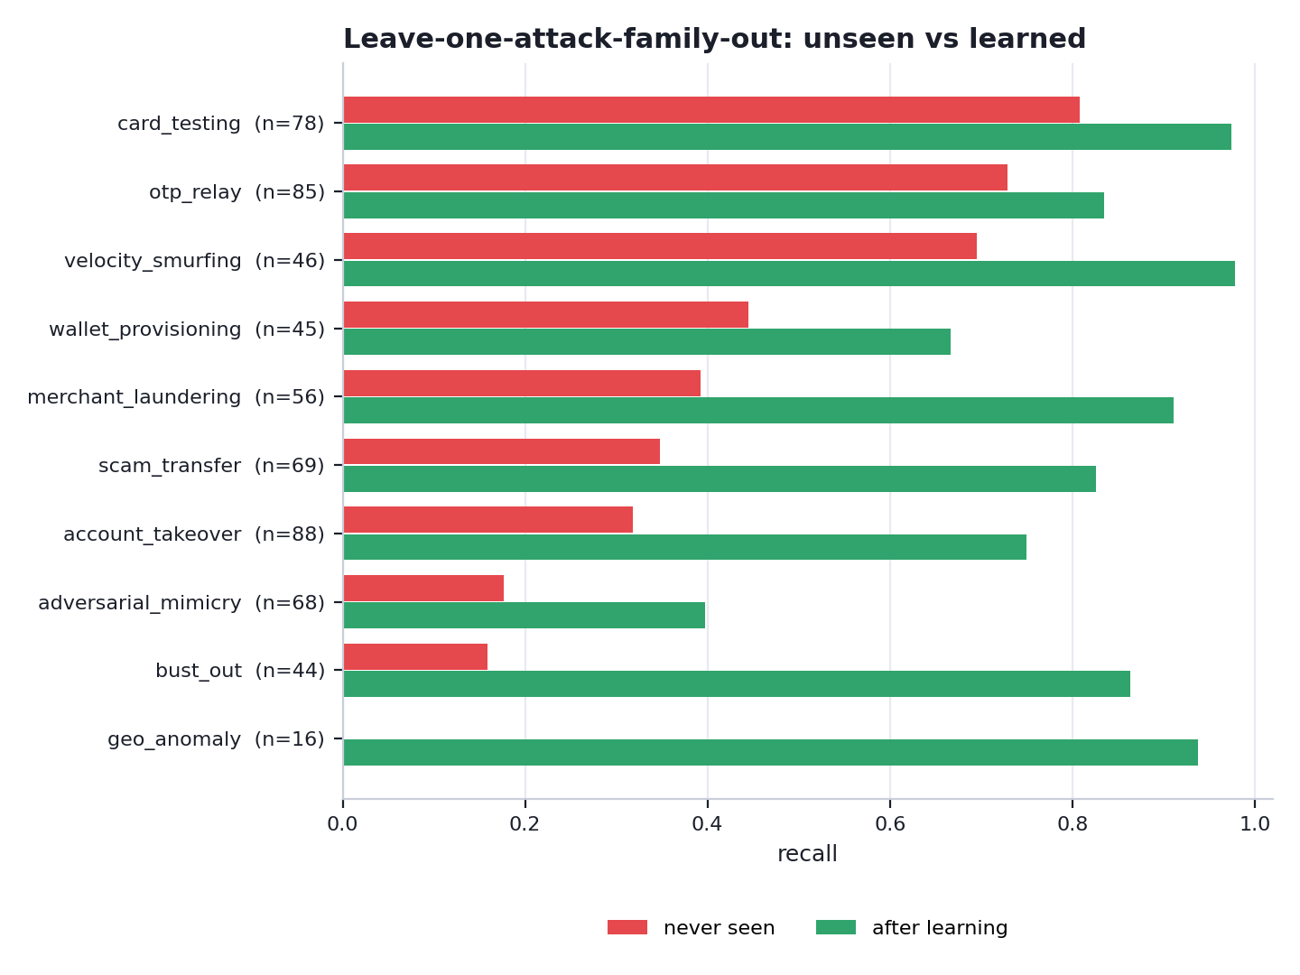
Unseen versus learned, by family.
MARKED * — TOO THIN TO HEADLINE
geo_anomaly rest on fewer than 30 held-out examples. They are shown for completeness and deliberately not used as the hero result: the interval is far too wide to carry a headline, however good the point estimate looks. The hero result is selected automatically from the families that clear the sample-size floor.

HOW TO READ THIS
This measures UNSEEN -> LEARNED on synthetic data, not zero-shot detection and not production performance. recall_after_learning is an upper bound obtained by putting the family into training directly; the closed loop has to reach it by generating the family itself. Families with a small n_test carry wide uncertainty and are reported with their sample size for that reason.

9. Hero result
Attack family: bust out, removed from training entirely.
Stage | Recall | 95% interval | n
Never seen — the blind spot | 16% | 8–29% | 44
After the lab generated and replayed it | 86% | 73–94% | 44

Labelled explicitly as unseen → learned. It is not evidence of zero-shot detection, and it is not a production result.
This family is chosen automatically as the largest measured gain among families with at least 30 held-out examples. Families below that floor produce wider intervals than a headline can carry, so they are reported in the table above and never led with — however good the point estimate looks.

10. Residual frontiers
Some attacks remain difficult after adaptation, and the loop is designed to surface them rather than smooth them over:
- Behavioural mimicry on the legitimate centroid — when every individual signal is held inside the cardholder's own normal range, there is very little left for an authorization-time model to separate.
- Victim-authorized payments — the genuine customer authenticates and authorizes. The transaction is legitimate by every signal the authorization carries.
- First-party dispute abuse — indistinguishable from a genuine purchase at authorization; the fraud is the later dispute, which is post-outcome by definition.
These are reported as residual frontiers with their measured recall. They are exactly why continuous red teaming is required, and exactly why the right control for them is friction and post-transaction intervention rather than a hard decline.

11. Real-world feasibility
Online, the authorization path reads precomputed per-card and network counters, scores, calibrates, applies a versioned policy and logs reason codes. It never trains and it never calls a language model. The relational features are running counters keyed on card, device, IP and merchant — constant-time lookups, not graph queries — and they are the signals an issuer or a single merchant cannot compute alone but a payment network can.
Offline, the red-team loop generates attacks, stress-tests, replays and retrains on a research cadence, and its output passes through the promotion gates above before it could reach production. A real deployment would additionally run the challenger in shadow against live traffic, monitor drift, and feed analyst outcomes back — none of which is simulated here.

12. Limitations
- Synthetic data only. No real cardholder data is used anywhere, and every number in this document is a simulation result.
- No validation against real payment data. A labelled backtest on issuer data is the necessary next step before any of these figures means anything operationally.
- Nothing here has been reviewed or validated by Mastercard, and no part of this describes any real payment-network system.
- Some fraud is not observable at authorization time; those families are reported with low recall rather than excluded.
- Residual frontiers are not solved.
- The text arm is a trivially separable synthetic sanity check, never evidence of detection efficacy. Its corpus is composed from a fixed slot vocabulary, so the two classes separate on vocabulary alone and the score is high for that reason and no other. It measures the corpus, not the detector, and would not survive contact with real scam messages. Every detection claim in this submission rests on the transaction model alone.
- Network features are computed over synthetic relationships only.
- No shadow rollout, drift monitoring, analyst feedback loop, or production latency and availability engineering.

13. Future work
- Validation against a labelled issuer backtest, and a cross-check on a public fraud benchmark.
- UPI and account-to-account as first-class simulated rails, with VPA-style payee identity and instant-settlement semantics.
- Richer entity-graph features for coordinated rings, beyond the current counter-based relational signals.
- Oracle-guided evasion, where the red team probes the score surface directly rather than reasoning from measured feature attribution.
- Multilingual and code-mixed scam-text generation, with detection reported separately on the non-English slice.
- Shadow-mode deployment simulation and drift monitoring to complete the governance story.

14. Reproducing every number in this document
python -m pip install -r requirements.txt
python -m src.pipeline # regenerate every artifact
python -m pytest tests/ -q # test suite
python -m docs.build_docs # regenerate README + this document
streamlit run app/Home.py # the web prototype
Everything flows from a single seed (config.GLOBAL_SEED = 42, schema version 2.0). This document is generated directly from the committed artifacts, so it cannot disagree with the README or the web prototype: they all read the same files.

