**Software Architecture Document (SAD)**

**Project:** Student Attendance Management System (SAMS)  
**Version:** 1.0  
**Authors:** Lakshya Sukruthi N, N V Manya, Navyashree J  
**Date:** 30-09-2025  
**Status:** Draft

**Revision History**

|  |  |  |  |
| --- | --- | --- | --- |
| **Version** | **Date** | **Description** | **Author** |
| 1.0 | 30-09-2025 | Initial Draft of SAD | Project Team |

**Approvals**

|  |  |  |
| --- | --- | --- |
| **Role** | **Name** | **Signature / Date** |
| QA Lead |  |  |
| Development Lead |  |  |
| Security Lead |  |  |
| Compliance Officer |  |  |
| Product Owner |  |  |

**1. Introduction**

The Student Attendance Management System (SAMS) is designed to automate and streamline the attendance tracking process across students, teachers, administrators, and parents.  
This Software Architecture Description (SAD) aligns with requirements from the SRS and validation via the Test Plan, ensuring coverage for functionality, performance, security, and FERPA compliance.

**2. Document Overview**

This document describes the architecture and design of SAMS. It covers high-level structure, chosen patterns, component interactions, data flows, security considerations, and compliance requirements.  
It ensures traceability with the Test Plan, validating key features such as authentication, attendance, reporting, notifications, mobile access, and FERPA compliance.

**3. Architecture**

The SAMS architecture follows a layered, cloud-hosted model with **presentation**, **application**, and **data** layers.  
It supports scalability (10,000 concurrent users), TLS encryption, audit logging, LDAP integration, SMTP/SMS gateways, and high availability with load balancers.

**3.3 Component (UML) Diagram**

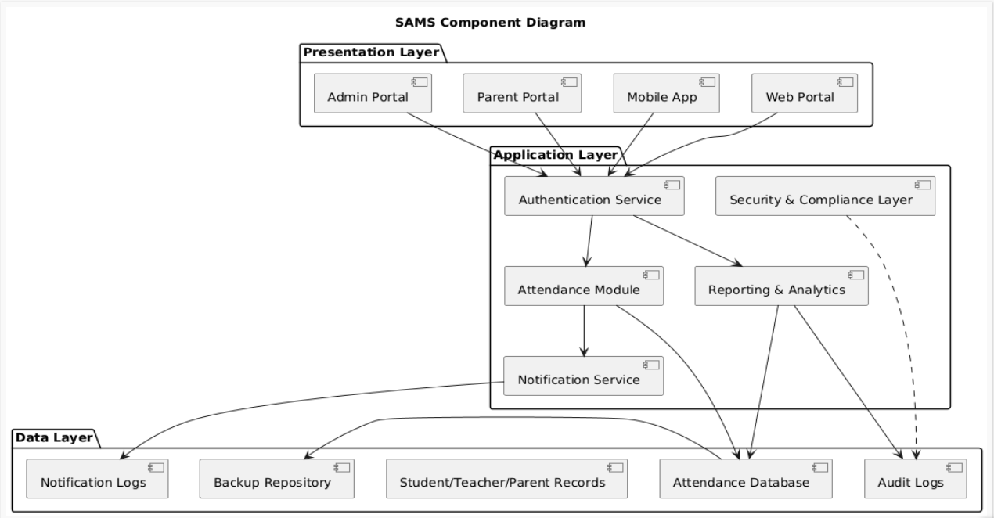

**3.4 Component Descriptions**

* **Authentication Service** – Login via username/password, LDAP, or SSO
* **Attendance Module** – Manual, QR code, and proximity card attendance
* **Notification Service** – Email and SMS alerts with configurable preferences
* **Reporting & Analytics** – Reports in CSV, PDF, dashboards, attendance percentage calculations
* **Admin Portal** – Manage users, classes, and schedules
* **Parent Portal** – Secure access to child’s attendance and notifications
* **Mobile Apps** – iOS/Android apps for attendance marking and viewing reports
* **Backup & Recovery** – Daily backups with 4-hour restore SLA

**3.5 Chosen Architecture Pattern and Rationale**

The architecture adopts a **layered and modular** pattern. Each layer handles distinct concerns:

* Authentication & authorization
* Attendance services
* Notifications
* Reporting & analytics
* Compliance & auditing

This design ensures maintainability, scalability, and compliance. Cloud deployment with redundancy supports 99.5% uptime.

**3.6 Technology Stack & Data Stores**

* **Frontend:** Web (responsive, WCAG 2.1 AA), iOS/Android apps
* **Backend:** Web application layer (Java/Python/.NET)
* **Database:** MySQL/PostgreSQL with backup and recovery
* **Authentication:** LDAP, SSO
* **Notifications:** SMTP for email, SMS Gateway
* **Testing Tools:** Selenium, Appium, JMeter, OWASP ZAP
* **Deployment:** Cloud-hosted with load balancers

**Data Stores:**

* Student, teacher, and parent records
* Attendance data with timestamps
* Notification logs
* Audit logs (FERPA requirement)
* Backup repositories

**3.7 Risks & Mitigations**

* **Build delays** → Regular sync with dev team
* **Test environment downtime** → Backup cloud environments
* **Third-party service unavailability** → Use mocks/sandbox environments
* **FERPA compliance delays** → Early compliance team involvement
* **Limited mobile devices** → Use emulators/cloud testing devices

**3.8 Traceability to Requirements**

All functional (SAMS-F-001 to SAMS-F-043), non-functional (SAMS-NF-001 to SAMS-NF-005), and security (SAMS-SR-001 to SAMS-SR-005) requirements are validated via test cases.  
Examples:

* **Authentication** → TC-Auth-01 to TC-Auth-06
* **Attendance** → TC-Attend-01 to TC-Attend-08
* **Notifications** → TC-Notify-01 to TC-Notify-05
* **Reporting** → TC-Report-01 to TC-Report-06
* **Security & Compliance** → TC-Sec-01 to TC-Sec-05, TC-Comp-01 to TC-Comp-03

**3.9 Security Architecture**

* TLS 1.2+ enforced for all communication
* Secure password storage using bcrypt hashing
* Session timeout (30 mins)
* Role-based access control
* Input validation against SQL injection and XSS
* Comprehensive audit logging with timestamps
* Encrypted database connections & credential rotation
* FERPA-compliant access restrictions

**4. Design**

**4.1 Design Overview**

Modules include:

* Authentication & Authorization
* Attendance Recording (manual, QR, proximity card)
* Notifications (email, SMS)
* Reporting & Analytics (CSV, Excel, PDF, dashboards)
* Admin Portal
* Parent Portal
* Mobile Applications (iOS/Android)
* Backup & Recovery
* Security & Compliance Layer

**4.2 UML Sequence Diagrams**

1. **Login Flow**

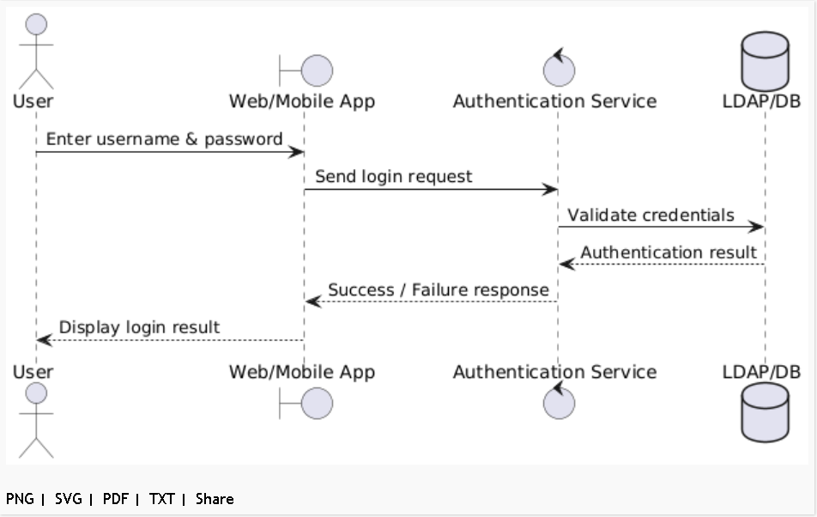

2. **Attendance Marking (QR Code)**

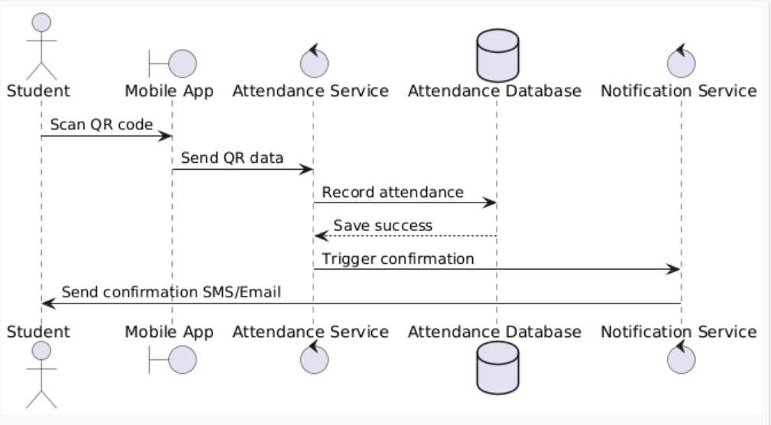

3. **Notification Flow**

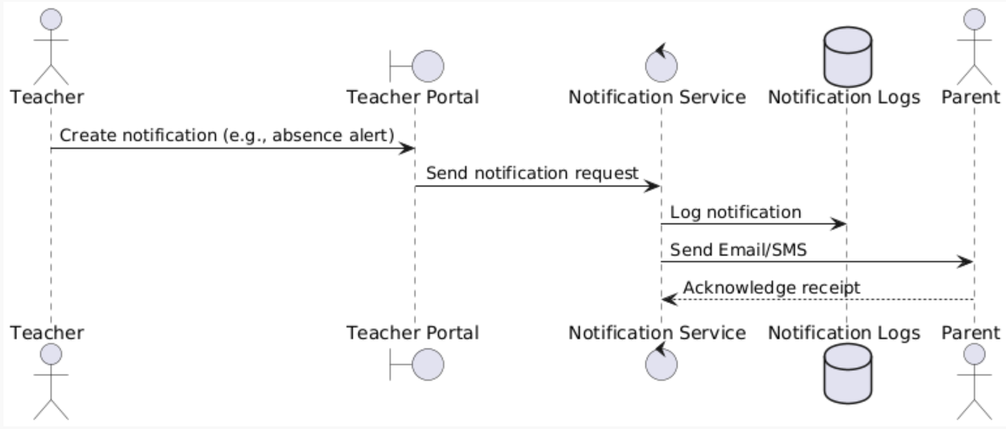

4. **Reporting Flow**

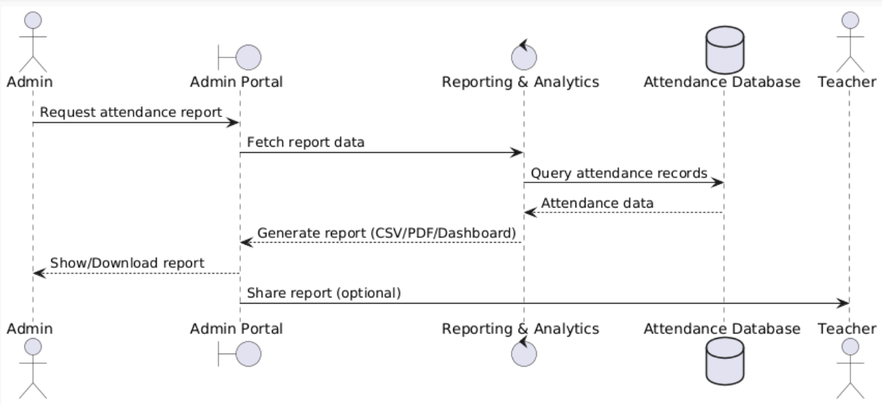

**4.3 API Design**

* RESTful APIs for authentication, attendance, reports, and notifications
* Secure endpoints with token-based authentication
* JSON/XML payloads for interoperability

**4.4 Error Handling, Logging & Monitoring**

**Error Handling:**

* User-friendly messages for failed logins, attendance marking errors, or report failures
* Graceful degradation on external service outages

**Logging & Monitoring:**

* FERPA-compliant audit logs
* Security event logs
* Performance monitoring with JMeter
* Automated alerts for system failures

**4.5 UX Design**

* Web UI is responsive and **WCAG 2.1 AA compliant**
* Features: screen reader compatibility, keyboard navigation, proper color contrast
* Mobile apps follow **iOS and Android guidelines**
* Parent portal designed for simplicity for non-technical users

**4.6 Open Issues & Next Steps**

**Open Issues:**

* Biometric integration postponed to future phases
* Curriculum and grade management excluded from current scope

**Next Steps:**

* Complete UAT with educators, parents, and administrators
* Collect feedback for phase 2 features
* Plan for biometric/RFID hardware integrations

**5. Appendices**

* **References:** SRS v1.0, Test Plan v1.0, FERPA Guidelines, WCAG 2.1 AA Standards
* **Glossary:**
  + SAMS – Student Attendance Management System
  + FERPA – Family Educational Rights and Privacy Act
  + WCAG – Web Content Accessibility Guidelines