Project: Student Attendance Management System (SAMS)
Version: 1.0
Authors: Development Team
Date: November 15, 2025
Status: Implementation Complete / Final Documentation

Revision History
Version | Date | Author | Change Summary | Approval
1.0 | August 18, 2025 | Instructor | Initial SRS with diagrams | Approved
2.0 | November 15, 2025 | Development Team | Final implementation documentation | Approved

Approvals
Role | Name | Signature / Email | Date
Course Coordinator
Project Supervisor
Table of Contents
- Introduction
- Overall Description
- External Interface Requirements
- System Features (Detailed)
- Non-Functional Requirements
- Security Requirements
- Quality Attributes & Acceptance Tests
- System Models and Diagrams
- Requirements Traceability Matrix

1. Introduction
1.1 Purpose
This document is a Software Requirements Specification (SRS) for the Student Attendance Management System (SAMS). It defines functional and non-functional requirements, interfaces, security requirements, and verification criteria for a web-based attendance tracking system serving educational institutions.
1.2 Scope
SAMS is a Flask-based web application that automates attendance tracking for educational institutions. The system covers:
- In Scope:
  - Multi-role user authentication (Admin, Faculty, Student)
  - Real-time attendance calculation and reporting
  - Report generation (CSV, PDF formats)
  - Audit logging and system monitoring
  - Responsive web interface for desktop and mobile devices
- Out of Scope:
  - Biometric attendance (fingerprint, facial recognition)
  - Mobile native applications (iOS/Android)
  - Integration with Learning Management Systems (LMS)
  - Payment/fee management
  - Grade/examination management
  - Library management integration
1.3 Audience
- Software Developers and QA Engineers
- System Administrators and Database Administrators
- Faculty Members and Administrative Staff
- Students
- Project Evaluators and Stakeholders
1.4 Definitions, Acronyms, and Abbreviations
Term | Definition
SAMS | Student Attendance Management System
CRUD | Create, Read, Update, Delete operations
UI | User Interface
API | Application Programming Interface
ORM | Object-Relational Mapping
RBAC | Role-Based Access Control
CSV | Comma-Separated Values file format
PDF | Portable Document Format
SQLAlchemy | Python SQL toolkit and ORM
Flask | Python web application framework
Bootstrap | Frontend CSS framework
Jinja2 | Template engine for Python

2. Overall Description
2.1 Product Perspective
SAMS is a standalone web-based application built on Flask framework that provides:
- Architecture: Model-View-Controller (MVC) pattern
- Database: SQLite (development), PostgreSQL-ready (production)
- Frontend: Responsive HTML5/CSS3 with Bootstrap 5
- Backend: Python Flask with SQLAlchemy ORM
- Authentication: Session-based with password hashing
- Deployment: Can run on any Python-compatible web server
2.2 Product Functions
2.2.1 User Management (Admin)
- Create, view, and delete user accounts
- Assign roles (Admin, Faculty, Student)
- Manage user profiles and credentials
- View system-wide statistics
2.2.2 Course & Class Management (Admin)
- Create and manage courses
- Assign faculty to classes
- Define class sections and schedules
- Enroll students in classes
2.2.3 Attendance Management (Faculty)
- Create attendance sessions
- Mark attendance manually (Present/Absent/Late)
- Edit attendance within 24-hour window
- Finalize and lock attendance sessions
- View real-time attendance statistics
2.2.4 Attendance Tracking (Student)
- View attendance summary across all courses
- View detailed attendance history
- Check attendance percentage in real-time
2.2.5 Reporting & Analytics
- Generate class-wise attendance reports
- Export reports in CSV and PDF formats
- Filter by date range and courses
- View student-wise attendance breakdown
- System-wide analytics dashboard
2.3 User Roles and Characteristics
2.3.1 Administrator
- Characteristics: Technical proficiency, system management experience
- Responsibilities: System configuration, user management, oversight
- Access Level: Full system access
- Expected Usage: Daily for monitoring, periodic for configuration
2.3.2 Faculty
- Characteristics: Basic computer literacy, teaching experience
- Responsibilities: Attendance marking, report generation
- Access Level: Own classes and students only
- Expected Usage: Multiple times daily during class sessions
2.3.3 Student
- Characteristics: Basic smartphone/computer literacy
- Responsibilities: Mark own attendance, monitor progress
- Access Level: Own attendance records only
- Expected Usage: Daily for attendance, periodic for tracking
2.4 Operating Environment
- Server: Any platform supporting Python 3.8+
- Client: Modern web browsers (Chrome 90+, Firefox 88+, Safari 14+, Edge 90+)
- Database: SQLite (development), PostgreSQL 12+ (production)
- Network: LAN or Internet with stable connection
- Resolution: Responsive design supporting 320px to 4K displays
2.5 Design and Implementation Constraints
- Technology Stack: Must use Flask framework
- Database: SQLAlchemy ORM for database abstraction
- Security: Password hashing using Werkzeug
- Session Management: Flask session with 30-minute timeout
- Template Engine: Jinja2 for HTML rendering
- No External Authentication: OAuth not implemented
- Browser Storage: Cannot use localStorage/sessionStorage
- File Upload: Limited to text-based imports only
2.6 Assumptions and Dependencies
Assumptions
- Users have basic computer/smartphone literacy
- Stable internet connection available
- Modern web browser installed
Dependencies
- Python 3.8 or higher
- Flask 2.3+
- SQLAlchemy 2.0+
- Bootstrap 5.3+
- ReportLab (PDF generation)

3. External Interface Requirements
3.1 User Interfaces
3.1.1 Login Interface
- Username and password fields
- Role-based dashboard redirection
- Password masking
- Error message display
- Demo credentials display
3.1.2 Admin Dashboard
- Statistics cards (Users, Courses, Classes)
- Quick action buttons
- Recent activity audit log
- Navigation menu with role-specific links
3.1.3 Faculty Dashboard
- Class list with course details
- Today's session overview
- Quick actions (Create Session, View Reports)
- Statistics display
3.1.4 Student Dashboard
- Attendance summary cards with progress bars
- Course-wise breakdown
3.1.5 Attendance Marking Interface
- Student list with current status badges
- One-click status change buttons (No confirmation)
- Real-time statistics counter
- Quick actions (Mark All Present/Absent)
- Finalize button with confirmation
3.1.6 Responsive Design Requirements
- Mobile-first approach
- Collapsible navigation on small screens
- Touch-friendly buttons (minimum 44x44px)
- Readable text (minimum 16px font size)
- High contrast for accessibility
3.2 Hardware Interfaces
3.2.1 Server Hardware
- Minimum: 2GB RAM, dual-core processor
- Recommended: 4GB RAM, quad-core processor
- Storage: Minimum 10GB free space
3.3 Software Interfaces
3.3.1 Database Interface
- System: SQLite (development) / PostgreSQL (production)
- Protocol: SQLAlchemy ORM
- Operations: CRUD operations on 10 tables
- Transactions: ACID compliance maintained
3.3.2 Email Interface (Optional)
- Protocol: SMTP over TLS
- Server: Gmail SMTP or institutional email server
- Port: 587 (TLS)
- Authentication: Username/password or app-specific password
3.3.3 Template Engine
- System: Jinja2
- Purpose: Dynamic HTML rendering
- Features: Template inheritance, filters, macros
3.4 Communications Interfaces
3.4.1 HTTP/HTTPS Protocol
- Port: 5000 (development), 80/443 (production)
- Methods: GET, POST
- Response Formats: HTML, JSON (API endpoints)
- Session Management: Secure cookies with 30-minute timeout
3.4.2 AJAX Communications
- Purpose: Real-time attendance updates
- Format: JSON
- Endpoints: /api/attendance/update, /api/attendance/finalize

4. System Features (Detailed)
4.1 Authentication and Authorization
4.1.1 User Login (SAMS-F-001)
Priority: High
Type: Functional
Description: Authenticate users using username and password with role-based access control.
Requirement ID | Requirement | Acceptance Criteria | Test Case
SAMS-F-001.1 | System shall validate username and password against database | Valid credentials lead to role-specific dashboard | TC-Auth-01
SAMS-F-001.2 | System shall hash passwords using Werkzeug | Passwords stored as hashes in database | TC-Auth-02
SAMS-F-001.3 | System shall lock account after 3 failed attempts | Further login attempts blocked | TC-Auth-03
SAMS-F-001.4 | System shall create session with 30-minute timeout | Session expires after inactivity | TC-Auth-04
SAMS-F-001.5 | System shall log all login attempts with IP address | Audit log contains login records | TC-Auth-05
Dependencies: User table, AuditLog table

4.1.2 Role-Based Access Control (SAMS-F-002)
Priority: High
Type: Functional
Description: Restrict access to features based on user role.
Requirement ID | Requirement | Acceptance Criteria | Test Case
SAMS-F-002.1 | Admin shall access all system features | Full menu navigation available | TC-RBAC-01
SAMS-F-002.2 | Faculty shall access only teaching-related features | Limited to classes, sessions, reports | TC-RBAC-02
SAMS-F-002.3 | Students shall access only attendance viewing | Cannot access admin/faculty pages | TC-RBAC-03
SAMS-F-002.4 | System shall redirect unauthorized access attempts | 403/redirect to appropriate dashboard | TC-RBAC-04
Dependencies: User role assignment, session management

4.1.3 Password Management (SAMS-F-003)
Priority: Medium
Type: Functional
Description: Allow users to change their passwords securely.
Requirement ID | Requirement | Acceptance Criteria | Test Case
SAMS-F-003.1 | System shall verify current password before change | Old password must match | TC-Pass-01
SAMS-F-003.2 | System shall enforce minimum 6-character password | Short passwords rejected | TC-Pass-02
SAMS-F-003.3 | System shall require password confirmation | New passwords must match | TC-Pass-03
SAMS-F-003.4 | System shall log password changes | Audit record created | TC-Pass-04
Dependencies: User authentication, audit logging

4.2 User Management (Admin)
4.2.1 Create User Account (SAMS-F-004)
Priority: High
Type: Functional
Description: Admin can create new user accounts with role-specific profiles.
Requirement ID | Requirement | Acceptance Criteria | Test Case
SAMS-F-004.1 | System shall create user with username, email, password, role | User record created in database | TC-User-01
SAMS-F-004.2 | System shall validate unique username and email | Duplicates rejected with error | TC-User-02
SAMS-F-004.3 | System shall create Student profile if role is student | Student table record linked to user | TC-User-03
SAMS-F-004.4 | System shall create Faculty profile if role is faculty | Faculty table record linked to user | TC-User-04
SAMS-F-004.5 | System shall hash password before storage | Password stored as hash | TC-User-05
Dependencies: User table, Student table, Faculty table

4.2.2 View User List (SAMS-F-005)
Priority: High
Type: Functional
Description: Admin can view all users grouped by role and section.
Requirement ID | Requirement | Acceptance Criteria | Test Case
SAMS-F-005.1 | System shall display admins in separate section | Admin users shown with count | TC-View-01
SAMS-F-005.2 | System shall display faculty with department info | Faculty list shows designation | TC-View-02
SAMS-F-005.3 | System shall group students by section | Students organized by year/section | TC-View-03
SAMS-F-005.4 | System shall show user status (Active/Inactive) | Status badge displayed | TC-View-04
Dependencies: User table, Student table, Faculty table

4.2.3 Delete User Account (SAMS-F-006)
Priority: High
Type: Functional
Description: Admin can delete user accounts with cascade deletion of related records.
Requirement ID | Requirement | Acceptance Criteria | Test Case
SAMS-F-006.1 | System shall delete user and all related records | Cascade delete implemented | TC-Delete-01
SAMS-F-006.2 | System shall prevent deletion of last admin | Error message if only admin | TC-Delete-02
SAMS-F-006.3 | System shall delete student profile when deleting student | Student record removed | TC-Delete-03
SAMS-F-006.4 | System shall delete all attendance records for student | No orphaned records | TC-Delete-04
SAMS-F-006.5 | System shall log deletion with details | Audit record created | TC-Delete-05
Dependencies: Foreign key cascade constraints

4.3 Course and Class Management (Admin)
4.3.1 Create Course (SAMS-F-007)
Priority: High
Type: Functional
Description: Admin can create courses with code, name, credits, and metadata.
Requirement ID | Requirement | Acceptance Criteria | Test Case
SAMS-F-007.1 | System shall create course with unique code | Course record created | TC-Course-01
SAMS-F-007.2 | System shall validate unique course code | Duplicates rejected | TC-Course-02
SAMS-F-007.3 | System shall store department, year, semester | Metadata saved correctly | TC-Course-03
SAMS-F-007.4 | System shall display courses grouped by department | Department grouping works | TC-Course-04
Dependencies: Course table

4.3.2 Create Class (SAMS-F-008)
Priority: High
Type: Functional
Description: Admin can create classes by assigning faculty to courses with schedule.
Requirement ID | Requirement | Acceptance Criteria | Test Case
SAMS-F-008.1 | System shall create class with course, faculty, section | Class record created | TC-Class-01
SAMS-F-008.2 | System shall validate schedule format (e.g., "MWF 10:00-11:00") | Invalid format rejected | TC-Class-02
SAMS-F-008.3 | System shall validate room format (e.g., "Lab 101") | Invalid format rejected | TC-Class-03
SAMS-F-008.4 | System shall check if students exist in section | Warning if section empty | TC-Class-04
SAMS-F-008.5 | System shall auto-enroll students matching section | Enrollments created | TC-Class-05
Dependencies: Course table, Faculty table, Student table, Enrollment table

4.4 Attendance Session Management (Faculty)
4.4.1 Create Attendance Session (SAMS-F-009)
Priority: High
Type: Functional
Description: Faculty can create attendance sessions for their classes.
Requirement ID | Requirement | Acceptance Criteria | Test Case
SAMS-F-009.1 | System shall create session with date, start time, end time | Session record created | TC-Session-01
SAMS-F-009.2 | System shall validate end time is after start time | Invalid times rejected | TC-Session-02
SAMS-F-009.3 | System shall auto-set end time to 1 hour after start | Default suggestion works | TC-Session-03
SAMS-F-009.4 | System shall redirect to attendance marking page | Navigation works | TC-Session-04
SAMS-F-009.5 | System shall log session creation | Audit record created | TC-Session-05
Dependencies: Class table, Faculty profile

4.4.2 Mark Attendance Manually (SAMS-F-011)
Priority: High
Type: Functional
Description: Faculty can manually mark students as Present/Absent/Late.
Requirement ID | Requirement | Acceptance Criteria | Test Case
SAMS-F-011.1 | System shall display all enrolled students | Student list shows | TC-Mark-01
SAMS-F-011.2 | System shall update attendance status instantly (no confirmation) | Status changes immediately | TC-Mark-02
SAMS-F-011.3 | System shall allow status change (Present/Absent/Late) | All statuses work | TC-Mark-03
SAMS-F-011.4 | System shall update statistics counter in real-time | Counts update live | TC-Mark-04
SAMS-F-011.5 | System shall highlight updated row briefly | Visual feedback shown | TC-Mark-05
Dependencies: Enrollment table, Attendance table, jQuery

4.4.3 Edit Attendance (SAMS-F-012)
Priority: High
Type: Functional
Description: Faculty can edit attendance within 24-hour window after session ends.
Requirement ID | Requirement | Acceptance Criteria | Test Case
SAMS-F-012.1 | System shall allow editing within 24 hours of session end | Edit buttons enabled | TC-Edit-01
SAMS-F-012.2 | System shall disable editing after 24 hours | Edit buttons disabled | TC-Edit-02
SAMS-F-012.3 | System shall prevent editing of finalized sessions | Error message shown | TC-Edit-03
SAMS-F-012.4 | System shall update marked_at timestamp on edit | Timestamp updated | TC-Edit-04
SAMS-F-012.5 | System shall log attendance edits | Audit record created | TC-Edit-05
Dependencies: Session timestamp, Attendance table

4.4.4 Finalize Session (SAMS-F-013)
Priority: High
Type: Functional
Description: Faculty can finalize sessions to prevent further edits.
Requirement ID | Requirement | Acceptance Criteria | Test Case
SAMS-F-013.1 | System shall lock session on finalization | is_finalized flag set | TC-Final-01
SAMS-F-013.2 | System shall show confirmation dialog with unmarked count | Warning displayed | TC-Final-02
SAMS-F-013.3 | System shall prevent edits after finalization | Error on edit attempt | TC-Final-03
SAMS-F-013.4 | System shall record finalization timestamp | finalized_at saved | TC-Final-04
SAMS-F-013.5 | System shall log finalization action | Audit record created | TC-Final-05
Dependencies: Session table, API endpoint

4.4.5 Quick Actions (SAMS-F-014)
Priority: Medium
Type: Functional
Description: Faculty can mark all students with single action.
Requirement ID | Requirement | Acceptance Criteria | Test Case
SAMS-F-014.1 | System shall mark all students present with confirmation | All status updated | TC-Quick-01
SAMS-F-014.2 | System shall mark all students absent with confirmation | All status updated | TC-Quick-02
SAMS-F-014.3 | System shall batch update with 100ms delay per student | Updates smooth | TC-Quick-03
Dependencies: jQuery, Attendance API

4.5 Attendance Tracking (Student)
4.5.1 View Attendance Summary (SAMS-F-015)
Priority: High
Type: Functional
Description: Students can view overall attendance across all courses.
Requirement ID | Requirement | Acceptance Criteria | Test Case
SAMS-F-015.1 | System shall display course-wise attendance | All enrollments shown | TC-Stud-01
SAMS-F-015.2 | System shall calculate attendance percentage | Correct percentage shown | TC-Stud-02
SAMS-F-015.3 | System shall color-code by threshold (75%) | Green/Yellow/Red display | TC-Stud-03
SAMS-F-015.4 | System shall show session counts (Present/Total) | Correct counts shown | TC-Stud-04
Dependencies: Enrollment table, Attendance calculation

4.5.2 View Detailed Attendance (SAMS-F-016)
Priority: High
Type: Functional
Description: Students can view session-wise attendance for each course.
Requirement ID | Requirement | Acceptance Criteria | Test Case
SAMS-F-016.1 | System shall display all sessions for selected class | Session list shown | TC-Detail-01
SAMS-F-016.2 | System shall show status per session (Present/Absent/Late) | Badges displayed | TC-Detail-02
SAMS-F-016.3 | System shall display date, time, and marked_at | All fields visible | TC-Detail-03
SAMS-F-016.4 | System shall show "Not Marked" for pending sessions | Status clear | TC-Detail-04
Dependencies: Session table, Attendance table

4.6 Reporting and Analytics
4.6.1 Generate Class Report (SAMS-F-018)
Priority: High
Type: Functional
Description: Faculty can generate attendance reports for their classes.
Requirement ID | Requirement | Acceptance Criteria | Test Case
SAMS-F-018.1 | System shall display student-wise attendance table | All students shown | TC-Report-01
SAMS-F-018.2 | System shall show Total, Present, Absent, Late counts | Counts accurate | TC-Report-02
SAMS-F-018.3 | System shall calculate attendance percentage | Correct percentage | TC-Report-03
SAMS-F-018.4 | System shall show summary statistics | Total students, ranges shown | TC-Report-04
Dependencies: Attendance calculation

4.6.2 Export to CSV (SAMS-F-019)
Priority: High
Type: Functional
Description: Faculty/Admin can export attendance data to CSV format.
Requirement ID | Requirement | Acceptance Criteria | Test Case
SAMS-F-019.1 | System shall generate CSV with headers | File downloads | TC-CSV-01
SAMS-F-019.2 | System shall include Student ID, Name, counts, percentage | All fields present | TC-CSV-02
SAMS-F-019.3 | System shall name file with timestamp | Unique filename | TC-CSV-03
SAMS-F-019.4 | System shall format percentage with % symbol | Formatting correct | TC-CSV-04
Dependencies: CSV library, Python StringIO

4.6.3 Export to PDF (SAMS-F-020)
Priority: High
Type: Functional
Description: Faculty can export attendance reports to PDF format.
Requirement ID | Requirement | Acceptance Criteria | Test Case
SAMS-F-020.1 | System shall generate PDF with header | File downloads | TC-PDF-01
SAMS-F-020.2 | System shall include course info in title | Metadata visible | TC-PDF-02
SAMS-F-020.3 | System shall format table with borders | Table styled | TC-PDF-03
SAMS-F-020.4 | System shall color-code header row | Gray background | TC-PDF-04
Dependencies: ReportLab library

4.6.4 Admin Reports (SAMS-F-021)
Priority: Medium
Type: Functional
Description: Admin can generate system-wide attendance reports.
Requirement ID | Requirement | Acceptance Criteria | Test Case
SAMS-F-021.1 | System shall filter by course, department, date range | Filters work | TC-Admin-Rep-01
SAMS-F-021.2 | System shall auto-populate department from course | Dynamic population | TC-Admin-Rep-02
SAMS-F-021.3 | System shall validate end date after start date | Validation works | TC-Admin-Rep-03
SAMS-F-021.4 | System shall export filtered data to CSV | Export works | TC-Admin-Rep-04
Dependencies: Complex SQL queries, date validation

5. Non-functional Requirements (detailed)
NFRs below are measurable and tied to test plans. IDs SAMS-NF-###.
Req ID | Requirement | Category | Priority | Acceptance Criteria / Measurement
SAMS-NF-001 | System shall support up to 10,000 concurrent users with response time ≤ 3 seconds for 95% of requests | Performance | High | Load testing shows 95th percentile ≤ 3s. Test: TC-Perf-01
SAMS-NF-002 | System shall maintain 99.5% uptime during academic hours (8 AM - 6 PM) | Reliability | High | Monthly uptime reports show ≥99.5% availability. Test: Operations monitoring
SAMS-NF-003 | System shall comply with FERPA requirements for student data privacy | Security/Compliance | High | FERPA compliance audit checklist pass. Test: TC-Sec-01
SAMS-NF-004 | System shall backup all data daily with ability to restore within 4 hours | Data Protection | High | Backup and restore procedures tested monthly. Test: TC-Backup-01
SAMS-NF-005 | Web interface shall be responsive and usable on devices with minimum 1024x768 resolution | Usability | Medium | UI testing on various screen sizes passes. Test: TC-UI-01
5.1 Security
5.1.1 Security Objectives
- Data Confidentiality: Ensure student attendance data is accessible only to authorized personnel.
- System Integrity: Prevent unauthorized modification of attendance records and system configuration.
5.1.2 Security Requirements
Req ID | Requirement (shall...) | Type | Priority | Acceptance Criteria / Test Case Ref
SAMS-SR-001 | All data transmission shall use HTTPS encryption (TLS 1.2+) | Security | High | Network traffic analysis shows only encrypted connections. Test: TC-Sec-02
SAMS-SR-002 | User passwords shall meet complexity requirements and be hashed using bcrypt | Security | High | Password policy enforced and hash verification passes. Test: TC-Sec-03
SAMS-SR-003 | System shall log all user actions with timestamps for audit trail | Security | High | Audit logs capture all CRUD operations with user identification. Test: TC-Sec-04
SAMS-SR-004 | Database connections shall use encrypted connections with credential rotation | Security | Medium | Database traffic encrypted and credentials updated quarterly. Test: TC-Sec-05
SAMS-SR-005 | System shall implement input validation to prevent SQL injection and XSS attacks | Security | High | Security scanning tools show no vulnerabilities. Test: TC-Sec-06

6. Quality attributes & Acceptance tests
Exit criteria for acceptance:
- All high-priority functional requirements implemented and verified.
- No critical NFR failures.
- Security audit passed.
- RTM shows all test cases passed with ≥90% success rate.
Acceptance test suites include:
- Authentication, Student Management, Attendance Recording, Reporting, Performance, Security, and Usability tests.
Performance benchmarks:
- System must handle typical daily load of 5,000 students marking attendance within 15-minute peak periods.
Data integrity requirements:
- All attendance records must have complete audit trails with no data loss tolerance.

7. System Models and Diagrams
7.1 UML Use-Case Diagrams
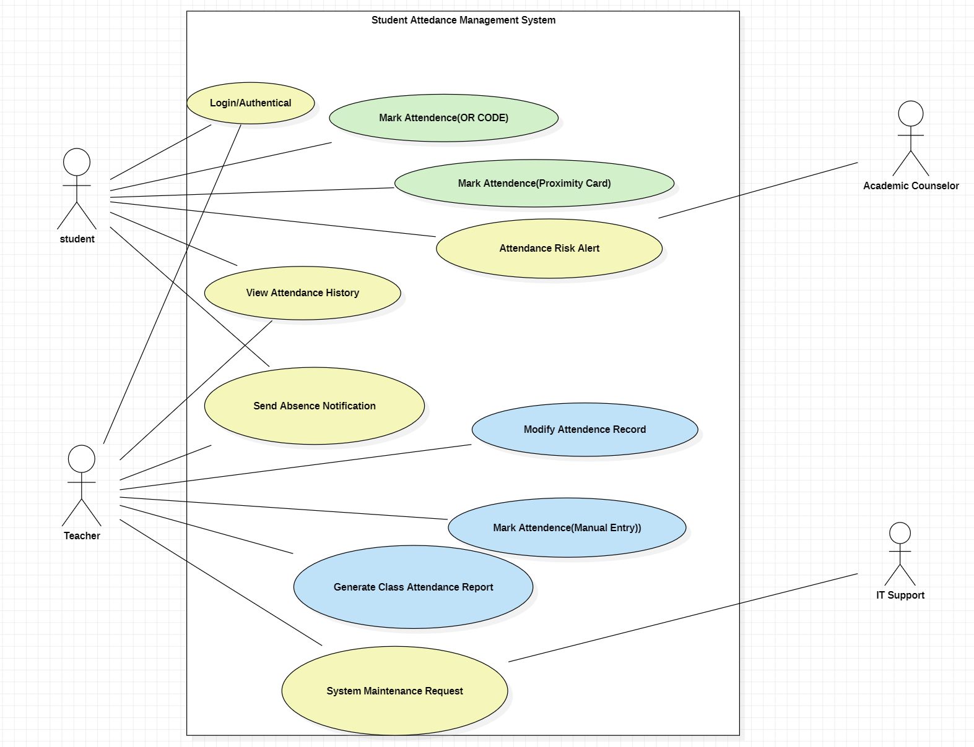
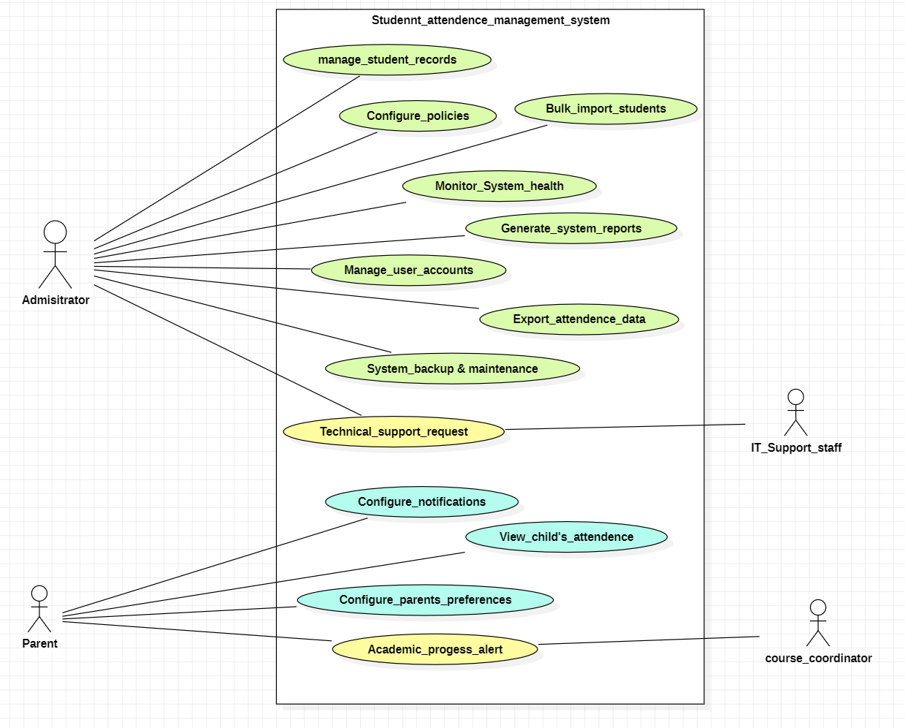

Technology Stack Recommendations
Component | Technology | Justification
Frontend Framework | React.js | Modern, responsive UI with component-based architecture
Backend Framework | Python Flask | Lightweight, scalable REST API framework
Database | PostgreSQL / MySQL | Relational db for structured attendance data
Authentication | JWT/OAuth2.0 | Secure token-based authentication with SSO
Mobile App | React Native | Cross-platform mobile development
Web Server | Nginx | High-performance web server with load balancing
Caching | Redis | Fast session management and caching

Implementation Guidelines
Phase 1: Core Development (Weeks 1–4)
- User authentication and authorization
- Basic student and course management modules
- Manual attendance recording UI and backend
- Database schema design and setup
Phase 2: Enhancement and Testing (Weeks 5–12)
- Advanced analytics and reporting
- Mobile app development for attendance marking
- Integration with external systems/APIs
- Performance optimization and security hardening
Phase 3: Deployment and Monitoring (Weeks 13–14)
- Production environment deployment
- System monitoring and alerting setup
- User training and documentation
- Final acceptance and performance testing

Requirements Traceability Matrix (RTM)
Req ID | Requirement Short | Section Ref / Design | Module | Test Case(s) | Status (N/P/A) | Comments
SAMS-F-001 | User authentication | 4.1 / DS-Auth-01 | AuthModule | TC-Auth-01 | A
SAMS-F-002 | Role-based access control | 4.1 / DS-Auth-02 | AuthModule | TC-Auth-02 | A | Admin, Teacher, Student roles
SAMS-F-003 | Admin login | 4.1 / DS-Auth-03 | AuthModule | TC-Auth-03 | A | Secure admin authentication
SAMS-F-004 | Admin privileges | 4.1 / DS-Auth-04 | AuthModule | TC-Auth-04 | A | Full system access & control
SAMS-F-005 | Admin user management | 4.1 / DS-Auth-05 | AuthModule | TC-Auth-05 | A | Create, edit, delete users
SAMS-F-011 | Student profile management | 4.2 / DS-Student-02 | StudentModule | TC-Student-02 | A | Personal info, enrollment details
SAMS-F-013 | Student view own attendance | 4.2 / DS-Student-04 | StudentModule | TC-Student-04 | A | View personal attendance records
SAMS-F-014 | Student attendance by class | 4.2 / DS-Student-05 | StudentModule | TC-Student-05 | A | Filter attendance by course/class
SAMS-F-015 | Class/Course CRUD | 4.3 / DS-Class-01 | ClassModule | TC-Class-01 | A | Create, edit, delete classes
SAMS-F-016 | Class scheduling | 4.3 / DS-Class-02 | ClassModule | TC-Class-02 | A | Time, day, room assignment
SAMS-F-018 | Teacher-class assignment | 4.3 / DS-Class-04 | ClassModule | TC-Class-04 | A | Assign faculty to courses
SAMS-F-020 | Teacher/Faculty CRUD | 4.4 / DS-Teacher-01 | TeacherModule | TC-Teacher-01 | A | Manage faculty profiles
SAMS-F-021 | Teacher permissions | 4.4 / DS-Teacher-02 | TeacherModule | TC-Teacher-02 | A | Course-specific access
SAMS-F-022 | Teacher schedule view | 4.4 / DS-Teacher-03 | TeacherModule | TC-Teacher-03 | A | View assigned classes
SAMS-F-030 | Manual attendance marking | 4.5 / DS-Attend-01 | AttendanceModule | TC-Attend-01 | A | Mark present/absent/late
SAMS-F-031 | Attendance by date/class | 4.5 / DS-Attend-02 | AttendanceModule | TC-Attend-02 | A | Session-based recording
SAMS-F-032 | Attendance history view | 4.5 / DS-Attend-03 | AttendanceModule | TC-Attend-03 | A | Student attendance records
SAMS-F-035 | Bulk attendance marking | 4.5 / DS-Attend-06 | AttendanceModule | TC-Attend-06 | A | Mark entire class at once
SAMS-F-040 | Attendance reports | 4.6 / DS-Report-01 | ReportModule | TC-Report-01 | A | Daily, weekly, monthly reports
SAMS-F-042 | Export reports | 4.6 / DS-Report-03 | ReportModule | TC-Report-03 | A | PDF, Excel, CSV formats
SAMS-F-043 | Analytics dashboard | 4.6 / DS-Report-04 | ReportModule | TC-Report-04 | A | Charts, trends, statistics
SAMS-F-044 | Custom report builder | 4.6 / DS-Report-05 | ReportModule | TC-Report-05 | A | Filter by date, class, student
SAMS-F-052 | Bulk update operations | 4.7 / DS-Bulk-03 | BulkModule | TC-Bulk-03 | A | Mass edit student/class data
SECURITY REQUIREMENTS
SAMS-SR-002 | Data encryption at rest | 5.4 / DS-Sec-02 | Database | TC-Sec-02 | A | AES-256 encryption
SAMS-SR-003 | SQL injection prevention | 5.4 / DS-Sec-03 | WebAPI | TC-Sec-03 | A | Parameterized queries
SAMS-SR-007 | Audit logging | 5.4 / DS-Sec-07 | AuditModule | TC-Sec-07 | A | Track all user actions

Summary Statistics
Category | Count
Total Requirements | 27
Functional Requirements | 22
Security Requirements | 3
Non-Functional Requirements | 2

Status Legend
Code | Meaning
N | Not Started
P | In Progress
A | Approved/Completed
F | Failed Testing
B | Blocked

