Software Architecture and Design Specification
Project: Student Attendance Management System (SAMS)
Version: 1.0
Authors: QA Team
Date: 15-11-2025
Status: Final

Revision History
Version | Date | Author | Change Summary
1.0 | 15-11-2025 | QA Team | Initial release

Approvals
Role | Name | Signature/Date
Solution Architect
Dev Lead
QA Lead

1. Introduction
1.1 Purpose :
This document specifies the architecture and design of the Student Attendance Management System (SAMS). It provides comprehensive technical documentation including system architecture, component designs, UML diagrams, API specifications, security architecture, and technology stack decisions.
1.2 Scope:
Covers SAMS core services: user authentication and authorization (Admin/Faculty/Student roles), attendance session management, attendance marking (manual and bulk operations), real-time AJAX updates, report generation (CSV/PDF), audit logging, and cascade delete operations.
1.3 Audience :
Developers, QA engineers, security auditors, database administrators, UI/UX designers, instructors, and maintenance teams.
1.4 Definitions :
SAMS (Student Attendance Management System), AJAX (Asynchronous JavaScript and XML), ORM (Object-Relational Mapping), RBAC (Role-Based Access Control), CSRF (Cross-Site Request Forgery), XSS (Cross-Site Scripting), SQLAlchemy (Python SQL toolkit and ORM), Flask (Python web framework), Jinja2 (Template engine), bcrypt (Password hashing algorithm).
2. Document Overview
2.1 How to use this document This document provides architectural deliverables including component diagrams, sequence diagrams for critical workflows, API design specifications, database schema, security threat model (STRIDE), technology stack rationale, and architectural decision records (ADRs). Developers should reference Section 3 for architecture patterns, Section 4 for detailed component designs, and Section 3.9 for security implementation guidelines.
2.2 Related Documents SAMS Software Requirements Specification (SRS) v1.0, SAMS Software Test Plan (STP) v1.0, Requirements Traceability Matrix (RTM), Core Test Cases Document, Flask Documentation v2.3, SQLAlchemy Documentation v2.0, Bootstrap 5 Documentation.
3. Architecture
3.1 Goals & Constraints
Goals:
- Secure authentication and authorization with role-based access control
- Real-time attendance updates without page reloads (AJAX)
- 99.5% system availability during academic hours
- Responsive design supporting desktop, tablet, and mobile devices
- Comprehensive audit logging for all user actions
- Efficient cascade delete operations maintaining referential integrity
- Scalable to support 1000+ students, 100+ faculty, 500+ courses
Constraints:
- Python 3.8+ and Flask 2.3+ required
- SQLite for development, PostgreSQL for production
- No email delivery testing (SMTP configuration excluded)
- Browser support limited to Chrome and Firefox latest versions
- 30-minute session timeout for security
- 24-hour edit window for attendance modification
- Single-server deployment initially (no distributed architecture)
3.2 Stakeholders & Concerns
Students: Easy access to attendance records, clear percentage visualization,
Faculty: Quick attendance marking, bulk operations, real-time updates, report export (CSV/PDF)
Administrators: User management, course/class setup, system-wide reporting, audit trail visibility
IT Security: Password hashing, session security, SQL injection prevention, XSS protection, CSRF tokens
Database Administrators: Referential integrity, cascade deletes, backup/recovery procedures
Developers: Code maintainability, modular design, clear separation of concerns, comprehensive test coverage
3.3 Component (UML) Diagram
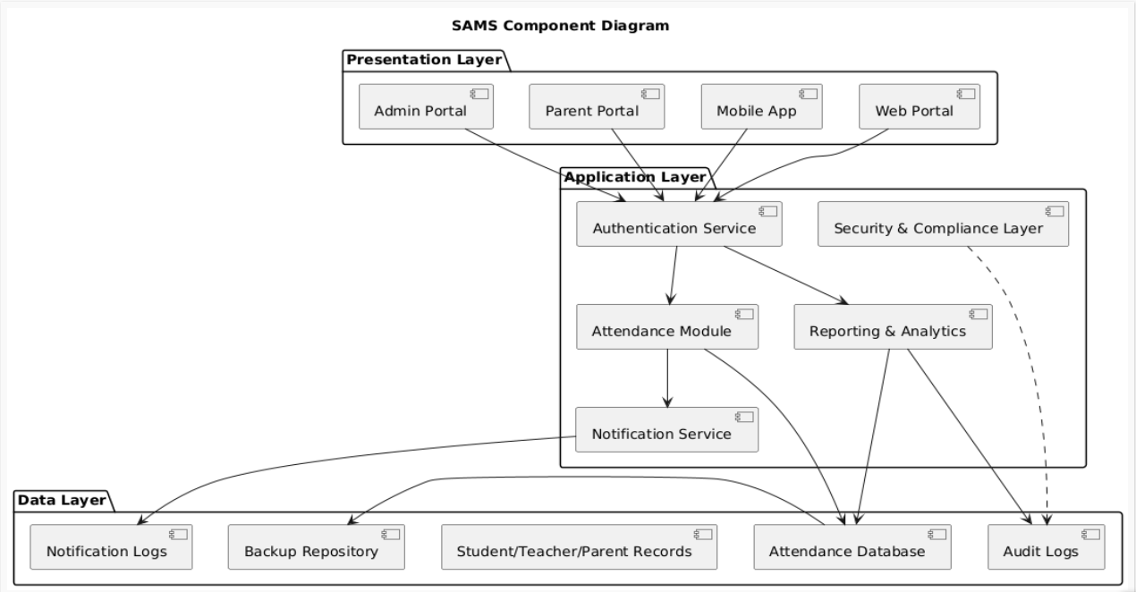
3.4 Component Descriptions
Admin UI Layer (9 HTML templates)
- dashboard.html: Statistics cards (students, faculty, courses, classes), recent activity log
- users.html: User management grouped by role (Admins, Faculty, Students by Section)
- add_user.html: User creation form with role-specific fields (student/faculty/admin)
- courses.html: Course listing grouped by department (CS, IT)
- add_course.html: Course creation form with validation
- classes.html: Class listing with course, faculty, section, schedule, room
- add_class.html: Class creation with schedule/room format validation (JavaScript)
- attendance_report.html: Filterable attendance report with CSV download
- reports.html: Reports hub with navigation cards
Faculty UI Layer (7 HTML templates)
- dashboard.html: Assigned classes, today's sessions, quick actions, statistics
- classes.html: Class cards with View Details/New Session/Report buttons
- class_detail.html: Enrolled students (40), recent sessions (last 10), quick actions
- create_session.html: Session form with date/time validation (end > start)
- mark_attendance.html: Real-time AJAX attendance marking, bulk operations, finalize button
- session_detail.html: View-only session with attendance list and statistics
- class_report.html: Detailed report with summary stats and export options (CSV/PDF)
- reports.html: Reports hub for all assigned classes
Student UI Layer (4 HTML templates)
- dashboard.html: Attendance summary cards for all courses, progress bars,
- attendance.html: Enrolled classes overview with View Attendance buttons
- class_attendance.html: Detailed attendance for specific class (date, time, status)
Flask Application (app.py - 2500+ lines)
- Route Handlers: 30+ endpoints for admin/faculty/student operations
- Authentication: login_required, role_required decorators, password hashing (bcrypt)
- Business Logic: calculate_attendance_percentage(), can_edit_attendance(), send_email()
- Helper Functions: log_audit(), generate_password_hash(), check_password_hash()
- Session Management: 30-minute timeout, last_activity tracking, before_request hook
Authentication Module
- login(): Validates credentials, creates session, logs audit entry
- logout(): Clears session, logs audit entry, redirects to login
- change_password(): Validates current password, updates hash, logs change
- RBAC: role_required() decorator enforces Admin/Faculty/Student access control
- Session Timeout: check_session_timeout() before_request hook
SQLAlchemy ORM (Database Models)
- User: id, username, email, password_hash, role, full_name, created_at, is_active
- Student: id, user_id (FK), student_id, department, year, section, parent_email
- Faculty: id, user_id (FK), faculty_id, department, designation
- Course: id, course_code (unique), course_name, department, credits, year, semester
- Class: id, course_id (FK), faculty_id (FK), section, schedule, room
- Enrollment: id, student_id (FK), class_id (FK), enrollment_date
- AttendanceSession: id, class_id (FK), date, start_time, end_time, created_by (FK), is_finalized
- Attendance: id, session_id (FK), student_id (FK), status, marked_at, marked_by (FK)
- AuditLog: id, user_id (FK), action, entity_type, entity_id, details, ip_address, timestamp
AJAX Handler (jQuery 3.7.1)
- Real-time attendance marking without page reload
- Status badge updates (Present=green, Absent=red, Late=yellow)
- Statistics counter updates (present/absent/late/unmarked counts)
- Loading indicators during async operations
- Error handling with user-friendly messages
Report Generation
- CSV Export: Uses Python csv module, generates filename with timestamp
- PDF Export: Uses ReportLab library, creates formatted tables with headers
- Filters: Course, department, date range selection
- Data: Student ID, Name, Department, Course, Total Sessions, Present, Percentage
3.5 Chosen Architecture Pattern and Rationale
Primary Pattern: Layered (N-Tier) Architecture
Layers:
- Presentation Layer: HTML templates (Jinja2), CSS (Bootstrap 5), JavaScript (jQuery)
- Application Layer: Flask route handlers, business logic functions
- Data Access Layer: SQLAlchemy ORM models
- Database Layer: SQLite (dev) / PostgreSQL (prod)
Rationale:
- Clear separation of concerns: UI, business logic, data access
- Easier maintenance: Changes in one layer don't affect others
- Testability: Each layer can be tested independently (unit tests for business logic, integration tests for routes)
- Scalability: Can replace SQLite with PostgreSQL without changing application logic
- Team structure: Frontend developers work on templates, backend on Flask routes, DBA on database
Rejected Alternatives:
- Microservices: Overly complex for SAMS scale (single application, limited services)
- Single-Page Application (SPA): Would require React/Vue/Angular, increases complexity, harder to implement server-side rendering
- Monolithic MVC: Less flexible than layered, harder to scale individual components
3.6 Technology Stack & Data Stores
Backend:
- Python 3.8+: Language choice for rapid development, extensive libraries
- Flask 2.3+: Lightweight web framework, easy routing, template support
- SQLAlchemy 2.0: ORM for database abstraction, supports multiple databases
- Werkzeug: Password hashing (bcrypt), security utilities
- pytest: Unit and integration testing framework
- pytest-flask: Flask-specific test fixtures
Frontend:
- HTML5: Semantic markup, accessibility support
- CSS3: Custom styles plus Bootstrap 5
- Bootstrap 5: Responsive grid, components (cards, tables, badges, buttons)
- jQuery 3.7.1: AJAX requests, DOM manipulation, event handling
- Jinja2: Server-side template rendering, template inheritance
Database:
- Development: SQLite (sams.db) - file-based, no server setup required
- Production: PostgreSQL - ACID compliance, better concurrency, production-ready
Report Generation:
- CSV: Python csv module (built-in)
- PDF: ReportLab library - programmatic PDF creation with tables and formatting
Security:
- bcrypt: Password hashing algorithm (via Werkzeug)
- Flask-Session: Server-side session management
- WTF-CSRF: Cross-Site Request Forgery protection
Development Tools:
- Git: Version control
- VS Code / PyCharm: IDEs
- pytest: Testing
- Coverage.py: Code coverage measurement
3.7 Risks & Mitigations
Risk | Impact | Probability | Mitigation
SQLite limitations in production (concurrency) | High | Medium | Migrate to PostgreSQL for production deployment
Session timeout interrupting active work | Medium | High | Auto-save drafts, warn user before timeout, extend session on activity
AJAX failures causing lost attendance data | High | Low | Implement retry logic, show error messages, fall back to full page submission
Cascade delete accidentally removing critical data | High | Medium | Implement soft deletes, require confirmation dialogs, maintain backup schedule
24-hour edit window too restrictive | Medium | Medium | Allow admin override, provide audit trail for late edits
jQuery dependency for AJAX | Low | Low | Consider migrating to Fetch API (native JavaScript) in future versions
No email testing capability | Medium | High | Document SMTP setup requirements, provide configuration examples
Single server deployment (no redundancy) | High | Low | Plan for load balancer + multiple app servers for production
3.8 Traceability to Requirements
Requirement ID | Component | Implementation
SAMS-AUTH-001 | Authentication Module | login() function, User model, password_hash verification
SAMS-AUTH-005 | RBAC | role_required() decorator, session['role'] check
SAMS-AUTH-006 | Session Timeout | check_session_timeout() before_request hook, 30-minute timedelta
SAMS-ADMIN-006 | Cascade Delete | SQLAlchemy relationships with cascade="all, delete-orphan"
SAMS-ADMIN-014 | Empty Section Check | Student.query.filter_by(section=X).count() validation in add_class route
SAMS-FAC-004 | Create Session | /faculty/attendance/create route, AttendanceSession model
SAMS-FAC-007-009 | Mark Attendance | /faculty/attendance/mark route, Attendance model, AJAX handler
SAMS-FAC-012-013 | Bulk Operations | markAllPresent/markAllAbsent jQuery functions
SAMS-LOGIC-001-003 | Attendance Calculation | calculate_attendance_percentage() function, (Present+Late)/Total*100
SAMS-LOGIC-004-006 | Edit Window | can_edit_attendance() function, datetime comparison, is_finalized check
SAMS-SEC-001 | Password Hashing | generate_password_hash(), check_password_hash() from Werkzeug
SAMS-UI-004-005 | Format Validation | JavaScript regex validation in add_class.html
3.9 Security Architecture
Threat Modeling (STRIDE Analysis)
Spoofing Identity
- Threat: Attacker impersonates legitimate user
- Mitigation: Password hashing (bcrypt), session-based authentication, 30-minute timeout
- Implementation: generate_password_hash() stores bcrypt hashes, login() validates credentials
Tampering with Data
- Threat: Unauthorized modification of attendance records or user data
- Mitigation: Role-based access control (RBAC), 24-hour edit window, finalized sessions locked
- Implementation: role_required() decorator, can_edit_attendance() check, is_finalized flag
Repudiation
- Threat: User denies performing an action
- Mitigation: Comprehensive audit logging with user ID, IP address, timestamp
- Implementation: log_audit() function, AuditLog model, request.remote_addr capture
Information Disclosure
- Threat: Unauthorized access to sensitive student/faculty data
- Mitigation: Role-based page access, template-based authorization, session validation
- Implementation: login_required, role_required decorators, session['role'] checks
Denial of Service
- Threat: System overload or unavailability
- Mitigation: Rate limiting (future), database connection pooling, efficient queries
- Implementation: SQLAlchemy connection pool, indexed database columns, pagination
Elevation of Privilege
- Threat: Student accesses admin/faculty functions
- Mitigation: Strict role checking on all protected routes, HTTP 302/403 responses
- Implementation: role_required('admin'), role_required('faculty') decorators
SQL Injection
- Threat: Malicious SQL code execution via user input
- Mitigation: SQLAlchemy ORM (parameterized queries), no raw SQL execution
- Implementation: All database operations use ORM methods (query.filter_by(), db.session.add())
Cross-Site Scripting (XSS)
- Threat: Malicious JavaScript execution in browser
- Mitigation: Jinja2 automatic template escaping, no innerHTML manipulation
- Implementation: {{ variable }} auto-escapes HTML, |safe filter avoided
Cross-Site Request Forgery (CSRF)
- Threat: Unauthorized actions submitted via forged requests
- Mitigation: CSRF tokens in forms (disabled in testing only)
- Implementation: WTF_CSRF_ENABLED=True in production, Flask-WTF integration
Session Hijacking
- Threat: Attacker steals session cookie
- Mitigation: Secure cookies (HTTPS), HttpOnly flag, 30-minute timeout
- Implementation: app.config['SESSION_COOKIE_SECURE']=True, SESSION_COOKIE_HTTPONLY=True
4. Design
4.1 Design Overview
SAMS is designed with a layered architecture emphasizing separation of concerns, modularity, and testability. The Flask application serves as the central controller, routing requests to appropriate handlers, enforcing authentication/authorization, and coordinating between the ORM layer and presentation layer. Real-time interactivity is achieved through jQuery AJAX calls, eliminating page reloads for attendance marking. The database schema implements referential integrity with cascade deletes to maintain data consistency.
Key Design Principles:
- DRY (Don't Repeat Yourself): Helper functions (calculate_attendance_percentage, log_audit) reused across routes
- Single Responsibility: Each model represents one entity, each route handles one action
- Fail-Safe Defaults: Users logged out by default, sessions expire automatically, finalized sessions cannot be edited
- Defense in Depth: Multiple security layers (authentication, authorization, input validation, audit logging)
4.2 UML Sequence Diagrams1. Login Flow
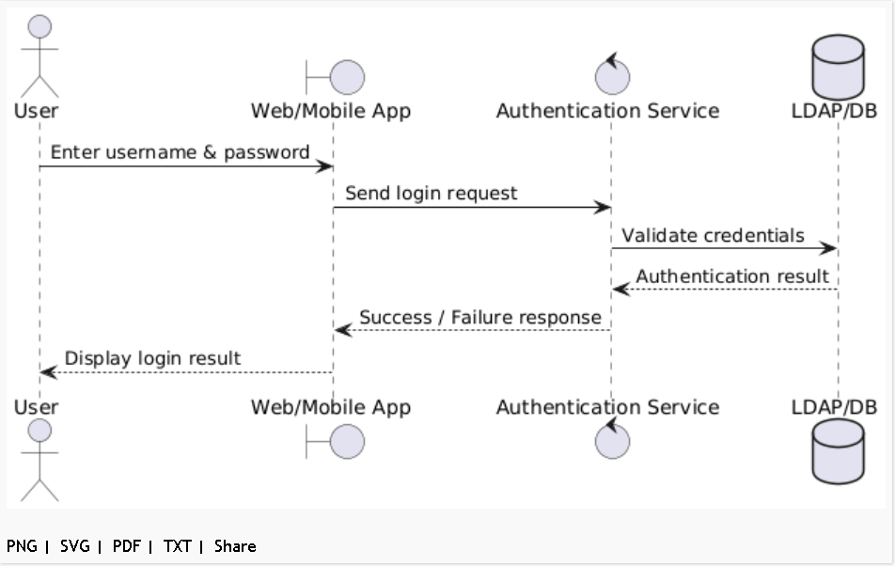

4.3.Reporting Flow
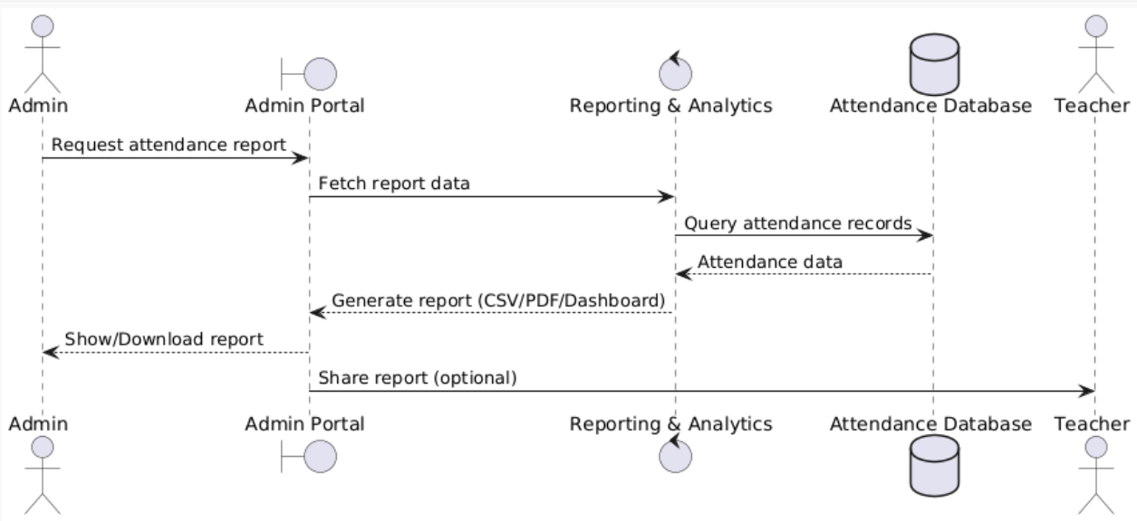
4.4 API Design
- RESTful APIs for authentication, attendance, reports.
- Endpoints secured with token-based authentication to ensure role-based access (Faculty, Admin, Student).
- Supports JSON and XML payloads for system interoperability and integration with third-party systems.
- All APIs are versioned and adhere to consistent naming conventions to ensure maintainability and scalability.

4.5 Error Handling, Logging & Monitoring
- Error Handling:
User-friendly error messages displayed for failed logins, attendance marking errors, and report generation issues.
- System follows graceful degradation behavior in case of external service or network outages.
Standard HTTP status codes used consistently across APIs.
Logging & Monitoring:
- FERPA-compliant audit logs record sensitive user actions such as attendance updates, generation, and logins.
- Security and access control violations recorded separately in security event logs.
Performance metrics monitored using tools like JMeter and integrated dashboards (Datadog/New Relic).
- Automated alerting configured for system downtime, abnormal error rates, and performance degradation.
4.5 UX Design
- The web interface is responsive and fully compliant with WCAG 2.1 AA accessibility standards.
- Key accessibility features include screen reader compatibility, keyboard navigation, and sufficient color contrast.
- Mobile applications follow native platform design guidelines (Material Design for Android, Human Interface Guidelines for iOS).
- Design principles prioritize clarity, consistency, and efficiency to minimize faculty workload and improve user satisfaction.

4.6 Open Issues & Next Steps
Open Issues:
- Biometric integration (fingerprint/facial recognition) postponed to future release phases.
- Curriculum and grade management functionalities excluded from current implementation scope.
Next Steps:
- Conduct User Acceptance Testing (UAT) with educators, administrators.
- Gather stakeholder feedback for prioritizing Phase 2 features.
- Plan and prototype biometric/RFID-based attendance hardware integration.

5. Appendices
References:
- Software Requirements Specification (SRS) v1.0
- Test Plan v1.0
- FERPA Guidelines
- WCAG 2.1 AA Accessibility Standards
Glossary:
- SAMS: Student Attendance Management System
- FERPA: Family Educational Rights and Privacy Act
- WCAG: Web Content Accessibility Guidelines

