College of Computer Studies
Laboratory Exercise No. 5

Topic: | Temperature and Humidity Sensor in ESP32 | Week No. | 2
Course Code: | CSST105 | Term: | Inter Semester
Course Title: | Robotics | Academic Year: | 2025-2026

Temperature and Humidity Sensor in ESP32
Objective:
To design a system using the ESP32 to collect and transmit temperature and humidity data from a DHT11/22 sensor.
At the end of this laboratory exercise, the students should be able to:
- Interface a DHT11/DHT22 sensor with the ESP32 microcontroller.
- Acquire and process temperature and humidity data.
- Implement conditional decision-making algorithms.
- Design an environmental alert system using LEDs and a buzzer.
- Analyze collected sensor data and evaluate system performance.

Materials Required:
- ESP32 Development Board
- DHT11/DHT22 Temperature and Humidity Sensor
- Breadboard and Jumper Wires
- Buzzer, LEDs, and pull-up resistors
- Arduino IDE

Pre-Lab Preparation:
- Software Installation:
  - Install the Arduino IDE and set it up for ESP32 development.
- Wiring Setup:
Identify DHT Sensor Pins:

DHT sensors typically have three pins:
- VCC (Power)
- GND (Ground)
- Data (Signal)

Wiring the DHT Sensor:

VCC Pin:
Connect the VCC pin of the DHT sensor to the 3.3V pin on the ESP32.
GND Pin:
Connect the GND pin of the DHT sensor to a GND pin on the ESP32.
Data Pin:
Connect the Data pin of the DHT sensor to a GPIO pin on the ESP32 (e.g., GPIO 23).
Adding a Pull-Up Resistor (Optional but Recommended):

Connect a 4.7kΩ to 10kΩ resistor between the Data pin and VCC. This helps stabilize the signal.
Double-Check Connections:

Ensure all connections are secure and correctly placed according to the pins defined.

- Download and Install Bluetooth Serial Terminal on Google Playstore (for android only)
Lab Activity Steps:
- Set Up the ESP32 Environment:
  - Open Arduino IDE, select the ESP32 board, and choose the appropriate COM port.
- Code Development:
  - Create a new sketch and include the necessary libraries:
#include <Wire.h>
#include <LiquidCrystal_I2C.h>
#include <DHT.h>

// LCD setup (I2C address 0x27, 16 columns, 2 rows)
LiquidCrystal_I2C lcd(0x27, 16, 2);

// DHT11 sensor setup
#define DHTPIN 23 // GPIO pin connected to DHT11 data pin
#define DHTTYPE DHT11 // DHT 11 sensor
DHT dht(DHTPIN, DHTTYPE);

void setup() {
Serial.begin(115200);
lcd.init(); // Initialize LCD
lcd.backlight(); // Turn on backlight

dht.begin(); // Initialize DHT sensor

lcd.clear();
lcd.setCursor(0, 0);
lcd.print("Starting...");
delay(1000);
}

void loop() {
float t = dht.readTemperature();
float h = dht.readHumidity();

// Check if any reads failed and exit early (to try again).
if (isnan(t) || isnan(h)) {
Serial.println("Failed to read from DHT sensor!");
return;
}

Serial.print("DHT11: ");
Serial.print(t);
Serial.print(" C, ");
Serial.print(h);
Serial.println(" %");

lcd.clear();
lcd.setCursor(0, 0);
lcd.print("Temp: ");
lcd.print((int)t);
lcd.print(" C");

lcd.setCursor(0, 1);
lcd.print("Humidity: ");
lcd.print((int)h);
lcd.print(" %");

delay(5000); // Wait 5 seconds before next reading
}

- Make the circuit
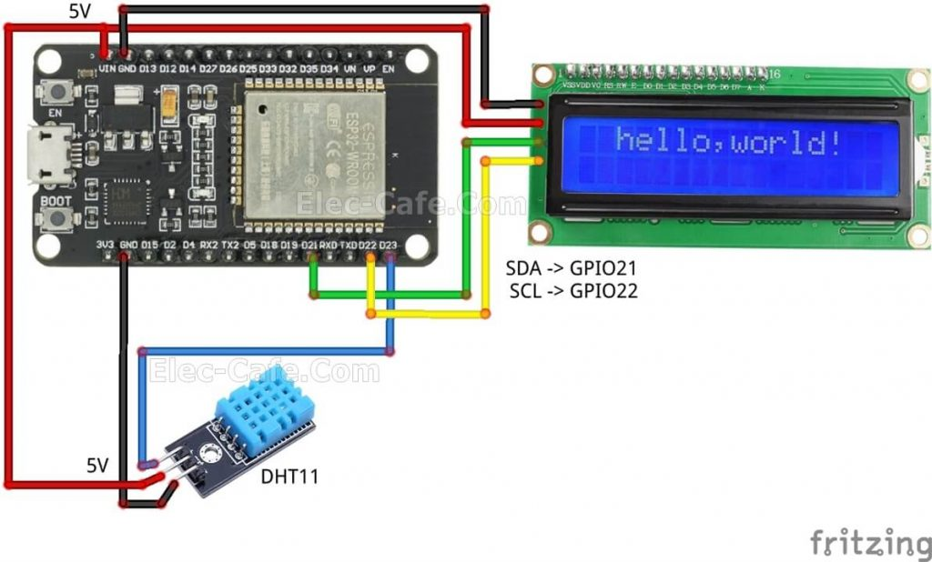
- Upload the Code:
  - Connect the ESP32 and upload the code.
- Data Monitoring:
  - Observe real-time temperature and humidity readings in the LCD Display.

Experimental Procedure:
Part A: Sensor Interfacing
- Construct the circuit according to the wiring table.
- Install the DHT sensor library.
- Verify that temperature and humidity values are displayed in the Serial Monitor. \

Part B: Environmental Classification
Program the ESP32 to classify the environment into:
Normal
- Green LED ON
- Red LED OFF
- Buzzer OFF

Warning
- Green LED OFF
- Red LED BLINKING
- Buzzer beeps every 2 seconds

Critical
- Green LED OFF
- Red LED FAST BLINKING
- Continuous buzzer alarm

Environmental Condition Classification Table
Status | Temperature (°C) | Humidity (%) | System Response
Normal | 18°C – 20°C | 40% – 60% | Green LED ON, Buzzer OFF
Warning | 21°C – 25°C | 30% – 39% OR 61% – 75% | Yellow LED ON (or Red LED Blinking), Slow Buzzer
Critical | ≥ 30°C | < 30% OR > 75% | Red LED ON, Rapid Buzzer Alarm

Alternative Decision Matrix
Temperature Range | Humidity Range | Status
18°C – 20°C | 40% – 60% | Normal
21°C – 25°C | 30% – 39% | Warning
21°C – 25°C | 61% – 75% | Warning
≥ 30°C | < 30% | Critical
≥ 30°C | > 75% | Critical

Example Readings
Temperature (°C) | Humidity (%) | Status
19 | 50 | Normal
20 | 45 | Normal
23 | 35 | Warning
25 | 70 | Warning
30 | 28 | Critical
32 | 80 | Critical
35 | 85 | Critical

Suggested Logic for ESP32
#include <DHT.h>
#include <LiquidCrystal_I2C.h>

#define DHTPIN 4
#define DHTTYPE DHT22 #DHT11 if no DHT22

#define GREEN_LED 18
#define RED_LED 19
#define BUZZER 23

DHT dht(DHTPIN, DHTTYPE);

void setup() {
Serial.begin(115200);

pinMode(GREEN_LED, OUTPUT);
pinMode(RED_LED, OUTPUT);
pinMode(BUZZER, OUTPUT);

dht.begin();
}

void loop() {

float humidity = dht.readHumidity();
float temperature = dht.readTemperature();

if (isnan(humidity) || isnan(temperature)) {
Serial.println("Sensor Error!");
return;
}

Serial.print("Temperature: ");
Serial.print(temperature);
Serial.print(" °C ");

Serial.print("Humidity: ");
Serial.print(humidity);
Serial.println(" %");

if ((temperature >= 18 && temperature <= 20) &&
(humidity >= 40 && humidity <= 60))
{
status = "NORMAL";
}
else if ((temperature > 20 && temperature <= 25) ||
(humidity >= 30 && humidity < 40) ||
(humidity > 60 && humidity <= 75))
{
status = "WARNING";
}
else if (temperature >= 30 ||
humidity < 30 ||
humidity > 75)
{
status = "CRITICAL";
} else if (temperature > 30 || humidity < 40) {

digitalWrite(GREEN_LED, LOW);
digitalWrite(RED_LED, HIGH);
delay(250);
digitalWrite(RED_LED, LOW);

digitalWrite(BUZZER, HIGH);
delay(250);
digitalWrite(BUZZER, LOW);

Serial.println("STATUS: WARNING");

}
else {

digitalWrite(GREEN_LED, HIGH);
digitalWrite(RED_LED, LOW);
digitalWrite(BUZZER, LOW);

Serial.println("STATUS: NORMAL");
}

delay(2000);
}

Guide Questions
- What is the difference between DHT11 and DHT22 in terms of accuracy and range?
- Why is environmental monitoring important in robotic systems?
- How does an ESP32 process digital sensor data?
- What is the purpose of implementing warning and critical thresholds?
- How can IoT improve environmental monitoring systems?
- What challenges were encountered during sensor interfacing?
- How would you improve the system for industrial deployment?

Conclusion:

