Sunapee Buoy Data Logger DO Offset 2013-2015

B. Steele, Weathers Lab, Cary Institute

2022-02-16

# Sunapee Buoy Dissolved Oxygen Offset Timeline

This script is meant to identify and document offsets in the dissolved oxygen (DO) record from the Campbell data logger history from 2013-2015. The script also documents decisions made about the data as published on EDI. This is meant to serve as a reference document to other researchers who intend to use the dissolved oxygen data from the Lake Sunapee Protective Association (LSPA) buoy.

At the initial deployment mid-2010 of the buoy until 2016, the metadata record for the dissolved oxygen sensor had no mention of calibration of the unit. Towards the end of 2013, an offset was introduced at the level of the Campbell data logger program in order to compensate for the difference between manual DO measurements and the data being recorded at the buoy. The offset applied on 2013-09-25 affected the shallow and deep DO sensors. This offset was in effect through the data recorded at the Harbor location in April 2014, prior to a data gap due to logger reset. When the logger was reset in June 2014, the offset from 2013-09-25 remained. This offset was removed from the Cambell data logger program on 2014-07-28. A new offset was introduced on 2014-09-18, and though there is not a record of this particular datalogger program, the notes in the diary of the program state that the shallow DO offset was adjusted to -2 for mg/L and -20 for percent saturation. This offset persisted until a new Ponsel DO sensor was installed on 2015-06-03. From that point forward, there is no offset applied to the DO sensors. No offset was applied to the deep DO sensor on 2014-09-18.

Four primary actions have been taken to resolve these offsets and assist others in using the LSPA dissolved oxygen data:

1. all offset DO data are stored in a column with the suffix ’_withoffval’
2. offset values from the programs are stored in the columns with the prefix ‘offval_’
3. raw data values are back-calculated where offsets are present and stored in the DO data column without a suffix, indicating *raw data*
4. a flag column indicates documented calibration (‘c’) and cleaning (‘w’), and where cleaning is presumed based on behavior of data (‘wp’). An ‘x’ flag persists until the first documented calibration of the DO sensor or in years that there was no documented calibration on record. An ‘o’ indicates that the data were back-calculated from an offset.

Data subject to an offset will be referred to as **‘offset data’**; data with no offset applied or back-calculated from the offset data will be referred to as **‘raw data’** - note that these are not actual raw data precisely, but rather the most raw data we have available from the data logger.

For a comparison of manual DO measurements and buoy-derived DO data, see the document *LSPA buoy DO Visual History*, also included in this data package.

## DO offset documentation from the Campbell datalogger files

This data logger diary was copied from the most recent CSI file dated 2019-05-12.

2009-01-14 - LW - Rewrote CSI file from *.dld dumped from datalogger, old CSI file lost - Changed most of the voltage range options to autorange, more accurate, only 1ms slower

2009-02-23 - LW - Added radio battery measurement

2009-07-25 - JRM - Added Digital compass, wind vector, max wind speed/direction. Changed EI to 30 sec.

2009-08-07 - JRM - Add filter for compass read error

2009-08-11 - JRM - Add filter for Templine read error

2010-05-20 - JRM - Replace old Templine filter with new one that checks all locations. Changed EI back to 60 sec. - Add code for 22 sensor Templine.

2013-07-30 - JRM - Add PONSEL DO sensor. Read as three additional values after templine string from same inst.

2013-09-10 - JRM - Change PONSEL measure command to aC! (concurrent measurement)

2013-09-25 - JRM - Add corrections for DO sensor calibration

2014-01-13 - JRM - Change DO and Templine read to every 3 minutes

2014-07-28 - JRM - Removed low DO & hi DO offsets separately read low DO sensor, removed one temp sensor from line

2014-09-18 - JCF - Made corrections on shallow DO based on Cal rdgs: -20 for sat and -2 for ppm 9/15/2014

2015-06-03 - JRM - Added new Ponsel DO and sonde with chlorophyl sensor

2018-05-12 - JRM - removed templine invalid reading filter

2019-05-12 - jrm - Replaced templine invalid reading filter

### Prior to 2013-09-10

There were no saved programs prior to 2013-09-10. It appears that there were no offsets applied to the data at the Campbell datalogger. This assessment was made because there are no obvious jumps in the DO data prior to that time, except where sensors were changed or where there were data gaps for buoy maintenance.

### 2013-09-10 - JRM - Change PONSEL measure command to aC! (concurrent measurement)

No offsets present in this program

;Measure DO Probe  
 5: SDI-12 Recorder (P105)  
 1: 1 SDI-12 Address  
 2: 0 Start Measurement (aM!)  
 3: 2 Port  
 4: 2 Loc [ DOTemp ]  
 5: 1.0 Multiplier  
 6: 0.0 Offset  
   
;Measure 10 thermistors and PONSEL DO  
 6: SDI-12 Recorder (P105)  
 1: 0 SDI-12 Address  
 2: 0 -- Start Measurement (aM!) ;  
 3: 1 Port  
 4: 5 Loc [ TempLn00 ]  
 5: 1.0 Multiplier  
 6: 0.0 Offset

### 2013-09-25 - JRM - Add corrections for DO sensor calibration

This file documents offsets for saturation and concentration for both sensors (‘2:’ of each section)

; Correction for deep DO sensor Saturation  
 7: Z=X+F (P34)  
 1: 17 X Loc [ DoLowSat ]  
 2: -73.7 F  
 3: 22 Z Loc [ DlsatCor ]  
  
; Correction for deep DO sensor PPM  
 8: Z=X+F (P34)  
 1: 18 X Loc [ DoLowPPM ]  
 2: -6.7 F  
 3: 23 Z Loc [ DlppmCor ]  
  
; Correction for shallow DO Saturation  
 9: Z=X+F (P34)  
 1: 3 X Loc [ DOSat ]  
 2: -16.5 F  
 3: 24 Z Loc [ DosatCor ]  
  
; Correction for shallow DO sensor PPM  
 10: Z=X+F (P34)  
 1: 4 X Loc [ DOPPM ]  
 2: -1.72 F  
 3: 25 Z Loc [ DoppmCor ]

### 2014-07-28 - JRM - Removed low DO & hi DO offsets separately read low DO sensor, removed one temp sensor from line

There is no CSI file associated with this change. Assume it sets all corrections from 2013-09-25 back to zero

### 2014-09-18 - JCF - Made corrections on shallow DO based on Cal rdgs: -20 for sat and -2 for ppm 9/15/2014

There is no CSI file associated with this change. Assume -20 for sat and -2 for ppm upper sensor only, as described in the diary.

### 2013-06-03 - JRM - Added new Ponsel DO and sonde with chlorophyl sensor

This record indicates no DO offset, assume it was zeroed out from 2014-09-18 change.

; Correction for deep DO sensor Saturation  
 12: Z=X+F (P34)  
 1: 16 X Loc [ DoLowSat ]  
 2: 0 F  
 3: 24 Z Loc [ DlsatCor ]  
  
; Correction for deep DO sensor PPM  
 13: Z=X+F (P34)  
 1: 17 X Loc [ DoLowPPM ]  
 2: 0.0 F  
 3: 25 Z Loc [ DlppmCor ]  
  
; Correction for shallow DO Saturation  
 14: Z=X+F (P34)  
 1: 19 X Loc [ DOSat ]  
 2: 0 F  
 3: 26 Z Loc [ DosatCor ]  
  
; Correction for shallow DO sensor PPM  
 15: Z=X+F (P34)  
 1: 20 X Loc [ DOPPM ]  
 2: 0 F  
 3: 27 Z Loc [ DoppmCor ]

### 2018-05-12 - JRM - removed templine invalid reading filter

This record indicates no DO offsets

; Correction for deep DO sensor Saturation  
 7: Z=X+F (P34)  
 1: 16 X Loc [ DoLowSat ]  
 2: 0 F  
 3: 24 Z Loc [ DlsatCor ]  
  
; Correction for deep DO sensor PPM  
 8: Z=X+F (P34)  
 1: 17 X Loc [ DoLowPPM ]  
 2: 0.0 F  
 3: 25 Z Loc [ DlppmCor ]  
  
; Correction for shallow DO Saturation  
 9: Z=X+F (P34)  
 1: 19 X Loc [ DOSat ]  
 2: 0 F  
 3: 26 Z Loc [ DosatCor ]  
  
; Correction for shallow DO sensor PPM  
 10: Z=X+F (P34)  
 1: 20 X Loc [ DOPPM ]  
 2: 0 F  
 3: 27 Z Loc [ DoppmCor ]

### 2019-05-12 - jrm - Replaced templine invalid reading filter

This record indicates no offset for DO sensors

; Correction for deep DO sensor Saturation  
 12: Z=X+F (P34)  
 1: 16 X Loc [ DoLowSat ]  
 2: 0 F  
 3: 24 Z Loc [ DlsatCor ]  
  
; Correction for deep DO sensor PPM  
 13: Z=X+F (P34)  
 1: 17 X Loc [ DoLowPPM ]  
 2: 0.0 F  
 3: 25 Z Loc [ DlppmCor ]  
  
; Correction for shallow DO Saturation  
 14: Z=X+F (P34)  
 1: 19 X Loc [ DOSat ]  
 2: 0 F  
 3: 26 Z Loc [ DosatCor ]  
  
; Correction for shallow DO sensor PPM  
 15: Z=X+F (P34)  
 1: 20 X Loc [ DOPPM ]  
 2: 0 F  
 3: 27 Z Loc [ DoppmCor ]

## DO visual history of the data logger offset

The graphs below show the raw DO data from the buoy as well as the data with an offset applied. Offset values are indicated with grey symbols and back-calculated raw values are indicated with yellow symbols. Black symbols are raw data recorded without offset.

Flag defninitions:

x: no calibration on record  
  
o: data back-calculated from offset values  
  
wp: cleaning presumed (not visible at this level)

### 2013

**Shallow DO:**

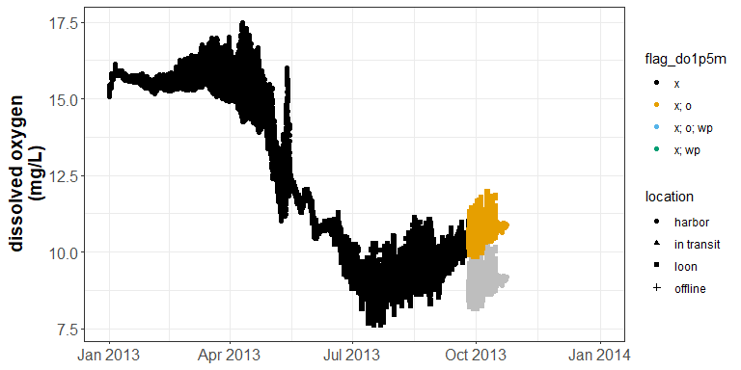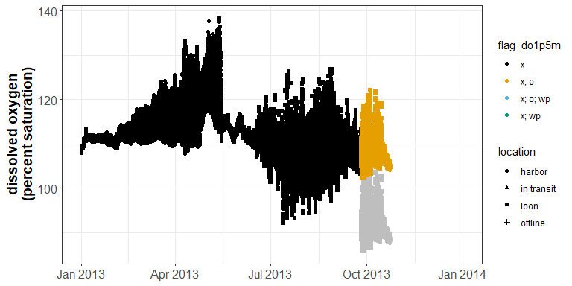

Offset of **-1.72** applied to DO concentration values, **-16.5** applied to percent saturation values on 2013-09-25.

**Deep DO:**

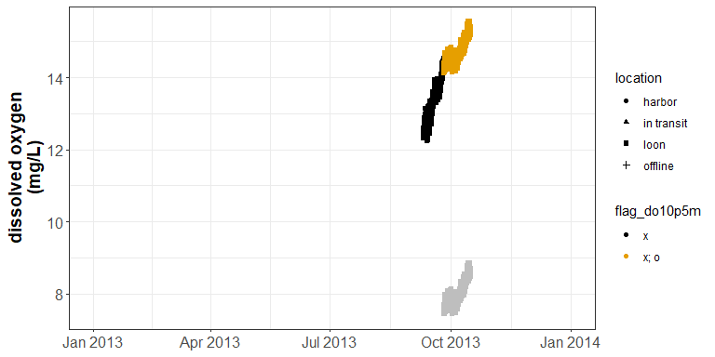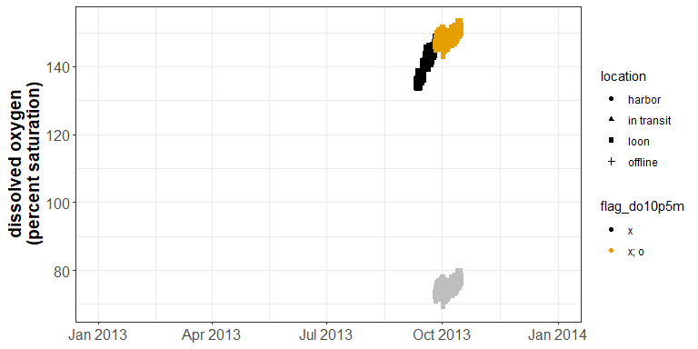

Deep DO sensor was deployed at ~ 10.5m in September. Offset of **-6.7** applied to DO concentration values, **-73.7** applied to percent saturation values on 2013-09-25.

### 2014

**Shallow DO:**

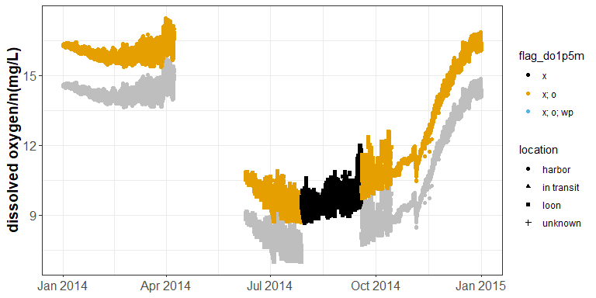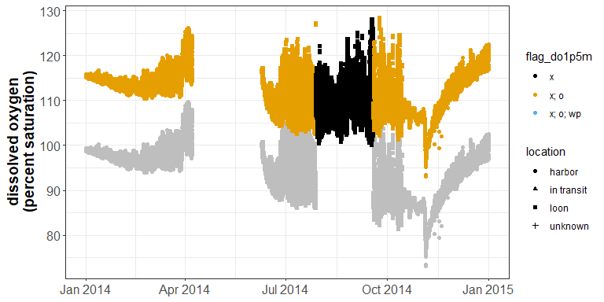

Offset from 2013 of **-1.72** applied to DO concentration values, **-16.5** applied to percent saturation values, remained in effect until 2014-07-28. A new offset was introduced 2014-09-18 of **-2** for the concentration values and **-20** for the percent saturation values.

**Deep DO:**

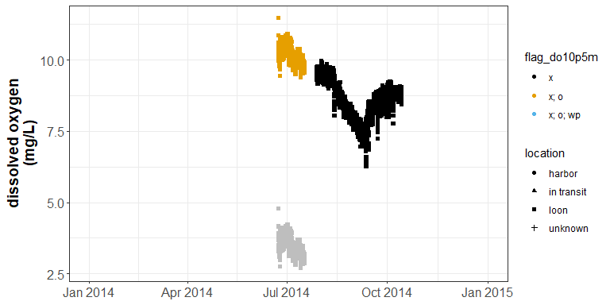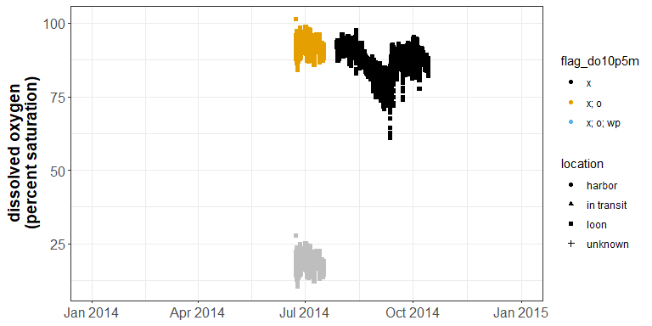

Offset from 2013 of **-6.7** applied to DO concentration values and **-73.7** applied to percent saturation values remained in effect through 2014-07-28. No offset was applied to the deep DO values at the time of the September shallow DO offset.

### 2015

**Shallow DO:**

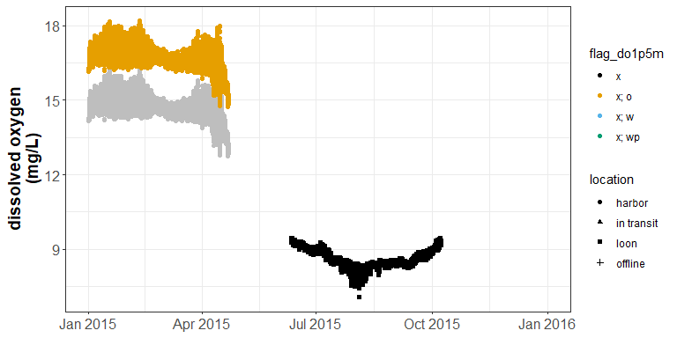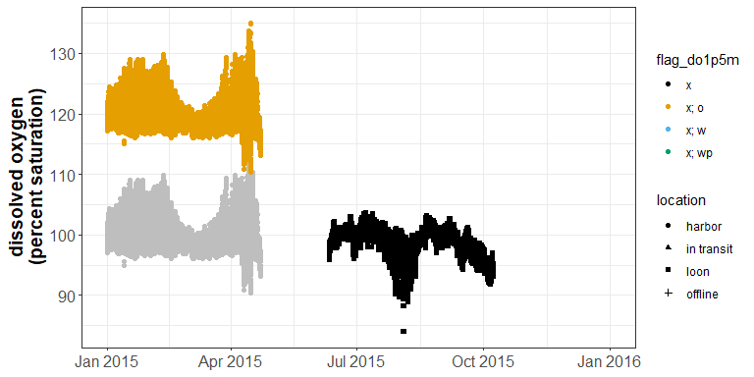

The offset from 2014-09-18, of **-2** for the concentration values and **-20** for the percent saturation values, remained until a new Ponsel DO unit was installed prior to buoy move in June 2015 when the data logger program was overhauled.

**Deep DO:**

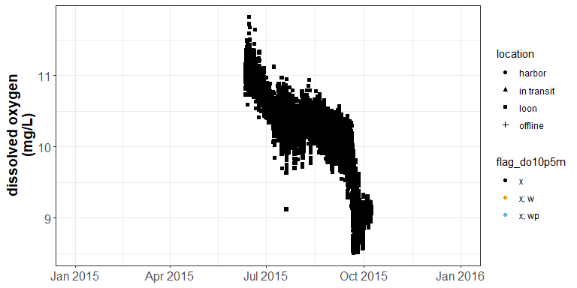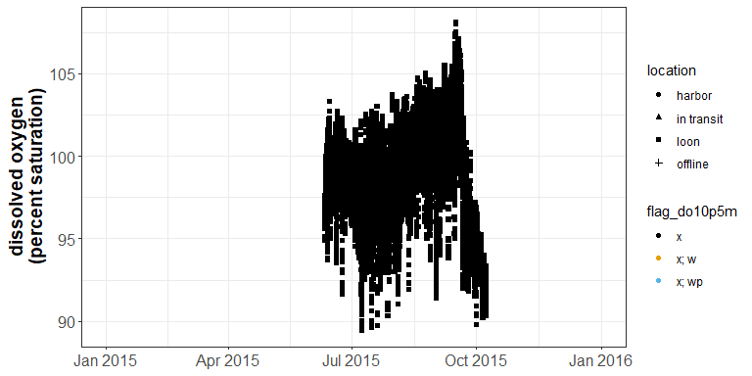

There were no offsets applied to the deep DO values in 2015.

# Conclusions

While the offsets applied at the data logger compensated for calibration issues at the sensor, the application of offset values was not systematic or continuous. Due to the sporadic nature of the offsets, we back-calculated raw DO values for consistency in the data stream and for end-users to determine the best course of action in correcting the DO data for their needs. See the *LSPA buoy DO Visual History* document within this data package.