Simulation-Based Power-Analysis for Factorial ANOVA Designs

|  |
| --- |
| Daniël Lakens1 & Aaron Caldwell2 |
| 1 Eindhoven University of Technology, The Netherlands |
| 2 Department of Health, Human Performance and Recreation, University of Arkansas, USA |
|  |

# Author note

All code used to create this manuscript is provided in an OSF repository at <https://osf.io/xxxxx/>.

Correspondence concerning this article should be addressed to Daniël Lakens, ATLAS 9.402, 5600 MB, Eindhoven, The Netherlands. E-mail: [D.Lakens@tue.nl](mailto:D.Lakens@tue.nl)

Abstract

Researchers need to design informative studies. When the goal of an experiment is to test a hypothesis based on a frequentist hypothesis test it is important to justify the sample size based on the statistical power of the study. However, researchers are faced with challenges when they try to calculate power for factorial ANOVA designs. First, current software solutions are limited as they do not allow power analyses for more complex designs involving multiple within factors. Second, they require partial eta-squared or Cohen’s f as input, which are not the most intuitive way to specify predicted effects in an ANOVA, and do not generalize to different experimental designs. We have created R functions and an online Shiny app that performs simulations for ANOVA designs for up to three factors with an unlimited number of levels. Predicted effects are entered by specifying means, standard deviations, and correlations (for within factors). The simulation provides a-priori power analyses for all effects in the ANOVA, and all simple comparisons. No other software is currently available that allows researchers to so easily perform power analyses for a wide range of ANOVA designs. The app plots *p*-value distributions for all tests, and allows researchers to select a range of options to correct for multiple comparisons. This tutorial will teach researchers how to perform power analysis for ANOVA designs, and through simulations illustrate important factors that determine the statistical power of factorial ANOVA designs.

*Keywords:* power analysis, ANOVA, hypothesis test, sample size justification

Word count: Main text contains 4654 words.

Simulation-Based Power-Analysis for Factorial ANOVA Designs

Statistical power is the probability of observing a statistically signficant result, given a specified effect size, alpha level, and sample size. When a researcher aims to analyze a study based on an analysis of variance (ANOVA) with the goal of observing a significant result the sample size of the study should be justified based on the statistical power of the test. A study that has low power to detect effects the researcher is interested in has a high Type 2 error rate, and leads to a high probability of saying there is no effect, when there actually is a true effect to be found. Several excellent resources exist that explain power analyses, including books (Aberson, 2019; Cohen, 1988), general reviews (Maxwell, Kelley, & Rausch, 2008), and practical primers (Brysbaert, under review; Perugini, Gallucci, & Costantini, 2018). Whereas power analyses for simple comparisons are relatively easy to perform, an a-priori power analysis for factorial ANOVA designs is a challenge. Available software solutions do not provide easy options for more complex designs (e.g., a 2x2x2 design, where the first factor is manipulated between participants, and the last two factors are manipulated within participants). Popular software solutions such as G*power require participants to enter their predictions as Cohen’s f or partial eta squared (), which are not the most intuitive way to specify a hypothesized pattern of results, and do not generalize to different experimental designs.

Here, we demonstrate how to perform power analyses for factorial ANOVA designs based on simulations. We provide R code and a Shiny app that can be used to calculate the statistical power based on a predicted pattern of means, standard deviations, and correlations (for within factors). Simulating studies, and calculating their *p*-values and effect sizes, are a useful way to gain a better understanding of the factors that determine the statistical power of hypothesis tests. After providing an introduction to statistical power in general, and for the *F*-test specifically, we will demonstrate how the power of factorial ANOVA designs depends on the pattern of means across conditions, the number of factors and levels, and the sample size. We will also illustrate the importance of controlling Type 1 error rates in exploratory ANOVA’s, and the importance to design studies that have high power for main effects and interactions in an ANOVA, but also for follow-up tests for simple effects.

# Factors That Determine Power in ANOVA Designs

You perform a study in which participants interact with an artificial voice assistant who sounds either cheerful or sad. You measure how much 80 participants in each condition enjoy interacting with the voice assistant on a line marking scale (coded continously from -5 to 5) and observe a mean of 0 in the sad condition, and a means of 1 in the cheerful condition, with an estimated standard deviation of 2. After submitting your manuscript for publications, reviewers ask you to add a study with a neutral control condition to examine whether cheerful voices increase, or sad voices decrease enjoyment (or both). Depending on what the mean in the neutral condition is, which sample size would you need to have a high powered study for the expected pattern or means? A collaborator suggests to switch from a between design to a within design, to more efficiently collect the data. Which consequence will this switching to a within-subject design have on the sample size planning? Because the effect size in the first study could be considered ‘medium’ based on the benchmarks by Cohen (1988), does it make sense to plan for a ‘medium’ effect size in either the between of within ANOVA design? And if you justify the sample size based on the ANOVA, will the study also have sufficient statistical power for the simple effects (or vice versa)?

Performing simulation studies is an excellent way to develop intuitions about these questions. The power in ANOVA designs depends on the pattern of means, the number of groups, the standard deviation, the correlation between dependent measures, the alpha level, and the sample size. After these factors have been specified, a simulation study can be perform to run the planned statistical test on generated data many times, and summarize the results. Where analytic power solutions exists in software such as G*Power for ANOVA designs with up to one within-subject factor, simulation studies are more flexible (and can for example be used to see what happens in a 3x3x3 within-subject design).

# Statistical Power When Comparing Differences Among Group Means

Let’s consider the initial study we described above, where two group means are compared. We can test the difference between two means with a *t*-test of a one-way single factor ANOVA, and the two tests are mathematically equivalent. Figure and Figure visualize the distribution of Cohen’s d and partial eta-squared that should be observed when there is no effect (grey curves) and when the observed difference between means equals the true effect. In both figures the light grey areas under the curve mark the observed results that would lead to a Type 1 error (observing a statistically significant result if the null-hypothesis is true) and the dark grey areas under the curve marks the observed effect sizes that would lead to a Type 2 error. An observed effect is statistically significant if the observed effect size is larger than the critical value. Critical values are often expressed as *t*-values or *F*-values, but can be expressed as effect sizes (Cohen’s d and partial eta-squared), and any observed effect size larger than the critical effect size will be statistically significant. The goal of power analysis is to choose a sample size so that the probability of observing a statistically significant effect for a specified effect size reaches a desired probability. In both Figures, 88.16% of the expected effect sizes, if the true effect size is d = 0.5 or = 0.0588 and 80 participants in each condition are collected, will be more extreme than the critical effect size (which is d = 0.312 or = 0.024).

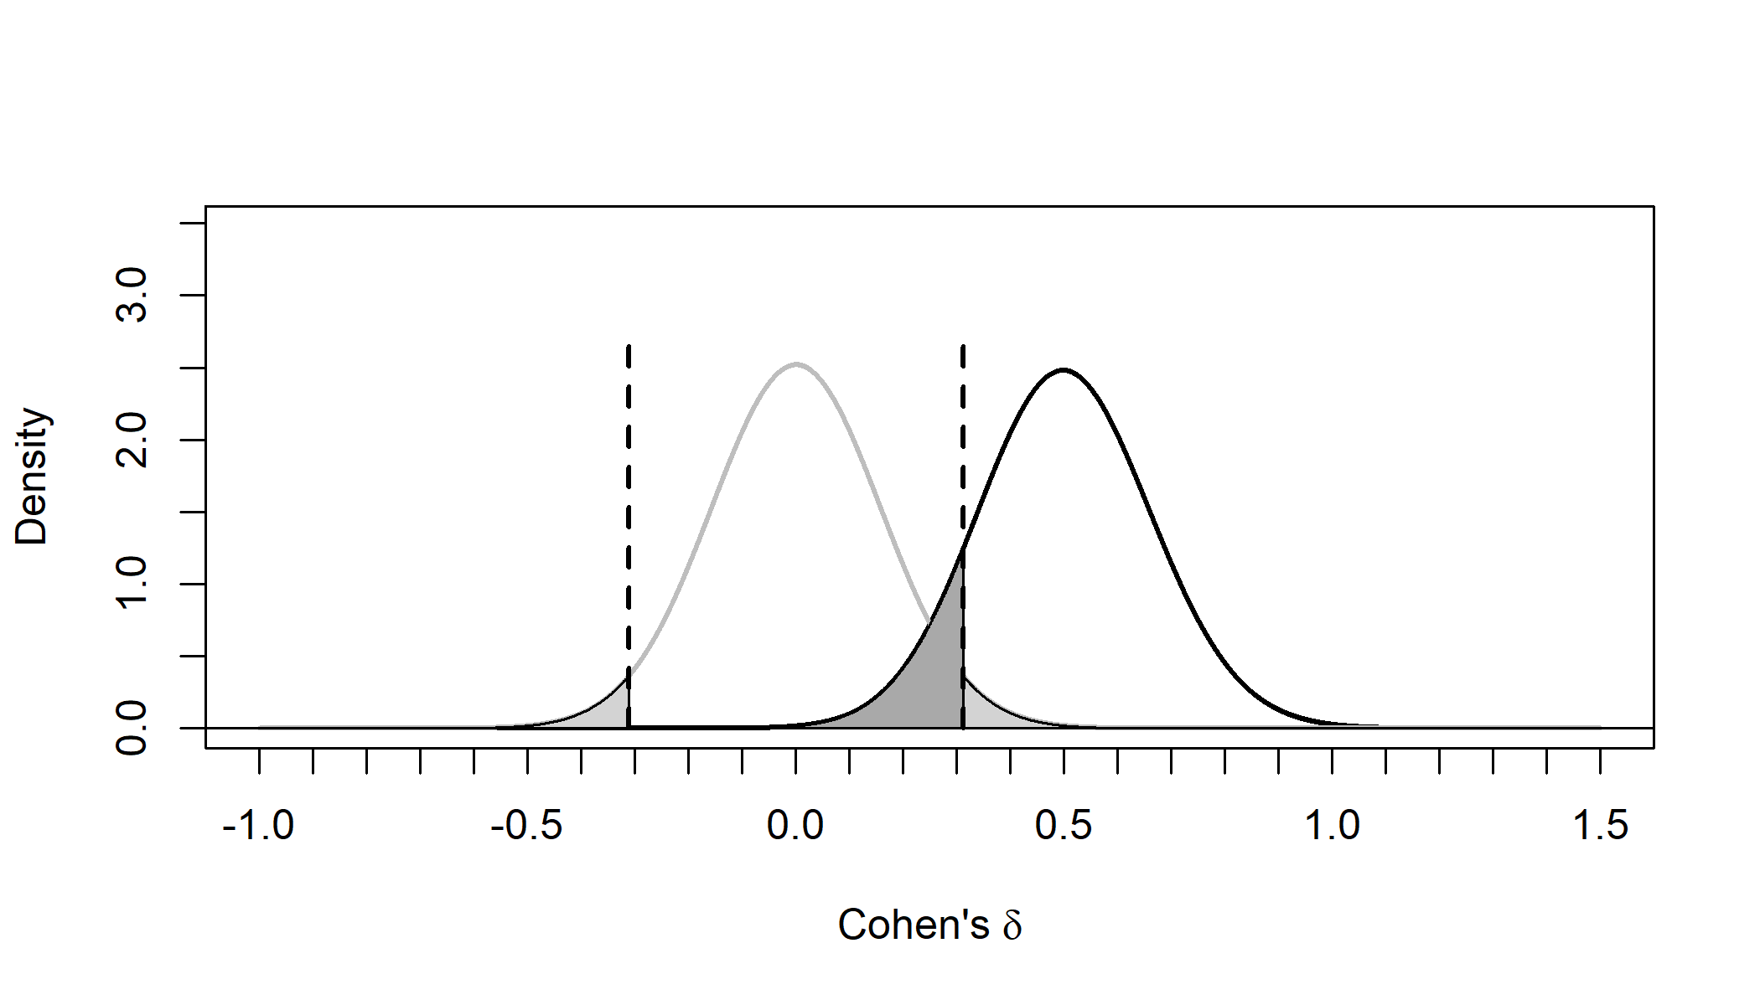

Figure 1 Distribution of Cohen’s d under the null-hypothesis (grey curve) and alternative hypothesis assuming d = 0.5 (black curve).

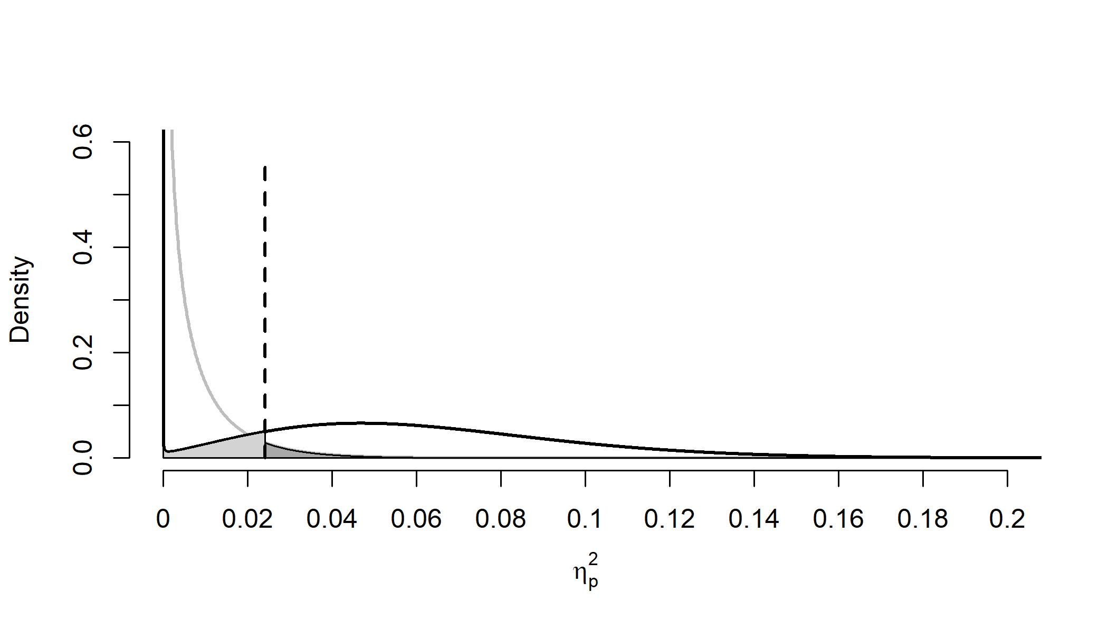

Figure 2 Distribution of eta-squared under the null-hypothesis (grey curve) and alternative hypothesis assuming partial eta-squared = 0.0588 (black curve).

Two relationships between the *t*-test and the *F*-test when comparing two means are worth pointing out. First, , or the *F*-value equals the *t*-value, squared. Whereas we typically think of a *t*-test as the difference between means, the relationship between the *t*-test and *F*-test reveals that we can also use the group means to calculate the variance of the difference between the two means . The *F*-test is used to compute the ratio of the between group variance and the within group variance, and the between group variance can be used to compare more than two means. An *F*-value of 1 means the two variances are equal (as is expected when the null-hypothesis is true) and Cohen’s f and would be zero. Second, for two groups the effect size for an ANOVA, Cohen’s f, is half the size of the effect size for standardized mean differences, Cohen’s d, or . Cohen’s d is calculated by dividing the difference between means by the standard deviation, or

If we have two groups with means of 1 and 2, and the standard deviation is 2, Cohen’s d is (2-1)/2, or 0.5. Cohen’s f is the standard deviation of the population means divided by the population standard deviation (Cohen, 1988), or:

where for equal sample sizes,

Because Cohen’s f is an essential part of power power analyses for factorial ANOVA designs, it is worth illustrating how it is calculated in an example. If we again take two means of 1 and 2, and a standard deviation of 2, the grand mean is 1.5. We subtract each condition mean from the grand mean, take the square, calculate the sum of squares, divide it by two, and take the square root. , and We see Cohen’s f is half as large as Cohen’s d. Power analyses for ANOVA are based on Cohen’s f, but popular power anaysis software such as G*Power (Faul, Erdfelder, Lang, & Buchner, 2007) also allows researchers to specify the effect size as partial eta-squared (). Partial eta-squared can be converted into Cohen’s f:

and Cohen’s f can be converted into partial eta-squared:

In the example above, . To calculate the statistical power assuming a specific true effect size we need the noncentrality parameter of the distribution. In both Figure and Figure we see examples of the non-central *t*-distribution and non-central *F*-distribution, or the shape of the expected test statistics when there is a true effect. Power calculations rely on the nonceptrality parameter (often referred to as lambda, or ). Based on (which specifies the shape of the expected distribution) and the critical test statistic (which specifies the part of the distribution that is more extreme than the test statistic needed for a statistically significant test result) we can calculate how often, in the long run, we can expect test results that will be statistically significant.

# Simulating Statistical Power for Different Factorial Designs

We have created R code and a Shiny app that simulate factorial ANOVA designs. At the core, the code generates data for each condition in the design, performs the test, and calculates the percentage of significant results and average effect size of all main effects and interactions, as well as all simple effects. It requires specifying the design of the study in a string of numbers (for the levels in each factor) and letters (a ‘b’ for between factors or ‘w’ for within factors). Our initial study above is a ‘2b’ or two level between subject design. For ease of interpreting the simulation results, the factors and levels can be named (for our example, Condtion, cheerful, sad). The planned sample size should be specified, which is 80 participants in each between subjects condition. The means for each condition should be specified (0 and 1), as well as the standard deviation (2). For within designs the correlation between variables should be specified. With these variables specified, the design is set up for the simulation. For a visual confirmation of the input, a figure is created that displays the means.

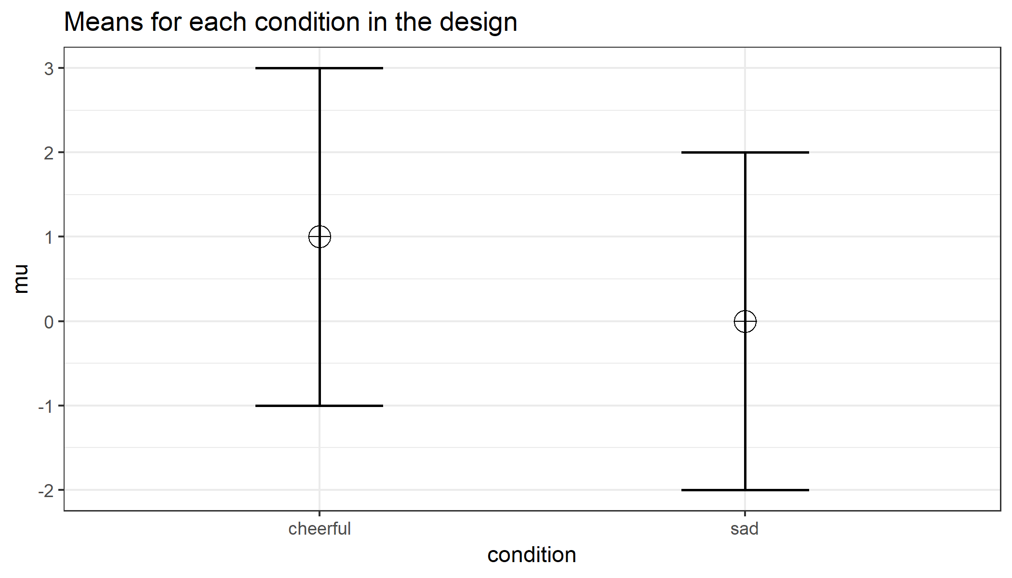

Figure 3 Vizualization for the expected means and confidence intervals for the four conditions.

The results of a simulation study will vary each time the simulation is performed (but can be made reproducible by specifying a ‘seed’ number). Results become more stable, the more simulations are performed, but the simulations also take longer. The functions that performs the simulation requires specifying the number of simulations, the alpha level for the tests, and any adjustment for multiple comparisons for the ANOVA. If 100.000 simulations are performed in R with a seed set to 2019 (these settings will be used for all simulation results in this manuscript), we see the statistical power (based on the percentage of *p* < results) is 88.03 and the average effect size is 0.06. The simulation also provides the results for the simple effects, based on *t*-tests comparing each group. Since there are only two groups in this example, the results for the statistical power are identical, but the effect size is -0.50, which is the effect size in Cohen’s d. Now the basic idea behind the simulation is clear, we can start exploring how changing the experimental design influences our power. We will first examine what happens if we add a third condition to the design. Let’s assume we expect the neutral voice condition to fall either between the cheerful and sad conditions, or perhaps to be equal to the cheerful condition (based on the idea that the sad voice leads to less enjoyment, but the cheerful voice does not lead to more enjoyment). The design now has 3 between subject conditions, and we can explore what happens if we would collect 80 participants in each condition.

If we assume the mean falls exactly between between the cheerful and sad conditions the simulations show the statistical power for our design is reduced to 81.71, and the effect size is 0.05. If we assume the mean the mean is equal to the cheerful condition, the power increases to 91.57. Compared to the two group design, three things have changed. First, an additional group was added to the design, which increases the numerator degrees of freedom, which makes the non-central *F*-distribution more similar to the central *F*-distribution, and reduces the statistical power. Second, the total sample size is 50% larger, which increases the statistical power. Third, the effect size has decreased, which reduces the statistical power. The exact effect of these three changes on the statistical power is difficult to predict. The most important conclusion based on these simuations is that when the design is changed, one can not assume the effect size remains unchanged.

What happens if we would perform the second study as a within-participants design? Instead of collecting three groups of participants, we only collect one group, and let this group evaluate the cheerful, neutral, and sad voice assistants. The sample size needed in a within-design (), relative to the sample needed in between-design (), is (from Maxwell & Delaney, 2004, p. 562, formula 47):

Here *a* is the number of within-subject levels, is the correlation between the measurements, and the formula assumes normal distributions and compound symmetry, and ignores the difference in degrees of freedom between the two types of tests, so it is a rough (but useful) approximation. Whenever the correlation between dependent measures is positive, the sample size that is needed in a within-participants condition will be smaller than the requires sample size for a between-participants condition.

We need to be able to estimate the correlation between the dependent variables we can expect. Ideally, this estimate will be based on data from previous experiments. If we plan to collect 80 participants, and assume the correlation between all dependent variables is 0.5, the power for the repeated-measures ANOVA is 98.29. Note that simulation studies allow for great flexibility, and the Shiny app also allows researchers to enter a correlation matrix specifying the expected correlation between each individual pair of measurements, instead of assuming the correlations between dependent variables are identical for all pairs.

# Power for Interactions

The effect size for an ANOVA design depends on the pattern of means. Let’s assume the researcher aims to perform a follow-up test to examine the effect of a second factor on the enjoyment of interacting with an artificial voice assistant. In addition to making the voice sound cheerful or sad, a second factor is introduced by making the voice sound more robotic compared to the default human-like voice. Different patterns of results could be expected. Either the same effect is observed for robotic voices, or no effect is observed for robotic voices, or the opposite effect is observed for robotic voices (a ‘Marvin-the-Depressed-Robot-Effect’). In the first case, we will only observe a main effect of voice, but in the other two scenarios there is an interaction effect between human-likeness of the voice and the emotional tone of the voice. We can start by simulating the power for a cross-over interaction for a 2x2 between-participant design with 80 participants in each group.

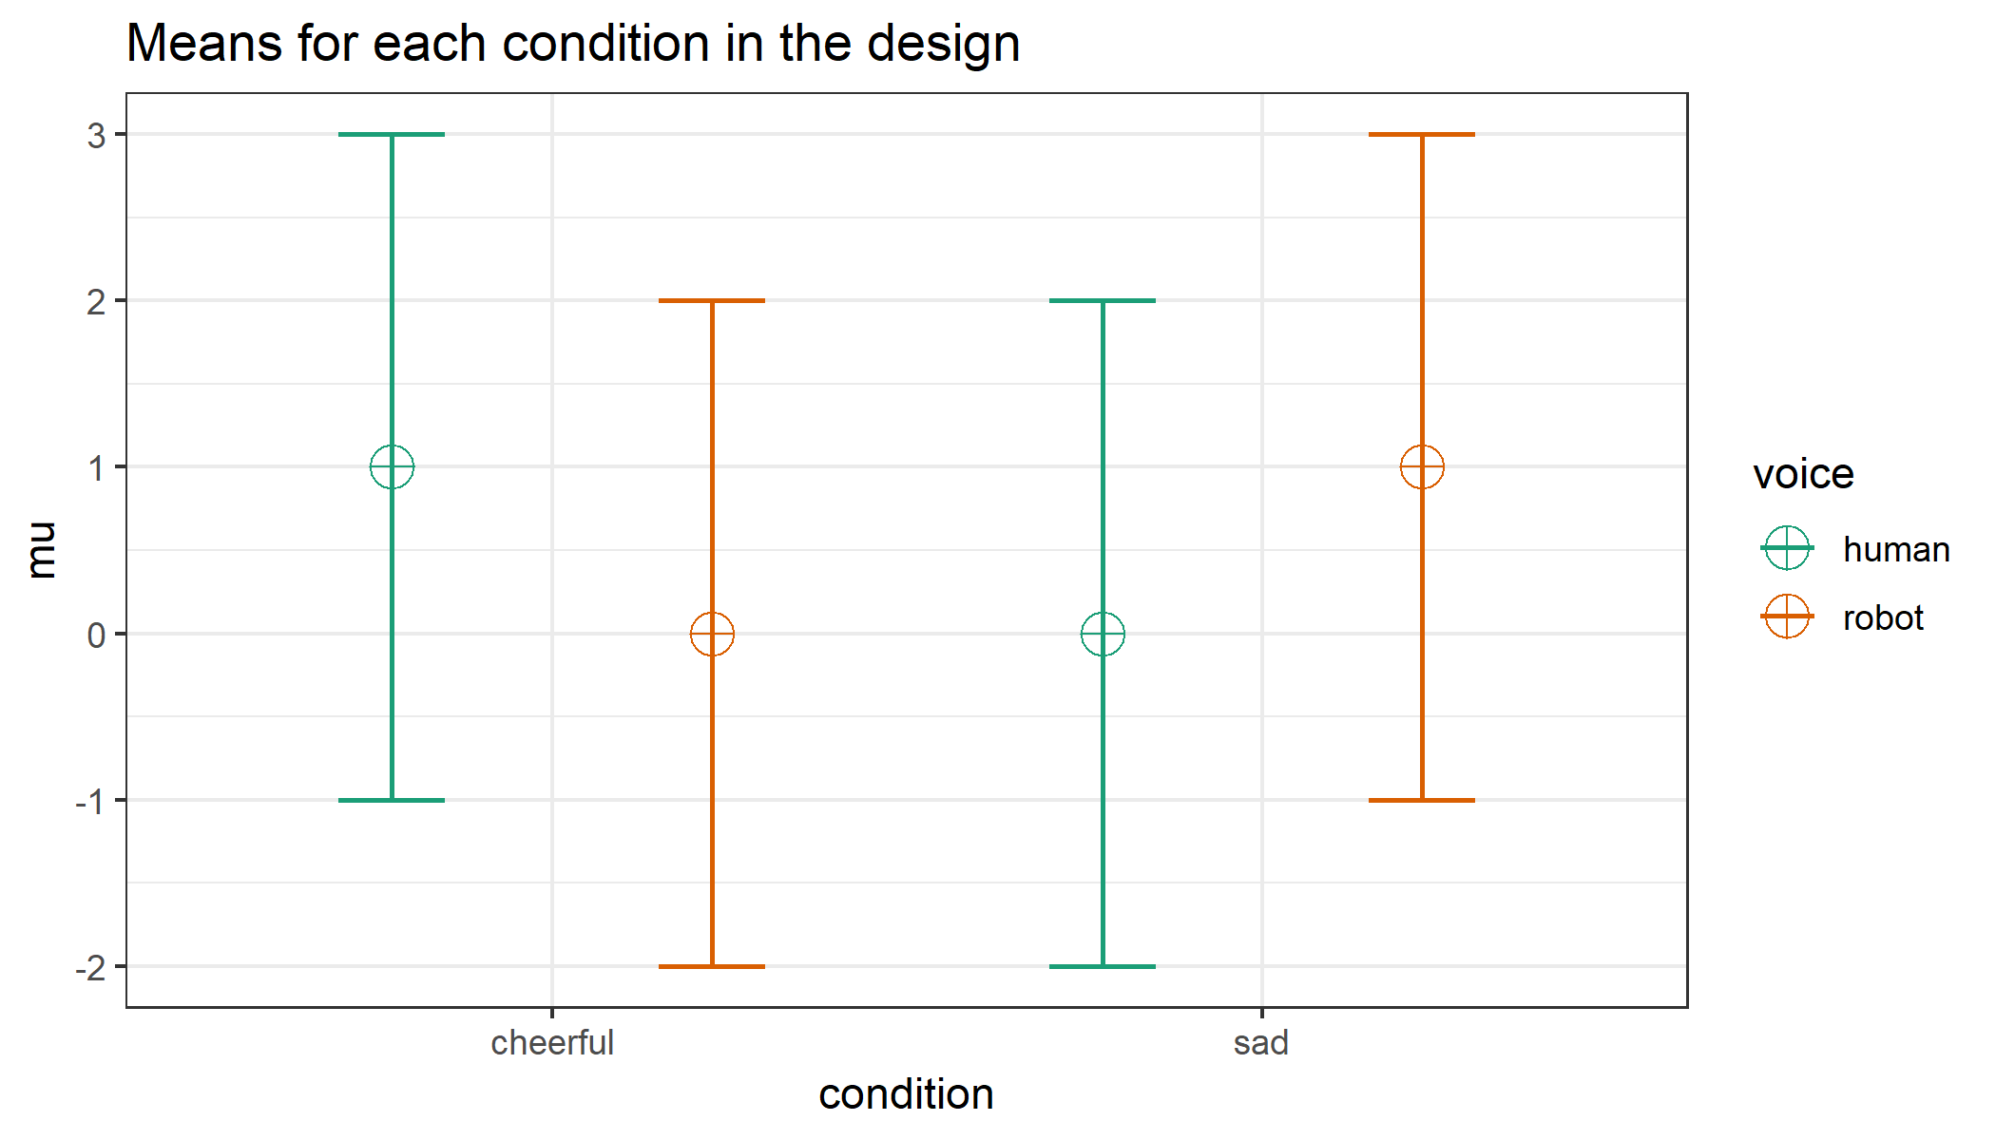

Figure 4 Vizualization for the expected means and confidence intervals for each condition.

Mathematically the interaction effect is computed as the cell mean minus the sum of the grand mean, the marginal mean in row i minus the grand mean, and the marginal mean in column j minus grand mean. For example, for the cheerful human-like voice condition this is 1 (the value in the cell) - (0.5 [the grand mean] + 0.5 [the cell mean minus the marginal mean in row 1, 0.5] + 0.5 [the cell mean minus the marginal mean in column 2, 0.5]). 1 - (0.5 + (0.5) + (0.5)) = -0.5. Completing this for all four cells gives the values -0.5, 0.5, 0.5, -0.5. Cohen’s f is then . Cohen’s f for the 2x2 design is the same as for the two-group design, but we have collected twice as many people in total (4 times 80). Simulations show we have would have exactly the same power for a cross-over (or sometimes called ‘disordinal’) interaction is we halved the sample size per group from 80 to 40. Main effects in an ANOVA are based on the mean averaged over the other factors (e.g., the main effect of human-like versus robot-like voice, irrespective of whether it is cheerful or sad). The interaction effect, which can be contrast coded as 1, -1, -1, 1, is similarly a test of whether the effects are non-additive based on the scores in each cell, where the null-hypothesis of no additive effect can be rejected if the deviation expected when effects in each cell would be purely additive can be rejected. The key insight here is that the total sample size determines the power (cf. Westfall (2015)).

We can also examine what the statistical power would be if the pattern of results indicated that there was no difference in interacting with a cheerful of sad conversational agent with a robot voice. In this case, we expect an ‘ordinal’ interaction (the means for the human-like voice are never lower than the means for the robot-like voice, and thus there is no cross-over effect). The pattern of means is now 1, 0, 0, 0. As has been pointed out (Giner-Sorolla, 2018; Simonsohn, 2014) these designs require larger samples to have the same power to detect the interaction compared to the two-group comparison. The reason for this is that the effect size is only half as large, with Cohen’s f = 0.125 (compared to 0.25 in the cross-over interaction). To achieve the same power as for the two-group comparison, a total sample size of 635 is required, almost four times as large as the sample size for the two-group comparison.

The power in the 2x2 ordinal interaction where only one cell mean differs from the other three cell means is identical to the power we would have if the single mean was twice as far from the remaining means (for a pattern of means of 2, 0, 0, 0). Similarly, if we would examine a 2x2x2 interaction where only one cell differs from the other means, Cohen’s f would be 0.25 only when the pattern of means is 4, 0, 0, 0, 0, 0, 0, 0 across the eight cells. The take-home message is that the effect size, and thus the power, for interactions in ANOVA designs depends on the pattern of the means. A ‘medium’ effect size translates into a much more extreme pattern of means in an ordinal interaction than in a disordinal (crossover) interaction, or in a 2x2x2 interaction compared to a 2x2 interaction. For this reason, it is not very intuitive to start a power analysis based on an assumption of the effect size. The same effect size can represent very different patterns of means depending on the type of interaction and the number of factors (see also Perugini et al. (2018)). Instead, it might be more intuitive to think about the pattern of means that you expect, and compute the corresponding Cohen’s f.

# Power for Within Designs

Whereas in an independent *t*-test the two measurements are uncorrelated, in a within design the observations are correlated. This has an effect on the standard deviation of the difference scores. In turn, because the standardized effect size is the mean difference divided by the standard deviation of the difference scores, the correlation has an effect on the standardized mean difference in a within design, referred to as Cohen’s (because it is the effect size of the difference score between x and y, z). The relation is:

Therefore, the relation between and d is . As Cohen (1988) writes: “In other words, a given difference between population means for matched (dependent) samples is standardized by a value which is as large as would be the case were they independent”. If we enter a correlation of 0.5 in the formula, we get . In other words, when the correlation is 0.5, d = . When there is a strong correlation between dependent variables, for example *r* = 0.9, we get , and a of 1 in a within design is equivalent to a d = 0.45 in a between design. Reversely, , so with a *r* = 0.9, a d of 1 would be a = 2.24. Some consider this increase in compared to d when observations are strongly correlated an ‘inflation’ when effect sizes are estimated, but since the reduction in the standard deviation of the difference scores due to the correlation makes it easier to distinguish signal from noise in a hypothesis test, Cohen’s is the effect size used in power analyses.

There is no equivalent Cohen’s for a within subject ANOVA, as there is a Cohen’s for a dependent *t*-test. Instead, the value for lambda () is adjusted based on the correlation. In a between-participants one-way ANOVA lambda is calculated as:

where f is Cohen’s f and N is the total sample size. For a one-way within-participant design lambda is multiplied by *u*, a correction for within-designs, calculated as:

where k is the number of levels of the within-participant factor, and is the correlation between dependent variables. If the correlation is 0, Equation @ref{eq:within-n} shows that the required sample size is reduced only because each participants contributes multiple measurements, so for two groups the required sample size is halved. If the correlation is larger than zero, both for the dependent *t*-test as for the repeated measures ANOVA, the required sample size to achieve a desired level of statistical power decreases as the correlation increases. Note that in the simulation, the correlation can be specified for each pair of measurements, but in the formula the correlation is assumed to be the same for all pairs.

Cohen’s f is identical in within and between designs. However, Equation (??) and (??) no longer hold when measurements are correlated. The average effect size for a between design with 80 participants in each condition, means of 1, 0.5, and 0, and a standard deviation of 2 was 0.05, while the estimated effect size increased to 0.12 with a correlation of 0.7 between dependent measurements. The default settings in G*Power expect an f or that does not incorporate the correlation, while the correlation is incorporated in the output of software package such as SPSS. For a one-way within design, Cohen’s f can be converted into Cohen’s f as SPSS provides it through:

and subsequently tranformed to through Equation (??).

# Power for simple comparisons

Although an initial goal when performing an ANOVA might be to test the *omnibus null hypothesis*, which answers the question whether there are *any* differences between group means, we often want to know which groups differ from each other. Thus, an ANOVA is often followd up by individual comparisons (whether *planned* or *post-hoc*). One feature of the simulation is that it provides the statistical power for all individual comparisons that can be performed. The power and effect size estimates are based on *t*-test. Although *t*-t-tests ignore the variance estimates from other groups (when factors have more than 2 levels), which can yield power benefits, the homogeneity assumption is often not warranted in psychological research. Violations of the homogeneity assumption impact Type 1 error rates (Delacre, Lakens, & Leys, 2017; Delacre, Lakens, Mora, & Leys, 2018).  
Furthermore, *t*-tests allow researchers to specify directional predictions which increase the power of individual comparisons.

Power analysis for individual comparisons are relatively straightforward and can easily be done in all power analysis software. Nevertheless, in our anecdotal experience evaluating sample size justifications for an ethical review board researchers often forget to power their ANOVA designs for follow-up tests. We hope that providing a complete overview of the tests a researcher might be interested in will prevent this. Furthermore, researchers need to take the correlation between dependent measures into account (e.g., enter Cohen’s instead of d), which the simulation does automatically.

For example, comsider a 2x2 mixed ANOVA with 2 levels manipulated within and two between, with a predicted crossover interaction (means 1, 0, 0, 1), a standard deviation of 2, a correlation between dependent observations of 0.7, and 20 participants per between subjects condition. Although the power for the cross-over interaction is high (power_result$main_results$power[3]%), the power for the independent between subject comparisons where there is a difference is only power_result$pc_results$power[2]%, while the power for correlated between subjects effects is power_result$pc_results$power[1]%. Sometimes the interaction in the ANOVA will have more power than the independent comparisons (i.e., in the case of a cross-over interaction) and sometimes the power for the interacction will be lower than independent comparisons.

# Type 1 Error Control in Exploratory ANOVA’s

In a 2x2x2 design, an ANOVA will give the test results for three main effects, three two-way interactions, and one three-way interaction. Thatâs 7 statistical tests. The probability of making at least one Type 1 error in a single 2x2x2 ANOVA is = 30%.

# P-value dsitributions

# References

Aberson, C. L. (2019). *Applied Power Analysis for the Behavioral Sciences: 2nd Edition* (2 edition.). New York: Routledge.

Brysbaert, M. (under review). How many participants do we have to include in properly powered experiments? A tutorial of power analysis with some simple guidelines. *Journal of Cognition*.

Cohen, J. (1988). *Statistical power analysis for the behavioral sciences* (2nd ed.). Hillsdale, N.J: L. Erlbaum Associates.

Delacre, M., Lakens, D., & Leys, C. (2017). Why Psychologists Should by Default Use Welch’s *t*-test Instead of Student’s *t*-test. *International Review of Social Psychology*, *30*(1). doi:[10.5334/irsp.82](https://doi.org/10.5334/irsp.82)

Delacre, M., Lakens, D., Mora, Y., & Leys, C. (2018). Why Psychologists Should Always Report the W-test Instead of the F-Test ANOVA. *PsyArXiv*. doi:[10.17605/OSF.IO/WNEZG](https://doi.org/10.17605/OSF.IO/WNEZG)

Faul, F., Erdfelder, E., Lang, A.-G., & Buchner, A. (2007). GPower 3: A flexible statistical power analysis program for the social, behavioral, and biomedical sciences. *Behavior Research Methods*, *39*(2), 175–191. doi:[10.3758/BF03193146](https://doi.org/10.3758/BF03193146)

Giner-Sorolla, R. (2018, January). Powering Your Interaction. *Approaching Significance*.

Maxwell, S. E., Kelley, K., & Rausch, J. R. (2008). Sample Size Planning for Statistical Power and Accuracy in Parameter Estimation. *Annual Review of Psychology*, *59*(1), 537–563. doi:[10.1146/annurev.psych.59.103006.093735](https://doi.org/10.1146/annurev.psych.59.103006.093735)

Perugini, M., Gallucci, M., & Costantini, G. (2018). A Practical Primer To Power Analysis for Simple Experimental Designs. *International Review of Social Psychology*, *31*(1), 20. doi:[10.5334/irsp.181](https://doi.org/10.5334/irsp.181)

Simonsohn, U. (2014, March). No-way Interactions. *Data Colada*.

Westfall, J. (2015, May). Think about total N, not n per cell. *Cookie Scientist*.