MLB Championship Success:
Data Analysis on Determining Play-Off Metrics

Ranson Touch
Oregon State University
CS 332 – Intro to Applied Data Science
Computer Science Major
touchr@oregonstate.edu

Table of Contents
Introduction 1
Data Gathering 5
Direct Data Download(s) 5
Data Gathering Using an API 7
Data Cleaning 11
Los Angeles Dodgers Regular Season Batting Data 11
Los Angeles Dodgers Batting Post-Season Stats 16
Unsupervised Learning with Kmeans Clustering 22
Postseason Dodger Batter Stats 22
K = 2 25
K = 3 27
K = 4 29
Conclusions 31
Supervised Learning with Decision Trees 32
Conclusion 38
Conclusions 40
Reference 43

Introduction
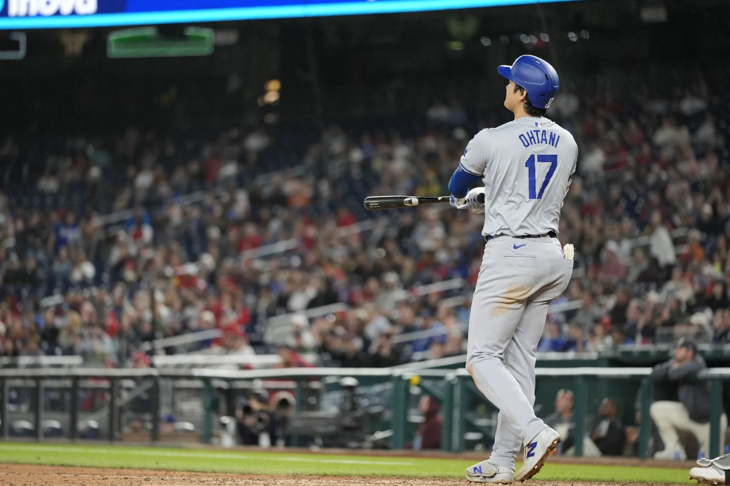

Figure 1: The "GOAT" of baseball
Source: Fanatics
The MLB Postseason is often described as a different game from the 162-game regular season—pitching changes shorten, bullpen leverage spikes, and small edges on the margins (defense, baserunning, matchups) loom large. Regular-season dominance doesn’t always translate into October success, which makes identifying the metrics that actually move series outcomes both interesting and useful. Fans are used to seeing “100-win teams” get bounced early while supposedly less impressive clubs catch fire at just the right time, which only adds to the mystery of what really works in October.
I chose this topic because I love baseball analytics and want to understand which measurable factors separate World Series contenders from early exits. As a fan, I’ve watched teams with elite rotations ride pitching to a title and others win by combining on-base skills, power, and airtight defense. Those contrasts led me to ask: what quantifiable elements best predict postseason advancement in MLB? Is it mainly run prevention, overwhelming lineups, or some balance of the two that helps a team keep moving through each round?
This question matters to a lot of different people. Front offices and coaching staffs are constantly trying to build rosters that are not only good from April to September, but also built to survive the chaos of October. Players feel the difference too—one clutch swing or one defensive mistake can define how their entire season is remembered. And fans, of course, live and die with each playoff game, arguing about whether their team “has the right mix” to actually win it all. Having a clearer sense of which on-field strengths tend to show up in deeper runs can help everyone talk about postseason performance in a way that goes beyond vague ideas like “clutch” or “momentum.”
To make this big question more concrete, this project looks at patterns in postseason performance over multiple years and asks what kinds of strengths tend to show up in teams that advance. Do successful playoff teams lean more on shutdown pitching staffs, or do they usually have lineups that combine getting on base with real power? Are tight, low-scoring wins more common for teams that go far, or do future champions tend to outslug their opponents? By framing the topic this way, the goal is to connect the drama of October baseball with specific, measurable on-field traits that fans and decision-makers already care about.
In the end, this project is about turning the familiar story of “the postseason is different” into something more concrete. Instead of just accepting that anything can happen in October, it asks whether there are consistent patterns behind the teams that keep winning series and the ones that go home early. The answers won’t remove all the randomness that makes the playoffs exciting, but they can help explain why certain teams feel built for October—and what might be missing when they fall short.
Research Questions:
- Which team metrics predict series wins most strongly?
  - Compare hitting metrics (OPS, wOBA, HR/PA), pitching metrics (ERA-, FIP-, K-BB%), and defense (Def runs saved, OAA) vs. round advancement.
- Is run prevention (pitching + defense) more important than run production in October?
  - Model series outcomes using composite prevention metrics (staff K-BB%, WHIP, bullpen xFIP in high leverage, team OAA) vs. production metrics (wOBA, ISO).
- How does home-run rate and quality of contact relate to postseason success?
  - Examine HR rate, Barrel% and Hard-Hit% vs. series outcomes.
- Do deeper bullpens and high-leverage performance drive advancement?
  - Use bullpen innings share, average Leverage Index (gmLI), and late-inning K-BB%/xFIP to predict wins.
- Is clutch performance (late/close) a reliable predictor or just noise?
  - Compare regular-season “late & close” production to postseason results; test stability year-over-year.
- How big is home-field advantage in best-of series?
  - Estimate win probability differences by home vs. away, controlling for opponent strength.
- Does contact quality vs. contact rate matter more in October?
  - Contrast high-contact teams (low K%) with high-damage teams (high ISO/Barrel%) on advancement.
- Does baserunning (SB%, Extra Bases Taken) correlate with postseason wins?
  - Analyze SB attempts/success and BsR (baserunning runs) vs. round outcomes.
- Which individual advanced stats (WAR, WPA, Win Probability Added in postseason, xwOBA) best associate with deep runs?
  - Compare profiles of teams with multiple high-WAR or high-WPA performers vs. early exits.
- Do teams with multiple frontline starters outperform those led by one ace?
- Measure playoff rotation depth (top-3 SP xERA/xFIP) vs. series advancement.

Data Gathering

Direct Data Download(s)
- Kaggle – Dodgers Batting & Pitching (1958 – 2023)
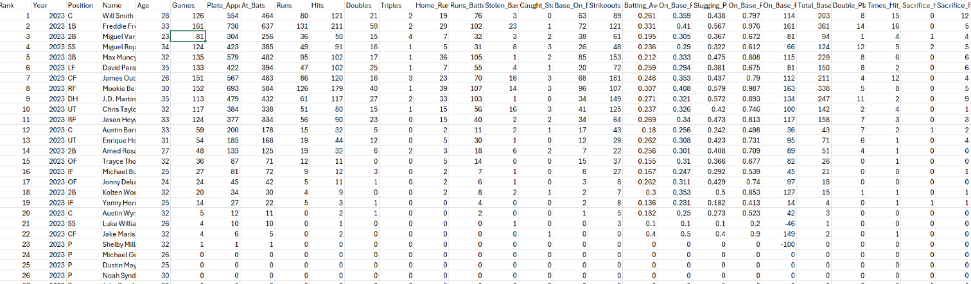
  - https://www.kaggle.com/datasets/mattop/los-angeles-dodgers-batting-and-pitching-1958-2023
Figure 2: Player Stats w/ advanced metrics from Excel
The dataset I’m using comes from Kaggle and contains team-season batting and pitching data for the Los Angeles Dodgers from 1958 through 2023. It’s a labeled, quantitative time series that spans the club’s modern era in Los Angeles and is well-suited for long-form content. Furthermore, the Dodgers are a consistent winning team which allows for data to explore why exactly the Dodgers are such an incredible franchise.
On the batting side, the file typically includes identifiers such as season/year along with common team metrics—for example G/PA/AB (games, plate appearances, at-bats), R/H/2B/3B/HR/RBI, BB/SO/SB/CS, and rate stats like AVG (batting average), OBP (on-base percentage), SLG (slugging), and OPS (on-base plus slugging). The pitching portion provides G/GS/IP (games, starts, innings), H/R/ER/HR, BB/SO, and run-prevention/efficiency indicators such as ERA and often WHIP; many historical team datasets also include saves and other summary totals. Together, these variables give a comprehensive view of the Dodgers’ offensive production and run prevention by season, enabling comparisons across the time periods of Dodgers dominance.
This dataset is valuable for studying postseason readiness and overall team quality because it allows you to connect run creation (e.g., OBP/SLG/OPS, HR rate) with run prevention (e.g., ERA, WHIP, strikeout-to-walk profile) at the team level. You can, for example, identify seasons characterized by elite contact/OBP teams versus true-outcome power teams, or rotations/bullpens that drove success via high strikeout rates and low walk rates. Since the data are organized by year, it’s straightforward to align regular-season performance with postseason outcomes, highlight standout seasons, and quantify how shifts in strategy (small ball vs. power; starter-heavy vs. bullpen-centric) correlate with wins.
- Kaggle – MLB Pitching Data
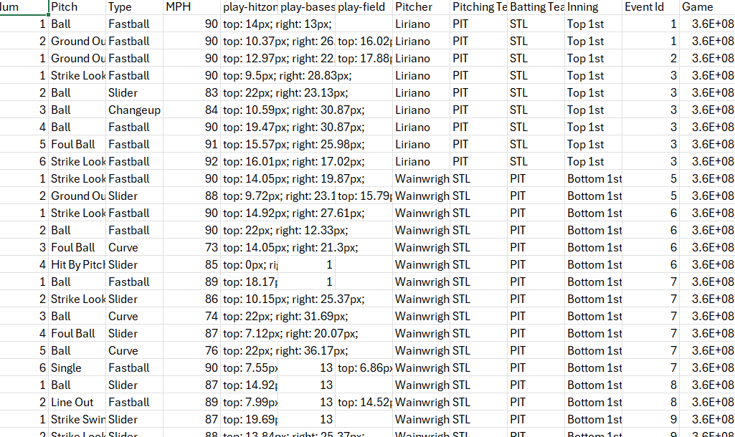
  - https://www.kaggle.com/datasets/josephvm/mlb-game-data?select=games.csv
Figure 3: Pitching Data
The data-set I’ve gathered is from the website Kaggle. It is a mixed data set that contains both qualitative and quantitative data sets. The qualitative columns are the pitcher, pitch, type of pitch, pitching team, batting team and inning. The qualitative columns are the mph (miles per hour), the play-hitzone, play-bases and play-field. This is a comprehensive dataset for pitching that allows to see what specific pitches are strongest against specific teams. It goes through each individual pitch for every team. This creates an incredibly large dataset that was too massive to see past a certain point. There are over 8 columns (variables) and has over 1000 rows. In order to see everything, I must use python to extract the specific content that I want to use.
This data-set will help forward me in my goal to assert what specific pitches work directly towards play-off success. What’s the average speed for pitches to obtain maximum success? What percentage of pitches work better from the 1st Inning to the 9th Inning? Are there any types of pitches that work better during overtime? All these questions can be answered through the amount of extensive pitching data from the data-set.

Data Gathering Using an API
- MLB StatsAPI (No Key Required)
  - Base URL: https://statsapi.mlb.com/api/v1
  - Query URL: https://statsapi.mlb.com/api/v1/schedule/postseason?season=2024
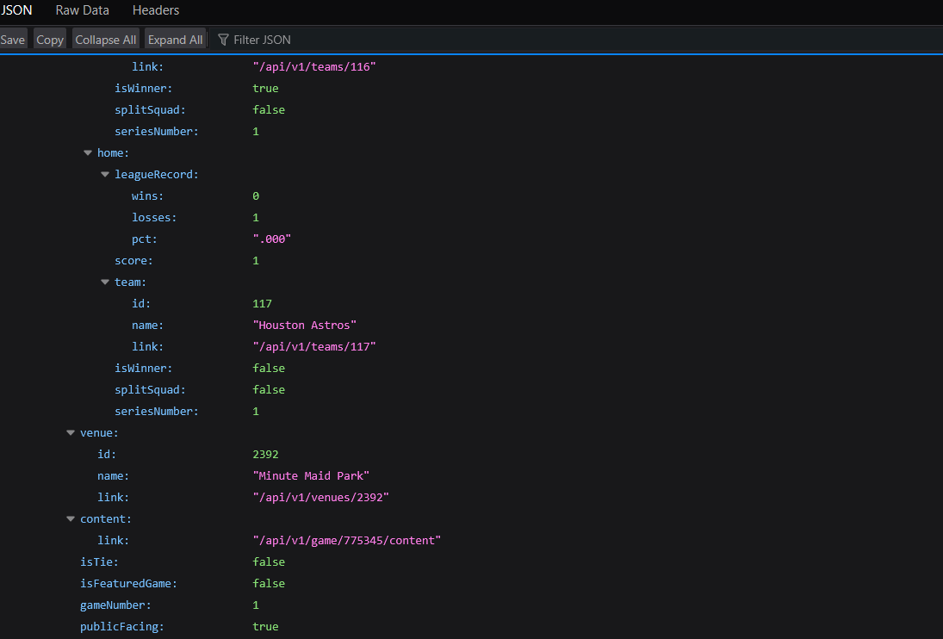
  - Box Scores: https://statsapi.mlb.com/api/v1/game/{gamePk}/boxscore
Figure 4: JSON Data

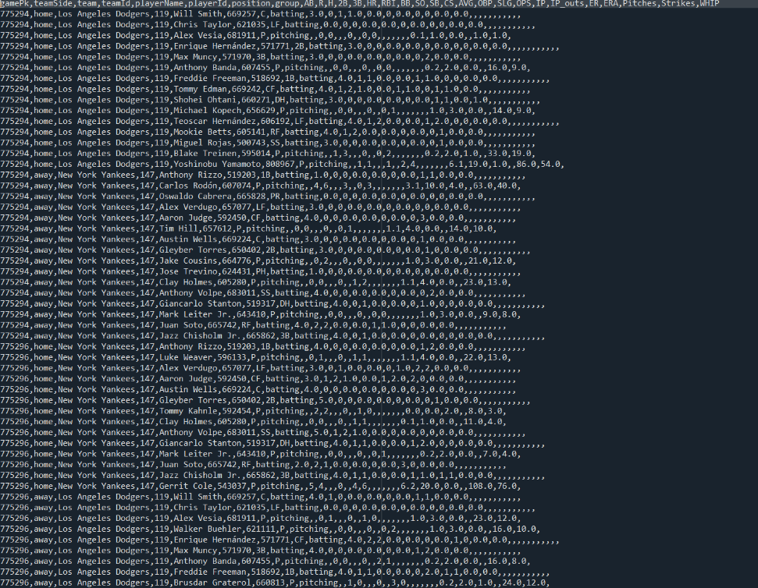
I originally chose to work on the NBA play-off’s but obtaining an API for NBA stats was too complicated and expensive. I used the MLB Stats API because they do not require a key nor is it expensive. Everything is public free information which allows the actual data analysis to be easier. It’s an official JSON API that exposes teams, schedules, games, box-scores, play-by-play, and advanced stats. I created a python code to extract specific data from a certain date during the MLB season. I chose to extract the postseason stats during the 2024 Play-Off’s.
Figure 5: MLB Postseason 2024 Raw Data from Python
With my code, I requested a specific date – the postseason games for the 2024 season. I called upon the postseason bracket endpoint: GET /schedule/postseason?season=2024. Next, I traversed the nested JSON and collected every gamePK (Game ID) value. This allowed for me to obtain every postseason game for 2024. For every gamePK, I called GET /game/{gamePK}/boxscore. This allowed me to obtain data for each player on each team. The specific stats I got were for both sides, Batting and Pitching. The specific stats are listed below.
Batting
- AB (At-Bats)
- R (Runs Scored)
- H (Hits)
- 2B (Doubles)
- 3B (Triples)
- HR (Home Runs)
- RBI (Runs Batted In)
- BB (Walks / Bases on Balls)
- SO (Strikeouts)
- SB (Stolen Bases)
- CS (Caught Stealing)
- AVG (Batting Average)
- OBP (On-Base Percentage)
- SLG (Slugging Percentage)
- OPS (On-Base Plus Slugging)
Pitching
- IP (Innings Pitched — measured in outs/3; e.g., 5.2 = 5 innings + 2 outs)
- H (Hits Allowed)
- R (Runs Allowed)
- ER (Earned Runs)
- BB (Walks Issued / Bases on Balls)
- SO (Strikeouts)
- HR (Home Runs Allowed)
- ERA (Earned Run Average — earned runs per 9 IP)
- Pitches (Total Pitches Thrown)
- Strikes (Total Strikes Thrown)
- WHIP (Walks + Hits per Inning Pitched)
After obtaining the data, I normalized the JSON into a flat table with one row per player-game. Upon the finished data, I saved everything to CSV file for data analysis.
The data-set will allow me to reach my goal of specific traits to look out for during the play-offs. What type of players step up the most during the postseason? Is there a specific type of player that is necessary?

Data Cleaning

Los Angeles Dodgers Regular Season Batting Data
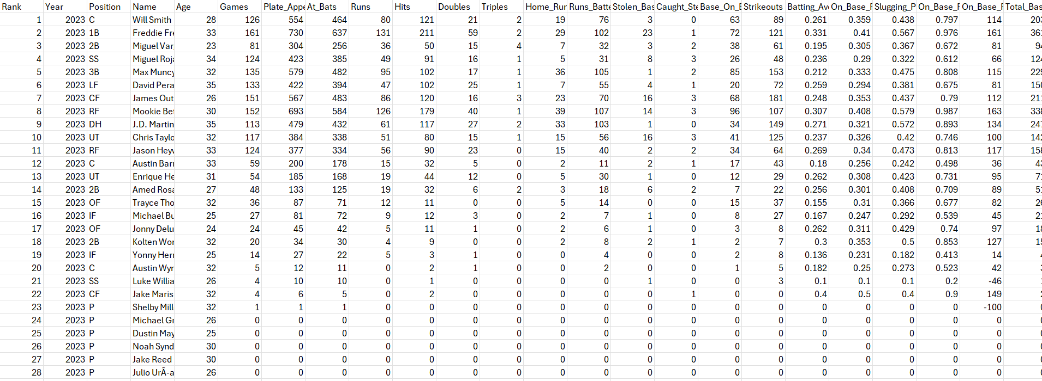
Figure 6: Before Batting Data for Dodgers
I am using the Los Angeles Dodgers batting dataset and will perform targeted cleaning. First, I used Python to validate data integrity by inspecting each column’s data type; all fields matched their expected types. Rather than correcting types, I will streamline the dataset by removing variables that are not needed for my analysis. The retained columns are Year, Position, Name, Age, Batting Average, On-Base Percentage, and Slugging Percentage. Their data types are as follows: Year — int64; Position — object; Name — object; Age — int64; Batting Average — float64; On-Base Percentage — float64; Slugging Percentage — float64. These results indicate no type-related quality issues. For example, if year had a word in it, it would no longer say that it was an int64. The same could be said in reverse for columns such as Batting Average or On-Base Percentage.
I will use Year, Position, Name, and Age to identify each player and provide their respective role and developmental context. At-Bat quantifies how many times a player was given a chance to bat. Batting Average is included as a core measure of contact and hit frequency, while On-Base Percentage captures the ability to reach base (including walks and HBP), and Slugging Percentage reflects power production. Together, these variables offer a concise, non-redundant view of player performance suitable for trend analysis and comparative evaluation.
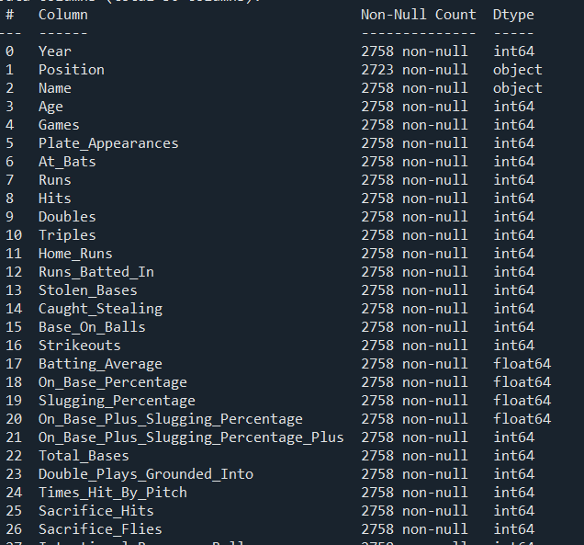
To ensure that data is completely clean, I used Python to see if there were any empty columns. I found out there are no empty columns.
Figure 7: Null Count
The next step is to ensure that no data goes beyond the reasonable expectations of stats. For example, Years should not be before the 1900s, Age should not go below 16 or above 60, Batting Average should not go above 1, On-Base Percentage should not go above 1.2 and Slugging Percentage should not go above 2.5.
Figure 8: Bad Count is 0
The next step is to ensure if there are any outliers for the data. Using Python, I created a boxplot to show the outliers for the Batting Average, On-Base Percentage, and Slugging Percentage to reveal what they are and if they are valid.
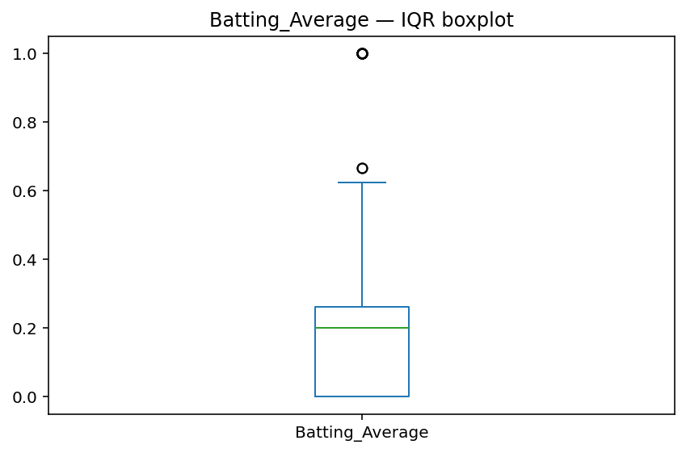
Batting Average has a few outliers beyond the medium but can be explained through short sampling of a few players throughout the Dodger’s season. They may reflect a player with a few hits over very few at-bats which can post a Batting Average close to 1.0000. With that in mind, there is no need to remove the data from our research.
Figure 9: Outliers
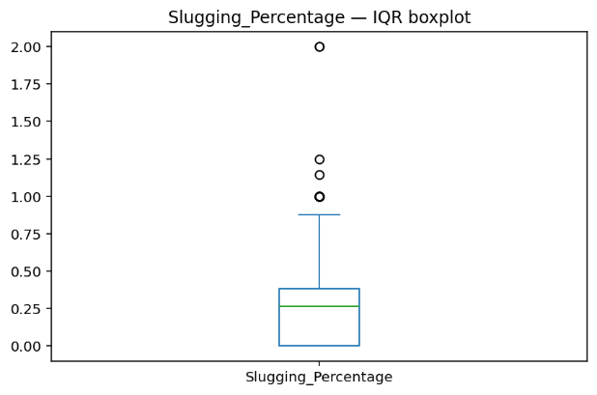
In fact, the same can be explained for Slugging Percentage and On-Base Percentage.
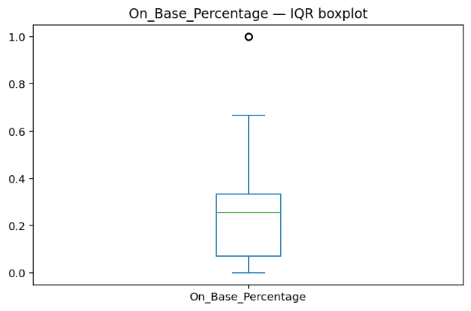
A player can have close to near perfection for On Base Percentages and Slugging Percentages with very few at-bats. With that in mind, none of the outliers are necessary to remove. If anything, we can choose to ignore those data variables considering how they will not play a significant role in determining what quantifies a successful player due to the context of the low amounts of at-bats.
Next, the step is to ensure that the data is normalized using min-max. We will only want to use the quantitative columns which is revealed below.
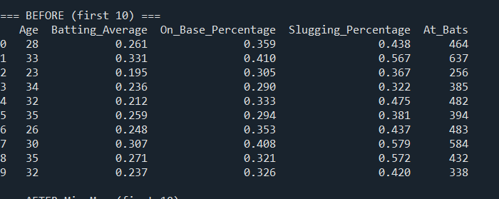
Figure 10: Quantitative Columns
Above are the columns that will be used before we begin to use Python to normalize them. After normalizing the variables, the dataset will begin to go between 0 or 1.
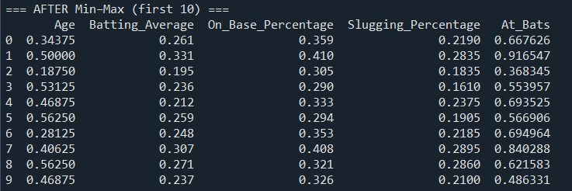
Figure 11: Normalized Min-Max Dataset
The normalized dataset is listed above.
The next step is to create a data frame that contains only unlabeled and quantitative data. Through Python, we created a dataframe of just that for future KMeans analysis.
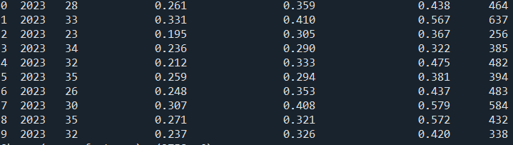Figure 12: Quantitative Dataframe
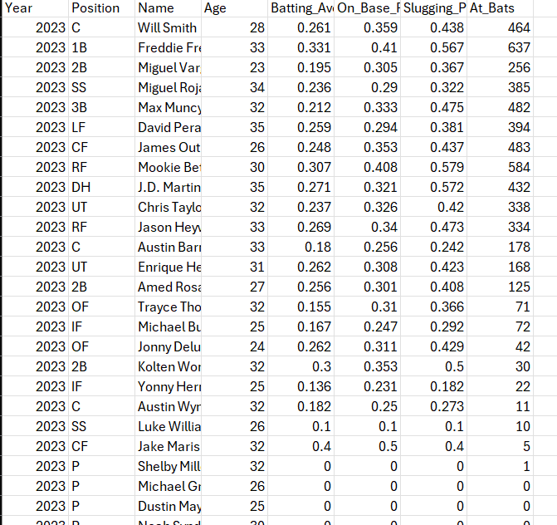
Overall, the Dodger’s Batting Records are now secure and ready to use.
Figure 13: After Clean Dataset

Los Angeles Dodgers Batting Post-Season Stats
I will be using dataset that I received from the MLB API. I will be reviewing information about the Dodger’s Post-Season Stats for Batting. I have a clean data-set from the MLB API which gave me the results that I wanted.
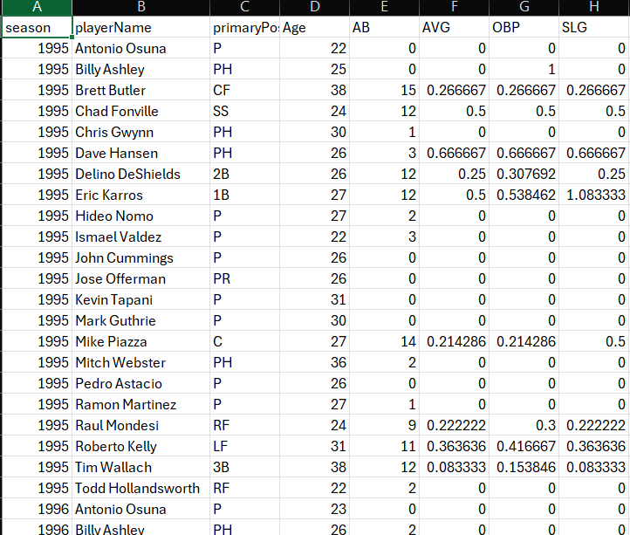
Figure 14: Before Data
The data I have displayed are the post-season year, playerName, primaryPosition, Age, AB, AVG, OBP, and SLG. One way I was able to verify the results were all good was the data type. . Their data types are as follows: Year — int64; Position — object; Name — object; Age — int64; Batting Average — float64; On-Base Percentage — float64; Slugging Percentage — float64 and At-Bats – float64. These results indicate no type-related quality issues. For example, if year had a word in it, it would no longer say that it was an int64. The same could be said in reverse for columns such as Batting Average or On-Base Percentage.
I will use Year, Position, Name, and Age to identify each player and provide their respective role and developmental context. At-Bat quantifies how many times a player was given a chance to bat. Batting Average is included as a core measure of contact and hit frequency, while On-Base Percentage captures the ability to reach base (including walks and HBP), and Slugging Percentage reflects power production. Together, these variables offer a concise, non-redundant view of player performance suitable for trend analysis and comparative evaluation. The main difference between the previous data sample of the Dodgers was that the previous dataset encompasses the regular season while the dataset I have for this encompasses only the postseason. We can then deduce the difference between a regular season player and a postseason player.

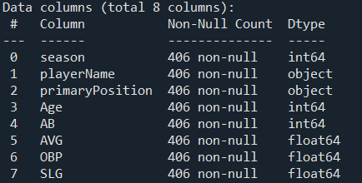
Figure 15: DataTypes and Non-Null Count
Using python, we were able to realize that there were no missing values for the data. There was a non-null count which meant there were no missing values.
The next step is to ensure that there are no outliers in the data. Using a boxplot for each data column, we can determine what the outliers are and if they are a valid target or not.
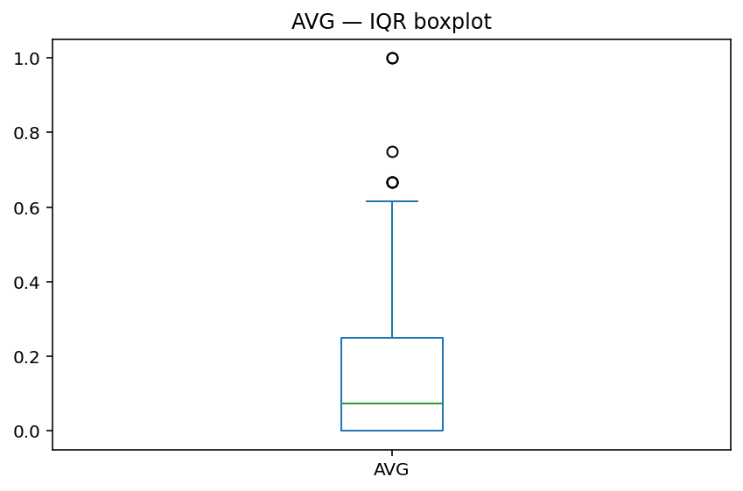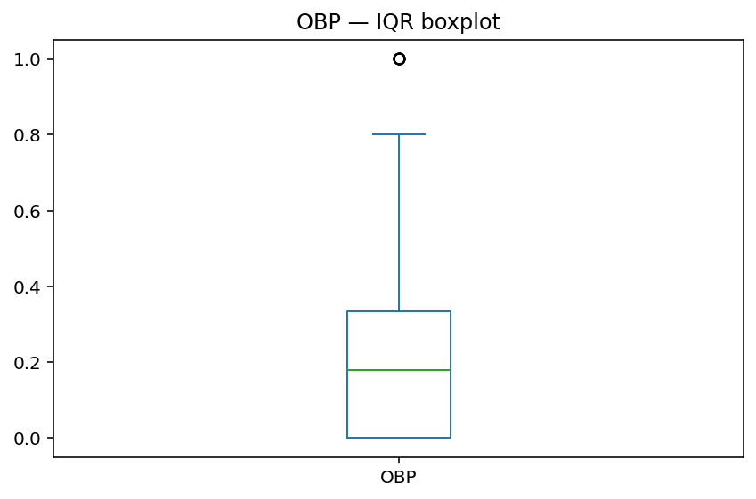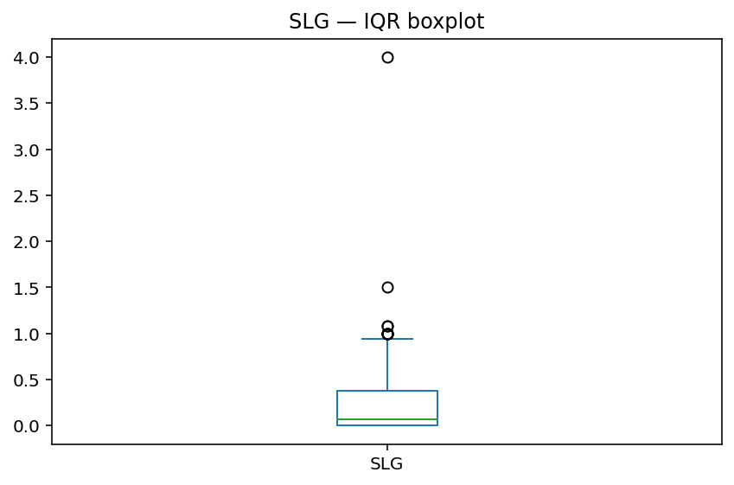

The box-plots all reveal that there were outliers for each position. However, we can determine that the values are not exaggerative nor are they invalid. Looking at the At-Bat’s for each player, we can determine that the players that had a near 100% rate for Batting Average, On-Base Percentage and Slugging Percentage was due to the fact that they had an usually low amount of at-bats which allowed them to have such a high rate.
The next step is to create a data frame so that the new data frame is normalized using min-max. Using python, we can show the difference between the original dataset and the after-normalization dataset.
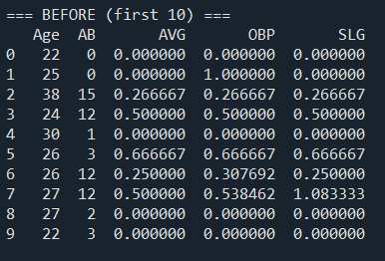
Figure 16: Original Dataset
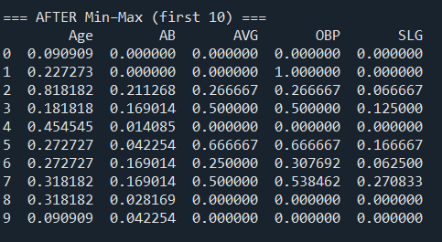
Figure 17: Normalization Dataset
Next, we will create a new data frame that contains only unlabeled and quantitative data to use for Kmeans. We can use python to build that.
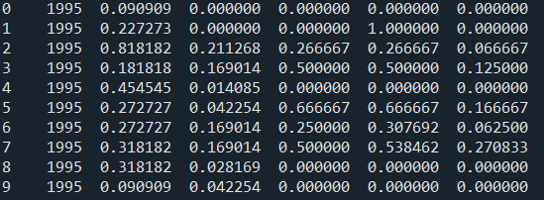
Figure 18: Kmeans Dataset
Overall, the dataset is clean as it is already as it is taken from the MLB API which is a direct download from the MLB website. Now we can use the data to compare the different stats between the regular season vs the post-season.
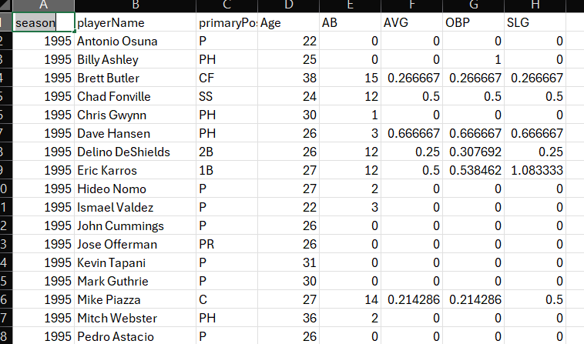
Figure 19: Clean Dataset

Unsupervised Learning with Kmeans Clustering

Postseason Dodger Batter Stats
I plan to use the dataset for the postseason stats for the Dodgers batters. I already had the data clean earlier for K means which means we’re ready to visualize the data.
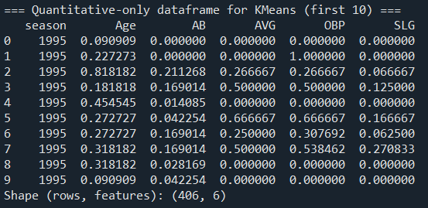
Figure 20: Clean Dataframe
We prepared the dataset earlier by removing all quantitative columns while keeping the quantitative columns.
Visualizing the data is a key method to understanding the data. As only three columns can be used, I will pick AB (At Bat), OBP (On-Base Percentage) and SLG (Slugging Percentage). I picked those 3 variables as it will allow us to fully understand how strong the Dodgers postseason battings are for postseason success. We will remove the other columns to make sure we can begin K means analysis.

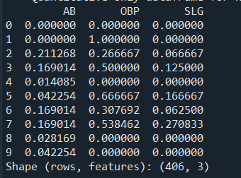
Figure 21: K means Data
Now that we have our finished dataset, we will begin to visualize the code with a 3D visualization.
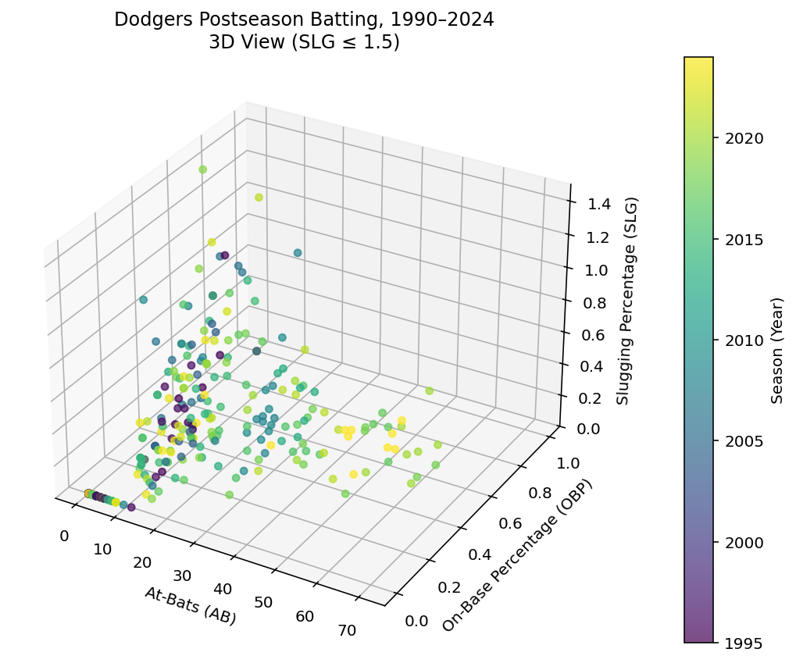
Figure 22: At-Bats vs On Base Percentage vs Slugging Percentage
In this 3D scatterplot, each point represents a Dodgers hitter in a given postseason. The three axes show At-Bats, On-Base Percentages and Slugging Percentages, while the color of each point reveals the season, with darker colors for older years and brighter yellow for more recent seasons. Most of the players fall with a dense cluster between 5-35 At-Bats, OBP from roughly 0.2-0.6 and SLG between 0.2-0.9 range. The graph reveals that the Dodgers, as a postseason team seem to perform relatively well on a normal basis.
For this view, I limited SLG to values of 1.5 and below which removed a few extreme small-sample outliers. Thios allows it to make it much easier to see the main cluster of typical performances for the players. Within the main cluster, there is a visible positive relationship between OBP and SLG: hitters who reach base more often also tend to hit for more power; nonetheless, there is still a noticeable spread that reveals how some players contribute more through getting on base rather than contributing more through slugging.
Looking at the colors and the extremes on each axis reveals even more patterns. Along the right side of the plot, there are a cluster of players with higher At-Bats (around 60-70) that are more recent (2015 and up). This reveals that there have been more regulars who have accumulated a lot of postseason opportunities for the Dodgers. This lines up with the Dodgers becoming more and more successful recently than they were decades ago.
The next step is to apply k means clustering to the prepared dataset. We will use the library from Sklearn to discuss the K means using k = 2, k = 3 and k = 4.

K = 2
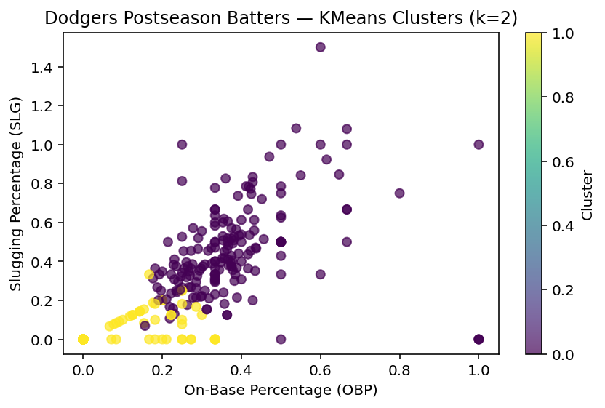
For the value of k = 2, we have split the hitters into 2 groups based on AB, OBP and SLG.
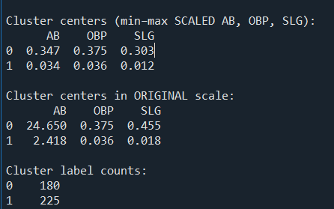
Figure 23: Cluster Centers
Cluster 0 has a centroid around 24.7 AB, .375 OBP and a .455 SLG Percentages. This describes hitters who got a moderate amount of postseason playing time and, on average, hit decently well. They reach base more than a third of the time and show decent power. There are over 180 players in the group, nearly half of the entire postseason players. This reveals how the Dodgers have a smaller but more productive group that carries most of the offensive load.
Cluster 1 has a centroid around 2.4 AB, .036 OBP and .018 SLG, which is basically no playing time and almost no production. These are hitters who had only a couple of at-bats in the postseason and, on average, did not reach base or had enough hit power at all. There are over 225 players in the group which tells that a large share of postseason plate appearances come from brief, low-impact stints (pinch hitters, late-inning subs, call-ups).
Conclusions have been made that for the Dodgers, they use the same core group of post-season players in the play-offs. They do not make many changes to their group beyond subbing out players for specific situations.

K = 3
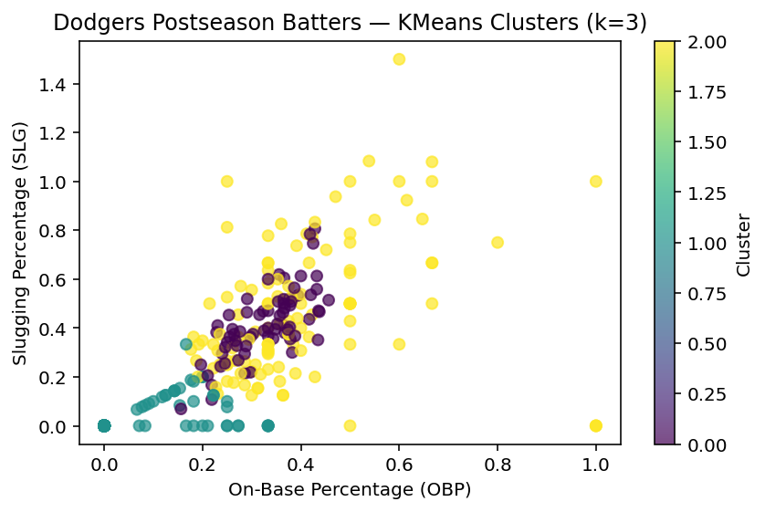
Figure 24: Cluster 0 vs Cluster 1 vs Cluster 2
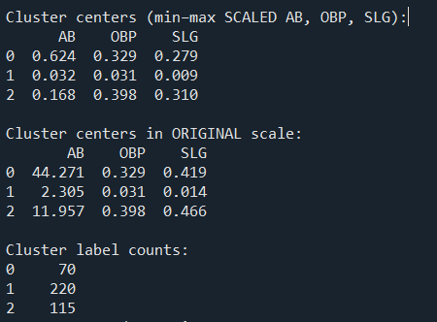
Figure 25: Cluster Centers

The k = 3 results reveal three types of postseason hitters now.
Cluster 0 has a centroid of 44.27 Abs, 0.329 OBP and .419 SLG. There are only 70 players on this list which shows that these are the hitters that the Dodgers have to rely on to gain postseason success. Having so few players in comparison to the other clusters also reveals how hard it is to obtain postseason players that can be relied on a consistent basis. When the Dodgers have these types of players, their chances of success rise dramatically.
Cluster 1 has a centroid of 2.3 AB, 0.031 OBP and a .014 SLG. These make up the majority of players with over 220 players. These are basically the no-playing time/ no production group of the Dodgers. These are guys who only get a couple of AB’s and, on average, don’t reach base nor hit for much power. This cluster is more defined in comparison to k = 2. We get to see further proof that these are the type of players that have very few opportunities to raise their own stats due to their status in the game – bench players, pinch hitters, late-inning substitutions.
Cluster 2 has a centroid of 12 AB, .398 OBP and .466 SLG. As the second largest group with over 115 players, these players represent the part-time contributors. They don’t have as much AB’s but when they do play, they hit at an amazing rate. While they do have more OBP and SLG percentages than Cluster 0 (the heavy hitters of the Dodgers), it’s explained by their lack of AB’s. They have less AB’s which inflates their stats in comparison to their counterparts. This just means that they can be relied on as role players.

K = 4
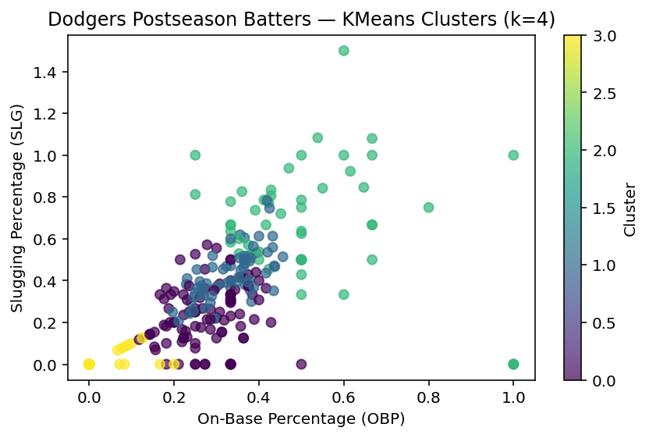
Figure 26: Cluster 0 vs 1 vs 2 vs 3
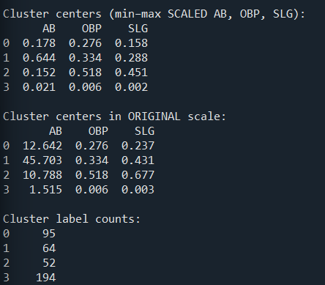
Figure 27: Cluster Centers
With cluster of 4, we can differentiate even more – revealing more archetypes of post-season players.
Cluster 0 has an AB of 12 AB’s, 0.276 OBP and a 0.237 SLG. With over 95 players, these hitters get a small to moderate number of AB’s, but their production is at a below average both in getting on base and slugging power. Based on these stats, we can conclude that they are most likely bottom of the order bats or role players who were in the lineup but didn’t produce much. On the scatter graph, they sit in the lower to middle region.
Cluster 1 has an AB of 45 AB’s, 0.334 OBP and a 0.431 SLG. With only 64 players, these hitters are the high-volume regular hitters. They have the most AB’s with a respectable average of OBP and SLG’s. We can conclude that these players are the players who are near the top to the middle of the line-up – usually the players who help determine play-off success.
Cluster 2 has an AB of 10.8, 0.518 OBP and a 0.677 SLG. With only 52 players, these are guys who performed exceptionally well – strong on base percentages with a very high slugging percentage. These can be explained as players who are either role players who started extremely strong or as star Dodger players who only had a short postseason run. Limited runs can inflate stats. They appear near the top of the scatter plot.
Cluster 3 has an AB of 1.5 AB, .006 OBP and a 0.003 SLG. With the highest rate of players, a whopping 194, we can determine that these are the hitters that basically never got it going during the postseason. These are the most low-impact, short-stint players that can be explained as being pinch hitters, defensive subs or late-inning substitutions. They are near the very bottom of the scatter plot.

Conclusions
Overall, we can draw conclusions on the splits from k = 2 to k = 4. K = 2 had a simple split between contributors vs. non-contributors of the game of baseball. It was a defined separation that needed to be defined further for more analysis. Luckily, k = 3 gave us the opportunity to further define the contributors of the game. K = 3 divided up the groups into 3 distinct groups – regulars, efficient part-timers and non-contributors. Regulars are the high-volume hitters, efficient part-timers are the lower volume but very efficient hitters and the non-contributors are, basically, the non-contributors.
When dividing up the groups into 4, we start to split the part-timers into weak vs strong part-timers. We have the regular high-volume hitters, the strong part-timers, the weak part-timers and the non-contributors. The differences are smaller than they were before, but they help explain more archetypes of baseball that can help contribute as to why certain teams do better than others.
The Dodgers have a consistent group of guys that can contribute in the play-offs which explains why they have so much success in their runs. Having a large group of guys who don’t contribute (the non-contributors) is completely normal in the game of baseball. Baseball is an extremely hard sport, and it’s not expected to have over a 50% hitting rate. It’s a game of inches not miles and having players that can step over that imaginary line of improvement can mean the difference between making a long post-season run and a short stint. Every player must contribute to a team’s success.

Supervised Learning with Decision Trees
The first step to take when it comes to using Decision Tree Modeling is choosing a data source. The data that I will be using will be a continuation of the Dodger’s postseason batting averages from 1990-2024.
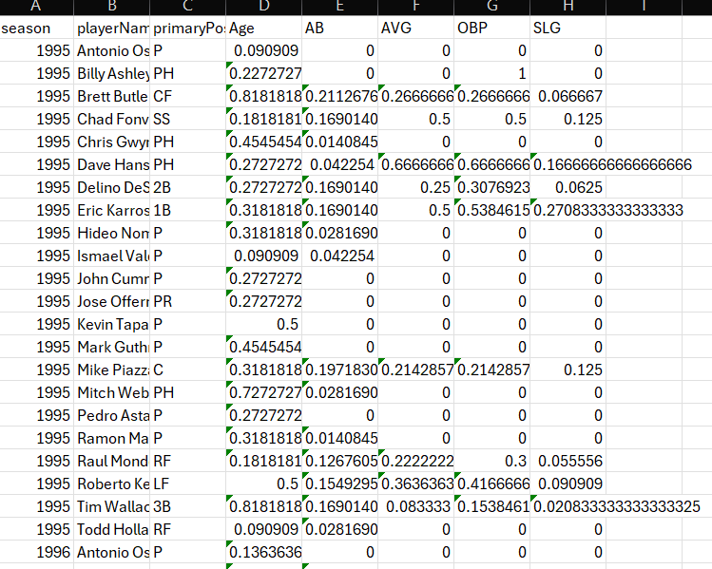
Figure 28: Dodger's Post-Season Batting Averages
In order for the data to be used for Sklearn Decision Tree Classification, the dataset must be labeled and only have quantitative columns for the features. The next step is to ensure that any data that is qualitative must be removed. With my data, the playerName and primaryPosition are removed from the dataset.
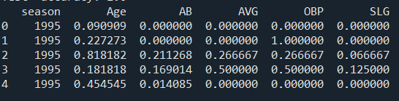
Figure 29: Removal of Qualitative Data
The next step is to choose a label column that my data will predict. The one that I will predict will be defining what a good batter consists of. To do so, I will create 2 labels – 0 (worse batters), 1 (better batters). They will be defined by their slugging averages. The label will be called Good Hitters. After adjusting to these new rows, we get an equal amount of 0 and 1.
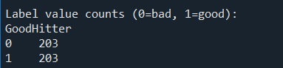
Figure 30: Value Count of 0 and 1
This shows that our dataset is perfectly balanced.
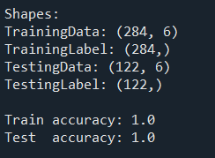
Figure 31: TrainingData, TrainingLabel, TestingData and TestingLabel
The Training Data: (284, 6) shows that there are 284 players in the training set. Each player is described by 6 quantitative variables – season, Age, At Bats, Averages, On-Base- Percentage and Slugging Percentage. The Training Label shows that there are 284 labels for each player. The Testing Data (122, 6) reveals that there are 122 players from the testing set with the same 6 features and 122 labels.
The next step is to create visualizations of our training data to offer information about the data.
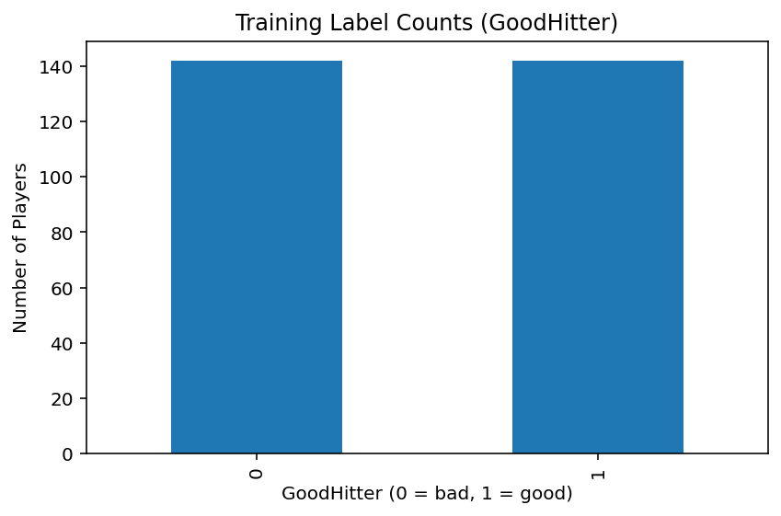
Figure 32: Training Label
The bar chart reveals that the training data is perfectly balanced between bad and good hitters, with almost the same amount of players in each group. Because the GoodHitters’s are based on a median split of slugging percentage, half of the batters are classified as below-median and half at-or above median in terms of power production. A balanced label is helpful because the Decision Tree will not be trained on a dataset that favors one class, therefore, excluding any type of bias.
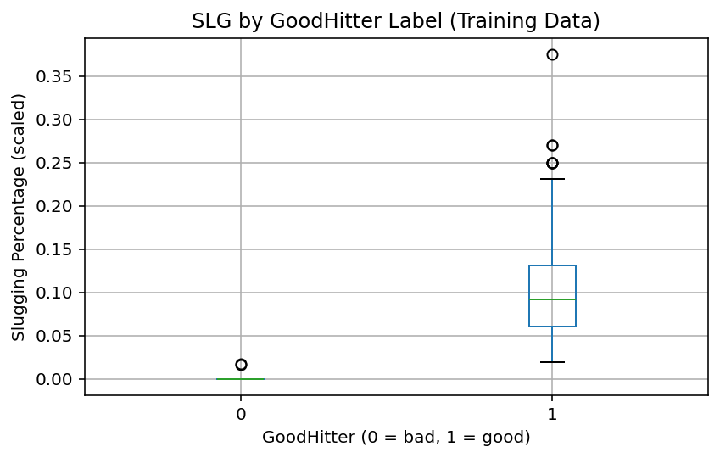
Figure 33: Boxplot SLG
This plot shows that the Goodhitter label separates players be their slugging percentage. Batters labeled 0 have SLG values that are essentially at the very bottom of the scaled range while batters labeled 1 have much higher SLG values with a median well above the 0 group and a wider spread into the higher end of the scale. This strong separation can help explain why the Decision Tree can predict the labels accurately.
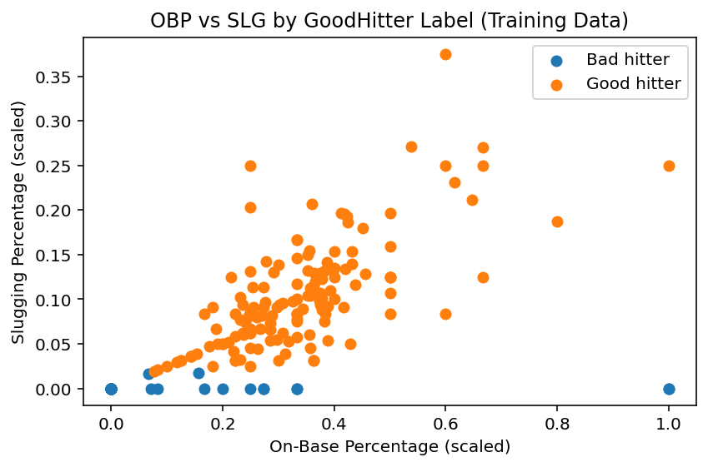
Figure 34: Scatter Plot
This scatter plot suggests that on-base ability and power are strongly linked for the players labeled as good hitters, while bad hitters tend to cluster in a low-performance region on both metrics. Most of the good hitters are well above the median slugging percentage which shows what exactly is needed to be defined as a good hitter.
After training the Decision Tree on the Training Data and then testing it on the Testing Data, I evaluated the performance using a confusion matrix.
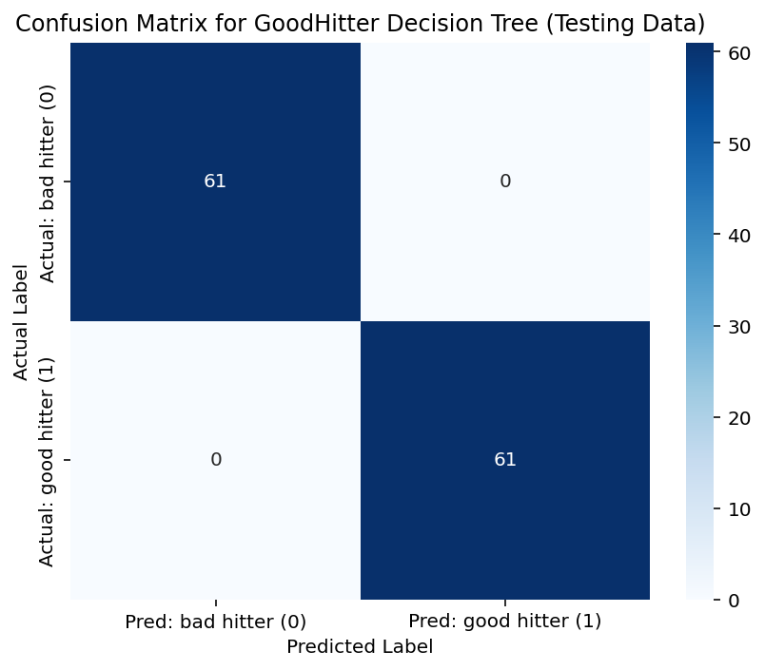
Figure 35: Confusion Matrix
The matrix shows that every batter in the test set was placed on the diagonal cells (bad hitters predicted as 0 and good hitters predicted as 1), with 0 counts in the off-diagonal cells. This means that the model made no misclassifications on the Testing Data, yielding an overall accuracy of 100%. This is expected because the GoodHitter label was defined directly from the slugging percentage (SLG) and the SLG was one of the predictor variables. The Decision Tree basically relearned the same threshold rule used to create the label.

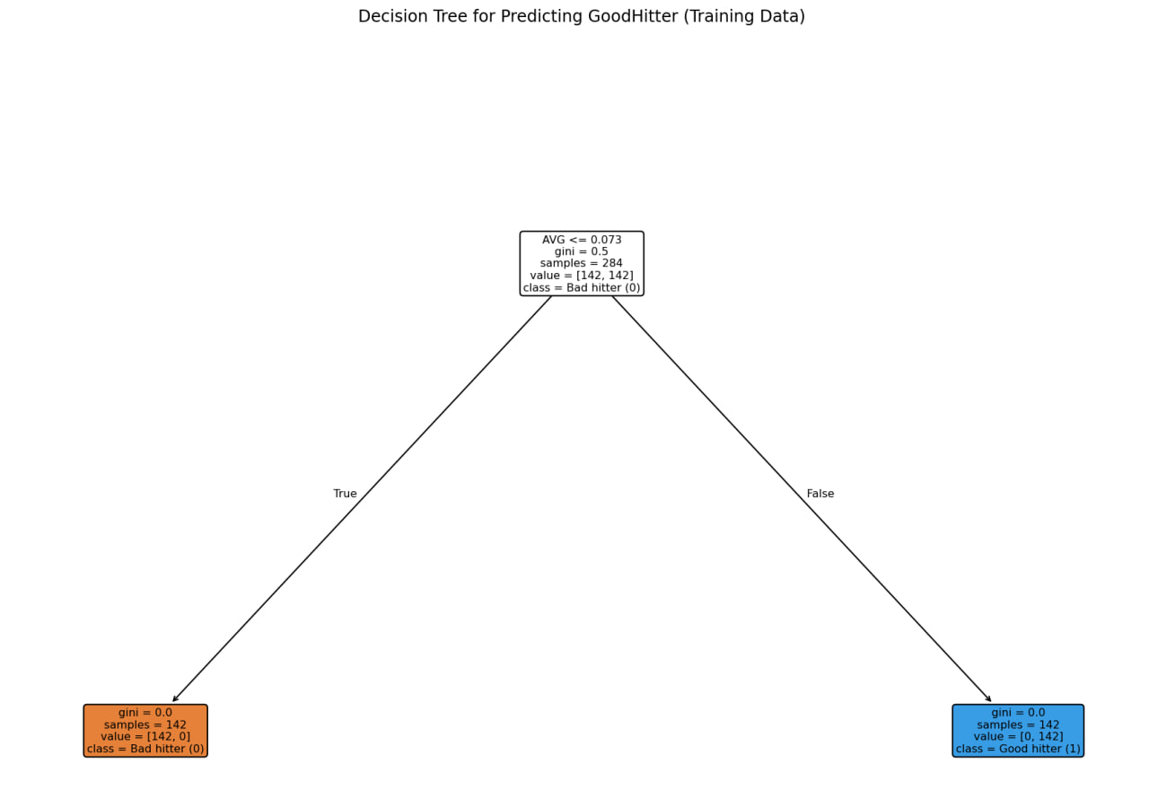
This Decision Tree learned a simple rule: it splits hitters only based on batting average (AVG). If a player’s AVG is at or below 0.073, the model predicts they are a bad hitter; if it is a higher AVF, the model will create a good hitter. Each leaf node is accurate. All bad on the left side and all good on the right side.
Figure 36: Decision Tree

Conclusion
For this project, I used a decision tree model to separate postseason Dodgers hitters into two groups: “good hitters” and “bad hitters.” I defined good hitters as players whose slugging percentage (a power-hitting stat that rewards extra-base hits) was at or above the middle value in the data, and bad hitters as those below that point. This gave me a very balanced dataset – about half of the players in each group – and I trained the model on part of the data and tested it on the rest to see how well it could tell the difference.
The model ended up learning a very simple rule. It basically says: “If a player’s batting average is above a small cutoff, call them a good hitter; if it’s below that cutoff, call them a bad hitter.” Using just this one split, the tree correctly classified every player in the test set, so it agreed 100% with the way I had labeled the hitters. The visualizations support this: the “good hitter” group has clearly higher slugging percentages and generally higher on-base percentages, while the “bad hitter” group is clustered at the low end for both stats.
Overall, the analysis tells us that in this postseason dataset, basic hitting results move together: players who get more hits also tend to hit for more power and reach base more often. Because of that, the model doesn’t need a really complicated set of rules to separate strong and weak bats- it can draw a straight line to define weak and strong batters. This kind of result is useful because it confirms what I, have personally, defined as a good hitter to what we know for offensive productions.

Conclusions
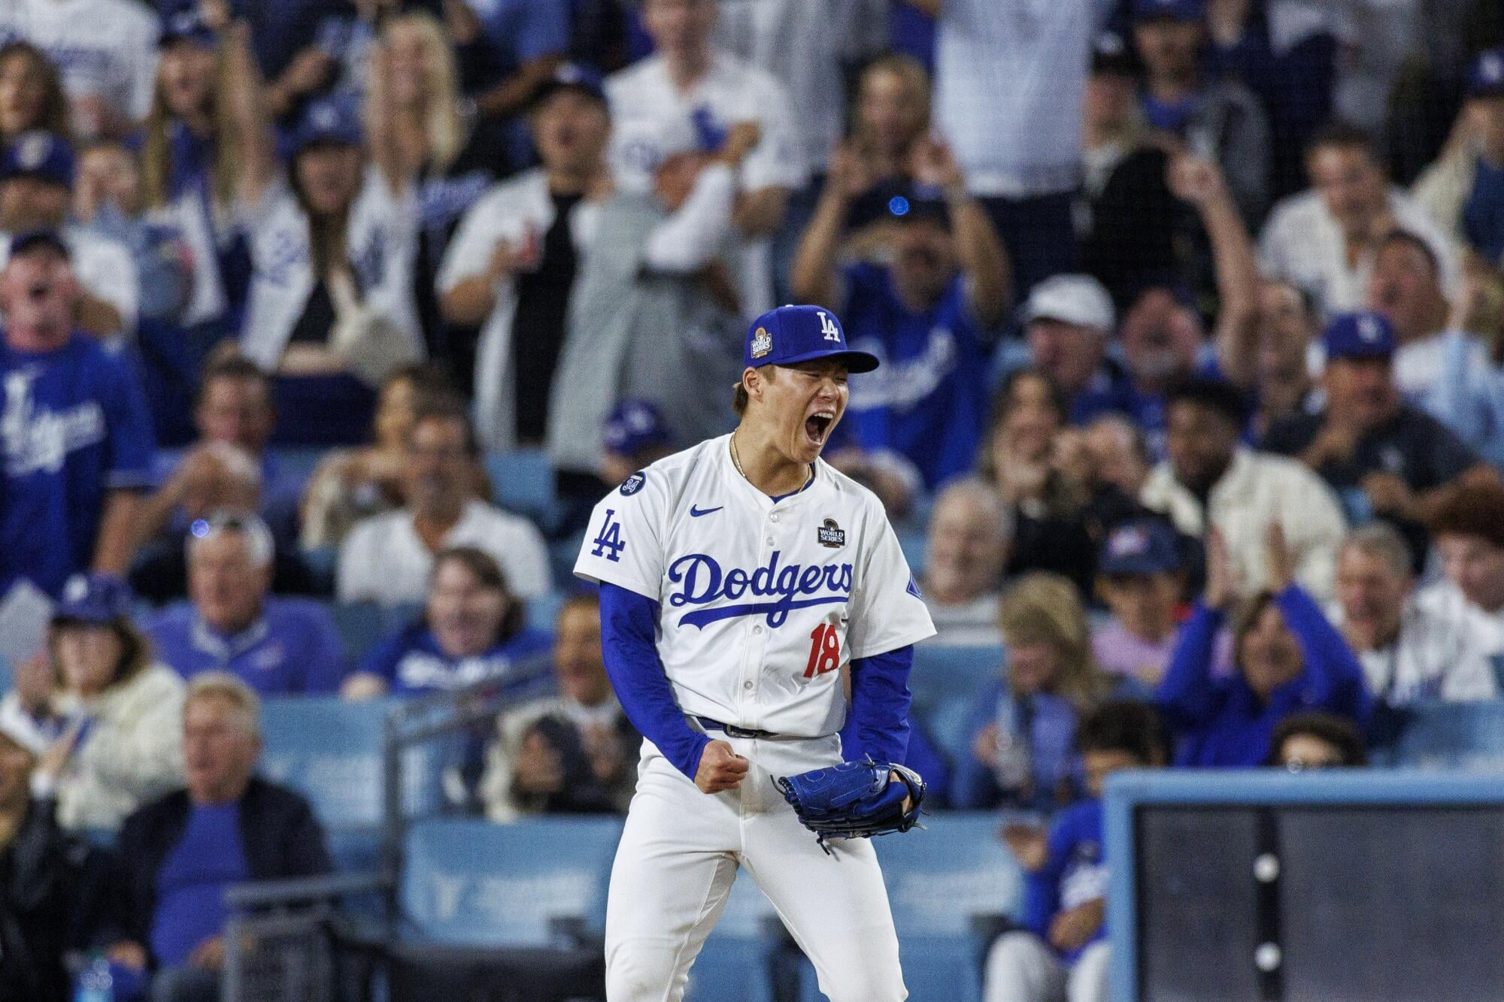
Figure 37: Dodgers Win
Over the last three and a half decade, the Dodgers have relied on very different types of hitters to carry their offense in October. By looking at how often players came to the plate, how often they reached base, how much power they showed, and how old they were at the time, we were able to see clear patterns in the way postseason lineups have actually been built. Instead of just thinking about “good” or “bad” hitters, the data suggested distinct roles: everyday stars who do the heavy lifting, surprise bats who make a big impact in limited chances, steady role players, and depth pieces who barely get to swing.
One of the clearest lessons is how important the “everyday anchors” are. These are the hitters who rack up a lot of at-bats in a single postseason run and still manage to post solid numbers in getting on base and hitting for extra bases. When these players are productive, the offense looks deeper and more stable, because they are in the middle of almost every rally. The flipside is that when this group struggles, it’s very hard for the rest of the lineup to make up the difference, no matter how many interesting supporting pieces the team has around them.
A second important group is what we might call the “impact bats.” These are hitters who don’t always get the same number of chances as the everyday starters, but when they do play, their numbers are extremely strong. They often show up as younger players or part-time starters who bring a lot of power or on-base skill in a smaller number of opportunities. For a front office or coaching staff, this suggests that finding and trusting these types of hitters can be a real advantage in October. Giving them just a few extra plate appearances at the right time could swing a game or even a series, especially when the usual stars are being pitched around or are having a cold stretch.
Finally, the data also highlighted how many players fall into more limited roles. There are “role players” who get a modest number of chances and produce average-looking results, and there is also a long list of players who barely get on the field at all. For those players, their numbers are often so small that it’s hard to judge their true ability from postseason stats alone. This is an important reminder not to overreact to tiny samples. A player who went hitless in just a couple of at-bats in October should not automatically be labeled as a poor performer; the data mainly tells us that their role was small, not that they are incapable of contributing.
Overall, the story that emerges is that the Dodgers’ postseason offenses are built around a core of everyday hitters, boosted by a smaller group of high-impact bats, and surrounded by role players and depth pieces whose opportunities and results are much more limited. For decision-makers, this means that October success depends not just on having “big names,” but on making sure those key everyday hitters are supported by at least a few impact bats who can change a game in fewer chances. It also means being careful about how postseason numbers are interpreted, especially for bench players with very few at-bats. Used wisely, these patterns can help the team design lineups, manage playing time, and think more clearly about which types of hitters they need to prioritize going into future playoff runs.

Reference
Bloomberg. (2024). The “GOAT” of basketball dunking” [Photograph]. Bloomberg. https://www.bloomberg.com/en/news/thp/2024-04-24/shohei-ohtani-hits-450-foot-homer-into-second-deck-at-nationals-park-in-dodgers-4-1-win
josephvm. (n.d.). MLB Game Data [Data set]. Kaggle. https://www.kaggle.com/datasets/josephvm/mlb-game-data
Los Angeles Dodgers Batting & Pitching (1958–2023) — Kaggle: https://www.kaggle.com/datasets/mattop/los-angeles-dodgers-batting-and-pitching-1958-2023
Major League Baseball. (2024). MLB StatsAPI: Postseason schedule and box scores (2024 season) [Data set]. MLB Advanced Media. https://statsapi.mlb.com/api/v1

