Zillah Robot Challenge for High Schools
Saturday, March 9, 2013

7:30 am | Registration begins in the ZHS gymnasium.  Teams are allowed to practice until the competition begins.  Teams can arrive anytime between 7:30 am and 8:15 am, though the  sooner you arrive, the more practice time you will have.
8:15 am | Opening remarks and overview of the day.
8:20 am | Round 1:  Half of the teams will participate in Sumo Robot Competition  The other half will participate in the Maze Competition
11:00 am | Keynote Presentation – To Be Announced!
12:00 pm | Lunch  Lunch is provided for all teams and their advisors and chaperones.  During lunch, teams may prepare for the next competition.
12:30 pm | Round 2: Teams participate in the opposite competition from the morning round.  Half of the teams will participate in Sumo Robot Competition  The other half will participate in the Maze Competition
2:30 pm | Sumo Robot Competition round 1 and 2 winners will face off for the Sumo Championship. Also the runner ups from each round will also face off for 3rd and 4th place.
2:40 pm | Teams prepare for Bonus Round competition  At 2:40 pm teams will receive directions on the final competition of  the day. They will then have this time to prepare their robots and  write their programs.
3:30 pm | Bonus Round Competition
4:00 pm | Teams disassemble robot and inventory all parts prior to turn in.  All robot kits turned in by 4:30 pm.
4:30 pm | Awards and Closing Remarks
4:45 pm | See you in December of 2013 for our next competition!

The Zillah Robot Challenge on March 9, 2013 will consist of three different competitions:
- “The Maze”
- “Mini-Sumo”
- “Bonus Round”
  - The Bonus Round will not be fully announced until the day of the competition.
  - Rules for the Bonus Round will be similar to the rules listed for the first two competitions.

General Competition Rules:
- No objects functioning as remote controls are allowed at the competition.
- During a match team members may switch in and out of the table area as long as only two team members are next to the competition table at any time.
- Each team will be provided a “home base” table to keep their equipment and personal items and to make repairs or modifications to their robot. Power outlets for laptops will be available at each table.
- The robot must fit inside a box 8 in. by 8 in. by 8 in.
- The robot’s weight (including accessories) must not exceed 22 ounces.
- Teams are only permitted to spend $5 on extra parts, sensors, or other modifications (robot must stay within the size/weight limits).
  - Tournament officials will evaluate the robot to see if the robot has been modified beyond the supplied kit and supplemental parts supplied by ZHS. If it has, teams are required to bring receipts to verify costs. If it is determined that more than $5 has been spent (or if more than $5 worth of donated materials has been used) then the team will be asked to remove all parts or sensors not provided by ZHS.
- Teams may not use any other motors than the ones provided in the kits.
- Any infractions or rules violations will be brought to the attention of the Head Official. The Head Official’s judgment will be final.

“The Maze” Competition Rules:

- Each team will be allowed to “test drive” the tracks during the first 30 minutes of each session to perform testing and calibration.
- The maze will be constructed using solid walls that are at least 5 inches tall, and separated by at least 9 inches. (see photo for sample, however, please note that the sample image is NOT a layout for this competition)
- Some of the walls will be painted, some will not. Paint color will vary from extremely dark to very bright.
- The robots will need to navigate through the maze using any of the available sensors in the Boe-Bot kit.
- Please note that the maze will be built on the gym floor, without any underlayment, meaning that the floor will have inconsistent coloring.
- Before the competition starts, all contestants will be invited to examine the courses. Any issues must be brought to the attention of the judges before the competition begins.
- Each team will complete each of the 4 different mazes, with their combined times resulting in their overall score.
- The contestants start a course by pressing their robot’s reset button. Timing of the run will begin when the robot crosses the start line.
- Each course run will be timed by a judge with a stopwatch. The judges will be used as the official timing for the run and will be measured to the tenth of a second.
- Once a course run has started, no contestant or official may touch the track or interfere with the robots in any way except to reset a robot as stated in #11. Resets are done only by one pre-selected team member.
- The pre-selected team member may pick up the robot and reset it behind the last successfully passed check point at any time (this means the robot will be placed behind its current location, not forward of it). Resetting a robot onto the course incurs a 15-second penalty (plus however much time it takes the team member to replace it).
- A robot’s run ends when it has completed the course, or it is deemed by the official to be unable to track the line, or at the end of 3 minutes.
- Any robot that does not complete the course will be given an official time of 3 minutes.
- A robot may only make one official attempt at a course.

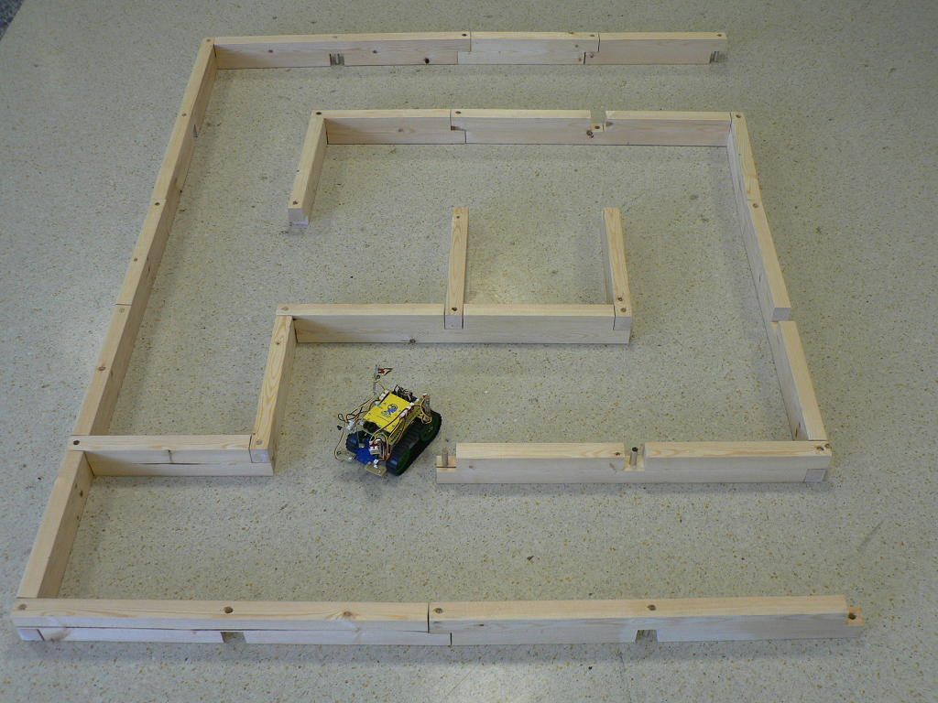

The team with the lowest combined time from all 4 courses will be declared the winner.

Mini-Sumo Robot Competition Rules:

- The sumo contest involves two separate contestants who operate robots by having the robots push their opponent out of the sumo ring according to the game rules presented here.
- The robot must be to the size and weight standards previously stated.
- The robot may not include a device that obstructs the control of the opponent’s operation such as a jamming device or strobe light.
- The robot may not include any parts that might damage the other robot (such as extensions intended to make contact with the resistors/wiring on the opposing robot).
- The robot may not include any parts that might damage or deface the sumo ring.
- The robot may not include a device that insufflates (pour, spill, drop, ooze, eject, fire, shoot, squirt, etc.) any liquid, powder, or gas.
- The robot may not include an inflaming device.
- The robot may not include a throwing device.
- The may not include any part that fixes the robot to the sumo ring surface and prevents it from moving (such as suckers, glue, and so on). The robot must always be able to move.
- The robot may not include any device that increases the apparent weight of the robot. Examples include: using vacuums, fans, or magnetic systems to push/pull the robot down into the sumo ring surface.
- In general, keep it simple, and don’t do damage.
- Each round is two minutes long at most.
- When neither contestant is a clear win, the winner will be decided by the judges. The judge will select the winner based on which robot was the most aggressive robot. However, if no obvious superiority exists and a winner cannot be determined, an extra two-minute match can be played.

**Under the Following Conditions a Team Will Win the Round:
- When a robot ejects its opponent from the sumo ring with a fair action. The robot is considered ejected the moment any part of the robot touches any part of the exterior of the sumo ring. Touching any part of the cylindrical side of the sumo ring is not considered ejected, and the robot is still in play.
- When the opponent’s robot steps out of the sumo ring on its own (for any reason).
- When the opponent’s robot is disqualified or has had more than one violation or one warning.
- Is awarded to a contestant when their opponent is given a second warning.

**Any of the Following Actions Will Result in the Team Losing the Round:
- A part (or parts) of the robot that exceeds a weight of 10 grams is separated and dropped from the robot.
- The robot stops moving on the sumo ring for more than 10 seconds.
- The robot emits smoke.

**A Contestant Who Takes Any of the Following Actions Will Receive a Warning Which May Lead to a Forfeit:
- Any team member reaches into the table and sumo ring before the referee’s call ends the match.
- Preparation for restart takes more than 30 seconds.
- Any other actions that may be deemed unfair occur.
- Continued complaints or inappropriate remarks made by a contestant (Verbally or non-verbally) about a referee’s decisions, condition of the sumo ring, or environment, will not be tolerated.

**A Match Will Be Stopped and a Rematch Will Be Started Under the Following Conditions:
- The robots are locked together in such a way that no more actions appears to be possible or they rotate in similar circles several times.
- Both the robots are moving, but they don’t appear they will ever contact each other.
- Both robots leave the sumo ring at the same time.
- Any other condition under which the referee judges that no winner can be decided.
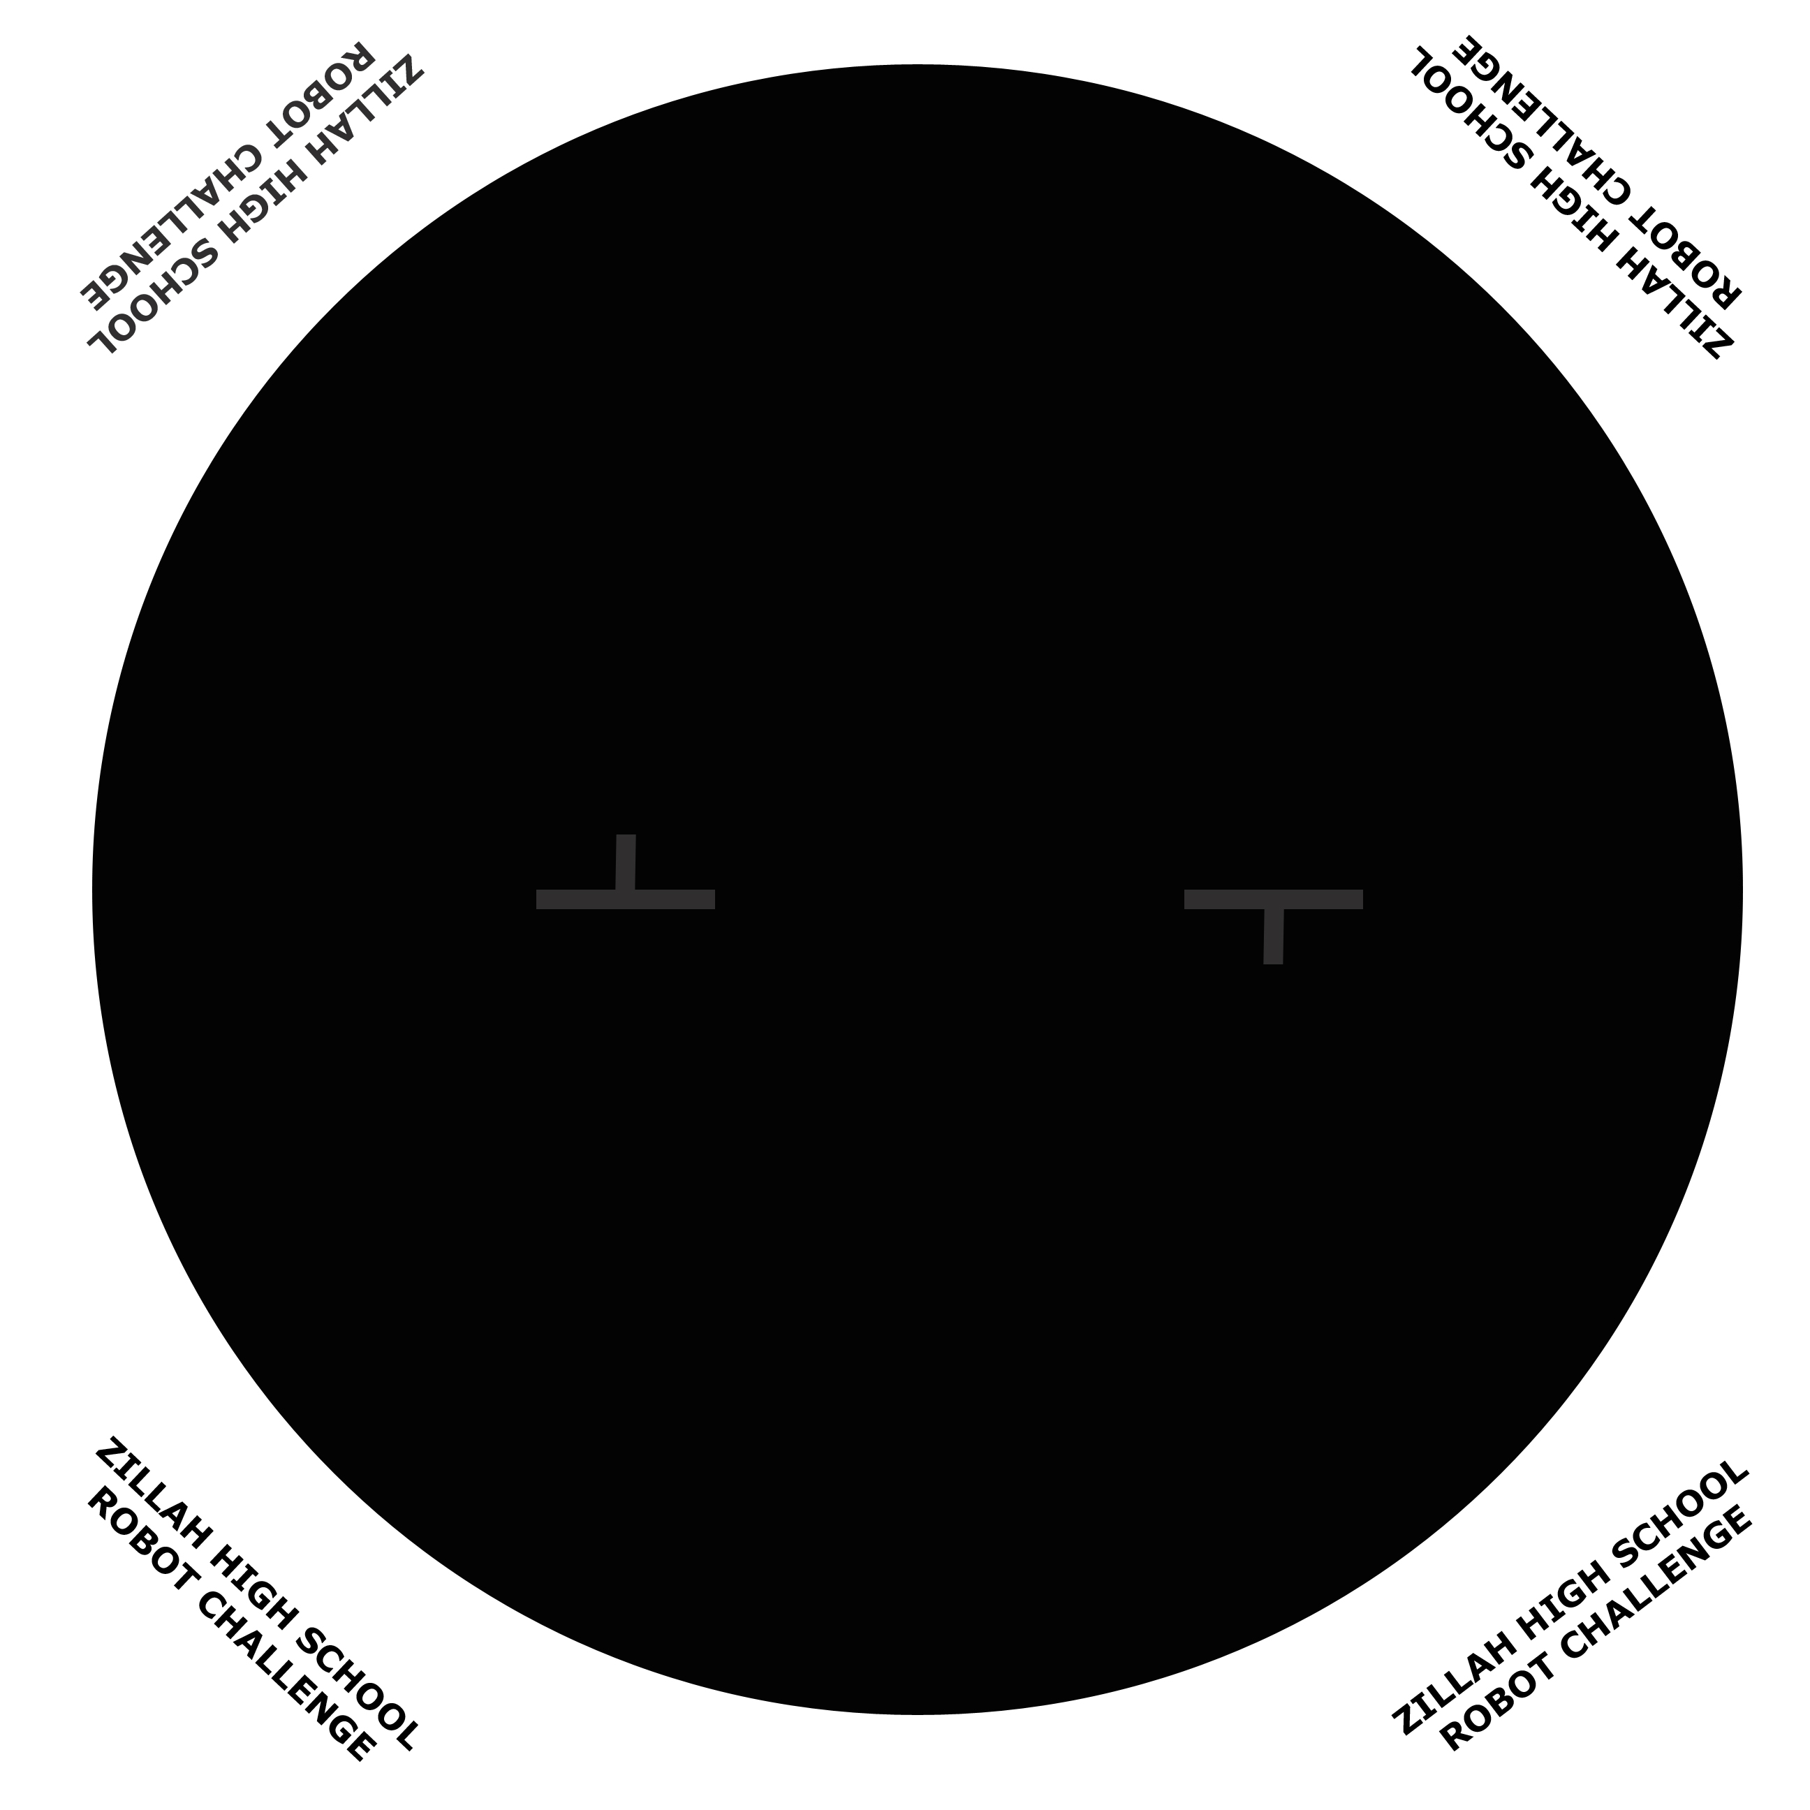
*This is a sample mat only, actual mats used will vary slightly,
but will have the same coloration. The actual mats have a 30” black circle diameter.

The bot on the left starting line, must start behind the horizontal line facing up, while the bot on the right must start behind the horizontal line facing down (as viewed from this image)

Competition Scoring

- Teams earn points for their performance in the Light Following, Mini-Sumo Competition, and in the Bonus Round according to their placing. (First place earns 1 point; second place earns 2 points; etc.)
- In the event of a tie during a competition, the points awarded for the places will be evenly divided between the tying teams. Such that a tie for 1st place between 2 teams would result in 1.5 points awarded to each team, as (1+2)/2=1.5. A three-way tie for 3rd place would award 4 points per team as (3+4+5)/3=4
- The combined scores from all three competitions will dictate the overall Zillah Robot Challenge winner. (Lowest combined score wins.)

