**Setting Up MySQL with Docker and Vanilla JavaScript for Testing Database Connections**

1. **Set up MySQL Using Docker**

**Output:-**

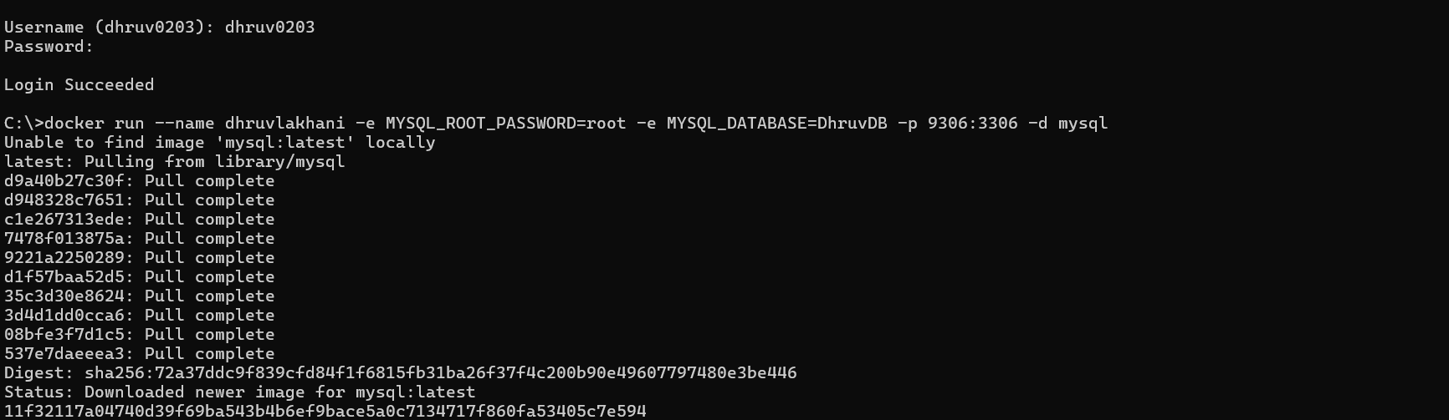

1. **Verify Container Status**

**Output:-**



1. **Test Database Connection Using Vanilla JavaScript.**

**Output:-**

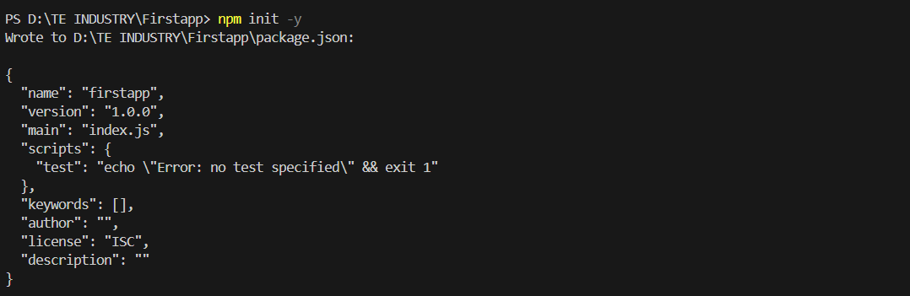

● npm i mysql2

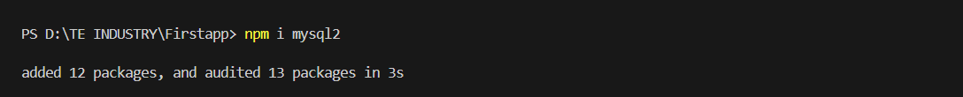

* **Create an `index.js` file and write the code in it.**

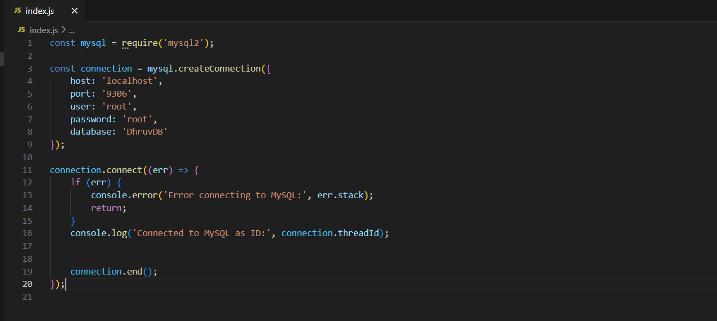

* **node index.js**

