

PUSL3190 Computing Project

Final Report

PresentIQ - Smart Web System to Help
Improve Presentation Speech Skills

Supervisor: Ms.Dulanjali Wijesekara

Name: Hathnapitiya Hathnapitiya
Plymouth Index Number: 10953524
Degree Program: BSc (Hons) Computer Science
Contents
Acknowledgement 4
Abstract 5
Chapter 1 — Introduction 6
1.1 Background of the Study 6
1.2 Problem Statement 6
1.3 Research Motivation 7
1.4 Aim of the Project 7
1.5 Project Objectives 7
1.7 Project Deliverables 8
1.8 Report Structure 8
Chapter 2 — Literature Review 9
2.1 Introduction 9
2.2 Communication Skills and Presentation Training 9
2.3 Public Speaking Anxiety and Speech Delivery Difficulties 9
2.4 Automated Speech Recognition (ASR) Systems 10
2.5 AI-Based Speech Evaluation Systems 10
2.6 Speech Feature Analysis Techniques 11
2.7 Machine Learning Approaches for Speech Evaluation 12
2.8 Review of Existing Systems 12
2.9 Research Gap Analysis 13
2.10 Chapter Summary 14
Chapter 3: Requirements Analysis and Feasibility Study 15
3.1 Introduction 15
3.2 Fact Gathering Techniques 15
3.3 Functional Requirements 16
3.4 Non-Functional Requirements 16
3.5 User Roles and Responsibilities 17
3.6 Use Case Analysis 17
3.7 Operational Feasibility 17
3.8 Technical Feasibility 18
3.9 Economic Feasibility 18
3.10 Chapter Summary 19
Chapter 4 — System Design and Architecture 20
4.1 Introduction 20
4.2 System Overview 20
4.3 High-Level Architecture 20
4.4 Frontend Architecture 21
4.5 Backend Architecture 21
4.6 Database Design 22
4.7 API Design and Communication Flow 22
4.8 AI Processing Pipeline 23
4.9 Authentication and Security Design 23
4.10 UML Diagrams 23
4.11 Networking and Deployment Architecture 28
4.12 Chapter Summary 28
Chapter 5 — System Implementation 29
5.1 Introduction 29
5.2 Development Methodology 29
5.3 Frontend Implementation 29
5.4 Backend Implementation 34
5.5 Speech Transcription Implementation 35
5.6 Feature Extraction Implementation 35
5.7 Machine Learning Scoring System 36
5.8 Feedback Generation Mechanism 36
5.9 Admin Dashboard Implementation 36
5.10 Hardware Design 37
5.11 Chapter Summary 37
Chapter 6: Testing and Evaluation 38
6.1 Introduction 38
6.2 Testing Strategy 38
6.3 Functional Testing 38
6.4 API Testing 39
6.5 User Interface Testing 40
6.6 Performance Evaluation 40
6.7 Security Evaluation 41
6.8 Usability Evaluation 41
6.9 System Limitations 41
6.10 Chapter Summary 42
Chapter 7 — End-Project Report and Post-Mortem 43
7.1 Project Outcomes 43
7.2 Objectives Achievement Evaluation 43
7.3 Comparison with Initial Proposal 44
7.4 Technical and Development Reflections 44
7.5 Lessons Learned 45
7.6 Future Improvements 45
Chapter 8 — Conclusion 47
8.1 Summary of the Project 47
8.2 Final Evaluation 47
8.3 Concluding Remarks 48
References 49
Appendices 51
Appendix A — Source Code Repository Link 51
Appendix B — GitHub Commit History 51
Appendix C — Additional Screenshots 51
Appendix D — Test Results 51
Appendix E — PID 51
Appendix F — Interim Report 51
Appendix G — Supervisory Meeting Records 51

Acknowledgement

Abstract
Presentation and oral communication skills are critical in the academic environment, but undergraduate students often struggle to develop this skill because they have few opportunities to practice independently and receive consistent feedback. In this project, introduce PresentIQ that is a web-based system to provide automated analysis and structured feedback to improve presentation speech skills. It is simply intended to supplement self paced learning, where speech delivery is assessed objectively and uniformly. The proposed solution integrates automatic speech recognition to transcribe audio recordings and extract key speech features including speaking rate, pause frequency, filler word usage, pitch variation, and energy levels. A hybrid technique that combines machine learning models and rule-based techniques is used to evaluate the overall performance of the presentation based on these features. Using this analysis it can provide a template-based feedback mechanism that generates clear, actionable recommendations and an interactive dashboard which allows the user to track their progress over multiple practice sessions. Initial implementation demonstrates accurate speech transcription and consistent extraction of delivery features, enabling reliable performance evaluation. The system produces objective and structured feedback, addressing the limitations of traditional subjective assessment methods and existing communication training tools. Overall, PresentIQ is a useful tool for the continuous improvement of presentation skills over time that contributes to preparing comfortable and skilled communicators in undergraduate education.
Keywords
Automatic Speech Recognition . Presentation Speech Skills . Speech Feature Extraction . Machine Learning . Structured Feedback

Chapter 1 — Introduction

1.1 Background of the Study

Effective presentation and oral communication skills are now a growing requirement for higher education and in the workplace. Graduates are not only expected to have technical knowledge, but also to be able to clearly communicate ideas, present information confidently and engage audiences in academic and work settings. But many undergraduate students struggle with presenting, especially aspects of their presentation speech that are associated with speaking rate, fluency, filler-words, pauses and vocal confidence.

The traditional presentation practice is generally based on feedback from lecturers and/or peers in the classroom evaluation. This feedback may be helpful. However, it can sometimes be too limited, subjective and not available when using the item in independent practice. In recent times, there have been advancements in Artificial Intelligence, Automatic Speech Recognition, and audio-processing technology which can be leveraged to assist students with automated speech analysis. These technologies can record a specific speech feature and offer feedback to help learners continually enhance their delivery of a presentation.

PresentIQ is proposed as an online AI speech evaluation platform for undergraduate students to help develop their spoken English presentation skills using automated transcription, speech analysis, scoring and structured feedback.

1.2 Problem Statement

Continuous, objective and structured feedback is not available to undergraduate students, when they must rehearse their presentations on their own. Manual assessments today are mainly based upon lecturers or peers, heavily depending on individual assessment and limited feedback opportunities. Therefore, students might not be able to identify certain areas of weakness in their speech delivery.

There are also some restrictions on existing speech training applications. Many only speak about pronunciation or about conversational speaking, instead of academic presentation speaking. Some commercial systems give scores without explaining how they are generated, diminishing the educational value of the score. Consequently, an accessible system that can analyse the presentation speech by quantifying its characteristics (such as speaking rate, pauses, filler words, pitch variation and energy variation) and provide feedback to the user, in an understandable manner, is required.

1.3 Research Motivation

This project is motivated by the requirement for improving independent presentation practice by intelligently and transparently providing feedback. Academic confidence is well linked to communication skills, as is employability, but students are often not given as many opportunities as they need to practice their communication skills outside formal assessment.

Another driving force for this project is the practicality of integrating full-stack web development with AI-powered speech analysis. PresentIQ shows that software engineering and AI can be a solution to a real problem in education, by combining a modern front-end, back-end API, speech transcription, machine learning-based scoring and visualization of feedback.

1.4 Aim of the Project

The goal of this project is to create and build PresentIQ, a web-based platform that uses AI to analyse spoken presentation and give structured feedback to undergraduate students to improve their presentation speech.

1.5 Project Objectives

The main objectives of the project are:

- To build a web app where people can record or upload audio of a presentation.
- To add user authentication and session management.
- To input speech that has been uploaded and converted into text, automatically, through the use of an automatic speech recognition model.
- To extract speech delivery features like pauses, filler words, speaking rate, pitch variation and energy variation.
- To create presentation performance scores with the help of AI/ML based analysis.
- To allow for structured feedback, transcript insights and visual progress indicators.
- To build an admin panel to control users, session, feedback, analytics and platform settings.
- The system is limited to a single user.

The features of PresentIQ are: User registration, login, creating speech sessions, uploading audio, backend audio processing, audio transcription, feature extraction, scoring, and feedback presentation. It allows for practice and exam mode. Practice mode offers more detailed coaching-style feedback, exam mode is more focused on the score-based evaluation.

There is also a user dashboard, speech analysis interface, public feedback showcase and administrative dashboard. The system is not designed to correct real-time speech or assess language or make fully human-like evaluations. The accuracy of scoring is also dependent on the available machine-learning models, audio quality, and speech-processing limitations.

1.7 Project Deliverables

The final deliverables of the main project will be a full-stack web app, the FastAPI backend service, the SQLite database, the audio upload and processing pipeline, the speech transcription module, the scoring and feedback generation module, the user dashboard, the admin dashboard, the source-code repository, the user guide, and the final project documentation, followed by testing evidence.

1.8 Report Structure

This report is organized into eight chapters. Chapter 1 presents background of the project, problem, aim, objectives, scope and deliverables of the project. In Chapter 2 relevant literature and existing speech evaluation systems are reviewed. The requirements analysis and feasibility study is presented in Chapter 3. The system design and architecture is explained in Chapter 4. In Chapter 5, the implementation of the frontend, backend, and AI-processing pipeline is discussed. Testing and analysis of the system is done in Chapter 6. The end project report and postmortem reflection is presented in Chapter 7. The report ends in Chapter 8 with suggestions for future improvements.

Chapter 2 — Literature Review

2.1 Introduction

This chapter reviews existing literature related to communication-skills development, presentation training, speech-analysis technologies, and AI-based speech evaluation systems. The review is concerned with the use of Artificial Intelligence, Automatic Speech Recognition and machine-learning methods to analyze speech delivery and provide automated feedback to the speaker(s). Existing communication-training platforms are also assessed to see how well they fit the proposed PresentIQ system, and to determine their strengths and weaknesses.

2.2 Communication Skills and Presentation Training

Communication skills are very well known as necessary skills in academia, and also in professional settings. In a world with a growing emphasis on communication, clarity, and collaboration, employers are increasingly demanding that graduates possess these abilities (Gatta et al., 2025). In higher education, presentation assessment is generally used to assess subject knowledge as well as communication skills.

Presentation training is a process of enhancing some areas of presentation such as fluency, pacing, confidence, variation of voice and engagement with the audience. Effective delivery of the presentation helps to improve the understanding of the presentation and speaker credibility. Many pupils, however, lack the opportunities to practice these skills systematically and receive feedback which is tailored to their needs and at a level they can access, making it difficult for them to develop them themselves.

Typically, training is conducted by the lecturer and participants' peers by using their evaluations and feedback. These strategies can facilitate communication development but tend to be subjective and limited to classroom settings. Research has, therefore, investigated the possibility of using technology to enhance presentation practice and communication skills training.

2.3 Public Speaking Anxiety and Speech Delivery Difficulties

One of the most common communication problems faced by university students is the fear of public speaking. Research shows that anxiety while delivering presentations may have a negative impact on the presenter's confidence, fluency and audience engagement (Lintner and Belovecová, 2024). Students with presentation anxiety can speak too fast, have too many pauses, use too many filler words, and/or vary their vocal delivery.

The skills of presenting the speech can have a big effect on the effectiveness of the presentation. Studies indicate that speaking rate, pauses, and pitch variation can be regarded as indicators of confidence and credibility to audiences (Wang and Li, 2021). Too fast speech can sometimes make it difficult to understand, and monotone speech can make it hard for the listener to follow.

Communication difficulties can be greater in multilingual schools like Sri Lanka where opportunities for the practice of spoken English may be lessened and proficiency in English may vary. Employability studies conducted nationally have documented the dissatisfaction of employers in relation to graduates' communication and presentation skills (Cader et al., 2024). These problems emphasize the need for systems that will facilitate independent development of communication skills.

2.4 Automated Speech Recognition (ASR) Systems

The Automatic Speech Recognition (ASR) systems process speech and transform it into machine-readable text. With the developments in deep learning and large-scale language modelling, ASR technologies have improved greatly. State-of-the-art ASR systems with transducers exhibit greater robustness when processing various accents, speech conditions, and background-noise conditions.

Whisper is a large-scale, weakly supervised ASR model trained on multilingual speech data, developed by OpenAI (Radford et al., 2022). The model does well in transcription accuracy in a wide range of audio conditions and it can be used in educational speech-analysis applications. Whisper is more adaptable and dependable than traditional methods of speech recognition.

The application of ASR technologies is increasingly extended to the field of education, language-learning systems and communication-training applications. Being able to create accurate transcripts opens up a number of speech-analysis tasks, such as the detection of fillers, calculation of speech rate, and the generation of feedback.

2.5 AI-Based Speech Evaluation Systems

AI technology is being used more to facilitate automated communication assessment and speech training. The AI evaluation systems process speech recordings and produce various scores for fluency, pronunciation, tempo, and confidence. These systems are designed to give the learner feedback that is always easily available and available.

Based on the research, it can be concluded that systems that provide automatic feedback can enhance the motivation and self-awareness of learners, especially if the feedback is meaningful and meaningful. (Isotalus, Eklund and Karppinen, 2024). AI-powered educational systems can also allow learners to practise on their own without constant supervision.

But there are some drawbacks to existing platforms for assessing speech using AI. Numerous commercial systems use proprietary algorithms and offer little information about how the scores are derived. This decreases transparency and can have a negative effect on the usefulness of an educational tool. In addition, certain platforms concentrate more on pronunciation, which is not the same as a more general analysis of presentation delivery.

2.6 Speech Feature Analysis Techniques

When assessing communication effectiveness, speech-analysis systems typically analyze quantifiable aspects of speech delivery. The features can be extracted from audio recordings by signal-processing and transcription methods.

Speaking Rate Analysis

Speaking rate is the amount of words spoken in a specific time frame, usually in Words Per Minute (WPM). The speed at which a speech is delivered can greatly influence the understanding and interest of the audience. Too fast talking could make it unclear and too slow talking could make the audience not pay attention (Wang & Li, 2021).

Pause Detection

Speech fluency and confidence are indicated by pauses. Use pauses to add emphasis and clarity, but not too many for it to show hesitation or uncertainty. Pause detection normally takes place by implementing the silence-detection techniques in the pipelines of the audio processing system.

Filler Word Detection

Filler words like “um,” “uh” and “like” are frequently linked to speech hesitation and decreased fluency. Some studies have shown that more than a certain number of fillers can have a negative impact on the quality of communication and its reception by the audience (Hutin, Hu and Degand, 2024). Filler-word detection is usually performed using transcript analysis.

Pitch and Energy Analysis

The variation of pitch and the energy level of voice help to make speech expressive and to engage the listener. Routine speech patterns can make it harder to present, while varying speech patterns can enhance the clarity of communication. Librosa is one of the typical audio-processing libraries that is used for pitch and energy feature extraction from speech recordings.

2.7 Machine Learning Approaches for Speech Evaluation

Speech-analysis and educational-evaluation systems widely use machine-learning techniques. Feature-based machine-learning models analyze relationships between extracted speech features and presentation-quality indicators. Popular methods are Random Forest, Support Vector Machine (SVM), and XGBoost.

Tree-based models are often chosen as they are generally competitive at capturing the structure of the data, and the predictions are relatively interpretable. They can test the ability to communicate based on combinations of speaking rate, pauses, filler words and vocal variation.

Machine-learning techniques also aid in scalable automated assessment by minimizing manual assessment. The quality of the training data, feature selection, and the diversity of the datasets, however, have a significant impact on the model's performance.

2.8 Review of Existing Systems

Orai

Orai is a public speaking training app that will give you feedback on your pacing, filler words, and vocal energy. The website features coaching for presentations and guided practice sessions. While the speech insights are helpful in Orai, the scoring system is a proprietary one and there is not enough information about the calculation of the scores.

ELSA Speak

ELSA Speak is an AI-powered language-learning tool, mainly for pronunciation training. The system assesses speech pronunciation and gives feedback to language learners. The platform primarily focuses on the phonetic accuracy, however, it does not focus on overall presentation delivery (pacing, pause, presentation fluency, etc.).

Duolingo English Test

AI-powered speech analysis is integrated into the Duolingo English Test's language assessment process. The platform scores spoken answers by automated scoring. The system is useful for language testing but it is mostly developed for the purpose of language-proficiency measurement and continuous practice feedback is not the primary focus.

2.9 Research Gap Analysis

Based on the literature review, there are various limitations found in the existing communication-training systems. Traditional assessment approaches do not offer much for continued independent learning. Current AI models focus mainly on pronunciation or conversational speech instead of academic presentation delivery. Moreover, the output of many commercial systems is also not easily interpretable, with high levels of opacity.

It is thus necessary to have a clear, accessible and measurable platform that can deliver structured and understandable feedback and an analysis of measurable presentation delivery characteristics. PresentIQ's mission is to fill this void by combining ASR, speech-feature extraction, machine-learning-based speech evaluation, with a single, educational platform that tracks progress visually.

2.10 Chapter Summary

The literature for communication-skills development, problems with public speaking, technologies of ASR, speech evaluation using AI, and speech-feature analysis techniques were reviewed. Analyzed existing systems and machine-learning approaches for existing limitations and opportunities for improvement. The review highlights the importance of creating an easy-to-understand and accessible AI-based presentation-training platform, laying the groundwork for the design and development of the PresentIQ system.

Chapter 3: Requirements Analysis and Feasibility Study

3.1 Introduction

The requirements analysis process is an important phase in software development as it sets the groundwork for the functional and non-functional requirements of the proposed software system. To build a solution that satisfies the needs of the users, the system behavior, technical limits, and operational requirements, a clear vision of the user needs, system behavior, technical constraints, and operational requirements are required to ensure the solution developed addresses the problem identified. The requirements analysis and feasibility study of the PresentIQ system is presented in this chapter. It explains how information is being collected, what are the requirements for the system, what are the roles of users, use case study, and feasibility of the proposed platform from operational, technical and economic aspects.

3.2 Fact Gathering Techniques

To gain insight into the problems related to presentation-speech improvement and to determine proper requirements for the proposed system, several fact-gathering techniques were applied. One of the main methods employed in the analysis was literature review. Academic, industry, and public speaking skills studies were examined to gain insight into common speech delivery issues, public speaking anxiety, and the application of AI technologies in speech evaluation.

The observation method was also employed to examine the undergraduate’s presentation practices in academic setting. The problems found in the presentations were excessive use of filler words, speed of speech during presentations, lack of variation of voice, and hesitation during the presentation. The speech-analysis features needed in the proposed system were determined through these observations.

Besides this, existing communication-training platforms were also evaluated and their strengths and gaps were identified. This analysis identified a need for a transparent and educationally informed presentation-analysis platform that can offer structured feedback and measurables.

3.3 Functional Requirements

The functional requirements specify what services and operations the system is required to provide. The PresentIQ platform is optimized for presentation-speech analysis, session management, feedback generation and administration monitoring.

The primary functional requirement is user registration and authentication, speech recording and uploading, session creation and management, automatic speech transcription, extraction of speech features, speech scoring with machine learning and generation of feedback. The system should also provide visual dashboards to view analysis results, transcripts, speech metrics and progress tracking for multiple sessions.

There needs to be administrative functionality that allows for user administration, platform statistical reporting, public feedback moderation and platform setting configuration. These requirements altogether outline the fundamental operational workflow of the system.

3.4 Non-Functional Requirements

Nonfunctional requirements are the quality attributes and operational requirements of the system. Performance is also crucial, because the operation of audio-processing and transcription should take place in reasonable time. The system should be able to analyze short recordings of presentations efficiently with minimal delay.

Another major requirement is usability since the platform is aimed at undergraduate students with different technical backgrounds. The interface must thus be intuitive, responsive, and easy to navigate. Security should come into account for user authentication, password protection, administration access and storage of the uploaded audio and analysis data.

Reliability and maintainability are also important factors. The system architecture should facilitate modular development and future expansion without extensive changes to the system structure. To guarantee accessibility on typical devices used in school, compatibility with modern web browsers is required.

3.5 User Roles and Responsibilities

PresentIQ system has two basic roles for its users: Administrators and Standard Users. The standard users are undergraduate students or learners who use the platform for practicing and evaluating presentation speech. They are tasked with creating accounts, uploading or recording speech, viewing analysis results and tracking progress via the dashboard interface.

The administrators will deal with the working details of the platform. Daily tasks involve overseeing user activity, checking out speech-analysis sessions, moderating public feedback input, configuring platform features and analyzing platform use. This helps in clear segregation of user and administrator task, which leads to better security of system and organization.

3.6 Use Case Analysis

The use-case analysis method was applied to determine interactions between actors of the system and important functions of the platform. The initial user flow starts with user registration and authentication. Once logged in, users can generate presentation sessions, choose the practice/exam mode, upload speech files and start the analysis process.

The uploaded audio recordings are uploaded to the backend system, where they are transcribed, features extracted from the speech, scored and feedback generated. These are then available for users on the dashboard interface with transcripts, speech metrics, and performance summaries.

Administrative Use Cases involve viewing user statistics, monitoring uploaded sessions, moderating feedback content and managing platform settings. The use case analysis shows the interaction between the Frontend interfaces, Backend services and the AI Processing modules in the system workflow.

3.7 Operational Feasibility

Operational feasibility is an assessment of whether or not a proposed system can work in the intended environment. PresentIQ is operationally viable because it is focussed on the identified educational need of communication-skills improvement and independent presentation practice.

The platform is designed to be an internet driven framework that can be used by standard computing devices and normal web browsers, making operation easier for users. Automated feedback generation also means that students can practise presentations without constant supervision and can repeat them as many times as they like. Speech analysis and visual feedback facilitate self-directed learning and development of communication skills.

3.8 Technical Feasibility

Technical Feasibility considers if technologies and development resources available for implementation are feasible. Technically, the PresentIQ system is possible, as it is based on state-of-the-art and well-established technologies when it comes to the frontend development, backend services, speech processing, and machine learning.

The entire Frontend is built with Next.js and React, while the Backend Services are created with FastAPI and Python. Speech transcription is done with the Whisper ASR model, and audio-feature-extraction libraries like Librosa and NumPy are supported. Evaluation of machine-learning is done with scikit-learn based models.

Additionally, the modular system architecture enhances technical maintainability and scalability. The proposed system can be successfully implemented because there is existing knowledge on the part of the developers and availability of open-source frameworks.

3.9 Economic Feasibility

Economic feasibility is the assessment of the project's ability to meet acceptable financial constraints. The ease of cost of implementation of PresentIQ is due to the fact that it is based on open source technology and frameworks, with a huge savings in software licensing costs.

No special equipment or infrastructure is required to complete the development process. There are also lower operational costs since the platform can be hosted on an affordable solution. Automated Speech Evaluation also helps to eliminate the need to provide costly instructor training sessions.

Thus, the project has good economic viability for an undergraduate computer project and is of high didactic value.

3.10 Chapter Summary

In this chapter, the requirements analysis and feasibility study of the PresentIQ platform were presented. Operational behavior of system was explained using various fact-gathering techniques, functional and non-functional requirements, user roles and use case analysis. Feedbacks from operational, technical and economic feasibility studies confirmed that the proposed platform is feasible, viable and appropriate to be implemented with the current web-development and AI technologies.

Chapter 4 — System Design and Architecture

4.1 Introduction

This chapter discusses system design and architecture of PresentIQ. The design emphasizes modularity, maintainability, and scalability to accommodate a web-based user interface that allows users to interact with the system, with the backend incorporating speech processing and AI evaluation. The architecture is designed to be modular, allowing for the separation of different components of the system, including the AI processing, authentication, database, and backend components.

4.2 System Overview

PresentIQ is a web application that includes all the necessary tools to analyze spoken English presentations. Users can register, log in, set up speech training sessions, upload sounds, and receive comprehensive feedback. Uploaded audio files are processed in the backend for transcription, speech features extraction, score generation and storing analysis results. These results are displayed on dashboards, transcript views, charts, and coaching suggestions on the frontend. There is also an administrative panel to monitor the platform, manage users, moderate feedback, analyze and configure features.

4.3 High-Level Architecture

The system is layered Client-Server based. Next.js, React, TypeScript, Tailwind CSS, and UI components are used to implement the presentation layer. FastAPI is used to build the application layer, providing RESTful APIs for authentication, session management, audio upload, retrieval of audio analysis results, feedback, and administration. Users, sessions, analysis payloads, public feedback, and platform settings are stored in a data layer using SQLite and SQLAlchemy models.

There is a separate AI-processing layer for transcription, feature extraction, scoring and feedback generation. This separation makes the system more maintainable as user interface changes do not impact on the changes in the speech-analysis pipeline. It also enables future scalability, meaning that the AI-processing service itself could be deployed elsewhere, such as a separate worker, or on the cloud.
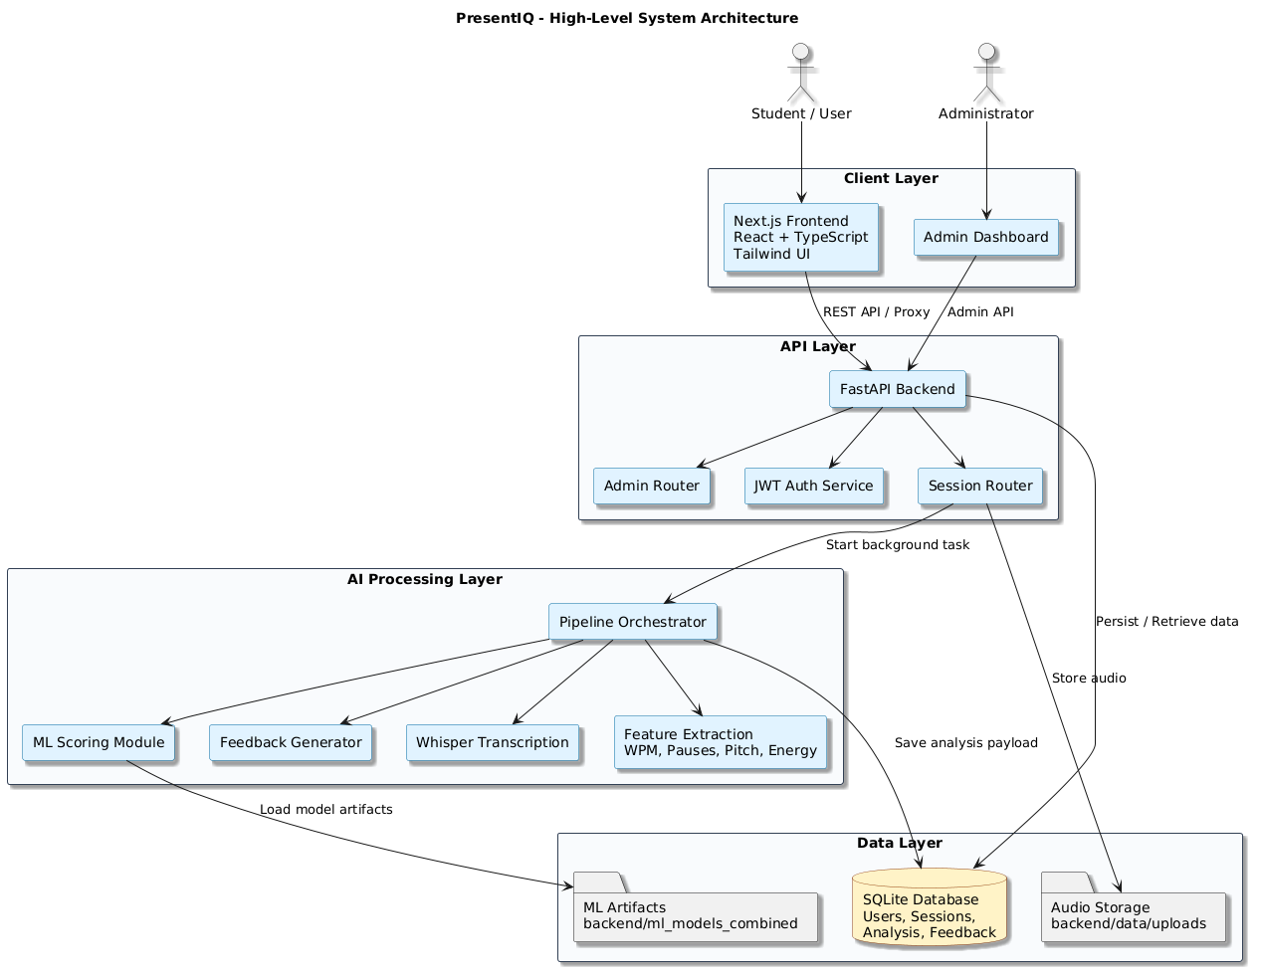
Figure 1

4.4 Frontend Architecture

The frontend is organized into user interface and admin interface. Landing page, authentication screens, dashboard, new practice flow and speech-analysis screen are pages visible to the user. These interfaces enable users to control sessions and to visualize feedback. Progress cards, charts, and additional cards showing scores, filler-word statistics, transcript insights, and skill-level indicators.

Two ways of communicating with the backend: either by configuring an API URL or by using a Next.js proxy route. This proxying method allows for a more centralized API communication and minimises direct access of backend endpoints from the frontend components. Considering the target users might not have the same technical expertise, the frontend design focuses on usability, responsiveness, and clarity.

4.5 Backend Architecture

Backend is built with FastAPI and is structured in a modular way with the router. Different routers for authentication and session, admin operations, password reset and feedback. This makes it easier to read and test and maintain the structure.

The core backend services offered are transcription, analysis, pipeline orchestration and model scoring. The session router is responsible for the creation of a speech session, uploading of audio material, retrieval of analysis, and deletion of a speech session. An audio file is uploaded to the backend which then processes it in the background and stores it on the server locally. This helps to avoid API blocking while processing long running transcription/analysis tasks.

4.6 Database Design

The database structure enables user administration, session storage, analysis results, feedback moderation and settings of the platform. The main entities are: User, Practice Session, Session Analysis, User Feedback and Platform Setting. Each user can take several practice sessions and have several analysis records each time. Transcript output, speech metrics, scores, insights, and coaching suggestions are maintained in a structured format in the analysis payload.

For the development, SQLite was chosen because it is light, easy to setup and is appropriate for the prototype of a university project. The SQL Alchemy design however does have the advantage of allowing for easy migration to the production database of PostgreSQL or another database in the future with only minor changes to the structure.

4.7 API Design and Communication Flow

The design of the API is RESTful. Authentication endpoints include registration, logging in, accessing profile information, password changes and account management. Session endpoints are used for creating sessions, uploading audio, listing sessions, polling session analysis and deleting a session. Admin endpoints offer platform analytics, platform stats, user management, feedback moderation, and feature-toggling.

The communication flow starts with creating a session from the frontend. Once audio is uploaded, the audio back end will store the audio file and begin background processing, responding to the request immediately. The frontend is then periodically polling the analysis endpoint until the processing status becomes "completed". When the analysis payload is ready, the frontend shows the scores, transcripts, insights and feedback.

4.8 AI Processing Pipeline

One of the major parts of the system is the AI-processing pipeline. It starts with audio ingestion (uploaded file is stored and associated with a session). The transcription service then utilizes speech recognition to convert speech to text with the assistance of Whisper. Analysis service retrieves speech characteristics that include speaking rate, filler word rate, pause patterns, pitch variation, and energy variation.

The extracted features go into the scoring module, which will try to load the trained model artifacts. If there are no model artifacts, then the system infers fallback scoring behaviour to keep some functionality going. Analysis payload contains scores, transcript analysis, summary feedback and coaching tips. Practice mode gives greater detailed suggestions for improvement; Exam mode gives more stringent scoring-based suggestions.

4.9 Authentication and Security Design

System authentication is based on JWT. Valid user credentials during login time create a signed token that, in turn, allows access to protected endpoints. Passlib uses Argon2 for hashing passwords; this means that plain-text passwords are not saved.

Admin endpoints are secured for the reason that they don't let unauthorised access to sensitive platform details. The architecture also comes with a separation of user level and admin level functionality, minimizing misuse of privileges. Authentic user accounts have associated uploaded audio files and analysis results that users can only access their own.

4.10 UML Diagrams

Use Case Diagram

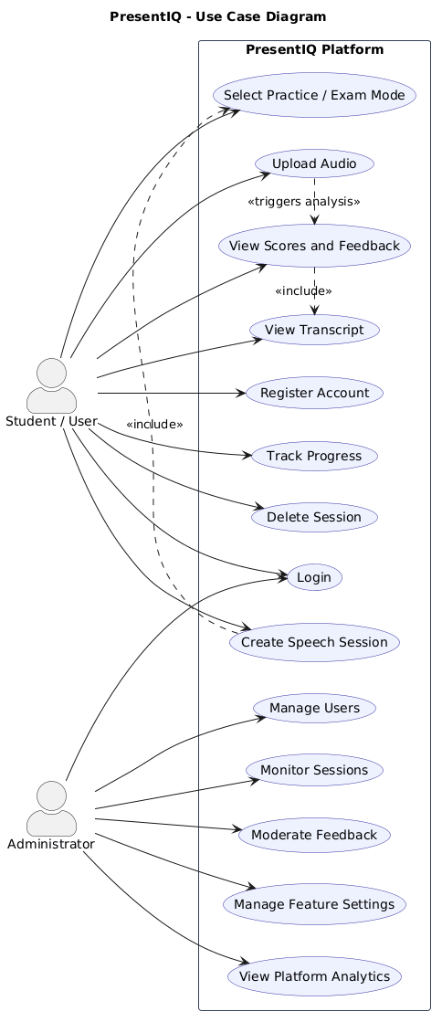
The use case diagram is used to identify the key interactions between users, administrators and platform. The standard users are able to register, log in, create sessions, upload audio, view analysis, and track progress. Administrators can track users, review sessions, moderate feedback, review analytics and manage settings.
Figure 2
Class Diagram

The class diagram illustrates the major entities in the system and their interrelationships. It encompasses Users, Practice Sessions, Analysis Records, Feedback Notes, Platform Settings and Service Classes including Transcription, Analysis, Pipeline Orchestration and Scoring. This helps to design in a modular object-oriented way.

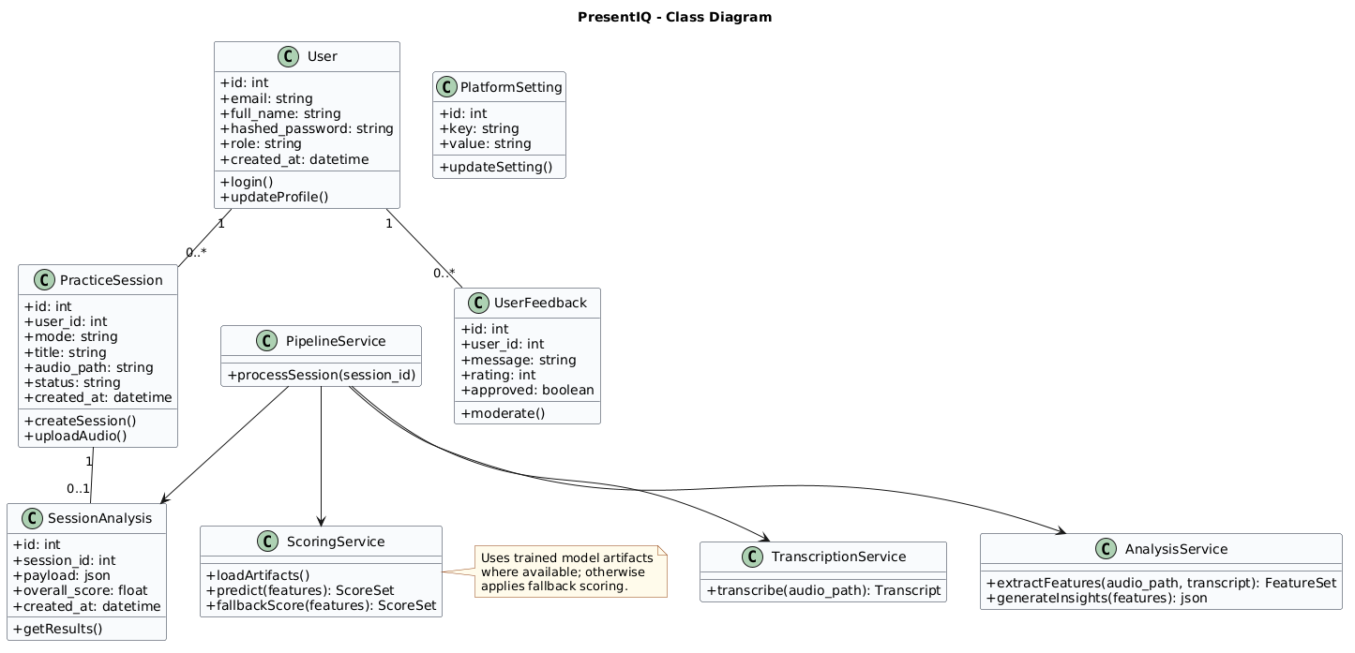
Figure 3

Sequence Diagram

The sequence diagram illustrates the process of audio analysis starting from session creation and ending with the display of results. It shows interaction between the front end and back end endpoints, how background processing is triggered and how the front end gets the completed analysis by polling.

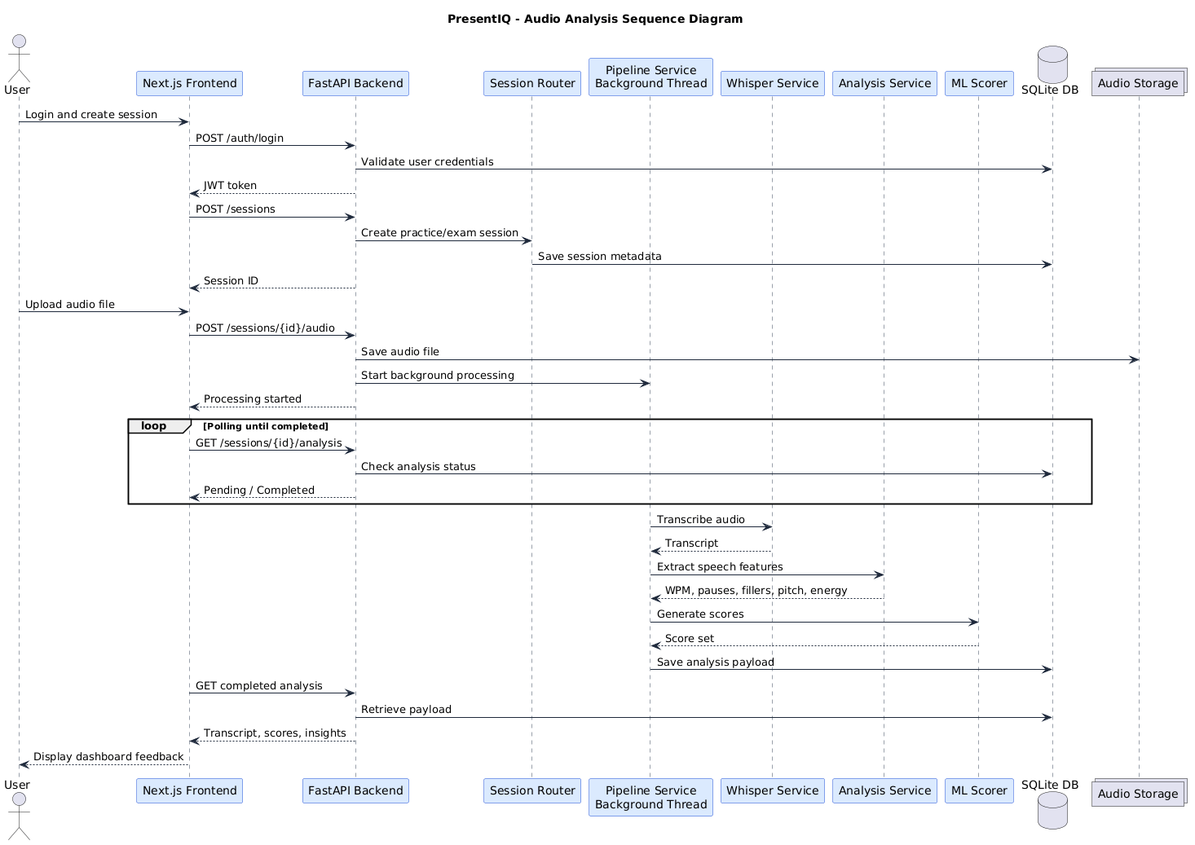
Figure 4

ER Diagram

The ER diagram represents the structure of a database. It illustrates the user-to-sessions-to-session analyses-to-feedback records-to-platform settings relationships. This design enables tracking of progress, administrative monitoring and structured storage of analysis results.
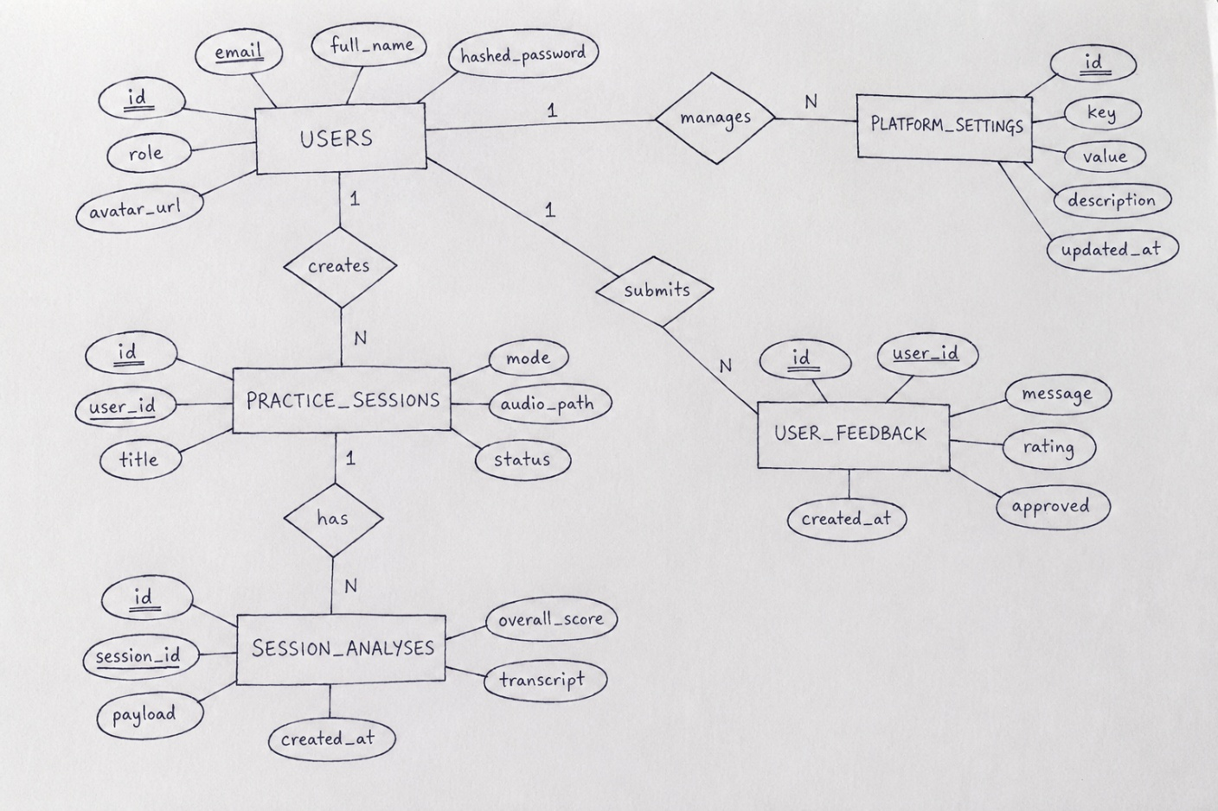
Figure 5

4.11 Networking and Deployment Architecture

The design approach for networking is a client-server approach. The Frontend communicates with the FastAPI backend and is used with a browser. The backend connects local file storage, the SQLite database and AI processing modules. They are both running in development, with the frontend on port 3000 and the backend on port 8000. In production, the front end and back end may be deployed separately, and the secure HTTPS communication protocol can be used, with the production level database.

4.12 Chapter Summary

In this chapter, the design and architecture of PresentIQ have been explained. It is built as a multi-layered system with a full stack of separation of the frontend interfaces, backend APIs, database storage, authentication features, and AI-processing services. The design facilitates maintainability, modularity, and scalability for future use, and allows for automated speech analysis and structured feedback delivery.

Chapter 5 — System Implementation

5.1 Introduction

The implementation of the PresentIQ platform is described in this chapter. It offers fullstack implementation with frontend interfaces, backend API services, speech processing modules, machine learning components, and administrative tools all seamlessly integrated. The development of the system was made step by step to make sure that individual modules were tested before being integrated into the system.

5.2 Development Methodology

The project started with a Waterfall approach as there was a very limited initial scope for integrating external speech-analysis services. But as the project started to progress to the development of custom speech-feature extraction and machine learning experiments would be required, an iterative approach was needed.

It was decided to use an Agile-inspired development methodology that was to be used. It was built incrementally, starting with the authentication and frontend infrastructure, speech upload, integration of transcription, feature extraction, scoring logic, and visualizing the results on the dashboard. This continuous development process enabled the ongoing testing, refinement, and integration of AI-processing elements.

5.3 Frontend Implementation

The front end was developed using Next.js App Router, React, TypeScript and Tailwind CSS. The interface was designed to be responsive, clear and accessible to undergraduate users of varying technical backgrounds. Accessibility and interface consistency were enhanced by integrating Radix UI components.

The frontend architecture is divided into reusable UI components, views, hooks and layers of API communication. This is a modular structure which makes maintenance easier and expands the interface in the future more easily.

Authentication Interfaces
Registration, login, password recovery and account management were provided with authentication interfaces. The frontend has been enhanced with JWT based authentication to ensure secure user sessions. Once successfully logged in, protected API calls include authentication tokens that are stored.
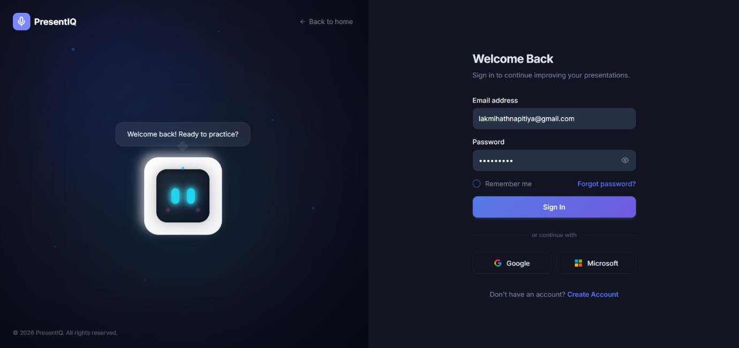
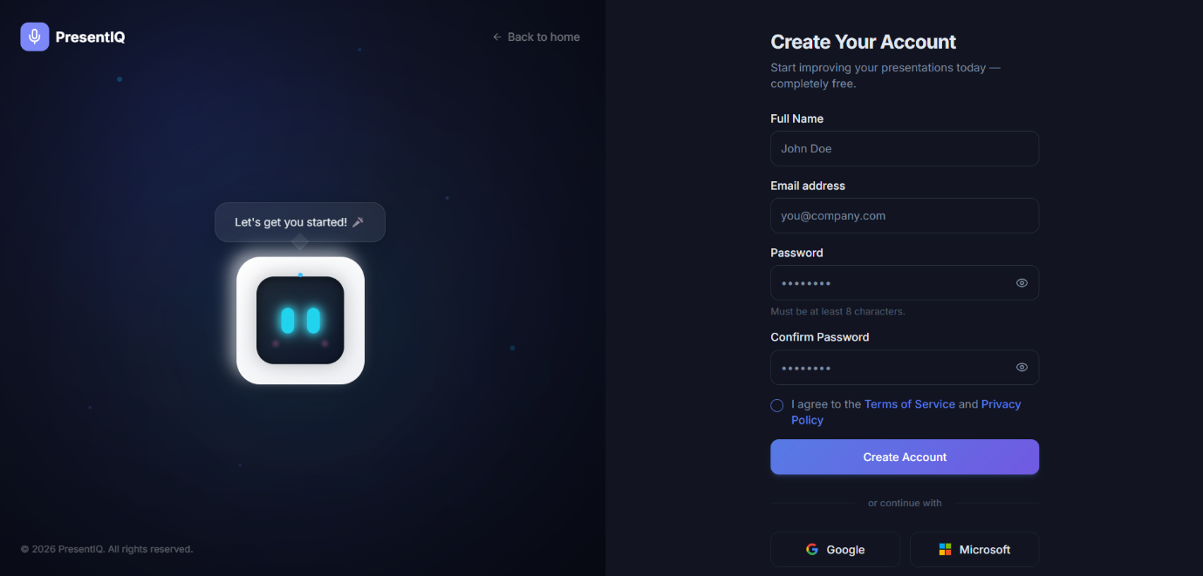
Security measures to deal with incorrect credentials, duplicate sign-up, and password update processes were put in place. The authentication flow aims to reduce the complexity while still being secure and usable.
Figure 7
Figure 6

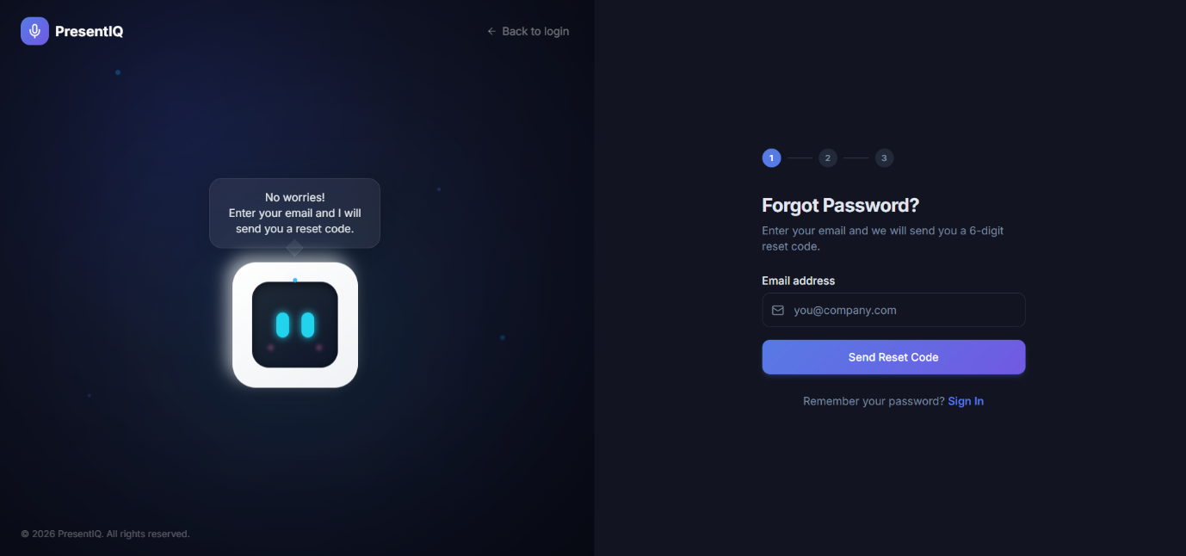
Figure 8

Dashboard Implementation

The dashboard view offers users session summaries, analysis history, progress tracking and score visualization. Speech metrics, skill scores, filler-word statistics and progress indicators for various practice sessions were implemented using chart.js and Recharts.

The dashboard also shows a summary of recent activity cards, transcript summaries and coaching recommendations. The interface was designed to be intuitive and user-friendly, allowing users to easily interpret the results of the analysis.
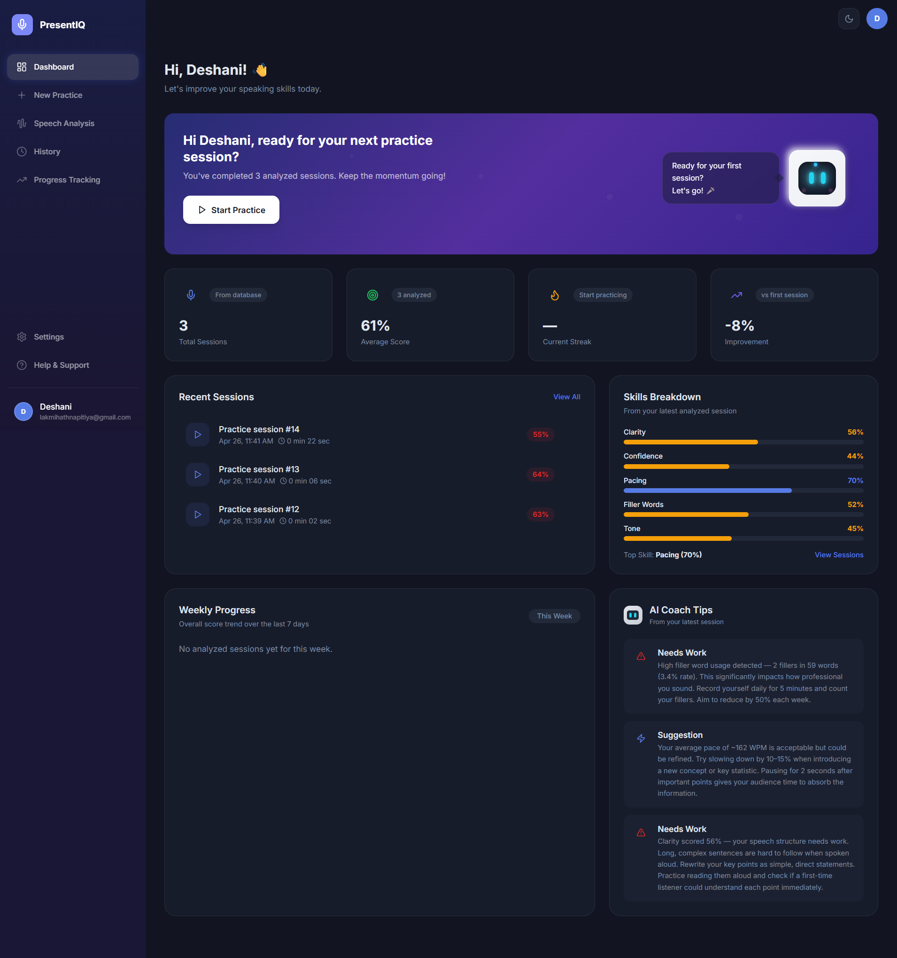
Figure 9
Speech Analysis Interface
The speech-analysis interface shows analysis results in detail after completion of analysis. This comprises transcripts, an overall score of performance, speech metrics, filler-word analysis and generated feedback. Practice mode includes coaching based suggestions, and exam mode includes evaluation based on the scores.
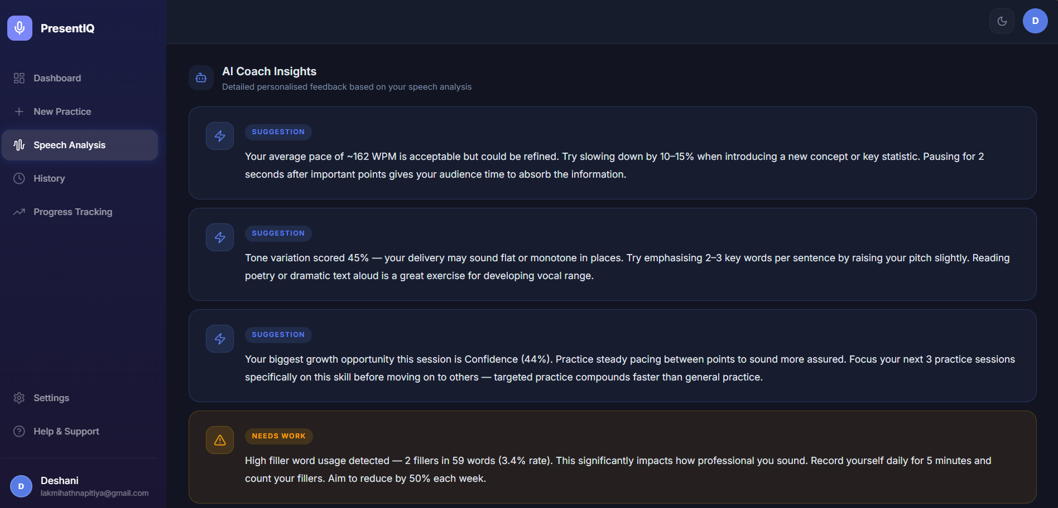
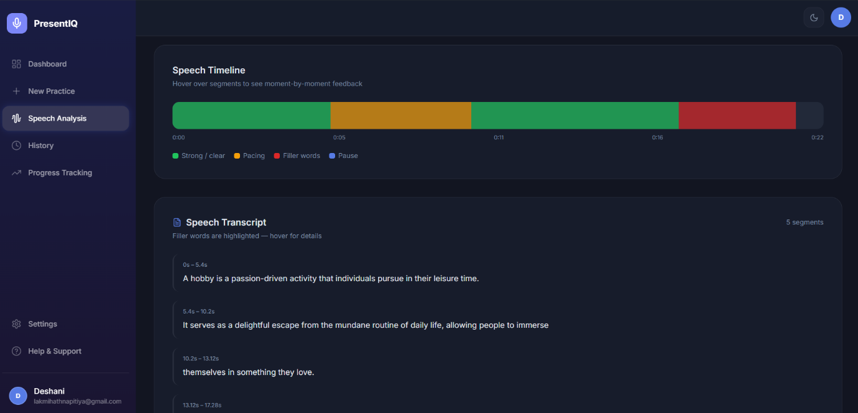
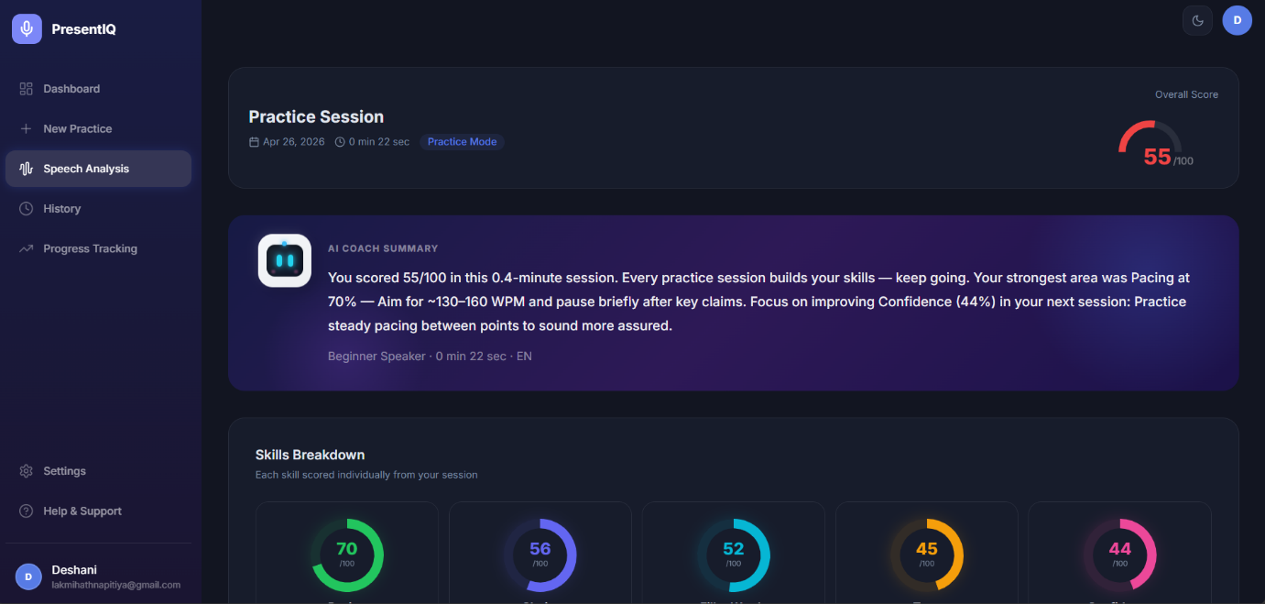
The interface can be used asynchronously with frontend polling for result retrieval. The frontend periodically sends requests for processing status until the audio is finished being processed, while the backend processes the audio and returns the status of the analysis operation

5.4 Backend Implementation

FastAPI and Python were used to develop the backend. The choice of FastAPI was driven by its lightweight design, its asynchronous functionality and its suitability for API services that integrate machine learning.

The backend is designed around modular architecture, with different routers responsible for authentication, handling sessions, providing feedback and administrative services. This makes it easier to maintain and test individual parts.

FastAPI Service Structure

The FastAPI application was designed using dedicated routers and service modules. Authentication routers are responsible for user registration and login, password resets, and user profile management. Speech-session creation, analysis retrieval, audio uploads and deletion workflows are all handled by session routers.

Service modules handle transcription, feature extraction, scoring and orchestration. Users, sessions, analyses and feedback records are accessed through structured interactions with the database using SQLAlchemy ORM models.

Session Management

The session-management system enables users to set up a practice or exam session prior to upload of speech recordings. All session metadata, processing status, timestamps and analysis payloads are saved in the database.

Audio files uploaded are stored in their own file system in backend audio directories, and there are still database references. This separation is beneficial for organisation and to avoid storing big binary files directly in the database records.

Background Audio Processing

The background-processing workflow is one of the most key things about the implementation. Speech transcription and feature extraction are complex functions which can be costly in terms of computation time and resource usage, and thus can cause delay in API response time if these functions are carried out synchronously.

To overcome this, audio recordings are uploaded in the background threads. Once uploaded, the backend will immediately respond and the analysis tasks will run in parallel. This design will make the app more responsive and will not block the frontend in case of long-running operations.

5.5 Speech Transcription Implementation

Faster-whisper was used to implement speech transcription. Audio recordings that are uploaded are sent through the transcription pipeline to create text transcripts. The transcribed output is then subjected to the analysis of filler words, calculation of speaking rate and visualization of the transcript.

The following are some of the reasons for choosing Whisper: Some of the reasons Whisper was chosen: The transcription service was designed to be modular and easily expandable by being incorporated as a backend module.

5.6 Feature Extraction Implementation

The extraction of speech features was done by programming with Librosa, NumPy and custom analysis functions. Measurable presentation-delivery indicators such as speaking rate, pause frequency, pause duration, usage of filler words, pitch variation, energy variation are extracted from the system.

Speech duration and word counts for the transcript are used to determine speaking rate. The silence-analysis techniques are addressed to stop detection, whereas the pitch and energy features are from signal processing of the audio signal. Features are extracted and placed into structured analysis payloads which can be later scored and visualized.

5.7 Machine Learning Scoring System

The machine-learning scoring system works by analyzing the speech features it extracts to come up with the indicators for the presentation. They trained models using scikit-learn because of their reliability, interpretability and the appropriateness of structured feature-based evaluation.

The scoring module tries to load the trained model artefacts from the special scoring directories. Fall back scoring behaviour is applied in order to keep the major part of the system in function if there are no trained models. This design will help to increase the robustness and avoid complete failure of the pipeline when there are missing model artifacts.

5.8 Feedback Generation Mechanism

The feedback-generation system decodes the extracted features and generates scores into suggested coaching structures. Feedback rules judge factors like using too many filler words, too fast of a rate or not enough vocal variation.

The practice mode provides detailed feedback that is oriented toward coaching and working on practice to facilitate improvement. In exam mode, the more rigid assessment will be used and there will be fewer coaching explanations, mimicking the conditions of a formal assessment.

5.9 Admin Dashboard Implementation

The administrative dashboard was created to aid in platform management and maintenance. Scores, distribution, feedback, system activity and user statistics are available to administrators.

Other administrative features include moderation of testimonials in the public, platform configuration settings and feature-toggling. Administrative routes are secured by role based access control to ensure that no unauthorized access can be made to these routes.

5.10 Hardware Design

There were some technical difficulties during implementation process. A difficulty was one of maintaining responsiveness in speech processing operations. A solution was found in the form of background-thread based processing and asynchronous frontend polling.

The challenge was also the variation of audio quality that was uploaded. The transcription errors and reliability of pause detection differed according to the environment in which they were recorded. To ensure consistency, some audio normalization techniques and threshold adjustments were added.

However, incorporating machine learning was also difficult as it was not always possible to have trained model artifacts in the hands of developers. To solve this problem, fallbacks were added to the scoring behavior and it was made possible to run the platform without model loading.

5.11 Chapter Summary

This chapter explained the development of the PresentIQ platform, from the front-end interfaces through to the back-end services, transcription modules, feature extraction, machine-learning scoring, feedback generation, and administrative features. The deployment integrated the latest web development advancements with cutting edge AI speech analysis capabilities, resulting in a modular and extensible assessment platform for presentations.

Chapter 6: Testing and Evaluation

6.1 Introduction

Testing and evaluation are an integral part of software development processes since these checks will determine if the implemented system meets functional requirements, performance expectations, usability and security requirements. The PresentIQ platform was tested using various methods such as functional testing, API testing, user-interface testing, performance testing, security testing, and usability testing. The testing activities were carried out for the purposes of reliability and effectiveness test of the system under realistic operating conditions.

6.2 Testing Strategy

PresentIQ testing was done in a module-wise fashion, testing all the components of the front end, all the backend services, and all the modules used for processing the AI, as well as the interaction with the database, before putting all of them in place as a system. Manual testing and automated endpoint validation have been carried out during the development.

The functional testing was carried out to ensure that the operation of the system would behave as expected. Backend communication and response handling was validated using API testing. User-interface testing has been done on the responsiveness, navigation and accessibility of the website. The performance evaluation focused on processing responsiveness when performing speech analysis and security testing looked at authentication protection and the behavior of restricted access.

Testing was done in incremental steps as it was implemented, to detect problems early and keep the integration failures to a minimum.

6.3 Functional Testing

Functional testing was performed to ensure that the main platform functions were executed properly when users interacted with them. This testing process assessed authentication workflows, session creation, audio uploads, generation of audio transcriptions, retrieval of feedback, and administrative functions.

Table 1 presents selected functional test cases used during system evaluation.
Test ID | Feature Tested | Expected Result | Actual Result | Status
FT01 | User Registration | New user account created successfully | Account created and stored in database | Passed
FT02 | User Login | JWT token generated for valid credentials | Token generated successfully | Passed
FT03 | Session Creation | Practice session stored in database | Session created correctly | Passed
FT04 | Audio Upload | Audio file uploaded successfully | File stored in uploads directory | Passed
FT05 | Speech Transcription | Transcript generated from uploaded audio | Transcript returned successfully | Passed
FT06 | Analysis Retrieval | Analysis payload returned after processing | Results displayed correctly | Passed
FT07 | Admin Dashboard Access | Only administrators can access dashboard | Access restricted successfully | Passed
FT08 | Session Deletion | User session removed from database | Session deleted successfully | Passed

6.4 API Testing

Communication between front end and back end services were validated by API testing. Requests were made through the browser and API testing tools to ensure requests were being handled, authentication was being validated, responses were being returned in a consistent manner, and errors were being managed.

Authentication and session management, audio upload, and analysis retrieval endpoints were assessed. The handling of errors due to invalid credentials, unauthorized requests, unsupported file formats, and invalid session identifiers, were also tested.

Table 2 summarises selected API test cases.
API Endpoint | Test Scenario | Expected Response | Result
POST /auth/login | Valid login credentials | JWT token returned | Passed
POST /sessions | Create practice session | Session ID returned | Passed
POST /sessions/id /audio | Upload audio file | Processing initiated | Passed
GET /sessions/id /analysis | Retrieve analysis payload | JSON analysis returned | Passed
GET /admin/stats | Unauthorized access attempt | Access denied | Passed

6.5 User Interface Testing

The user-interface testing concentrated on responsiveness, layout consistency, accessibility and navigation behavior in the most prevalent desktop browsers. The authentication screens, dashboard, upload workflow, analysis pages and administrative dashboard were tested.

The platform responded well on various screen resolutions and aligned the components correctly during all the navigation sequences. Elements of the visual feedback, like charts, score indicators and sections of the transcript, were checked to be readable and understandable.

Frontend polling behavior was also tested during the speech analysis process. The interface updated the processing states successfully without any manual page refreshes, thus enhancing usability of the interface while doing long running analysis.

6.6 Performance Evaluation

Evaluation covered mostly response to speech processing and stability in backend upon performing audio analysis operations. As these transcription and feature extraction tasks are computationally intensive, it was deemed important that processing efficiency was taken into account as a quality attribute.

Using the background-thread processing approach, the frontend was much more responsive since the request was not blocked in the analysis operation. Most speech signals successfully processed within reasonable response time under local development conditions, (2-3 minutes) for short speech signals.

Multiple sequential session uploads were also performed using the system and stable behaviour was observed. But, due to testing in a local development environment, the testing of large-scale concurrency was limited.

6.7 Security Evaluation

Security evaluation included authentication protection, handling of passwords, access control and secure session management. JWT-based authentication was also tried to verify that the protected endpoints return only restricted data if there is a valid access token.

Password hashing with Argon2 was effective at storing passwords in the database in an unreadable format. Role based access control was implemented, meaning that standard users could not have access to administrative analytics and moderation functions.

Further testing verified that all the unauthorized requests to protected endpoints received the proper access denied responses. These security features enhanced the cover of uploaded audio recordings and analysis payloads and user account information.

6.8 Usability Evaluation

Usability evaluation was conducted to assess the ease of navigation, clarity of feedback presentation, as well as the accessibility of platform workflows. Informal observations by the users showed that they were able to register, upload audio, and interpret results from analysis without technical support.

Visual indicators and charts made it easier to interpret metrics from speech, simplifying the dashboard design by presenting the scores, insights from the transcript and filler-word statistics. The feedback from the practice mode was most useful as it gave suggestions to act upon, not just numerical scores.

These advantages were tempered by the need, by some users, for further explanation of the significance of some speech metrics, especially pitch variation and energy analysis. This indicates that further improvement may be needed in providing explanatory guidance in the interface.

6.9 System Limitations

The system accomplished the goals and goals set forth, however there are some limitations. The quality of the recordings, noise conditions, and trained machine-learning artifacts are all factors affecting speech-analysis accuracy. Inaccurate transcription and a lack of accurate pause detection can arise due to poor quality audio.

The machine learning model used also has a small number of training sets which could limit generalization in accent and speech style. Moreover, the real implementation currently works within a local deployment environment, and it has not been tested with large-scale production workloads.

Currently, analysis of presentations is only available in English, and live speech coaching is not available. The constraints highlight possible future enhancements and development.

6.10 Chapter Summary

This chapter presented the testing and evaluation process for the PresentIQ platform. The following functional, API, user-interface, performance, security, and usability tests were conducted to ensure that the system implemented is reliable and effective. The results proved that the platform is capable of supporting automatic analysis of presentation speech and at the same time keeping the general usability, responsiveness and security of the platform at an acceptable level.

Chapter 7 — End-Project Report and Post-Mortem

7.1 Project Outcomes

The PresentIQ project was successfully completed with the development of a full stack AI-based speech evaluation platform to assist undergraduate students in enhancing presentation and communication skills. The entire system is implemented on a single web application with interfaces on the front end, a back-end API system, speech transcription, audio-feature-extraction, machine-learning-based scoring, and structured feedback generation.

The ultimate implementation includes user authentication, speech-session management, audio upload, asynchronous processing, transcript creation, performance evaluation and progress tracking. There are also administrative features such as users monitoring, session tracking, analytics and public feedback moderation. The final architecture shows the integration of Artificial Intelligence technologies to solve an educational communication-skills issue, using contemporary web-development practices.

The project was also successful in meeting its goal of developing an interpretable speech-evaluation system. The platform isn't just about having a black-and-white score; it features measurable speech markers like speaking rate, filler words, pauses, pitch range, and energy analysis, and enables users to gain deeper insights into presentation strengths and weaknesses.

7.2 Objectives Achievement Evaluation

Most of the project goals were met during implementation. Next.js and FastAPI have been used to develop the web-based platform to record and upload presentation speech successfully. Whisper based ASR integration was added, allowing to generate transcriptions for uploaded recordings.

Evaluation of speaking rate, pauses, filler words, pitch variation and energy variation were also applied to speech feature extraction and found to be successful. Machine learning based scoring functionality was added for creating presentation-quality indicators and fallback scoring mechanisms were added to provide greater reliability when trained model artifacts were not available.

The system also met the goal of providing structured and visual feedback in the form of dashboards, charts, transcript analysis and coaching tips. Administrative tools for user- and session-monitoring, analytics, and moderation were also successfully finished.

But some advanced objectives were only partially accomplished. With limited development resources and computing, large-scale dataset training and evaluation for advanced speech conditions was not feasible. These drawbacks do not detract from the overall goal of the project, which was to create a usable and functional product.

7.3 Comparison with Initial Proposal

The final implementation design had many changes from the original project design. The project started with relatively simple architecture at the initial planning phase, the project was to incorporate external speech-analysis APIs. The initial concept involved adopting a Waterfall development approach as it was thought that the proposed implementation would mainly involve backend integration.

The project scope evolved as development went forward, extending the work to investigate custom artificial intelligence (AI) based speech analysis and feature extraction. The system used internal transcription, speech feature analysis, machine learning scoring and feedback generation modules, instead of relying solely on external APIs. This change raised the technical level of the project but also enhanced transparency and educational benefit.

The development methodology also shifted from Waterfall to a more agile oriented process. Through implementation, speech-processing techniques, scoring logic and the integration of the front-end are continually being refined. The result was a much more sophisticated and technically complete system than was initially suggested.

7.4 Technical and Development Reflections

There were several significant technical reflections that arose during the process of development. One of the key takeaways was the realization of the intricacies of embedding AI processing pipelines into web-based systems. Speech transcription and feature extraction caused computational overhead, impacting backend responsiveness initially. Background thread processing really enhanced system responsiveness and usability.

The other reflection was on the problems of speech-data variability. The reliability and the accuracy of the transcription and the detection of the pauses were influenced by the differences in quality of recording, background noise, and in style of speaking. It has proved the significance of preprocessing and threshold calibration in a speech-analysis system.

The project also emphasized the significance of the modular design in a holistic AI application. Developing the deployment process for the project was easier, because the software components for the frontend interfaces, backend services, database models and modules for AI processing were separated. The maintainability of the project was improved and the debugging process during development was made easier. This modular design would also allow for further scalability and deployment enhancements.

7.5 Lessons Learned

The project was a great experience in learning a lot about full-stack software development, how to integrate AI, speech processing, and learning about iterative system development. A key takeaway was the need to consider the balance between technical complexity and maintainability. The efficiency of development and integration stability were greatly affected by early architectural decisions.

Another key takeaway was the real-world difficulties of embedding machine learning in production systems. Ensuring these AI pipelines are robust and reliable necessitates the implementation of the model, as well as strong error handling, fallback mechanisms, and processing workflows.

Project also enhanced the understanding of user centered interface design. The usability, clarity and the techniques in which feedback would be presented in a readable and educationally useful format for complex analysis results was a matter of careful consideration.

7.6 Future Improvements

In future development stages, there are several improvements which can be made to the PresentIQ platform. One significant improvement would be to have real time, live, speech analysis rather than post upload analysis. This would enable users to get instant feedback when they present.

Further advances include the addition of multi-lingual speech support, deployment in the cloud, scalable distributed processing and GPU based transcription services. Larger and more varied speech datasets, used to train more sophisticated machine-learning models, could help to enhance the accuracy and adaptability of scoring in this regard, as well as in terms of accent and speaking style.

Potential enhancements for future iterations of the platform may include emotion analysis, gesture recognition, AI-based coaching assistants, and mobile application integration, all of which would further enhance the platform's ability to provide a comprehensive training experience for communication skills.

Chapter 8 — Conclusion

8.1 Summary of the Project

This project targeted the design and development of PresentIQ, an AI-based web-based platform that will help undergraduate students enhance their presentation skills by analyzing and generating structured feedback with their speech. The project responded to the lack of independence in presentation evaluation that is traditionally provided by lecturers or peer comments, and the inadequate opportunities to practice independently provided by traditional assessment methods.

The final implementation was a blend of modern front end and backend technologies, speech processing and machine learning techniques. The platform allows for user authentication, speech-session management, upload of audio, automatic speech transcription, speech-feature extraction, speech scoring, and presentation of the visual feedback. The system can judge the measurable characteristics of a speaker's speech delivery, such as speaking rate, pause patterns, filler-word usage, pitch variation, and energy variation, and provide user-friendly feedback.

The architecture was designed as a modular full stack featuring a Next.js front end, FastAPI backend services, SQLite for database storage and AI for processing using Whisper, Librosa and Scikit-learn technologies. Administrative features are also provided to enable analytics, moderation and platform management.

Testing and evaluation showed that the platform was able to meet the basic workflows needed for an automated presentation-speech evaluation. The functional testing, API validation, usability analysis and security evaluation verified that the system is reliable in normal use and that the system uses is acceptable in terms of responsiveness and usability.

8.2 Final Evaluation

Overall, the project was able to address its main goals and to show that it is possible to combine Artificial Intelligence and state-of-the-art web development technologies in the field of educational communication skills training. The implementation also included speech metrics that were easy to interpret and structured feedback, that facilitate independent presentation practice, in addition to automated scoring.

The most notable achievement of the project was the successful integration of Speech Processing techniques in an asynchronous manner in a responsive Web-based environment. Background-thread processing enhanced user experience by avoiding the blocking of the frontend during background-intensive tasks like transcription and analysis.

But there are some restrictions. Machine-learning artifacts, training data, and quality of recorded speech are all factors that impact the reliability of speech analysis. Moreover, the current implementation is mainly devoted to the evaluation of speech in English and to the local deployment setting. Although the system has some constraints, it has good technical feasibility and is a good basis for further expansion and refinement.

8.3 Concluding Remarks

Overall, PresentIQ illustrates how speech analysis technology powered by AI can be implemented to assist in developing communication skills in a higher education setting. The project integrated software engineering, machine learning, speech processing, and user-interface design to develop a usable education platform that can be used for self-practice of presentations.

This completed system demonstrates the potential accessibility, measurability, and interpretability of intelligent educational technologies for providing feedback on communication training. This platform has the potential to become a more sophisticated speech coaching platform with scalable applications for further enhancements across the education and professional contexts.

References
Aryadoust, V. (2023). Topic and Accent Coverage in a Commercialized L2 Listening Test:
Implications for Test-takers’ Identity. pp.1–21. [Online].
Available at: doi:10.1093/applin/amad062 [Accessed 14 January 2026].
Cader.Ishan, Hassan, S., Mok, A. and Tan, S. (2024). Transnational education in
Sri Lanka: Operational and quality assurance landscape.

Chen, H. H.-J. (2011). Developing and evaluating an oral skills training website supported by
automatic speech recognition technology. European Association for Computer Assisted
Language Learning, 23 (1), pp.59–78. [Online].
Available at: doi:10.1017/S0958344010000285 [Accessed 14 January 2026].

Gamage, D. G. M. P. M. and Henegedara, R. H. G. W. P. K. (2019). Employability of
university graduates; Investigation of graduate’s and employer’s perspectives on
employability. International Journal of Scientific and Research Publications, 9 (7), p.946.
[Online].
Available at: doi:10.29322/IJSRP.9.07.2019.p91124 [Accessed 14 January 2026].

Gatta, M., Kahn, J., J. Koncz, A., Galbraith, A., Patil, S. and Longenberger, A. (2025). Job
Outlook 2025 Spring Update. Bethlehem .

Hutin, M., Hu, J. and Degand, L. (2024). Uh, um and mh: Are filled pauses prone to conversational
convergence? pp.1–5. [Online].
Available at: https://dial.uclouvain.be/pr/boreal/en/object/boreal%3A289397/datastream [Accessed
14 January 2026].

Isotalus, P., Eklund, M. and Karppinen, K. (2024). Communication Teacher ISSN: (Print)
(Online) Journal homepage: www.tandfonline.com/journals/rcmt20 Artificial intelligence as a
feedback provider in practicing public speaking. [Online].
Available at: doi:10.1080/17404622.2024.2407910 [Accessed 14 January 2026].

Lintner, T. and Belovecová, B. (2024). Demographic predictors of public speaking anxiety
among university students. Current Psychology , pp.1–19.
Radford, A., Kim, J. W., Xu, T., Brockman, G., Mcleavey, C. and Sutskever, I. (2022). Robust
Speech Recognition via Large-Scale Weak Supervision. [Online].
Available at: https://github.com/openai/ [Accessed 14 January 2026].

Wang and Li. (2021). British English-Speaking Speed 2020. Academic Journal of Humanities
& Social Sciences, 4, pp.93–100. [Online].
Available at: doi:10.25236/AJHSS.2021.040517 [Accessed 14 January 2026].
(2024). Employability Skills Survey 2024 IT / Software Industry of Sri Lanka 2 Employability
Skills Survey 2024. Colombo 03 . [Online].
Available at: https://slasscom.lk/wp-content/uploads/2024/07/SLASSCOM
EMPLOYABILITY- SKILLS-REPORT-2024.pdf [Accessed 14 January 2026].

Appendices

Appendix A — Source Code Repository Link

Appendix B — GitHub Commit History

Appendix C — Additional Screenshots

Appendix D — Test Results

Appendix E — PID

Appendix F — Interim Report

Appendix G — Supervisory Meeting Records

