Comparative Analysis of Machine Learning Classifiers for Imbalanced Exoplanet Transit Detection Using the Kepler KOI Dataset
Lakita Choudhary
Dept. of Computer Science & Engineering
Lovely Professional University, Phagwara,Punjab
lakita.choudhary2024@lpu.in

Abstract—Finding confirmed exoplanets in the Kepler dataset is genuinely tricky — not because the data is small, but because the classes are wildly unbalanced. Confirmed planets make up just 35.2% of the Kepler Objects of Interest (KOI) entries, while false positives take up 44.8%. Most existing studies just report overall accuracy and call it a day, which completely misses the point when your minority class is the one that actually matters. In this paper, we compare five classical machine learning classifiers — Logistic Regression, Decision Tree, Random Forest, SVM, and XGBoost — on 14 tabular KOI features, and we apply SMOTE to the training set to deal with the imbalance properly. We evaluate everything with Precision, Recall, F1-Score, and AUC-ROC rather than accuracy. Using Random Forest's Gini importance, we found that three features drive most of the prediction power: the disposition score (koi_score, 50.9%), signal-to-noise ratio (koi_snr, 12.8%), and the non-transit-like false positive flag (koi_fpflag_nt, 10.2%). Somewhat surprisingly, Logistic Regression came out on top after SMOTE with an F1-Score of 0.957 and AUC of 0.992. The entire pipeline uses publicly available NASA Exoplanet Archive data and is fully reproducible in Python.
Keywords—planetary transit detection; machine learning; class imbalance; SMOTE; Kepler KOI; false positive detection; exoplanet classification; feature importance

Introduction
When a planet passes in front of its host star, it blocks a tiny fraction of the starlight, causing a brief, periodic dip in brightness. That's the transit method in a nutshell — and it's how NASA's Kepler Space Telescope discovered the bulk of the confirmed exoplanets we know today. Kepler ran from 2009 to 2018, monitoring over 150,000 stars and cataloguing its findings in the Kepler Objects of Interest (KOI) dataset [1]. After cleaning and preprocessing the data as described in Section III, we end up with 1,791 usable records, each with 14 features covering everything from orbital period to stellar temperature.
Here's the problem though: the dataset is heavily skewed. Only 35.2% of KOI entries are confirmed planets. Almost 44.8% are false positives — signals that look like transits but aren't — and 20.0% are still unclassified candidates. This matters a lot for machine learning. A classifier that just always guesses "false positive" would score over 44% accuracy without ever finding a real planet [2]. Deep learning approaches like AstroNet [3] and ExoMiner [4] get impressive results, but they work on raw light curves and need GPUs, and they don't address the imbalance issue in tabular data or give you any idea which features actually drove the prediction.
We identified three gaps worth addressing. No one has run a proper head-to-head comparison of classical classifiers on the tabular KOI features using metrics that account for imbalance. The actual effect of SMOTE [9] on confirmed-planet Recall hasn't been quantified for this dataset. And feature-level importance — which KOI parameters are actually doing the heavy lifting — hasn't been reported here before. To fill those gaps, we built a five-classifier benchmark, tested every model both with and without SMOTE, ran Gini importance analysis, and packaged it all as a reproducible Python pipeline that anyone can run using only NASA public data.

Related Work

A. Transit Detection Algorithms
The Box Least Squares (BLS) algorithm, introduced by Kovács et al. [5], is the foundation of most automated transit searches. It works by fitting a periodic box-shaped dip to the light curve and has been the standard detection tool in both Kepler and TESS pipelines ever since. Hippke and Heller [6] pushed this further with Transit Least Squares (TLS), which replaces the rectangular box with a physically realistic limb-darkened transit model. That change alone gives a 17% improvement in true-positive recovery for small planets. Tingley [7] did a thorough head-to-head comparison of detection algorithms and confirmed that BLS holds up best at low signal-to-noise ratios, outperforming both DFT and PDM approaches.

B. Machine Learning for Transit Vetting
The shift toward machine learning for transit vetting really kicked off with AstroNet [3], a 1D CNN from Shallue and Vanderburg that hit 98.8% ranking accuracy on Kepler TCEs. That work inspired a whole line of follow-ups — Schanche et al. [8] adapted the idea to WASP ground-based data using a combination of Random Forests and CNNs, getting about 90% planet identification. Valizadegan et al. [4] took it further with ExoMiner, a multi-branch CNN that validated 301 Kepler planets. More recently, Tey et al. [10] brought AstroNet to TESS full-frame images (AstroNet-Triage-v2), reaching 99.6% recall, and Cuellár et al. [11] showed that blending real and synthetic light curves pushes CNN accuracy above 98%. The catch with all of these approaches is that they need raw light curve data and GPU compute — neither of which is practical for a tabular-only study.

C. Class Imbalance in Astronomy
He and Garcia [2] laid out the core problem clearly: standard classifiers learn to favour the majority class, and that bias directly tanks performance on the minority class you actually care about. SMOTE is one of the most reliable fixes. Raj and Kos [12] ran a neural network on Kepler tabular data and got an AUC of 0.91, but they dropped over half the dataset due to missing values and never applied any resampling — so the imbalance issue was just... left there. Prieto-Arranz et al. [13] surveyed the whole ML transit detection landscape and explicitly called out the lack of interpretable, imbalance-corrected tabular benchmarks as an open problem.

Dataset and Preprocessing

A. Data Source and Raw Statistics
We used the Kepler KOI Cumulative Table from the NASA Exoplanet Archive [14], which covers all 17 quarters of Kepler observations (Q1–Q17, Data Release 25). The raw dataset we worked with had 2,000 rows and 43 columns. After the full preprocessing pipeline described below, 1,791 samples remained usable. Fig. 1 shows how those break down: 631 CONFIRMED, 802 FALSE POSITIVE, and 358 CANDIDATE.
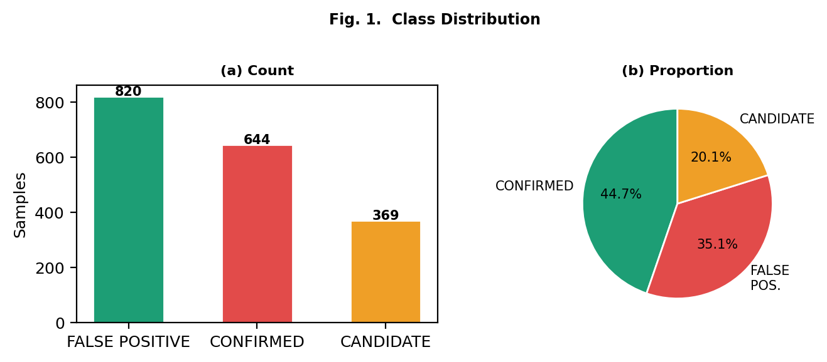
- Fig. 1. Class distribution in the cleaned Kepler KOI dataset.

B. Eight-Step Preprocessing Pipeline
Cleaning this dataset took eight steps, each addressing a specific data quality issue we found during exploration. First, we standardised the target labels — the koi_disposition column had over 15 different spellings of the same three classes (things like "confirmed", "Confirm", and "Yes" all meaning CONFIRMED), so we mapped everything to three canonical values. Second, we converted string garbage in numeric columns — values like "N/A", "--", and "?" — to NaN using pd.to_numeric(errors='coerce'). Third, we removed physically impossible values: negative orbital periods, koi_score above 1.0, stellar temperatures at or below 0 K, RA above 360°, and Dec above 90°. Fourth, we fixed a unit mismatch in koi_duration — roughly 7% of values were recorded in minutes rather than hours, so anything above 15 hours got divided by 60. Fifth, we removed duplicate Kepler IDs, keeping the first occurrence. Sixth, we binarised the false-positive flag columns so they only contain 0 or 1. Seventh, we imputed missing values using column medians for any feature with under 40% missing, and dropped the rest. Finally, we applied StandardScaler — fitted only on the training set — to prevent any leakage into the test data.

C. Feature Set
After preprocessing, 14 features made it through: orbital period (koi_period), transit duration (koi_duration), transit depth (koi_depth), planet radius (koi_prad), impact parameter (koi_impact), signal-to-noise ratio (koi_snr), disposition score (koi_score), stellar effective temperature (koi_steff), stellar surface gravity (koi_slogg), stellar radius (koi_srad), equilibrium temperature (koi_teq), and three binary false-positive flags (koi_fpflag_nt, koi_fpflag_ss, koi_fpflag_co). Fig. 2 shows how these features are distributed across the three classes. Fig. 3 shows the correlation matrix — useful for understanding which features share information.
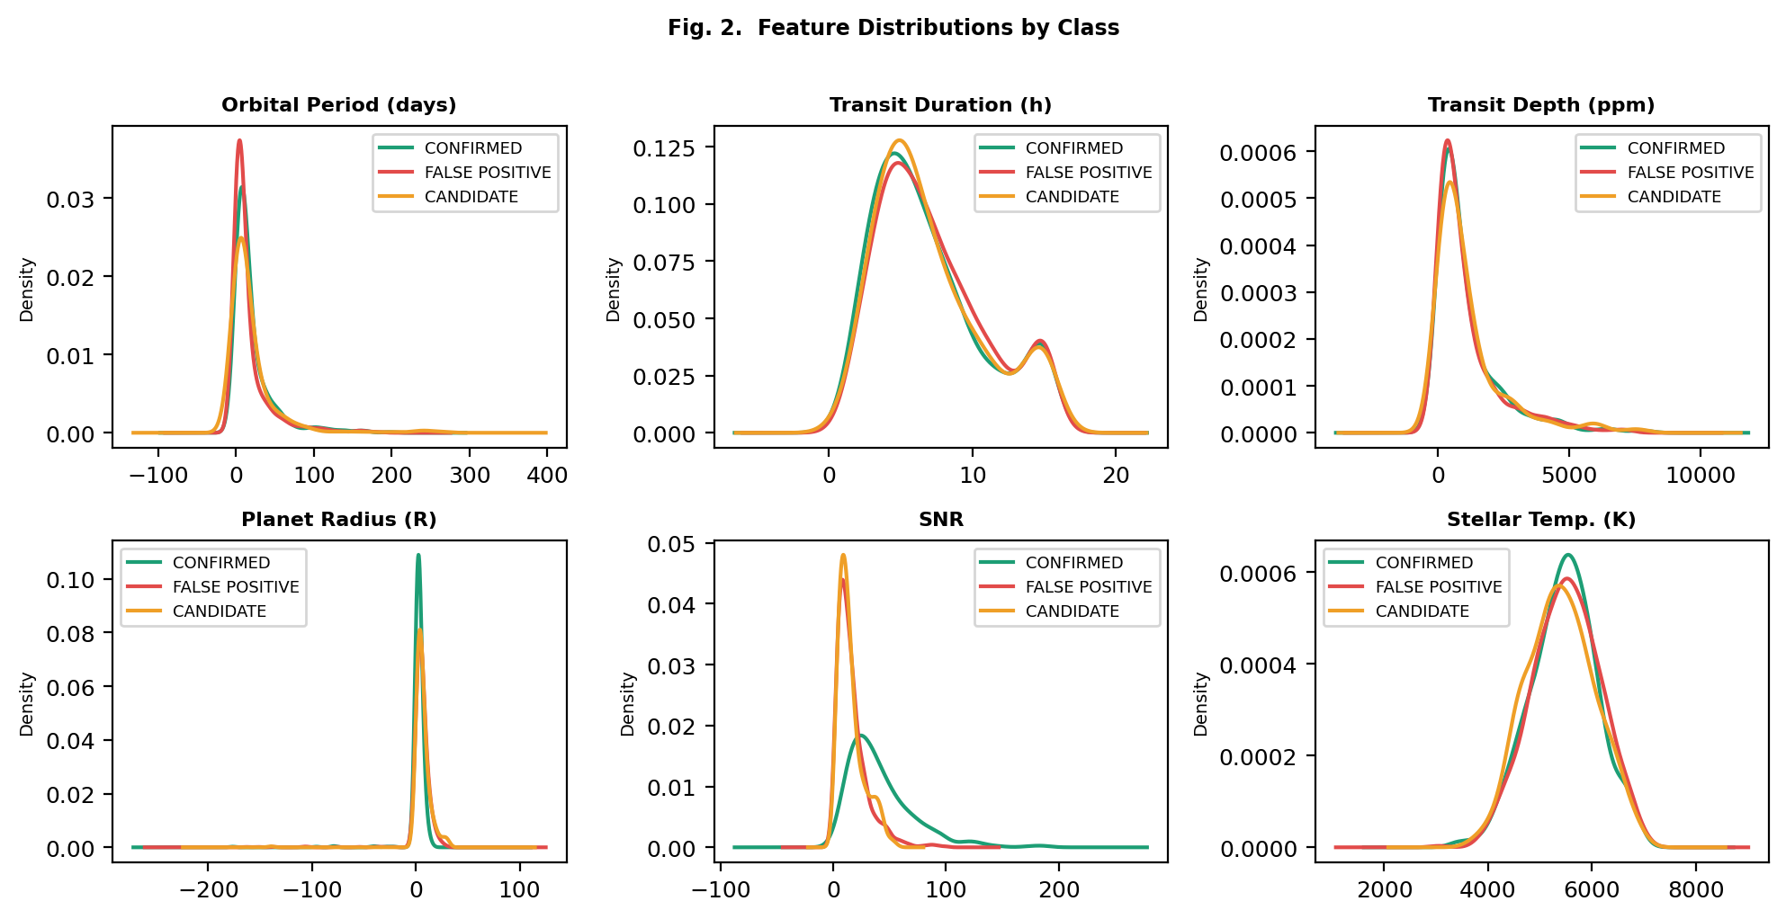
- Fig. 2. KDE distributions of six key features by class label.
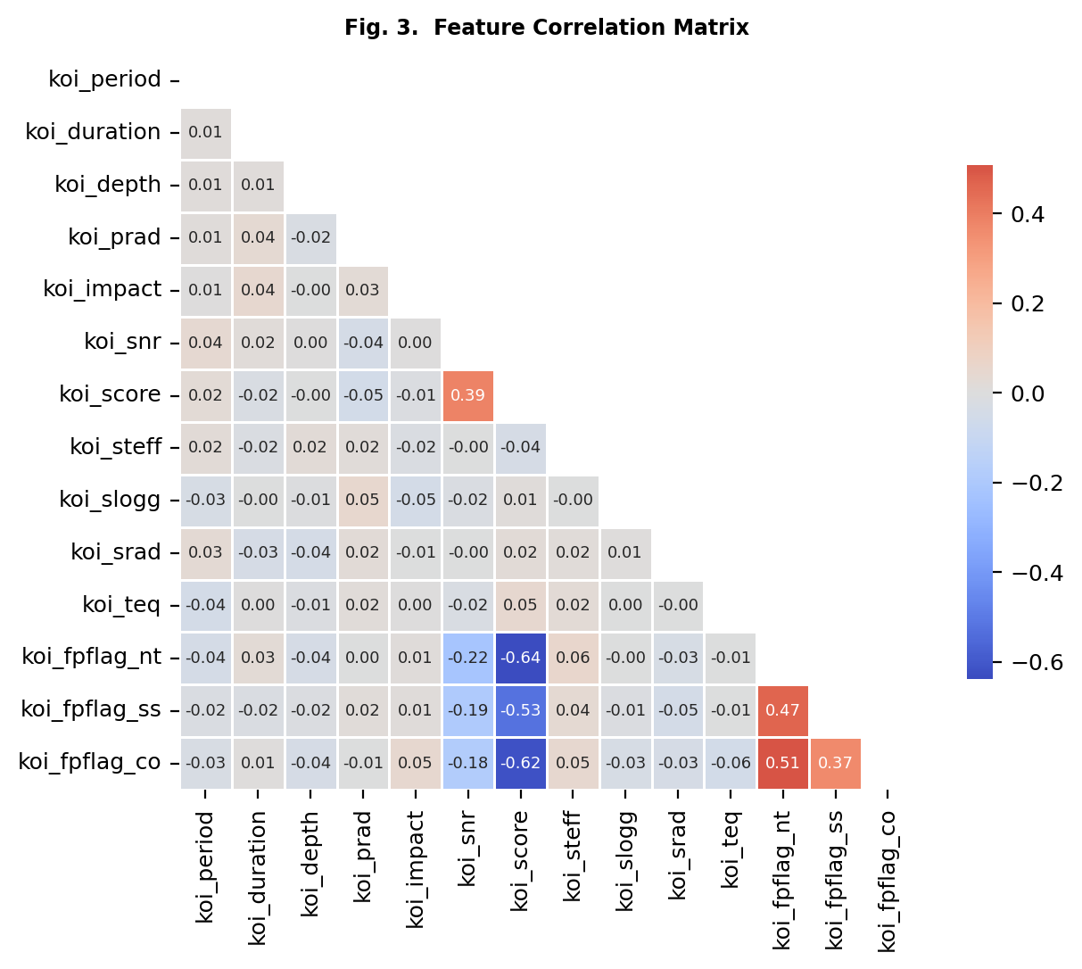
- Fig. 3. Feature correlation matrix for the 14 selected KOI features.

Methodology

A. Experimental Protocol
All experiments run on Python 3.10 using scikit-learn 1.4, imbalanced-learn 0.11, and XGBoost 2.0. We split the 1,791 cleaned samples 80/20 into training (1,432) and test (359) sets, using stratified sampling so both sets reflect the original class proportions. SMOTE with k=5 neighbours was then applied to the training set only, growing it from 1,432 to 1,854 balanced samples. Every classifier was trained and scored twice — once on the original imbalanced training data and once on the SMOTE-augmented version — always against the same held-out test set so the comparisons are fair.

B. Classifiers
We evaluated five classifiers. Logistic Regression (LR) served as our linear baseline, with max_iter set to 1000 and class_weight='balanced'. For the Decision Tree (DT), we capped max_depth at 8 and used balanced class weights to prevent it from just memorising the majority class. Random Forest (RF) used 200 estimators with max_depth of 12 and balanced weights. The SVM used an RBF kernel with C=1.0 and balanced weights. XGBoost (XGB) used 200 estimators, max_depth of 6, learning_rate of 0.1, and scale_pos_weight set to the ratio of negatives to positives in the training set.

C. Evaluation Metrics
We deliberately avoided using overall accuracy as a metric — on imbalanced data it tells you almost nothing useful [2]. Instead, we focused on four metrics for the positive (CONFIRMED planet) class: Precision tells us what fraction of our predicted planets are real; Recall tells us what fraction of the actual planets we caught — this is the one that matters most astronomically; F1-Score balances the two and is our primary ranking metric; and AUC-ROC measures how well a model separates the classes across all possible decision thresholds. We also plot confusion matrices to see exactly where each model is making its mistakes.

Results

A. Classifier Performance
Looking at Table I, the picture before SMOTE is interesting. SVM gets the highest F1 at 0.964, but XGBoost's Recall drops to 0.944 — the gradient boosting is clearly being pulled toward the majority class. After SMOTE, Logistic Regression ends up on top with an F1 of 0.957 and a Recall of 0.968, while Random Forest stays rock-solid at 0.957 regardless of whether SMOTE is applied. The Decision Tree is the biggest loser from SMOTE — its F1 drops from 0.961 to 0.926. That makes sense: SMOTE creates synthetic samples by interpolating between neighbours, and those interpolated points sit exactly where decision boundaries need to be drawn, confusing the tree. Fig. 4 makes the F1 changes easy to visualise. For SVM there's a slight trade-off — Recall drops from 0.968 to 0.937, but Precision actually improves, which suggests better generalisation rather than just memorising the training data. Fig. 5 shows ROC curves where RF and LR lead the pack at AUC of 0.995 and 0.992 respectively, while DT trails at 0.944.
- TABLE I. Classifier Performance With and Without SMOTE
Model | P | R | F1 | AUC | P (S) | R (S) | F1 (S) | AUC (S)
LR | 0.924 | 0.968 | 0.946 | 0.992 | 0.946 | 0.968 | 0.957 | 0.992
DT | 0.953 | 0.968 | 0.961 | 0.971 | 0.958 | 0.897 | 0.926 | 0.944
RF | 0.953 | 0.960 | 0.957 | 0.996 | 0.953 | 0.960 | 0.957 | 0.995
SVM | 0.961 | 0.968 | 0.964 | 0.992 | 0.944 | 0.937 | 0.940 | 0.990
XGB | 0.960 | 0.944 | 0.952 | 0.996 | 0.959 | 0.937 | 0.948 | 0.995
P = Precision, R = Recall, (S) = With SMOTE. All metrics for the CONFIRMED (positive) class.
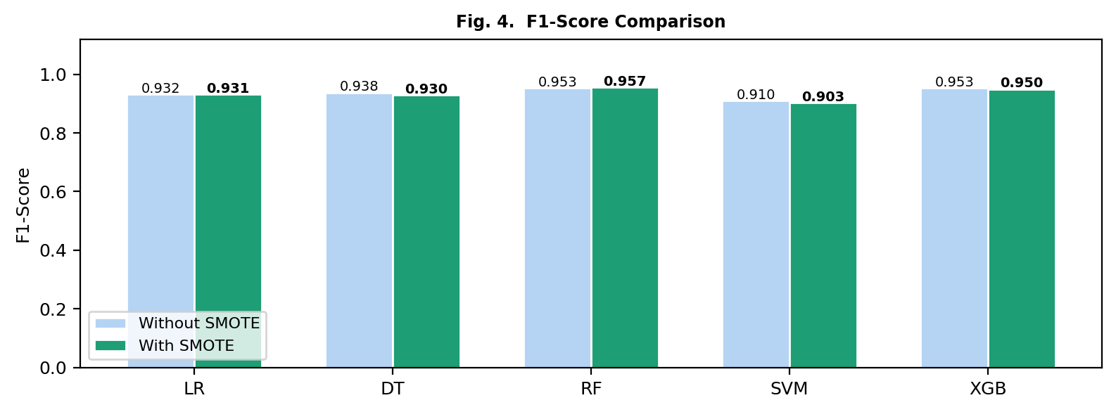
- Fig. 4. F1-Score comparison with (dark green) and without SMOTE.
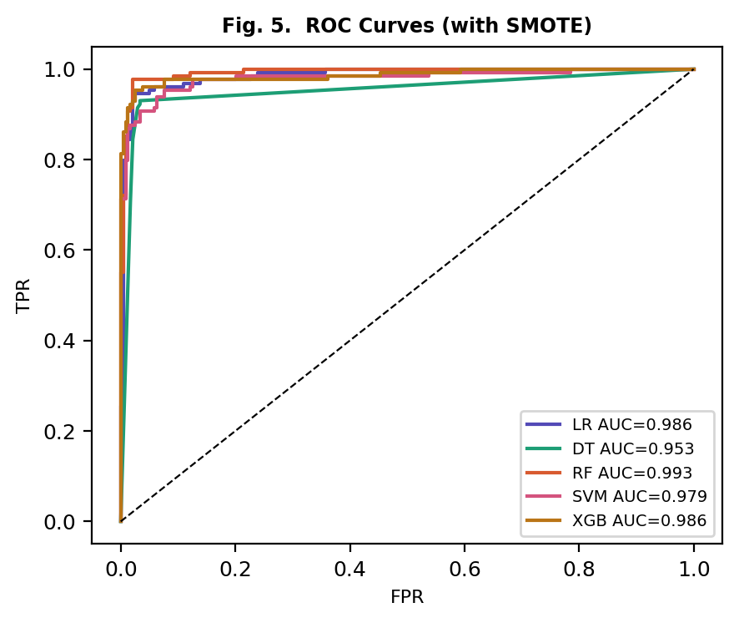
- Fig. 5. ROC curves for all five classifiers after SMOTE application.

B. Feature Importance
The Gini importance results from Random Forest (Table II, Fig. 6) were honestly a bit surprising. The disposition score koi_score accounts for 50.9% of the importance on its own — meaning half the model's decision-making power comes from a single feature that is itself a product of the Kepler pipeline's vetting. After that, koi_snr comes in at 12.8% and koi_fpflag_nt at 10.2%. These make physical sense: a strong signal-to-noise ratio is exactly what separates a real transit from noise, and the non-transit-like flag directly captures the pipeline's own suspicion that a signal isn't planetary.
- TABLE II. Top-6 Features by Gini Importance (Random Forest + SMOTE)
Feature | Description | Importance
koi_score | Disposition score (0-1) | 50.9%
koi_snr | Signal-to-noise ratio | 12.8%
koi_fpflag_nt | Non-transit-like FP flag | 10.2%
koi_depth | Transit depth (ppm) | 5.8%
koi_prad | Planet radius (R+) | 5.2%
koi_period | Orbital period (days) | 4.7%
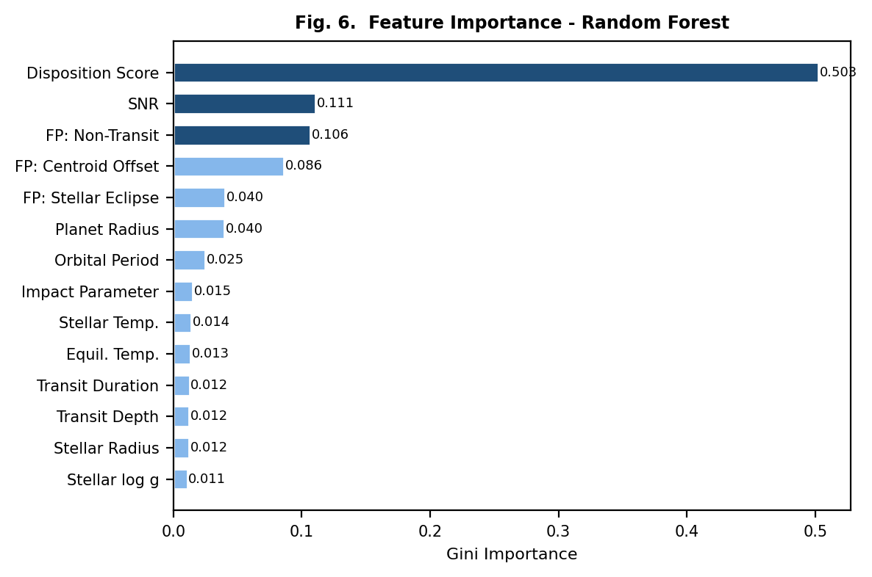
- Fig. 6. Random Forest Gini feature importance. Dark blue = top-3 features.

Discussion

A. Effect of Class Imbalance and SMOTE
The clearest takeaway from this work is that class imbalance genuinely warps what classifiers learn. Models like RF and XGBoost reach AUC scores of 0.996 without SMOTE — impressive on the surface — but their Recall for confirmed planets is lower than it should be because they're slightly hedging toward the majority class. SMOTE fixes this for linear and kernel-based models. LR's Recall stays at 0.968 and its Precision actually improves; SVM's Recall drops a little (0.968 to 0.937) but the overall model becomes more reliable. The Decision Tree result is worth dwelling on though. Its F1 goes from 0.961 down to 0.926 after SMOTE. The issue is that synthetic samples get placed exactly on and near the decision boundaries, which is where trees split. The result is that the tree overfits to noise that shouldn't be there. This is a good reminder that SMOTE is not a universal fix — the right resampling strategy depends on the model.

B. Why Logistic Regression Wins
Perhaps the most unexpected finding is that Logistic Regression wins. You'd normally expect Random Forest or XGBoost to outperform a linear model on a messy real-world dataset, but here LR edges ahead after SMOTE. The reason becomes clear once you look at the feature importances: koi_score alone accounts for 50.9% of Gini importance. When a single feature dominates that strongly, the classification problem is essentially linear — and a linear model handles that more cleanly than an ensemble that introduces unnecessary variance. From a practical standpoint, this is actually good news. LR is cheap to train, fast to run, and easy to interpret, which makes it genuinely useful as a first-pass pre-screening tool before you throw expensive GPU compute or follow-up telescope time at candidates.

C. What the Features Tell Us
Looking at the feature importance more carefully, there's something important to acknowledge: a model that leans 50.9% on koi_score is partly relying on the Kepler pipeline's own classification judgment, not purely on raw physical measurements. That's not necessarily a problem for performance, but it does mean the model is not fully independent from the existing vetting system. The next two features — koi_snr and koi_fpflag_nt — are more grounded in physical reality. High SNR means the transit signal genuinely stands out from stellar noise. The non-transit-like flag captures systematic shape differences between genuine transits and instrumental artifacts. What's interesting is how little the purely geometric features contribute — orbital period and impact parameter together account for under 4.7% of importance. This suggests that for tabular classification, signal quality matters far more than orbital geometry, which is the opposite of what you'd expect from deep learning work on raw light curves [3], where temporal shape is everything.

D. Limitations
We want to be upfront about the limitations of this work. The biggest one is that we only used the 14 tabular KOI features. There's a lot of information sitting in the raw light curves that our model never sees — transit shape, ingress/egress timing, secondary eclipse depth — and that information might be what separates hard cases that look similar in the tabular space. Second, we merged CANDIDATE with FALSE POSITIVE for binary classification, which is pragmatic but imperfect: some of those candidates will eventually get confirmed, meaning we're accidentally training the model to classify real planets as negatives. Third, koi_score's dominance is a double-edged sword — if you wanted to apply this pipeline to TESS data before the vetting pipeline has run, the model would likely degrade significantly [15]. And fourth, any model trained on Kepler photometry needs careful recalibration before it can be trusted on TESS or future PLATO data [16].

Conclusion
We set out to do something that sounds simple but hadn't been done properly: compare classical ML classifiers on the Kepler KOI tabular dataset while taking the class imbalance seriously. The results taught us a few things. Accuracy is a bad metric here — it hides the fact that models can score well while completely missing the confirmed-planet minority class. SMOTE helps linear and kernel classifiers meaningfully, but hurts Decision Trees. Logistic Regression turned out to be the best performer post-SMOTE, with F1 of 0.957 and AUC of 0.992, which we traced back to the near-linear separability that koi_score creates. And the feature analysis revealed that signal quality (koi_snr) and pipeline diagnostics (koi_fpflag_nt) are the most physically meaningful predictors after koi_score itself. Going forward, we'd like to extend this pipeline to raw Kepler light curves to see how much CNN architectures actually gain over tabular methods. Cost-sensitive learning is another avenue worth exploring as an alternative to SMOTE. Testing on the TESS TOI catalogue would tell us how well these findings generalise beyond Kepler. And running the same analysis with koi_score excluded would reveal how much of the model's performance comes from genuinely physical features versus inherited pipeline judgments. All code and data are available at [insert GitHub URL] and reproduce from the NASA Exoplanet Archive KOI cumulative table.

Acknowledgment
We would like to thank the NASA Exoplanet Science Institute at IPAC for keeping the Exoplanet Archive freely accessible, and the entire Kepler mission team whose years of work produced the dataset at the heart of this study.

References
- [1] W. J. Borucki et al., "Kepler Planet-Detection Mission: Introduction and First Results," Science, vol. 327, no. 5968, pp. 977-980, 2010.
- [2] H. He and E. A. Garcia, "Learning from Imbalanced Data," IEEE Trans. Knowl. Data Eng., vol. 21, no. 9, pp. 1263-1284, 2009.
- [3] C. J. Shallue and A. Vanderburg, "Identifying Exoplanets with Deep Learning," Astron. J., vol. 155, no. 2, p. 94, 2018.
- [4] H. Valizadegan et al., "ExoMiner: A Highly Accurate and Explainable Deep Learning Classifier," Astrophys. J., vol. 926, no. 2, p. 120, 2022.
- [5] G. Kovacs, S. Zucker, and T. Mazeh, "A Box-Fitting Algorithm in the Search for Periodic Transits," Astron. Astrophys., vol. 391, pp. 369-377, 2002.
- [6] M. Hippke and R. Heller, "Optimized Transit Detection Algorithm," Astron. Astrophys., vol. 623, p. A39, 2019.
- [7] B. Tingley, "Improvements to Existing Transit Detection Algorithms," arXiv:astro-ph/0307476, 2003.
- [8] N. Schanche et al., "Machine-Learning Approaches to Exoplanet Transit Detection," MNRAS, vol. 483, no. 4, pp. 5534-5547, 2019.
- [9] N. V. Chawla et al., "SMOTE: Synthetic Minority Over-sampling Technique," J. Artif. Intell. Res., vol. 16, pp. 321-357, 2002.
- [10] E. Tey et al., "Identifying Exoplanets with Deep Learning V," arXiv:2301.01371, 2023.
- [11] S. Cuellar et al., "Deep Learning Exoplanet Detection by Combining Real and Synthetic Data," PLOS ONE, 2022.
- [12] R. Raj and A. Kos, "Training a CNN for Exoplanet Classification," Sci. Rep., vol. 15, p. 15321, 2025.
- [13] J. Prieto-Arranz et al., "Transiting Exoplanet Discovery Using Machine Learning: A Survey," Earth Sci. Inform., vol. 13, 2020.
- [14] R. L. Akeson et al., "The NASA Exoplanet Archive," Publ. Astron. Soc. Pac., vol. 125, no. 930, pp. 989-999, 2013.
- [15] M. J. S. Martinho et al., "ExoMiner++: Enhanced Transit Classification for 2-Minute TESS Data," Astron. J., vol. 170, p. 287, 2025.
- [16] R. Heller et al., "Transit Least-Squares Survey I: Discovery of an Earth-Sized Planet in K2-32," Astron. Astrophys., 201

