Project ID :
25-26J-371
- Topic (12 words max)
Ai-Powered Personalized Lifestyle Recommendation System For Early Hypertension Risk Prediction In Office Workers

- Research group the project belongs to
SST - Software Systems & Technologies

- Specialization of the project belongs to
Information Technology (IT)

- If a continuation of a previous project:
Project ID | 25-26J-371
Year | 2025

- Brief description of the research problem including references (200 – 500 words max) – references not included in word count.
Hypertension, commonly known as high blood pressure, is a major health concern in Sri Lanka, particularly among office workers aged 25–50. Prolonged sedentary behavior, unhealthy dietary habits, and work-related stress contribute significantly to the development of hypertension in this population. Many individuals remain unaware of their condition until it reaches a critical stage, as routine health checks are infrequent and existing health advice is often generic and not tailored to personal lifestyles. Early detection and prevention are therefore crucial to reduce the long-term health and economic burden of hypertension.
Traditional hypertension management relies on occasional clinical measurements and general health guidance, which fails to account for individual lifestyle factors, genetic predispositions, and daily habits. Recent research demonstrates that machine learning models can effectively predict the risk of developing hypertension using demographic, lifestyle, and family history data. Studies have shown that features such as age, BMI, dietary patterns, smoking, alcohol consumption, physical activity levels, and family history are strong predictors of hypertension risk (PLOS ONE, 2023; Scientific Reports, 2023). These findings indicate that personalized, data-driven interventions can identify individuals at high risk before clinical symptoms manifest.

In this context, the proposed research aims to develop an AI-powered mobile application for early hypertension risk prediction among Sri Lankan office workers. The app will collect self-reported lifestyle, demographic, and family history data, and employ machine learning algorithms such as XGBoost and Random Forest to estimate individual risk. In addition to risk prediction, the app will offer personalized recommendations, including meal plans based on local dietary preferences aligned with the DASH diet, tailored exercise routines, and stress management techniques using cognitive-behavioral strategies. Recommendations will adapt over time based on user progress, creating a dynamic and practical system for hypertension prevention.
This research is grounded in evidence from recent studies indicating that lifestyle and demographic factors can accurately predict hypertension risk, making early intervention feasible without relying solely on clinical measurements or wearable devices (Preventive Medicine, 2014; PLOS ONE, 2023). By integrating AI with personalized guidance, the proposed solution addresses the limitations of current health practices, offering an achievable, scalable, and culturally relevant approach to mitigating hypertension risk in Sri Lankan office workers.

- Brief description of the nature of the solution including a conceptual diagram (250 words max)

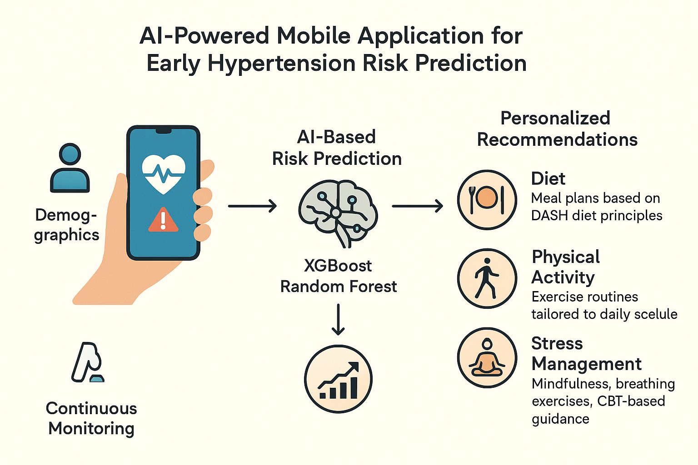

The proposed solution is an AI-powered mobile application designed to predict early hypertension risk and provide personalized interventions for Sri Lankan office workers aged 25–50. The app collects user-specific data, including demographics, lifestyle habits, dietary patterns, physical activity levels, sleep quality, and family history. Using machine learning algorithms such as XGBoost and Random Forest, the app estimates each user’s risk of developing hypertension, enabling early intervention before clinical symptoms appear.
Once the risk is identified, the system generates personalized recommendations in three main areas: diet, physical activity, and stress management. Meal plans are created based on a local food database aligned with the DASH diet principles, emphasizing low salt intake and nutrients that support healthy blood pressure. Exercise routines are tailored to the user’s daily schedule and fitness level, incorporating walking, yoga, and light resistance training. Stress management techniques, including mindfulness, breathing exercises, and cognitive-behavioral therapy (CBT)–based guidance, are suggested according to the user’s self-reported stress levels.
The app continuously monitors user progress through self-reported updates and feedback, adjusting recommendations weekly to ensure they remain practical, safe, and effective. This iterative process enables a personalized, adaptive system that empowers office workers to manage their hypertension risk proactively.

- Brief description of specialized domain expertise, knowledge, and data requirements (300 words max)

The development of an AI-powered hypertension prevention app requires expertise across multiple specialized domains, combining healthcare knowledge with data science, machine learning, and mobile application development.
1. Medical and Health Expertise:
A foundational understanding of hypertension, its risk factors, and preventive strategies is essential. This includes knowledge of lifestyle contributors (e.g., diet, physical activity, stress) and how demographic factors (age, BMI, family history) influence risk. Expertise in nutrition, especially relating to local Sri Lankan diets and the DASH diet principles, is critical for creating culturally relevant and effective meal plans. Knowledge of exercise physiology ensures that physical activity recommendations are safe, appropriate, and adaptable to varied fitness levels. Additionally, understanding mental wellness strategies, including mindfulness and cognitive-behavioral therapy (CBT) techniques, is necessary for effective stress management interventions.
2. Data Science and Machine Learning Expertise:
Implementing predictive models for hypertension risk requires experience in supervised machine learning, feature selection, model evaluation, and interpretability techniques (e.g., SHAP values). Familiarity with algorithms such as XGBoost and Random Forest is necessary for risk prediction. Knowledge of preprocessing self-reported lifestyle data, handling missing values, and creating robust datasets ensures the models remain accurate and reliable.
3. Mobile Application Development:
Expertise in mobile app development, including user interface (UI) and user experience (UX) design, ensures that the application is user-friendly and accessible. Integration of data input forms, recommendation modules, and feedback loops is essential for practical usability.
4. Data Requirements:
The app will require self-reported data on lifestyle habits (diet, exercise, sleep), demographic information (age, gender, BMI), family history of hypertension, and stress levels. Additionally, a local food nutrient database is needed to generate meal plans. Historical datasets linking lifestyle factors to hypertension outcomes will be required to train machine learning models, either from public health surveys, clinical studies, or prior research datasets.

- Objectives and Novelty

Main Objective
To develop an AI-powered mobile application that predicts early hypertension risk among Sri Lankan office workers and provides personalized, actionable recommendations for diet, physical activity, and stress management to prevent the onset of hypertension.
Member Name with Registration No | Sub Objective | Tasks | Novelty
Rathnayaka L.P.N.K. IT22178886 | Early Hypertension Risk Prediction | • Collect lifestyle, demographic, and family history data (age, BMI, diet habits, sleep, smoking/alcohol).  • Train machine learning models (e.g., Random Forest, XGBoost) to predict hypertension risk. | Unlike most studies that emphasize diagnosing hypertension using large clinical datasets, this research focuses on early risk prediction tailored for low-resource settings and population-specific lifestyle patterns.
Jayanath M.I.T IT22587206 | Personalized Meal Plans (Healthy Diet Recommendations) | • Build a food database linked to nutrients and hypertension outcomes.  • Generate meal plans based on the DASH diet (low salt, high potassium, magnesium, calcium).  • Adjust recommendations weekly depending on the user’s progress and preferences. | provide generic diet advice, this module integrates a heterogeneous ONN with nutrient-level attention and disease-aware logic to deliver early, personalized, risk-filtered food recommendations and dynamic portion control, specifically designed for individual health profiles.
Ravindu S.L IT22587756 | Tailored Physical Activity Recommendations | • Collect user’s daily activity levels (through simple self-report or app tracking).  • Recommend safe exercises (walking, yoga, light resistance training).  • Provide a feedback loop to adjust activity plans gradually. | A unique exercise recommendation engine that adapts activity intensity based on user progress, making exercise safe and effective for reducing hypertension risk.
Jayawardana N.S.G  IT22623690 | Stress & Mental Wellness Monitoring | • Use questionnaires and simple stress check-ins to detect stress levels.  • Apply AI + Cognitive Behavioral Therapy (CBT) methods to recommend relaxation techniques (breathing, meditation, mindfulness).  • Track stress patterns and suggest improvements over time. | Unlike most studies focusing on traditional, resource-intensive counseling, this module provides an AI-powered, psychiatrist-driven approach to deliver affordable, private, and accurate mental health support tailored for office workers.

- Individual component description of how it is complied with the specialization.
Member Name with Registration No | Description
Early Hypertension Risk Prediction | This component involves collecting lifestyle, demographic, and family history data and applying machine learning algorithms to predict hypertension risk. The specialist applies expertise in data preprocessing, feature selection, model training (Random Forest, XGBoost), evaluation, and interpretability. This ensures the predictions are accurate, reliable, and evidence-based, aligning with the team member’s data science and AI specialization.
Personalized Meal Plans (Healthy Diet Recommendations) | This module focuses on generating culturally appropriate, hypertension-preventive meal plans based on Sri Lankan foods and DASH diet principles. The specialist’s expertise in nutrition, dietetics, and clinical knowledge of hypertension ensures that recommendations are safe, balanced, and tailored to each user’s dietary habits.
Tailored Physical Activity Recommendations | The physical activity component collects daily activity data from users and generates exercise plans suitable for their fitness level and schedule. The specialist applies knowledge in exercise physiology, safe training practices, and health promotion to recommend walking, yoga, or light resistance exercises that reduce hypertension risk without causing injury.
Stress & Mental Wellness Monitoring | This module monitors stress levels using questionnaires and self-assessments, then provides relaxation techniques based on cognitive-behavioral therapy (CBT) and mindfulness practices. The specialist’s expertise in mental health ensures interventions are effective, practical, and adapted to the user’s routine and stress patterns.

Acceptable: Mark/Select as necessary
Topic Assessment Accepted
Topic Assessment Accepted with minor changes*
Topic Assessment to be Resubmitted with major changes*
Topic Assessment Rejected. Topic must be changed

* Detailed comments given below
Comments

Staff Member’s Name | Signature

*Important:
- According to the comments given by the evaluator, make the necessary modifications and get the approval by the Evaluator.
- If the project topic is rejected, identify a new topic, and request the RP Team for a new topic assessment.

