RUBS: AI

*Note: This was sourced from notes, which will be provided in a separate file.*

## The AI Object

*Figure 1*

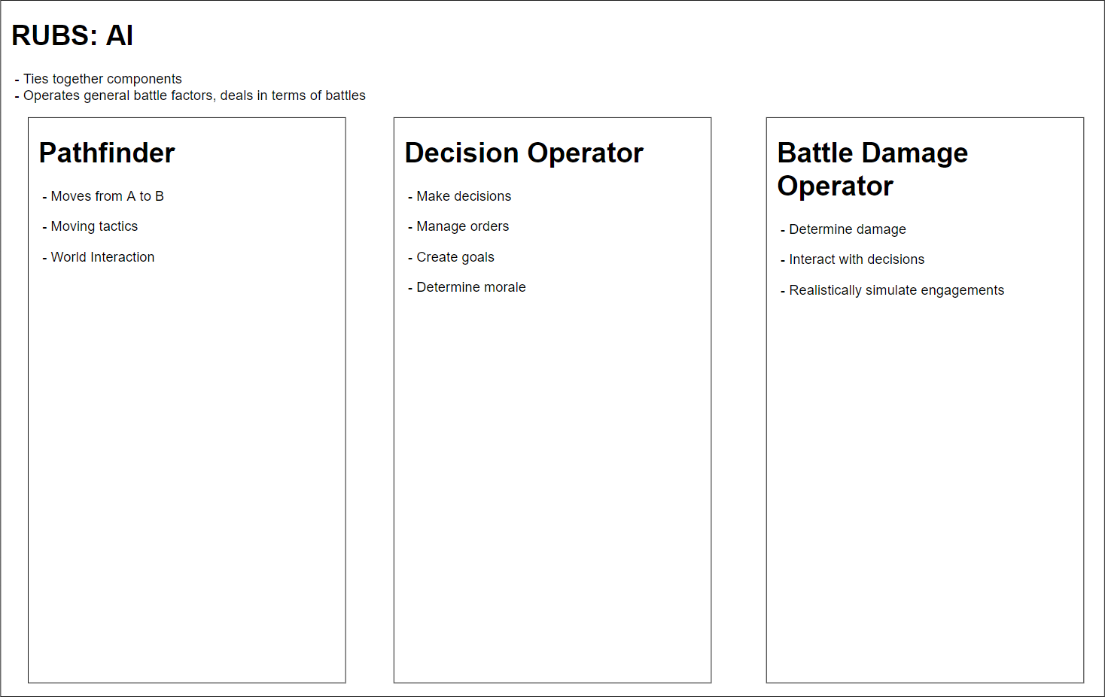

Figure 1 describes how the pathfinder, decision operator, and battle damage operator components work together in a larger RUBS: AI object to create a battle. The AI object deals with entire armies, while the components deal with individual units in armies.

## The Pathfinder Component

<To be filled in>

## Decision Operator Component

<To be filled in>

## Battle Damage Operator Component

<to be filled in>