**Model Training with Scikit-Learn**

**Encode the Target Labels**

Output

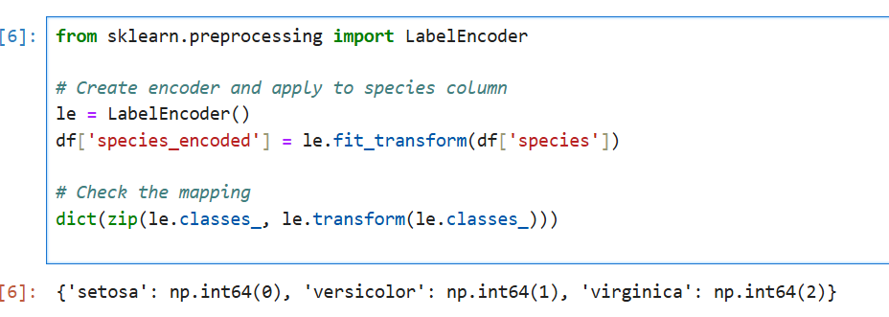

**Split Data into Features and Target**

# Features (X) and target (y)

X = df[['sepal_length', 'sepal_width', 'petal_length', 'petal_width']]

y = df['species_encoded']

**Train a Classifier (e.g., Logistic Regression)**

from sklearn.linear_model import LogisticRegression # Create and train the model model = LogisticRegression(max_iter=200) model.fit(X_train, y_train)

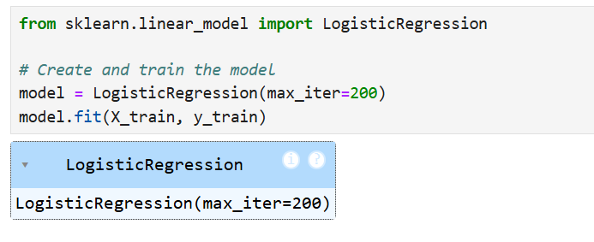

**Model Training.”**

**Train Multiple Models**

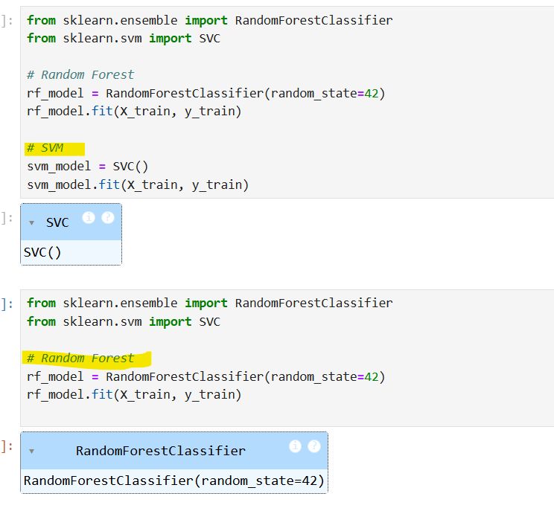

**Cross-Validation for All Models**

**Save the Best Model**

**Accuracy Score**

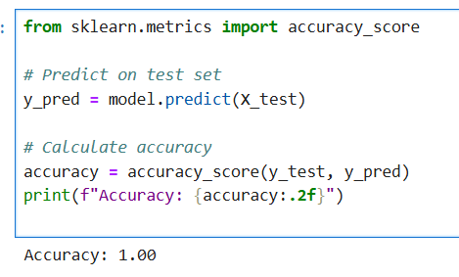

**Confusion Matrix**

**Classification Report**

from sklearn.metrics import classification_report # Print report print(classification_report(y_test, y_pred, target_names=le.classes_))

This is the results:

* Precision
* Recall
* F1-score
* Support

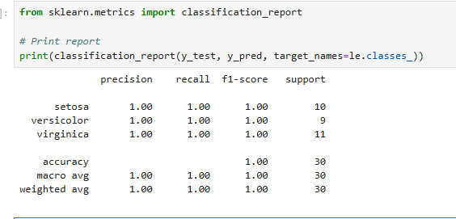

**Run the App Locally**



