Socket Programming Assignment - Report
Chatting system using TCP/UDP Protocols
Course: CSCI 21023 - Data Communication and Networks
Date: 19/11/2025
Programming Language: Python
GitHub repository URL : https://github.com/LakminaRubasinghe/Socket_Programming_Project

1. Group Members and Roles
Member | What They Do
CS/2022/009  CS/2022/044 | • Write server.py  • Write client.py  • Set up Azure Virtual Machine
CS/2022/025  CS/2022/070 | • Implement the GUI of the software  • Test everything works  • Make the final Document

2. System Setup and Configuration
Local Client 1 ←→ Azure Server ←→ Local Client 2
(20.189.75.229 : 9009 TCP, 9010 UDP)
Configuration Details
Component | Specification
Cloud Server | Azure VM, Windows, Standard D2ls v5 (2 vcpus, 4 GiB memory)
Public IP | 20.189.75.229 (Static), Port: 9009 TCP, 9010 UDP
Local Host 1 | Windows 11, Role: Client 1
Local Host 2 | Windows 11, Role: Client 2
Network Security | Azure NSG: Allow TCP 9009 inbound from Any  Azure NSG: Allow UDP 9010 inbound from Any
Protocol | TCP or UDP (User can select), UTF-8 encoding

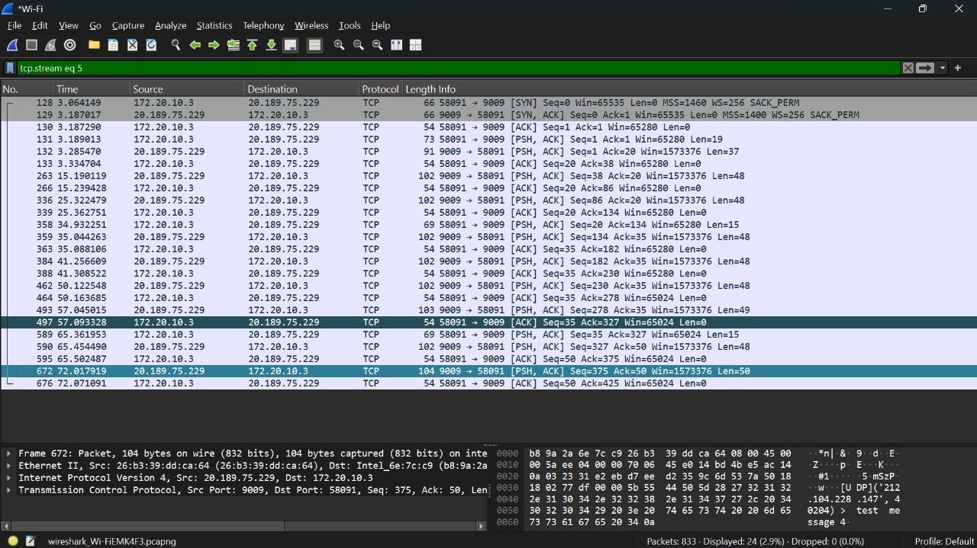
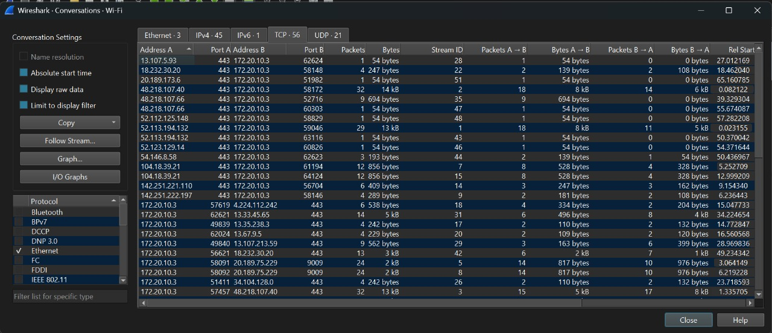
TCP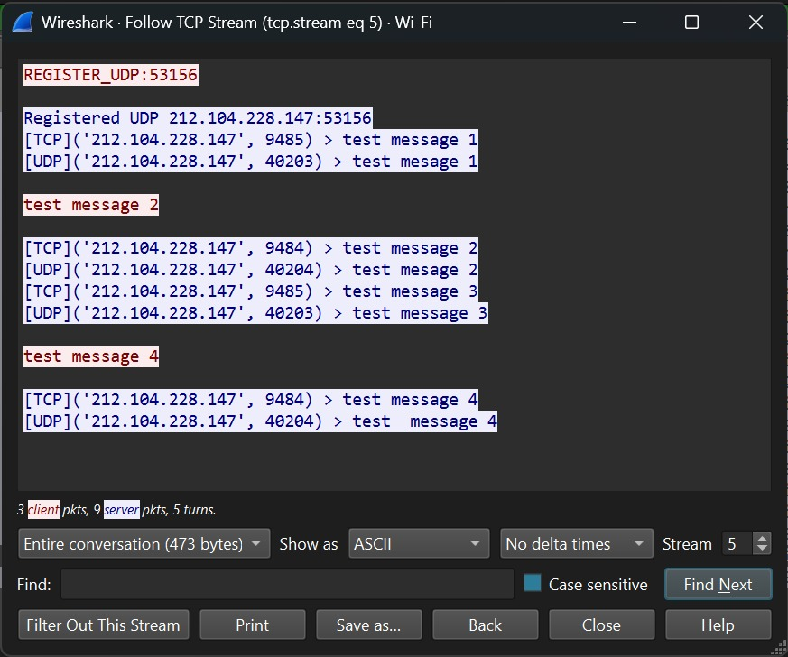

UDP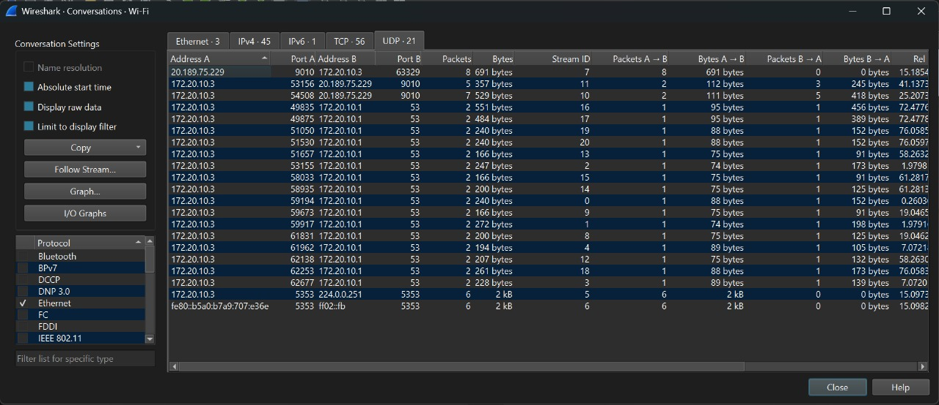
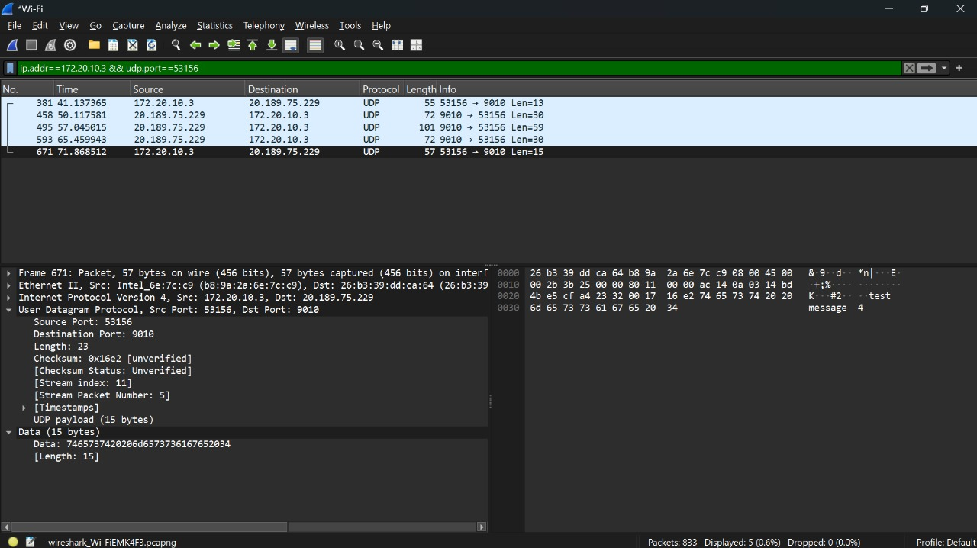
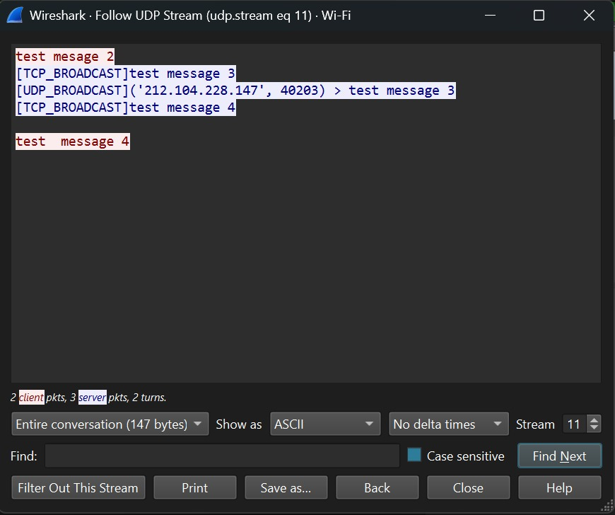

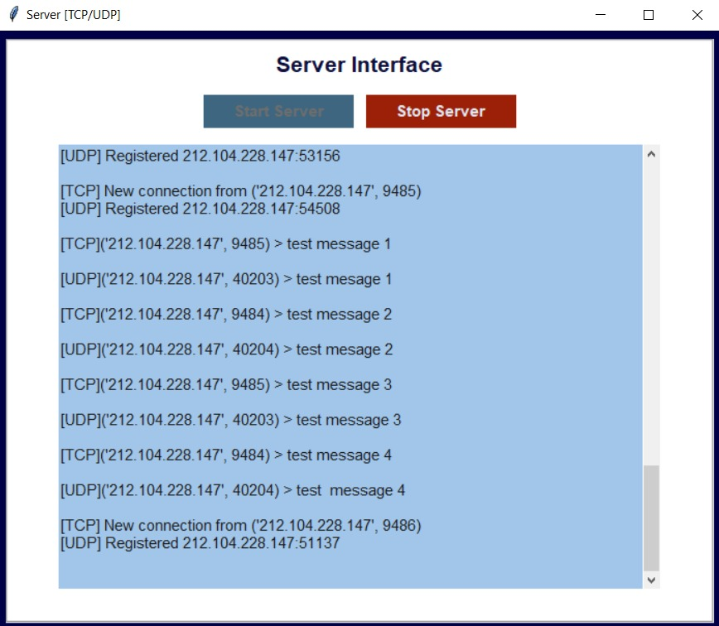
INTERFACES
