**INDUSTRIAL INTERNSHIP REPORT**

Object Counter using LDR

Report by - Lakshay Beri



|  |
| --- |
| **Executive Summary** |
| This report provides details of the Industrial Internship provided by upskill Campus and The IoT Academy in collaboration with Industrial Partner UniConverge Technologies Pvt Ltd (UCT).  This internship was focused on a project/problem statement provided by UCT. We had to finish the project including the report in 6 weeks’ time.  My project was Object counter using LDR.  This internship gave me a very good opportunity to get exposure to Industrial problems and design/implement solution for that. It was an overall great experience to have this internship. |



**TABLE OF CONTENTS**

**Topic**  **Page**

|  |  |
| --- | --- |
| Abstract & Preface | 3 |
| Preface | 4 |
| Introduction | 5 |
| Related Work | 11 |
| Implementation | 12 |
| Object Sensor and Counter | 16 |
| Future Scope | 17 |
| Conclusion | 18 |
| References | 19 |

**ABSTRACT**

The sensor and counter are a reliable system that uses the function of counting people/guests in the room. When someone enters the room, the counter rises by one; When someone leaves the room, the counter decreases by one and all people in theroom are displayed on LCD. It transmits signals from sensors and stores them in  ROM. The courage of this project is not only counting the number of people entering the room, but also turning on the light according to the number of people entering.  This system is important in many placeswhere administrators need to count visitors.  
The number of guests does not impose any restrictions on the entrance and exit of  the  company, but it has many uses and can provide information to the  management about the  number of people and runner activities in distribution. The basic  technique of counting  visitors involves sharing human watchers to count the  number of visitors entering and leaving site. It is readily available in the market and easy to manufacture.

# **PREFACE**

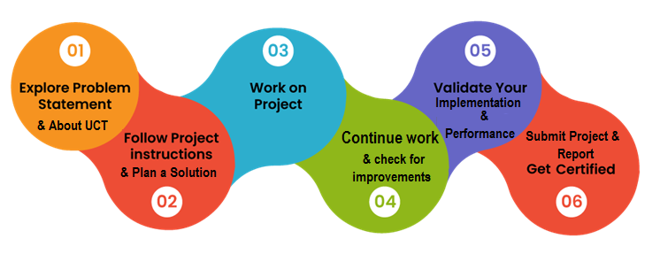

A relevant internship helps you know in advance how the things work and make you ready for the forthcoming.

The program was planned in a very organised and sequential learning modules with a little bit of assessment part too for testing our knowledge.

I was able to learn a lot during this 6-week internship program and was an eye opener towards the upcoming corporate world and its working.

Thanks to Mr. Kaushlendra Singh Sisodia, who have helped me directly or indirectly.

I would only advice all the juniors to be consistent (consistency >> intelligence) and disciplined.

**INTRODUCTION**

The "Object Counters and Sensors" research project includes sensors, motors, etc. It's based on some things like interacting with the Arduino microcontroller. The counter can count people in both. This circuit can be used to count people entering the lobby/shop/home/office at the entrance and can count people leaving the lobby by reducing the number of the same door or exit depending on where the sensor is placed in the store. It can be used at the entrances of public places such as parking lots. The main purpose of this work is in our home, school, college or workplace where we see the fans and lights even if there is no one in the rooms or areas and facilities. This happens with peace of mind because we forgot to turn off the light or because we are in a hurry. "Object Sensor and Counter" has been designed to avoid such situations.

## About UniConverge Technologies Pvt Ltd

A company established in 2013 and working in Digital Transformation domain and providing Industrial solutions with prime focus on sustainability and RoI.

For developing its products and solutions it is leveraging various**Cutting Edge Technologies e.g. Internet of Things (IoT), Cyber Security, Cloud computing (AWS, Azure), Machine Learning, Communication Technologies (4G/5G/LoRaWAN), Java Full Stack, Python, Front end**etc.



1. UCT IoT Platform **(****)**

**UCT Insight** is an IOT platform designed for quick deployment of IOT applications on the same time providing valuable “insight” for your process/business. It has been built in Java for backend and ReactJS for Front end. It has support for MySQL and various NoSql Databases.

* It enables device connectivity via industry standard IoT protocols - MQTT, CoAP, HTTP, Modbus TCP, OPC UA
* It supports both cloud and on-premises deployments.

It has features to  
• Build Your own dashboard  
• Analytics and Reporting  
• Alert and Notification  
• Integration with third party application(Power BI, SAP, ERP)  
• Rule Engine

 

1. **Smart Factory Platform (****)**

Factory watch is a platform for smart factory needs.

It provides Users/ Factory

* with a scalable solution for their Production and asset monitoring
* OEE and predictive maintenance solution scaling up to digital twin for your assets.
* to unleased the true potential of the data that their machines are generating and helps to identify the KPIs and also improve them.
* A modular architecture that allows users to choose the service that they what to start and then can scale to more complex solutions as per their demands.

Its unique SaaS model helps users to save time, cost and money.

 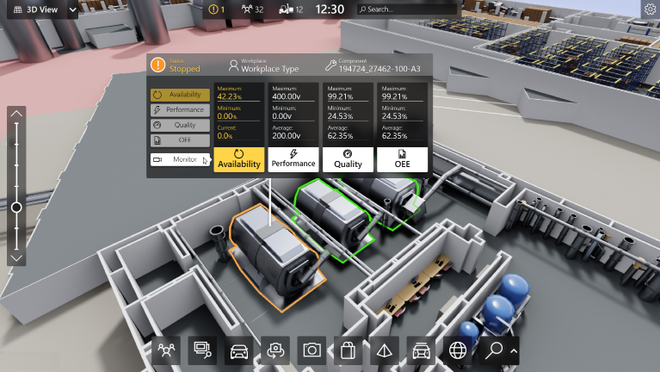

1.  based Solution

UCT is one of the early adopters of LoRAWAN technology and providing solution in Aggrotech, Smart cities, Industrial Monitoring, Smart Street Light, Smart Water/ Gas/ Electricity metering solutions etc.

1. Predictive Maintenance

UCT is providing Industrial Machine health monitoring and Predictive maintenance solution leveraging Embedded system, Industrial IoT and Machine Learning Technologies by finding Remaining useful life time of various Machines used in production process.



## About upskill Campus (USC)

upskill Campus along with The IoT Academy and in association with Uniconverge technologies has facilitated the smooth execution of the complete internship process.

USC is a career development platform that delivers **personalized executive coaching** in a more affordable, scalable and measurable way.



Seeing need of upskilling in self paced manner along-with additional support services e.g. Internship, projects, interaction with Industry experts, Career growth Services

<https://www.upskillcampus.com/>

upSkill Campus aiming to upskill 1 million learners in next 5 year

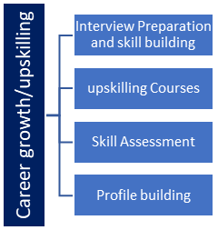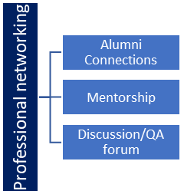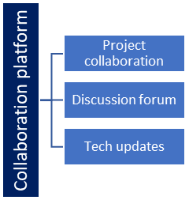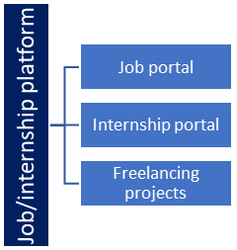

## The IoT Academy

The IoT academy is EdTech Division of UCT that is running long executive certification programs in collaboration with EICT Academy, IITK, IITR and IITG in multiple domains.

## Objectives of this Internship program

The objective for this internship program was to

 ☛ get practical experience of working in the industry.

 ☛ to solve real world problems.

 ☛ to have improved job prospects.

 ☛ to have Improved understanding of our field and its applications.

 ☛ to have Personal growth like better communication and problem solving.

**RELATED WORK**

Gaurav Waradkar, Hitesh Ramina, Vinay Maitry, Tejasvi Ansurkar, Asha Rawat, Parth Dasin “Automated Room Light Controller with Visitor Counter” is a reliable circuit that takes over the task of controlling the room lights as well us counting number of persons / visitors in the room very accurately [1]. Ying-Wen Bai, Yi-Te Ku in “Automatic room light intensity detection and control using a microprocessor and light sensors” propose a design using both a microprocessor and light sensors for automatic room light detection and control. Their design, the HLCM (Home Light Control Module) which will be installed in every light fixture of a family [2].

Subhankar Chattoraj, Aditya Chakrabortyisin “Bidirectional Visitor Counter with Automatic Room Light Controller and Arduino as the master controller” proposed the system counts both the entering and exiting visitor of the auditorium or hall or another place, where it is placed. Depending upon the sensors interruption, the system identifies the entry and exit of the visitor [3]. Sonali K. Pawar, in „Automatic Room Light Controller Using microcontroller ATMEGA16A and bidirectional visitor counter “controls a room light as well as count the number of individuals entering and leaving a room. When the number of individuals in a room is greater than 5 then 2 lights will be switched ON [4]. E.Shilpaisin „Implementation of Automatic Room Light Controller with Visitor Counter Design using 8051 Microcontroller‟ proposed and designed in this paper that is the visitor counter that is bidirectional in feature which can read both the incoming and outgoing traffic and agents at same time securely[5].Erdem, Hin "Design and implementation of data acquisition for fuzzy logic controller" is that need for a device that can automatically control the lightening system of a room and capability of taking count of number of people in a room on its own has been long overdue[6]. Dr. AbhijitBanubakodein” Energy Efficient Automized Public Utility” proposed that the basic objective after using a PLC is that PLC has a capability of handling several Inputs, Output signals especially discrete. The overall automation of the Utility is controlled using SCADA software [7].

**IMPLEMENTATION**

This project has two modules, first one is known as “Object counter” and second module is known as “Automatic room light controller”. Main concept behind this project is known as “Object counter” which measures the number of persons entering in any room like seminar hall, conference room, hotel rooms. Here Arduino receives the signals from the sensors, and this signal is operated under the control of software which is stored in the ROM. LCD display placed outside the room displays this value of person count. This person count will be incremented if somebody enters inside the room and at that time lights are turned on. And in reverse way, person count will be decremented if somebody leaves the room. When number of persons inside the room is zero, lights inside the room are turned off. For sensing the person and light we are using the light dependent register (LDR). By using this sensor and its related circuit diagram we can count the persons. The high-performance Microchip Pico Power 8-bit AVR RISC-based microcontroller combines 32KB ISP flash memory with read-while-write capabilities, 1024B EEPROM, 2KB SRAM, 23 general purpose I/O lines, 32 general purpose working registers, three flexible timer/counters with compare modes, internal and external interrupts, serial programmable USART, a byte-oriented 2 wire serial interface, SPI serial port, a 6-channel 10-bit A/D converter , programmable watchdog timer with internal oscillator, and five software selectable power saving modes. The device operates between 1.8-5.5 volts.

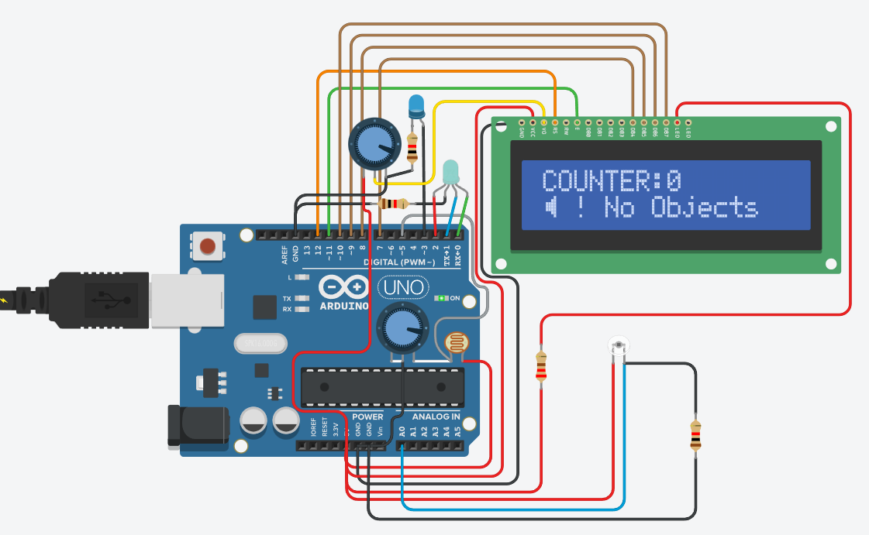

Fig 1: Counter (Tinker CAD)

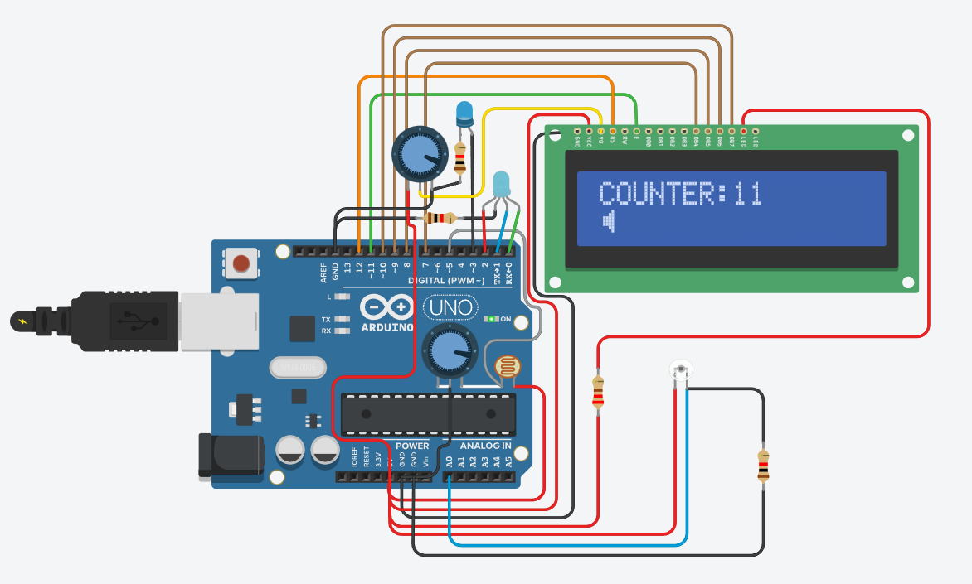



Fig 2: Counter Increment

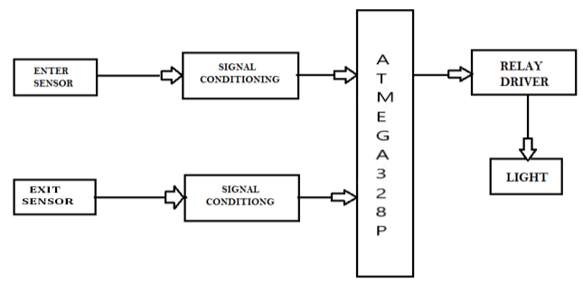



Fig 3: Block Diagram

Advantages: -

1. Low Cost

2. Easy to use

3. Implement in Single door

4. Main advantage of this project is that it helps in energy conservation. Because when they is nobody inside the room then light are automatically turned off.

5. Human effort to count the number of people is eliminated. Since this project does the automatic person counting with the help of two sensor installed on door frame.

Application: -

1. For Counting purposes

2. For Automatic Room Light Control

**Project Link (Code + Model):**

<https://www.tinkercad.com/things/7Z8rUEAtyfj-objectcounter>

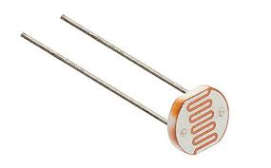 Fig 4: LDR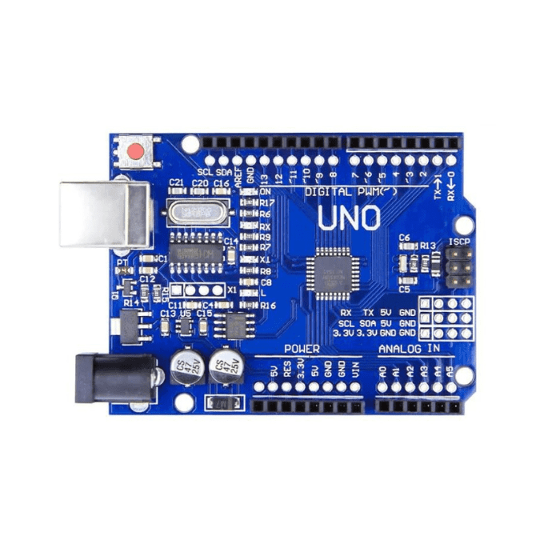 Fig 5: Arduino Uno (AtmelAtmega328p)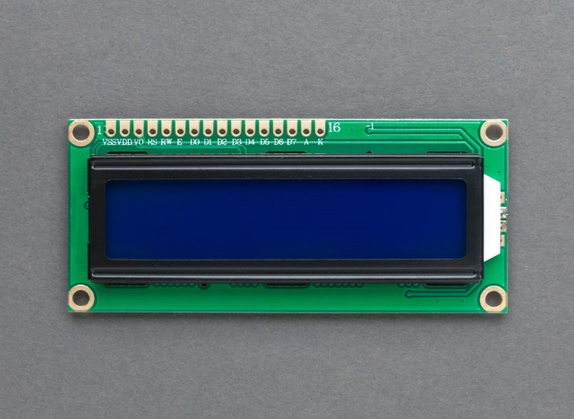 Fig 6: 16x2 LCD

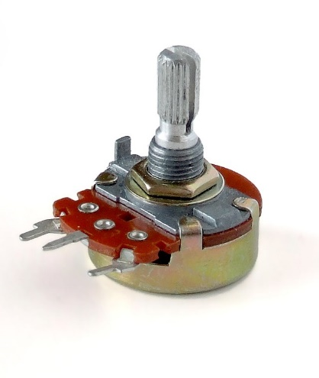Fig 7: Potentiometer

**OBJECT SENSOR AND COUNTER**

The project “Object sensor and counter” is divided in four parts: Arduino Uno, LDR sensors, micro controller and counter display. Arduino is a microcontroller-based open-source electronic prototyping board which can be programmed with an easy-to-use Arduino IDE. The board is equipped with sets of digital and analog input/output (I/O) pins that may be interfaced to various expansion boards (shields) and other circuits. The board has 14 Digital pins, 6 Analog pins, and programmable with the Arduino IDE (Integrated Development Environment) via a type-B USB cable. It can be powered by the USB cable or by an external 9-volt battery, though it accepts voltages between 7 and 20 volts. It is also similar to the Arduino Nano and Leonardo. We have used one LDR module, potentiometer and LED’s. Potentiometer is used for setting reference voltage at comparator’s one terminal and IR sensors sense the object or person and provide a change in voltage at comparator’s second terminal.

A microcontroller is the most prominent black rectangular chip with 28 pins. Think of it as the brains of your Arduino. The microcontroller used on the UNO board is Atmega328P by Atmel (a major microcontroller manufacturer). A16x2 LCD display is very basic module and is very commonly used in various devices and circuits.

These modules are preferred over seven segments and other multi segment LEDs. The reasons being: LCDs are economical; easily programmable; have no limitation of displaying special & even custom characters (unlike in seven segments), animations and so on.

**FUTURE SCOPE**

This undertaking offers us a chance to do a major task in future. The applications expressed above are some demo applications that are totally conceivable with its future turn of events. At first for the impediment of time and required reserve we had the option to foster simply a home machine control framework. The framework will likewise work utilizing IR sensor.

1. It wills more effective than Laser light and Photodiode. Thus, we have a major work scope in this area. That's what we trust, we will actually want to finish every one of the elements required for its definitive applications.

2. We can send this information to distant area utilizing portable or web.

3. Voice caution framework can be added to demonstrate that room is full and individual can't enter inside.

**CONCLUSION**

"Automatic light control with guest participation" is a system that controls the lighting (LED) of the room (classroom, court, room) and counts the number of people entering the room.  According to our project motto "Automate, save energy, extend the life of equipment and  intelligently deliver the necessary products". It will register a series of infrared sensor inputs/outputs and manage the guest counter accordingly. When a person enters a queue in court, the infrared electronic equipment in each row will set the count limit for that row accordingly. When the user leaves the door, the guest is reduced.

At the end, it was a very informative project and it gave me the chance to explore new things. I am very thankful to all those who created this course and mentors who were always there to solve our problems.

**REFERENCES**

1. Gaurav Varadkar, Hitesh Ramina, Vinay Maitry, Tejasvi Ansurkar, Asha Rawat, Parth Das “Automated Room Light Controller with Visitor Counter” Imperial Journal of Interdisciplinary Research (IJIR) Vol-2, Issue-4, 2016Page:777-780.
2. Ying-Wen Bai, Yi-Te Ku “Automatic room light intensity detection and control using a microprocessor and light sensors” IEEE Transactions on Consumer Electronics (Volume: 54, Issue: 3, August 2008) Page:1173-1176
3. Kadam Shah, Prakash Savaliya and Mitesh Patel "Automatic Room Light Controller with Bidirectional Visitor Counter" (IJICTRD) International Journal of ICT Research and Development Vol-1 Issue-4 ISSN: 2395-4841Page:33-38.
4. Karthikeyan, Saran Sriram, Piyush “Automatic Lighting Using Arduino and PIR Sensor” International Journal of Computer Science Trends and Technology (IJCST) – Volume- 6 Issue 5, Sep-Oct 2018 ISSN: 2347-8578 Page:58-60.
5. Dr. Lenina SVB “Automatic Gadget Control System Using Arduino And PIR Sensor” International Journal of Management, Technology And Engineering Volume-8, Issue 9, November 2018 ISSN NO : 2249-7455 Page:458-464.