* Analysis of hash table size = 20

For sample-text1 =[ 46,52,30,35,49,49,29,44,39,48,45,45,46,40,38,54,54,55,36,39]

Maximum no of keys in a bucket = 55

Minimum no of keys in a bucket= 29

Average no of keys in a bucket = 43.65

For sample-text2 = [38,26,25,31,28,32,31,45,20,41,30,29,34,31,27,33,31,35,36,34]

Maximum no of keys in a bucket = 45

Minimum no of keys in a bucket= 20

Average no of keys in a bucket = 31.85

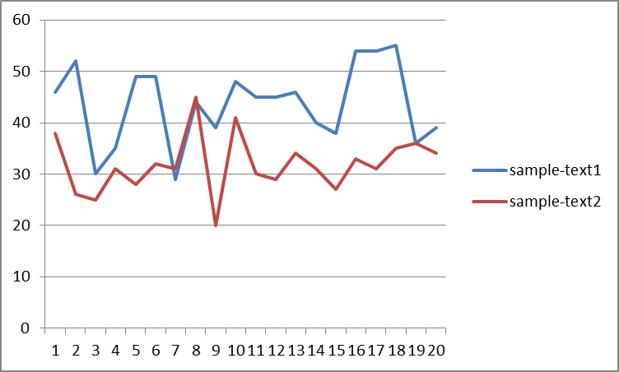

* Analysis of hash table size = 30

For sample-text1 =

[ 31,35,27,24,27,33,29,29,22,35,32,33,26,27,31,42,28,33,20,22,28,29,23,24,29,28,26,37, 33,30]

Maximum no of keys in a bucket = 42

Minimum no of keys in a bucket= 20

Average no of keys in a bucket = 29.1

For sample-text2 = [23,20,21,15,22,17,19,26,18,28,24,19,19,24,15,18,20,32,17,26,21,16,19,23,18,30,23,22,21,21]

Maximum no of keys in a bucket = 32

Minimum no of keys in a bucket= 15

Average no of keys in a bucket = 21.33

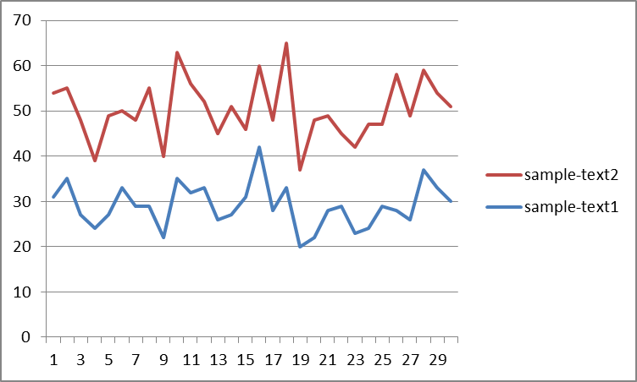

* Analysis of hash table size = 40

For sample-text1 =

[29,26,21,18,26,25,6,23,25,25,26,28,27,19,9,29,24,26,24,22,17,26,9,17,23,24,23,21,14, 23,19,17,19,21,29,25,30,29,12,17]

Maximum no of keys in a bucket = 30

Minimum no of keys in a bucket= 6

Average no of keys in a bucket = 21.825

For sample-text2 = [18,19,10,16,11,16,13,17,8,22,17,20,14,6,10,11,17,24,22,19,20,7,15,15,17,16,18,28,12, 19,13,9,20,25,17,22,14,11,14,15]

Maximum no of keys in a bucket = 28

Minimum no of keys in a bucket= 6

Average no of keys in a bucket = 15.925

