

Netaji Subhas University of Technology

|  |
| --- |
| COMPUTER SCIENCE AND ENGINEERING  THIRD YEAR  COCSC14 |

Principles of Compiler Construction

Submitted by:-

Laksh Sachdeva

2022UCS1572

|  |  |
| --- | --- |
| **Sr No.** | **PRACTICALS** |
| 1 | Implement a program for symbol table using hashing in C programming |
| 2 | Implement a two-pass assembler 8085/8086 |
| 3 | Develop a simple calculator using LEX and YACC tools. |
| 4 | Develop a Parser for ‘C’ using the LEX and YACC tools. |
| 5 | Develop Lexical Analyzer for ‘C’ using LEX tool |
| 6 | Represent C language using Context Free Language. |
| 7 | Add assignment statement , If then else statement and while loop to the calculator and generate the three address code for the same. |

INDEX

1)Implement a program for symbol table using hashing

#include <stdio.h>

#include <stdlib.h>

#include <string.h>

#define MAX 11

struct symb

{

int add; // Address

char label[10]; // Label

} sy[MAX];

void search();

void Iprob(int a[], int key, int num);

int create(int num);

void display(int a[]);

int main()

{

int a[MAX], num, key, i, ch;

char ans;

// Initialize the symbol table

for (i = 0; i < MAX; i++)

{

a[i] = 0;

sy[i].add = 0;

strcpy(sy[i].label, "");

}

do

{

printf("\nEnter your choice:");

printf("\n1 - Create entry in the symbol table\n2 - Search in the symbol table\n");

scanf("%d", &ch);

switch (ch)

{

case 1:

do

{

printf("\nEnter the address: ");

scanf("%d", &num);

key = create(num);

printf("Enter the label: ");

scanf("%s", sy[key].label);

Iprob(a, key, num);

printf("\nContinue? 0 for no, 1 for yes: ");

scanf(" %c", &ans);

} while (ans == '1');

display(a);

break;

case 2:

search();

break;

default:

printf("Invalid choice!\n");

}

} while (ch <= 2);

return 0;

}

int create(int num)

{

int key = num % MAX;

return key;

}

void Iprob(int a[], int key, int num)

{

int i, flag = 0, count = 0;

if (a[key] == 0)

{

a[key] = num;

sy[key].add = num;

}

else

{

for (i = 0; i < MAX; i++)

{

if (a[i] != 0)

count++;

}

if (count == MAX)

{

printf("\nHash table is full");

display(a);

exit(1);

}

for (i = key + 1; i < MAX; i++)

{

if (a[i] == 0)

{

a[i] = num;

flag = 1;

sy[i].add = num;

break;

}

}

if (flag == 0)

{

for (i = 0; i < key; i++)

{

if (a[i] == 0)

{

a[i] = num;

sy[i].add = num;

break;

}

}

}

}

}

void display(int a[])

{

FILE *fp;

int i;

fp = fopen("symbol.txt", "w");

printf("\nSymbol Table:");

printf("\nHash Index | Address | Label\n");

for (i = 0; i < MAX; i++)

{

if (a[i] != 0)

{

printf("%d | %d | %s\n", i, sy[i].add, sy[i].label);

fprintf(fp, "%d %d %s\n", i, sy[i].add, sy[i].label);

}

}

fclose(fp);

}

void search()

{

FILE *fp;

char la[10];

int found = 0, i;

printf("Enter the label: ");

scanf("%s", la);

fp = fopen("symbol.txt", "r");

for (i = 0; i < MAX; i++)

{

fscanf(fp, "%d %d %s", &i, &sy[i].add, sy[i].label);

if (sy[i].add != 0 && strcmp(sy[i].label, la) == 0)

{

printf("\nThe label '%s' is present in the symbol table at address: %d\n", la, sy[i].add);

found = 1;

break;

}

}

if (!found)

{

printf("\nThe label '%s' is not present in the symbol table\n", la);

}

fclose(fp);

}

OUTPUT

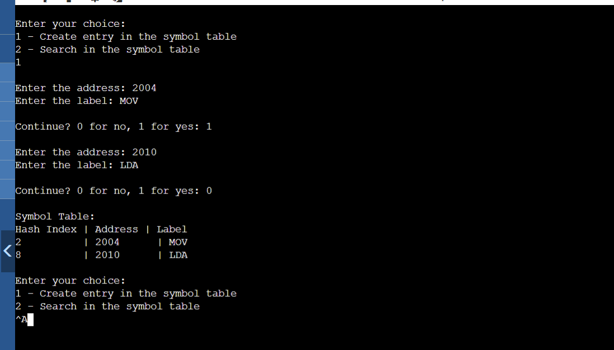

1. Implement a two-pass assembler 8085/8086

Main File – main.c

#include <bits/stdc++.h>

using namespace std;

string convert(int decimal) {

    string binary = "" ;

    for (int i = decimal; i > 0; i /= 2) {

        binary = to_string(i % 2) + binary;

    }

    if (binary.length() < 8) {

        binary = string(8 - binary.length(), '0') + binary;

    }

    return binary;

}

struct Mnemonics {

    string name;

    string binary;

    int size;

} mot[20];

struct Symbol {

    string name;

    string type;

    int location;

    int size;

    int section_id;

    string is_global;

};

struct Section {

    int id;

    string name;

    int size;

};

vector<Symbol> symtab;  // Symbol Table

vector<Section> sect;   // Section Table

int lc = 0;             // Location Counter

int sec_id = 0;         // Section Id

int var_lc;             // Store location of variable in Pass2

ifstream infile;        // Input File Stream

ofstream outfile;       // Output File Stream

string word;            // Read word by word from file

string temp;            // Temporary variable

int control, size;      // Control variables for search

void init() {

    // Initializing Machine Opcode Table

    //name binary size

    mot[0] = {"ADD", "00000001", 1};

    mot[1] = {"ADDI", "00000010", 5};

    mot[2] = {"CMP", "00000011", 5};

    mot[3] = {"INC", "00000100", 1};

    mot[4] = {"JE", "00000101", 5};

    mot[5] = {"JMP", "00000110", 5};

    mot[6] = {"LOAD", "00000111", 5};

    mot[7] = {"LOADI", "00001000", 5};

    mot[8] = {"MVTI", "00001001", 5};

    mot[9] = {"MOV", "00001010", 1};

    mot[10] = {"STOP", "00001111", 1};

    mot[11] = {"STORE", "00001100", 5};

    mot[12] = {"STOREI", "00001101", 1};

}

int search_mot(const string& opcode) {

    for (int i = 0; i < 13; ++i) {

        if (mot[i].name == opcode) {

            return i;

        }

    }

    return -1;

}

int search_symbol(const string& variable) {

    for (const auto& sym : symtab) {

        if (sym.name == variable) {

            return sym.location;

        }

    }

    return -1;

}

int size_evaluation(const string& data) {

    int size = 0;

    for (char c : data) {

        if (c == ',') {

            size += 4;

        }

    }

    size += 4;

    return size;

}

string data_break(const string& data) {

    string final;

    string temp = "";

    for (char c : data) {

        if (c == ',') {

            final += convert(atoi(temp.c_str())) + ",";

            temp = "";

        } else {

            temp += c;

        }

    }

    if (!temp.empty()) {

        final += convert(atoi(temp.c_str()));

    }

    return final;

}

void store_symlab() {

    outfile.open("symbol.csv");

    outfile << "Name,Type,Location,Size,SectionId,IsGlobal\n";

    for (const auto& sym : symtab) {

        outfile << sym.name << ','

                << sym.type << ','

                << sym.location << ','

                << sym.size << ','

                << sym.section_id << ','

                << sym.is_global << '\n';

    }

    outfile.close();

}

void store_sec() {

    outfile.open("section.csv");

    outfile << "ID,Name,Size\n";

    for (const auto& sec : sect) {

        outfile << sec.id << ','

                << sec.name << ','

                << sec.size << '\n';

    }

    outfile.close();

}

void pass1() {

    infile.open("input.txt");

    while (infile >> word) {

        control = search_mot(word);

        if (control == -1) {

            temp = word;

            if (word.find(":") != string::npos) {

                // Label found

                Symbol s = {temp.erase(word.length() - 1, 1), "label", lc, -1, sec_id, "false"};

                symtab.push_back(s);

            } else if (word == "section") {

                infile >> word;

                ++sec_id;

                Section a = {sec_id, word, 0};

                sect.push_back(a);

                if (sec_id != 1) {

                    sect[sec_id - 2].size = lc;

                    lc = 0;

                }

            } else if (word == "global") {

                infile >> word;

                Symbol b = {word, "label", -1, -1, -1, "true"};

                symtab.push_back(b);

            } else if (word == "extern") {

                infile >> word;

                Symbol b = {word, "external", -1, -1, -1, "false"};

                symtab.push_back(b);

            } else {

                infile >> word;

                infile >> word;

                int len = size_evaluation(word);

                Symbol b = {temp, "var", lc, len, sec_id, "false"};

                symtab.push_back(b);

                lc += len;

            }

        } else {

            if (!(control == 7 || control == 12)) infile >> word;

            // LOADI and STOREI do not have any parameter

            if (control == 2 || control == 8 || control == 9) infile >> word;

            lc += mot[control].size;

        }

    }

    sect[sec_id - 1].size = lc;

    store_symlab();

    store_sec();

    infile.close();

}

void pass2() {

    infile.open("input.txt");

    outfile.open("output.txt");

    while (infile >> word) {

        control = search_mot(word);

        if (control == -1) {

            temp = word;

            if (word.find(":") != string::npos) {

                outfile << "";

            } else if (word == "global") {

                infile >> word;

                outfile << "global " << word << '\n';

            } else if (word == "extern") {

                infile >> word;

                outfile << "extern " << word << '\n';

            } else if (word == "section") {

                infile >> word;

                outfile << "section ." << word << '\n';

                lc = 0;

            } else {

                infile >> word;

                infile >> word;

                outfile << convert(lc) << " " << data_break(word) << '\n';

                int len = size_evaluation(word);

                lc += len;

            }

        } else {

            outfile << convert(lc) << " " << mot[control].binary;

            if (control == 0 || control == 3) {

                infile >> word;

                outfile << " " << word;

            } else if (control == 1 || control == 4 || control == 5 || control == 6 || control == 11) {

                infile >> word;

                var_lc = search_symbol(word);

                if (var_lc == -1) {

                    outfile << " " << convert(atoi(word.c_str()));

                } else {

                    outfile << " " << convert(var_lc);

                }

            } else if (control == 9) {

                infile >> word;

                outfile << " " << word;q

                infile >> word;

                outfile << " " << word;

            }

            lc += mot[control].size;

            outfile << '\n';

        }

    }

    outfile.close();

    infile.close();

}

int main() {

    init();

    pass1();

    lc = 0;

    pass2();

    return 0;

}

Input.txt

global main

extern test

section data

X dd 10,20,40,5,7,9,53,8,11,13

sum dd 0,10

section text

MVI I,X

MVI B,0

MVI C,0

L1: LOADI

ADD C

MOV C,A

INC B

CMP B,10

JE L2

ADDI 4

JMP L1

L2: STORE sum

STOP

Section.csv

ID,Name,Size

1,data,48

2,text,48

Symbol.csv

Name,Type,Location,Size,SectionId,IsGlobal

main,label,-1,-1,-1,true

test,external,-1,-1,-1,false

X,var,0,40,1,false

sum,var,40,8,1,false

MVI,var,0,4,2,false

B,0,var,4,8,2,false

L1,label,12,-1,2,false

B,var,19,8,2,false

L2,label,42,-1,2,false

Output.txt

global main

extern test

section .data

00000000 00001010,00010100,00101000,00000101,00000111,00001001,00110101,00001000,00001011,00001101

00101000 00000000,00001010

section .text

00000000 00000000

00000100 00000000,00000000

00001100 00001000

00010001 00000001 C

00010010 00001010 C,A INC

00010011 00000000,00001010

00011011 00000101 00101010

00100000 00000010 00000100

00100101 00000110 00001100

00101010 00001100 00101000

00101111 00001111

1. Develop a simple calculator using LEX and YACC tools.

* ##cal.l file

%{

/* Definition section */

#include<stdio.h>

#include "cl.tab.h"

extern int yylval;

%}

/* Rule Section */

%%

[0-9]+ {

yylval=atoi(yytext);

return NUMBER;

}

[\t] ;

[\n] return 0;

. return yytext[0];

%%

int yywrap()

{

return 1;

}

* ##cl.y FILE

%{

/* Definition section */

#include<stdio.h>

int flag=0;

%}

%token NUMBER

%left '+' '-'

%left '*' '/' '%'

%left '(' ')'

/* Rule Section */

%%

ArithmeticExpression: E{

printf("\nResult=%d\n", $$);

return 0;

};

E:E'+'E {$$=$1+$3;}

|E'-'E {$$=$1-$3;}

|E'*'E {$$=$1*$3;}

|E'/'E {$$=$1/$3;}

|E'%'E {$$=$1%$3;}

|'('E')' {$$=$2;}

| NUMBER {$$=$1;}

;

%%

//driver code

void main()

{

printf("\nEnter Any Arithmetic Expression :\n");

yyparse();

if(flag==0)

printf("\nEntered arithmetic expression is Valid\n\n");

}

void yyerror(char *a)

{

printf("\nEntered arithmetic expression is Invalid\n\n");

flag=1;

}

* To Run this Code File Use this ->

bison -d cl.y

flex cal.l

gcc lex.yy.c cl.tab.c -w

a.exe

* OUTPUT

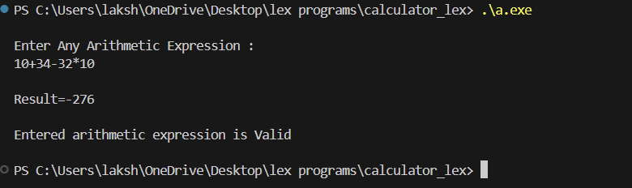

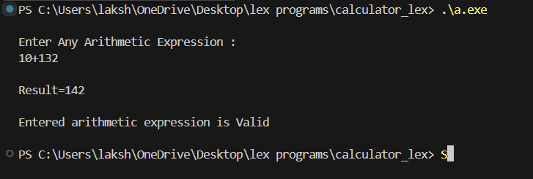

1. Develop a Parser for ‘C’ using the LEX and YACC tools.

* Parser.y

%{

#include<stdio.h>

int yylex(void);

int yyerror(const char *s);

int success = 1;

%}

%token int_const char_const float_const id string storage_const type_const qual_const struct_const enum_const DEFINE

%token IF FOR DO WHILE BREAK SWITCH CONTINUE RETURN CASE DEFAULT GOTO SIZEOF PUNC or_const and_const eq_const shift_const rel_const inc_const

%token point_const ELSE HEADER

%left '+' '-'

%left '*' '/'

%right UMINUS

%nonassoc "then"

%nonassoc ELSE

%start program_unit

%%

program_unit : HEADER program_unit

| DEFINE primary_exp program_unit

| translation_unit

;

translation_unit : external_decl

| translation_unit external_decl

;

external_decl : function_definition

| decl

;

function_definition : decl_specs declarator decl_list compound_stat

| declarator decl_list compound_stat

| decl_specs declarator compound_stat

| declarator compound_stat

;

decl : decl_specs init_declarator_list ';'

| decl_specs ';'

;

decl_list : decl

| decl_list decl

;

decl_specs : storage_class_spec decl_specs

| storage_class_spec

| type_spec decl_specs

| type_spec

| type_qualifier decl_specs

| type_qualifier

;

storage_class_spec : storage_const

;

type_spec : type_const

| struct_or_union_spec

| enum_spec

;

type_qualifier : qual_const

;

struct_or_union_spec : struct_or_union id '{' struct_decl_list '}' ';'

| struct_or_union id

;

struct_or_union : struct_const

;

struct_decl_list : struct_decl

| struct_decl_list struct_decl

;

init_declarator_list : init_declarator

| init_declarator_list ',' init_declarator

;

init_declarator : declarator

| declarator '=' initializer

;

struct_decl : spec_qualifier_list struct_declarator_list ';'

;

spec_qualifier_list : type_spec spec_qualifier_list

| type_spec

| type_qualifier spec_qualifier_list

| type_qualifier

;

struct_declarator_list : struct_declarator

| struct_declarator_list ',' struct_declarator

;

struct_declarator : declarator

| declarator ':' conditional_exp

| ':' conditional_exp

;

enum_spec : enum_const id '{' enumerator_list '}'

| enum_const '{' enumerator_list '}'

| enum_const id

;

enumerator_list : enumerator

| enumerator_list ',' enumerator

;

enumerator : id

| id '=' conditional_exp

;

declarator : pointer direct_declarator

| direct_declarator

;

direct_declarator : id

| '(' declarator ')'

| direct_declarator '[' conditional_exp ']'

| direct_declarator '[' ']'

| direct_declarator '(' param_list ')'

| direct_declarator '(' id_list ')'

| direct_declarator '(' ')'

;

pointer : '*' type_qualifier_list

| '*'

| '*' type_qualifier_list pointer

| '*' pointer

;

type_qualifier_list : type_qualifier

| type_qualifier_list type_qualifier

;

param_list : param_decl

| param_list ',' param_decl

;

param_decl : decl_specs declarator

| decl_specs abstract_declarator

| decl_specs

;

id_list : id

| id_list ',' id

;

initializer : assignment_exp

| '{' initializer_list '}'

| '{' initializer_list ',' '}'

;

initializer_list : initializer

| initializer_list ',' initializer

;

type_name : spec_qualifier_list abstract_declarator

| spec_qualifier_list

;

abstract_declarator : pointer

| pointer direct_abstract_declarator

| direct_abstract_declarator

;

direct_abstract_declarator : '(' abstract_declarator ')'

| direct_abstract_declarator '[' conditional_exp ']'

| '[' conditional_exp ']'

| direct_abstract_declarator '[' ']'

| '[' ']'

| direct_abstract_declarator '(' param_list ')'

| '(' param_list ')'

| direct_abstract_declarator '(' ')'

| '(' ')'

;

stat : labeled_stat

| exp_stat

| compound_stat

| selection_stat

| iteration_stat

| jump_stat

;

labeled_stat : id ':' stat

| CASE int_const ':' stat

| DEFAULT ':' stat

;

exp_stat : exp ';'

| ';'

;

compound_stat : '{' decl_list stat_list '}'

| '{' stat_list '}'

| '{' decl_list '}'

| '{' '}'

;

stat_list : stat

| stat_list stat

;

selection_stat : IF '(' exp ')' stat %prec "then"

| IF '(' exp ')' stat ELSE stat

| SWITCH '(' exp ')' stat

;

iteration_stat : WHILE '(' exp ')' stat

| DO stat WHILE '(' exp ')' ';'

| FOR '(' exp ';' exp ';' exp ')' stat

| FOR '(' exp ';' exp ';' ')' stat

| FOR '(' exp ';' ';' exp ')' stat

| FOR '(' exp ';' ';' ')' stat

| FOR '(' ';' exp ';' exp ')' stat

| FOR '(' ';' exp ';' ')' stat

| FOR '(' ';' ';' exp ')' stat

| FOR '(' ';' ';' ')' stat

;

jump_stat : GOTO id ';'

| CONTINUE ';'

| BREAK ';'

| RETURN exp ';'

| RETURN ';'

;

exp : assignment_exp

| exp ',' assignment_exp

;

assignment_exp : conditional_exp

| unary_exp assignment_operator assignment_exp

;

assignment_operator : PUNC

| '='

;

conditional_exp : logical_or_exp

| logical_or_exp '?' exp ':' conditional_exp

;

logical_or_exp : logical_and_exp

| logical_or_exp or_const logical_and_exp

;

logical_and_exp : inclusive_or_exp

| logical_and_exp and_const inclusive_or_exp

;

inclusive_or_exp : exclusive_or_exp

| inclusive_or_exp '|' exclusive_or_exp

;

exclusive_or_exp : and_exp

| exclusive_or_exp '^' and_exp

;

and_exp : equality_exp

| and_exp '&' equality_exp

;

equality_exp : relational_exp

| equality_exp eq_const relational_exp

;

relational_exp : shift_expression

| relational_exp '<' shift_expression

| relational_exp '>' shift_expression

| relational_exp rel_const shift_expression

;

shift_expression : additive_exp

| shift_expression shift_const additive_exp

;

additive_exp : mult_exp

| additive_exp '+' mult_exp

| additive_exp '-' mult_exp

;

mult_exp : cast_exp

| mult_exp '*' cast_exp

| mult_exp '/' cast_exp

| mult_exp '%' cast_exp

;

cast_exp : unary_exp

| '(' type_name ')' cast_exp

;

unary_exp : postfix_exp

| inc_const unary_exp

| unary_operator cast_exp

| SIZEOF unary_exp

| SIZEOF '(' type_name ')'

;

unary_operator : '&' | '*' | '+' | '-' | '~' | '!'

;

postfix_exp : primary_exp

| postfix_exp '[' exp ']'

| postfix_exp '(' argument_exp_list ')'

| postfix_exp '(' ')'

| postfix_exp '.' id

| postfix_exp point_const id

| postfix_exp inc_const

;

primary_exp : id

| consts

| string

| '(' exp ')'

;

argument_exp_list : assignment_exp

| argument_exp_list ',' assignment_exp

;

consts : int_const

| char_const

| float_const

| enum_const

;

%%

int main()

{

yyparse();

if(success)

printf("Parsing Successful\n");

return 0;

}

int yyerror(const char *msg)

{

extern int yylineno;

printf("Parsing Failed\nLine Number: %d %s\n",yylineno,msg);

success = 0;

return 0;

}

* Parser.l

%option yylineno

%{

#include<stdio.h>

#include"parser.tab.h"

%}

%%

"#include"[ ]+<[a-zA-z_][a-zA-z_0-9.]*> {return HEADER;}

"#define"[ ]+[a-zA-z_][a-zA-z_0-9]* {return DEFINE;}

"auto"|"register"|"static"|"extern"|"typedef" {return storage_const;}

"void"|"char"|"short"|"int"|"long"|"float"|"double"|"signed"|"unsigned" {return type_const;}

"const"|"volatile" {return qual_const;}

"enum" {return enum_const;}

"struct"|"union" {return struct_const;}

"case" {return CASE;}

"default" {return DEFAULT;}

"if" {return IF;}

"switch" {return SWITCH;}

"else" {return ELSE;}

"for" {return FOR;}

"do" {return DO;}

"while" {return WHILE;}

"goto" {return GOTO;}

"continue" {return CONTINUE;}

"break" {return BREAK;}

"return" {return RETURN;}

"sizeof" {return SIZEOF;}

"||" {return or_const;}

"&&" {return and_const;}

"=="|"!=" {return eq_const;}

"<="|">=" {return rel_const;}

">>"|"<<" {return shift_const;}

"++"|"--" {return inc_const;}

"->" {return point_const;}

"*="|"/="|"+="|"%="|">>="|"-="|"<<="|"&="|"^="|"|=" {return PUNC;}

[0-9]+ {return int_const;}

[0-9]+"."[0-9]+ {return float_const;}

"'"."'" {return char_const;}

[a-zA-z_][a-zA-z_0-9]* {return id;}

\".*\" {return string;}

"//"(\\.|[^\n])*[\n] ;

[/][*]([^*]|[*]*[^*/])*[*]+[/] ;

[ \t\n] ;

";"|"="|","|"{"|"}"|"("|")"|"["|"]"|"*"|"+"|"-"|"/"|"?"|":"|"&"|"|"|"^"|"!"|"~"|"%"|"<"|">" {return yytext[0];}

%%

int yywrap(void)

{

return 1;

}

🡪 How to run code ?

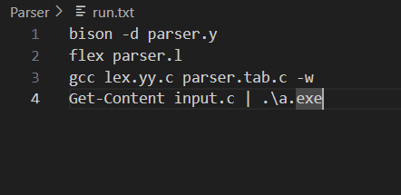

* OUTPUT

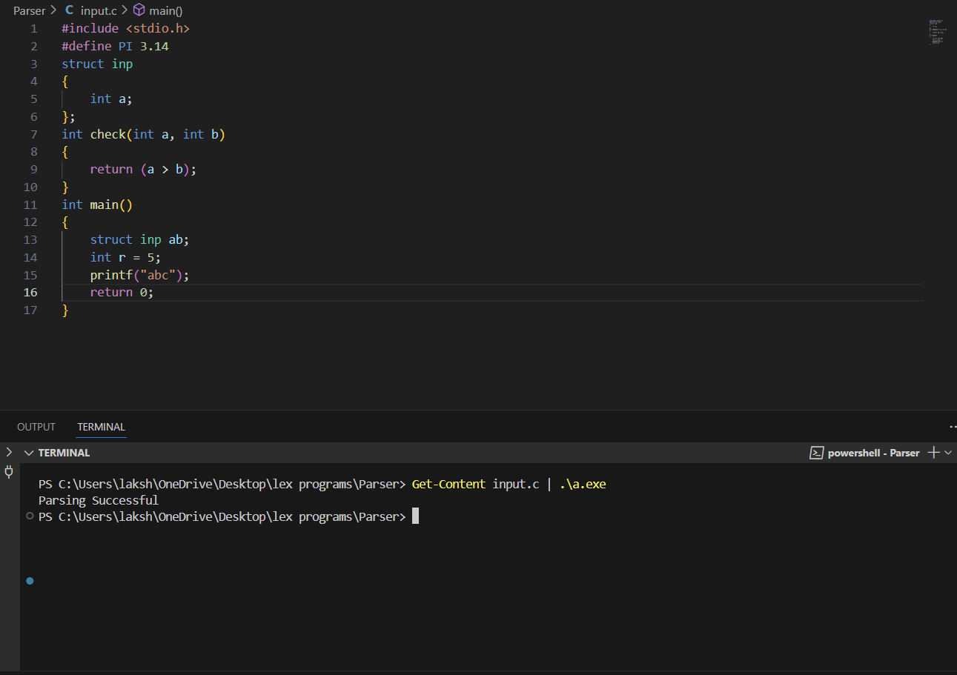

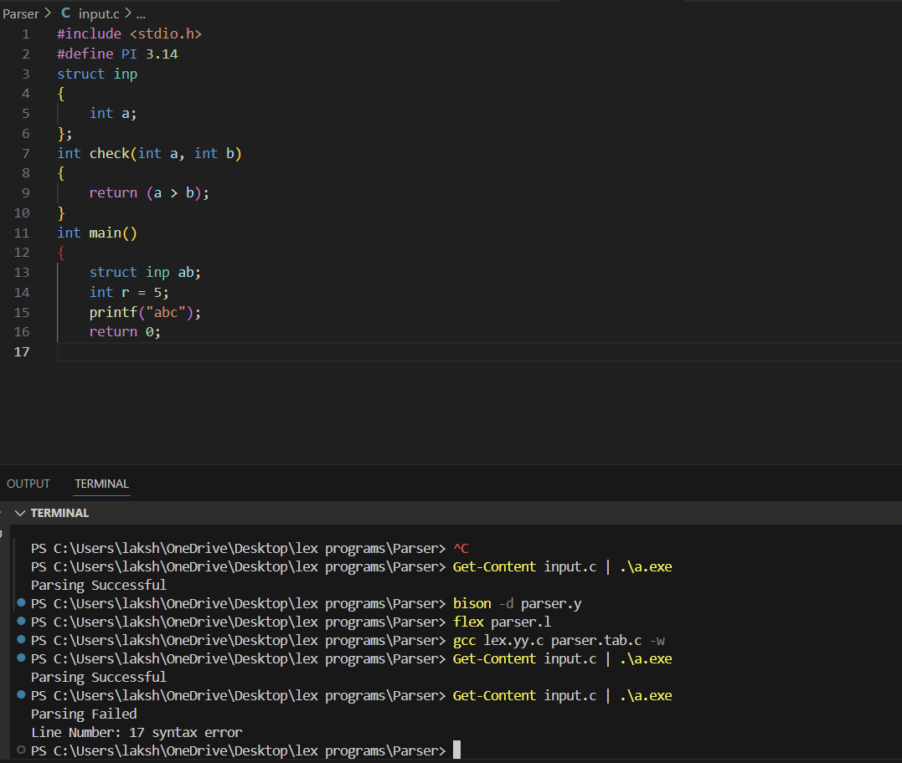

5) Develop Lexical Analyzer for ‘C’ using LEX tool

* C_lex_analyser.l

%{

int COMMENT=0;

%}

identifier [a-zA-Z][a-zA-Z0-9]*

%%

#.*\n {printf("%sThis is a PREPROCESSOR DIRECTIVE\n",yytext);}

auto|break|case|char|const|continue|default|do|double|else|enum|extern|float|for|goto|if|int|long|register|return|short|signed|sizeof|static|struct|switch|typedef|union|unsigned|void|volatile|while {printf("\n%s is a KEYWORD",yytext);}

"/*" {COMMENT = 1;}

"*/" {COMMENT = 0;}

{identifier}\( {if(!COMMENT)printf("\nFUNCTION: \n%s",yytext);}

{identifier}(\[[0-9]*\])? {if(!COMMENT) printf("\n%s is an IDENTIFIER",yytext);}

\".*\" {if(!COMMENT)printf("\n%s is a STRING",yytext);}

[0-9]+ {if(!COMMENT) printf("\n%s is a NUMBER ",yytext);}

\{ {if(!COMMENT) printf("\nBLOCK BEGINS");}

\} {if(!COMMENT) printf("\nBLOCK ENDS");}

\) {if(!COMMENT);printf("\n)");}

= {if(!COMMENT) printf("\n%s is an ASSIGNMENT OPERATOR",yytext);}

\<= |

\>= |

\< |

\== |

\!= |

\> {if(!COMMENT) printf("\n%s is a RELATIONAL OPERATOR",yytext);}

\, |

\; {if(!COMMENT) printf("\n%s is a SEPERATOR",yytext);}

%%

int main(int argc, char **argv)

{

FILE *file;

file=fopen("input.c","r");

if(!file)

{

printf("could not open the file");

exit(0);

}

yyin=file;

yylex();

printf("\n");

return(0);

}

int yywrap()

{

return(1);

}

* Input.c

#include <stdio.h>

void main(int a)

{

    /* HELLO This is a comment*/

    int a, b, c;

    a = 1;

    b = 2;

    if (a > b)

        c = 0;

    else

        c = -1;

    printf("The value of c: %d", c);

    for (int i = 0; i < 5; i++)

        i++;

    return 0;

}

* To RUN

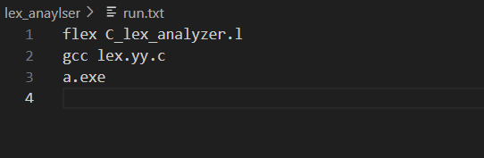

* OUTPUT

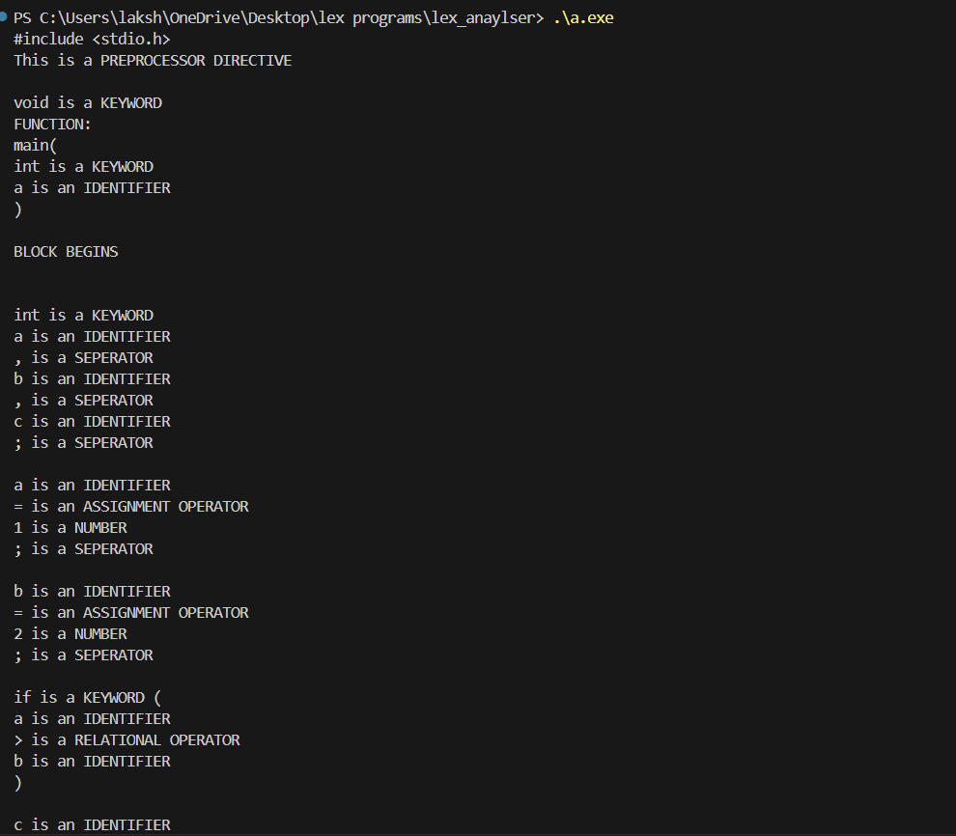

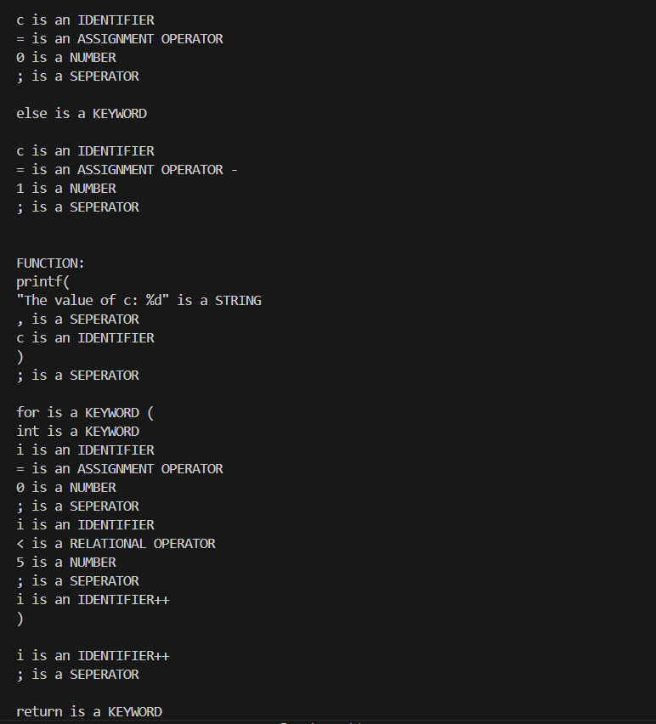

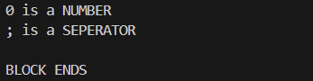

1. **Represent C language using Context Free Language**

The Context Free Grammar for C language can be given by G = (V, T, S, P):

where:

V = set of non-terminals

= {program_unit, translation_unit, external_decl, function_definition, decl, decl_list, decl_specs, storage_class_spec, type_spec, type_qualifier, struct_or_union_spec, struct_or_union, struct_decl_list, init_declarator_list, init_declarator, struct_decl, spec_qualifier_list, struct_declarator_list, struct_declarator_list, struct_declarator, enum_spec, enumerator_list, enumerator, declarator, direct_declarator, pointer, type_qualifier_list, param_list, param_decl, id_list, initializer, initializer_list, type_name, abstract_declarator, direct_abstract_declarator, stat, labeled_stat, exp_stat,compound_stat, stat_list, selection_stat, iteration_stat, jump_stat, exp assignment_exp, assignment_operator, conditional_exp, logical_or_exp, logical_and_exp, inclusive_or_exp, exclusive_or_exp, and_exp, equality_exp, relational_exp, shift_expression, additive_exp, mult_exp, cast_exp, unary_exp, unary_operator, postfix_exp, primary_exp, argument_exp_list, consts, int_const, char_const, float_const, id, string, enumeration_const, storage_const, type_const, qual_const, struct_const, enum_const, DEFINE, IF, ELSE, FOR, DO, WHILE, BREAK, SWITCH, CONTINUE, RETURN, CASE, DEFAULT, GOTO, SIZEOF, PUNC, or_const, and_const, eq_const, shift_const, rel_const, inc_const, point_const, HEADER}

T = set of terminals

= {All ASCII characters}

S = start symbol = program_unit

P = set of productions

program_unit -> HEADER program_unit

| DEFINE primary_exp program_unit

| translation_unit

translation_unit -> external_decl

| translation_unit external_decl

external_decl -> function_definition

| decl

function_definition -> decl_specs declarator decl_list compound_stat

| declarator decl_list compound_stat

| decl_specs declarator compound_stat

| declarator compound_stat

decl -> decl_specs init_declarator_list ';'

| decl_specs ';'

decl_list -> decl

| decl_list decl

decl_specs -> storage_class_spec decl_specs

| storage_class_spec

| type_spec decl_specs

| type_spec

| type_qualifier decl_specs

| type_qualifier

storage_class_spec -> storage_const

type_spec -> type_const

| struct_or_union_spec

| enum_spec

type_qualifier -> qual_const

struct_or_union_spec -> struct_or_union id '{' struct_decl_list '}' ';'

| struct_or_union id

struct_or_union -> struct_const

struct_decl_list -> struct_decl

| struct_decl_list struct_decl

init_declarator_list -> init_declarator

| init_declarator_list ',' init_declarator

init_declarator -> declarator

| declarator '=' initializer

struct_decl -> spec_qualifier_list struct_declarator_list ';'

spec_qualifier_list -> type_spec spec_qualifier_list

| type_spec

| type_qualifier spec_qualifier_list

| type_qualifier

struct_declarator_list -> struct_declarator

| struct_declarator_list ',' struct_declarator

struct_declarator -> declarator

| declarator ':' conditional_exp

| ':' conditional_exp

enum_spec -> enum_const id '{' enumerator_list '}'

| enum_const '{' enumerator_list '}'

| enum_const id

enumerator_list -> enumerator

| enumerator_list ',' enumerator

enumerator -> id

| id '=' conditional_exp

declarator -> pointer direct_declarator

| direct_declarator

direct_declarator -> id

| '(' declarator ')'

| direct_declarator '[' conditional_exp ']'

| direct_declarator '[' ']'

| direct_declarator '(' param_list ')'

| direct_declarator '(' id_list ')'

| direct_declarator '(' ')'

pointer -> '*' type_qualifier_list

| '*'

| '*' type_qualifier_list pointer

| '*' pointer

type_qualifier_list -> type_qualifier

| type_qualifier_list type_qualifier

param_list -> param_decl

| param_list ',' param_decl

param_decl -> decl_specs declarator

| decl_specs abstract_declarator

| decl_specs

id_list -> id

| id_list ',' id

initializer -> assignment_exp

| '{' initializer_list '}'

| '{' initializer_list ',' '}'

initializer_list -> initializer

| initializer_list ',' initializer

type_name -> spec_qualifier_list abstract_declarator

| spec_qualifier_list

abstract_declarator -> pointer

| pointer direct_abstract_declarator

| direct_abstract_declarator

direct_abstract_declarator -> '(' abstract_declarator ')'

| direct_abstract_declarator '[' conditional_exp ']'

| '[' conditional_exp ']'

| direct_abstract_declarator '[' ']'

| '[' ']'

| direct_abstract_declarator '(' param_list ')'

| '(' param_list ')'

| direct_abstract_declarator '(' ')'

| '(' ')'

stat -> labeled_stat

| exp_stat

| compound_stat

| selection_stat

| iteration_stat

| jump_stat

labeled_stat -> id ':' stat

| CASE int_const ':' stat

| DEFAULT ':' stat

exp_stat -> exp ';'

| ';'

compound_stat -> '{' decl_list stat_list '}'

| '{' stat_list '}'

| '{' decl_list '}'

| '{' '}'

stat_list -> stat

| stat_list stat

selection_stat -> IF '(' exp ')' stat %prec "then"

| IF '(' exp ')' stat ELSE stat

| SWITCH '(' exp ')' stat

iteration_stat -> WHILE '(' exp ')' stat

| DO stat WHILE '(' exp ')' ';'

| FOR '(' exp ';' exp ';' exp ')' stat

| FOR '(' exp ';' exp ';' ')' stat

| FOR '(' exp ';' ';' exp ')' stat

| FOR '(' exp ';' ';' ')' stat

| FOR '(' ';' exp ';' exp ')' stat

| FOR '(' ';' exp ';' ')' stat

| FOR '(' ';' ';' exp ')' stat

| FOR '(' ';' ';' ')' stat

jump_stat -> GOTO id ';'

| CONTINUE ';'

| BREAK ';'

| RETURN exp ';'

| RETURN ';'

exp -> assignment_exp

| exp ',' assignment_exp

assignment_exp -> conditional_exp

| unary_exp assignment_operator assignment_exp

assignment_operator -> PUNC

| '='

conditional_exp -> logical_or_exp

| logical_or_exp '?' exp ':' conditional_exp

logical_or_exp -> logical_and_exp

| logical_or_exp or_const logical_and_exp

logical_and_exp -> inclusive_or_exp

| logical_and_exp and_const inclusive_or_exp

inclusive_or_exp -> exclusive_or_exp

| inclusive_or_exp '|' exclusive_or_exp

exclusive_or_exp -> and_exp

| exclusive_or_exp '^' and_exp

and_exp -> equality_exp

| and_exp '&' equality_exp

equality_exp -> relational_exp

| equality_exp eq_const relational_exp

relational_exp -> shift_expression

| relational_exp '<' shift_expression

| relational_exp '>' shift_expression

| relational_exp rel_const shift_expression

shift_expression -> additive_exp

| shift_expression shift_const additive_exp

additive_exp -> mult_exp

| additive_exp '+' mult_exp

| additive_exp '-' mult_exp

mult_exp -> cast_exp

| mult_exp '*' cast_exp

| mult_exp '/' cast_exp

| mult_exp '%' cast_exp

cast_exp -> unary_exp

| '(' type_name ')' cast_exp

unary_exp -> postfix_exp

| inc_const unary_exp

| unary_operator cast_exp

| SIZEOF unary_exp

| SIZEOF '(' type_name ')'

unary_operator -> '&' | '*' | '+' | '-' | '~' | '!'

postfix_exp -> primary_exp

| postfix_exp '[' exp ']'

| postfix_exp '(' argument_exp_list ')'

| postfix_exp '(' ')'

| postfix_exp '.' id

| postfix_exp point_const id

| postfix_exp inc_const

primary_exp -> id

| consts

| string

| '(' exp ')'

argument_exp_list -> assignment_exp

| argument_exp_list ',' assignment_exp

consts -> int_const

| char_const

| float_const

| enumeration_const

int_const -> [0-9]+

char_const -> "'"."'"

float_const -> [0-9]+"."[0-9]+

id -> [a-zA-z_][a-zA-z_0-9]*

string -> \".*\"

enum_const -> "enum"

storage_const -> "auto"

| "register"

| "static"

| "extern"

| "typedef"

type_const -> "void"

| "char"

| "short"

| "int"

| "long"

| "float"

| "double"

| "signed"

| "unsigned"

qual_const -> "const"

| "volatile"

struct_const -> "struct"

| "union"

DEFINE -> "#define"[ ]+[a-zA-z_][a-zA-z_0-9]*

IF -> "if"

ELSE -> "else"

FOR -> "for"

DO -> "do"

WHILE -> "while"

BREAK -> "break"

SWITCH -> "switch"

CONTINUE -> "continue"

RETURN -> "return"

CASE -> "case"

DEFAULT -> "default"

GOTO -> "goto"

SIZEOF -> "sizeof"

PUNC -> "*="

| "/="

| "+="

| "%="

| ">>="

| "-="

| "<<="

| "&="

| "^="

| "|="

or_const -> "||"

and_const -> "&&"

eq_const -> "=="

| "!="

shift_const -> ">>"

| "<<"

rel_const -> "<="

| ">="

inc_const -> "++"

| "--"

point_const -> "->"

HEADER -> "#include"[ ]+<[a-zA-z_][a-zA-z_0-9.]*>

1. Add assignment statement , If then else statement and while loop to the calculator and generate the three address code for the same.

#include <stdio.h>

#include <string.h>

// Label counter for TAC generation

int labelCounter = 0;

int tempCounter = 0;

// Function to generate new labels and temporary variables

char* newLabel() {

static char label[10];

sprintf(label, "L%d", labelCounter++);

return label;

}

char* newTemp() {

static char temp[10];

sprintf(temp, "t%d", tempCounter++);

return temp;

}

// Function prototypes

void generateAssignment(char* id, char* expr);

void generateIfElse(char* condition, char* trueBlock, char* falseBlock);

void generateWhileLoop(char* condition, char* body);

int main() {

// Example usage

generateAssignment("x", "a + b");

generateIfElse("a < b", "x = a + b", "x = a - b");

generateWhileLoop("a < b", "a = a + 1");

return 0;

}

// Function to generate TAC for assignment statements

void generateAssignment(char* id, char* expr) {

printf("%s = %s\n", id, expr);

}

// Function to generate TAC for if-then-else statements

void generateIfElse(char* condition, char* trueBlock, char* falseBlock) {

char* L1 = newLabel();

char* L2 = newLabel();

char* L3 = newLabel();

printf("if %s goto %s\n", condition, L1);

printf("goto %s\n", L2);

printf("%s: %s\n", L1, trueBlock);

printf("goto %s\n", L3);

printf("%s: %s\n", L2, falseBlock);

printf("%s:\n", L3);

}

// Function to generate TAC for while loops

void generateWhileLoop(char* condition, char* body) {

char* L1 = newLabel();

char* L2 = newLabel();

printf("%s: if not %s goto %s\n", L1, condition, L2);

printf("%s\n", body);

printf("goto %s\n", L1);

printf("%s:\n", L2);

}

Output

