GLA UNIVERSITY, GREATER NOIDA
Greater Noida – 201310, Uttar Pradesh, India


STUDENT ACADEMIC SUPPORT AND EARLY-INTERVENTION SYSTEM
SOFTWARE REQUIREMENT SPECIFICATION

BACHELOR OF TECHNOLOGY
in
COMPUTER SCIENCE & ENGINEERING – AI

Submitted By
LAKSHYA VARSHNEY
Roll No.: 22515500056 | Section: NE

Under the Supervision of  Mr. Palash Singh  GLA University, Greater Noida | Reviewed By  Mr. Gautam Mukherjee  GLA University, Greater Noida

SCHOOL / DEPARTMENT OF COMPUTER SCIENCE & ENGINEERING / APPLICATIONS
GLA UNIVERSITY, GREATER NOIDA – 201310
SEPTEMBER, 2026

Revision History

Version | Date | Change | Reason
1.0 | 04-09-2026 | Initial version | First submission

1. Introduction

1.1 Purpose

This Software Requirement Specification (SRS) defines the requirements for version 1.0 of the Student Academic Support and Early-Intervention System. It provides the baseline against which the planned web application, machine-learning component, and test cases will be verified.

1.2 Scope

The system helps students view their academic progress and helps authorised faculty advisors identify students who may benefit from academic support. The system analyses historical educational indicators and presents a support-needed indicator for decision support. The system does not automatically declare that a student will fail, impose academic penalties, or replace an advisor's judgement.

1.3 Definitions

Term | Definition
Support-needed indicator | A model-assisted indicator that a student may benefit from additional academic support.
Prediction score | The model's estimated probability that the student belongs to the support-needed category.
Level 0 baseline | A classifier that ignores all inputs and always predicts the majority class.
Level 1 baseline | A no-ML classifier that uses the majority class within each failures group.
Support case | A record created by an advisor to document a follow-up action for a student.

2. Overall Description

2.1 User Classes

User class | Who they are | What they may do
Student | An authenticated student whose academic record is stored in the system. | View own progress, indicators and support information.
Faculty Advisor | An authenticated advisor responsible for authorised students. | View assigned students, review indicators, create support cases and record follow-up.

2.2 Assumptions and Dependencies

- The UCI Student Performance Mathematics dataset is available during development; a verified local copy will be used if the public source is temporarily unavailable.
- The application depends on Node.js, Express.js, MongoDB, Python and Scikit-learn; if the prediction service is unavailable, the system shall show the stored Level 0 baseline.
- The core application shall run in the local development environment without requiring an external paid service.

2.3 Constraints

C1 The selected Mathematics dataset contains 395 student records, limiting statistical power and generalisability.
C2 The source data has no unique application student ID; the system shall assign an internal identifier.

3. Data Source and Baseline

Item | Value | Required now?
Dataset name | UCI Student Performance — Mathematics (student-mat.csv) | Yes
Source and URL | UCI Machine Learning Repository — https://archive.ics.uci.edu/dataset/320/student%2Bperformance | Yes
Licence / terms of use | Creative Commons Attribution 4.0 International (CC BY 4.0) | Yes
Number of rows and columns | 395 rows × 33 columns | Yes
Prediction target | Derived support-needed indicator: G3 < 10 | Yes
Task type | Binary classification: support-needed / not support-needed | Yes
Class balance | 130 support-needed (32.9%); 265 not support-needed (67.1%) | Yes
Primary evaluation metric | Precision@20 | Yes
Why that metric | The advisor's first review list is limited to 20 students; this measures how many of those 20 actually need support. | Yes
Level 0 baseline and its score | Always predict the majority class (not support-needed) → Precision@20 = 0% | Yes
Known data quality problems | No missing values reported; no unique application ID; G1/G2 are strongly related to G3, so target leakage must be avoided. | Yes
Level 1 baseline and its score | Group by failures and predict each group's majority class; score to be calculated on the held-out test split. | Later
Target for this release | Beat the Level 1 Precision@20 baseline on the held-out test set. | Later

4. System Architecture

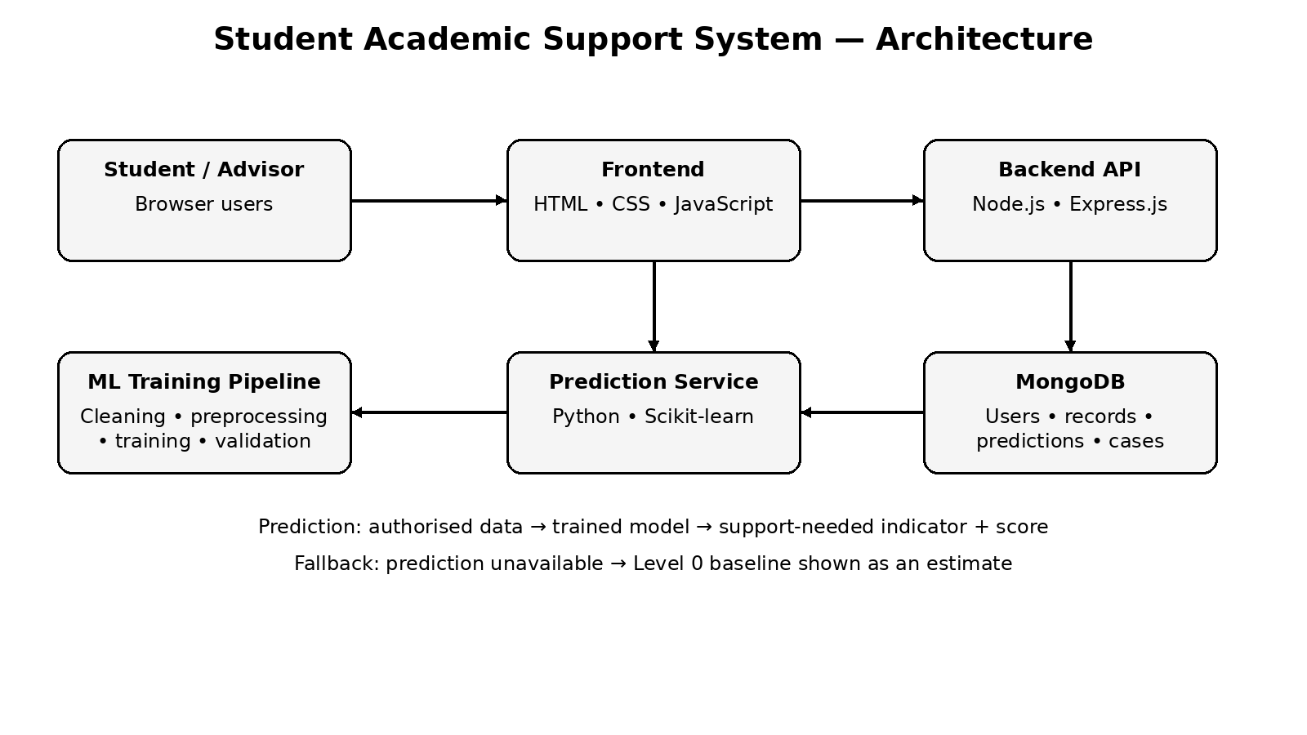
Figure 1: System architecture of the Student Academic Support and Early-Intervention System.

Component | Responsibility
Frontend | Provides login, dashboards, charts and authorised user interactions.
Backend API | Handles authentication, authorisation, application logic and REST API requests.
MongoDB | Stores users, student records, predictions, support cases and appointments.
ML Training Pipeline | Prepares data, trains candidate classifiers and evaluates them against baselines.
Prediction Service | Receives valid prediction inputs and returns the support-needed indicator and score.
Visualization Layer | Presents academic summaries, model evaluation and statistical views.

5. Functional Requirements

5.1 Authentication and Academic Access
FR-1.1 The system shall accept a valid student or advisor email and password for login.
FR-1.2 The system shall reject invalid login credentials with an authentication error.
FR-1.3 The system shall restrict student users to their own academic record.
FR-1.4 The system shall restrict advisor users to authorised student records.

5.2 Student, Advisor and Model Functions

FR-1.5 The system shall provide a logout action that ends the current authenticated session.
FR-2.1 The system shall display the authenticated student's academic indicators and historical performance.
FR-2.2 The system shall display the student's support-needed indicator when a prediction is available.
FR-2.3 The system shall allow an advisor to view authorised students with their support indicators.
FR-2.4 The system shall display statistical and visual summaries used for academic-support review.
FR-3.1 The system shall allow an advisor to create a support case for an authorised student.
FR-3.2 The system shall allow an advisor to record a support-case reason and note.
FR-3.3 The system shall display the current status of each support case.
FR-3.4 The system shall allow an advisor to update a support case status.
FR-3.5 The system shall allow a student to view the status of support actions associated with their own record.
FR-4.1 The system shall accept only validated academic and educational inputs defined for the prediction service.
FR-4.2 The system shall return a support-needed indicator and prediction score for a valid prediction request.
FR-4.3 The system shall present the prediction score as an estimated probability and display the main contributing factors used for explanation.
FR-4.4 The system shall, when the prediction service is unavailable or returns no usable result, display the Level 0 baseline labelled as an estimate.
FR-4.5 The system shall allow an advisor to record a human review decision without changing the stored model prediction.

6. Non-Functional Requirements

NFR-1 The system shall return a single-student prediction response within 5 seconds at the 95th percentile during local testing.
NFR-2 The system shall enforce role-based access control on every protected API route.
NFR-3 The system shall record student_id, model_version, prediction score and prediction timestamp for every completed prediction.
NFR-4 The system shall display an error message and retain the last valid stored prediction when the prediction service is unavailable.

7. Build Plan

7.1 Minimum Viable Product

FR / NFR ID | Requirement (short) | Why this one is in the MVP
FR-1.1 | User login | Authentication is the entry point for both roles.
FR-1.3 | Student access control | Privacy must work before exposing academic information.
FR-2.1 | Student progress view | Provides a usable system before ML is added.
FR-2.3 | Advisor student list | Provides the core advisor review workflow.
FR-4.4 | Level 0 fallback | Keeps the application demonstrable if the ML service is unavailable.
NFR-2 | Role-based API access | Protects student information from the first working version.
NFR-3 | Prediction logging | Makes later evaluation traceable to a student and model version.

Deliberately not in the MVP: FR-3.5 student-facing support-case status. Before adding it, the advisor workflow and privacy rules must be stable.

7.2 Build Order

For reference, the fixed project stages:
Stage | Deliverable | Date
Development Sprint I | Prototype / initial working model | 27 Sep 2026
Development Sprint II | 50% functional application | 17 Oct 2026
Development Sprint III | 75–80% functional application | 7 Nov 2026
Testing & Validation | Test report and bug log | 17 Nov 2026
Deployment & Documentation | Deployed application, user manual, technical documentation | 30 Nov 2026
Final Presentation | Final report, presentation and viva | 5–10 Dec 2026

Your plan:
Stage | What will be working by then | FR / NFR IDs | How I will know it is done
Sprint I  27 Sep | Authentication, student progress view, advisor list and Level 0 fallback. | FR-1.1–FR-1.5, FR-2.1, FR-2.3, FR-4.4, NFR-2 | Login as both roles; view authorised data; show fallback.
Sprint II  17 Oct | Support cases, database integration, prediction service and stored prediction records. | FR-2.2, FR-3.1–FR-3.4, FR-4.1, FR-4.2, FR-4.5, NFR-3 | Create a case; request prediction; see indicator and log.
Sprint III  7 Nov | Explanation, statistical views, student support status and complete dashboards. | FR-2.4, FR-3.5, FR-4.3, NFR-1, NFR-4 | Review charts, explanation and support status.
Testing  17 Nov | MVP and extended functions tested with test cases and bug log. | All FRs, NFR-1–NFR-4 | Run acceptance tests and record results.
Deployment  30 Nov | Deployed application and documentation. | All FRs, NFR-1–NFR-4 | Open deployed application and demonstrate core workflows.

8. Data Requirements

8.1 Entities

Entity: StudentProfile
Field | Type | Constraint / Notes
id | UUID | Primary key.
studentId | String | Not null; unique within the application.
course | String | Not null; e.g. Mathematics.
studyTime | Integer | 1–4 based on source coding.
failures | Integer | Non-negative; source-coded past class failures.
absences | Integer | 0 or greater.
G1 | Integer | 0–20; previous period grade.
G2 | Integer | 0–20; previous period grade.
G3 | Integer | 0–20; historical final grade; never sent as a prediction input.

Other entities: User, PredictionRecord, SupportCase, Appointment.

8.2 Entity Relationship Diagram

9. Design Decisions and Alternatives Considered

# | Decision | Alternative rejected | Reason
D1 | Use HTML, CSS and JavaScript for the frontend. | React | The course requires JavaScript and the solo project has a fixed time limit.
D2 | Use MongoDB for application data. | MySQL | Student, prediction and support-case records have varied structures and the stack is suitable for the project.
D3 | Use Logistic Regression as primary model with Decision Tree comparison. | Deep learning model | The dataset has 395 records and the system needs interpretable support indicators.

10. Acceptance Criteria

AC-1 A valid student login opens the student's dashboard and shows only that student's academic information.
AC-2 A valid advisor login opens the advisor dashboard and shows authorised students with support indicators.
AC-3 A student attempting to access another student's protected record receives an authorisation error and the record is not displayed.
AC-4 If the ML prediction service is unavailable, the advisor dashboard displays the Level 0 baseline clearly labelled as an estimate.

11. Out of Scope for This Release

Automatic academic penalties or disciplinary decisions. The system is advisory and requires human review.
Real-time integration with institutional attendance, LMS or examination systems. v1.0 uses a static public dataset.
Mobile application and chatbot functionality. These are excluded to keep the solo project focused on the required web application.

