Game Design Document

Fill up the Following document

1. Write the title of your project.

Soul Saver

1. What is the goal of the game?

To defeat all the enemies and collect 3 soul stones.

1. Write a brief story of your game?

Magic stones are the sacred relics maintaining the balance of the world the world…one day a bunch of bad guys stole the magic stones and the whole world descended into chaos….according to the legends these evils separately have even earlier tried to get these stone and had failed. But this time they were together under their head as grand slime and took over the magic stones… Now you as guardian of this world need to get these stones back ….can you bring back these magic stones ??

1. Which are the playing characters of this game?

* Playing characters are the ones which respond to the user based on the input from the user
* Cars, monkeys, dinos, wizards etc, are the playing characters in the game.

|  |  |  |  |  |
| --- | --- | --- | --- | --- |
| Number | Character Name | | What can this character do? | |
| 1 | Knight | | It is the hero who saves the world. | |
| 2 | Wizard | | It is the 2nd hero who saves the world. | |
|  | |  | |
|  | |  | |

1. Which are the Non Playing Characters of this game?

* Non Playing characters are the ones which don't have an action or a behaviour when the user interacts with the game.
* Hurdles, stones, bananas, coins, etc are non playing characters in the game.

|  |  |  |
| --- | --- | --- |
| Number | Character Name | What can this character do? |
| 1 | Evils | Against enemies |
| 2 | Enhancers | Helps player improve themselves |
| 3 | traders | Trades potions and weapons |
| 4 | Decorative items | To make the map |
| 5 | chests | To get some things |
| 6 |  |  |
|  |  |  |
|  |  |  |

Draw your imagination of this game. What does this game look like?

* Draw the game either on your computer or on paper,
* Add images of scenes of the game to show each of the playing and non-playing characters at least once.

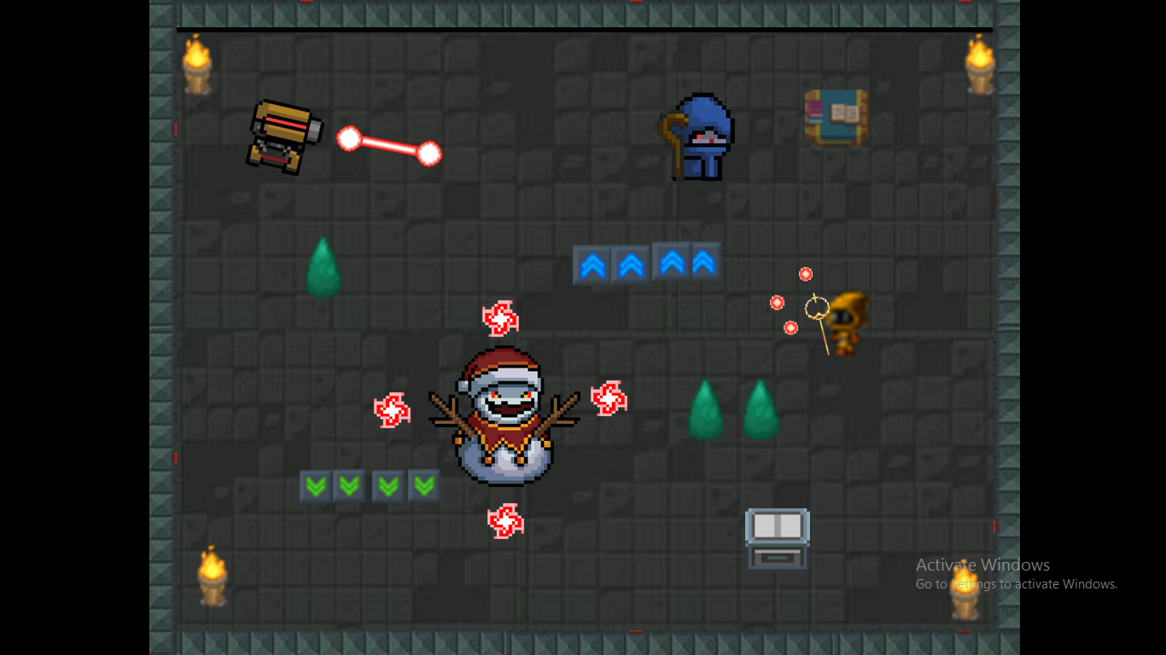

How do you plan to make your game engaging?

* Adding option for user to choose their special buffs(powers) before every floor…
* Adding traders or trainer in within the maps…
* Adding several weapons/ energy/ armour in game..
* And many more..