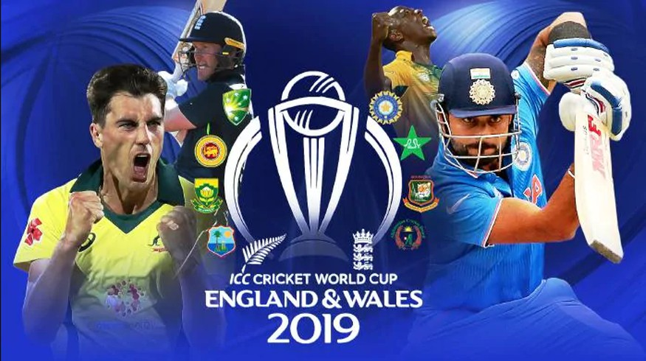

|  |  |
| --- | --- |
| TEAM1 |  |
| TEAM2 |  |
| RESULT |  |

**ICC WORLDCUP 2019**