EXPERIMENT-10
NAME: S Lakshan ROLLNO: 240701281
Create a data visualization (e.g., pie charts, bar graphs) for an Student Course Enrollment System using javascript

Aim:
The aim is to create data visualizations, such as pie charts and bar graphs, for an student course enrollment system using JavaScript.
Procedure:
- Create an HTML file (index.html) to design the webpage.
- Add two canvas elements to display bar chart and pie chart.
- Include the Chart.js library in the HTML file.
- Create a JavaScript file (app.js) to store data.
- Define data such as course names and number of students.
- Write code to generate bar chart and pie chart.

- Link the JavaScript file with the HTML file.
- Run the HTML file in a web browser.
Program:
- index.html:

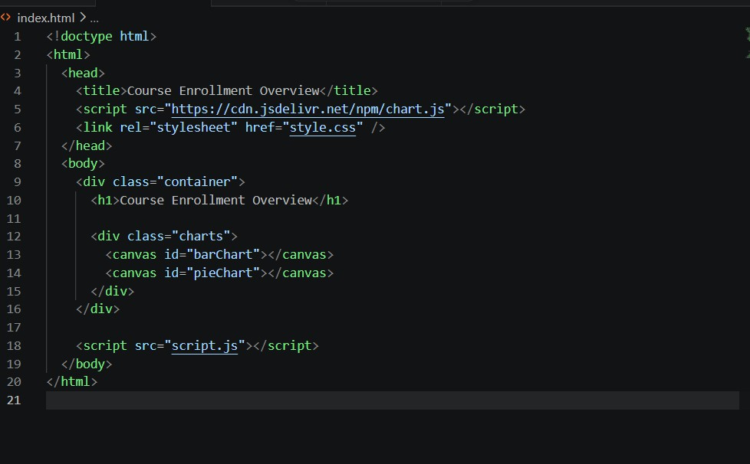

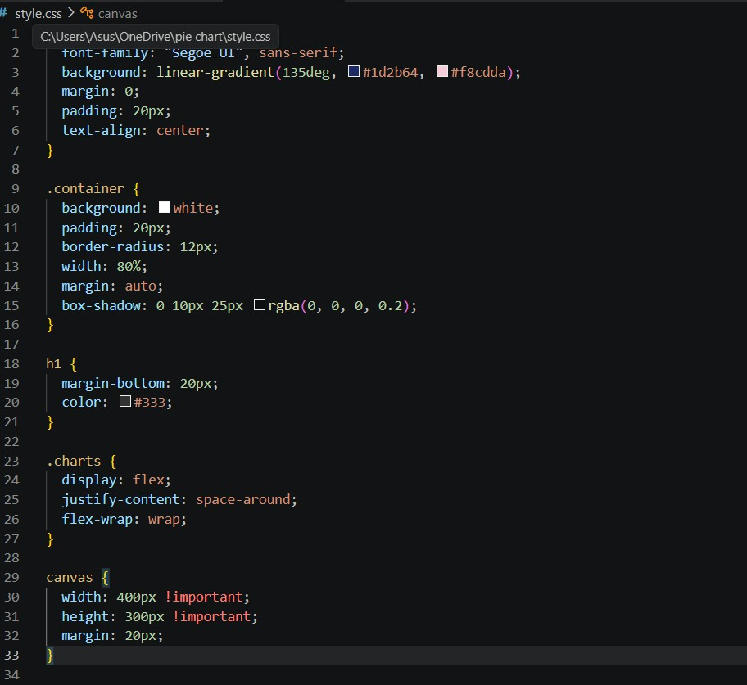
- app.js

- Script.js

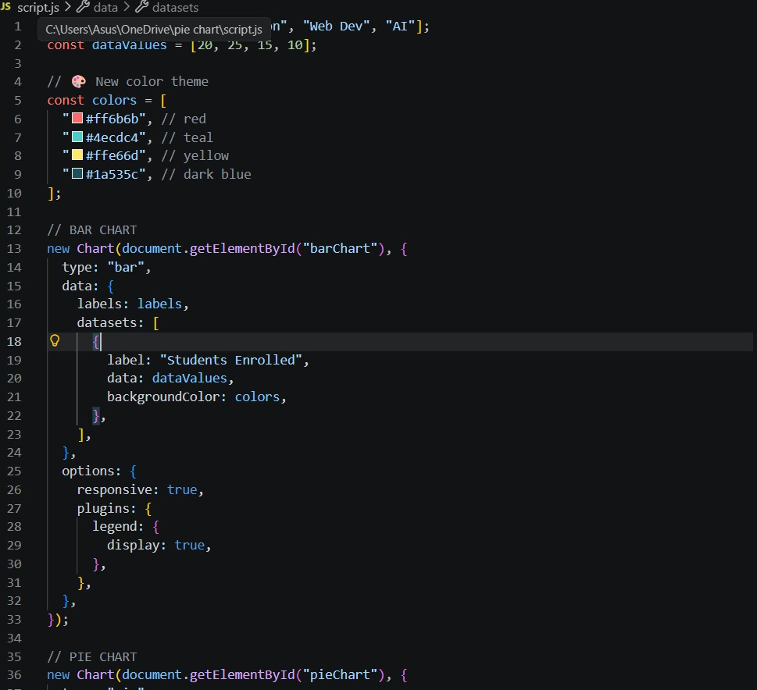
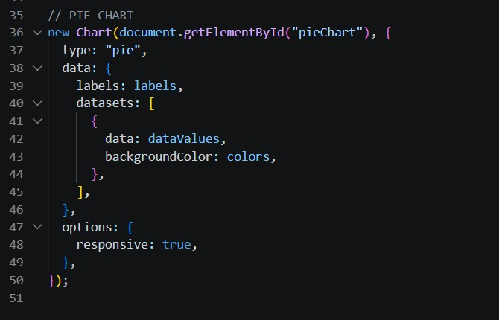

Output:

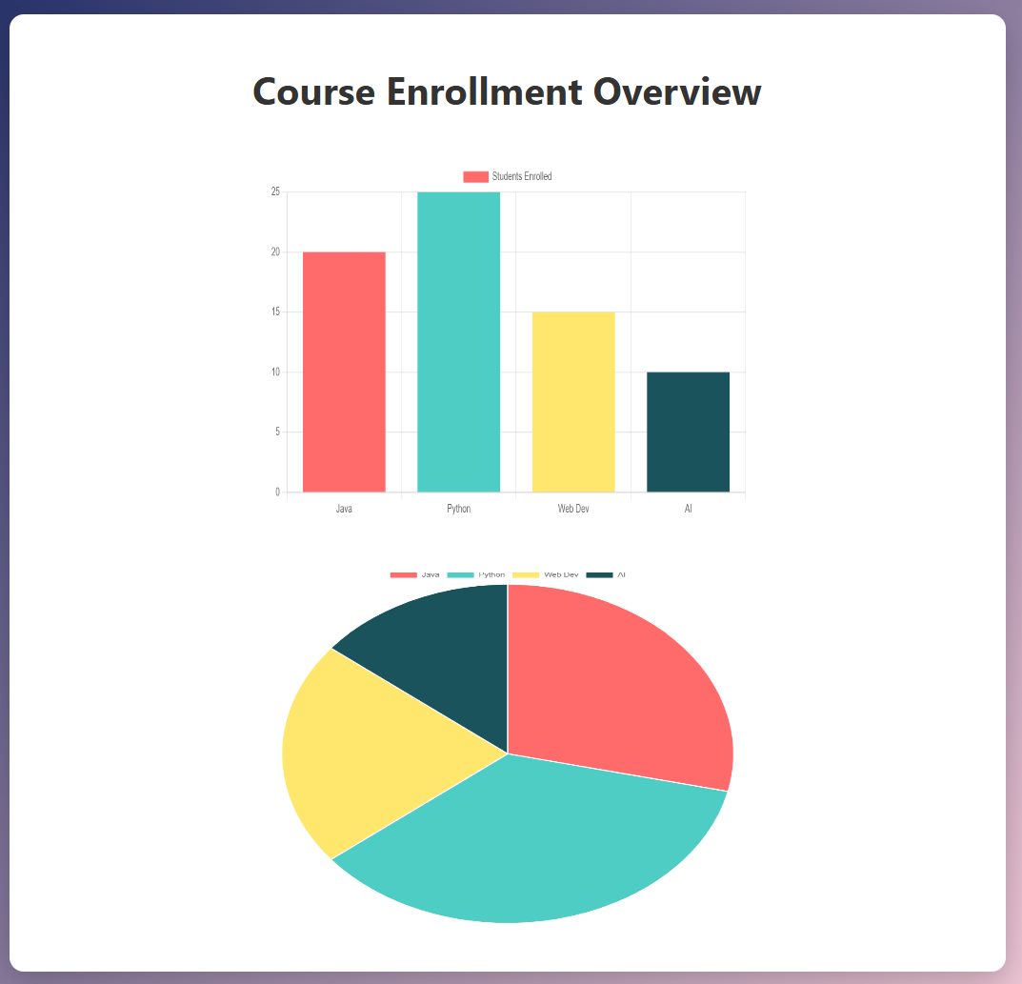
Result:
The course enrollment data is effectively visualized using bar and pie charts with a modern and colorful interface.

