KYCETRA-AI
Software Requirements Specification
RAG-Powered KYC & Fraud Investigation Copilot

Document field | Value
Version | 1.0 — Initial baseline
Date | 9 October 2026
Status | Proposed requirements baseline
Backend | Java 21 + Spring Boot 4.1.1 + Spring AI
Frontend | React + TypeScript
Data platform | PostgreSQL + pgvector
LLM | Google Gemini API; free tier for development subject to current quotas/terms
Build / runtime | Maven + Docker Compose
Audience | Project developer, reviewers, interviewers

Safety boundary: synthetic data only. This is a portfolio/educational decision-support prototype, not a production KYC decision engine.

Document control
Version | Date | Change | Status
1.0 | 2026-10-09 | Initial requirements, architecture, diagrams, and delivery plan | Baseline proposal
2.0 | 2026-10-09 | Phased scope; tenant/security roadmap; provider abstraction; governance, operations, integrations, and productization requirements | Revised proposal

Contents
- 1. Introduction
- 2. Product vision and scope
- 3. Stakeholders and user classes
- 4. Overall system description
- 5. Functional requirements
- 6. Non-functional requirements
- 7. Workflows and use-case diagram
- 8. Architecture and technical approach
- 9. Data model and class diagram
- 10. RAG design and Gemini integration
- 11. API requirements
- 12. Security, privacy, and responsible AI
- 13. Testing and acceptance criteria
- 14. Phase 0 — Six-week portfolio MVP implementation plan
- 15. Risks, assumptions, and decisions
- 16. Definition of done
- Appendix A — API examples

1. Introduction

1.1 Purpose
This SRS defines Kycetra-AI's phased requirements, architecture, domain model, security controls, acceptance criteria, and delivery roadmap. Version 2.0 separates a six-week portfolio MVP (Phase 0) from pilot-ready capabilities (Phase 1) and productization (Phase 2), so enterprise concerns are planned without making the first release unachievable.

1.2 Product summary
Kycetra-AI is a web application for compliance analysts to investigate synthetic KYC/identity-verification cases and consult policy documents through retrieval-augmented generation (RAG). It combines structured case data from PostgreSQL with passages retrieved from an indexed knowledge base. Gemini generates a response from supplied evidence; the interface displays citations and labels AI output as advisory.

1.3 Objectives
- Demonstrate strong Java/Spring Boot backend engineering and practical RAG implementation.
- Support case search, evidence review, policy Q&A, and traceable draft investigation reports.
- Evaluate retrieval and grounding quality with a repeatable dataset.
- Produce a reproducible GitHub portfolio project with documentation, tests, and diagrams.

1.4 Terms
Term | Meaning
KYC | Know Your Customer; identity verification and due diligence.
RAG | Retrieve relevant evidence and provide it to an LLM for grounded generation.
Embedding | Numeric text representation used for semantic similarity.
Chunk | A bounded passage indexed for retrieval.
RBAC | Role-Based Access Control.
PII | Personally identifiable information.
Citation | Reference to a source document/chunk supporting an answer.
Synthetic data | Artificial data that does not represent real customers.

2. Product vision and scope

2.1 Vision
Provide an evidence-first investigation workspace where an analyst can ask questions about a case, find relevant policy passages, and prepare a traceable report without treating the LLM as an authority or autonomous decision-maker.

2.2 In scope for MVP
- Authentication and authorization with analyst and administrator roles.
- CRUD, search, and filters for synthetic KYC cases, verification events, and transparent risk indicators.
- Upload policy/procedure documents in supported PDF, DOCX, or TXT formats.
- Text extraction, chunking, embeddings, vector storage, and hybrid retrieval.
- RAG questions combining authorized case facts and retrieved policy evidence.
- Answers with stable citations, evidence status, and abstention when evidence is insufficient.
- Draft investigation reports requiring human review and approval.
- Audit events for important user actions and AI investigation requests.
- Automated tests, RAG evaluation, Docker Compose, and setup documentation.

2.3 Out of scope
- Real identity documents, biometrics, liveness checks, or facial recognition.
- Production connections to banks, government identity systems, credit bureaus, or paid KYC providers.
- Automated account rejection, blacklisting, or final fraud determinations.
- Real customer PII, production secrets, or certified compliance claims.
- Multi-tenant enterprise hosting, high availability, microservices, Kafka, and Kubernetes for the MVP.
- Unrestricted LLM-generated SQL or autonomous web browsing.

2.4 Success measures
Measure | MVP target / method
Authentication | Protected endpoints reject missing/invalid credentials; role checks tested.
Case APIs | CRUD, filters, pagination, validation, and not-found cases covered by tests.
Retrieval | At least 50 labeled questions; report Recall@5.
Citations | Every policy-grounded answer has citations mapping to real retrieved chunks.
Grounding | Review at least 50 answers for supported claims and correct abstention.
Performance | Record median/p95 case-list latency and RAG stage latency on a documented environment.
Reproducibility | New developer can run the project from README and environment variables.

3. Stakeholders and user classes
Actor | Responsibilities | Permissions
Compliance Analyst | Review cases, ask questions, inspect evidence, prepare reports. | Access permitted cases; use RAG; create/edit drafts; view permitted audit context.
Administrator | Manage users/roles and knowledge documents; inspect ingestion and audit status. | Analyst actions plus user/role management and document administration.
Gemini API | Generate answers from evidence sent by backend. | No direct database access; receives only minimized context.
Developer / Maintainer | Build, test, configure, and troubleshoot. | Development access; secrets kept outside source control.

The MVP has two human roles. Do not add more roles until there is a concrete permission requirement. A user must not gain access by guessing a case ID.

4. Overall system description

4.1 Main capabilities
- Dashboard with stored case counts by status/risk band.
- Paginated case list with filters and a case-detail view.
- Verification events, rule-based risk indicators, notes, and related reports.
- Knowledge base document upload, metadata, ingestion status, and retry of failures.
- AI chat with citations, evidence status, and limitations.
- Draft report generation, analyst review/edit, and approval state.
- Admin tools for users, roles, documents, and audit events.

4.2 Technology baseline
Layer | Baseline
Java | Java 21 LTS
Backend | Spring Boot 4.1.1; choose a compatible stable release at setup.
API | Spring Web, Validation, Spring Security, OpenAPI.
AI | Spring AI with a Gemini integration supported by the chosen release.
Database | PostgreSQL + pgvector; Flyway migrations.
Persistence | Spring Data JPA plus JDBC/native SQL where vector operations need it.
Documents | Apache Tika for text extraction.
Frontend | React + TypeScript; Vite suitable for local development.
Build / runtime | Maven Wrapper and Docker Compose.
Secrets | Environment variables; no committed API keys/passwords.

4.3 Architecture
Use a modular monolith. Keep case management, identity/security, document ingestion, retrieval, chat orchestration, reporting, and audit logic in separate packages within one Spring Boot app. This is easier to build and test than microservices and appropriate for a portfolio-scale project.
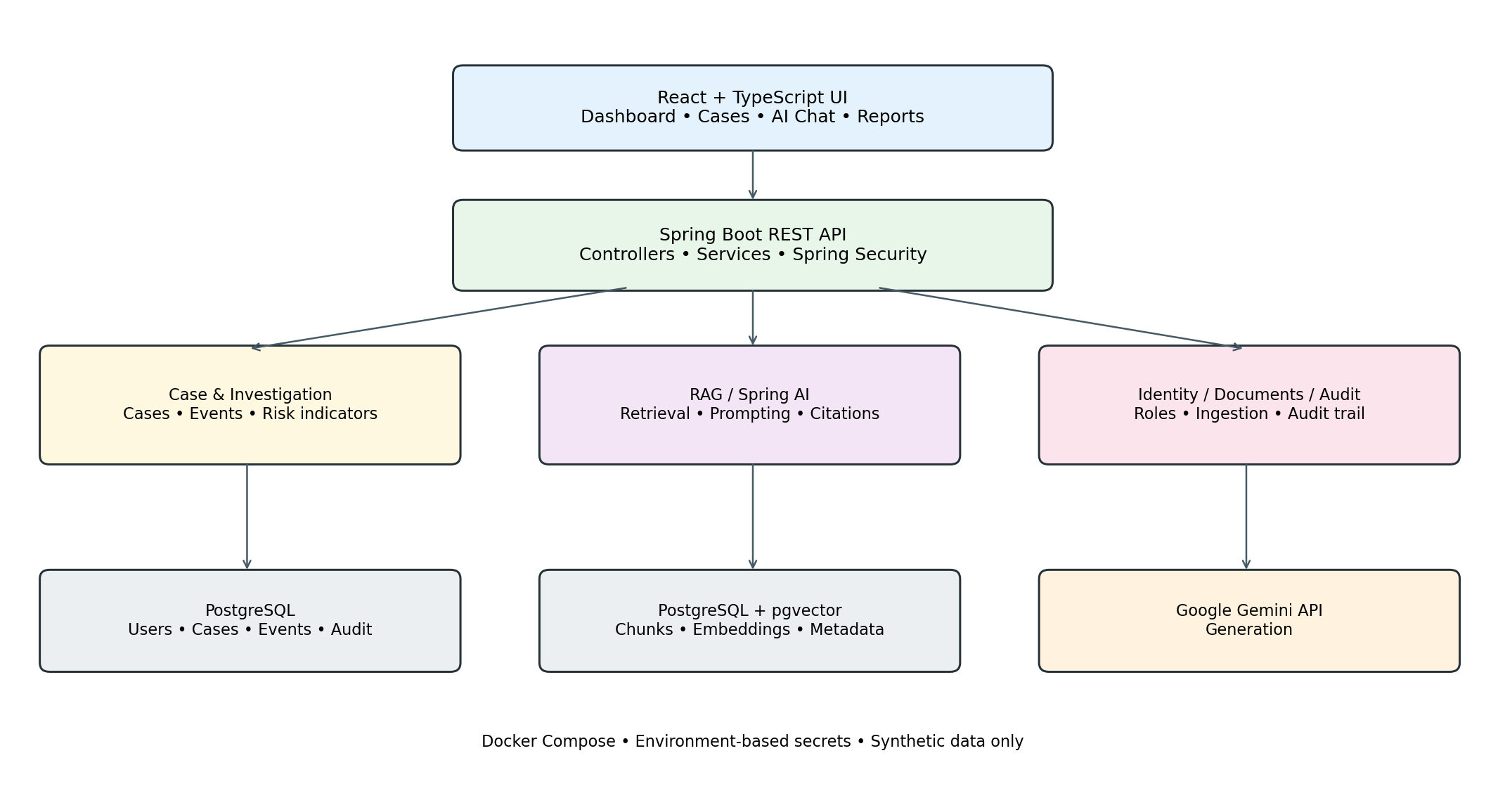
Figure 1. Proposed logical architecture.

5. Functional requirements
Priority: P0 = required for MVP; P1 = desirable if time permits; P2 = future enhancement. Requirement IDs should be referenced in implementation issues and tests.
ID | Pri. | Area | Requirement
FR-001 | P0 | Authentication | Registered users can log in and receive a short-lived token or secure session.
FR-002 | P0 | Authentication | Invalid login uses a generic error that does not reveal whether an email exists.
FR-003 | P0 | Authorization | Every protected API enforces permissions server-side, not only in the frontend.
FR-004 | P0 | Users | Admins can create/disable users and assign roles; passwords are adaptively hashed.
FR-005 | P0 | Cases | Authorized users can create cases with unique references and validated fields.
FR-006 | P0 | Cases | Authorized users can retrieve a case; nonexistent/inaccessible records do not leak data.
FR-007 | P0 | Cases | Users can list/filter/paginate by reference, status, risk, and date range.
FR-008 | P0 | Cases | Permitted case updates are validated and audited.
FR-009 | P0 | Events | Store timestamped verification events linked to a case.
FR-010 | P0 | Risk | Support explainable rule indicators such as repeated failed attempts/shared synthetic device IDs; signals are not proof of fraud.
FR-011 | P0 | Documents | Admins upload policy documents with title, source, jurisdiction, version, and optional effective date.
FR-012 | P0 | Ingestion | Validate files, extract text, chunk, embed, store, and record success/failure.
FR-013 | P0 | Ingestion | Deduplicate by content hash/version unless explicit reprocessing is requested.
FR-014 | P0 | Retrieval | Retrieve relevant chunks using vector and keyword search; combine/rerank where supported.
FR-015 | P0 | RAG | Authenticated users can ask questions with optional case context; backend assembles authorized evidence.
FR-016 | P0 | Citations | Answers include stable source/chunk references, document title, and page/section when available.
FR-017 | P0 | Abstention | If evidence is insufficient, the assistant says so rather than inventing a policy answer.
FR-018 | P0 | RAG safety | Retrieved document text is untrusted data; embedded instructions must not be followed.
FR-019 | P0 | Access control | Retrieval filters evidence according to the user's permissions before calling Gemini.
FR-020 | P0 | Gemini | Gemini is called server-side; the key is never exposed to the browser.
FR-021 | P0 | Resilience | Handle provider timeouts, rate limits, quota exhaustion, invalid output, and outages safely.
FR-022 | P0 | Reports | Generate a draft report with facts, indicators, citations, limitations, and next steps.
FR-023 | P0 | Reports | AI reports remain drafts until reviewed/approved by an authorized human.
FR-024 | P0 | Audit | Audit login, role changes, case changes, uploads, RAG requests, and report approvals.
FR-025 | P0 | Audit | Never log passwords, tokens, API keys, or unnecessary sensitive prompt content.
FR-026 | P0 | Frontend | Provide loading, empty, validation, success, and error states.
FR-027 | P0 | Evaluation | Include a repeatable RAG test set and retrieval/citation evaluation.
FR-028 | P0 | Operations | Local setup is documented; database schema uses versioned migrations.
FR-029 | P1 | History | Users can view prior questions/answers subject to access and retention policy.
FR-030 | P1 | Export | Export approved reports to PDF or Markdown.
FR-031 | P1 | Ingestion | Admins can retry failed ingestion and inspect safe error summaries.
FR-032 | P2 | Analytics | Visualize relationships between synthetic cases sharing identifiers.

6. Non-functional requirements
ID | Category | Requirement
NFR-001 | Security | All non-public APIs require authentication; server-side authorization is mandatory.
NFR-002 | Secrets | Gemini key, DB credentials, and signing secret are environment-configured and never committed.
NFR-003 | Transport | HTTPS in deployed environments; local HTTP only for development.
NFR-004 | Passwords | Use Spring Security BCrypt/Argon2; no plaintext or reversible password storage.
NFR-005 | Validation | Validate DTOs, file types/sizes, page limits, IDs, and query lengths; use parameterized queries.
NFR-006 | LLM safety | Treat output as untrusted; never execute generated SQL/code or render unsafe HTML.
NFR-007 | Privacy | Use synthetic data and send only the minimum context to Gemini; review current provider terms.
NFR-008 | Resilience | Case CRUD remains usable when Gemini is unavailable.
NFR-009 | Performance | Target local p95 <500 ms for ordinary case-list requests on a documented dataset/machine.
NFR-010 | RAG latency | Measure retrieval, model-call, and end-to-end latency separately.
NFR-011 | Maintainability | Use controller/service/repository boundaries, DTOs, centralized exceptions, externalized config.
NFR-012 | Testability | Business logic and authorization tests must not require a live Gemini call.
NFR-013 | Observability | Use structured logs/request IDs without credentials or full sensitive content.
NFR-014 | Accessibility | Labeled forms, keyboard navigation, visible focus, readable errors.
NFR-015 | Portability | Reproducible local setup on supported OS with Docker.
NFR-016 | Integrity | Use DB constraints, foreign keys, transactions, and migrations.
NFR-017 | Traceability | Citations resolve to stored source chunks accessible to the current user.
NFR-018 | Responsible use | AI output is advisory; risk signals are explainable and human-reviewed.

7. Workflows and use-case diagram

7.1 Primary workflow: investigate a case
- Analyst logs in and opens a case they are allowed to access.
- Backend loads case facts, events, and deterministic risk indicators from PostgreSQL.
- Analyst asks a question, optionally selecting the case as context.
- Backend checks access, retrieves permitted policy chunks, and assembles bounded context.
- Gemini returns a structured answer; backend validates citations against retrieved chunk IDs.
- UI shows answer, citations, evidence status, and limitations.
- Analyst may create a draft report; the action is audited.

7.2 Use-case diagram
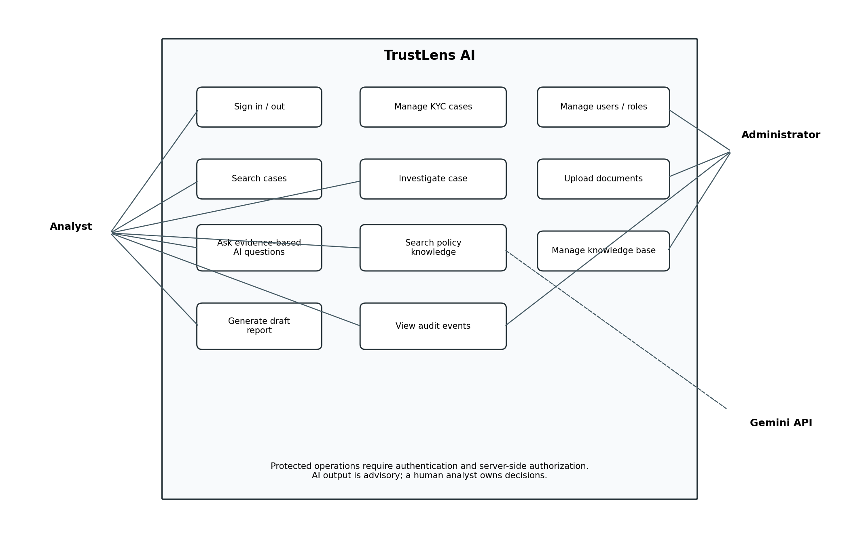
Figure 2. Use cases for analysts, administrators, and the Gemini service.

7.3 Use-case descriptions
Use case | Actor | Precondition | Outcome
UC-01 Sign in | Analyst/Admin | Enabled account exists. | Session/token issued or safe failure.
UC-02 Manage case | Analyst | Authenticated and authorized. | Case created/read/updated; action audited.
UC-03 Upload document | Admin | File meets upload policy. | Document indexed or safe failure status recorded.
UC-04 Ask AI | Analyst | Case/source access checked. | Cited answer or insufficient-evidence response.
UC-05 Generate report | Analyst | Case accessible and evidence available. | Draft report created with citations.
UC-06 Manage users | Admin | Admin role verified. | User/role change saved and audited.
UC-07 View audit | Admin | Admin role verified. | Audit records shown without secrets.

8. Architecture and technical approach

8.1 Package boundaries
Package | Responsibility | Guardrail
security | Login, token/session, password hashing, role checks. | No case/RAG business logic.
user | User entity and admin operations. | Never return password hashes.
casefile | Case CRUD, filters, status and event associations. | Do not use LLM as authoritative data source.
investigation | Deterministic indicators and investigation orchestration. | Signals are not a final fraud verdict.
knowledge | Upload, parsing, metadata, chunking, ingestion status. | Documents are untrusted input.
rag | Retrieval, context filtering, prompt, Gemini call, citations. | No bypass of access checks; no model-generated SQL execution.
report | Draft generation and human approval state. | No automatic approval.
audit | Append-only audit events. | No secrets or unnecessary PII.
common | Shared DTO conventions/errors/utilities. | Avoid unrelated code accumulation.

8.2 Dependency direction
Controllers call application services; services coordinate repositories and domain logic. RAG calls retrieval and a Gemini client abstraction. Controllers return DTOs rather than JPA entities. External provider calls are isolated so tests can use a fake/mock client.

8.3 Database migration rules
- Use Flyway; do not rely on Hibernate schema auto-update beyond disposable experiments.
- Enable pgvector and verify the extension during setup.
- Choose embedding dimensions to match the selected embedding model; model changes may require re-embedding all chunks.
- Use UUID IDs, UTC timestamps, foreign keys, indexes for case filters, and a unique content hash for deduplication.

9. Data model and class diagram

9.1 Core entities
Entity | Purpose | Key fields
User | Application account. | id, email, passwordHash, role, enabled, createdAt
KycCase | Synthetic verification case. | id, caseReference, status, riskLevel, summary, createdBy, timestamps
VerificationEvent | Event associated with a case. | id, caseId, eventType, eventTime, detailsJson
RiskIndicator | Transparent rule result. | id, caseId, ruleCode, severity, explanation, detectedAt
KnowledgeDocument | Source file and ingestion metadata. | id, title, jurisdiction, version, contentHash, status
DocumentChunk | Indexed text segment. | id, documentId, chunkIndex, content, embedding, pageOrSection, metadata
ChatInteraction | Question/answer metadata. | id, userId, optional caseId, question, answer, status, latency
Citation | Source reference for answer. | id, interactionId, chunkId, relevanceScore
InvestigationReport | Draft/approved report. | id, caseId, createdBy, status, content, approvedBy, approvedAt
AuditEvent | Trace of important actions. | id, actorUserId, action, resource, outcome, requestId, createdAt

9.2 Relationships and constraints
- One KycCase has many VerificationEvents and RiskIndicators.
- One KnowledgeDocument has many DocumentChunks; each chunk belongs to one document.
- One ChatInteraction may reference one case and has zero or more Citations.
- Each Citation references a persisted DocumentChunk; source deletion must not silently leave misleading citations.
- A case may have multiple reports; approved reports record approver and approval time.
- The MVP may store role as an enum; normalize roles/permissions later if requirements grow.
- Audit events are append-only through application behavior; ordinary users cannot edit/delete history.

9.3 Conceptual class diagram
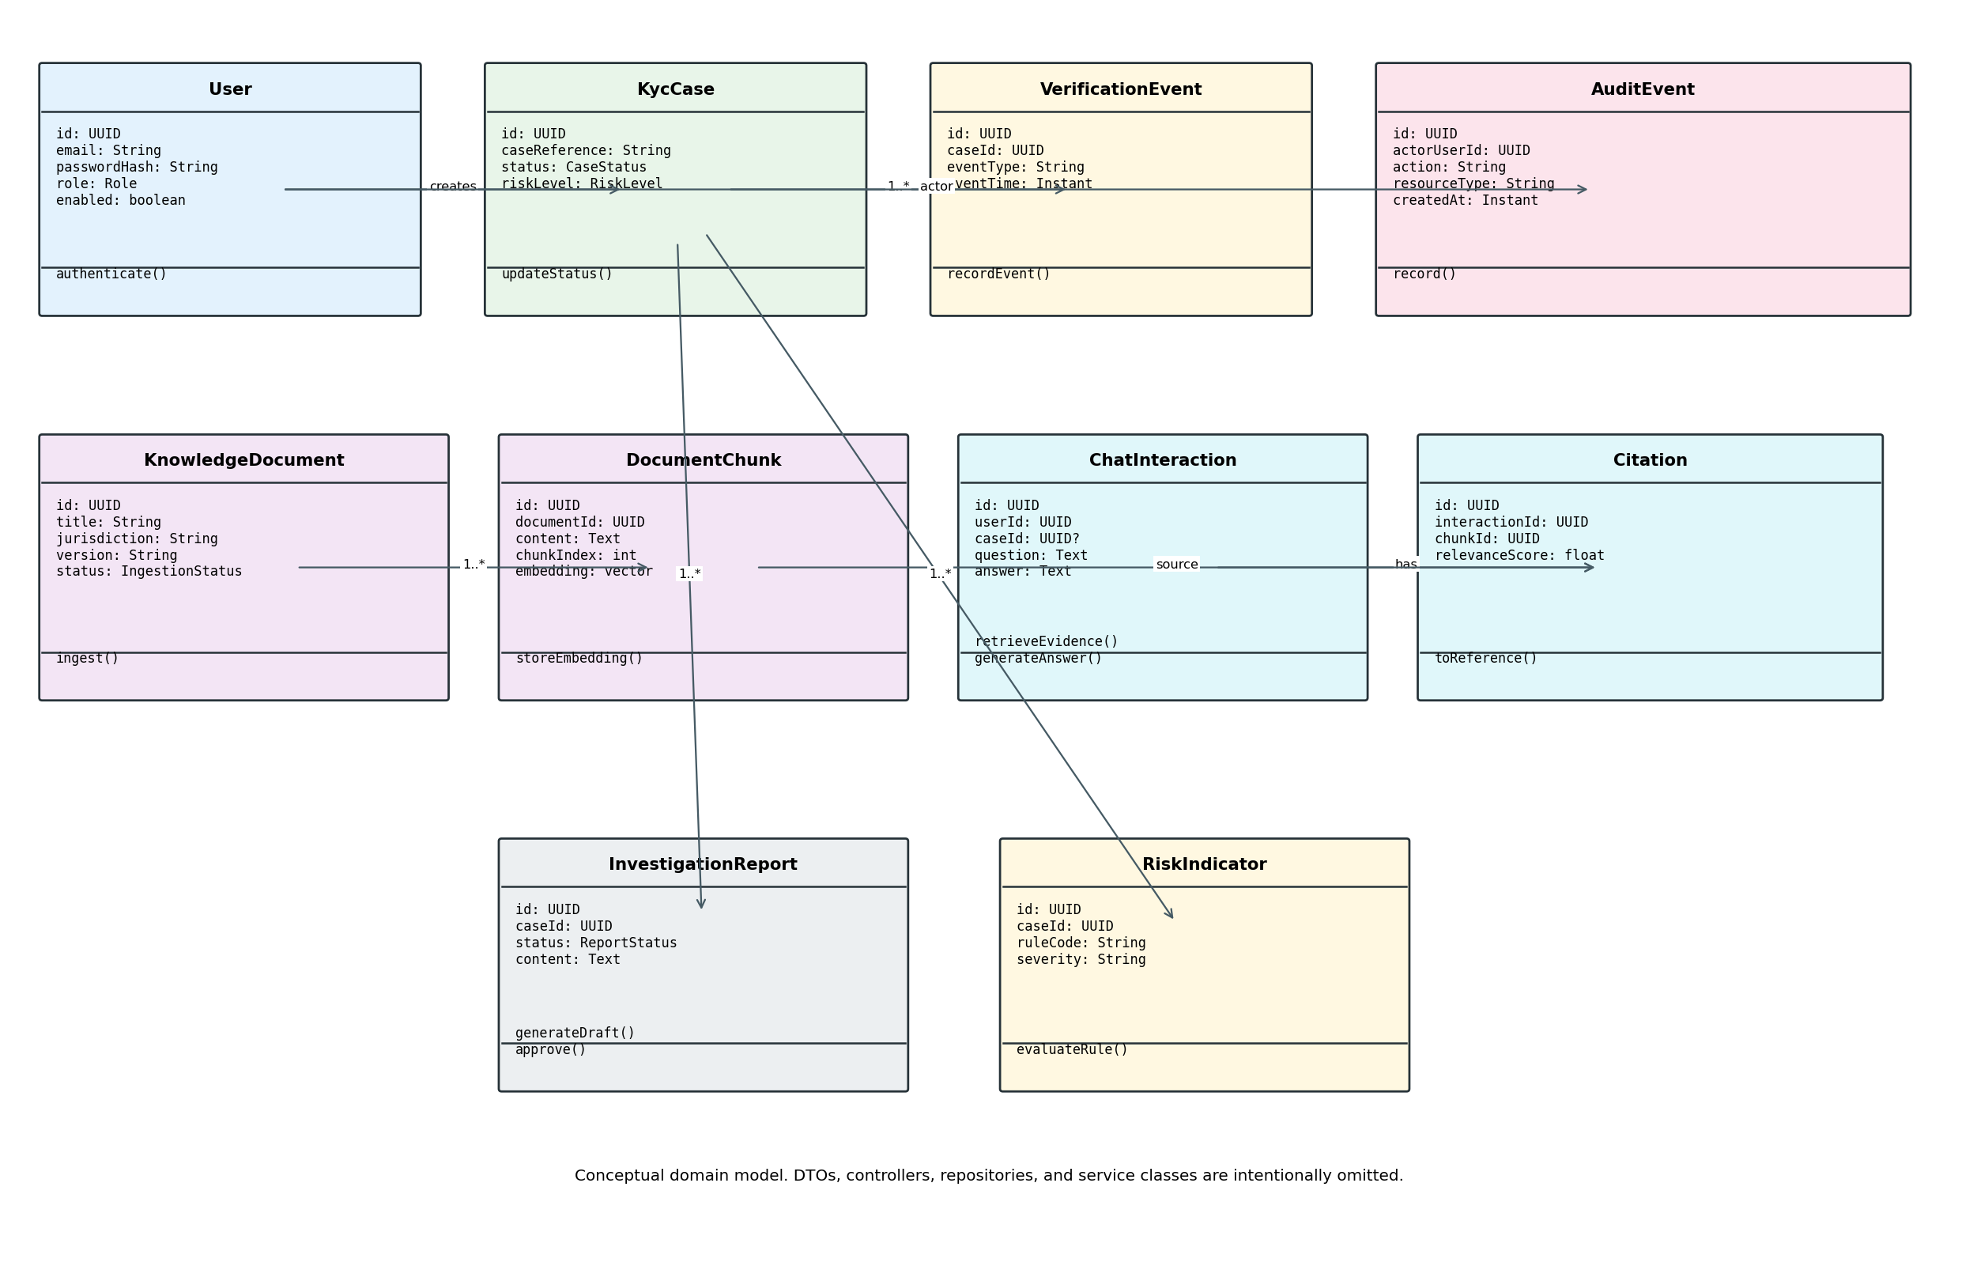
Figure 3. Conceptual domain entities; DTOs, controllers, repositories, and services are intentionally omitted.

9.4 Proposed service classes
Class | Responsibility
AuthService | Authenticate user and coordinate token/session issuance.
UserService | Admin-only user creation, disablement, and role changes.
CaseService | CRUD, filters, status updates, and per-case access checks.
InvestigationService | Compute/persist deterministic risk indicators.
DocumentIngestionService | Validate, extract, chunk, embed, persist, and track status.
RetrievalService | Apply authorization/metadata filters and retrieve/rerank chunks.
RagService | Orchestrate question, case context, retrieval, Gemini, citations, abstention.
GeminiClient | Abstraction around Spring AI Gemini integration.
CitationService | Map source IDs to persisted metadata and validate references.
ReportService | Build draft reports and enforce approval transitions.
AuditService | Record actions without sensitive secrets.

10. RAG design and Gemini integration

10.1 Document ingestion
- Validate file size, extension, MIME type, and content signature where feasible.
- Compute content hash and check for duplicate document/version.
- Extract text and metadata with Apache Tika; reject empty/unprocessable files clearly.
- Normalize text and chunk with overlap; preserve title, document ID, jurisdiction, version, chunk index, and page/section when available.
- Generate embeddings using a model supported by the selected Spring AI integration; confirm availability, dimension, and usage limits.
- Store chunks/vectors in PostgreSQL/pgvector and configure an appropriate vector index.
- Mark indexed only after all required chunks are saved; otherwise mark failed and permit safe retry.

10.2 Query-time RAG
- Authenticate user and validate question size and optional case ID.
- Verify access to the case and source documents before retrieval.
- Fetch bounded case facts/events using normal application services and parameterized SQL.
- Embed the query; retrieve candidates using vector similarity and keyword search with jurisdiction/version/access filters.
- Combine and rerank candidates if supported; cap retrieved chunks and total context size.
- Prompt Gemini with case facts and retrieved excerpts labeled as untrusted evidence; request citations and a structured output.
- Validate output and citation IDs. If references are invalid, use bounded repair logic or return a safe response.
- Return answer, citations, evidence status, limitations, and request ID; record latency/outcome.

10.3 Response contract
Field | Meaning
answer | Answer limited to evidence supplied.
evidenceStatus | SUPPORTED, PARTIAL, or INSUFFICIENT.
citations | Source IDs and source metadata.
limitations | Missing/conflicting evidence or uncertainty.
requestId | Trace ID for logs and support.

10.4 Gemini key, quotas, and resilience
- Create the key in Google AI Studio and store it as GEMINI_API_KEY in local environment configuration.
- Inject the key into Spring Boot/Docker Compose only. Never put it in React variables, frontend bundles, committed application.yml, screenshots, or logs.
- Keep model name and generation settings configurable. Verify the current Gemini model, Spring AI compatibility, free-tier quota, and data terms at implementation time.
- Handle 429/rate-limit, quota, timeout, and 5xx errors. Retry only retryable errors with bounded backoff.
- Use synthetic records only; review provider terms and obtain authorization before sending real or sensitive data.

10.5 RAG evaluation
Dimension | Method | Report
Retrieval | At least 50 labeled questions with expected source; Recall@5 and optionally MRR. | Versioned dataset and repeatable results.
Citation validity | Check cited IDs exist in retrieved chunks and resolve to source metadata. | Automated pass rate.
Grounding | Human review of claims against cited passages. | Score and representative failures.
Abstention | Ask unanswerable questions and check explicit uncertainty. | Pass rate.
Robustness | Conflicting versions, irrelevant chunks, injection, malformed output. | Test results and mitigations.
Latency | Measure embedding, retrieval, Gemini, and total duration. | Median/p95 in stated environment.

11. API requirements
Proposed routes use /api/v1. Payload details may be refined during implementation, but responsibilities and authorization expectations should remain stable.
Method / route | Purpose | Access
POST /api/v1/auth/login | Authenticate and issue token/session. | Public; rate-limited
POST /api/v1/auth/logout | Revoke token or clear session where supported. | Authenticated
GET /api/v1/users/me | Return safe profile and role. | Authenticated
GET /api/v1/cases | List/filter/paginate cases. | Analyst/Admin
POST /api/v1/cases | Create case. | Analyst/Admin
GET /api/v1/cases/{id} | Get authorized case details. | Authorized case user
PATCH /api/v1/cases/{id} | Update permitted fields/status. | Authorized case user
POST /api/v1/cases/{id}/events | Record verification event. | Authorized
POST /api/v1/documents | Upload and ingest document. | Admin
GET /api/v1/documents | List metadata and ingestion status. | Authorized
GET /api/v1/documents/{id} | Inspect metadata/status/chunks. | Authorized
POST /api/v1/ai/ask | Ask with optional case context. | Analyst/Admin
POST /api/v1/cases/{id}/reports | Create draft report. | Authorized case user
GET /api/v1/cases/{id}/reports | List reports. | Authorized case user
PATCH /api/v1/reports/{id}/approval | Approve reviewed report. | Authorized reviewer
GET /api/v1/admin/audit-events | Search audit events. | Admin
GET /actuator/health | Health check with sensitive details disabled. | Public or restricted by deployment

11.1 Error convention
Use a consistent JSON error object such as {timestamp, status, code, message, path, requestId, fieldErrors}. Never return stack traces, SQL details, keys, or raw provider payloads. Suggested statuses: 400 validation, 401 unauthenticated, 403 forbidden, 404 absent/inaccessible, 409 conflict, 413 oversized upload, 429 throttled, and 502/503 controlled provider failure.

11.2 Initial DTO examples
Login request: { email, password }. Response returns only token/session metadata and safe user profile.
AI request: { question, caseId?, jurisdiction? }. The backend validates case access and never trusts client-supplied case facts.
AI response: { answer, evidenceStatus, citations: [{sourceId, documentTitle, section}], limitations, requestId }.

12. Security, privacy, and responsible AI

12.1 Authentication and authorization
- Use Spring Security and BCrypt/Argon2 password hashing; no custom cryptography.
- If JWT is selected, validate signature, expiration, issuer/audience where configured, and allowed algorithm; keep signing key out of source control.
- Enforce roles on endpoints/services and check per-case access before returning data or assembling RAG context.
- Use generic login errors, login rate limits, and disabled-account checks.

12.2 File safety
- Allowlist file types, cap size, reject unsafe filenames/path traversal, and store uploads outside executable/static web roots.
- Treat extracted text as untrusted; never execute macros, scripts, or embedded instructions.
- Track ingestion state and define whether originals are retained or deleted.

12.3 LLM threat controls
- Prompt injection: label document excerpts as reference data and test malicious passages.
- Data leakage: authorize before retrieval, minimize context, and never send other users' private data.
- Hallucination: citations, evidence status, constrained response schema, and abstention tests.
- Overreliance: reports remain drafts until a human reviews them.
- Output safety: escape generated content; do not inject raw model HTML.
- Cost/abuse: question limits, context caps, rate limits, timeouts, and quota-aware behavior.

12.4 Audit and privacy
Record actor, action, time, resource, request ID, and outcome without retaining full prompts or document contents by default. Store only metadata needed for debugging and evaluation. Define a retention period for demo chat/audit data. Do not use real identity documents or customer records.

12.5 Limitations
This is a decision-support prototype. Risk indicators and generated summaries can be incomplete or wrong. It must not be represented as a certified KYC solution, legal advice, production fraud classifier, or autonomous adjudication system.

13. Testing and acceptance criteria

13.1 Test layers
Layer | Approach | Examples
Unit | JUnit 5 + Mockito | Case rules, access decisions, prompt assembly, citation mapping, abstention.
Integration | Spring Boot tests + Testcontainers PostgreSQL/pgvector where practical | Migrations, constraints, filters, vector persistence.
API/security | MockMvc or WebTestClient | 401/403, invalid DTOs, cross-case access, upload restrictions.
RAG contract | Mock Gemini client | Timeouts, malformed output, missing citation, quota errors, bounded retries.
RAG evaluation | Curated question set/script | Recall@5, citation validity, supported claims, unanswerable questions.
Frontend | Component/integration tests as time allows | Login, loading/error states, citations, report approval.
End-to-end | Docker Compose smoke test | Login → case → document → question → citations → draft report.

13.2 MVP acceptance checklist
- ☐ A clean checkout starts using documented prerequisites and environment variables.
- ☐ Flyway migrations create the schema and pgvector is enabled.
- ☐ Login works; unauthenticated requests fail; analyst/admin permissions are tested.
- ☐ Analyst can create/search synthetic cases and inspect events.
- ☐ Admin can upload a document and inspect ingestion status and indexed chunks.
- ☐ RAG returns a Gemini answer with citations mapping to actual retrieved chunks.
- ☐ Unanswerable questions trigger an insufficiency response.
- ☐ Users cannot retrieve unauthorized case facts or document chunks.
- ☐ Prompt injection does not bypass access control or trigger external actions.
- ☐ Draft reports require authorized human approval.
- ☐ Audit events are recorded without credential/key leakage.
- ☐ Tests pass and a repeatable RAG evaluation report is committed.

14. Phase 0 — Six-week portfolio MVP implementation plan
Each week ends with a working increment, a short review, and a demonstrable exit gate. Week 1 explicitly covers setup, Gemini connectivity, and authentication.

Week 1 — Foundation, Gemini connection, and authentication
- Create repository, README, Maven Spring Boot project, and React + TypeScript scaffold.
- Set up Java 21, compatible Spring Boot/Spring AI dependencies, environment config, and Docker Compose PostgreSQL/pgvector.
- Add Flyway and initial user/role migration; verify backend/database connectivity.
- Configure Gemini API key locally and implement a backend-only smoke-test service/endpoint; never expose key to browser.
- Implement password hashing, Spring Security, login, role checks, and /users/me. Decide JWT versus secure session and document lifecycle.
- Add global exception handling, OpenAPI, health check, .gitignore, and secret-handling checklist.
- Test login success/failure, 401/403, and mocked Gemini timeout/quota errors.
- Deliverable: runnable skeleton, protected endpoint, authentication, Gemini smoke test, and setup documentation.

Week 2 — Case management and data model
- Finalize entities, DTOs, enums, constraints, indexes, and Flyway migrations for cases, events, risk indicators, and audit.
- Implement create/read/update/list APIs with pagination and filters.
- Add validation, centralized errors, per-case access checks, and audit for case changes.
- Create synthetic seed data and test through Swagger/integration tests.
- Build basic React login, case list, detail, and create forms.
- Deliverable: usable case-management slice with automated tests.

Week 3 — Knowledge document ingestion
- Implement upload validation and size/type limits.
- Integrate Apache Tika; store metadata and content hash.
- Implement chunking, overlap, metadata preservation, ingestion status, and safe retry.
- Integrate an embedding model supported by chosen Spring AI release; verify dimension and availability.
- Enable pgvector, persist embeddings, and add keyword retrieval baseline.
- Build admin upload/list/status UI and ingestion tests.
- Deliverable: document upload → parse → chunk → embed → store → inspect.

Week 4 — RAG retrieval and Gemini answers
- Implement hybrid retrieval, metadata filters, candidate ranking/reranking where supported, and context limits.
- Create RAG endpoint and structured Gemini response contract.
- Return stable citations and handle insufficient evidence.
- Add injection documents, cross-user/case access tests, provider timeouts, and quota-aware errors.
- Build chat UI with answer, citations, evidence status, and limitations.
- Deliverable: end-to-end policy Q&A with citations.

Week 5 — Investigation logic and reports
- Implement transparent risk indicators for synthetic event patterns; document each rule's limits.
- Combine case context and policy retrieval in the investigation workflow.
- Generate draft reports with facts, indicators, cited policy evidence, limitations, and next steps.
- Implement report review/approval states and audit events.
- Add dashboard summaries and case/report navigation.
- Deliverable: case investigation and reviewable draft report workflow.

Week 6 — Evaluation, hardening, and release
- Label at least 50 evaluation questions, including answerable, unanswerable, conflicting-version, and injection cases.
- Report Recall@5, citation validity, grounding review, abstention performance, and latency.
- Run unit/integration/security tests; use Testcontainers where practical; fix high-priority defects.
- Review access control, secrets, file handling, logging, rate limits, prompt construction, and data minimization.
- Finish Docker Compose, README, diagrams, screenshots, and demo script.
- Deliverable: reproducible demo, test report, evaluation results, and portfolio-ready repository.

14.1 Weekly exit gates
Week | Exit gate
1 | App boots; DB connects; Gemini smoke test works; auth/roles pass; no secret committed.
2 | Case CRUD/filtering works; migrations and authorization tests pass.
3 | A supported document is indexed end-to-end and its chunks/vectors can be inspected.
4 | RAG answers include valid citations; abstention and prompt-injection tests run.
5 | Case investigation and draft report work with human review.
6 | Evaluation is repeatable; critical security tests pass; clean setup is reproducible.

15. Risks, assumptions, and decisions

15.1 Risks and mitigations
Risk | Impact | Mitigation
Gemini quota/model changes | Throttling or unavailable model. | Externalize model config; mock provider in tests; verify current model and quotas.
Embedding setup differs from generation | Retrieval may require a separate model/configuration. | Treat embeddings separately; verify Spring AI support and dimensions; version model and reindex when changed.
Weak retrieval | Plausible but incorrect answers. | Hybrid retrieval, metadata filters, citations, abstention, evaluation, human review.
Prompt injection | Model follows hostile document text. | Treat chunks as untrusted; enforce access/tools in backend; adversarial tests.
Scope creep | Six-week plan slips. | Prioritize P0; defer history, exports, and graph visualization.
PII enters demo | Privacy exposure. | Synthetic data only; clear upload guidance; minimize provider context.
Diagrams drift | Documentation diverges from code. | Treat diagrams as living docs and update after model changes.

15.2 Assumptions
- Portfolio/learning system, not production compliance software.
- Primarily one developer working in weekly increments.
- Gemini API availability and free-tier eligibility depend on current Google terms and quotas.
- Docker is available for local PostgreSQL/pgvector or a compatible local installation is used.
- Only synthetic records and suitable public/sample policies are used.
- Spring Boot/Spring AI versions and model integration details are verified at implementation time.

15.3 Decisions to lock
Decision | Baseline | Reason
Architecture | Modular monolith | Simpler for a solo portfolio project.
Backend | Java 21 + Spring Boot 4.1.1 | User-selected stack.
Build | Maven | Common, straightforward Java build tool.
Database | PostgreSQL + pgvector | Relational data and vectors together.
AI framework | Spring AI | Spring-native model/vector integrations.
LLM | Gemini API | Free-tier development option subject to current terms.
Auth | Spring Security; JWT or secure session decided Week 1 | Use a proven framework; document lifecycle.
Embeddings | Choose after verifying model and Spring AI support | Dimensions and provider limits must match.
Retrieval | Hybrid retrieval + citation validation + abstention | Improves evidence retrieval and traceability.
Reports | Human approval required | Avoid autonomous high-impact decisions.

16. Definition of done
- ☐ Requirements and acceptance behavior are clear.
- ☐ Inputs are validated and server-side authorization is enforced.
- ☐ Unit tests cover business logic; integration/API tests cover important flows.
- ☐ Errors do not leak stack traces, secrets, or internal provider payloads.
- ☐ Logging/audit is useful without unnecessary sensitive data.
- ☐ README/API documentation is updated and manual smoke test completed.
- ☐ AI features have repeatable evaluation or a documented test set and limitations.
- ☐ Changes are committed clearly; no secrets, real PII, or local environment files are committed.

Appendix A — Initial API examples

A.1 Case creation request
{
"caseReference": "TL-CASE-0001",
"status": "UNDER_REVIEW",
"summary": "Synthetic verification attempt requires manual review",
"jurisdiction": "US"
}

A.2 AI question request
{
"question": "Which policy requirements are relevant to this review?",
"caseId": "00000000-0000-0000-0000-000000000001",
"jurisdiction": "US"
}

A.3 AI response
{
"answer": "The retrieved policy requires the analyst to review ...",
"evidenceStatus": "SUPPORTED",
"citations": [{
"sourceId": "chunk-uuid",
"documentTitle": "Synthetic KYC Review Procedure",
"section": "Manual review"
}],
"limitations": [],
"requestId": "request-uuid"
}
Project build metadata: groupId = com.lakshan; artifactId = kycetra-ai; Spring Boot = 4.1.1; Java = 21.
Repository root: Kycetra-AI/ with separate backend/ and frontend/ folders.

A.4 Proposed repository layout
Kycetra-AI/
├── backend/ # Spring Boot 4.1.1, Java 21, Maven
│ ├── pom.xml # groupId: com.lakshan; artifactId: kycetra-ai
│ └── src/
│ ├── main/java/com/lakshan/
│ │ ├── config/ security/ user/ casefile/ investigation/
│ │ ├── knowledge/ rag/ report/ audit/ common/
│ ├── main/resources/db/migration/
│ └── test/java/com/lakshan/
├── frontend/ # React + TypeScript
│ └── src/ api/ components/ features/ pages/ routes/
├── evaluation/questions.jsonl
├── docs/Kycetra-AI_SRS.docx
├── docs/diagrams/
├── docker-compose.yml
├── .env.example
├── .gitignore
└── README.md

17. Version 2.0 — Phased scalability and product roadmap
This section extends the original SRS. Phase 0 remains a bounded portfolio project using synthetic data. Phase 1 and Phase 2 are roadmap requirements and must not be advertised as implemented until built and tested.

17.1 Delivery phases and release gates
Phase | Target | Purpose and exit gate
Phase 0 — Portfolio MVP | 6 weeks | Secure Spring Boot RAG workflow using synthetic cases, policy ingestion, citations, case investigation, draft reports, repeatable evaluation, and local deployment. Exit when the end-to-end demo, authorization/citation tests, evaluation report, and setup guide pass.
Phase 1 — Pilot-ready | Additional 6–8 weeks | Tenant isolation, OIDC/SAML planning or pilot SSO, CSV/REST ingestion, PII safeguards, async ingestion, finer-grained authorization, observability, retention/deletion and backup/restore runbooks. Exit when isolation, retrieval, recovery, and pilot-readiness tests pass.
Phase 2 — Productization | 8+ weeks, based on partner feedback | Provider adapters, deployment options, tamper-evident audit, evaluation release gates, usage controls, supervisor QA, ROI metrics, security documentation, and validated integrations. Exit when capabilities are tested and customer workflows are demonstrated.

These estimates are planning assumptions. Reprioritize after user interviews and design-partner feedback.

17.2 Phase 0 scope guardrails
- Keep the modular monolith; do not split the MVP into microservices.
- Use synthetic data only. Do not claim production compliance, certification, or production readiness.
- Gemini is the first working LLM adapter. Keep configuration externalized; do not delay the end-to-end flow for multiple providers.
- Use a single-tenant development deployment, but avoid hard-coded assumptions that prevent adding tenant context later. This is not equivalent to production tenant isolation.
- Make entity linking a simple core capability: link synthetic cases that share synthetic identifiers and show the reason for each relationship. Defer advanced graph visualization.
- Defer SSO/SCIM, live vendor integrations, commercial billing, full tenant administration, Helm/Kubernetes, and a production queue from Phase 0.

17.3 Additional functional requirements
Priority convention for this section: P0 = Phase 0; P1 = Phase 1 pilot-ready; P2 = Phase 2 productization.
ID | Priority | Area | Requirement
FR-033 | P1 | Multi-tenancy | Add tenantId to all tenant-owned records, including cases, events, risk indicators, documents, chunks/embeddings, interactions, citations, reports, audit records, and ingestion jobs. Derive tenant context from authenticated membership, never trust a client-supplied tenantId.
FR-034 | P1 | Isolation | Scope every read/write, vector search, background job, citation lookup, export, and delete operation by tenant. Use PostgreSQL Row-Level Security (RLS) as defense in depth, with safe tenant context setup/reset.
FR-035 | P1 | Isolation tests | Prove tenant A cannot enumerate, read, alter, export, cite, or infer tenant B's records or chunks through automated negative tests.
FR-036 | P2 | Provider abstraction | Define application-owned LLM and embedding interfaces/adapters. Gemini is first; Azure OpenAI, Bedrock, Vertex AI, and local Ollama/vLLM are candidates only after API, model, dimensions, terms, and cost are verified.
FR-037 | P2 | Model governance | Record provider/model/version where available, prompt-template version, embedding model/version, retrieval configuration/version, latency, outcome, and token/usage metadata where available.
FR-038 | P1 | Async ingestion | Use persisted ingestion jobs with status, idempotency, bounded retries, safe failure summaries, and a separately deployable worker. Start with a PostgreSQL-backed queue; add a broker only if measurements justify it.
FR-039 | P1 | Data entry | Provide validated CSV import and documented REST APIs with row-level errors, idempotency, authorization, and audit events.
FR-040 | P2 | Integrations | Create optional adapters for KYC vendors, sanctions/watchlist sources, and ticketing systems. Do not enable an integration before API access, licensing, jurisdiction, security, and data-processing terms are reviewed.
FR-041 | P1 | PII governance | Minimize/redact sensitive data before model calls; document source-file retention; support tenant-specific retention/deletion for records, files, chunks, vectors, and chat history where applicable.
FR-042 | P2 | Identity | Support enterprise OIDC or SAML SSO; SCIM provisioning is a later enhancement. Retain a controlled local development/break-glass option if needed.
FR-043 | P1 | Authorization | Add teams, queues, assignments, and per-document ACLs only as required by pilots. Apply jurisdiction and ACL filters before retrieval and citation generation.
FR-044 | P2 | Dual control | Support configurable independent review for selected reports, recording reviewer, decision, rationale, and timestamp.
FR-045 | P1/P2 | Audit integrity | Restrict audit update/delete paths in Phase 1. In Phase 2, add tamper-evident chaining or an independently protected sink and automated integrity verification.
FR-046 | P1 | Observability | Capture request IDs and stage timings for ingestion, embeddings, retrieval, model calls, citation validation, and report generation without logging secrets or full sensitive content by default.
FR-047 | P2 | Usage/cost | Track estimated tokens, model/embedding calls, and storage/retrieval usage per tenant where available; add quotas and rate limits before paid access.
FR-048 | P1 | Triage | Add an alert/exception queue with status, priority, owner, and reason for consistent analyst review.
FR-049 | P2 | Jurisdiction templates | Support versioned report templates per configured jurisdiction; label generated content advisory, not legal advice or a final decision.
FR-050 | P2 | Supervisor QA | Provide review of sampled AI interactions/reports, including citations, evidence status, model/prompt/retrieval versions, and reviewer feedback.
FR-051 | P2 | ROI | Measure observed time-to-first-draft, review time where available, case throughput, and citation correction rate. Do not promise savings without evidence.
FR-052 | P2 | Deployment | Document hardened self-hosting and evaluate managed SaaS only after isolation, backup/restore, monitoring, support, and governance are validated.

17.4 Additional non-functional requirements
ID | Priority | Requirement
NFR-019 | P1 | Enforce tenant isolation in application and database layers. Vector similarity must never bypass tenant, jurisdiction, or document ACL filters.
NFR-020 | P1 | Document encryption in transit and responsibilities for encryption at rest across database, files/object storage, backups, and secrets.
NFR-021 | P1 | Define retention/deletion behavior for source files, extracted text, chunks, embeddings, chat, exports, and backups where technically possible.
NFR-022 | P1 | Document sandbox/production separation and data handling. No real customer data until provider terms, authorization, retention, and controls are approved.
NFR-023 | P1 | Async ingestion must be idempotent, observable, retry-bounded, and recover safely after worker restart.
NFR-024 | P2 | Run versioned retrieval, citation, grounding, and security evaluations in CI; critical regressions should block release.
NFR-025 | P2 | Maintain a roadmap mapped to SOC 2 / ISO 27001 control themes without claiming certification or compliance before assessment.
NFR-026 | P2 | Provide usage indicators and quotas before commercial billing.
NFR-027 | P1 | Document and test backup/restore for relational records, source metadata, vectors, and audit data.
NFR-028 | P2 | Use OpenTelemetry-compatible tracing/metrics where practical; redact sensitive fields and document retention.
NFR-029 | P2 | Document regional deployment and data-residency options and limitations before accepting jurisdiction-bound customers.

17.5 Architecture and data-model decisions
- Retain the modular monolith through Phase 0 and initially through Phase 1. Separate the ingestion worker as a deployable process when async ingestion arrives, while sharing domain modules.
- Keep PostgreSQL + pgvector as the default store. Apply tenant/ACL metadata filters and appropriate indexes; consider a separate vector database only after measured load tests justify it.
- Include tenantId in tenant-owned tables, relevant unique constraints/indexes, background jobs, audit context, and every retrieval query in Phase 1.
- Keep provider-specific SDKs behind application-owned interfaces and normalize outputs to an internal response schema.
- Record model, prompt, retrieval, and embedding versions. Re-embedding may be required when embedding models or dimensions change.
- Start with a PostgreSQL-backed queue for ingestion. Add Kafka or another broker only when throughput or fan-out requirements demonstrate a need.
- RLS is defense in depth, not a replacement for service-level authorization and tenant-scoped queries.
Entity / concept | Phase | Additions / notes
Tenant | P1 | id, name, status, region, retention policy; tenant context comes from authenticated membership.
User / TenantMembership | P1 | Represent tenant membership and role; allow one user to belong to multiple tenants if product needs require it.
Tenant-owned entities | P1 | Add tenantId to KycCase, VerificationEvent, RiskIndicator, KnowledgeDocument, DocumentChunk, ChatInteraction, Citation, InvestigationReport, AuditEvent, and IngestionJob.
KnowledgeDocument / DocumentChunk | P1/P2 | Track ACL/jurisdiction, content hash, ingestion status, embedding provider/model/version, chunking version, and deletion state as required.
IngestionJob | P1 | tenant, source, idempotency key, state, attempts, safe error summary, timestamps, and worker lease/heartbeat if needed.
ModelInvocationMetadata | P2 | provider/model, prompt version, retrieval config, timing, usage, evidence status, and outcome.
Team / CaseAssignment / DocumentAccessRule | P1 | Add only where pilot permissions require them; enforce filters before retrieval.
ReviewDecision / UsageRecord / EvaluationRun / PromptTemplate | P2 | Support dual review, usage estimates, versioned evaluations, prompt versioning, and release-gate results.

17.6 External integration policy
- Phase 0: use synthetic data and mock adapters; no live KYC, sanctions, or ticketing connections.
- Phase 1: prioritize stable REST APIs and CSV import. Webhooks require authentication/signatures, replay protection, idempotency, and audit records.
- Phase 2 candidates include Sumsub/Onfido, OpenSanctions, and Jira/ServiceNow. These are examples, not committed dependencies; verify current API, product terms, licenses, and data-processing requirements before implementation.
- Keep credentials in a secret manager or deployment environment, never in source control or browser code.

17.7 Security and governance release gates
Gate | Evidence required
Phase 0 exit | Synthetic-only use; auth/access tests; citations resolve to retrieved chunk IDs; safe provider error handling; no committed secrets; prompt-injection tests documented.
Phase 1 pilot entry | Tenant isolation/RLS and vector-filter tests; PII minimization; retention/deletion runbook; backup/restore test; audit policy; data-flow diagram; approved provider terms.
Phase 2 commercial evaluation | Provider conformance tests; versioned evaluation CI gate; audit integrity verification; usage/quota controls; hardened deployment and incident runbooks; threat model/security-control mapping.

Free-tier model access is for development with synthetic data only after checking current provider quotas and terms. Do not send real customer or regulated data to a provider until its data-use, retention, regional processing, and contractual terms have been reviewed and approved.

17.8 Product discovery and commercial hypotheses
- Choose one initial segment and jurisdiction for discovery instead of claiming broad support for every KYC/AML workflow.
- Seek one or two design partners for structured feedback. A free pilot still needs written scope, approved data boundaries, success criteria, and an exit/deletion plan.
- Per-analyst-seat and per-case pricing are hypotheses to validate, not settled pricing.
- Measure time to first draft, reviewer corrections, citation quality, and case throughput against a baseline; describe outcomes as observed pilot metrics.
- Check name/trademark availability for Kycetra-AI before public release.
- Use suitable public regulator guidance and synthetic AML/KYC datasets; verify dataset licenses and suitability before redistribution or commercial use.

17.9 Revised roadmap checklist
- Phase 0 is done only when the original MVP acceptance checklist and six-week exit gates pass.
- Phase 1 is done only when cross-tenant negative tests, RLS behavior, deletion/retention checks, ingestion recovery, and pilot documentation pass.
- Phase 2 is done only when provider adapters, model/prompt/retrieval versioning, evaluation release gates, usage controls, deployment guidance, and tamper-evident audit checks are demonstrated.
- Do not advertise future-phase integrations, certifications, ROI, or production readiness until implemented and supported by evidence.

