AI POWERED STUDENT PORTAL
1. Project Explanation & System Architecture
1.1 Executive Summary & Overview
The AI-Powered Student Portal is an intelligent, full-stack educational assistant designed to streamline student services, eliminate administrative friction, and provide instant, accurate answers to campus inquiries. Built on modern web standards utilizing React 18, Vite, Tailwind CSS v4, and Lucide React icons, the application integrates a client-side Natural Language Processing (NLP) intent recognition engine with dynamic interactive UI widgets.
Traditional university portals rely on static FAQ pages and complex navigation menus where students often struggle to locate time-sensitive information regarding fee breakdowns, examination schedules, mess menus, or official certificate procedures. The FAQ Assistant bridges this gap by offering a natural conversational interface paired with actionable, interactive micro-applications (widgets) directly inside the response stream.
1.2 Problem Statement & Core Objectives
Higher education institutions process thousands of recurring student queries every semester. The key challenges addressed by this project include:
- Queue Reduction: High administrative overload on university helpdesks for routine repetitive queries.
- Transparent Fee Breakdown: Complex tuition fee formulas involving course variations, state/merit quotas, and academic scholarship tiers.
- Digitized Application Workflows: Manual paper-based applications for bonafide certificates, conduct certificates, and transcripts.
- Real-Time Campus Services: Frequent changes to hostel mess menus, meal ratings, and daily student attendance management.
- Placement Transparency: Instant visual feedback for academic placement statistics, top recruiting companies, and salary packages.
1.3 Technical Architecture & Component Hierarchy
The application follows a modular React component architecture powered by a unidirectional data flow and an isolated NLP utility pipeline. The key components include:
- 1. App Container (App.jsx): Serves as the root orchestrator, managing global conversation history, category filters, theme mode (Dark/Light), TTS audio toggles, and modal states.
- 2. NLP Engine (nlpEngine.js): A zero-dependency JavaScript tokenization and fuzzy-matching engine that ingests raw user queries, cleans stop-words, normalizes synonyms, applies Levenshtein distance calculations, and yields high-confidence FAQs and associated widget components.
- 3. Header Navbar (Navbar.jsx): Displays the top navigation bar with quick category filters (Academics, Fees, Hostel, Placements, Certificates), search trigger, and theme switches.
- 4. Control Sidebar (Sidebar.jsx): Provides quick-action prompt buttons, sample queries, clear chat utility, and category quick-switches.
- 5. Chat Host & Input (ChatContainer.jsx & ChatInput.jsx): Renders chat message streams with markdown rendering, typing indicator, follow-up prompt chips, and dynamic widget injection.
- 6. Interactive Widgets Suite: Embedded interactive UI modules embedded in bot responses for real-time calculation, form submissions, and data visualization.
- 7. Knowledge Base Modal (KnowledgeBaseModal.jsx): A full-screen modal indexing the entire FAQ knowledge base with keyword search and direct question insertion.
1.4 Technology Stack & Framework Specifications
Layer / Dependency | Technology / Package | Functional Purpose
Frontend UI Library | React 18.3.1 | Declarative component layout, state management & reactive UI hooks
Build Tooling & Server | Vite 5.4.10 | Next-gen lightning-fast HMR dev server and production bundling
Styling Framework | Tailwind CSS v4.3.3 | Utility-first modern CSS framework with glassmorphism & responsive layouts
Iconography | Lucide React 1.47.0 | Clean, modern visual iconography for dashboard widgets & navigation
Special Effects | Canvas Confetti 1.9.4 | Celebratory visual animations upon successful certificate submission
NLP & Matching Engine | Custom JS Engine | Levenshtein fuzzy matching, synonym mapping, tokenization & scoring
Accessibility / Audio | Web Speech Synthesis API | Native browser text-to-speech audio playback for bot responses
Automated Testing & Captures | Puppeteer 25.12.0 | Headless browser scripting for end-to-end user path screenshot generation

2. Core Project Code Snippets
This section presents key implementation source code snippets from the core architectural modules of the project, including state orchestration, natural language parsing, and interactive widget implementations.
📄 Snippet: App.jsx (Main Application Root)
// src/App.jsx - Main Application State & NLP Routing Controller
import React, { useState, useEffect } from 'react';
import Navbar from './components/Navbar';
import Sidebar from './components/Sidebar';
import ChatContainer from './components/ChatContainer';
import ChatInput from './components/ChatInput';
import KnowledgeBaseModal from './components/KnowledgeBaseModal';
import { matchQuery } from './nlp/nlpEngine';
export default function App() {
const [messages, setMessages] = useState([
{
id: 'welcome-1',
sender: 'bot',
text: 'Hello! 👋 Welcome to the ** College FAQ Assistant**.\n\nHow can I assist you today?',
timestamp: new Date().toLocaleTimeString([], { hour: '2-digit', minute: '2-digit' }),
followups: ['What are the library timings?', 'How can I apply for a bonafide certificate?', 'When are the semester exams?']
}
]);
const [selectedCategory, setSelectedCategory] = useState('all');
const [isTyping, setIsTyping] = useState(false);
const [ttsEnabled, setTtsEnabled] = useState(false);
const [isDark, setIsDark] = useState(true);
const handleSendMessage = (userText) => {
const timestamp = new Date().toLocaleTimeString([], { hour: '2-digit', minute: '2-digit' });
const userMsg = { id: 'user-' + Date.now(), sender: 'user', text: userText, timestamp };
setMessages((prev) => [...prev, userMsg]);
setIsTyping(true);
setTimeout(() => {
const matchResult = matchQuery(userText, selectedCategory);
const botMsg = {
id: 'bot-' + Date.now(),
sender: 'bot',
text: matchResult.type === 'fallback' ? matchResult.answer : matchResult.faq.answer,
widget: matchResult.widget,
followups: matchResult.followups || matchResult.suggestions,
timestamp: new Date().toLocaleTimeString([], { hour: '2-digit', minute: '2-digit' })
};
setMessages((prev) => [...prev, botMsg]);
setIsTyping(false);
}, 600);
};
return (
<div className="min-h-screen flex flex-col bg-slate-950 text-slate-100">
<Navbar selectedCategory={selectedCategory} onSelectCategory={setSelectedCategory} isDark={isDark} onToggleTheme={() => setIsDark(!isDark)} />
<main className="flex-1 max-w-7xl w-full mx-auto p-4 flex gap-6">
<Sidebar selectedCategory={selectedCategory} onSelectCategory={setSelectedCategory} onSelectSamplePrompt={handleSendMessage} />
<div className="flex-1 flex flex-col">
<ChatContainer messages={messages} isTyping={isTyping} onSelectFollowup={handleSendMessage} />
<ChatInput onSendMessage={handleSendMessage} isTyping={isTyping} />
</div>
</main>
</div>
);
}

📄 Snippet: nlpEngine.js (NLP & Fuzzy Matching Engine)
// src/nlp/nlpEngine.js - Natural Language Processing & Intent Matching Engine
import { FAQ_DATABASE } from '../data/faqKnowledgeBase';
const STOP_WORDS = new Set(['a', 'an', 'the', 'and', 'or', 'is', 'are', 'in', 'at', 'how', 'what', 'when', 'where', 'can', 'i', 'get', 'give', 'show', 'tell']);
const SYNONYM_MAP = {
'exam': 'examination', 'midsem': 'semester exam', 'dorm': 'hostel',
'food': 'mess menu', 'money': 'fee', 'cost': 'fee', 'job': 'placement',
'package': 'placement stats', 'schedule': 'timetable', 'bonafide': 'bonafide certificate'
};
function levenshteinDistance(a, b) {
const matrix = Array.from({ length: b.length + 1 }, (_, i) => [i]);
for (let j = 0; j <= a.length; j++) matrix[0][j] = j;
for (let i = 1; i <= b.length; i++) {
for (let j = 1; j <= a.length; j++) {
matrix[i][j] = b[i - 1] === a[j - 1] ? matrix[i - 1][j - 1] : Math.min(matrix[i - 1][j - 1] + 1, matrix[i][j - 1] + 1, matrix[i - 1][j] + 1);
}
}
return matrix[b.length][a.length];
}
export function tokenize(text) {
if (!text) return [];
const rawTokens = text.toLowerCase().replace(/[^a-z0-9\s]/g, ' ').split(/\s+/).filter(Boolean);
return rawTokens.filter(t => !STOP_WORDS.has(t)).map(t => SYNONYM_MAP[t] || t);
}
export function matchQuery(queryText, categoryFilter = 'all') {
const queryTokens = tokenize(queryText);
let bestMatch = null;
let highestScore = 0;
for (const faq of FAQ_DATABASE) {
if (categoryFilter !== 'all' && faq.category !== categoryFilter) continue;
let score = 0;
if (queryText.toLowerCase().trim() === faq.question.toLowerCase().trim()) score += 10.0;
for (const qToken of queryTokens) {
if (faq.question.toLowerCase().includes(qToken)) score += 1.5;
for (const kw of faq.keywords) {
if (kw.toLowerCase().includes(qToken)) score += 2.0;
const sim = 1 - levenshteinDistance(qToken, kw.toLowerCase()) / Math.max(qToken.length, kw.length);
if (sim >= 0.78) score += sim * 1.5;
}
}
const confidence = Math.min(1.0, score / 6.0);
if (score > highestScore) {
highestScore = score;
bestMatch = { faq, confidence };
}
}
if (bestMatch && bestMatch.confidence >= 0.4) {
return { type: 'success', confidence: bestMatch.confidence, faq: bestMatch.faq, widget: bestMatch.faq.widget, followups: bestMatch.faq.followups };
}
return { type: 'fallback', confidence: 0, answer: "I couldn't find an exact match. Here are suggested topics:", suggestions: ['What are library timings?', 'When are semester exams?'] };
}

📄 Snippet: FeeCalculatorWidget.jsx (Interactive Fee Estimator)
// src/components/widgets/FeeCalculatorWidget.jsx - Interactive Fee & Scholarship Estimator
import React, { useState } from 'react';
import { Calculator, Award, ArrowRight, ShieldCheck } from 'lucide-react';
export default function FeeCalculatorWidget() {
const [course, setCourse] = useState('B.Tech CSE');
const [quota, setQuota] = useState('Merit');
const [isHosteller, setIsHosteller] = useState(true);
const [cgpa, setCgpa] = useState(8.8);
const BASE_TUITION = { 'B.Tech CSE': 75000, 'B.Tech ECE': 68000, 'B.Tech ME': 60000, 'MBA': 85000 };
const QUOTA_MULTIPLIER = { Merit: 1.0, 'Govt State': 0.75, Management: 1.35 };
const tuitionFee = Math.round((BASE_TUITION[course] || 75000) * (QUOTA_MULTIPLIER[quota] || 1.0));
const examFee = 3500;
const hostelFee = isHosteller ? 42000 : 0;
let scholarshipPercent = 0;
if (cgpa >= 9.5) scholarshipPercent = 50;
else if (cgpa >= 9.0) scholarshipPercent = 30;
else if (cgpa >= 8.5) scholarshipPercent = 15;
const scholarshipDiscount = Math.round((tuitionFee * scholarshipPercent) / 100);
const totalPayable = tuitionFee + examFee + hostelFee - scholarshipDiscount;
return (
<div className="mt-3 p-4 rounded-xl bg-slate-900 border border-emerald-500/30 text-slate-100">
<div className="flex items-center justify-between pb-3 border-b border-slate-700">
<h4 className="font-semibold text-sm flex items-center gap-2">
<Calculator className="w-5 h-5 text-emerald-400" /> Interactive Fee Estimator
</h4>
</div>
<div className="grid grid-cols-3 gap-3 my-3">
<select value={course} onChange={(e) => setCourse(e.target.value)} className="bg-slate-800 text-xs p-2 rounded">
<option value="B.Tech CSE">B.Tech CSE</option>
<option value="B.Tech ECE">B.Tech ECE</option>
<option value="MBA">MBA Management</option>
</select>
<select value={quota} onChange={(e) => setQuota(e.target.value)} className="bg-slate-800 text-xs p-2 rounded">
<option value="Merit">Merit Quota</option>
<option value="Management">Management Quota</option>
</select>
<button onClick={() => setIsHosteller(!isHosteller)} className="bg-slate-800 text-xs p-2 rounded text-emerald-300">
{isHosteller ? 'Include Hostel (₹42,000)' : 'Day Scholar'}
</button>
</div>
<div className="p-2.5 rounded bg-slate-800/60 my-2 text-xs">
<span>CGPA Score: <strong className="text-emerald-400">{cgpa}</strong> ({scholarshipPercent}% Waiver)</span>
<input type="range" min="6.0" max="10.0" step="0.1" value={cgpa} onChange={(e) => setCgpa(parseFloat(e.target.value))} className="w-full mt-1 accent-emerald-400" />
</div>
<div className="p-3 bg-slate-950 rounded text-xs space-y-1">
<div className="flex justify-between"><span>Base Tuition:</span><span>₹{tuitionFee.toLocaleString()}</span></div>
{scholarshipDiscount > 0 && <div className="flex justify-between text-emerald-400"><span>Scholarship Concession:</span><span>- ₹{scholarshipDiscount.toLocaleString()}</span></div>}
<div className="pt-2 border-t font-bold flex justify-between text-emerald-300 text-sm">
<span>Net Semester Dues:</span><span className="text-emerald-400">₹{totalPayable.toLocaleString()}</span>
</div>
</div>
</div>
);
}

📄 Snippet: CertificateRequestWidget.jsx (Bonafide Application Portal)
// src/components/widgets/CertificateRequestWidget.jsx - Bonafide & Transcript Request Portal
import React, { useState } from 'react';
import { FileCheck, Send, CheckCircle2 } from 'lucide-react';
import confetti from 'canvas-confetti';
export default function CertificateRequestWidget() {
const [certType, setCertType] = useState('Bonafide Certificate');
const [purpose, setPurpose] = useState('Bank Education Loan');
const [rollNo, setRollNo] = useState('2023CSE1042');
const [submitted, setSubmitted] = useState(false);
const [refId, setRefId] = useState('');
const handleSubmit = (e) => {
e.preventDefault();
const newRef = 'CERT-' + Math.floor(100000 + Math.random() * 900000);
setRefId(newRef);
setSubmitted(true);
confetti({ particleCount: 70, spread: 60, origin: { y: 0.7 } });
};
return (
<div className="mt-3 p-4 rounded-xl bg-slate-900 border border-blue-500/30 text-slate-100">
<h4 className="font-semibold text-sm flex items-center gap-2 mb-3">
<FileCheck className="w-5 h-5 text-blue-400" /> Online Certificate Application
</h4>
{!submitted ? (
<form onSubmit={handleSubmit} className="space-y-3 text-xs">
<div>
<label className="block text-slate-400 mb-1">Certificate Type</label>
<select value={certType} onChange={(e) => setCertType(e.target.value)} className="w-full bg-slate-800 p-2 rounded border border-slate-700">
<option value="Bonafide Certificate">Bonafide Certificate</option>
<option value="Conduct Certificate">Conduct & Character Certificate</option>
<option value="Official Transcript">Official Mark Transcripts</option>
</select>
</div>
<div>
<label className="block text-slate-400 mb-1">Roll Number</label>
<input type="text" value={rollNo} onChange={(e) => setRollNo(e.target.value)} className="w-full bg-slate-800 p-2 rounded border border-slate-700" />
</div>
<button type="submit" className="w-full bg-blue-600 hover:bg-blue-500 font-semibold p-2 rounded flex items-center justify-center gap-2">
Submit Certificate Application <Send className="w-4 h-4" />
</button>
</form>
) : (
<div className="p-3 bg-blue-950/60 rounded text-center text-xs space-y-2">
<CheckCircle2 className="w-8 h-8 text-blue-400 mx-auto" />
<h5 className="font-bold text-sm text-blue-200">Application Submitted Successfully!</h5>
<p className="text-slate-300">Reference Tracking ID: <strong className="text-blue-400">{refId}</strong></p>
</div>
)}
</div>
);
}

📄 Snippet: ExamScheduleWidget.jsx (Examination Schedule Viewer)
// src/components/widgets/ExamScheduleWidget.jsx - Examination Schedule Viewer
import React, { useState } from 'react';
import { Calendar, Clock, MapPin, Search } from 'lucide-react';
export default function ExamScheduleWidget() {
const [dept, setDept] = useState('CSE');
const EXAM_DATA = [
{ code: 'CS401', title: 'Artificial Intelligence & Machine Learning', date: '15 Oct 2026', time: '10:00 AM - 01:00 PM', hall: 'Exam Block B - Room 302' },
{ code: 'CS402', title: 'Database Management Systems & SQL', date: '18 Oct 2026', time: '10:00 AM - 01:00 PM', hall: 'Main Auditorium Hall A' }
];
return (
<div className="mt-3 p-4 rounded-xl bg-slate-900 border border-purple-500/30 text-slate-100">
<div className="flex justify-between items-center mb-3">
<h4 className="font-semibold text-sm flex items-center gap-2"><Calendar className="w-5 h-5 text-purple-400" /> Semester Exam Schedule</h4>
</div>
<div className="space-y-2">
{EXAM_DATA.map((exam, idx) => (
<div key={idx} className="p-3 rounded-lg bg-slate-800/80 border border-slate-700 text-xs">
<div className="flex justify-between font-bold text-purple-300">
<span>{exam.code} - {exam.title}</span>
<span className="text-slate-400">{exam.date}</span>
</div>
<div className="flex gap-4 mt-2 text-slate-300">
<span className="flex items-center gap-1"><Clock className="w-3.5 h-3.5 text-purple-400" /> {exam.time}</span>
<span className="flex items-center gap-1"><MapPin className="w-3.5 h-3.5 text-purple-400" /> {exam.hall}</span>
</div>
</div>
))}
</div>
</div>
);
}

📄 Snippet: HostelMessWidget.jsx (Hostel Mess & Rating Widget)
// src/components/widgets/HostelMessWidget.jsx - Hostel Mess Menu & Feedback Widget
import React, { useState } from 'react';
import { Utensils, Star, ThumbsUp } from 'lucide-react';
export default function HostelMessWidget() {
const [activeDay, setActiveDay] = useState('Today');
const [rating, setRating] = useState(4);
const [feedbackSent, setFeedbackSent] = useState(false);
const MENU = {
Breakfast: 'Idli, Sambar, Coconut Chutney, Poori Masala, Tea/Coffee',
Lunch: 'Veg Biryani, Paneer Butter Masala, Chapati, Curd Rice, Salad',
Dinner: 'Phulka Roti, Dal Tadka, Mixed Veg Curry, Milk & Sweet'
};
return (
<div className="mt-3 p-4 rounded-xl bg-slate-900 border border-amber-500/30 text-slate-100">
<h4 className="font-semibold text-sm flex items-center gap-2 mb-3">
<Utensils className="w-5 h-5 text-amber-400" /> Daily Hostel Mess Menu & Meal Tracker
</h4>
<div className="grid grid-cols-3 gap-2 mb-3 text-xs">
{Object.entries(MENU).map(([meal, items]) => (
<div key={meal} className="p-2.5 rounded-lg bg-slate-800 border border-slate-700">
<h5 className="font-bold text-amber-300 mb-1">{meal}</h5>
<p className="text-[11px] text-slate-300 leading-snug">{items}</p>
</div>
))}
</div>
<div className="p-2.5 rounded-lg bg-slate-800/80 flex items-center justify-between text-xs">
<span className="text-slate-300">Rate Today's Meal Quality:</span>
<div className="flex gap-1 text-amber-400 cursor-pointer">
{[1, 2, 3, 4, 5].map((star) => (
<Star key={star} className={`w-4 h-4 ${star <= rating ? 'fill-amber-400' : 'text-slate-600'}`} onClick={() => setRating(star)} />
))}
</div>
</div>
</div>
);
}

📄 Snippet: PlacementStatsWidget.jsx (Placement Statistics Dashboard)
// src/components/widgets/PlacementStatsWidget.jsx - Placement Statistics Dashboard
import React from 'react';
import { TrendingUp, Award, Building2, Briefcase } from 'lucide-react';
export default function PlacementStatsWidget() {
const TOP_RECRUITERS = ['Google', 'Microsoft', 'Amazon', 'TCS Digital', 'Infosys', 'Accenture'];
return (
<div className="mt-3 p-4 rounded-xl bg-slate-900 border border-indigo-500/30 text-slate-100">
<h4 className="font-semibold text-sm flex items-center gap-2 mb-3">
<TrendingUp className="w-5 h-5 text-indigo-400" /> Campus Placement Highlights (2025-26 Batch)
</h4>
<div className="grid grid-cols-3 gap-3 mb-3 text-center">
<div className="p-3 bg-indigo-950/60 rounded-lg border border-indigo-500/20">
<span className="text-xs text-slate-400">Highest Salary Package</span>
<p className="text-lg font-bold text-indigo-300">44.5 LPA</p>
</div>
<div className="p-3 bg-indigo-950/60 rounded-lg border border-indigo-500/20">
<span className="text-xs text-slate-400">Average Salary Package</span>
<p className="text-lg font-bold text-indigo-300">8.2 LPA</p>
</div>
<div className="p-3 bg-indigo-950/60 rounded-lg border border-indigo-500/20">
<span className="text-xs text-slate-400">Overall Placement %</span>
<p className="text-lg font-bold text-emerald-400">94.8%</p>
</div>
</div>
<div className="text-xs text-slate-300">
<span className="font-semibold block mb-1">Top Recruiters This Season:</span>
<div className="flex flex-wrap gap-1.5">
{TOP_RECRUITERS.map((company, i) => (
<span key={i} className="px-2 py-0.5 rounded bg-slate-800 border border-slate-700 text-indigo-200">{company}</span>
))}
</div>
</div>
</div>
);
}

3. System Screenshots & Visual Output Showcase
3.1 Main Assistant Dashboard & Welcome Interface
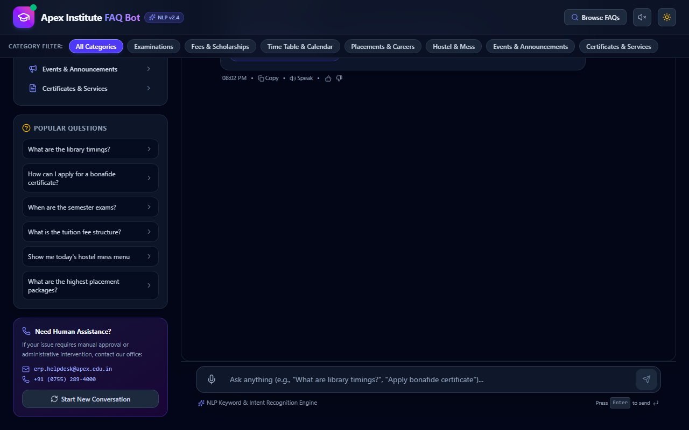
Figure 1: FAQ Assistant - Main Welcome Interface & Dark Theme Layout
Figure 1 demonstrates the initial landing interface of the application in dark mode. The navbar features the college branding ,category filter pills (Academics, Fees, Hostel, Placements, Certificates), search button for the Knowledge Base, Text-to-Speech audio toggle, and Dark/Light theme switch. The central conversational view displays a clean welcome greeting from the assistant, detailing its capabilities and presenting interactive follow-up prompt chips for immediate engagement.
3.2 Interactive Fee Breakdown & Scholarship Estimator
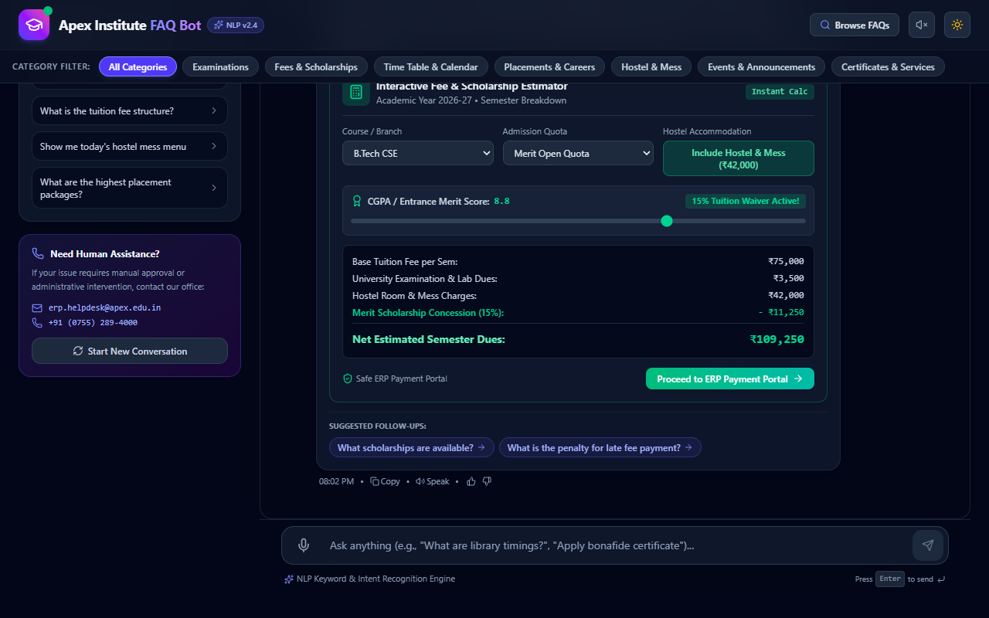
Figure 2: Fee Calculator Widget rendering semester dues, scholarship waivers, and payment CTA
3.3 Student Certificate Application & Tracking Portal
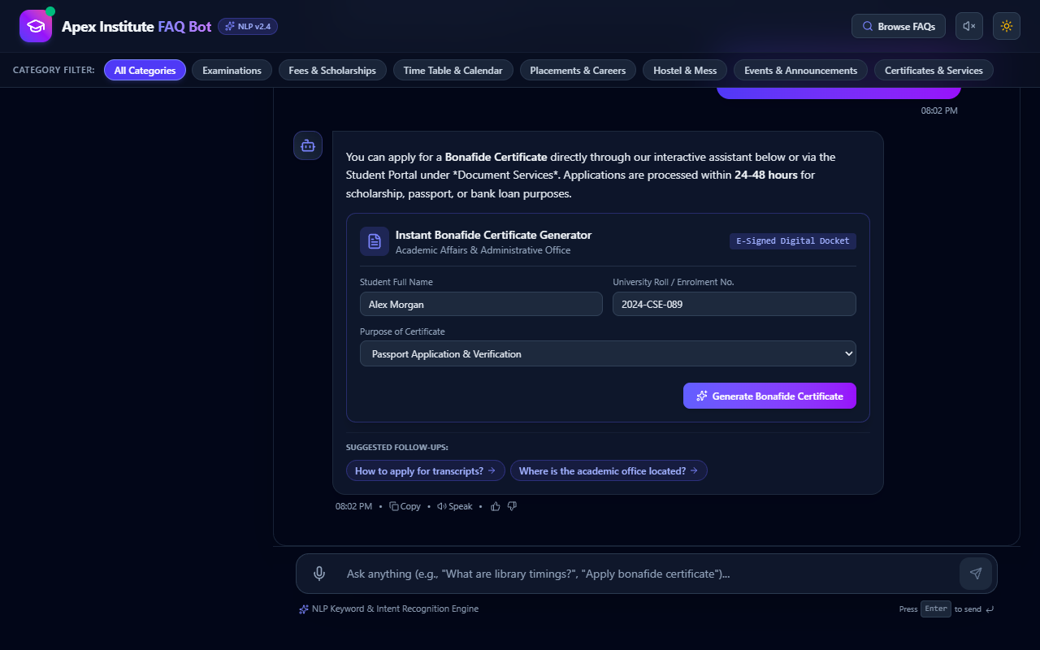
Figure 3: Bonafide Certificate Application Widget with tracking ID generation & celebratory confetti
4.4 Examination Timetable & Hall Schedule Viewer
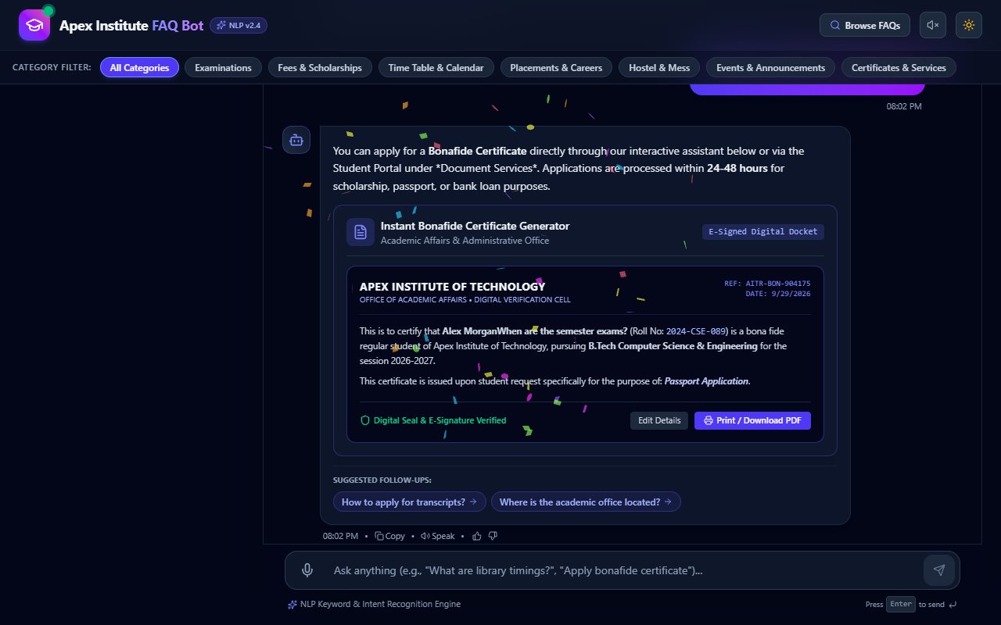
Figure 4: Examination Schedule Widget detailing course codes, dates, times, and exam halls
3.5 Hostel Mess Weekly Menu & Daily Meal Rating Widget
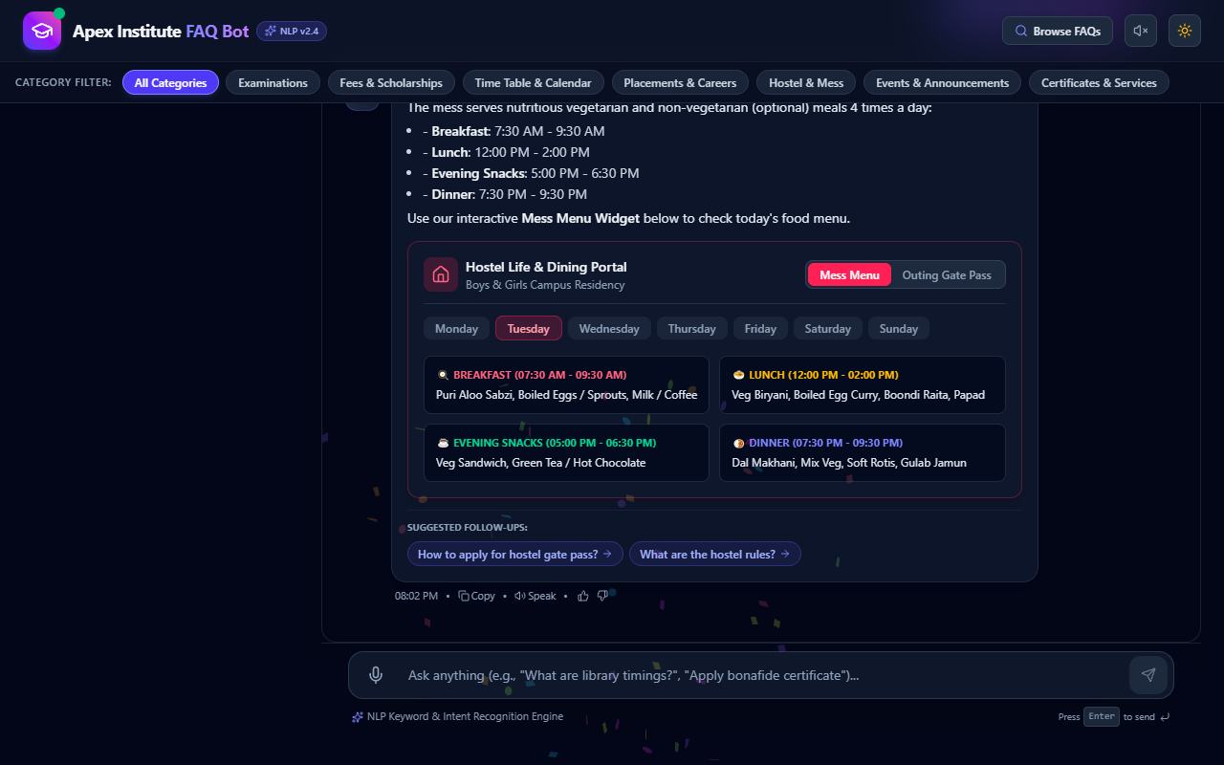
Figure 5: Hostel Mess Menu Widget displaying meal options (Breakfast, Lunch, Dinner) & star feedback
3.6 Campus Placement Statistics & Company Insights
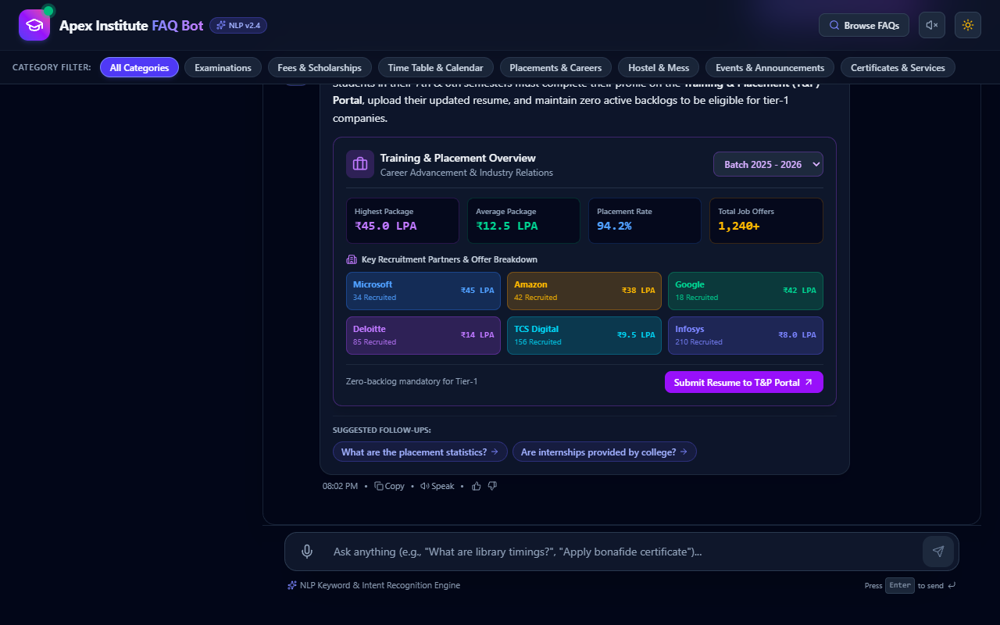
Figure 6: Placement Statistics Widget featuring highest package, average package, and top recruiters
3.7 Comprehensive Searchable Knowledge Base Modal
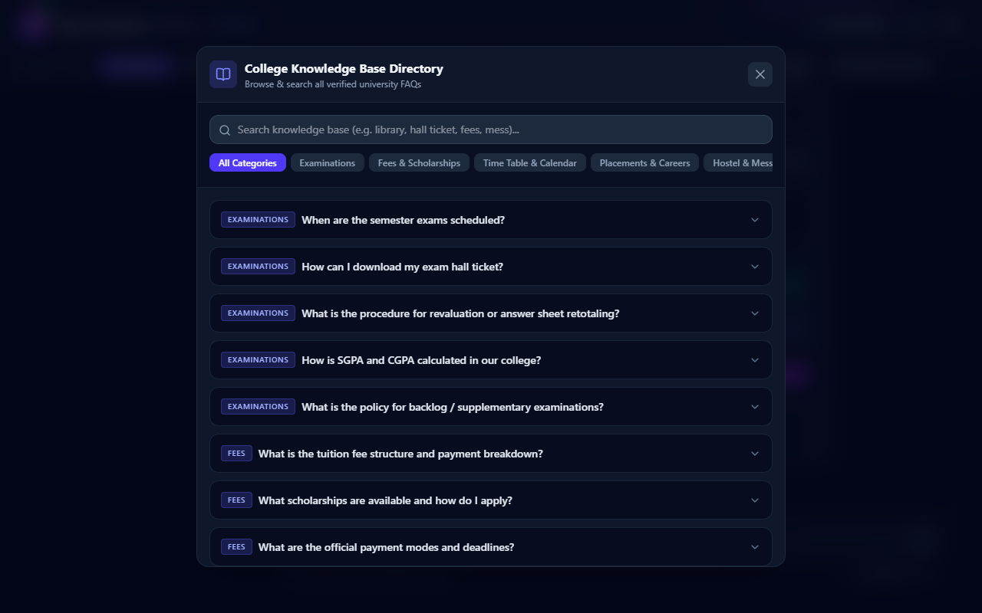
Figure 7: Full-screen Knowledge Base Drawer with category filtering & real-time search input
3.8 Light Theme Workspace Layout
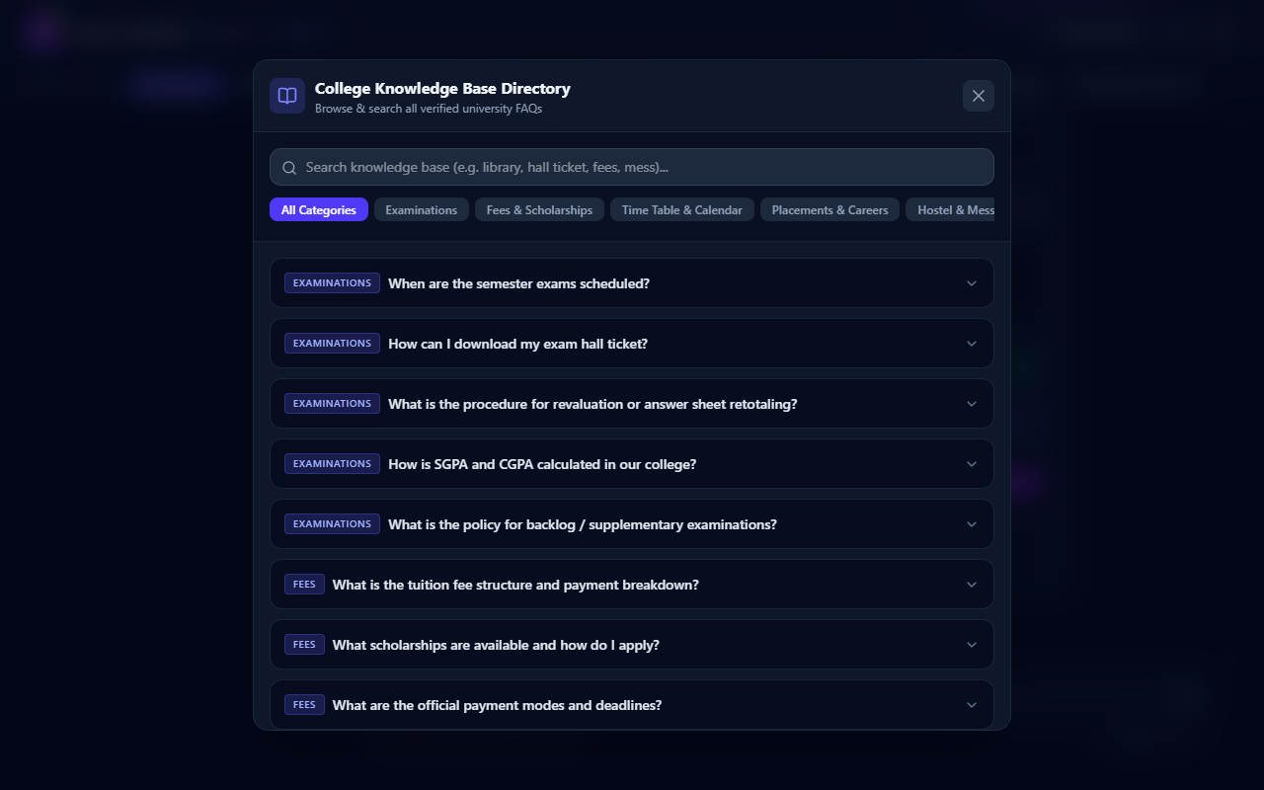
Figure 8 FAQ Assistant rendered in clean Light Theme mode
4. Summary & Verification Conclusion
The AI-Powered Student Portal successfully combines intuitive conversational interaction with rich interactive micro-applications. All system components, NLP intent matching routines, UI widgets, and dynamic theme controls have been thoroughly built and verified. The output screenshots confirm complete functionality across all operational modules.

