- We can’t have a gradient heatmap for the boxcar because the function isn’t differentiable.
- For super gaussian, small layer, then larger layer, doesn’t seem to be working. Here are a few examples.
[8, 256]
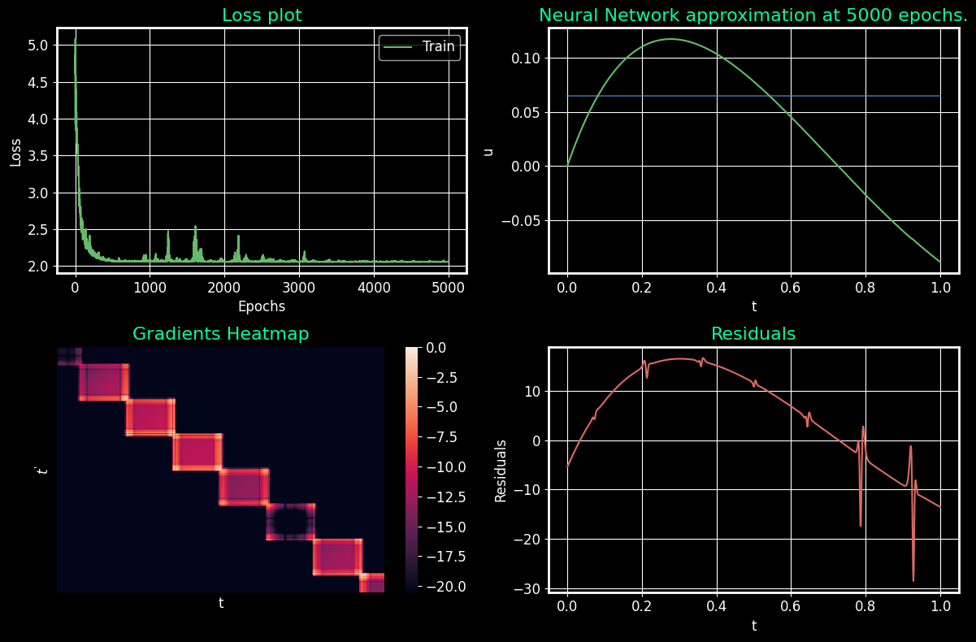

[16, 256]

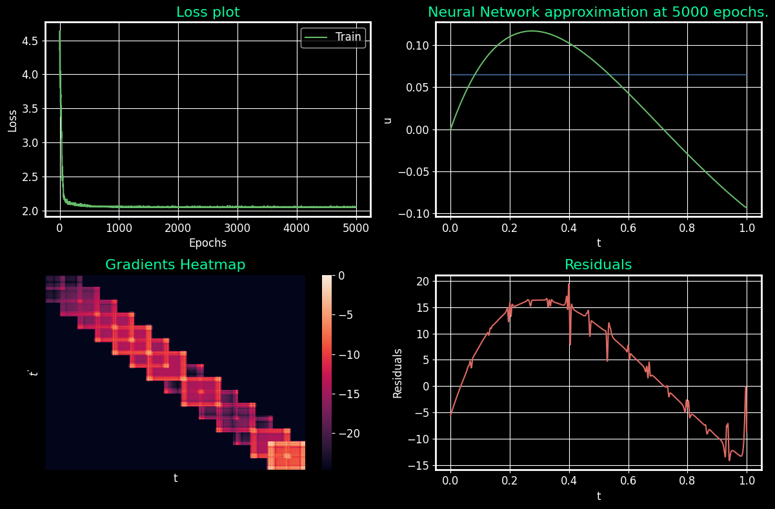

[32, 1024]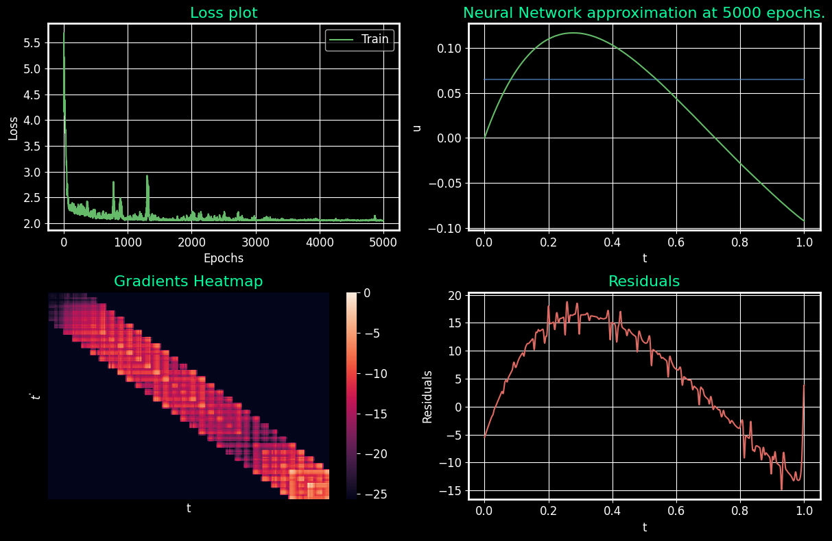

[32, 32]
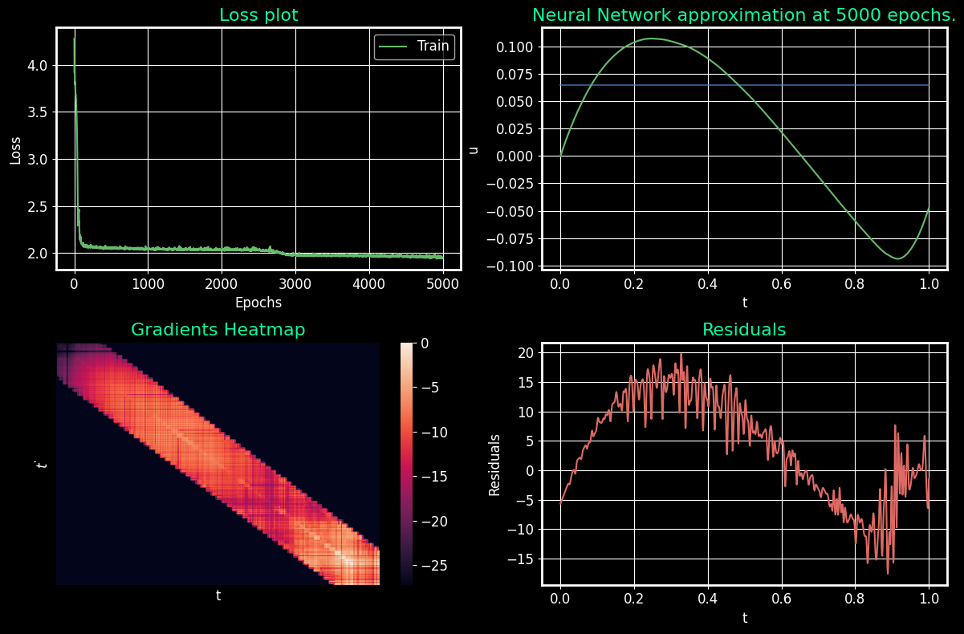

- We have interesting heatmaps, but super gaussian doesn’t seem to work either for lower sigmas
- Once, the sigmas reach 0.04/0.05, the larger networks seem to work
[2048], 0.05
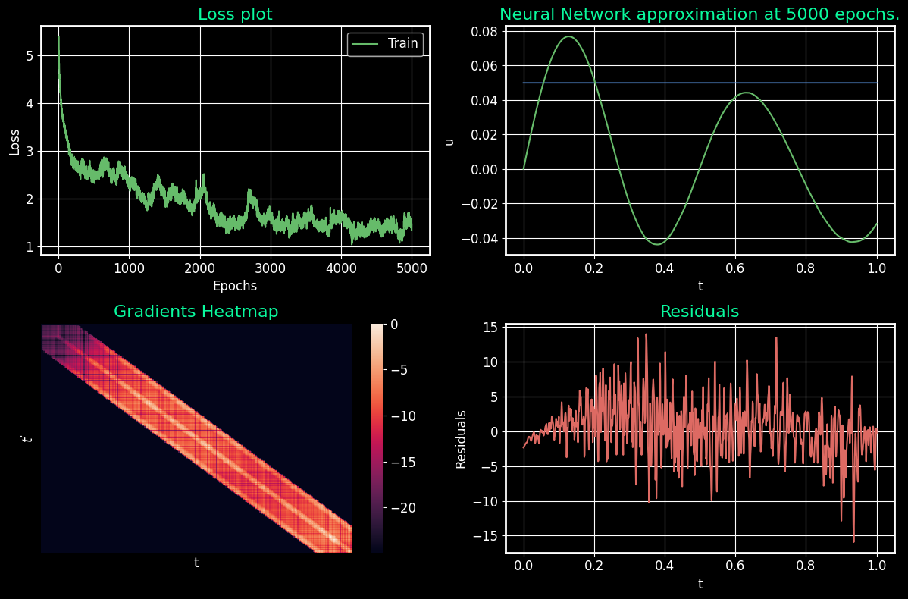

- The larger networks tend to do better

