- Even the smaller networks [8, 8, 8], perform better/on par with the precious results ([16, 256] with Gaussians).
- The major error in residuals is at the edges.
- Sigmas tend to increase to a high range for smaller networks [often reaching 0.5 ~ 0.7, and even 1 sometimes]
- [16, 16, 16] is more consistent, quickly reaching -3 and the sigmas are better controlled as well, although point 2 still exists.
- Going with the trend [32, 32, 32] performs better than [16, 16, 16]
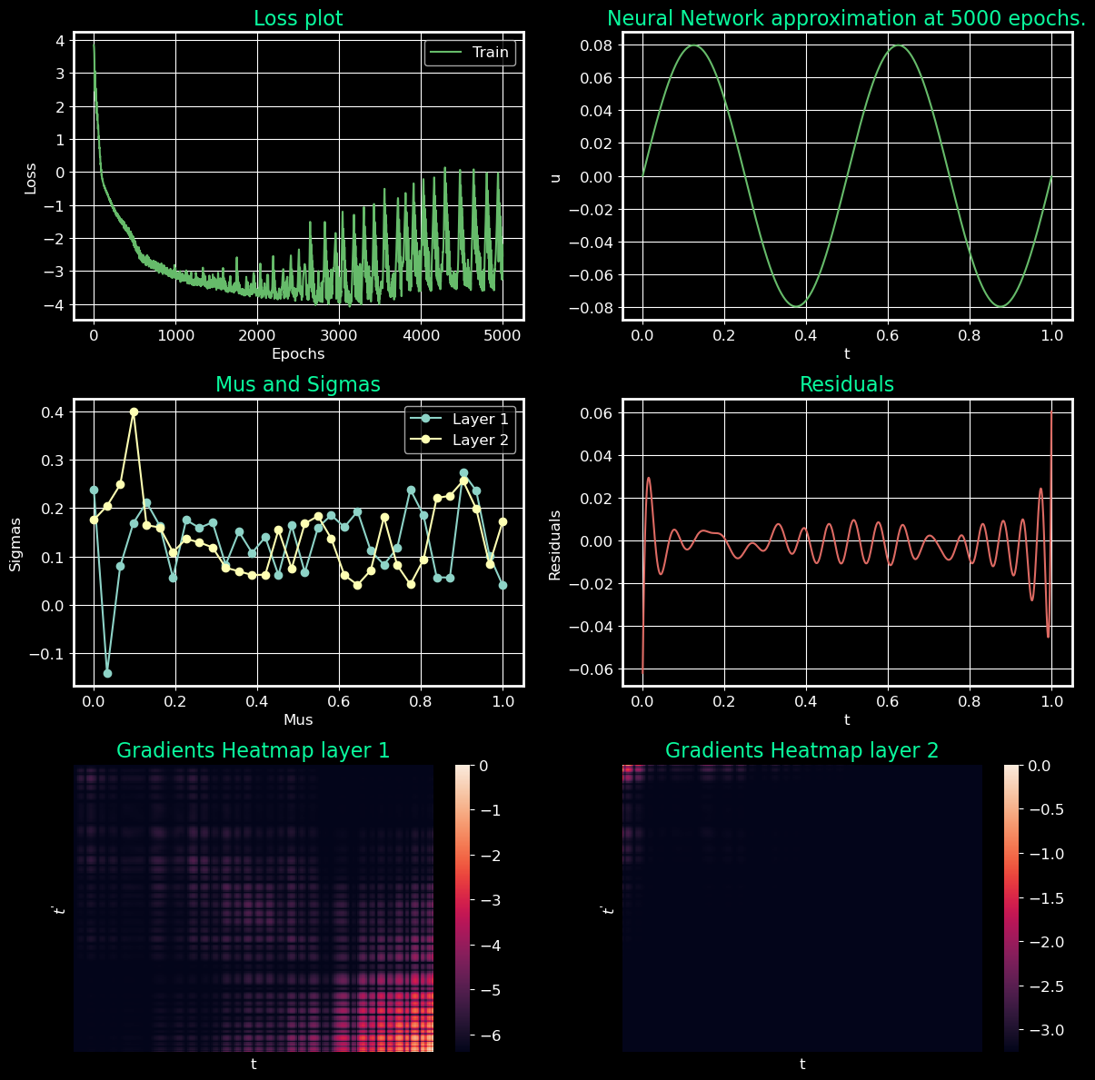

- [8, 16, 32] works as well or better than [32, 32, 32] in some cases.
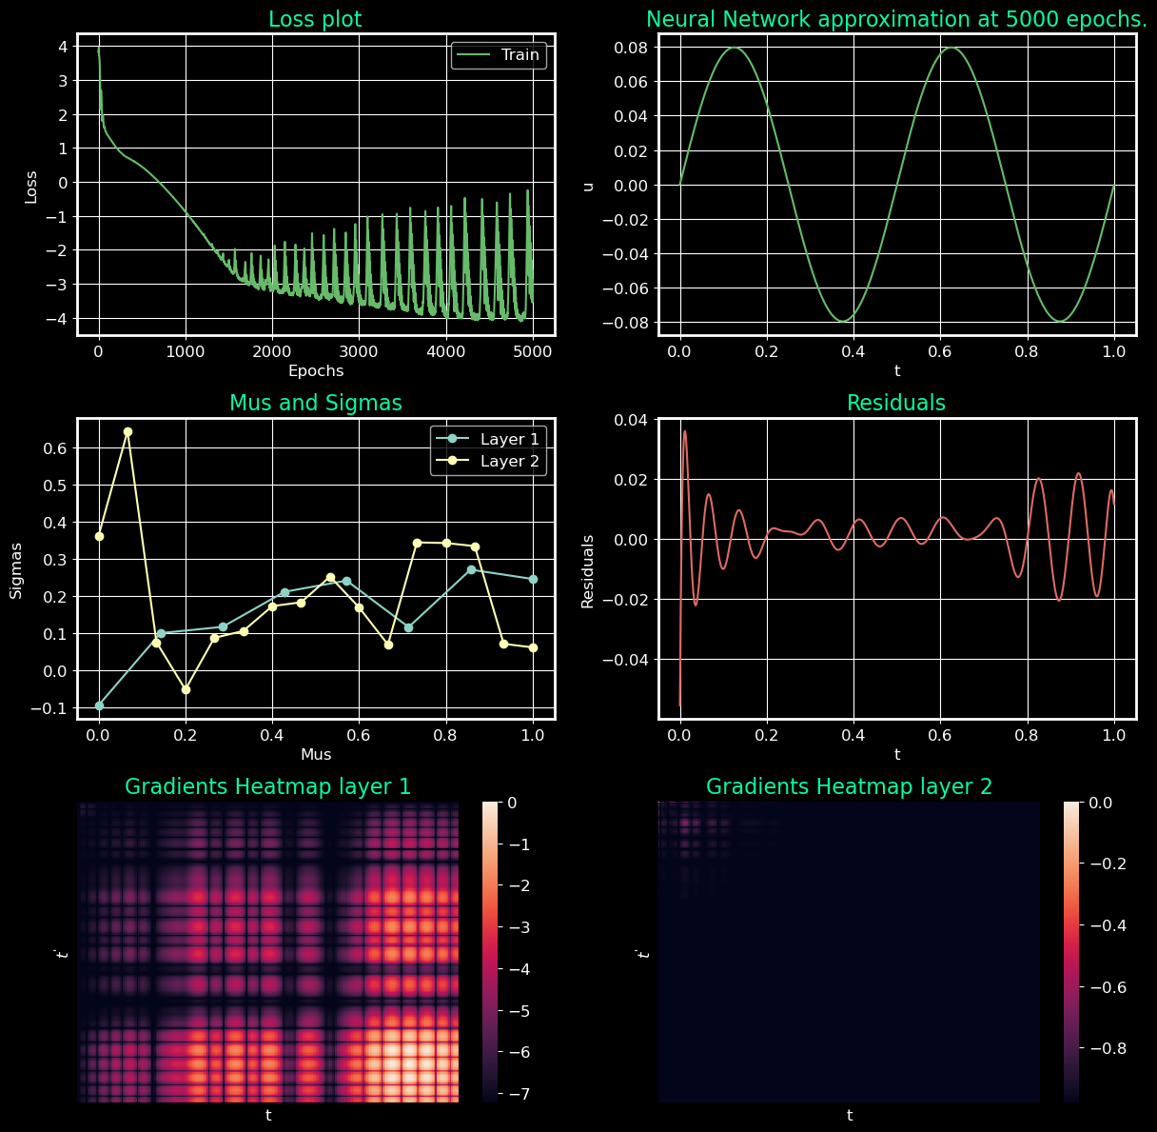

- Following the pattern [16, 32, 64] performs even better.
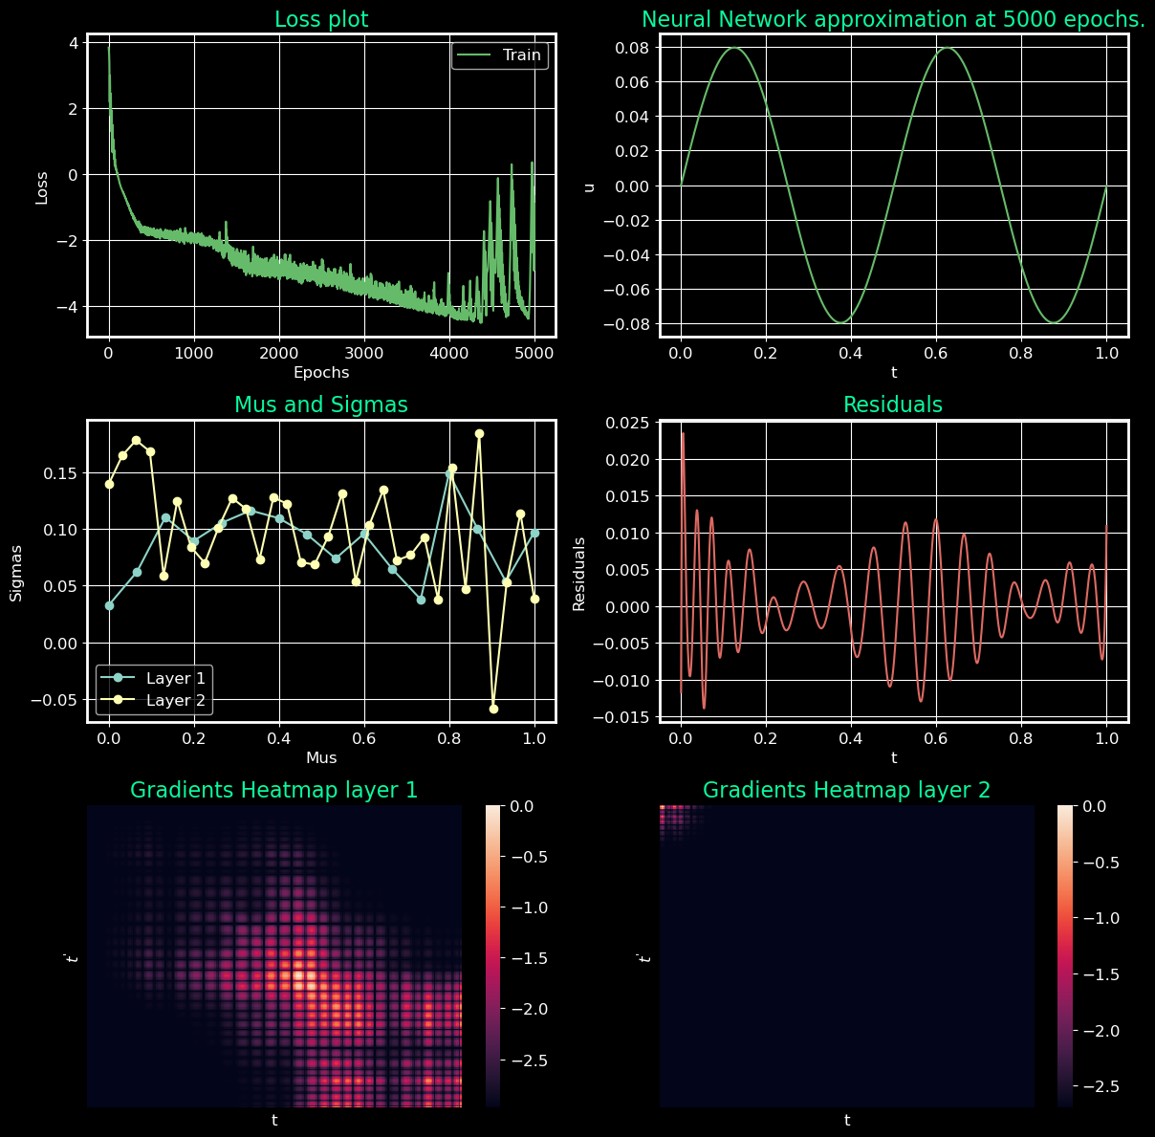

- [8, 16, 32, 64] same pattern, works better
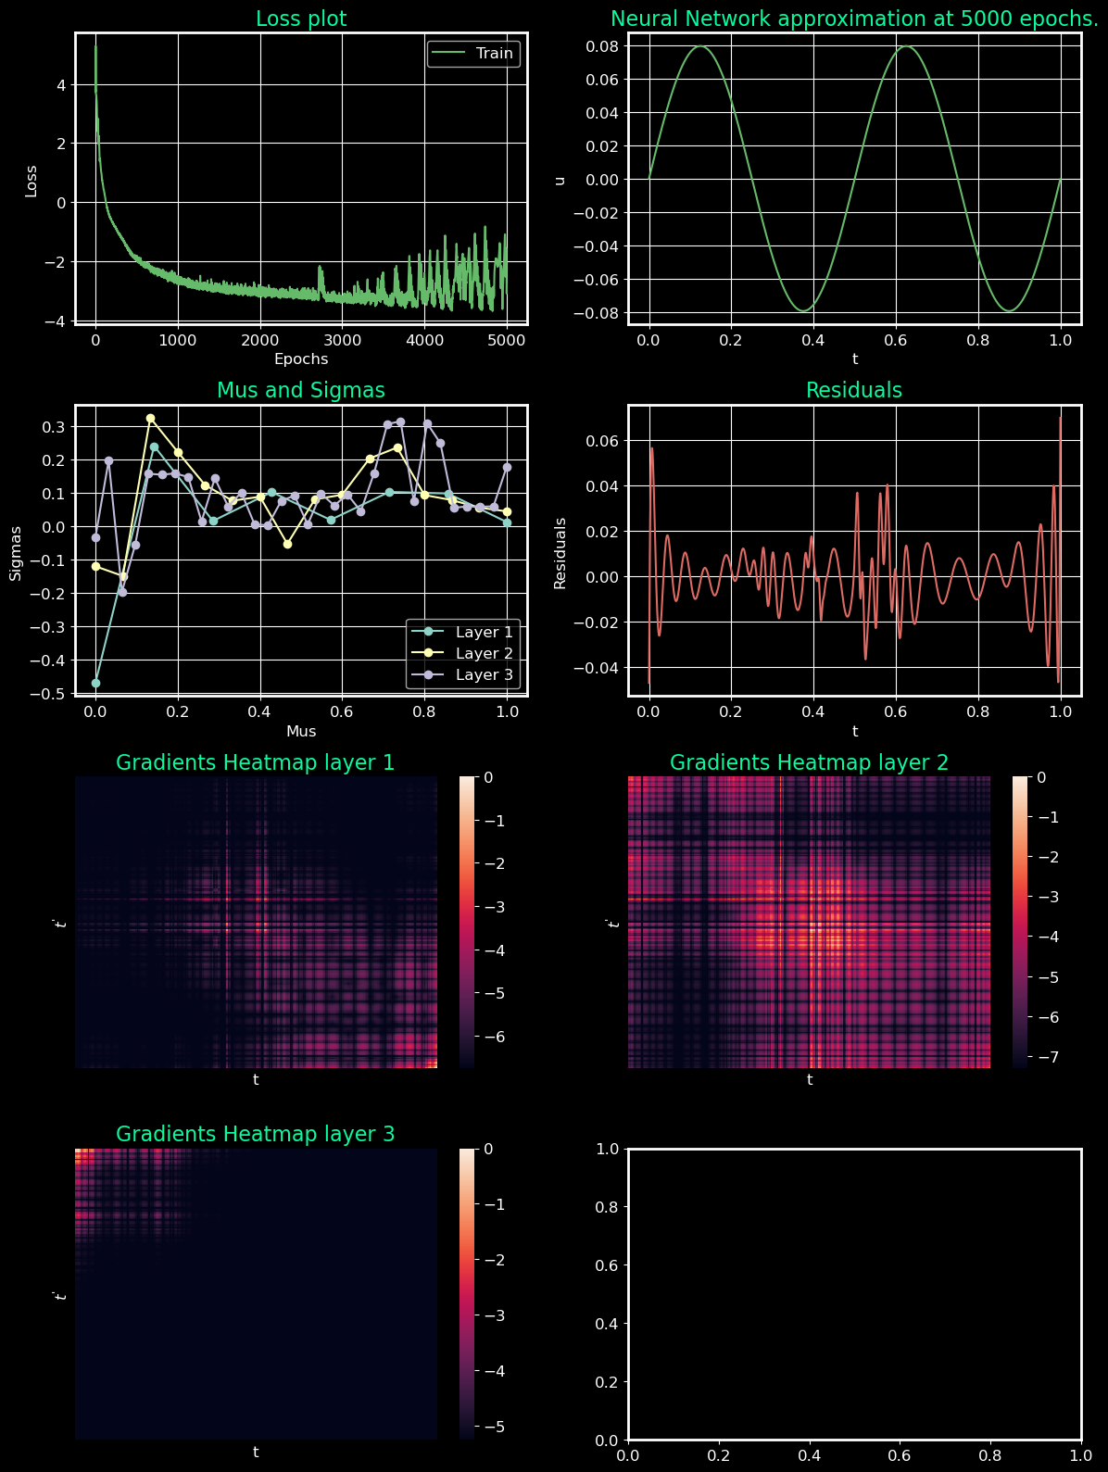
- [8, 16, 32, 64, 128] again, works better
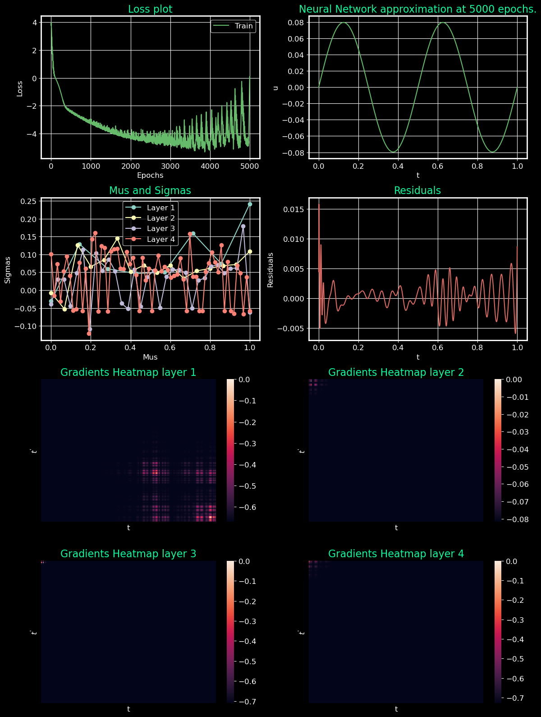
- [16, 16, 16, 16, 16]
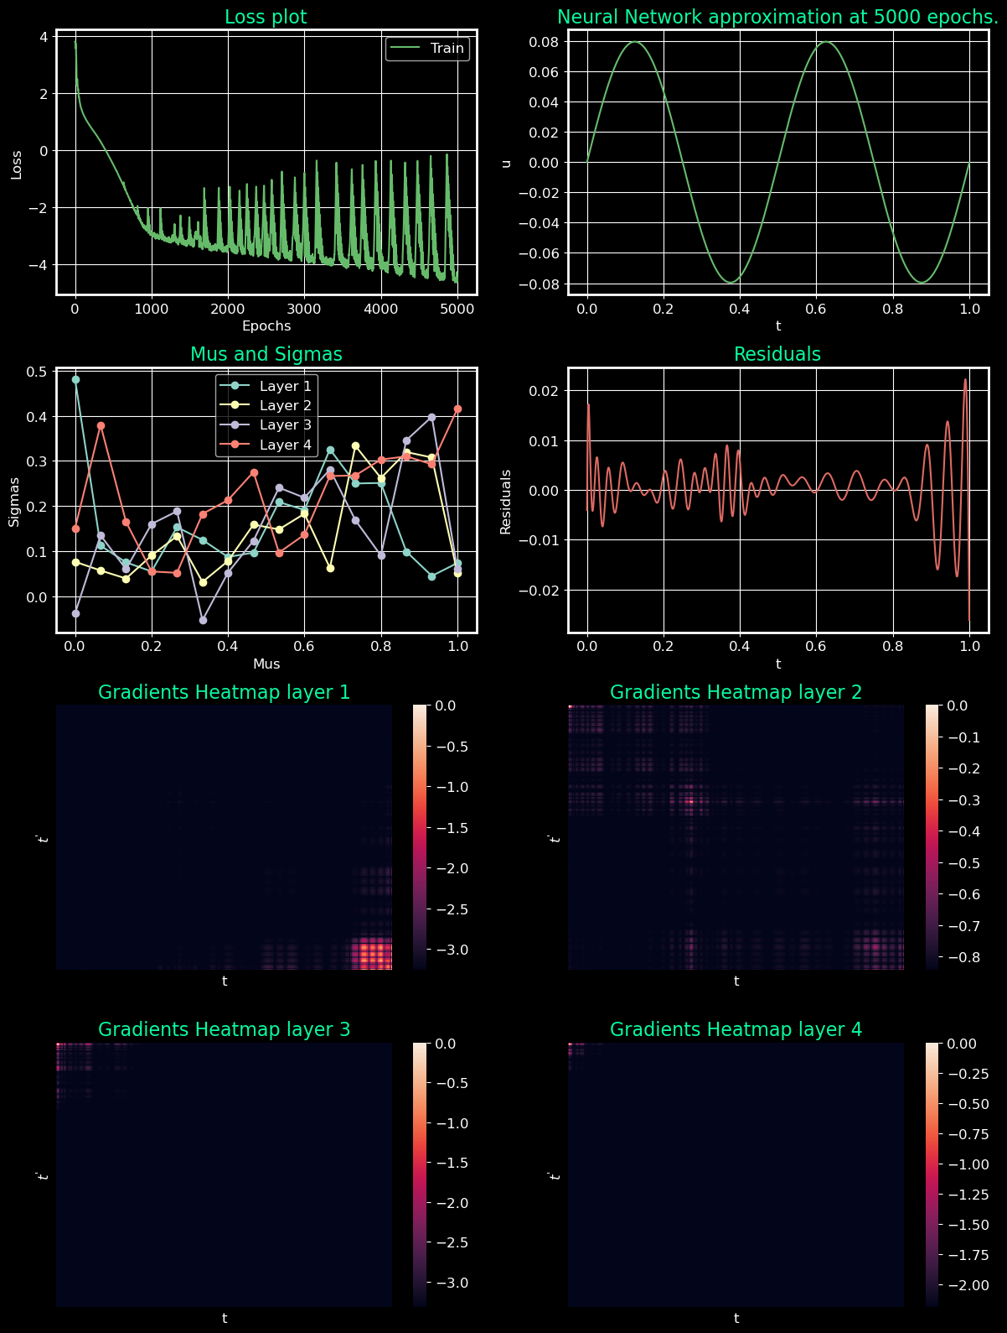
Conclusion till now: Adding more layers and increasing neurons seem to be helping (which usually doesn’t affect much in pins).
Results for 2nd run:
[8, till 256]
