[16, 256], sigma = 0.1
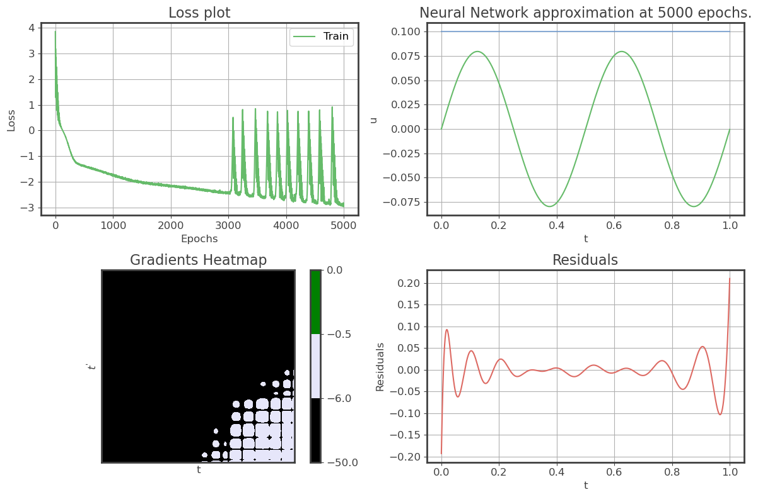
[8, 128], sigma = 0.3(Learnable), Mexican hat
