A REPORT OF INDUSTRIAL TRAINING

## at

## global-autotech.png

## Global Autotech Limited

SUBMITTED IN PARTIAL FULFILLMENT OF THE REQUIREMENT FOR THE AWARD OF THE DEGREE OF

BACHELOR OF TECHNOLOGY

(Information Technology)



**SUBMITTED BY:**

NAME : Lakshay Aggarwal

UNIVERSITY ROLL NO. : 43715003118

DEPARTMENT OF INFORMATION TECHNOLOGY

MAHARAJA SURAJMAL INSTITUTE OF TECHNOLOGY, DELHI

(Affiliated to GGSIPU , Delhi)

**CERTIFICATE**

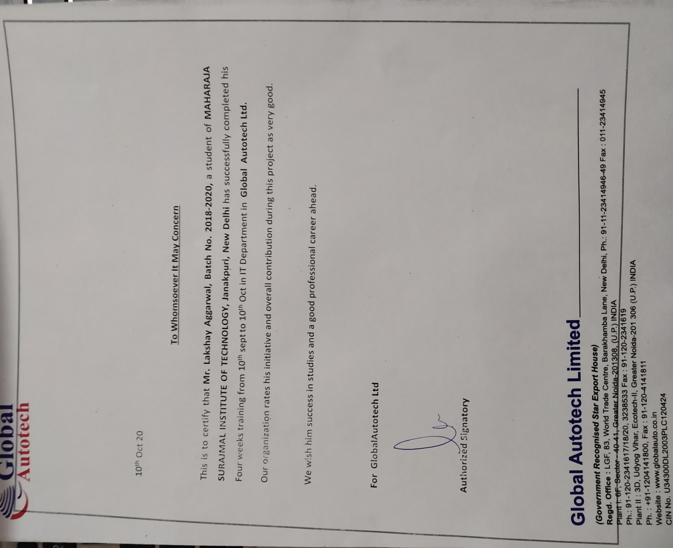

**MAHARAJA SURAJMAL INSTITUTE OF TECHNOLOGY**

**CANDIDATE'S DECLARATION**

I “Lakshay Aggarwal” hereby declare that I have undertaken four weeks industrial at **Global Autotech limited** during a period from Sept 10,2020to Oct 10,2020 in partial fulfillment of requirements for the award of degree of B.Tech (Information Technology) at MAHARAJA SURAJMAL INSTITUTE OF TECHNOLOGY, DELHI. The work which is being presented in the training report submitted to Department of Information Technology at Maharaja Surajmal Institute Of Technology, is an authentic record of training work.

Lakshay Aggarwal

Signature of the Student

Signature of internal examiner Signature of external examiner

**ABSTRACT**

The objective of a practical training is to learn something about industries practically and to be familiar with a working style of a technical worker to adjust simply according to industrial environment . This report deals with the equipments their relation and their general operating principle.

**Web development** is the work involved in developing a Web site for the Internet (World Wide Web) or an intranet (a private network). Web development can range from developing a simple single static page of plain text to complex Web-based Internet applications (Web apps), electronic businesses, and social network services. A more comprehensive list of tasks to which Web development commonly refers, may include Web engineering, Web design, Web content development, client liaison, client-side/server-side scripting, Web server and network security configuration, and e-commerce development.

Among Web professionals, "Web development" usually refers to the main non-design aspects of building Web sites: writing markup and coding.Web development may use content management systems (CMS) to make content changes easier and available with basic technical skills.

**ACKNOWLEDGEMENT**

The success and outcome of learning Web Development required a lot of guidance and assistance from many people and I am privileged to have most of along the completion of my course and the project. All that I have done is only due to such supervision and assistance and I would not forget to thank my instructor Avinash Malhotra . I am grateful to coding Avinash Malhotra for giving me precious knowledge in Web based Technologies and help me throughout the course whenever i needed. I hereby perceive this opportunity as a big milestone in my career development. I will use gained skills and knowledge in the best possible way and continue to work on their improvement.

Abstract

It is an Product Showcasing on Industrial Website where we create a virtual site of company produtcs items and depending on our choice we add product items in the cart without going outside specially in the current scenerios. It is more safer and convinient way of getting our without going outside.

The basic idea is to create a safe platform to Understand and to use the different basic technologies of Front-End Web Development like HTML , CSS, Java Script ,Bootstrap , JQuery to the fullest.This project includes the use of many platforms that can run on Java Sript. This project makes clear understanding of various aspects of Front-End Web Development ie. understanding the major aspects of UI Development

**TABLE OF CONTENTS**

|  |  |  |  |
| --- | --- | --- | --- |
| Chapter no. | | Title | Page no. |
| 1  2  3  4  5  6 | 1.1  1.2  1.3  1.4  3.1  3.2  3.3  3.4  3.5 | Organization Introduction  Vision  Methodology  Tenets they live by  About Organization  Introduction  Technologies used  HTML  CSS  Java Script  jQuery  Bootstrap  Project  Conclusion  References |  |

1. ORGANIZATION INTRODUCTION

global-autotech.png

Global Autotech Ltd manufactures machined HPDC parts, and Full Squeeze Casting. It is one of the largest suppliers of Piping assemblies (high & Low Pressure) , Tube connectors, Valves, Rotor, Pulley, Steel Shafts, Compressor Pistons & Swash Plates for automotive AC systems supplying to various Tier 1s. From its inception, Global Autotech has the vision to grow into one of the most dynamic organizations that will supply quality parts to a wide variety of customers across the globe.

Our achievements are accrued to the Highly skilled & Professional work force , their orientation towards the customer, zeal to learn ,excel and their indefatigable disposition towards new demanding Automotive & Engineering environment.

The metamorphosis of Global Autotech has been realized with the strong support of its esteemed customers and aspires to go all-out to meet the evolved needs.

As a responsible global citizen , we continue to meet all the social responsibilities. Global Autotech will continue to dedicate itself to the fruition of the Auto-Engineering fraternity and its contribution towards the society.

.

1.1 Vision

To become a Technology Leader by supplying World Class Products to Global Customers

1.2 Mission

To be preferred Global Source for Automotive Air-Conditioning and Precision Squeeze Cast Parts. To consolidate our Position and add Engine Parts and Forgings in our product range

* 1. Core Values
* Respect
* Fairness
* Team Work
* Goal Oriented
* Passion & Commitment
* Integrity & Trust

**1.4 IMS Policy**

In line with our Vision & Mission, Global Autotech shall strive to meet best global practices through Excellence in Quality, Value for Money, On-time deliveries, Continual improvement, Innovation  
 &  
Employee involvement to achieve expectations of our Customers, Associates and Society at large.  
While achieving this, We remain conscious about Health, Safety, Environment and Laws of the land

1. Introduction

In this current pandemic scenarios, world and technology is fastening its belts to develop new products that helps in staying safe and entertained without going out so to promote the interest of controlling the various applications on android phone. The above project describes a way for Getting a meal in a virtual online way instead of going outside.

The idea of the project is to showcase the products manufactured by

the Global

Autotech Limited company to their customers. Displaying even just

a cross section **of** the **products** you have available could be the difference between a potential customer paying you a visit or going elsewhere. Make it an easy choice by **showcasing** what you have on offer when people find your **website**.

1. Technologies Used

3.1 HTML

**HTML** stands for **Hyper Text Markup Language**, which is the most widely used language on Web to develop web pages. **HTML** was created by Berners-Lee in late 1991 but "HTML 2.0" was the first standard HTML specification which was published in 1995. HTML 4.01 was a major version of HTML and it was published in late 1999. Though HTML 4.01 version is widely used but currently we are having HTML-5 version which is an extension to HTML 4.01, and this version was published in 2012.

Why to Learn HTML?

Originally, **HTML** was developed with the intent of defining the structure of documents like headings, paragraphs, lists, and so forth to facilitate the sharing of scientific information between researchers. Now, HTML is being widely used to format web pages with the help of different tags available in HTML language.

**HTML** is a MUST for students and working professionals to become a great Software Engineer specially when they are working in Web Development Domain. I will list down some of the key advantages of learning HTML:

* **Create Web site** - You can create a website or customize an existing web template if you know HTML well.
* **Become a web designer** - If you want to start a carrer as a professional web designer, HTML and CSS designing is a must skill.
* **Understand web** - If you want to optimize your website, to boost its speed and performance, it is good to know HTML to yield best results.
* **Learn other languages** - Once you understands the basic of HTML then other related technologies like javascript, php, or angular are become easier to understand.

Applications of HTML

As mentioned before, HTML is one of the most widely used language over the web. I'm going to list few of them here:

* **Web pages development** - HTML is used to create pages which are rendered over the web. Almost every page of web is having html tags in it to render its details in browser.
* **Internet Navigation** - HTML provides tags which are used to navigate from one page to another and is heavily used in internet navigation.
* **Responsive UI** - HTML pages now-a-days works well on all platform, mobile, tabs, desktop or laptops owing to responsive design strategy.
* **Offline support** HTML pages once loaded can be made available offline on the machine without any need of internet.
* **Game development**- HTML5 has native support for rich experience and is now useful in gaming developent arena as well.

3.2 CSS

**CSS** is used to control the style of a web document in a simple and easy way.

**CSS** is the acronym for **"Cascading Style Sheet"**. This tutorial covers both the versions CSS1,CSS2 and CSS3, and gives a complete understanding of CSS, starting from its basics to advanced concepts.

Why to Learn CSS?

**Cascading Style Sheets**, fondly referred to as **CSS**, is a simple design language intended to simplify the process of making web pages presentable.

**CSS** is a MUST for students and working professionals to become a great Software Engineer specially when they are working in Web Development Domain. I will list down some of the key advantages of learning CSS:

* **Create Stunning Web site** - CSS handles the look and feel part of a web page. Using CSS, you can control the color of the text, the style of fonts, the spacing between paragraphs, how columns are sized and laid out, what background images or colors are used, layout designs,variations in display for different devices and screen sizes as well as a variety of other effects.
* **Become a web designer** - If you want to start a carrer as a professional web designer, HTML and CSS designing is a must skill.
* **Control web** - CSS is easy to learn and understand but it provides powerful control over the presentation of an HTML document. Most commonly, CSS is combined with the markup languages HTML or XHTML.
* **Learn other languages** - Once you understands the basic of HTML and CSS then other related technologies like javascript, php, or angular are become easier to understand.

Applications of CSS

As mentioned before, CSS is one of the most widely used style language over the web. I'm going to list few of them here:

* **CSS saves time** - You can write CSS once and then reuse same sheet in multiple HTML pages. You can define a style for each HTML element and apply it to as many Web pages as you want.
* **Pages load faster** - If you are using CSS, you do not need to write HTML tag attributes every time. Just write one CSS rule of a tag and apply it to all the occurrences of that tag. So less code means faster download times.
* **Easy maintenance** - To make a global change, simply change the style, and all elements in all the web pages will be updated automatically.
* **Superior styles to HTML** - CSS has a much wider array of attributes than HTML, so you can give a far better look to your HTML page in comparison to HTML attributes.
* **Multiple Device Compatibility** - Style sheets allow content to be optimized for more than one type of device. By using the same HTML document, different versions of a website can be presented for handheld devices such as PDAs and cell phones or for printing.
* **Global web standards**- Now HTML attributes are being deprecated and it is being recommended to use CSS. So its a good idea to start using CSS in all the HTML pages to make them compatible to future browsers.

3.3 Java Script

**JavaScript** is a lightweight, interpreted **programming** language. It is designed for creating network-centric applications. It is complimentary to and integrated with Java. **JavaScript** is very easy to implement because it is integrated with HTML. It is open and cross-platform.

Why to Learn Javascript

**Javascript** is a MUST for students and working professionals to become a great Software Engineer specially when they are working in Web Development Domain. I will list down some of the key advantages of learning Javascript:

* Javascript is the most popular **programming language** in the world and that makes it a programmer’s great choice. Once you learnt Javascript, it helps you developing great front-end as well as back-end softwares using different Javascript based frameworks like jQuery, Node.JS etc.
* Javascript is everywhere, it comes installed on every modern web browser and so to learn Javascript you really do not need any special environment setup. For example Chrome, Mozilla Firefox , Safari and every browser you know as of today, supports Javascript.
* Javascript helps you create really beautiful and crazy fast websites. You can develop your website with a console like look and feel and give your users the best Graphical User Experience.
* JavaScript usage has now extended to mobile app development, desktop app development, and game development. This opens many opportunities for you as Javascript Programmer.
* Due to high demand, there is tons of job growth and high pay for those who know JavaScript. You can navigate over to different job sites to see what having JavaScript skills looks like in the job market.
* Great thing about Javascript is that you will find tons of frameworks and Libraries already developed which can be used directly in your software development to reduce your time to market.

There are many useful **Javascript frameworks** and libraries available:

* Angular
* React
* jQuery
* Vue.js

It is really impossible to give a complete list of all the available Javascript frameworks and libraries. The Javascript world is just too large and too much new is happening.

Applications of Javascript Programming

As mentioned before, **Javascript** is one of the most widely used **programming languages** (Front-end as well as Back-end). It has it's presence in almost every area of software development. I'm going to list few of them here:

* **Manipulating HTML Pages** - Javascript helps in manipulating HTML page on the fly. This helps in adding and deleting any HTML tag very easily using javascript and modify your HTML to change its look and feel based on different devices and requirements.
* **Back-end Data Loading** - Javascript provides Ajax library which helps in loading back-end data while you are doing some other processing. This really gives an amazing experience to your website visitors.
* **Presentations** - JavaScript also provides the facility of creating presentations which gives website look and feel. JavaScript provides RevealJS and BespokeJS libraries to build a web-based slide presentations.
* **Server Applications** - Node JS is built on Chrome's Javascript runtime for building fast and scalable network applications. This is an event based library which helps in developing very sophisticated server applications including Web Servers.

3.4 jQuery



jQuery is a fast and concise JavaScript library created by John Resig in 2006. jQuery simplifies HTML document traversing, event handling, animating, and Ajax interactions for Rapid Web Development

jQuery is a fast and concise JavaScript Library created by John Resig in 2006 with a nice motto: **Write less, do more**. jQuery simplifies HTML document traversing, event handling, animating, and Ajax interactions for rapid web development. jQuery is a JavaScript toolkit designed to simplify various tasks by writing less code. Here is the list of important core features supported by jQuery −

* **DOM manipulation** − The jQuery made it easy to select DOM elements, negotiate them and modifying their content by using cross-browser open source selector engine called **Sizzle**.
* **Event handling** − The jQuery offers an elegant way to capture a wide variety of events, such as a user clicking on a link, without the need to clutter the HTML code itself with event handlers.
* **AJAX Support** − The jQuery helps you a lot to develop a responsive and featurerich site using AJAX technology.
* **Animations** − The jQuery comes with plenty of built-in animation effects which you can use in your websites.
* **Lightweight** − The jQuery is very lightweight library - about 19KB in size (Minified and gzipped).
* **Cross Browser Support** − The jQuery has cross-browser support, and works well in IE 6.0+, FF 2.0+, Safari 3.0+, Chrome and Opera 9.0+
* **Latest Technology** − The jQuery supports CSS3 selectors and basic XPath syntax.

3.5 BootStrap

Twitter Bootstrap is the most popular front end framework in the recent time. It is sleek, intuitive, and powerful mobile first front-end framework for faster and easier web development. It uses HTML, CSS and Javascript. This tutorial will teach you the basics of Bootstrap Framework using which you can create web projects with ease. The tutorial is divided into sections such as Bootstrap Basic Structure, Bootstrap CSS, Bootstrap Layout Components and Bootstrap Plugins. Each of these sections contain related topics with simple and useful examples.

Why to Learn Bootstrap?

* **Mobile first approach** − Bootstrap 3, framework consists of Mobile first styles throughout the entire library instead them of in separate files.
* **Browser Support** − It is supported by all popular browsers.



* **Easy to get started** − With just the knowledge of HTML and CSS anyone can get started with Bootstrap. Also the Bootstrap official site has a good documentation.
* **Responsive design** − Bootstrap's responsive CSS adjusts to Desktops, Tablets and Mobiles. More about the responsive design is in the chapter [Bootstrap Responsive Design.](https://www.tutorialspoint.com/bootstrap/bootstrap_responsive_utilities.htm)

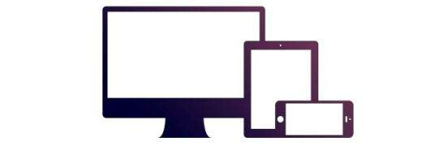

* Provides a clean and uniform solution for building an interface for developers.
* It contains beautiful and functional built-in components which are easy to customize.
* It also provides web based customization.
* And best of all it is an open source.

1. My Project

My project is based on product showcasing on an industrial website using HTML , CSS ,

JavaScript , Bootstrap & jQuery. I made this project to get started with Front End Web Development. Some of its snippets are



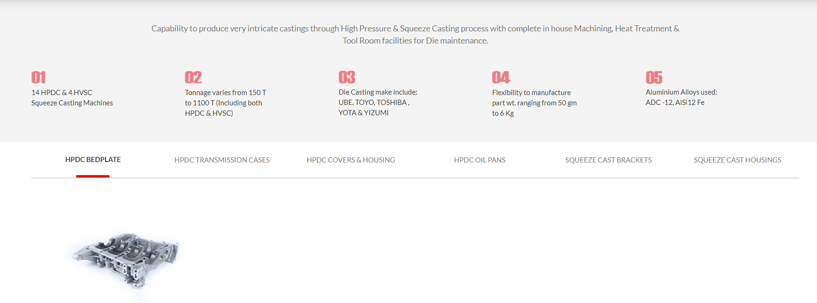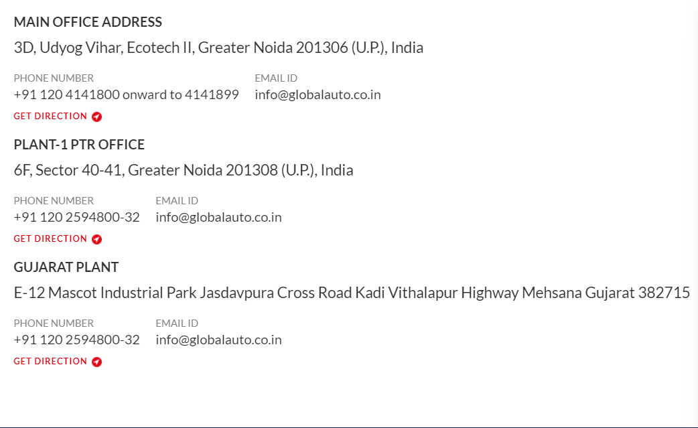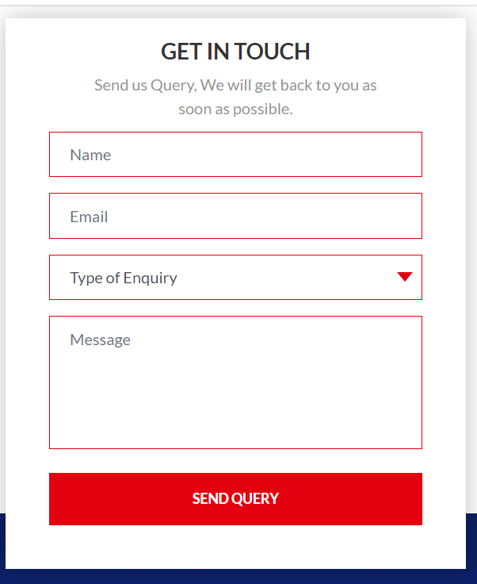

## code 1.PNG

## code 3.PNGcode w.PNG

## 5.Conclusion

In a nutshell, this internship has been an excellent and rewarding experience. I can conclude that there have been a lot I’ve learnt from my course. Needless to say, the technical aspects of the work I’ve done are not flawless and could be improved provided enough time.

As someone with no prior experience in JavaScript whatsoever I believe my time spent in research and discovering new languages was well worth it and contributed to finding an acceptable solution to an important aspect of web design and development. Two main things that I’ve learned the importance of are time-management skills and self-motivation.

Working with web development languages has increased my interest in them, hence prompting me to do more in the Web Design and Development and become more better & efficient in it.

References

1. www.w3schools.com
2. www.geeksforgeeks.org
3. [www.wikipedia.org](http://3.www.wikipedia.org/)
4. [www.internshala.com](http://4.www.internshala.com/)
5. [www.stackoverflow.com](http://5.www.stackoverflow.com/)
6. [www.youtube.com](http://6.www.youtube.com/)
7. <https://www.globalauto.co.in/product.html>