**COVID-19**

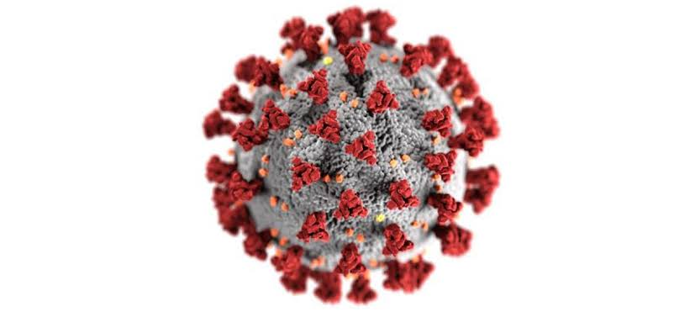

On 11 March 2020, WHO declared Novel Coronavirus Disease (COVID-19) outbreak as a pandemic and reiterated the call for countries to take immediate actions and scale up response to treat, detect and reduce transmission to save people’s lives.Coronaviruses are a large family of viruses which may cause illness in animals or humans. In humans, several coronaviruses are known to cause respiratory infections ranging from the common cold to more severe diseases such as Middle East Respiratory Syndrome (MERS) and Severe Acute Respiratory Syndrome (SARS). The most recently discovered coronavirus causes coronavirus disease COVID-19.

* Measures to protect yourself from Covid-19 are as follows :

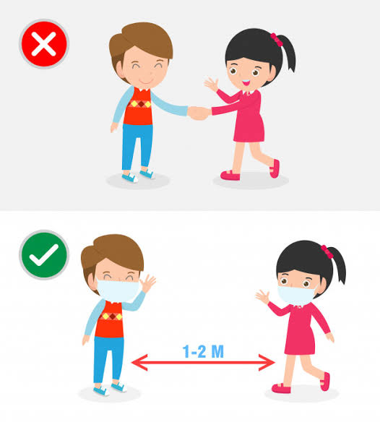

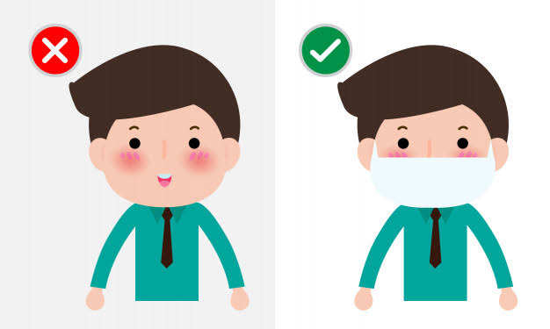My schemas for the topic covid19 are as follows:

1. Country_info(country_name,Total_case,Total_deaths)

**hive> create table country_info(country string,total_casesdouble,total_deaths double) row format delimited fields terminated by ;**

**hive> load data local inpath'/home/cloudera/Desktop/vasuja1.csv' into table country_info;**

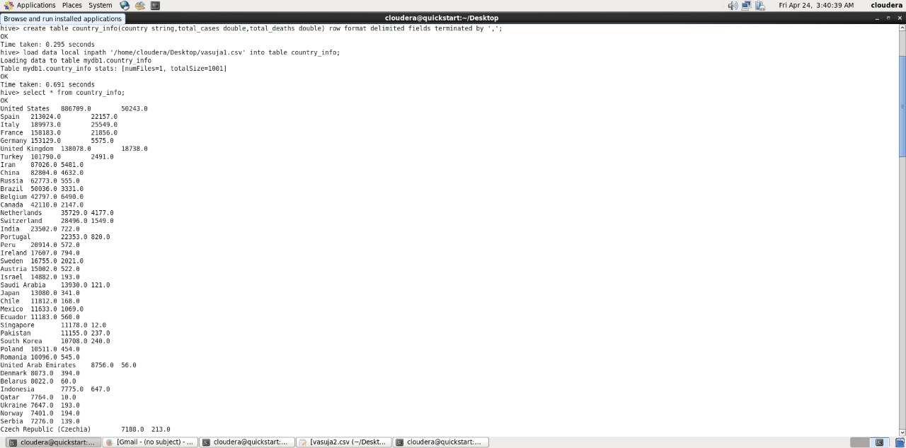

**hive>select * from country_info;**

2.Person_info(p_id,p_name,p_age,p_comorbitidies,p_gender)

**hive>create table person_info(p_idstring,p_namestring,p_ageint,p_co_morbitditystring,p_gender string) partitioned by (p_gender string) row format delimited fields terminated by ;**

**hive>create table dummy_table(p_idstring,p_namestring,p_ageint,p_co_morbitditystring,p_gender string) row format delimited fields terminated by ;**

**hive> load data local inpath'/home/cloudera/Desktop/vasuja2.csv' into table dummy_table;**

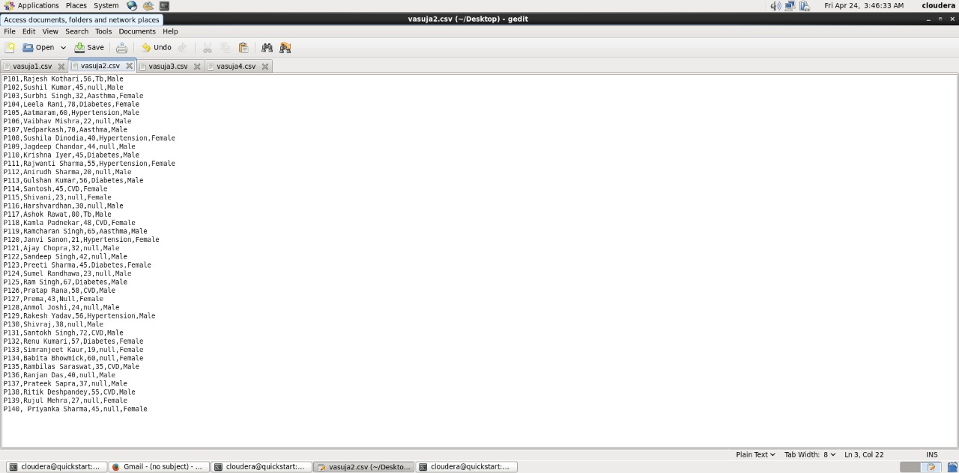

Partitioned directory

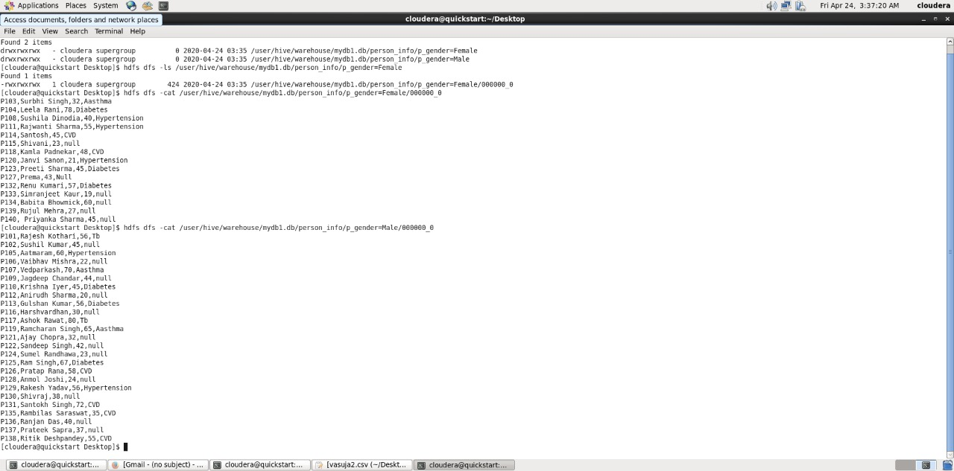

**hive>select * from dummy_table;**

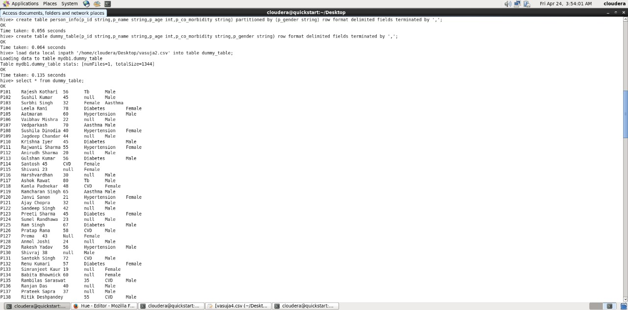

3.Hospital_info(p_id,h_name,h_city,h_state,h_total_cases)

**hive>create table hosp_info(p_idstring,h_namestring,h_citystring,h_statestring,h_total_cases double) row format delimited fields terminated by ;**

**hive> load data local inpath'/home/cloudera/Desktop/vasuja3.csv' into table hosp_info;**

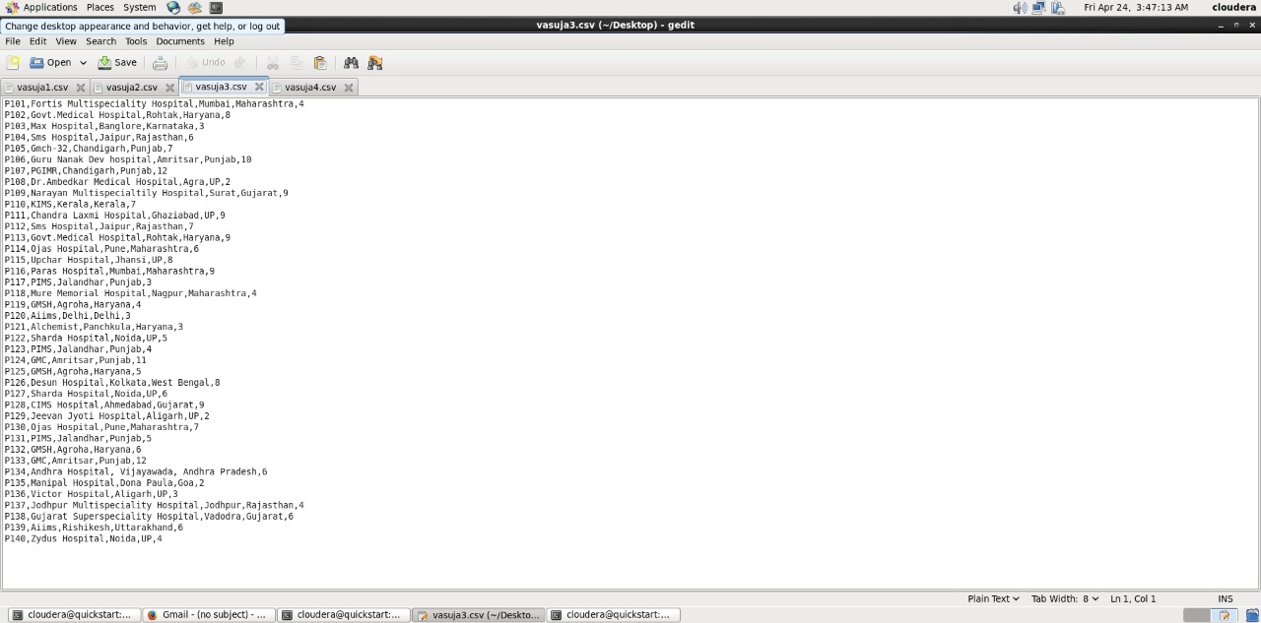

**hive>select * from hosp_info;**

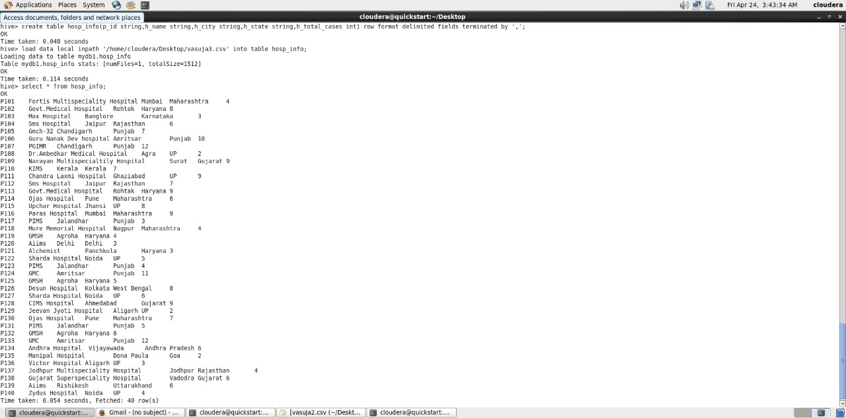

4.State_info(state,Total_name, Total_deaths)

**hive>create table state_info(states string,,total_casesdouble,total_deaths double) row format delimited fields terminated by ;**

**hive> load data localinpath'/home/cloudera/Desktop/vasuja4.csv' into table state_info;**

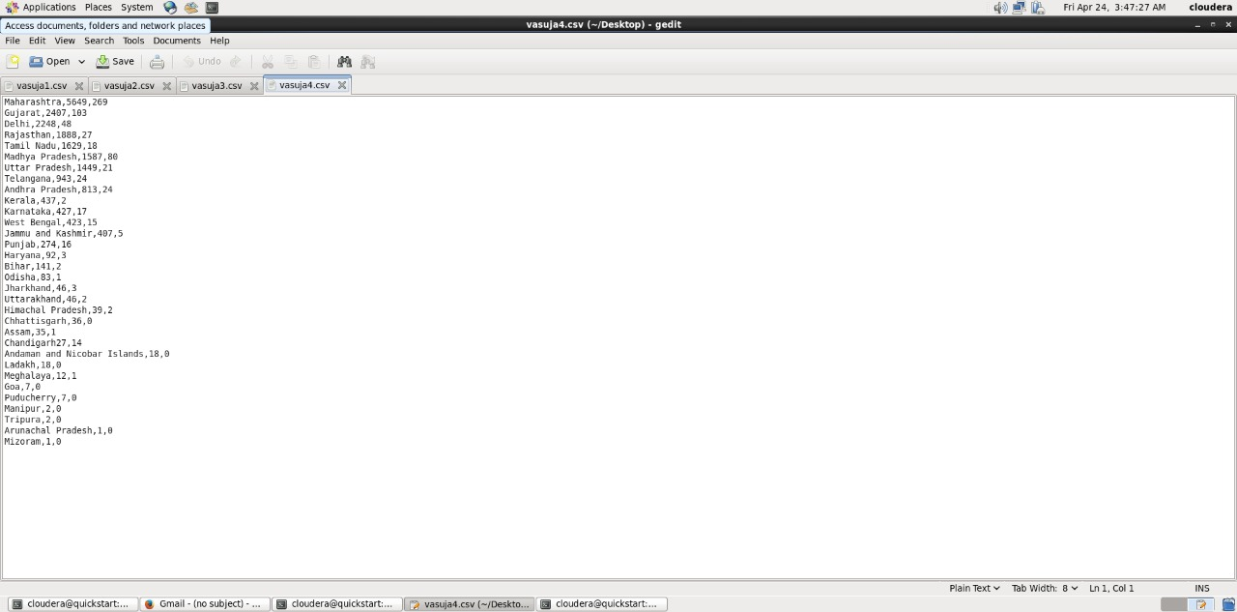

**hive>select * from state_info;**

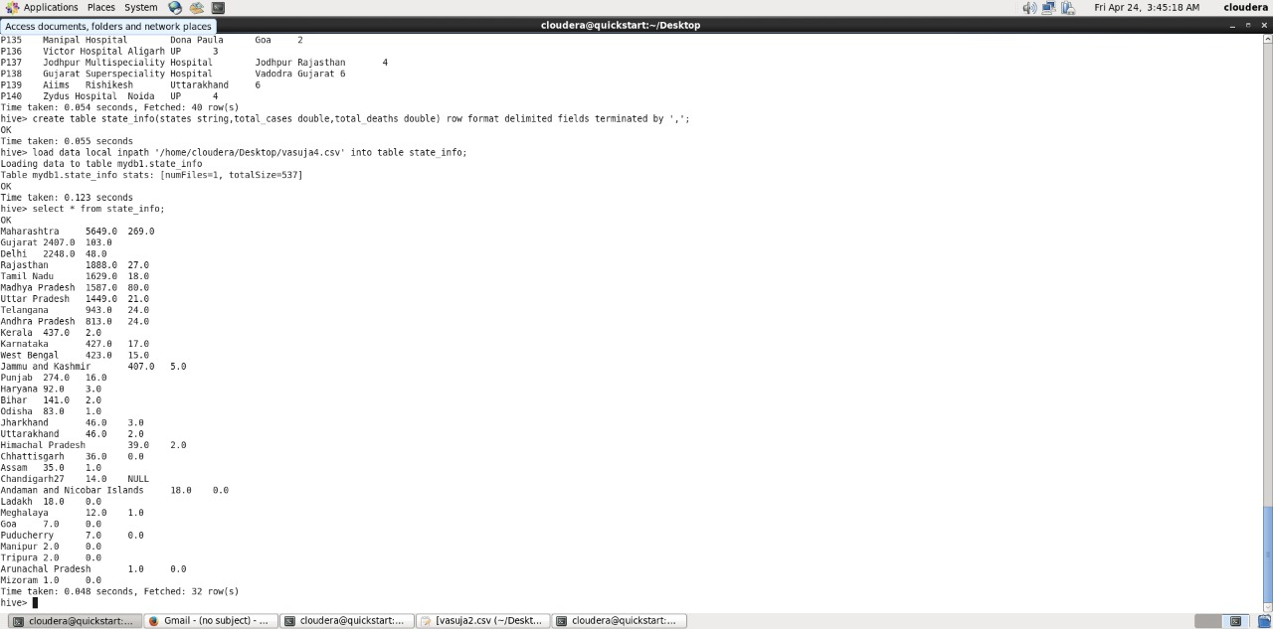



Challenges

Que1 Find the total number of cases,deaths all across the world.

Sol:- **hive> select concat ('Total_cases:',sum(total_cases)) ,concat ('Total_deaths:',sum(total_death)) from country_info;**

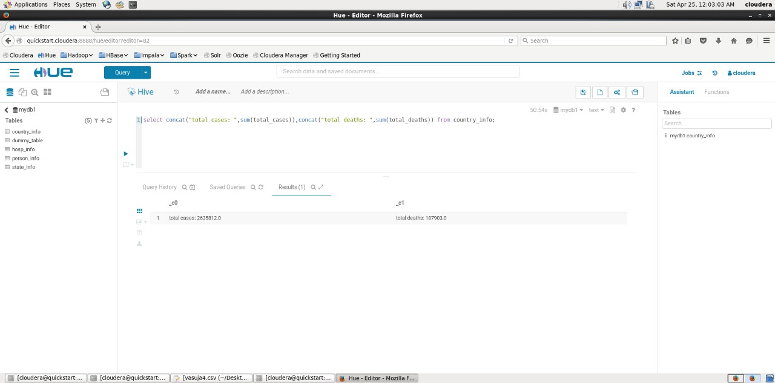

*From the above analysis, It represents total no of cases is around 27 lakhs and deaths are 19 lakhs so as always said "Prevention is better then cure" .Stay healthy stay safe.*

Que2 Find the healed cases all across the world and arrange them in ascending order.

Sol :- **hive>Select country, (Total_cases-Total_deaths) as recovered from country_info ORDER BY recovered ASC;**

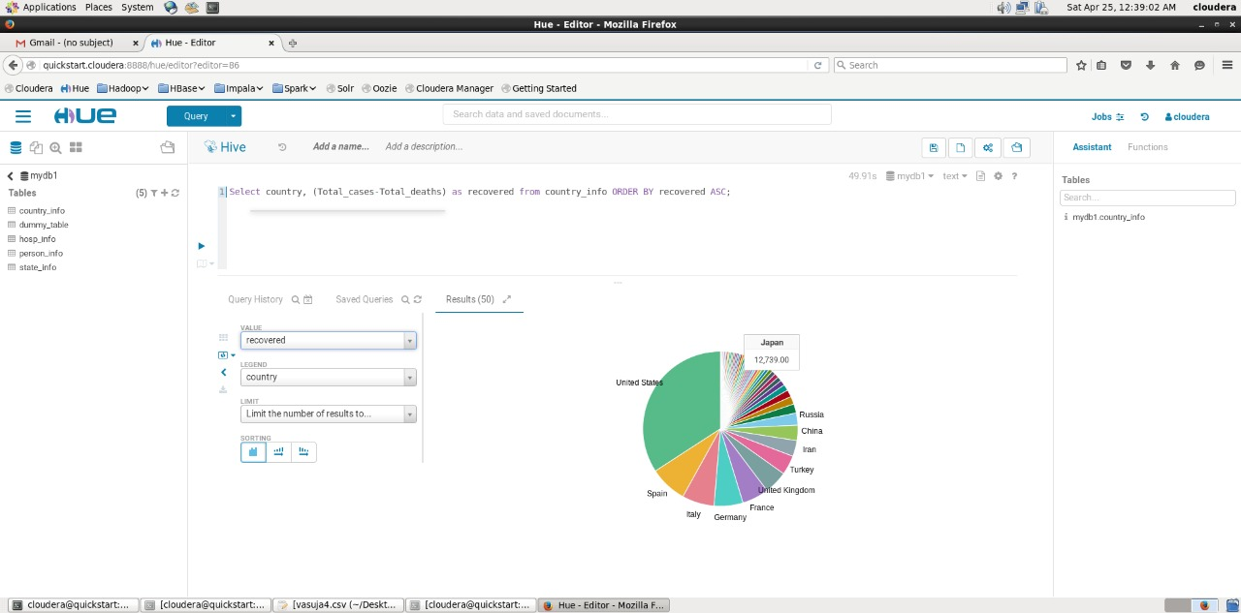

*From the above analysis, It represents the healed patients all across the world are maximum in United States.*

Que3 Display the country having max and min number of cases in the world.

Sol:- **hive> Select country, max(total_cases) from country_info GROUP BY country;**

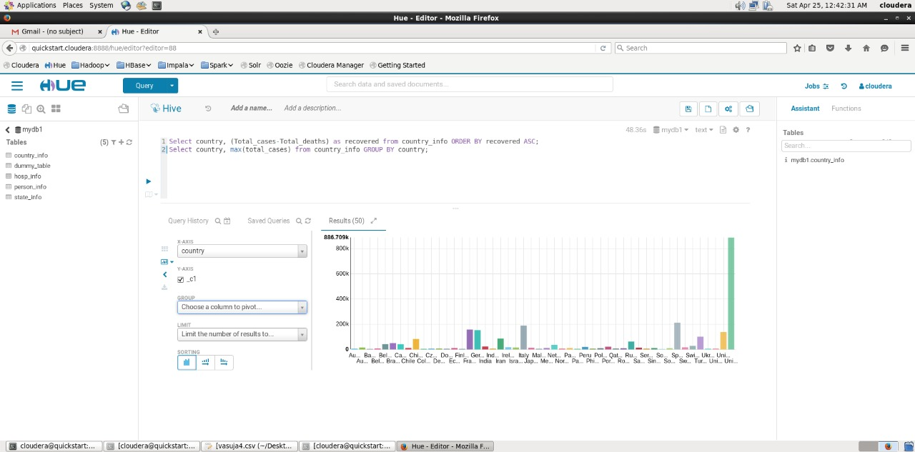

**hive>Select country, min(total_cases) from country_info GROUP BY country**;

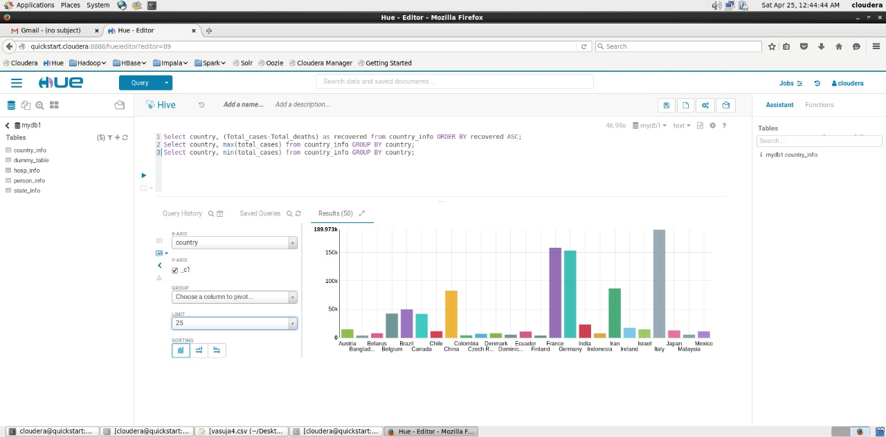

*From the above analysis , the graph represents maximum no. of cases in U.S. and minimum cases (with the limit of 25) in Italy.*

Que4Describe the prevalence of disease among males and females.

Sol:- **hive>Select count(p_gender) from person_info where p_gender = "Male";**

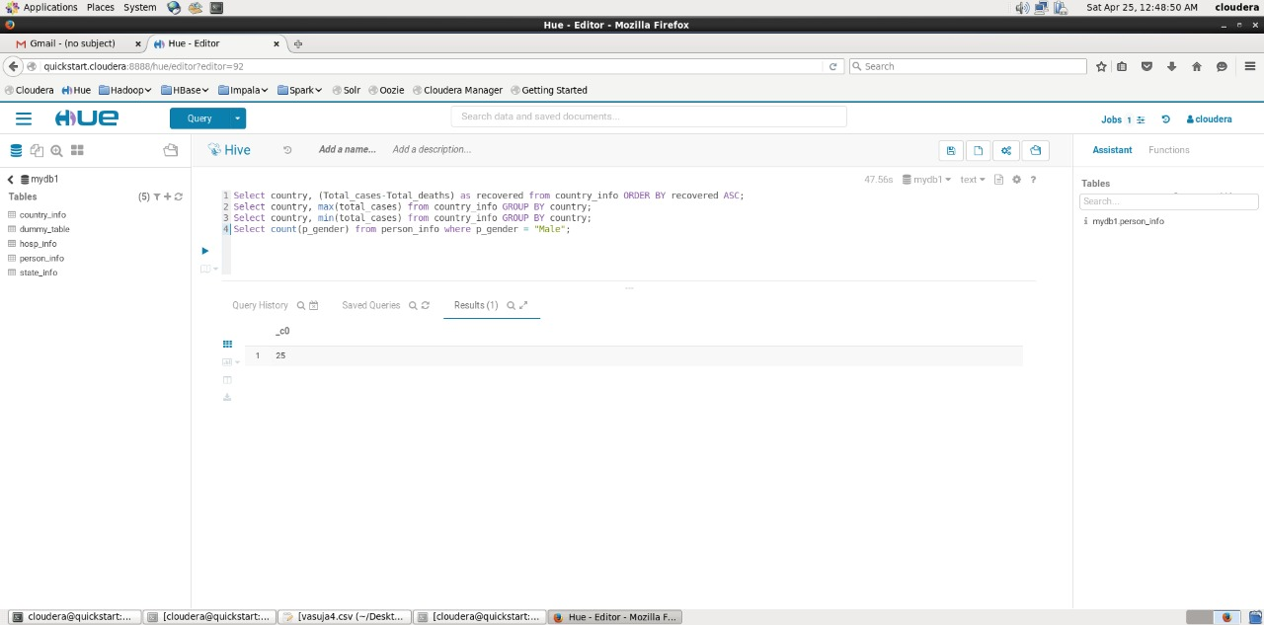

**hive>Select count(p_gender) from person_info where p_gender = "Female";**

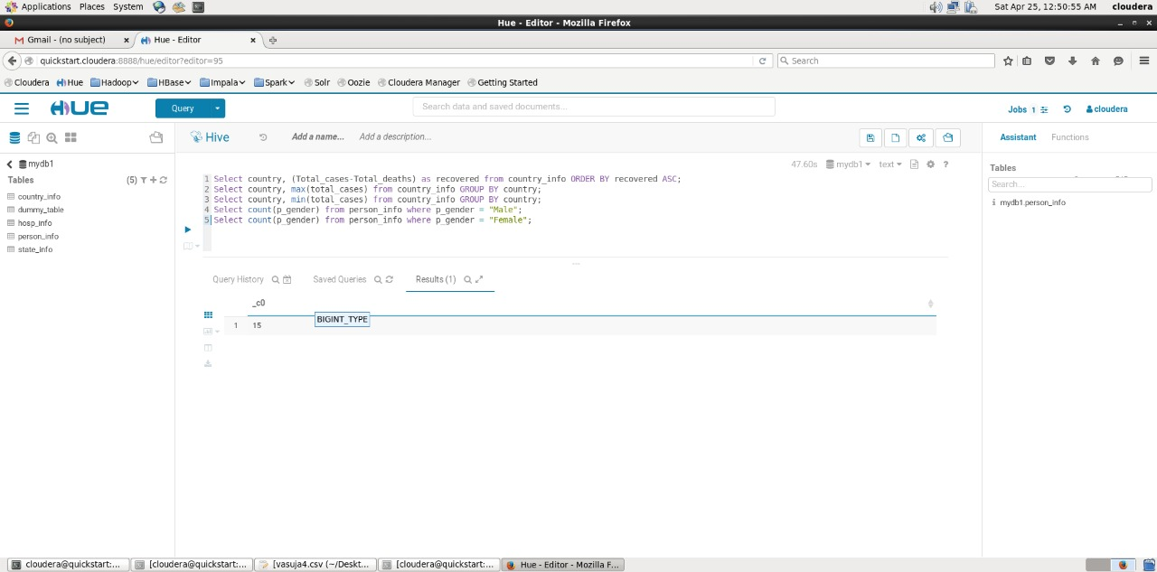

*From the above analysis, Total number of male patients are 25 and total number of female patients are 15 out of 40 patients. Therefore, currently male predominance is shown over females.*

Que5 Describle the prevalence of disease among different age groups in an interval of 20.

Sol:-**hive>Select count (*) from person_info where p_age between "1" and "20";**



**hive>Select count (*) from person_info where p_age between "20" and "40";**

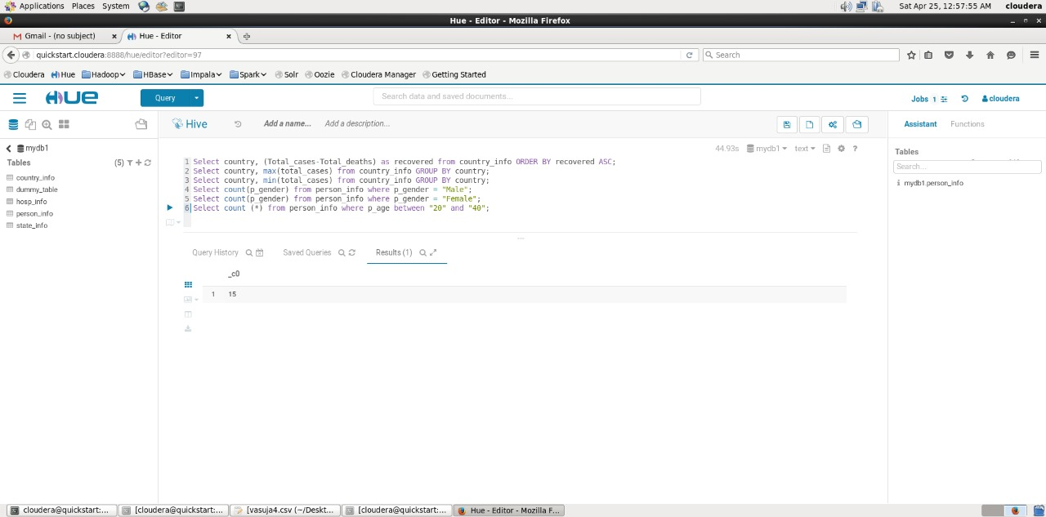

**hive>Select count (*) from person_info where p_age between "40" and "60";**

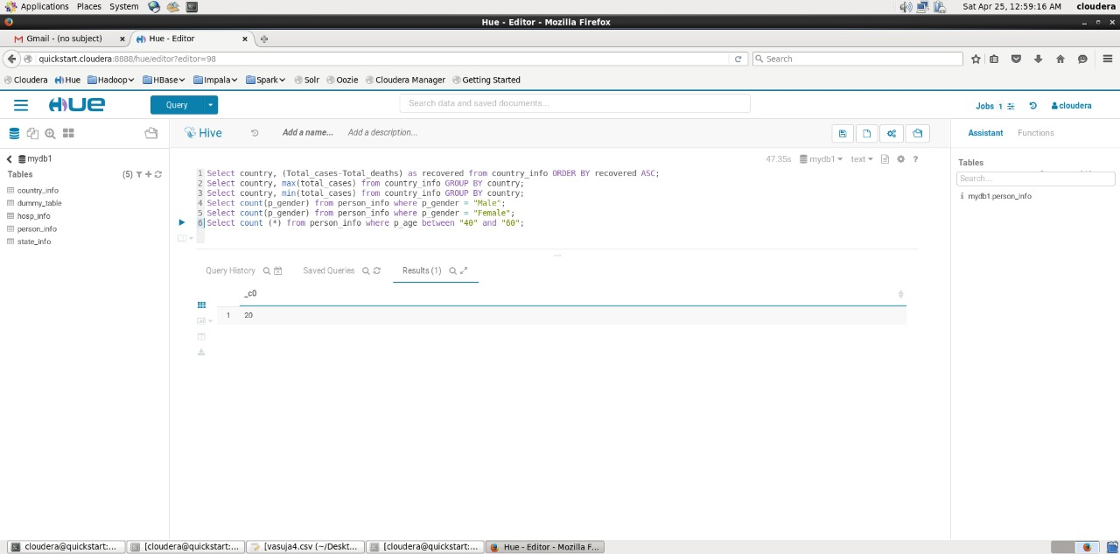

**hive>Select count (*) from person_info where p_age between** "60" and "80";

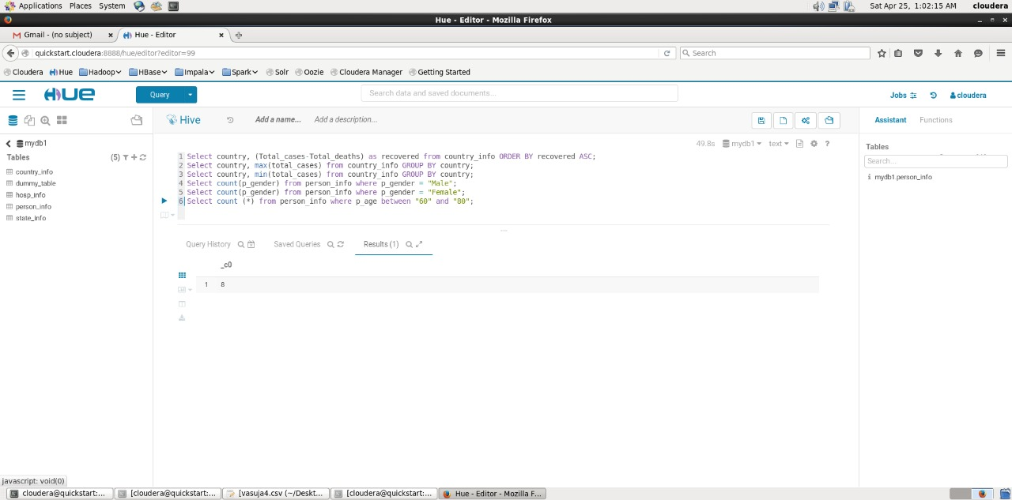

**hive>Select count (*) from person_info where p_age between "80" and "above";**

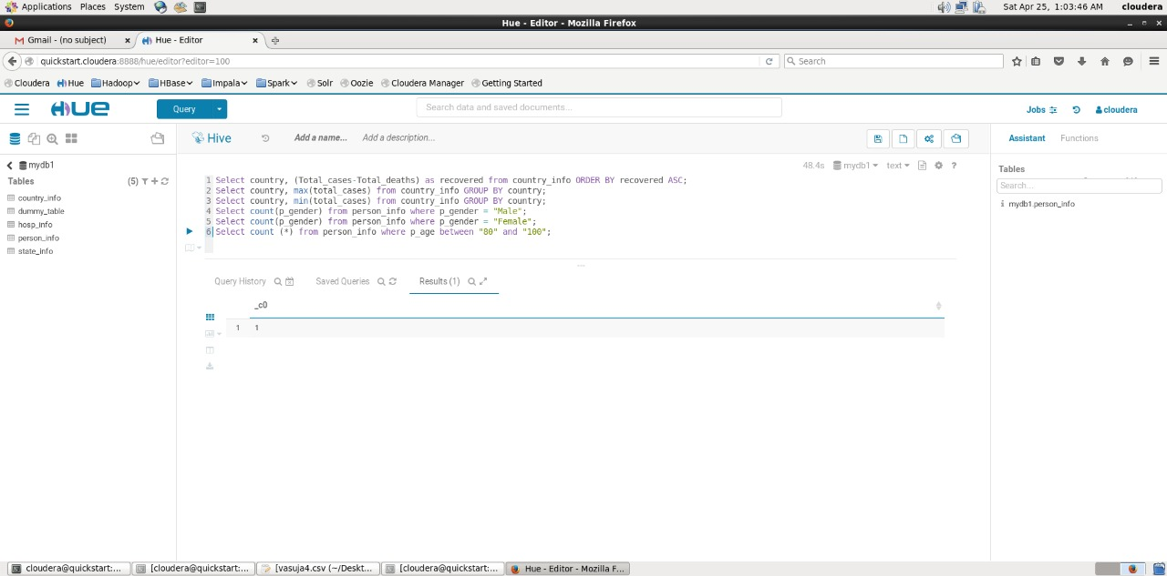

Que6 Count the co-morbidities in individuals such that co-morbidity is unique.

Answer: Select p_co-morbidity,count(p_co-morbidity) from table person_info GROUP BY p_cormorbidity;

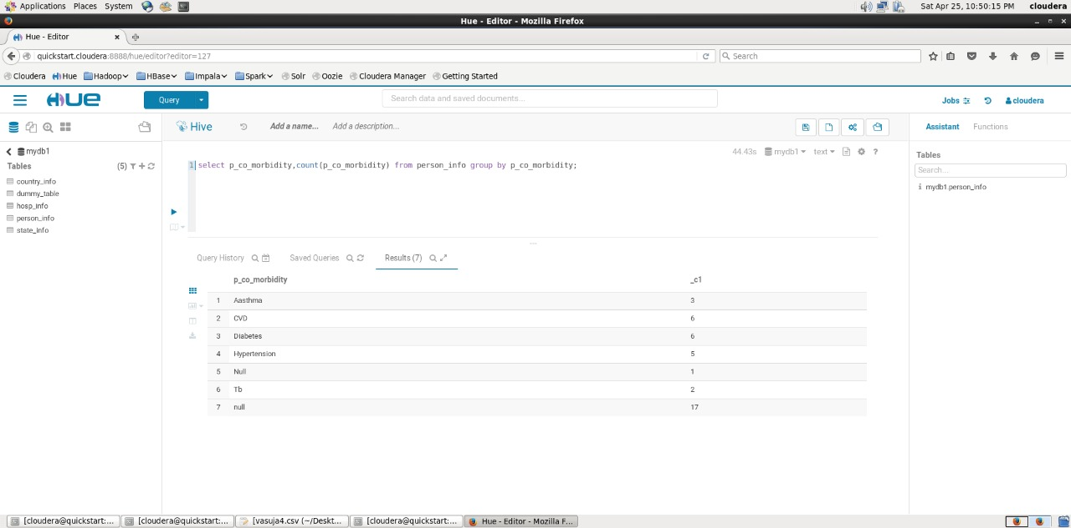

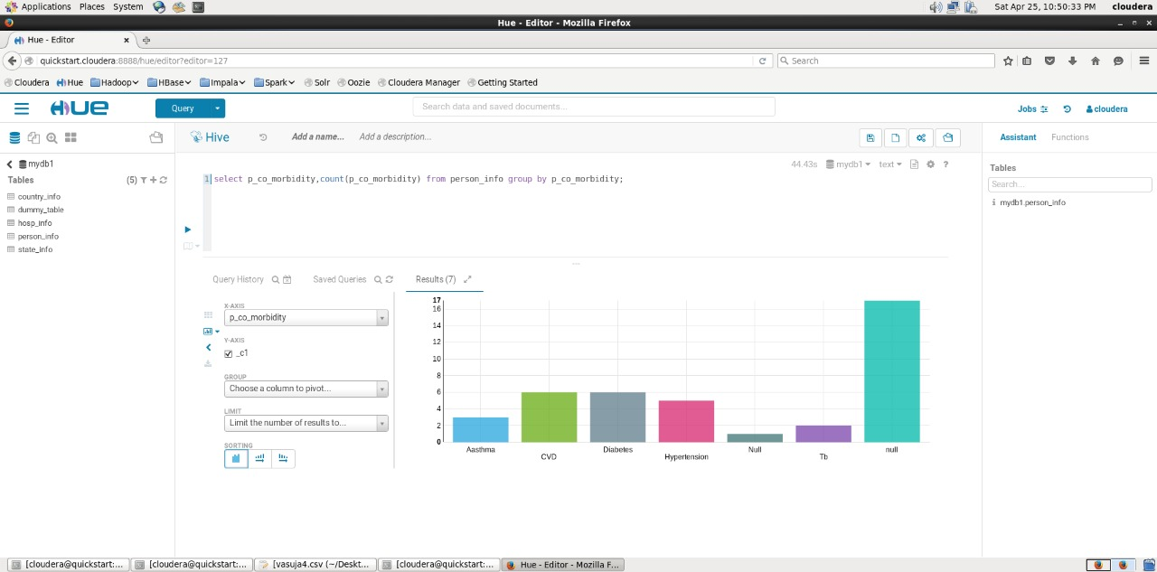

*From the above analysis it can be seen that patients suffering from cormorbidity are mostly diabetic and CVD.*

Que7 Find the max. and min. number of cases among the hospitals.

Sol:- **hive>Select h_name,max(h_total_cases) from hosp_info GROUP BY h_name;**

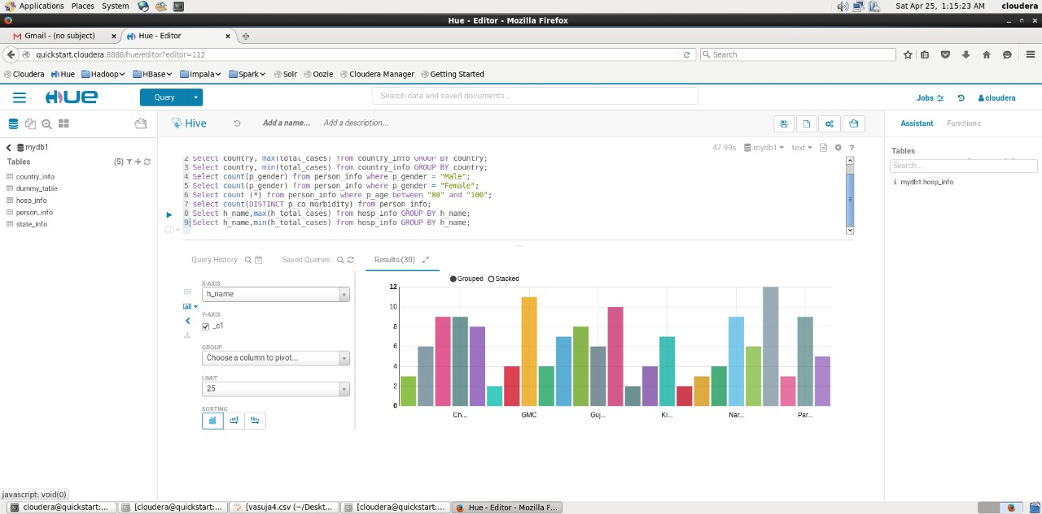

**hive>Select h_name,min(h_total_cases) from hosp_info GROUP BY h_name;**

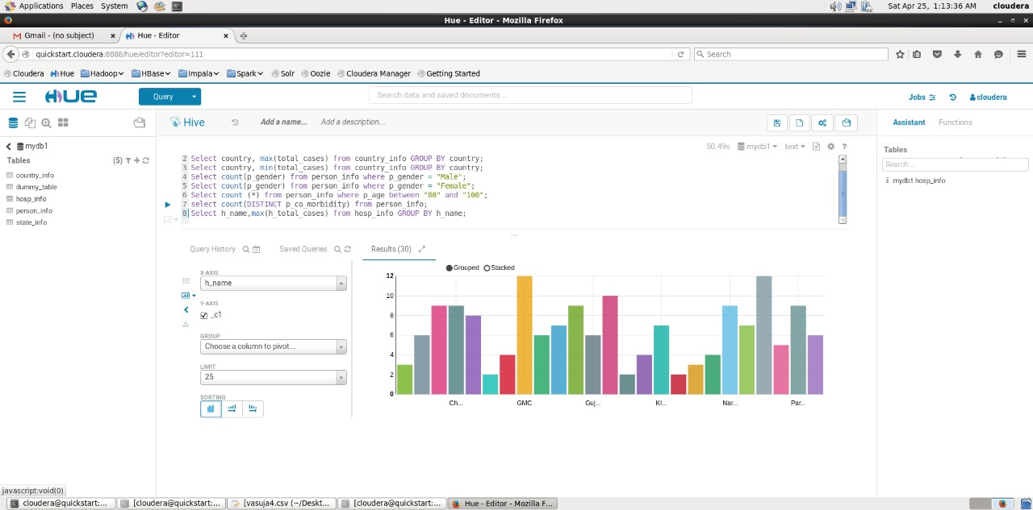

*The above graph represents the maximum and minimum number of cases among different hospitals of different cities . The difference is due to improved healthcare and increased testing among different hospitals of different states.*

Que 8Display the states having deaths Joless than 3

Sol:- **hive>Select states from state_info where total_deaths<3.0;**

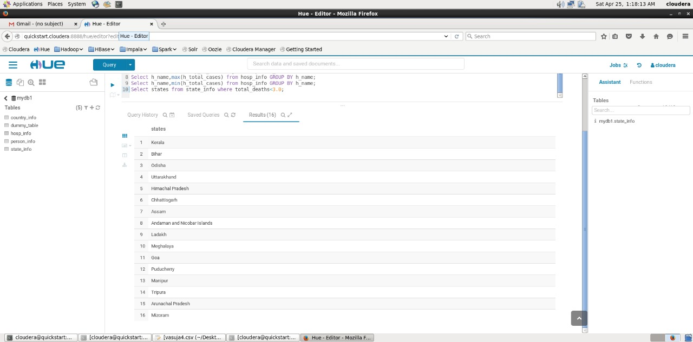

*The above data represents states having <3 deaths as there is very little exposure in these states as well as precautionary measures are being followed*.

Que9 Find the max and min number of cases among the states.

Sol:- **hive>Select states, max(total_cases) from state_info GROUP BY states;**

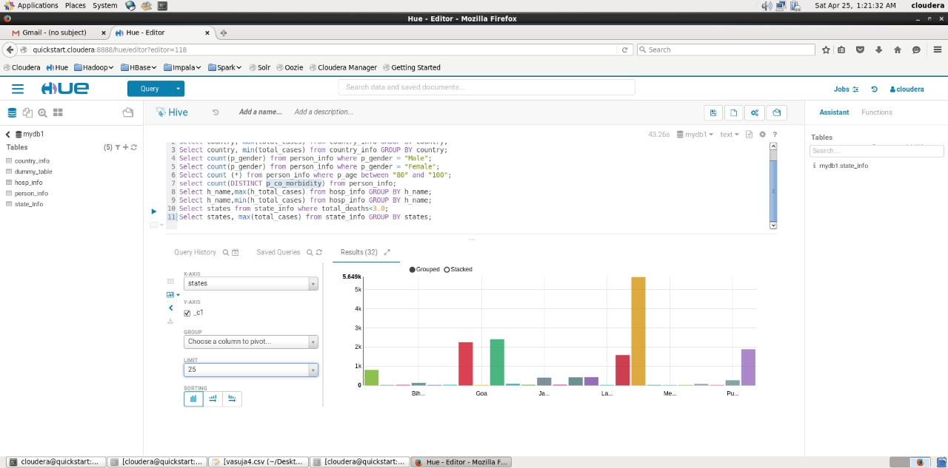

**hive>Select states, min(total_cases) from state_info GROUP BY states;**

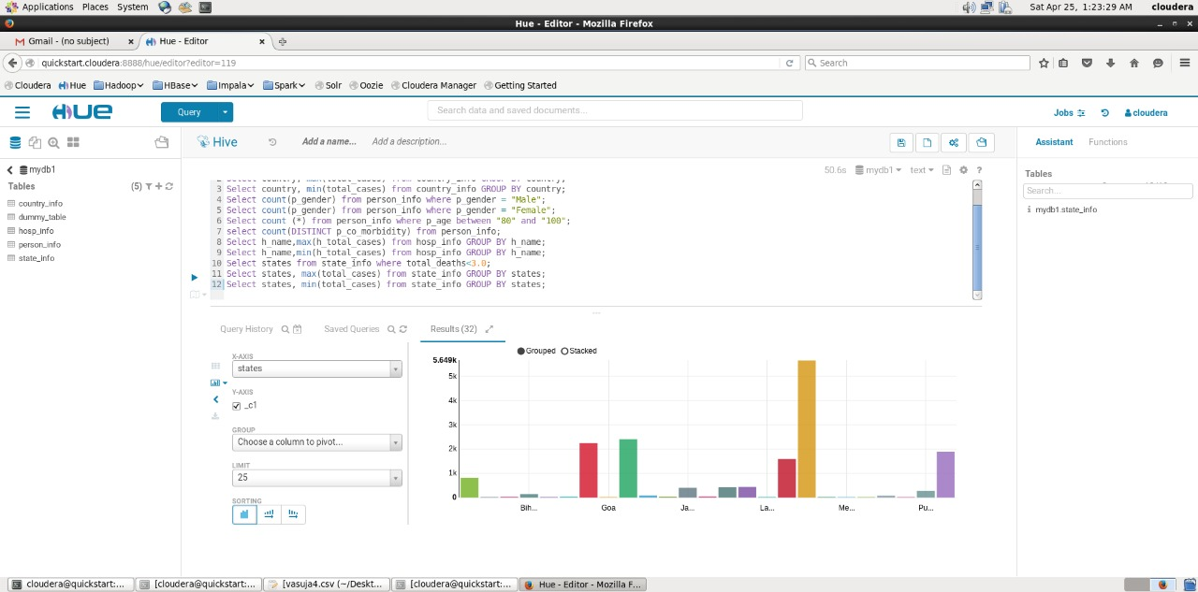

*From above graph, Maharashtra has the maximum no. of cases because of migration and overcrowding in search of employment opportunities.*

Que10 Find healed Patients among all different states.

Sol**:- hive>Select states, (Total_cases-Total_deaths) as recovered from state_info;**

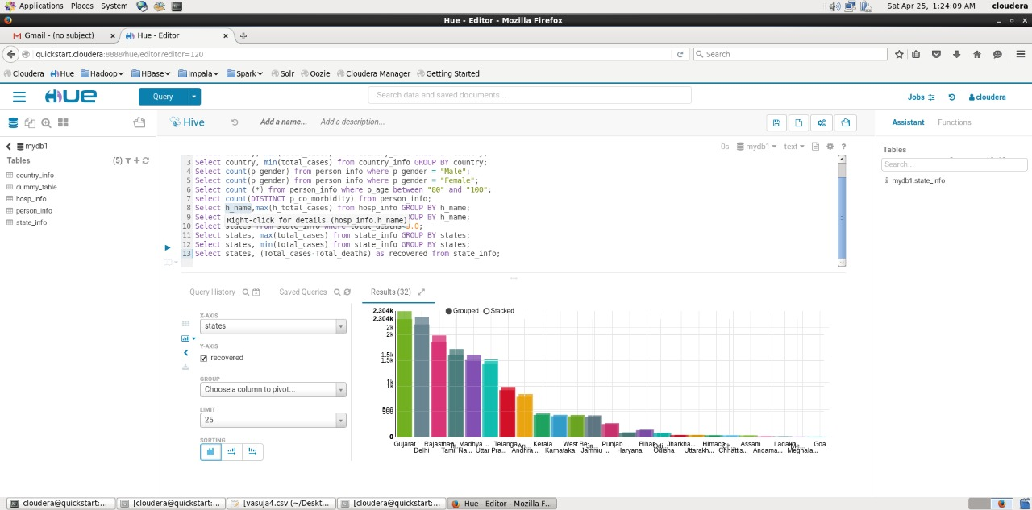

*The above graph shows the no. of healed patients among different states. Gujarat is the state having maximum number of recovered patients.*





