Advanced Functional Thinking

EXPERIMENT :09

Q1. Create a class called Employee whose objects are records for an employee. This class will be a derived class of the classs person which you will have to copy into a file of your own and compile. An employee record has an emplo name (inherited from the class person), an annual salary represented as a single value of type double, a year the employee started work as a single value of type int and a national insurance number, which is a value of type string. Your class should have a reasonable number of constructors and accessor methods, as well as an equals method. Write another class containing a main method to fully test your class definition.

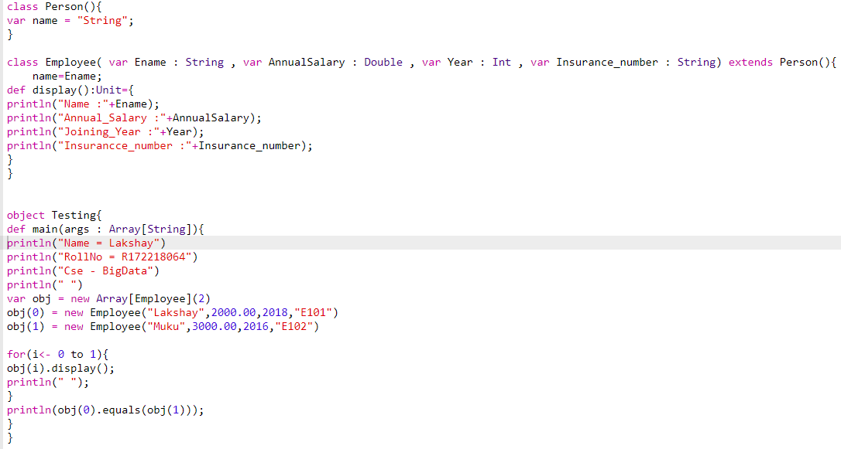

Output:

