**Scala Programming question**

**Question 1** File Dog-scala contains a declaration fo a Dog class. Save this file to your what instance variables and methods are provided. Files Labrador.scala and Yorkshire.scala contain declarations for classes that extend Dog. Save and study these files as well. File DogTestscaIa contains a simple driver program that creates a dog and makes it speak. Study DogTest.scala, save it to your directory, and compile and run it to see what it does. Now modify these files as follows:

1. Add statements in DogTest.scaIa after you create and print the dog to create and print a Yorkshire and a Labrador. Note that the Labrador constructor takes two parameters: the name and color of the labrador, both strings. Don't change any files besides DogTest.scala. Now recompile DogTestscaIa; you should get an error saying something like

Labrador.scala:18: Dog(scaIa.Iang.String) in Dog cannot be applied to ()

1 error

If you look at line 18 of Labrador.scala its just a {, and the constructor the compiler can't find isnt

called anywhere in this file.

a. what’s going on? (Hint: What call must be made in the constructor of a subclass?)

class Labrador(name: String,var color: String) extends Dog(name)

b. Fix the problem (which really is in Labrador) so that DogTest.scala creates and makes the Dog,

Labrador, and Yorkshire all speak.

class Labrador(name: String,var color: String) extends Dog(name)

c. Add code to DogTestscala to print the average breed weight for both your Labrador and your

Yorkshire. Use the avgBreedWeight() method for both .

**Scala Files:**

**Dog.scala**

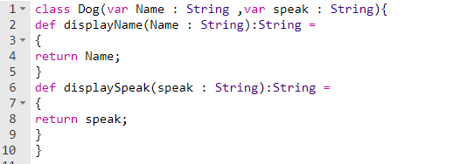

**Labrador.scala**

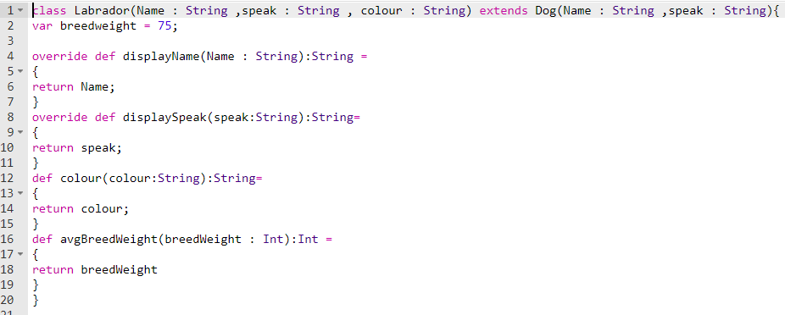

**Yorkshire.scala**

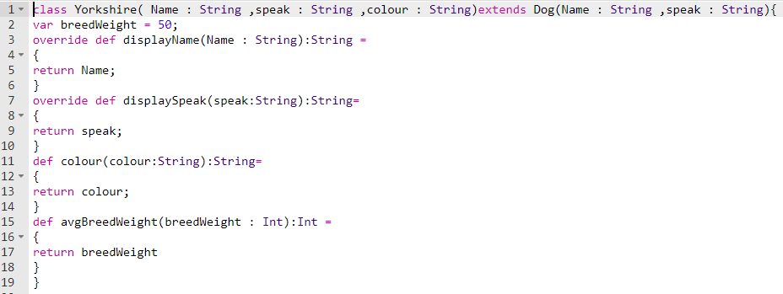

**DogTest.scala**

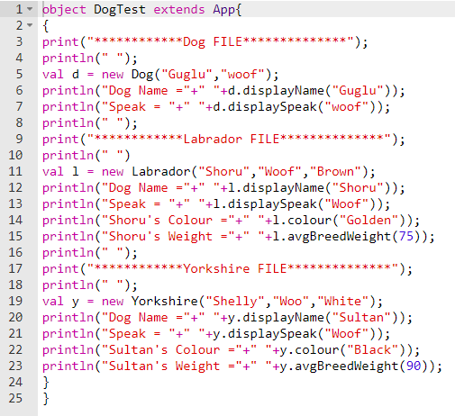

**Output:**

