Advanced Functional Thinking

Lab-5

1. Write a Scala program to sort a numeric array and a string array

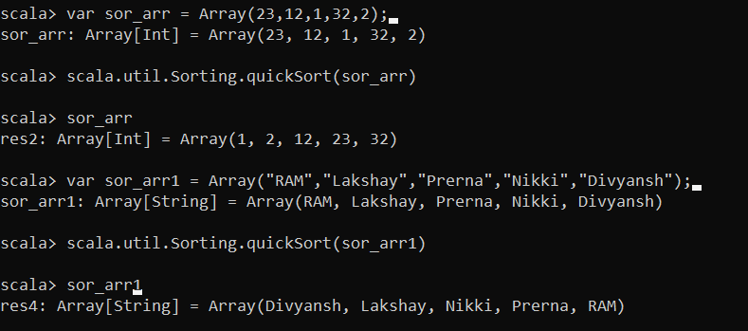

2. Write a Scala program to sum values of an array.

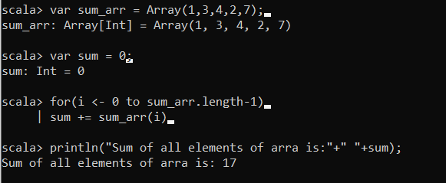

3. Write a Scala program to print the following grid. Expected Output:

- - - - - - - - - -

- - - - - - - - - -

- - - - - - - - - -

- - - - - - - - - -

- - - - - - - - - -

- - - - - - - - - -

- - - - - - - - - -

- - - - - - - - - -

- - - - - - - - - -

- - - - - - - - - -

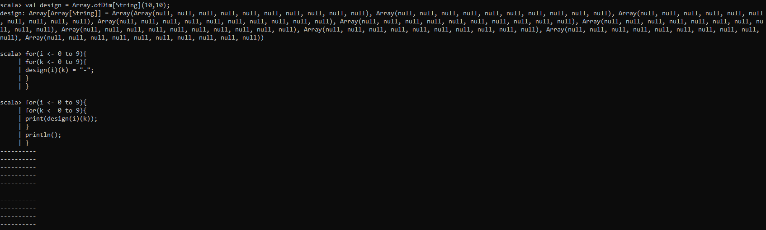

4. Write a Scala program to test if an array contains a specific value.

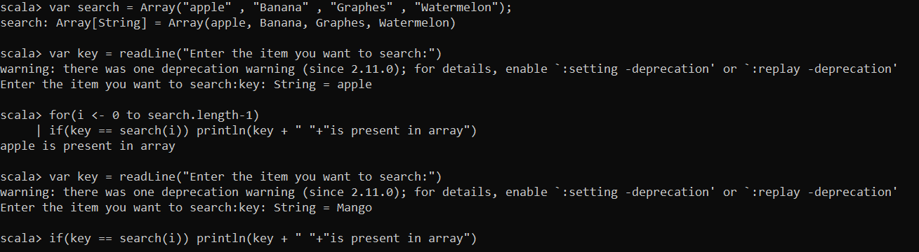

5. Write a program to remove a specific element from an array.

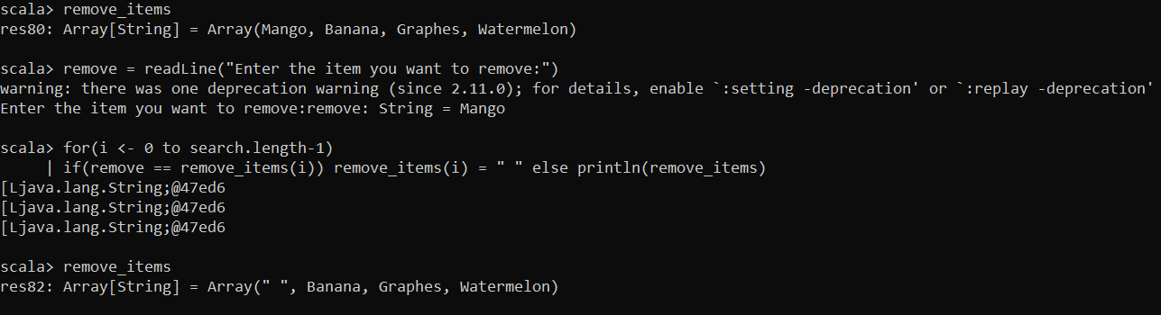

6. Write a program to find the maximum and minimum value of an array.

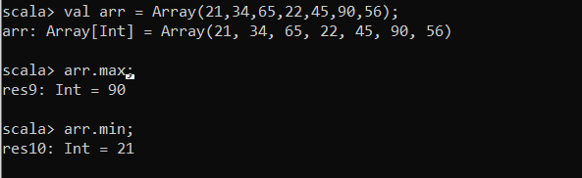

7. Write a program to reverse an array of integer values.

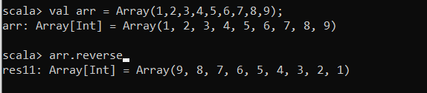

8. Write a Scala program to find the common elements between two arrays (string

values).

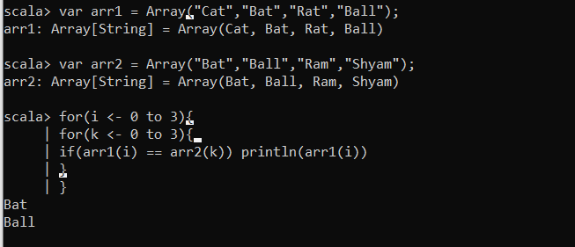

9. Write a program to remove duplicate elements from an array.

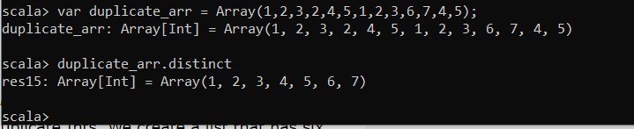

10. Write a program to convert an array to ArrayList.

