### Advanced Functional Thinking

### Lab 6

### Question 1 : Create a class named 'Student' with String variable 'name' and integer variable 'roll_no'. Assign the value of roll_no as '2' and that of name as "John" by creating an object of the class Student.

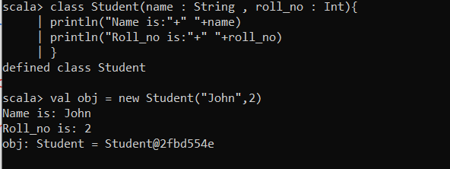

### Question 2: Assign and print the roll number, phone number and address of two students having names "Sam" and "John" respectively by creating two objects of class

### 'Student' .

### 2.PNG

### Question 3:Write a program to print the area and perimeter of a triangle having sides of 3, 4 and 5 units by creating a class named 'Triangle' without any parameter in its constructor.

### 3.PNG

### Question 4: Write a program to print the area and perimeter of a triangle having sides of 3, 4 and 5 units by creating a class named 'Triangle' with constructor having the three sides as its parameters.

### 4.PNG

### Question 5: Write a program to print the area of two rectangles having sides (4,5) and (5,8) respectively by creating a class named 'Rectangle' with a method named 'Area' which returns the area and length and breadth passed as parameters to its constructor.

### 5.PNG

### Question 6: Write a program to print the area of a rectangle by creating a class named 'Area' taking the values of its length and breadth as parameters of its constructor and having a method named 'returnArea' which returns the area of the rectangle. Length and breadth of rectangle are entered through keyboard.

### 6.PNG