Advanced Functional Thinking

Lab 4

Lakshay

R172218064

500067177

CSE-BIGDATA”B2”

Question1 : Create a scala Program to find the 8th character in the string : “University of Petroleum and Energy Studies”

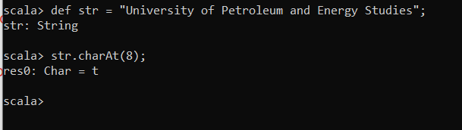

Question 2: Let us assume that you two baskets with bunch of items in each one . The first contains elements : “cake” , “Milk” , “ Cheese” , “Toilet Paper” and the second one has the following items : “Bread” ,”Water” ,” Juice”, ”Milk”, ”Cheese”. Write a scala program to find the common items b/w two baskets.

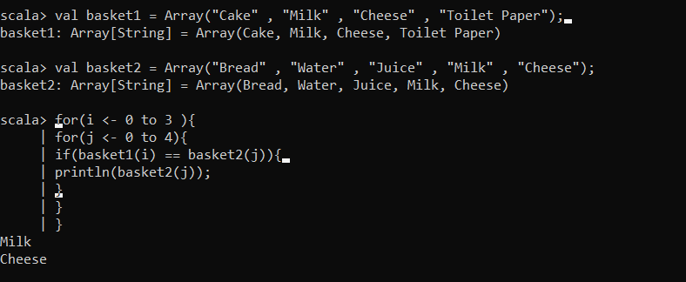

Que3: Assume a shopping basket with the following items: "Milk", "Cheese", "Donuts", "Apples", "Bananas". Represent the above items into an appropriate data structure, and thereafter define and use a value function that will remove all fruit items from the shopping basket. In other words, the shopping basket should only contain items "Milk", "Cheese" and "Donuts". Note also that the resulting output should be represented as an XML element format as shown below.

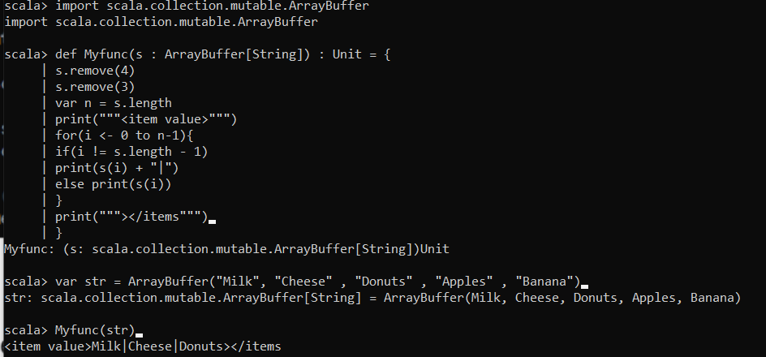

Question 4:  Assume the following lexical coupon codes: "A", "BB", "CCC", "DDDD", "EEEEE". Write a Scala program to create a new set of coupon codes based on the above one. The format for each coupon code should be as follows: "coupon code - i", where the number i is derived from the length of each corresponding coupon code.

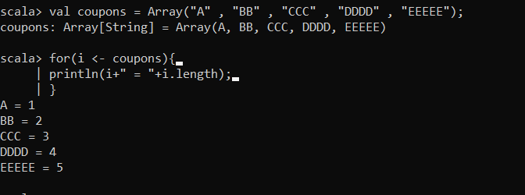

Question 5: Write a Scala script to check a given string is palindrome or not str = “Dot saw I was Tod ”.

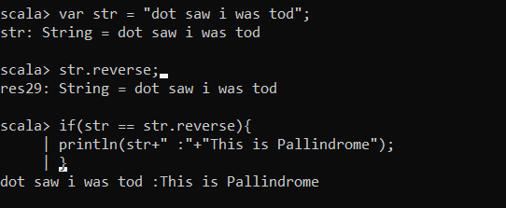

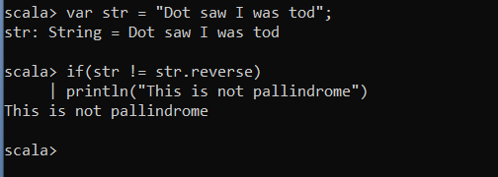

**Note :** When we write our same string using upper case alphabets we get “This is not palindrome” and when we consider whole string as lower case it gives us output as “This is Palindrome”.

Question 6: Write a scala script to find the maximum occurring character in given string str from above?

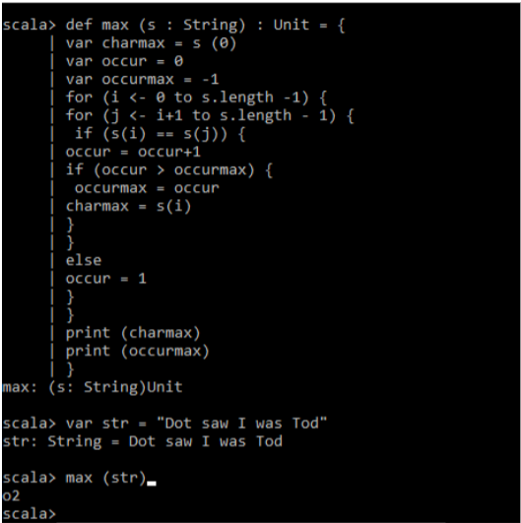

Question 7: Write a scala Program to reverse a string str.

