Advanced functional Thinking Lab 2

3) Print name and age of person in Bold and Underlined form

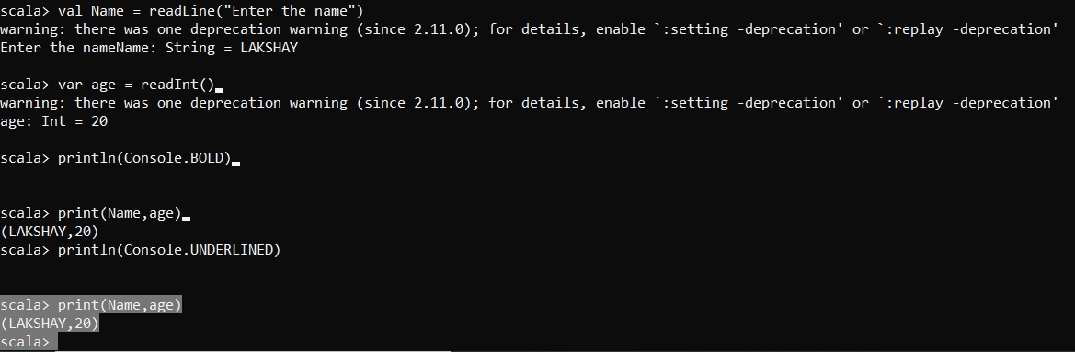

4) Donut Problem

