Advanced Functional Thinking Lab

Experiment -3

Starting console

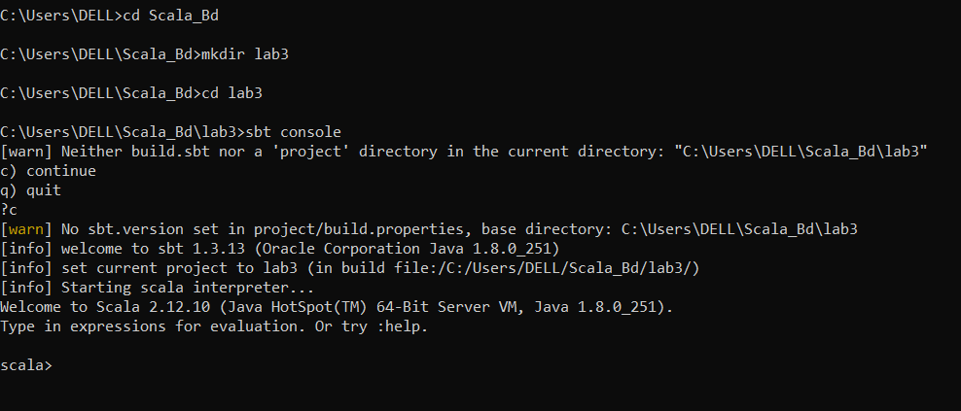

Create a function/method to check given year is leap year or not

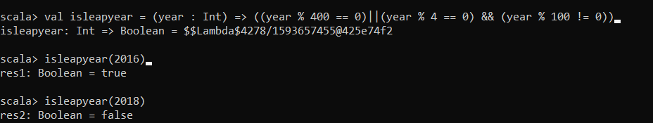

Using recursion print fibonnacie series

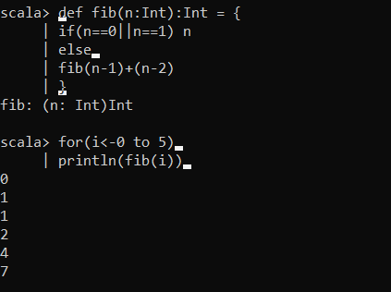

Using inline function calculate volume of a cube

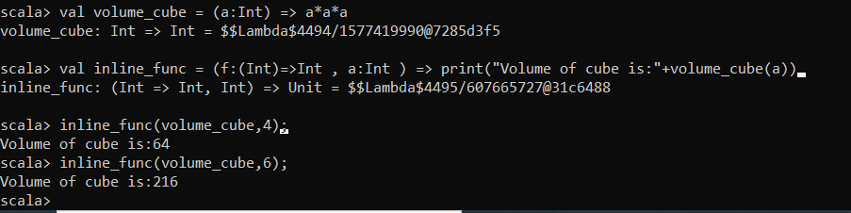

Find G.C.D using recursion

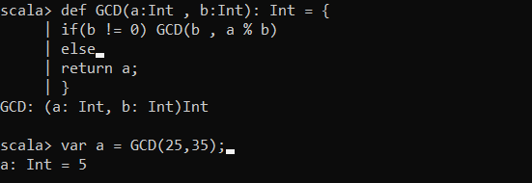

Reverse a string using recursion

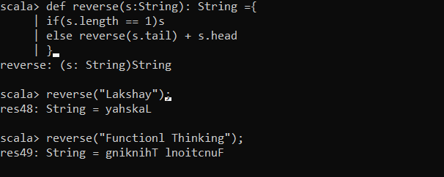

Convert binary number into Decimal and vice versa

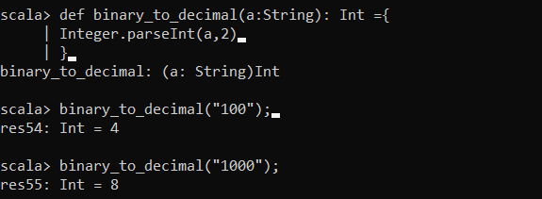

Decimal To Binary

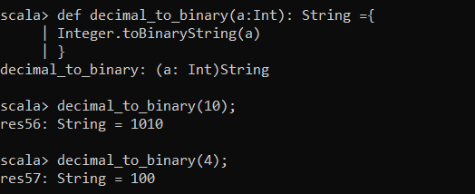

Check whether a number can be expressed as the sum of two prime numbers

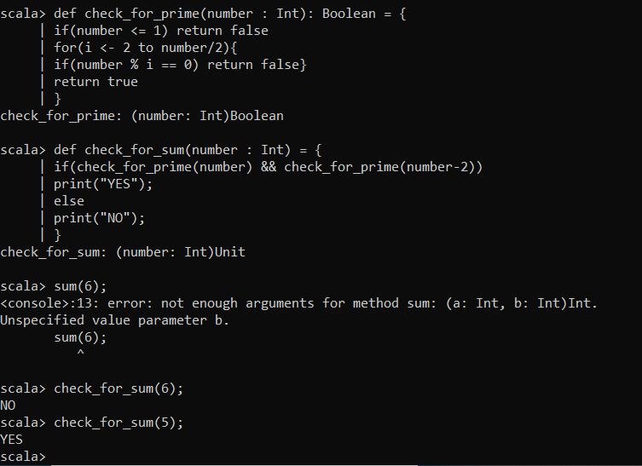

Check prime and Armstrong number by making Function

Prime number

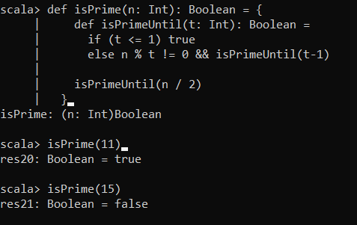

Armstrong number

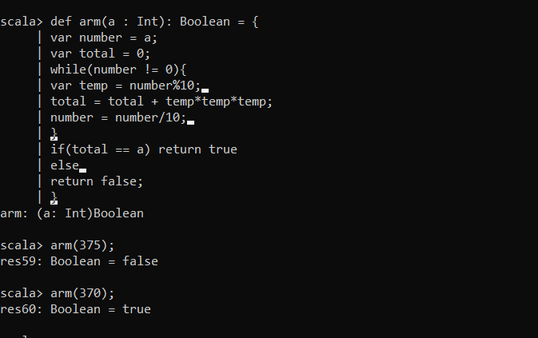

Find Square root of a number using Method

