Advanced Functional Thinking

Lab – 9B

**Question** . Create a trait name student records having five trait variables say,name(str), department (str), roll (int), subject_name (string) ,marks inalso create a trait method to display the marks of a particular student and store the records for all students.

Now, create a class name students details which inherit the propertiesof trait student records, and print the name of the student who scoredhighest marks in any subject.

Create one more trait “student_project” ,trait method pro details which includes project name(str), project credit(int), marks (int) and status (str type having only values pass fail), nowthrough student details class also print the marks and status.

**Code:**

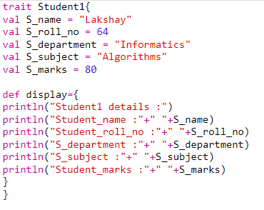

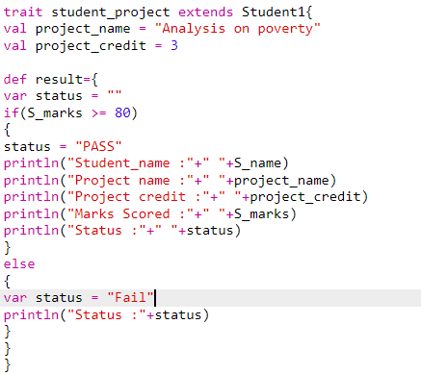

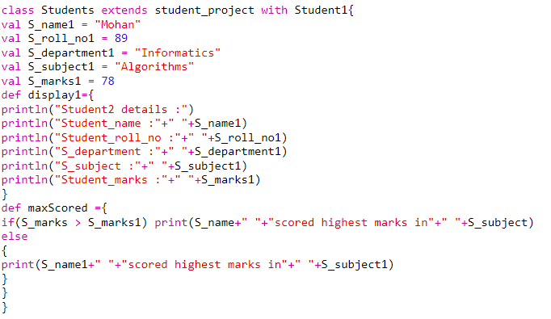

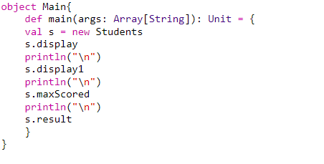

**Output:**

