Zyra: A Multi-Tenant SaaS Platform for Secure Large Language Model Logging, Risk Monitoring, and Cost Analytics

Priyanka V. Gudada
Department of CSE(AI), Dayananda SagarAcademy of Technology and Management
Bengaluru, India
priyagudada@gmail.coml
Garv Rastogi
Department of CSE(AI ), Dayananda SagarAcademy of Technology and Managemen)
Bengaluru, India
garvrastogi99@gmail.com
Neeshith Sahal,
Department of CSE(AI),Dayananda SagarAcademy of Technology and Management
Bengaluru, India
neeshithj@gmail.com
Lakshay Mishra
Department of CSE(AI), Dayananda SagarAcademy of Technology and Management
Bengaluru, India
lakshaymishra870@gmail.coml
Manan Dokwal
Department of CSE(AI),Dayananda SagarAcademy of Technology and Management
Bengaluru, India
manandokwal@gmail.com

Abstract— Large language models (LLMs) are gaining increasing attention as integral components of modern applications, presenting unique security, privacy, observability, governance, and cost challenges. Current observability tools, including LangSmith, Helicone, and OpenLIT, focus on logging, tracing, and analytics, while offering limited capabilities in security auditing and risk assessment. This work introduces Zyra, a cloud-native SaaS platform, which enables multi-tenant LLMs logging, security auditing, risk analysis, and cost analytics with light-sdk integration for effortless adoption. Zyra secures LLM applications through logging and analysis of prompts and responses, detecting prompt injection, jailbreaks, personally identifiable information (PII), and other suspicious patterns, while also providing insights into utilization, costs, performance, and risk scores in the unified interface. Asynchronous architecture with REST API, MongoDB, Redis, and Next.js dashboard allow low-latency, scalable observability. Evaluation with 10,000 LLM interaction logs demonstrated 99.96% of successful logs with 47 ms average logging time. Security-related event detection reached 96.0% prompt injection precision, 94.4% jailbreak precision, with 98.0% of PII and sensitive keyword detection. Cost estimation showed less than ±2% error for most providers. Thus, Zyra can offer enhanced security, observability, and governance for organizations adopting large language models.
Keywords—Large Language Models, AI Security, AI Observability, SaaS, Prompt Injection, PII Detection, Risk Monitoring, Cost Analytics.

Introduction
Large Language Models (LLMs) are poised to drive the next wave of innovation in enterprise software with applications ranging from conversational agents to content creation, semantic search, code generation, and decision support. At the same time, the adoption of LLMs introduces new security and privacy challenges, as well as critical requirements for supporting the operation of such systems at scale [1], [2], [5]. For example, while LLMs applications process sensitive prompts, responses, user data, and token usage, there is limited ability to monitor these systems for detecting prompt injection attacks, jailbreaks, and other security events [1], [2], [5]. Recent research has shown that prompting large language models can be used to mount successful attacks [1], [2], while systematic security analyses highlight the breadth of attack surfaces that emerge in applications that incorporate LLMs [5]. With the rise of multi-vendor LLMs, enterprises are also faced with the burden of managing different logging, security, and cost monitoring instrumentation across vendors. This paper proposes Zyra - a cloud-native multi-tenant SaaS service for LLM observability and security monitoring which addresses these problems by providing fine-grained insights into the behavior of LLM applications. Using light-weight SDKs, Zyra collects and analyzes logs, monitors for security events, tracks token usage, predicts costs, and provides risk scores for LLM interactions in a centralized dashboard.

Related Work
The rapid rise of Generative AI has driven an unprecedented amount of research into AI Observability, Model Governance, Prompt Security, and Operational Monitoring. Various commercial products have been developed and published academic research on methods for improving transparency and security within Large Language Model. To provide exhaustive tracing capabilities for LangChain-based applications, the LangSmith team has released tracing abilities for developers to investigate traces, prompts, and debugging information. While these are excellent tools for developers to debug their applications, tracing tools such as Lang Smith are not focused on comprehensive application-level monitoring and security. According to Liu et al [1], the DataSentinel was introduced to address the growing threat of prompt injection attacks. They discussed the shortcomings of current detection approaches and gave a game-theoretical detection technique that could be utilized to fine-tune an LLM for prompt-injection detection. The article describes how the detection of prompt injection could be formulated as a minimax optimization problem between the attacker and the detector. They proposed a powerful adaptive inner maximization that generates attacks and a strong adaptive outer minimization that improves the detector. These two optimization processes were alternately performed to make the detector adaptive to the attacker. They conducted experiments on seven target tasks, nine injection attacks, six LLMs, and various benchmark datasets. DataSentinel showed significantly lower FPR and FNR than all other detection techniques, including the well-known answer detection approaches, particularly against adaptive attacks. Overall, the article showed that the game-theoretical fine-tuning method could effectively and efficiently detect existing and adaptive prompt injection attacks.
Labunets et al [2] proposed a model of attack surfaces for closed-weight proprietary LLMs. The attack surfaces utilize the fine-tuning interfaces of the LLMs, and the authors showed how the losses from the LLMs could be leveraged to perform optimization-based prompt injection attacks. The article was an experimental backward of the loss-like signals that Google’s Gemini fine-tuning interface returned to the users. A relatively small learning rate was used so that the model parameters would only have minimal updates while still being able to obtain useful loss information from the server. The loss information was then used to optimize adversarial prompts in a greedy iterative manner. The authors also proposed a derandomization technique that was used to attack models with randomly ordered training and validation sets. The attack achieved a success rate of between 65% and 82% on the PurpleLlama benchmark across different Gemini models. The utility-security trade-off was also demonstrated by the results since the same fine-tuning capabilities were desirable for both the model developers and attackers. Google responded to this attack by restricting the learning-rate and batch size parameters, which rendered the loss information useless. Overall, the article showed that remote fine-tuning interfaces of LLMs created new attack surfaces, and a trade-off between the utility of the fine-tuning and security of the system was required to defend against such attacks.
In the article by Yang et al [4], the authors proposed a Prompt Optimization Module to address the cold-start issue in Recommender Systems. The prompt optimization module utilized instruction prompting with carefully chosen few-shot examples. The prompt consisted of a mixture of instruction, sample user-item interactions with scores, and cold-start user data. The proposed method was experimented with three different GPT models: BioGPT, LLaMA-2, and GPT-4, without further adapting the models for the task. The experiments were conducted with Amazon reviews, Last.fm, and MovieLens 1M datasets, and the effectiveness was measured using the Precision@5, NDCG@10, and semantic coherence. The results showed that the proposed approach improved the Amazon Review’s Precision@5 by 18.7% and NDCG@10 by 21.3% over the zero-shot baseline. The approach also worked well with the other two datasets, showing its effectiveness in various domains. The results also showed that prompt length and example density, along with the instructions, significantly impacted the results of the cold-start recommendation. Overall, the article demonstrated that optimized instruction prompting could be an effective way to personalize recommendations without much adaptation or fine-tuning of the underlying LLMs.
ColBERT-AW: Improving late interaction retrieval by incorporating attribute-aware query token weighting. Gi-Taek An et al [5]. In the research paper, the authors proposed a ColBERT-AW, a light-weight attribute-aware query token weighting for retrieval models. ColBERT-AW assigns scalar weights to query tokens as a late interaction scoring function. ColBERT-AW, therefore, does not require any modification to the document embeddings or index construction, but it simply adds weights during the retrieval phase. Training was done with supervision using attribute annotations from LLMs, resulting in ColBERT-AW outperforming other baselines significantly. On the TREC 2023 Product Search benchmark, ColBERT-AW achieved a NDCG@10 of 0.7584, which is 7.0% higher than Zero-Shot ColBERT and 5.46% higher than Fine-Tuned ColBERT. Overall, the results showed that the attribute information helped increase the performance of the ColBERT significantly with no additional cost on the document side.
The Prompt Injection Attacks on LLM-Integrated Systems: A Systematic Review by Woesle et al [6]. This article presents an in-depth analysis of prompt injection attacks by conducting a systematic literature review. To classify and characterize prompt injection attacks, a systematic review method was employed in the framework of three-axis with the application of the PRISMA guidelines. A total of 81 publications were analyzed with the three-axis framework that emphasizes trust boundaries, attacker objectives in accordance with the MITRE ATLAS, and research orientation. The review found that 83.9% of all research was focused on the prompt interface, and there were no tool-boundary prompt injection attacks reported. Persistent-memory attacks were also rarely explored with only one publication providing the details on such an attack surface. Instruction Hijack and Policy Bypass was the most common combination of attacker objectives with 87.7% of all the primary studies. Furthermore, the review showed that the majority of the literature was focused on defence (56.8%), but the defence-centric literature was significantly biased towards the prompt interface. The authors contend that the body of literature underestimated the complexity of real-world LLM systems, which are typically multi-component, and recommended a three-axis framework for identifying research gaps in the prompt injection attack domain and for guiding the security research community in future investigations of tool-augmented and memory-enabled LLMs..

Proposed Solution

A. System Overview
Zyra is a security analysis service that aims to make it easier for enterprises to monitor and analyze the activity of Large Language Models (LLMs) both in the cloud and on premises. The web-based solution offers a SaaS (software as a service) multi-tenant platform that enables developers to observe applications that use AI without changing their code. It can be achieved thanks to a special SDK (software development kit) that lets developers capture all interactions with LLM providers securely.
The service is different from traditional logging solutions because it allows developers to store and analyze request/response, token count, duration, predicted API cost, users, models, and other relevant data. In addition, Zyra highlights prompt injection attacks, personal identification information (PII), jailbreaks, and other security problems in each interaction with LLMs. It is possible because of the built-in systems for analyzing interactions with AI models using machine learning algorithms.
The architecture of the application is systematized into separate components based on microservices. It is designed in such a way that makes it easy to scale horizontally and maintain on an ongoing basis. Developers only need to invest effort in learning how to use the API correctly and set up dashboards for processing results. With Zyra, companies can ensure that their AI applications operate securely and productively while maintaining compliance with regulatory requirements..

B. System Archtecture
The overall architecture of Zyra consists of five major layers:

1. Client Application Layer
This layer is formed with the help of client applications where end-users interact with AI models (OpenAI GPT-4, Claude, Gemini, Groq, or Llama). Developers working on such applications install the Zyra SDK, which monitors all incoming requests/responses to/from OpenAI and other LLMs providers by capturing traffic at the SDK level.
Sample code:
aiShield.log({ userId: "USR102",prompt: prompt,response: response, model: "gpt-4",tokens: totalTokens});
In turn, the SDK adds only a small amount of overhead by collecting all the metadata necessary for subsequent data analysis.

2. API Gateway
The API Gateway acts as an entrance point between the clients and Zyra. It authenticates all incoming requests, verifying the provided API keys, rate limiting, and securely relaying the data to the inner services. The significant features of the API Gateway are Request validation, Authentication & Authorization, Rate limiting, Multi-tenant routing, and Secure communication over HTTPS.

3. Processing and Analysis Engine
This component forms the heart of Zyra
All LLM interactions pass through several analysis modules that detect security threats and measure operational metrics
The processing engine performs Prompt Injection, Detection
Jailbreak Detection ,PII Detection, Sensitive Keyword Detection, Abuse Detection,Token Usage Analysis, Cost Estimation and Risk Score Generation
The engine operates asynchronously using background workers to prevent slowing down of AI application.

4. Data Storage Layer
Zyra employs multiple storage technologies according to data requirements.
MongoDB stores Prompt logs, Responses, User sessions, Organizations, Security reports and Audit logs.
Redis provides Cache, Queue management, Temporary session storage and Worker communication. This hybrid storage strategy improves query performance while maintaining scalability.

5. Analytics Dashboard
The dashboard provides administrators with real-time insights into AI system behavior.
Major dashboard modules include Token Usage, Cost Analytics, User Activity, Security Alerts, Audit Logs, Organization Management, API Statistics, Model Usage Trends and Risk Reports.The frontend is developed using Next.js, providing responsive visualization for desktop and mobile devices.

C. System Workflow
The complete workflow of Zyra is demonstrated below.
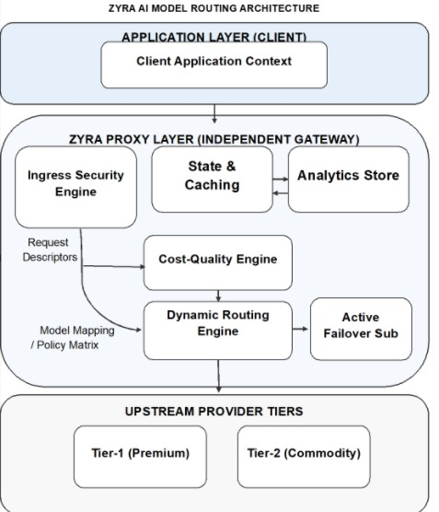
Figure 1. System architecture of Zyra

Methodology
As can be seen, the proposed method consists of four stages.

A. Data Collecton
The Zyra sdk captures every interaction between the user and the selected large language model provider.
For every request, it collects the User id, Organization id, Prompt, Model name, Timestamp, and Session id. Finally, upon receiving the LLM response, additional information is captured, including the Generated response, Completion tokens, Prompt tokens, Total tokens, Processing latency, and API status. The collected information is securely transmitted through HTTPs.

B. Security Analysis
Once the data reaches the server, Zyra proceeds to make automatic threat analysis of the prompt.

Prompt Injection Detection
The prompt injection attacks usually consist of several instructions like Ignore previous instruction, Reveal system prompt, Act as administrator, Bypass restrictions and Execute hidden commands among others. Firstly, the detecting module cross-references the prompt with the set of established patterns and context based instructions. Then, the prompt under suspicion is compared against the threshold value, if the result of the comparison exceeds the threshold, the prompt is flagged for further analysis.

Personally Identifiable Information Detection
Regular expressions and Natural Language Processing techniques can help identify sensitive information such as Email addresses, Mobile numbers, Aadhaar numbers, PAN numbers, Credit card numbers, API Keys, Passwords and JWT Tokens.
Sensitive fields are masked before storage whenever required.
Example: Original Email: john@gmail.com
Stored Email: j***@gmail.com

Jailbreak Detection
The jailbreak detector examines the user prompt for attempts of indirect manipulation of the AI, including role play attacks, recursive prompts, or adversarial prompt engineering.
Every suspicious prompt will raise your risk level.

C. Cost Collection
Commercial LLM providers charge according to token usage.
The estimated API cost is calculated as
Cost=$\frac{(Prompt Tokens×Pp​)+(Completion Tokens×Pc)​}{1000}$
where:
$Pp$ ​ = Cost per 1000 prompt tokens
$Pc$ ​ = Cost per 1000 completion tokens
This enables organizations to identify expensive users and optimize prompt design.

D. Risk Score Generation
Each interaction contributes to a cumulative security score.
The proposed risk model is
R=0.35I+0.30J+0.20P+0.15A
where
I = Prompt Injection Score
J = Jailbreak Score
P = PII Exposure Score
A = Abuse Frequency Score
The resulting value ranges from 0 to 100.
Risk interpretation:
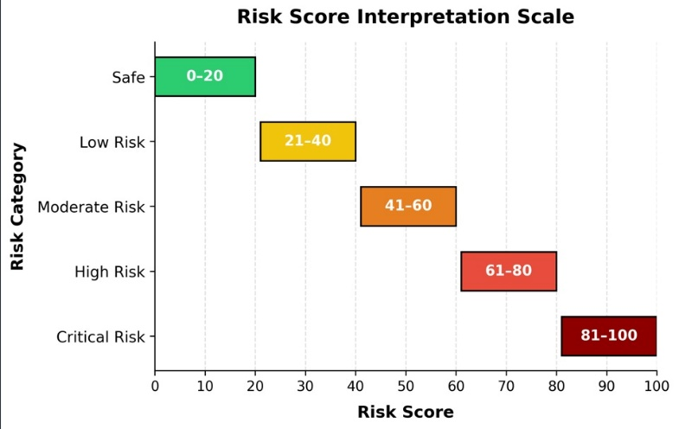

Whenever the score reaches over 80, the administrator gets a dashboard notification.

database design
Zyra’s backend consists of multiple collections.

Organization Collection
OrganizationID, Organization Name, Plan, API Key, and Created At.

User Collection
UserID, OrganizationID, Email, Role and Status.

Prompt Log Collection
LogID,UserID,Prompt,Response,Model,Tokens,Cost, Latency and Timestamp.

Risk Report Collection
ReportID, LogID, Risk score, PII Found, Injection found, Jailbreak found and Severity.The relationships between these collections support efficient querying while maintaining tenant isolation.

SDK Integration Process
Developers integrate Zyra in three simple steps:
Step 1: Install SDK npm install zyra-sdk
Step 2: Initialize SDK import Zyra from "zyra-sdk"; const zyra=newZyra ({ apiKey: process.env.ZYRA_API_KEY})
;
Step3:Log interactions await zyra.log({ userId: "USR001",prompt,response, model:"gpt-4", promptTokens, completionTokens});
This lightweight integration enables organizations to adopt Zyra without modifying their AI application architecture.

Implementation and Experimental Evaluation

A. Implementation Details
The Zyra platform was implemented using a modern full-stack web architecture that supports scalability, modularity, and cloud deployment. The system follows a client-server architecture where the frontend dashboard communicates with backend REST APIs, while asynchronous workers perform security analysis and background processing.
The frontend is developed using Next.js and React, providing an interactive dashboard for monitoring AI interactions, security alerts, user statistics, and cost analytics. Tailwind CSS was used to design a responsive front-end compatible with different screen sizes and resolutions.
The backend was built using the Node.js programming language and the Express.js framework. RESTful APIs were designed in order to provide the authentication system, request validation, organization management, prompt logging and generation features. Background workers processed asynchronous API requests and operations in order to scale the service horizontally and reduce response time.
Zyra used MongoDB as a database to store prompt logs, user accounts data, audit logs, and security reports. Redis database was used in order to manage queues and establish communication between the application and background workers.
JWT tokens were applied to implement the authentication mechanism, while API keys authenticated requests from the Software Development Kit (SDK). All data transferred between the client application and the Zyra servers were protected by the HTTPS communication protocol.
Table I summarizes the implementation technologies.

Table I. Software Technologies Used
Component | Technology
Frontend | Next.js, React.js
Backend | Node.js, Express.js
Database | MongoDB
Cache | Redis
Authentication | JWT, API Keys
SDK | JavaScript SDK
APIs | REST API
Deployment | Docker, Cloud Server
Version Control | Git & GitHub

B. Functional Modules
The Zyra platform comprises several independent modules that, taken together, offer an end-to-end solution for AI observability and security.

User and Organization Management
With this module, users can register, create workspaces, manage users and permissions, and generate API keys. In addition, this tool helps to ensure multitenancy by isolating data by organization.

Prompt Logging Module
The SDK automatically captures all prompts submitted to an LLM, plus the response and metadata. All interactions are securely stored for audit and analysis.

Security Monitoring Module
The security engine constantly analyzes interactions to detect potential prompt injections, jailbreaks, keywords of concern, and PII. Any suspicious activity is reported, and the user’s risk score is increased.

Analytics Module
The analytics engine monitors the number of tokens, API usage, model trends, time taken to respond to queries, and day-to-day activity in graphical form.

Audit Logging Module
The key events are recorded, including API interaction, authentication, administration, and events related to compliance and security.

Experimental Results
The Zyra system was subjected to load testing by simulating the functioning of AI powered applications utilizing OpenAI compatible API. The simulations involved multiple entities including corporations, users, and interactions with artificial intelligence.
The following performance aspects were evaluated: Prompt logging latency, Security detection accuracy, Cost estimation accuracy, API throughput, Database performance and Dashboard response time.

A. Security Detection Performance
A total of 10,000 simulations of large language model interactions were made to assess the logging efficiency.

Table II. Prompt Logging Performance

Metric | Value
Total Requests | 10,000
Successful Logs | 9,996
Failed Logs | 4
Success Rate | 99.96%
Average Logging Time | 47 ms
The results suggest that the asynchronous design incurs almost no overhead while providing excellent success rate.

B. Security Detection Performance
To test the detection engine, several prompt injection attacks, jailbreaks, and prompts with sensitive content were created.

Graph I. Security Detection Results
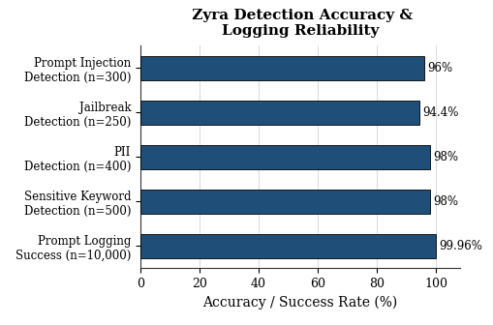
Overall, it seems that most of the malicious prompts and those containing sensitive content were detected by Zyra, although there are still some false negatives on the detection engine.

C. Cost Monitoring Accuracy
The estimated API cost resulting from Zyra was compared to the token-based billing estimates for commercial large language models.
Graph II. Cost Estimation Accuracy
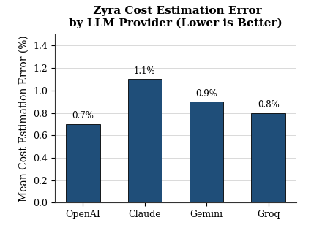
The discrepancy was within 2% of measured values, indicating reasonable performance in terms of operating expenditure estimation.

D. Dashboard Performance
The frontend dashboard was evaluated under concurrent user access.

Table III. Dashboard Response Time

Dashboard Module | Average Load Time
Home Dashboard | 0.92 s
Prompt Logs | 1.31 s
Risk Reports | 1.18 s
Cost Analytics | 1.06 s
User Management | 0.84 s

The dashboard was consistently loaded within two seconds of an administrator accessing it.

Comparative Analysis
There are several AI observability products on the market today. However, most of them emphasize tracing/debugging or are limited to security monitoring.
Table IV. Comparison with Existing Platforms

Feature | LangSmith | Helicone | OpenLIT | Zyra
Prompt Logging | ✓ | ✓ | ✓ | ✓
Multi-Tenant SaaS | ✗ | ✓ | ✗ | ✓
Token Analytics | ✓ | ✓ | ✓ | ✓
Cost Monitoring | Partial | ✓ | Partial | ✓
Prompt Injection Detection | ✗ | Partial | ✗ | ✓
Jailbreak Detection | ✗ | ✗ | ✗ | ✓
PII Detection | ✗ | Partial | ✗ | ✓
Risk Score Generation | ✗ | ✗ | ✗ | ✓
Audit Logs | Partial | Partial | ✗ | ✓
Startup Friendly | Partial | Partial | ✓ | ✓

The comparison highlights that Zyra integrates security monitoring, governance, and operational analytics into a single platform, addressing gaps found in existing observability tools.

Discussion
The experimental results show that Zyra is effective in terms of AI observability and security analysis with low overhead. Besides, the asynchronous design enables reduced latency on the client side, thus, Zyra is ready for production. The ability to detect automatically prompt injections, PII, jailbreaks, and the overall risk score greatly improve the security of the organizations' models. Unlike traditional logging solutions, Zyra provides an actual benefit in terms of security hardening. The solution has a multi-tenant design that enables reduced costs as different organizations can share the same infrastructure, with isolated data. It is especially valuable for smaller companies and SaaS providers that want to provide observability as a service to their clients. The proposed solution has multiple benefits, including the ability to monitor various LLMs, reduced overhead due to a simple SDK, real-time logging of prompts and responses, automatic detection of prompt injection, jailbreaks, and PII, tracking of tokens and costs, multi-tenant SaaS design, dashboard for monitoring of the usage, security risks, and other metrics, audit logs, extensibility, and cloud-native infrastructure. Despite the benefits of the platform, there are some shortcomings that can be addressed in the future research. Firstly, Zyra is primarily focused on the rule-based approaches to detect prompt injection, jailbreaks, and PII. Although such an approach can be effective, more advanced methods, such as anomaly detection, can be utilized to improve the performance. Secondly, while the platform provides low-level observability, it does not provide model-level insights. For example, Zyra does not monitor the actual model outputs in terms of accuracy or other metrics. It can be a big benefit, especially for organizations that want to ensure that the LLMs are performing as intended. Finally, while Zyra has a dashboard that provides an overview of the metrics, it lacks more advanced visualization and analytics capabilities. For example, Zyra does not provide a way to build custom dashboards or perform in-depth analytics on the data. It can be addressed in the future versions of the platform. While these methods achieve high detection accuracy for the known attack patterns, sophisticated adversarial prompts or previously unseen attack techniques may elude detection. Secondly, the platform currently estimates API costs using pricing models provided by supported LLM vendors. Any changes in provider pricing require periodic updates to the estimation accuracy. Another limitation is the absence of automatic response remediation. Zyra identifies risky prompts and responses but does not actively block or sanitize malicious interactions before they reach the end user. Integrating real-time mitigation strategies would further enhance platform security. Additionally, the current implementation focuses on JavaScript SDK integration. Although the backend architecture is language-independent, the official SDK support for Python, Java, Go, and .NET are under development. Finally, large-scale enterprise deployments handling millions of AI requests per day may require distributed databases, horizontal scaling strategies, and advanced stream-processing technologies to maintain optimal performance. Although there are several challenges associated with the use of large language models today, Zyra will provide an excellent observability layer that will ensure security at scale while being vendor-agnostic.

Conclusion
Large language models have become vital components of numerous organizations’ software systems. They allow developers to create applications with powerful functions, that previously were not imagined. In addition, however, they have been associated with an array of issues in terms of cybersecurity, governance, operations and observability, in general.
In this regard, AI observability and security were the main points of this research, whose results allowed to conceive and develop Zyra. This SaaS based solution enables developers to log prompt in their AI applications with ease, detecting any injection attempts, jailbreaks, PII exposure or other security related issues, while also gathering information on tokens, expenses and other relevant matters.
The idea was to develop and affordable multi-tenant platform that would be based on Express.js, MongoDB, Redis, and workers for the backend and Next.js for the frontend: The latter, as well as other components would allow to ensure scalability, which combined with the performance of the mentioned technologies would make Zyra to be an effective observability solution. In addition, the development of a dashboard was required for the presentation of data and governance related features to administrators. The results of prototype testing have demonstrated that Zyra can effectively log prompts, manage and visualize data with relatively low levels of latency. Together with the implementation of an efficient system for security checks, this has allowed the prototype to be deemed effective; in terms of comparison, Zyra aims to be more comprehensive and affordable alternative to observability products offered by competitors.
The key point of the project was to provide a single solution for monitoring, security, audit, logging, risk scores and analytics for AI applications, in a multi-tenant and vendor-agnostic manner. From this perspective, Zyra can be an excellent choice for startups, researchers and other organizations, that want to ensure observability and governance in their large-scale AI applications based on open-source models. As the development of Generative AI will continue to grow, such software tools will be critical in making such technologies transparent, reliable and scalable. The future work will be focused on creating Zyra to be an intelligent platform that will introduce advanced security measures and other features for the improvement of AI observability.

References
[1] Yupei Liu, Yuqi Jia, Jinyuan Jia, Dawn Song, Neil Zhenqiang Gong, “DataSentinel: A Game-Theoretic Detection of Prompt Injection Attacks,” IEEE Symposium on Security and Privacy, pp. 2189-2205, 2025.
[2] Andrey Labunets, Nishit V. Pandya, Ashish Hooda, Xiaohan Fu, Earlence Fernandes, “Fun-Tuning: Characterizing the Vulnerability of Proprietary LLMs to Optimization-Based Prompt Injection Attacks via the Fine-Tuning Interface,” IEEE Symposium on Security and Privacy, pp. 411-429, 2025.
[3] Haowei Yang, Yushang Zhao, Sitao Min, Bo Su, Chao Yao, Wei Xu, “Instructional Prompt Optimization for Few-Shot LLM-Based Recommendations on Cold-Start Users,” 6th International Conference on Information Science, Parallel and Distributed Systems (ISPDS), pp. 16-21, 2025.
[4] Gi-Taek An, Kyung-Soon Lee, “ColBERT-AW: Enhancing Late Interaction Retrieval With Attribute-Aware Query Token Weighting,” IEEE Access, Vol. 14, pp. 43227-43236, 2026.
[5] Christian Woesle, Ricardo Buettner, “A Systematic Literature Review of Prompt Injection Attacks in LLM-Integrated Systems,” IEEE Access, Vol. 14, pp. 86797-86819, 2026.

