

|  |  |
| --- | --- |
|  | International Journal of Scientific Research in Computer Science, Engineering and Information Technology [ISSN : 2456-3307](http://ijsrcseit.com/) (www.ijsrcseit.com) |

doi : <https://doi.org/10.32628/CSEIT1217368> **Android App for Women Safety**   
Dr. K Srinivas*1, Dr. Suwarna Gothane1, C. Saisha Krithika2, Anshika2, T. Susmitha2   
 1CSE, JNTUH/CMRTC/Professor, Hyderabad, Telangana, India   
2CSE, JNTUH/CMRTC/B. Tech Student, Hyderabad, Telangana, India

ABSTRACT

Article Info The usage of smart phones equipped with GPS navigation unit have increased Volume 7, Issue 3 rapidly from 3% to more than 20% in the past five years. Hence, a smart phone Page Number: 378-386 can be used efficiently for personal safety or various other protection purposes especially for women. This app can be activated by a single click when the user Publication Issue :   
 feels she is in danger. This application communiqués the user’s location to the May-June-2021 registered contacts for every few seconds in the form of message. Thus, it acts like a sentinel following behind the person till the user feels she is safe. This Article History paper presents analysis a unique feature of this application to send the message Accepted : 20 May 2021 to the registered contacts continuously till they are pressing ‘HELP’ button. Published : 29 May 2021 Continuous location tracking information via SMS helps to find the location of the victim quickly and can be rescued safely. This application aims to ensure women safety. This is achieved by addressing the circumstances that compromise the safety of women in today’s day and age. This app ensures women are not put into such situations through various features offered by our system.

Keywords : - Smart Phone, Android, Registered Contacts, GPS location, database, URL.

I.INTRODUCTION

In today’s world, it is not safe for a person to travel alone at night especially for women; it will be high time to travel alone because a woman is not highly strong as men to protect herself from them. The good way to reduce chances in becoming a victim of violent crime (robbery, sexual assault, rape, domestic violence) is to identify and call on resources to help you out of unsafe situations. Whether you are in instant trouble or got separated from friends during night and do not know to reach home, having these

apps on your phone can diminish our risk and bring assistance when we require it. In this paper, we present Security Alert an application for smart phones working over android platform. National Crime Records Bureau of India, reported incidents of crime against women increased 6.4% during 2012, and a crime against a woman is committed every three minutes. 65% of Indian men believe women should tolerate violence in order to keep the family together, and women sometimes deserve to be beaten. In January 2011, the International Men and Gender Equality Survey (IMAGES) Questionnaire reported

Copyright: © the author(s), publisher and licensee Technoscience Academy. This is an open-access article distributed under the 378

terms of the Creative Commons Attribution Non-Commercial License, which permits unrestricted non-commercial use,

distribution, and reproduction in any medium, provided the original work is properly cited



Dr. K Srinivas et al Int. J. Sci. Res. Comput. Sci. Eng. Inf. Technol, May-June - 2021, 7 (3) : 378-386

that 24% of Indian men had committed sexual violence at some point during their lives. Our motto in developing this app is to provide a safe environment to women through smart phone as today most of the people are carrying smart phones to wherever they go. Of course, the Delhi Nirbhaya case has made the Government to make the laws tougher, but even though the sexual crime rate in India have not decreased. So, it is better to take our own safety measures rather than becoming a victim of those crimes. This paper is organised as follows. Section– II describes the literature survey of the existing apps and the related work of creating the application. Section – III presents the proposed work and key features of the application. Consequently, the implementation of the application is described in the section IV. The section – V presents the testing results of the application after installing in the smart phone. Finally, section –VI concludes the paper and presents the future work for the paper explained in the Section – V and the work presents the final conclusion in the Section – VI.

II.RELATED WORK

As a part of literature survey, we investigated some applications of women safety that already exist in market. The aim is to observe how these applications work and to see how they can be improved and how are they different. To date it is identified that the following Android Apps of women security are good and are offering relatively similar service.

A. WOMEN’S SECURITY: This app is developed by AppSoftIndia. The key features of the app are: the user has to save some details. These details include: Email address and password of the user, Email address and mobile number of the recipient and a text message. Then, app is loaded as a “widget”, so that when the user touches the app, it alerts the recipient. Another key feature of app is that it

records the voice of surroundings for about 45 seconds and this recorded voice, text message containing location coordinates of the user is sent to the recipient mobile number. [4]

B. POLICE NEARBY: This app is developed by Big Systems in 2013.The police nearby scanner android app is built with the aim to connect citizens & students to their nearest police stations city wise at one click and will permit the community to become more involved right from your Android Smart phones. Any local, state, or school, College police department as well as other law enforcement agencies can use Police scanner Android App to provide you with enhanced service and get better communication. Police nearby app is free to download without signup. [5]

C. SCREAM ALARM: Scream Alarm, an android application developed by Go Pal AppMaker in November 2013. By clicking this app, it generates a very high-volume scream in times of distress when the lungs of a person fail in screaming in trouble. The generated scream is in a woman’s voice is severely helpful in discouraging the potential strong trouble makers. The only work done by this application is whenever the person pushes or touches the application, the phone screams loudly with a woman’s voice. [6] The applications mentioned above work on different platforms, some apps work on Android, Windows, IOS but some only in android or windows. But this application Security Alert is designed only for android platform but in future it can be extended to work over Windows and IOS platforms. Android platform is open source and was built using open Linux Kernel in order to enable the developers in creating fascinating mobile applications that will take full advantage of the handset offers. A Virtual Machine is designed and utilised by Android in order to optimize the memory and hardware resources of mobile environment. Android can be

Volume 7, Issue 3, May-June-2021 | http://ijsrcseit.com 379

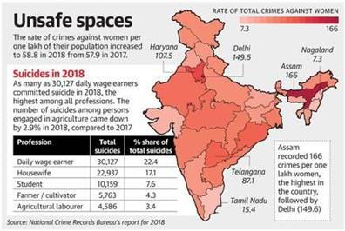

Dr. K Srinivas et al Int. J. Sci. Res. Comput. Sci. Eng. Inf. Technol, May-June - 2021, 7 (3) : 378-386

enlarged adequately to merge new cutting-edge reported rape cases in the year, 8% were from the

technologies as they emerge. Hence, android Dalit community.

platform will always continue to be evolved as a

developer community in order to build innovative applications for mobile environment.

In today's world, people using smart phones have increased rapidly and hence, a smart phone can be used efficiently for personal security or various other protection purposes. The heinous incident that outraged the entire nation have waken us to go for the safety issues and so a host of new apps have been developed to provide security systems to women via their phones. This paper presents, an Android Application for the Safety of Women and this app can be activated this app by a single click, whenever need arises. A single click on this app identifies the location of place through GPS and sends a message comprising this location URL to the registered contacts and also call on the first registered contact to help the one in dangerous situations.

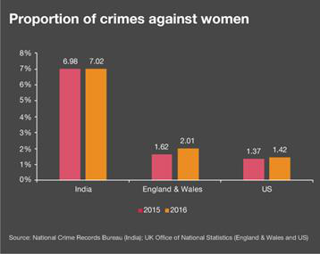

Fig.1. Statistics of international crime records.

In figure 1 as per the horrifying statistics, every 16 minutes, a woman is raped somewhere in India, and every four minutes woman experiences cruelty at the hands of her in-laws. In 2016, the country had recorded 88 rape cases every day. Of the total 32,033

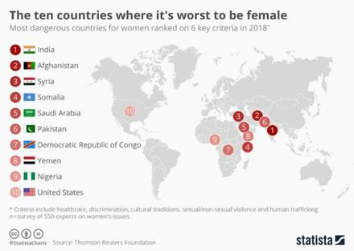

Fig.2. Survey of countries for crime on women

In figure 2 the majority of cases under crime against women under IPC were registered under ‘Cruelty by Husband or His Relatives’ (30.9%) followed by ‘Assault on Women with Intent to Outrage her Modesty’ (21.8%), ‘Kidnapping & Abduction of Women’ (17.9%) and ‘Rape’ (7.9%) The crime rate registered per lakh women population is 62.4 in 2019 in comparison with 58.8 in 2018”, the data shared by NCRB showed.

Fig.3.Rate of total crimes against women.

Volume 7, Issue 3, May-June-2021 | http://ijsrcseit.com 380

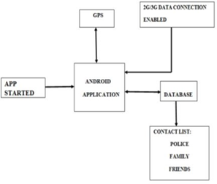

Dr. K Srinivas et al Int. J. Sci. Res. Comput. Sci. Eng. Inf. Technol, May-June - 2021, 7 (3) : 378-386

III.PROPOSED WORK   
 FEATURES OF THE PROJECT In this proposed system, the user writes the message

content and also selects the contacts to which the message has to be sent and save it. So, when he is in some danger by just opening the app and pressing the HELP button, the message stored will be sent to those

To reduce user effort and solve problems inherent to the cellular phones small screen, several functions are provided on the cellular viewer.

|  |  |  |
| --- | --- | --- |
| numbers he has added in this application. So that he | • | Supports multiple connections at the same time. |
| can receive the help in correct time. | • | Different work modes: "view only" and "full |

control".

|  |  |  |
| --- | --- | --- |
| ADVANTAGES | • | Different display modes: "windowed", "full |

screen", and "scaled".

|  |  |  |  |  |  |  |  |  |  |
| --- | --- | --- | --- | --- | --- | --- | --- | --- | --- |
| 1. | Your | loved | ones | and | close | friends | can | • | Runs as a service on the NT systems. |
| automatically receive text message. | | | | | | | | • | Works through the firewalls and supports |
| 2. Exact time of the alert triggered. Your location | | | | | | | | • | DHCP. |
| (with map link). | | | | | | | | Supports high screen resolutions and color |
| 3. The battery level of your phone. | | | | | | | | depths. |

4. It monitors the frequent no of shakes in a

particular locality or area and marks that particular location as DANGERZONE.

5. Automatic prompt for activating location.

6. Self-defense video for guiding victim, how to remain safe and protect in dangerous situations arising.

The proposed architecture depicted below shows the exact flow of control of the android application. Here the database acts as a storing media between the two mobile devices. The database information i.e., to which database the information has to be sent, the URL of the database is coded itself in the application.

|  |  |
| --- | --- |
| MODULES | From the database, the location coordinates are sent continuously to the registered contacts of the user. |

Help Button   
Which is useful for the user when he is in some   
problem or needs any help? When the user opens this   
application, he can see a HELP button. Then send   
SMS to Register contact nos.

|  |  |
| --- | --- |
| Adding Contact |  |

Using this module Adding 3 Emergency contacts   
numbers save it, so adding contact nos.

Messages

Store some message, to your danger situation. It’s Fig.4. Proposed Architecture on Android App for using to Emergency situation. women safety.

Volume 7, Issue 3, May-June-2021 | http://ijsrcseit.com 381

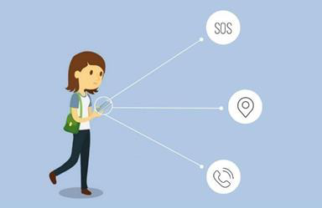

Dr. K Srinivas et al Int. J. Sci. Res. Comput. Sci. Eng. Inf. Technol, May-June - 2021, 7 (3) : 378-386

continuously which is the primary aim of the IV.IMPLEMENTATION proposed system and the person can be rescued.

This android application is useful when the user is in   
some problem or needs any help. When the user   
opens this application, can see a HELP button. Also,   
they can store a message and 3 contact numbers.   
When the user is in some difficulty or needs any help,   
they simply need to open the app and click on the   
“HELP” button. This application sends the message to   
those contact numbers which he has stored.

The total evaluation can be done in three major steps

|  |  |  |  |  |  |  |  |  |  |
| --- | --- | --- | --- | --- | --- | --- | --- | --- | --- |
| which | are | | described | | individually. | Evaluation | | | Fig.5. Implementation of proposed work. |
| describes | | the | | whole | implementation | | of | the |

application in three major steps.

The first major step is to enter the contact details in V.RESULTS

the application created. Those contacts can be our

relatives, friends and chief cop of the particular city the person we live in. When the application is installed in the smart phone for the first time the above contact details should be provided.

The application will save the given information. The second major step is to send the GPS information (GPS information can be in the form of the Co-ordinates or the URL which leads to the location of the person any stock map application in the likes of third-party application like Google, Nokia etc.) to the registered contacts at danger times or when the person is needed to be rescued. This step is followed only when the rescue button is pressed in application. The whole process of this step is done only when the device is connected to the proper mobile network and location service in the device is switched on

The testing results of the mentioned three sections are provided with screen shots taken in various intervals of time from the root device and contact’s device. Here, the root device means the device over which the rescue application is started; it means the user’s device. The contact’s device means the device to which the user’s location information is sent continuously. For installing the application in the mobile phone, firstly in the settings, “allow non-market apps to be worked over the device” must be checked as shown in the following figure 6. Figure 6 depicts the settings of the device such that only by placing checkmark over the mentioned icon, the app will be installed on the device. The Security Alert app icon can be placed anywhere on the home screen of the smart phone so that we can immediately touch

(GPS). over the application when we are in danger. Once

The third major step comprises of work done in sending the message containing location URL continuously to the registered contacts. Here, we have set the time interval as 5 minutes, so for every five minutes of time-lapse, SMS is sent to the registered contacts. Therefore, the exact location of the person can be tracked by the application

the application is installed on the mobile for the first time, the following screen shown in figure 7 will appear. Figure 7 depicts the HELP button and the settings icon. When you click on the settings icon figure 8 will appear. Figure 8 depicts the custom message and the contact list blocks and save button.

Volume 7, Issue 3, May-June-2021 | http://ijsrcseit.com 382

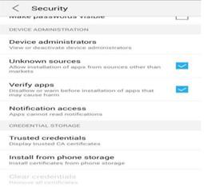

Dr. K Srinivas et al Int. J. Sci. Res. Comput. Sci. Eng. Inf. Technol, May-June - 2021, 7 (3) : 378-386

Fig.6. Settings of the device

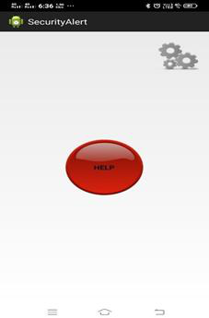

Fig.7. Layout of the app immediately after installation.

After pressing the settings symbol, the application screen appears as depicted in the figure 7. Figure 7 depicts the custom message and the contact list blocks and save button.

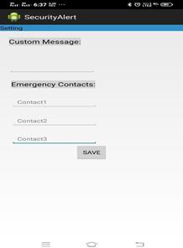

Fig.8. Layout of the second page for details.

After entering the custom message and the contact details, the application screen appears as depicted in the figure 9. After completion of writing the custom message and registering the contact details in the application, the save button must be clicked by the finger else the message and the contacts will not be saved.

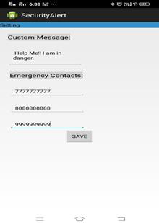

Fig.9.Details entered in the application.

After completion of saving the contact details, save button must be clicked to exit from the application

Volume 7, Issue 3, May-June-2021 | http://ijsrcseit.com 383

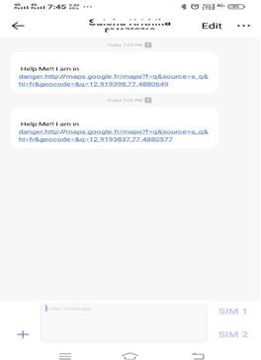

Dr. K Srinivas et al Int. J. Sci. Res. Comput. Sci. Eng. Inf. Technol, May-June - 2021, 7 (3) : 378-386

and Help button must be clicked to start the   
application immediately. There is no obligation of   
entering the message and the contact details each and   
every time when we open the application. Once   
entered and saved they will be registered in   
application till we change them.

Message received by the contact device immediately   
after starting the application. When we click help   
button of the application, it starts and the GPS starts   
running over the device and immediately the user’s   
location will be sent as shown in figure 10.

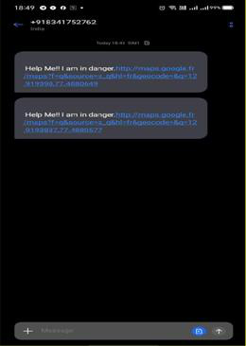

Fig.10.Message received by another contact device immediately after pressing the Help button in the application.

Fig.11. Depicts the message received by the second contact device immediately after pressing the Help button in the application.

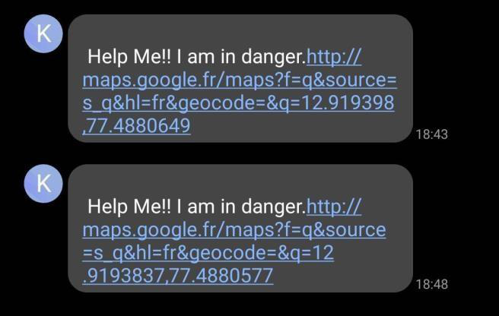

Fig.12. Message received by one of the contacts after five minutes span of time.

Figure 12 depicts the message received by one of the contact devices after five minutes of the start of the application. This mode of tracking the user i.e., getting user’s location at periodic intervals for every five minutes will be helpful when the user is moving i.e., if she is caught by the kidnapper and if they are taking her, we can rescue her by knowing the location in this manner. After receiving the message from the user, the URL in the message has to be

Volume 7, Issue 3, May-June-2021 | http://ijsrcseit.com 384

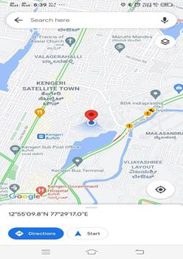

Dr. K Srinivas et al Int. J. Sci. Res. Comput. Sci. Eng. Inf. Technol, May-June - 2021, 7 (3) : 378-386

clicked in order to know the exact location of the city police control room database) instead of user. experimental database used here in the project. Also, some further upgrade can be done when the mobile network is not available for the root device and also if the root device is switched off. Thus, this app can help in a big way to rescue the women or men from unsafe conditions.

VII.ACKOWNLEDGEMENT

Apart from the efforts of us, the success of this paper   
depends largely on the encouragement and guidelines   
of many others. We take this opportunity to express   
my gratitude to CMR Technical Campus College   
Management for motivating us and for providing us   
all the facilities required for this work. We are deeply   
indebted to Chairman Shri Ch. Gopal Reddy, Smt. Ch.   
Vasantha Latha, Director Dr. A. Raji Reddy, HOD

Fig.13. Screen shown after clicking URL in the message received by the contact device.

CSE Dr. K. Srujan Raju, PRC Coordinator Dr. Suwarna Gothane, Project Guide Dr. K. Srinivas CMRTC who always have a been a constant source of

|  |  |
| --- | --- |
| Figure 13 depicts the Google Maps application which | inspiration for us. |

appears just after clicking the URL in the received message. The blue block “directions” in the application shows the exact location of the user.

VI.CONCLUSION AND FUTURE WORK

This paper describes the application, Security Alert that is designed in android platform for safety of women with the aid of recent improvements in mobile technology. In this project to use which is useful for the user when he is in some problem or needs any help. When the user opens this application, he can see a HELP button. Also, he can store a message and 3 contact numbers. When the user is in some difficulty or needs any help button. So, when the user opens this application can see a HELP button. Click that button to send SMS to register user. For

|  |  |  |  |  |  |
| --- | --- | --- | --- | --- | --- |
| future | development, | this | application | can | be |

integrated with the law enforcement database (e.g.,

VIII.REFERENCES

[1].Android Developers, Location APIs. URL: http://developer.android.com/google/playservice s/locat ion.html

|  |  |  |  |
| --- | --- | --- | --- |
| [2]."WOMEN’S | SECURITY", | Android | App |

developed by App Soft India, December 17, 2013. https://play. google. com/store /apps/ details? id= com. Zayaninfotech. security& hl=en [3]." POLIE NEARBY", Android app developed by Big Systems in 2013. https:// play. google. com/

|  |  |  |  |
| --- | --- | --- | --- |
| store/apps | /details? | id=com. | smoketech. |

PoliceNearby& hl=en   
[4]." SCREAM ALARM", Android app developed by GoPalAppMaker in November,2013 https: //play. google.com/store/apps/details?id=gopal.

appmaker. android. com&hl =en

Volume 7, Issue 3, May-June-2021 | http://ijsrcseit.com 385



Dr. K Srinivas et al Int. J. Sci. Res. Comput. Sci. Eng. Inf. Technol, May-June - 2021, 7 (3) : 378-386

[5].Saranya, J.; Selvakumar, J., “Implementation of   
children tracking system on android mobile   
terminals," 2013 IEEE International Conference   
on Communications and Signal Processing   
(ICCSP), vol., no., pp.961,965, 3-5 April 2013.

[6].Android Studio Development Essentials Book by   
Neil Smith   
[7].An Introduction to Database Systems Book by

|  |  |  |  |
| --- | --- | --- | --- |
| Christopher | J. | Date | firebase.google.com |

developer.android.com for SDK   
[8].B. Chougula, “Smart girls security system,"

|  |  |  |  |  |
| --- | --- | --- | --- | --- |
| International | Journal | of | Application | or |

Innovation in Engineering & Management,   
Volume 3, Issue 4, April 2014.

[9].PalvePramod, “GPS Based Advanced Soldier

|  |  |  |  |  |
| --- | --- | --- | --- | --- |
| Tracking | with | Emergency | Messages | & |

Communication System," International Journal   
of Advance Research in Computer Science and   
Management Studies Research Article, Volume   
2, Issue 6, June 2014.

Cite this article as :

Dr. K Srinivas, Dr. Suwarna Gothane, C. Saisha   
Krithika, Anshika, T. Susmitha, "Android App for   
Women Safety", International Journal of Scientific   
Research in Computer Science, Engineering and   
Information Technology (IJSRCSEIT), ISSN : 2456-  
3307, Volume 7 Issue 3, pp. 378-386, May-June 2021.

Available at   
:<https://doi.org/10.32628/CSEIT1217368>doi   
Journal URL :<https://ijsrcseit.com/CSEIT1217368>

Volume 7, Issue 3, May-June-2021 | http://ijsrcseit.com 386